1. Start t32marm.exe

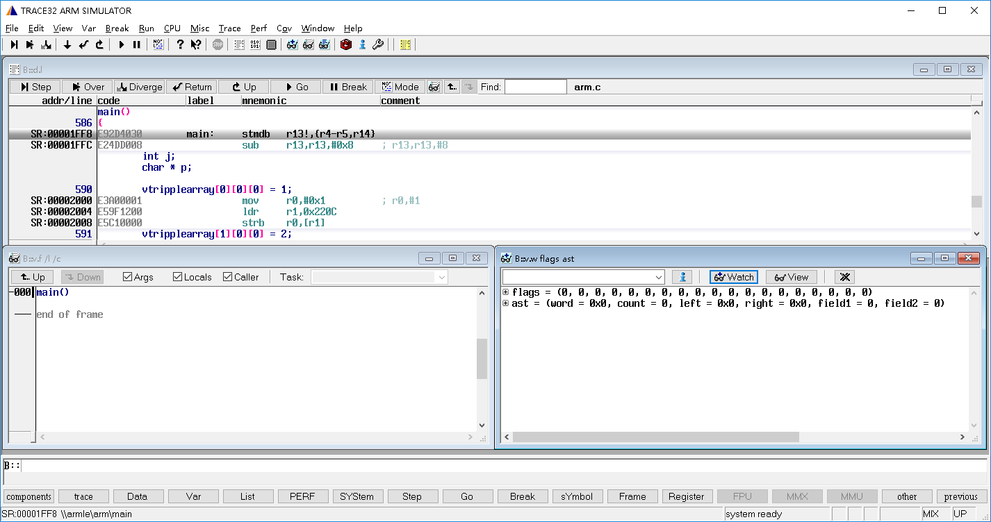

1. Click File-Run Scripts and select script load_memory_butterfli.cmm

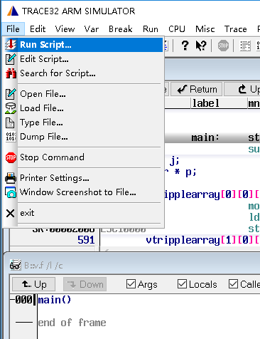

1. Select axf file

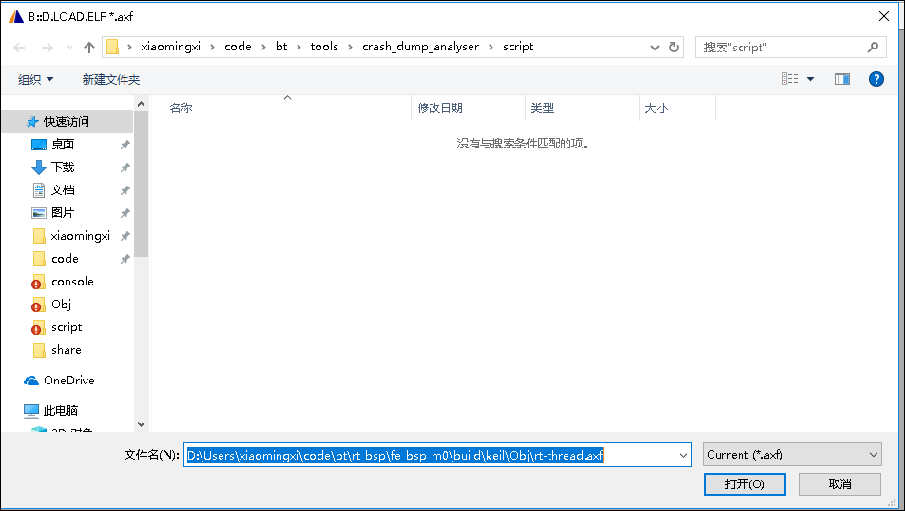

1. Select ROM memfile (memfile is generated by console_gui.py automatically when crash dump happened)

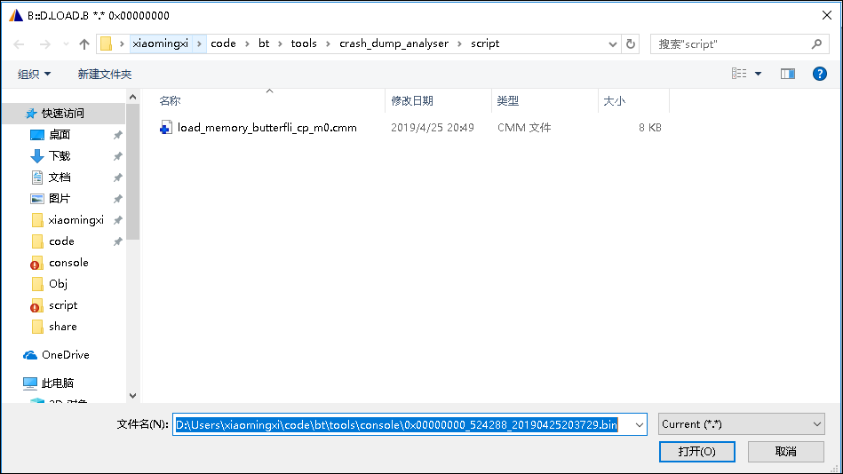

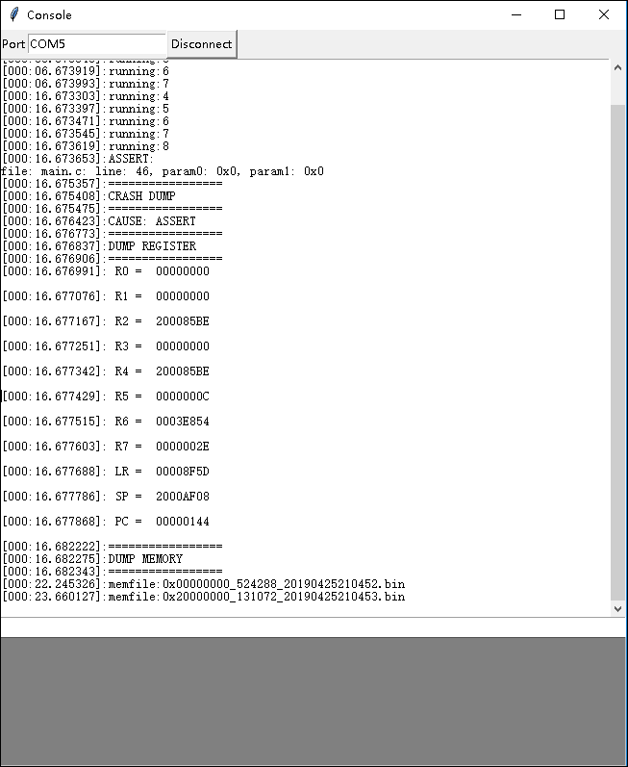

1. Select RAM memfile

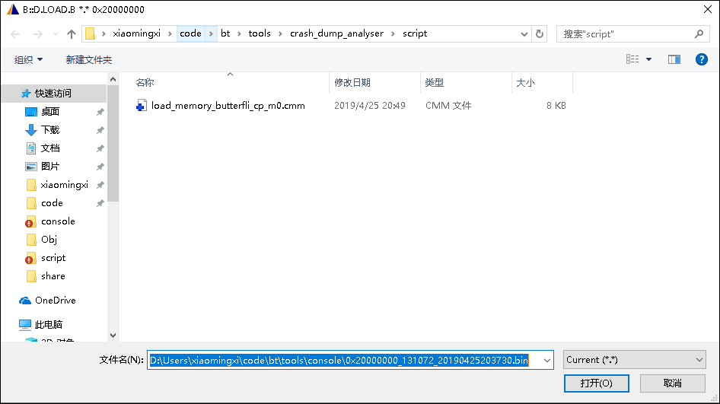

1. Select axf file again

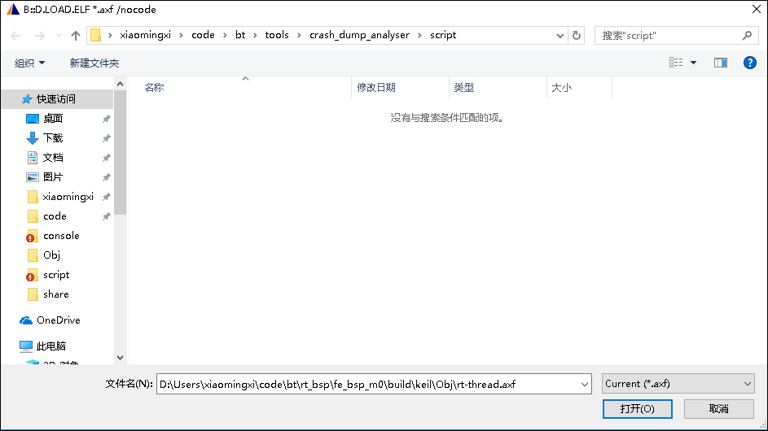

1. Then the window is displayed as below. Function call stack and variable watch window are opened by default.

