Description: | Battery Charging and Monitoring

The SP-48 battery pack will discharge over time and the cell voltages will drop. Like other Lithium chemistries, the batteries are permanently damaged if the cell voltage gets too low: in the SP-48, that minimum cell voltage is 2.7V.
- When the boat is turned on and sitting on the trailer, a full pack will lose about half its charge in a two-week period: we recommend checking it at least every two weeks.
- When the boat is turned off with the battery switch in the main payload bay, the pack can hold its charge for a long time: we recommend checking it at least every three months.
To properly monitor and maintain the SP-48 battery pack:
- Put the SP-48 on a charger.
- Set the SP-48 so it saves current power levels and battery status to the server.
- Check the SP-48 once every two weeks to confirm that the battery looks normal.
- Enable alerts so the SP-48 sends out a notification if the battery ever needs attention.
- Turn off the main battery switch if the SP-48 is idle for long periods of time.
Each of these is outlined in more detail below.

1: Charging the SP-48
There are three methods to charge the SP-48:
- Leave the boat so that the sun can hit the solar panels. The power draw when the boat is on the trailer is minimal, so just a little sunlight each day will keep it topped up.
- Connect the red high-speed external charger to the boat. The external charger fills the pack at roughly 10% per hour. It is safe to leave the red charger connected.
- Remove one solar panel and connect a small trickle charger to the solar panel connections in the deck. The connectors are standard MC4 solar connectors: the photo below shows an example, and which connector is positive / ground. Set the charger voltage to 20V, and set the current to 5A or less. It is safe to leave this power supply connected.
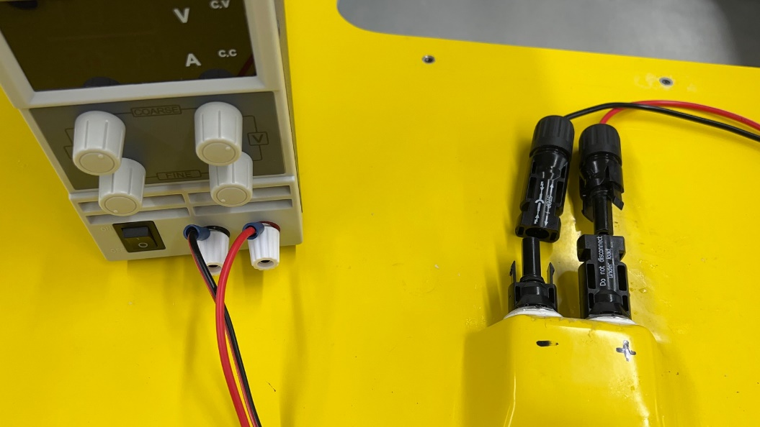

2: Set Reports / Timing to Log Data to the Server
The SP-48 logs key parameters to the database according to settings made from the Dashboard. When the boat is on the trailer, we recommend taking advantage of this built-in capability: the standard “Trailer Settings” are ideal for this purpose.
- Start Dashboard and connect to the SP-48. Use the Check button to confirm comms.
- Click Data, Reports / Timing to bring up the Reports / Timing dialog.
- Click Run all with recommended Trailer Settings
- The settings in the Reports / Timing dialog will change:
  - The RF Link will broadcast data at .05 minutes (3 seconds)
  - Cell1 will broadcast to the server at 15 minutes
The 3 second update for the RF Link provides high frequency updates to anyone nearby with an RF Link. The 15 minute update for Cell1 will save data to the server online every 15 minutes. This allows anyone to bring up the Dashboard and get a clear history of the battery charge and understand what is happening.

3: Check the SP-48
The safest way to ensure proper health of the SP-48 is simply to check it regularly. If the SP-48 is on the trailer with no payloads turned on then we suggest at least once every two weeks.
- Start Dashboard and connect to the SP-48. Use the Check button to confirm comms.
- If the boat is stored inside and is unable to get a GPS signal, the internal clocks will drift.
  - Click Time down in the lower-left of Dashboard to bring up the Time pane.
  - Click Set for each clock to set it to the time on your computer.
- Next, click Window, BMS to bring up the BMS dialog.
- At the bottom of the Dashboard main window, click Timeline to display the history view timeline.
- At the right of the timeline pane, click Show History to bring up the History dialog.
- Select to show the last 7 days of history and click OK.
- Once displayed, drag the timeline bar over the entire week-long period, and review the cell voltages in the BMS dialog:
  - Look for low cell voltages: the absolute minimum cell voltage is 2.7V, but a practical “battery empty” voltage is 3.1V. Put the boat on the charger if cells are low.
  - Look for cells that are different than the others. Any cell that is more than .1V away from the others means the pack is out of balance, or that a cell is damaged.

4: Set Alerts
The SP-48 Alert feature is a good backup to provide a reminder that the battery needs attention. The following steps setup standard alerts for the SP-48 to monitor the battery system:
- Click Data, Alerts to bring up the Alerts dialog.
- The upper half of the dialog has settings that are on the SP-48: click Get in the upper-right corner to retrieve the settings on the SP-48.
- In the Send Alert Over group, we normally suggest turning on RF, Cell1 and LAN and PC: make sure they are all checked. Checking SBD will send traffic over your SBD link: this is normally used for missions but is also safe to leave on when the boat is on shore.
- Under Standard Alerts:
  - Check BMS fault: this will generate an alert if the battery system has a fault, such as one or more cells having unexpected high or low voltages.
  - Check Low state of charge, and set the % to 40%: this will generate an alert when the pack gets below 40%.
- Click Set in the upper-right corner of the dialog to save your settings to the SP-48.
Next, setup the alert configuration on the server, so the server knows where to send the alerts.
- The lower half of the dialog has the settings on the server: click Get in the lower-right section to retrieve the server settings.
- Configure up to five recipients for alerts: for each recipient:
  - Check Send email and set their email address if they should receive email alerts
  - Check Send text and set their phone number if they should receive text alerts
  - Check Call and set their phone number if they should receive phone call alerts
- Under No Communications from Boat to Server:
  - Check No network communications for, and set it to 1800 seconds: this will generate an alert if the SP-48 has not contacted the server for half an hour, indicating that data is no longer being logged from the boat to the server.
- Click Set in the lower-right section of the dialog to save your settings to the server.
Together, these alerts capture potential problems while the boat is on the trailer and send you a message: this gives you time to react and manage the situation before the pack is damaged.

5: Main Battery Shutoff
As mentioned above, the batteries can last for months when the main battery switch is turned off.
However, with the switch turned off, there is no easy way to check the batteries: there are no alerts available, and the system will not be logging to the database. As a result, we suggest checking the system every three months. This entails turning the battery switch back on, and then using Dashboard to connect to the boat and review the status. This periodic check is important: it is the only way to detect a failure in the system causing discharge that could permanently damage the pack.

