User Manual

Project Homerweb

v1.0

DVL Holdings

Team Homerweb (Georgia Institute of Technology)

**Table of Contents**

1 **Welcome** 4

2 **User Account Operations** 5

2.1 Registering an Account 5

2.2 Logging In 5

2.3 Forgot Password 6

3 **User Announcements** 7

3.1 Viewing the Announcements 7

4 **User Courses/Lectures** 8

4.1 Viewing the List of Courses 8

4.2 Viewing the List of Lectures for a Course 8

4.3 Lecture Information/Resources 9

4.4 Lecture Resources/Video 10

4.5 Lecture Resources/PowerPoint 11

5 **User Subscriptions** 12

5.1 Extending a Subscription 12

5.2 Purchasing a new Subscription 13

6 **User Profile** 14

6.1 Editing a User Profile 14

7 **Admin Panel** 15

7.1 Accessing the Admin Panel 15

7.2 Admin Panel Home 16

8 **Managing Users** 17

8.1 Viewing User list 17

8.2 Add New User 18

8.3 Add User From Excel File 18

8.4 Edit User 19

9 **Managing Courses** 20

9.1 Viewing Course List 20

9.2 Add New Course 20

9.3 Edit Course Information 21

9.4 Add Course Admin 21

9.5 Remove Course Admin 21

9.6 Add Course Subscription 22

9.7 Delete Course Subscription 22

9.8 Edit Course Subscription 23

9.9 View Course Schedule 24

9.10 Add Schedule Item 24

10 **Templating** 25

10.1 Theme the Main page 25

1 **Welcome**

Welcome to the user manual of Project Homerweb. In this manual, you will find all the necessary instructions on how to use this product and/or services. In the coming pages, there will be a complete guide with screenshots that will show you the various tasks from logging in to the website to customizing your very own classes and lectures. Please refer to the table of contents to help locate your specific tasks.

Project Homerweb is still in development, therefore, this document is subject to changes in future versions.

2 **User Account Operations**

**2.1 Registering an account**

To register for an account, find the link that says “Register Here”. This link should be located below or near the vicinity of the Login box.

When registering, you must provide a valid and active e-mail account that you have access to. Your login information will be sent automatically to this registered e-mail address.

*See the example in figure 1.*

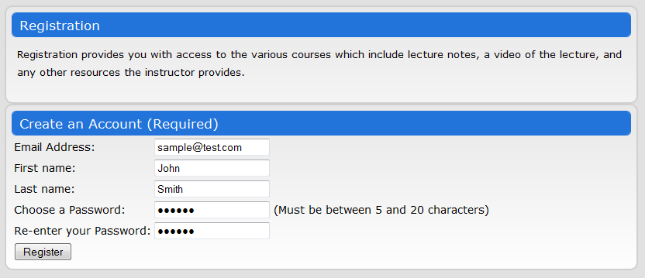

Figure 1

**2.2 Logging In**

To log into the site, find the login box. This login box requires a valid and active e-mail address and a password. Without both, a user cannot log into the site.

*See the example in figure 2.*

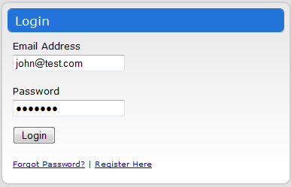

Figure 2

**2.3 Forgot Password**

If you have forgotten your password, please visit the “Forgot Password” link in the home page. The link is near the vicinity of the Login box.

To recover your password, simply enter in the e-mail address that you registered the account with. Your password will then be reset and e-mailed to the specified e-mail address.

*See the example in figure 3.*

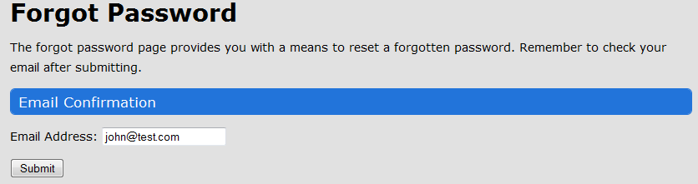

Figure 3

**3 User Announcements**

**3.1 Viewing the Announcements**

Once logged in, you will be brought to the “Home” tab, which displays the announcements for the courses that has posted an announcement. To view any particular announcements, simply click on the announcement link for that course.

The left module box displays the list of announcements for a particular course. The right module box displays the announcements for the currently selected course.

*See the example in figure 4.*

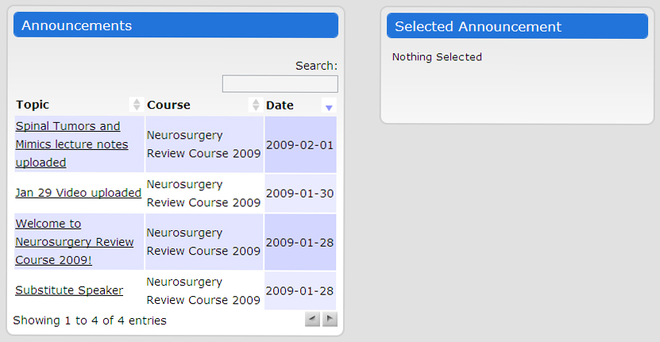

Figure 4

**4 User Courses/Lectures**

**4.1 Viewing the List of Courses**

To view the list of courses that you have registered for, click on the “Courses” tab. This will display the list of courses that you have access to, along with a brief description and their state date and end date.

**4.2 Viewing the List of Lectures for a Course**

Once you are in the “Courses” tab, if you want to view all the lectures pertaining to a specific course, simply click on that course link under the Course column.

Once a course link has been clicked, the page will now display a list of lectures for that course. The table will have the list of lectures along with the speaker for that lecture and the date and time it begins.

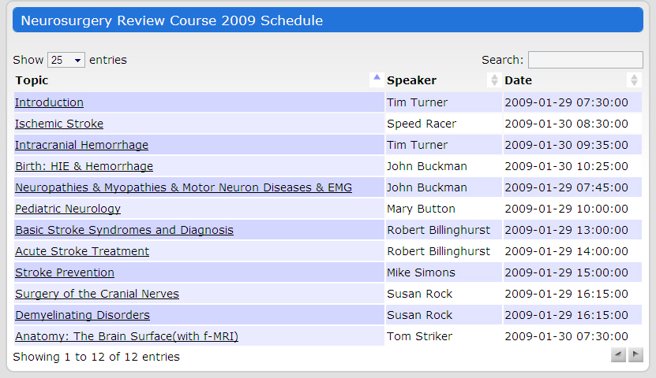

Figure 5

To get more information about a lecture, choose a lecture and click the link. See 4.3 for more information.

**4.3 Lecture Information/Resources**

To get information about a lecture, you must have completed the steps in 4.2. Once completed, the page will display the lecture name and various information such as the date, time, and the instructor. The resources for that lecture will be displayed within a table.

*See the example in figure 6.*

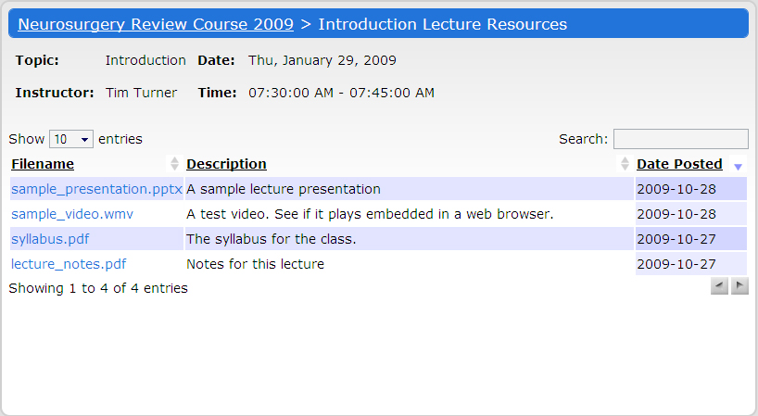

Figure 6

**4.4 Lecture Resources/Video**

To access a video lecture, the lecture must have provided a video in .wmv format. To watch the video, the user first must have Windows Media Player installed on their computer. To watch the video within a web browser, the user must have the Windows Media Player Plug-in for their browser.

After having the required plug-in and players, the video will be played within a webpage or a player, when clicked.

*See the example in figure 7.*

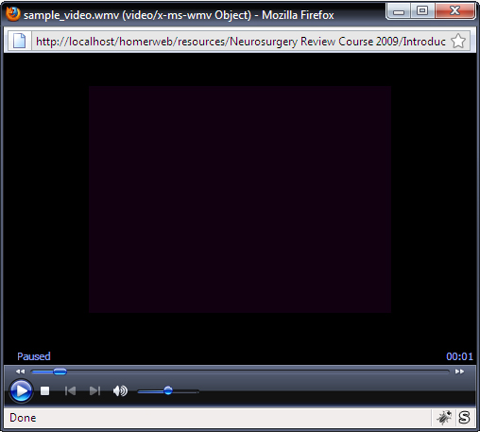

Figure 7

**4.5 Lecture Resources/PowerPoint**

If a PowerPoint exists for a lecture, the table of resources will display them. To view a certain PowerPoint presentation, simply click on the link that has a file name with extension .pptx.

The web browser will open up a new window much like in 4.4 and the user can watch the slides.

5 User Subscriptions

**5.1 Extending a Subscription**

To extend a subscription, the user must visit the subscriptions tab and select the course that they want to extend. The subscriptions page will display various tables.

*The subscription table*:

This table will display all the current subscriptions that the user has and ones that have expired.

To extend a subscription, click on the “Extend” button besides the subscription that you wish to extend.

Upon doing so, this will bring you to a new page where you can extend your subscription for that particular course.

*See the example in figure 08.*

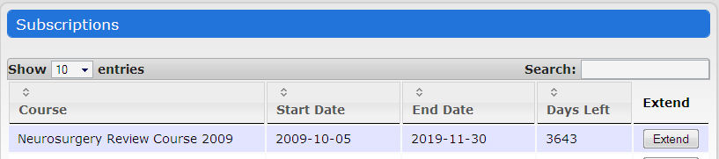

Figure 8

**5.2 Purchasing a new Subscription**

To purchase a new subscription, the user has to be in the “Subscriptions” tab. This tab will display various tables. The table that is relevant is the “Purchase New Courses” table.

*The Purchase New Course table*:

This table will be displayed directly below the “Subscriptions” table. In this purchase new course table, the user can pick a course that is currently available and register for it.

To do so, simply click the “Purchase” button next to the course. Upon doing so, a new page will be displayed that will ask if you to proceed with the process.

*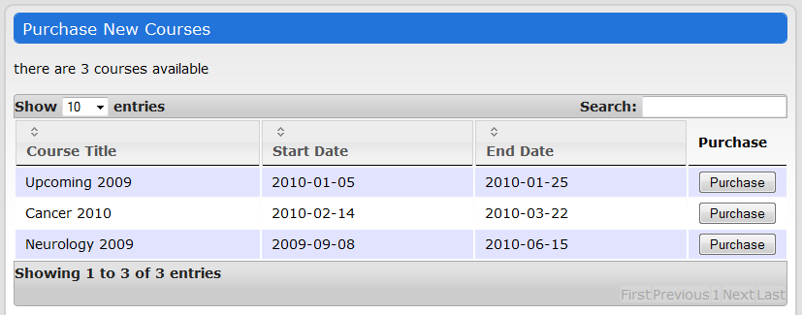See the example in figure 9.*

Figure 9

**6 User Profile**

**6.1 Editing a User Profile**

A user can edit his or her profile but visiting the “Edit Profile” tab. This page will display various fields that the user can edit about his or herself. Once completed, simply click the “Save Changes” button to complete the process.

*See the example in figure 10.*

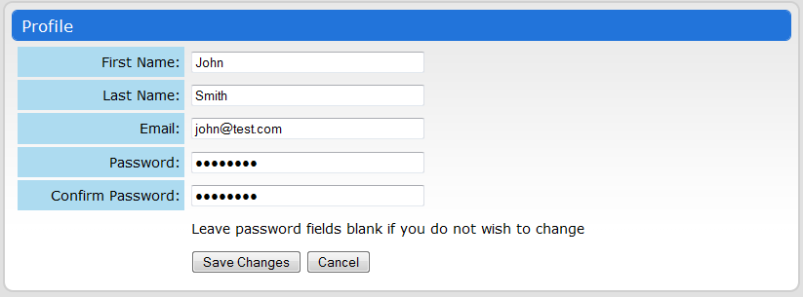

Figure 10

**7 Admin Panel**

**7.1 Accessing the Admin Panel**

Admins (site, course, and lecture) will see a button in the upper right corner of the User pages that will allow them to access the Admin Panel.

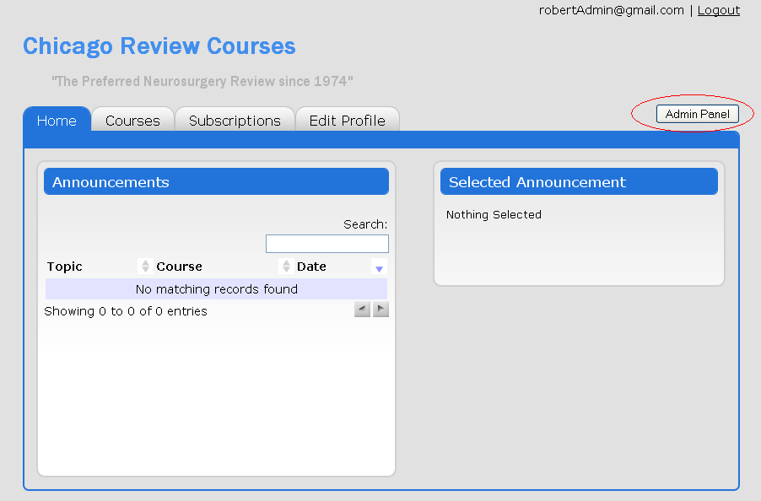

Figure 11

**7.2 Admin Panel Home**

The Admin Panel Home will appear differently depending on whether the user is a site admin, or a course or lecture admin. Site admins will be able to access Users, Courses, and Settings controls. Course and lecture admins will only be able to access Course controls, and they will have limitations within that category.

Site Admin Home:

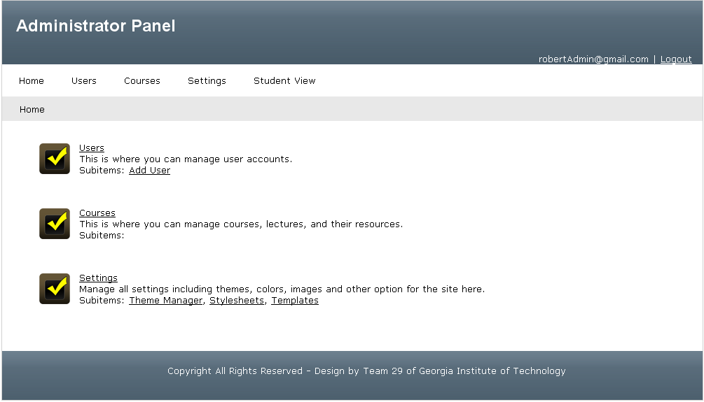

Course and/or Lecture Admin Home:

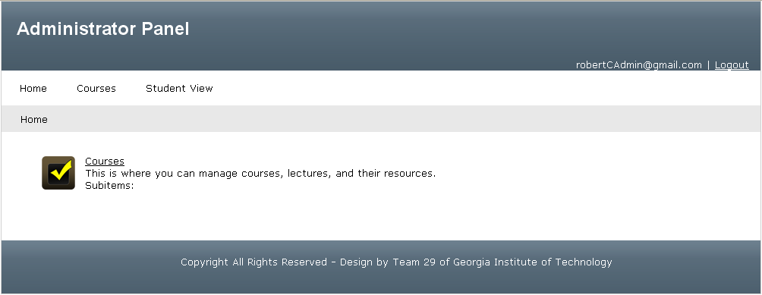

Figure 12

**8 Managing Users**

**8.1 Viewing User list**

After navigating to the Users section, you will see a table of users. You can increase the number of rows shown, page through the table, sort the table, or search the table using the drop down list, buttons, or search box.

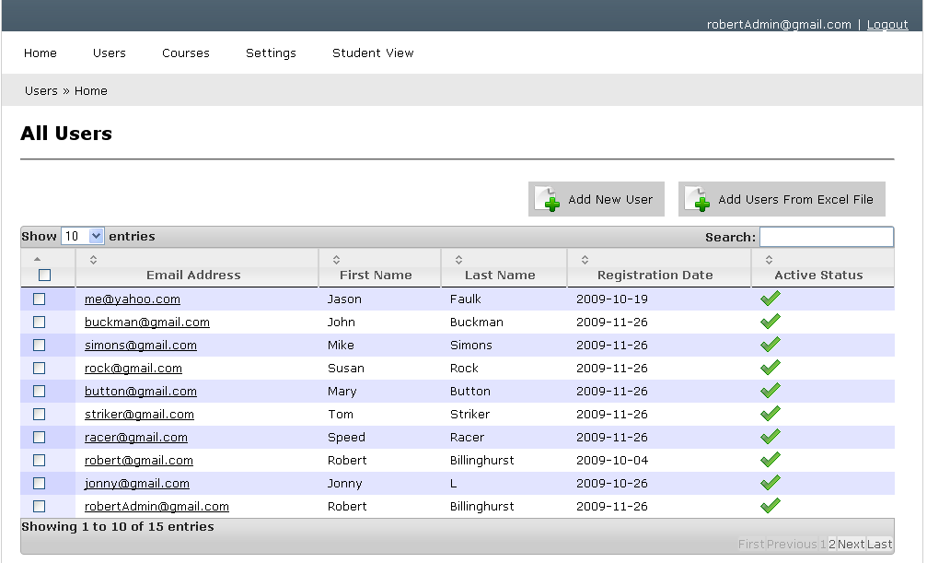

Figure 13

**8.2 Add New User**

Click on the Add New User button to add a user. You must enter a valid email address, first name, last name, and password. You can choose to either randomly generate a password or manually type in a password. You can also send an email to the created account if you want, and you can send them their account name and password using {email} and {password} to represent the email and password chosen.

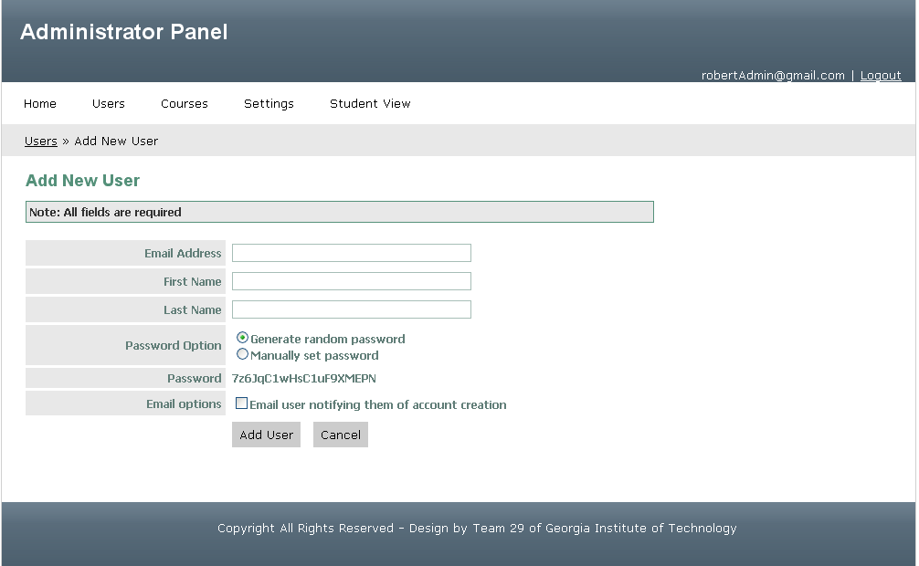

Figure 14

**8.3 Add Users From Excel File**

Click on the Add Users From Excel File button, and then select an excel spreadsheet. The spreadsheet uploaded should have 3 columns that are in this order: Email, first name, and last name. Do not insert any headers for the columns, only have a spreadsheet of data. The password for all users will be set to testing123.

**8.4 Edit User**

In the User View, click on a user email to edit that user.

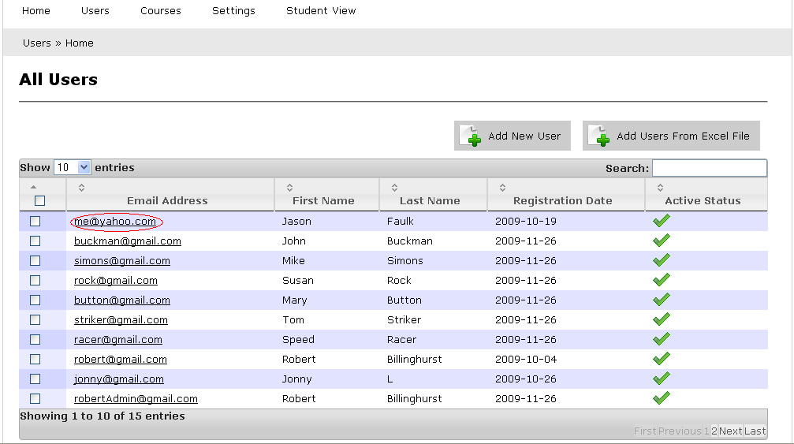

Figure 15

You are redirected to the Edit User page. Update fields as needed and click Save Changes. You can change the active status here.

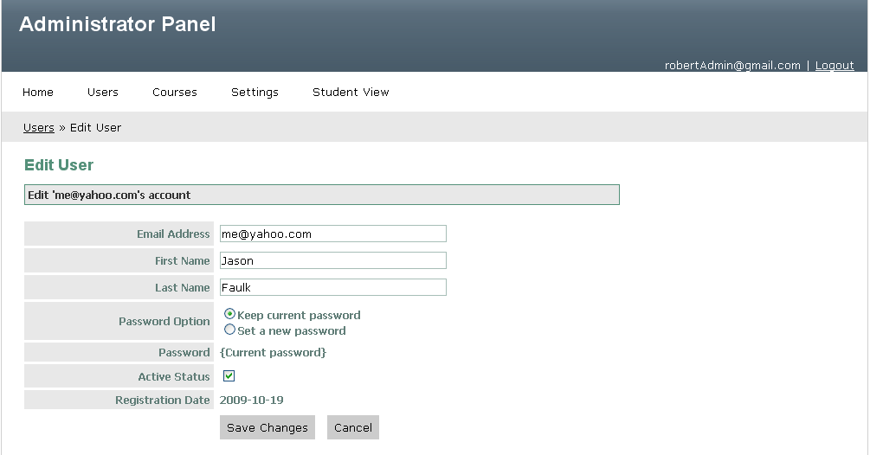

Figure 16

**9 Managing Courses**

**9.1 Viewing Course list**

After navigating to the Courses section, you will see a table of courses. You can increase the number of rows shown, page through the table, sort the table, or search the table using the drop down list, buttons, or search box.

**9.2 Add New Course**

To add a new course, click the “Add New Course” button at the top of the table. Upon doing so, a new page will be display like the one in the figure below. Simply fill in the required information for each fields and click “Add Course” when you’re done.

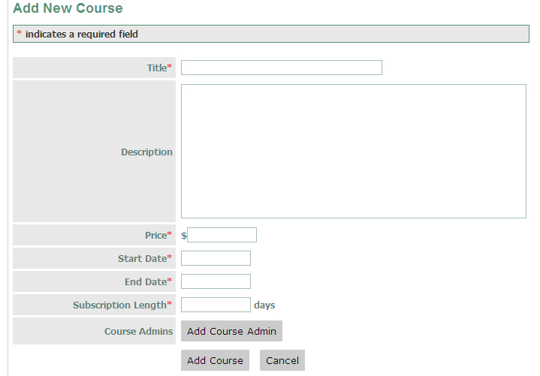

Figure 17

**9.3 Edit Course Information**

To edit a currently existing course, chose the course that you want to edit from the course table and click on it. After clicking on it, a page very much like the one in figure 20 will be displayed with the current values for that course. Edit the necessary information and click the “Save Changes” button.

**9.4 Add Course Admin**

To add an admin to a course, choose the course that you want to edit and click on it from the course tables. Navigate to the “Course Admins” tab while still under the “Edit Course” option. A new page will be displayed much like the one in figure 18.

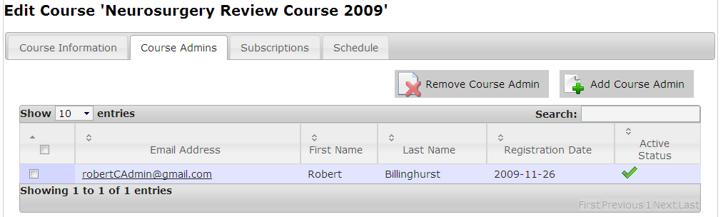

Figure 18

Once the “Add Course Admin” button is clicked, a dialog box will popup to ask you to choose from a list of users who will be the admin.

**9.5 Remove Course Admin**

To remove a course admin, refer to figure 18 above. You will have to choose the admins that you want to remove and tick the checkbox to the left of the name. After doing so, click on the “Remove Course Admin” button and that selected admin will be removed from the currently selected course.

**9.6 Add Course Subscription**

To add a user subscription to a particular course, click on the “Subscriptions” tab. Refer to figure 18 above for an example. In the subscriptions tab, you will be able to add a subscription by clicking on the “Add Subscription” button. A popup window will appear that will ask you to choose the user that you want to add the subscription to.

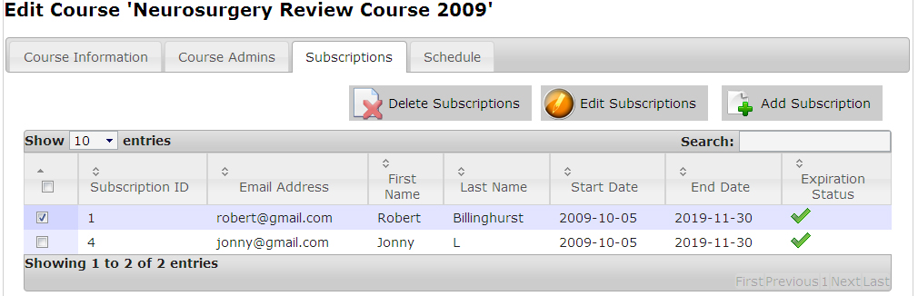

Figure 19

**9.7 Delete Course Subscription**

To delete a subscription from a course, select the user that you want to subscription to be deleted for and click the “Delete Subscription” button. Refer to Figure 19 for a visual guide.

**9.8 Edit Course Subscription**

To edit a subscription for a specific course, choose the user that you want to edit the subscription for and click the “Edit Subscription” button. Refer to Figure 22 for reference. Upon clicking the button, a popup window will appear that will allow you to edit the subscription. See figure 19 for an example.

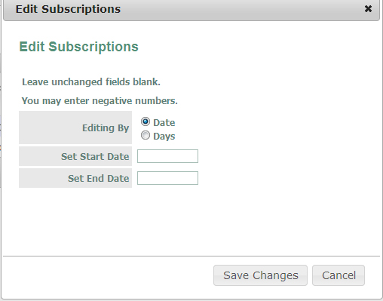

Figure 20

**9.9 View Course Schedule**

To view a schedule for a particular course, click on the “Schedule” button while being under the editing course page. Refer to figure 21 for reference.

The Schedule tab will display a table with all the lectures. To edit the schedule for a particular lecture, click on the lecture that you want to edit and a new page will be displayed that will allow you to edit the schedule fields.

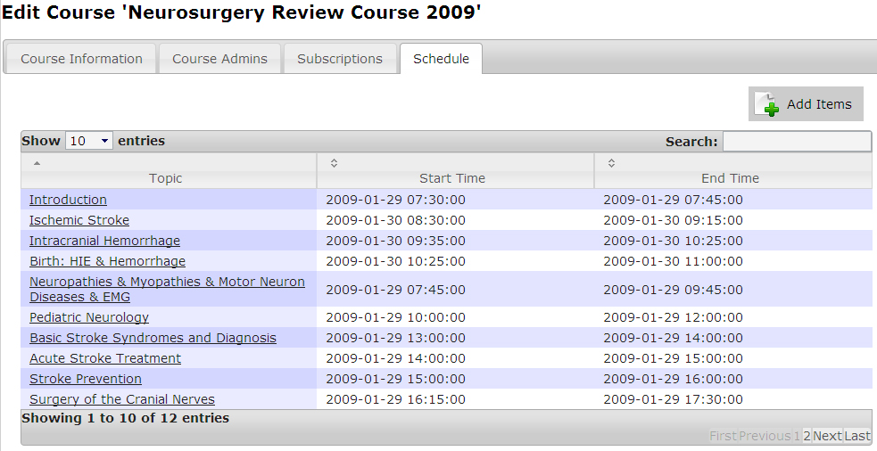

Figure 21

**9.10 Add Schedule Item**

To add an item to the schedule, click on the “Add Items” button under the “Schedule” tab. Refer to figure 24 for reference. Upon clicking on the button, a popup window will appear that will allow you add an item to the schedule.

**10 Templating**

**10.1 Theme the Main page**

To edit colors and images for the main page, click on the “Settings” tab from the main admin panel menu. A new page will be displayed where the user can edit the colors and images of the Main page.

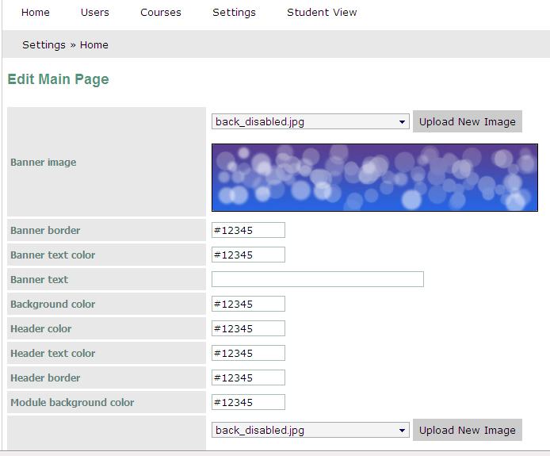

Figure 22