VIETNAM GENERAL CONFEDERATION OF LABOR

**TON ĐUC THANG UNIVERSITY**

**FACULTY OF INFORMATION TECHNOLOGY**



**web programming and aPPLICATIONS**

**FINAL REPORT**

Instructor: **MR.NGUYỄN VĨNH KHA**

Student: **NGUYỄN HỮU PHÚC– 520H0484**

**PHAN HOÀNG TUẤN– 520H0325**

**HÀ SỸ TẤN PHÁT– 520H0664**

**TRẦN QUANG KHÁNH – 520H0649**

Class **: 20H50301**

Course  **: 24**

**HO CHÍ MINH CITY, 2022**

VIETNAM GENERAL CONFEDERATION OF LABOR

**TON ĐUC THANG UNIVERSITY**

**FACULTY OF INFORMATION TECHNOLOGY**



**web programming and aPPLICATIONS**

**FINAL REPORT**

Instructor: **MR.NGUYỄN VĨNH KHA**

Student: **NGUYỄN HỮU PHÚC– 520H0484**

**PHAN HOÀNG TUẤN– 520H0325**

**HÀ SỸ TẤN PHÁT– 520H0664**

**TRẦN QUANG KHÁNH – 520H0649**

Class **: 20H50301**

Course  **: 24**

**HO CHÍ MINH CITY, 2022**

THANKFUL WORD

First of all, I would like to thank teacher Nguyen Vinh Kha for teaching and bringing us new knowledge and I wish him good health and continue your teaching path, I would like to thank the school and all the teachers for creating many conditions for the student to continue their studies.

MIDTERM ESSAY COMPLETED AT TON DUC THANG UNIVERSITY

I hereby declare that this is my our report and is under the guidance of Mr.Nguyen Vinh Kha. The research contents and results in this topic are honest and have not been published in any form before. The data in the tables for analysis, comments and evaluation are collected by the author himself from different sources, clearly stated in the reference section.

In addition, the project also uses a number of comments, assessments as well as data of other authors, other agencies and organizations, with citations and source annotations.

**If I find any fraud I take full responsibility for the content of my report**. Ton Duc Thang University is not related to copyright and copyright violations caused by me during the implementation process (if any).

*Ho Chi Minh city, 30 May, 2022*

*Author*

*(sign and write full name)*

*Nguyễn Hữu Phúc*

*Phan Hoàng Tuấn*

*Trần Quang Khánh*

*Hà Sỹ Tấn Phát*

TEACHER’S CONFIRMATION AND ASSESSMENT SECTION

**Confirmation section of the instructors**

_______________________________________________________________________________________________________________________________________________________________________________________________________________________________________________________________________________________________________________________________________________________________________________________________________________

Ho Chi Minh city, day month year

(sign and write full name)

**The evaluation part of the lecturer marks the report**

_______________________________________________________________________________________________________________________________________________________________________________________________________________________________________________________________________________________________________________________________________________________________________________________________________________

Ho Chi Minh city, day month year

(sign and write full name)

SUMMARY

In this report, we will apply the knowledge learned in class through exercises, lesson slides and the ability to self-study at home to build a website with elements such as frontend, backend, database, etc. Through this article, we will be able to know more about the process of creating a website with a single page application, learn more about how to use frameworks to build a web. The results obtained after completing this report are the knowledge and experiences that contribute to our future careers.

TABLE OF CONTENTS

THANKFUL WORD i

MIDTERM ESSAY COMPLETED AT TON DUC THANG UNIVERSITY ii

TEACHER’S CONFIRMATION AND ASSESSMENT SECTION iii

SUMMARY iv

TABLE OF CONTENTS 1

LIST OF DIAGRAMS, CHARTS AND TABLES 3

CHAPTER 1 – INTRODUCTION 4

1.1 Working Arrangement 4

1.2 Introduction to the topic 4

1.3 The reason for choosing the topic 4

CHAPTER 2 : functional description of our web 5

3.1 UML Diagram design 5

3.2 Customer registration 5

3.3 Navigate to the product store 6

3.4 Order products 6

3.5 Shopping cart 6

3.6 Show information of products 6

3.7 Show information about us 7

CHAPTER 3 : information about frameworks 8

3.1 Vue.js framework 8

3.2 Express framework 12

3.3 Main components and sample code 14

REFERENCE 15

**LIST OF ABBREVIATIONS**

SPA : Single Page Application

MPA : Multi Page Application

SEO : Search Engine Optimization

LIST OF DIAGRAMS, CHARTS AND TABLES

**LIST OF DIAGRAMS**

Diagram 1 UML Design Website UI 41

**LIST OF PICTURES**

Picture 1 How SPA works 6

Picture 2 framework for SPA 8

Picture 3 How Ajax works 10

Picture 4 WebSockets structure 11

Picture 5 SPA and MPA Lifecycle 12

Picture 6 result component 19

Picture 7 Results using computed property 22

Picture 8 How middleware works 29

Picture 9 How routing works 29

Picture 10 Express js structure 30

Picture 11 Customer information registration feature 35

Picture 12 Store registered customer information in the database part of MongoDB 35

Picture 13 Product page for customers to choose products 37

Picture 14 Product and customer information confirmation page 37

Picture 15 Shopping cart stores purchase history and customers can cancel orders 38

Picture 16 Database stores information about customers ordering products 38

Picture 17 Details about information of production 40

**LIST OF TABLES**

Table 1 Comparison table of SPA and MPA 12

CHAPTER 1 – INTRODUCTION

* 1. Working Arrangement

In order to complete this report smoothly, we have assigned work to each person on the team to be able to optimize time and work. Our team has a total of 4 people, and the work of each person is as follows :

Phan Hoàng Tuấn : is the person in charge of front-end programming for the website, He is responsible for designing UI for the website, adding products, setting up SPA for the website.

Nguyễn Hữu Phúc : is the person responsible for programming the back end for the website, has the job of building a server for the website to run, setting up the functions of a sales website.

Hà Sỹ Tấn Phát : is the person who has the job of managing the website's data by using MongoDB, build a powerpoint for middle presentation.

Trần Quang Khánh : Work on finding documentation and knowledge of frameworks and features related to programming languages, reporting formats.

* 1. Introduction to the topic

In this topic We will do a project on building a website to sell Apple phones using framework Vue.js, express.js and database MongoDB.

* 1. The reason for choosing the topic

The reason we chose this topic is to gain experience as well as learn more about how to make SPA-oriented sales sites. Along with that, it gives us the opportunity to learn about today's popular web frameworks to apply to writing websites on this topic. Realizing the importance of a website in the present time, we decided to choose a topic to improve our knowledge.

CHAPTER 2 : functional description of our web

1. UML Diagram design

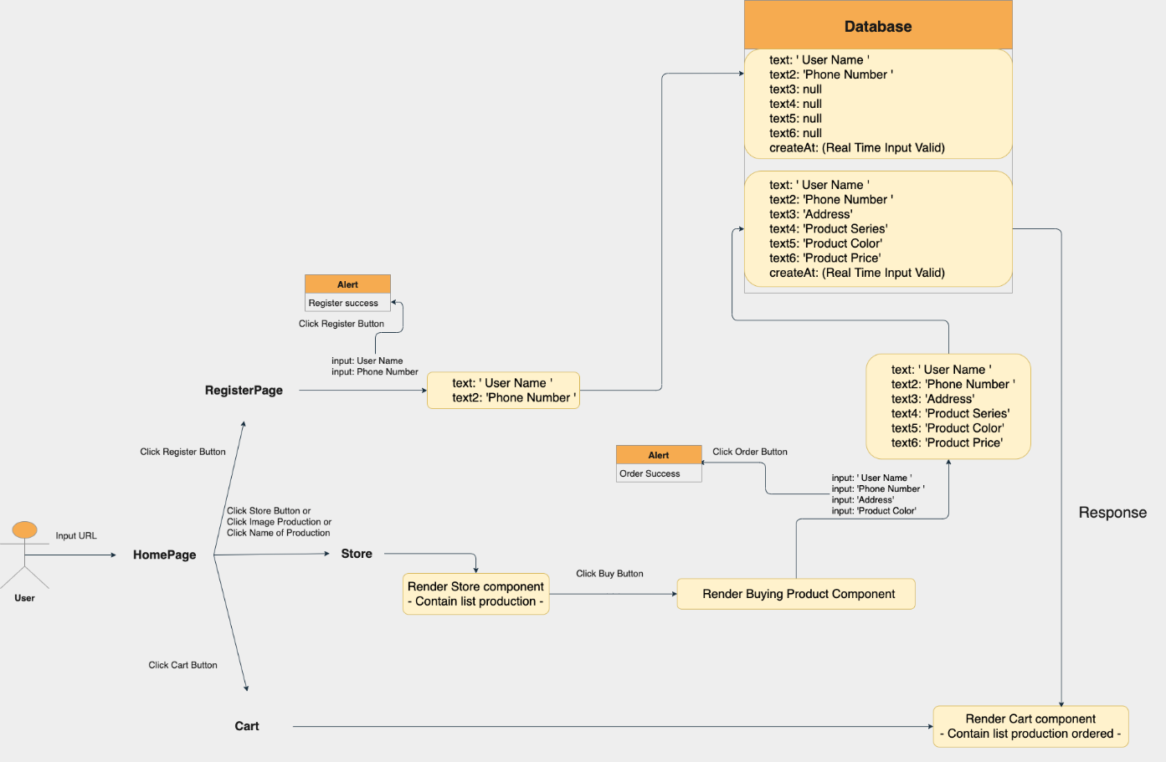

Diagram 1 : UML Design Website UI

The above UML Diagram that will describe specifically the functions of our SPA website about Apple products include the features of customer registration, order products, shopping cart, show information of products, show information about us and Navigate to the product store.

1. Customer registration

My team makes a hypothetical case that is a new ordering website, so they need some customer information, they can subscribe to receive new product information by entering their name and phone number, the staff will rely on that contact back quickly, create credibility with customers instead of replying via email. After entering the full name, entering the phone number, and clicking Register, an alert message will appear, the customer's information will be taken to the customer's database MongoDB.

1. Navigate to the product store

In this part the customer can view the product list in the Home page by selecting the Store item on the Menu Bar or the customer can choose the product classification depending on the model product which is located under the Special Discount billboard. When customers click on it, they will go to a page containing a method to view product information and a method to buy product.

1. Order products

When going to the product purchase page, the customer chooses to buy a certain product by clicking the Buy button, it will immediately go to the information confirmation page, the customer needs to fill in customer information, phone number, choose color, and on this page will display the product life and price to pay when receiving the goods, then click order, in this step, there will be a link to the shopping cart feature of the website.

1. Shopping cart

When a customer orders a product, the data of that product will be transferred to the database MongoDB, and the shopping cart will be the place to receive the server's response about the order the customer has just placed. Hence, the cart has the feature to display the purchase history and has the ability to cancel orders. Customers can click cancel the order by clicking Cancel order and the server will receive this request and cancel the order data in the database.

1. Show information of products

If you want to see the detailed configuration of each iPhone model such as Iphone X Series, Iphone 11 Series, etc. You can view it by going to the navigation bar under the discount billboard on the Home page and selecting the model you are interested in. Then the website will display the model image and with the methods of purchasing the product and viewing product information. To show the information of the products in this series, you just need to press the details button and the website will display all the information of these products.

1. Show information about us

At the bottom of the homepage will be a place for customers to know the information abous us such as full name, position, address, phone number, email to contact when needed.

CHAPTER 3 : information about frameworks

1. Vue.js framework
2. Concept

The story of Vue.js began in 2013 when Evan You was working at Google creating a lot of prototypes right in the browser. To that end, Evan took useful methods from other frameworks he worked with and officially released Vue.js in 2014.

Vue JS is a framework used to build user interfaces, when developing the view layer, users only need to use Vue's core library, which is easy to learn and integrate with other libraries. available institute or project. At the same time, if combined with modern techniques such as SFC (single file components) and support libraries, Vue also easily meets the needs of building single-page applications (SPA - Single-Page Applications).

1. Pros and cons

Advantages :

1. *Tiny size*

One of the pros of Vue.js framework, compared to more common frameworks, is its (unbearable) lightness. Thanks to its lightness, Vue is convenient to use for developing projects of various complexity - both small personal projects and multifunctional applications. The development process is also accelerated by the lightness of the framework. The framework is not only a fast to download and install the library, it also positively impacts your SEO and UX.

1. *User-friendly*

This feature of Vue.js may become one of the most popular. Unlike other frameworks, Vue.js facilitates the development process. As an app grows, the codebase doesn't get heavier. The main reason for the complexity of development is that all JSX templates and methods can exist in the same object.

In the case of Vue.js stylesheets, the HTML template and all necessary methods are isolated from each other, which allows you to control the process and understand what parts of the code can be accessed. We can assume that it will be easy to maintain the code portion of the project regardless of the complexity of the application or its updates.

1. *Easy to learn*

Vue.js is easy to learn even for a novice programmer, especially if the person already has a good understanding of JavaScript. The truth is that the Vue framework contains programming patterns and styles that are similar to those found in other JavaScript frameworks. One add-on is the Vue.js documentation which is very comprehensive and provides developers with a complete description of all the details of the job, from the installation of the library to the scalability of the application. Vue doesn’t require in depth knowledge of libraries, JSX, and TypeScript, as is often the case with other front-end technologies. All you need to start off is basic knowledge of HTML, CSS, and JavaScript, of course.

1. *Fast Renderization*

A document object model (DOM) is an application programming interface (API) for HTML and XML, modeling how text is structured. A virtual DOM is a representation of the real thing enabling changes to be synced. Synchronizing the virtual DOM is much more efficient than updating the actual DOM, which slows down performance.

When a user interacts with the page, the objects change their state, so that a browser has to update the information and render it on the screen. But, updating the whole DOM is cumbersome. For the sake of speed, Vue.js utilizes virtual DOM: Think of this as a copy of an original DOM that figures out what elements to update, without rerendering the whole DOM. This approach makes page rendering pretty quick and improves application performance.

1. *Simple Integration*

An important aspect of any emerging technology is the ability to integrate with existing applications. Vue is simple to integrate unlike other JavaScript frameworks - It can be used not only for building applications but also to include components into existing applications. There are libraries created to help this process and make it even simpler.

1. *Keeps the Focus on User Interfaces*

Vue.js is a framework that keeps a solid focus on working with user interfaces. This is possible because it only requires JS, CSS, and HTML to work with it and doesn't rely on too much Vue-specific stuff. For instance, for its Hybrid cloud, IBM used Vue.js as a front-end framework. This choice was made because of its gentle learning curve, it being lightweight, and its reliance on HTML, CSS, and JavaScript.

Disadvantages :

1. *Language Barrier*

One of the problems with Vue is that its biggest community is located in China, which can be problematic in the case of some packages or research. There are a lot of packages made by Chinese Vue developers, who write documentation in their native language. A lot of research for Vue subjects can lead to Chinese forums and discussions. This is problematic for speaking English only developers.

When a software engineer wants to work with Vue and searches for its content, they will often face forum discussions, instructions, and plugin descriptions in Chinese. This can be a problem for English-speaking developers.Worth mentioning is the fact that this problem slowly dissolves, as more global Vue communities grow up.

1. *Risk of over flexibility*

Vue offers significant flexibility, which offers a lot of freedom in using different approaches. Big projects can lead to problems with the inconsistency of code. In this situation Vue developers need to spend time reconciling the code, otherwise, different approaches can lead to more serious problems, like the different malfunctioning of applications and harder to get into the project development.

1. *Limited Resources*

As we know by now, Vue comes with a pretty wide ecosystem and various tools that a developer may require while starting to work on an application. Still, Vue is not as big as Angular and React. For instance, if you compare the number of plugins that are available in Vue.js and React, the difference is in the thousands. Besides, the existing plugins that developers might like to use with other frameworks are not often well supported. But with time, this won't be the case.

1. Vue js structure

The directory structure of a Vuejs project is as follows:

Node_modules folder : This is the directory that contains all the libraries needed to build Vue.

Public folder : This is the directory for static assets that you don't want to run through webpack.

Src folder : This is the directory containing the source code of the project. Inside there are folders :

* assets: This is where you will work with Webpack, the place you put any assets that are imported into your components.
* components: This is the folder containing the project's UI components
* router: This is where routes will be recorded and connected to the Components.
* View folder : With SPA (Single Page Application) application, there is only 1 page. Then the content of the page is changed without having to reload the page, then this is the folder includes this only page.
* App.vue: This is the entry point component. This is where all other components will be initialized. Roughly understood is the main profile of the project.
* main.js: Import the point file to mount App.vue. This is the file that exposes the App.vue component.

1. Express framework
2. Concept

Express.js was founded by TJ Holowaychuk. The first release, according to Express.js's GitHub repository, was on 22 May 2010**.** In June 2014, the project management rights were acquired by StrongLoop. StrongLoop was acquired by IBM in September 2015. In January 2016, IBM announced that it would place Express.js under the Node.js Foundation incubator.

Expressjs is also written as Express js, Express.js. This is a free and open source framework for Node.js. Express.js is used to design and build web applications simply and quickly.

Since Express js only requires Javascript programming language, building web applications and APIs becomes simpler for programmers and developers. Expressjs is also a framework of Node.js hence most pre-written code for programmers to work with.

Summary of some of the main functions of Expressjs are as follows :

* Set up intermediate classes to return HTTP requests.
* Defines a router to use with different actions based on HTTP methods and URLs.
* Allows returning HTML pages based on parameters.

1. Pros and cons

Advantages :

* Easy web creation: Due to its relatively light weight, Express.js helps organize web applications into a more organized MVC architecture. To use this source code, we need to know Javascript and HTML.
* Efficient and fast: Thanks to the Javascript Express js library which is a framework of Node.js, it helps programmers to build web applications more efficiently and quickly.
* Diversity: Expressjs is also part of a technology that makes it easier to manage web applications called the MEAN software stack.
* Easily build APIs: In fact, without using Express.js, you would have to go through a lot of complex programming steps to build an effective API. Express js has made programming in Node.js easier and has many additional new features.

Disadvantages :

* Express JS is only suitable for small-scale projects, large-scale projects that need to switch to Node JS.
* Unlike Node JS, Express JS only supports JavaScript language.
* Used only on the server side, not on the client side.

1. Express js structure

The structure of express js is very simple.

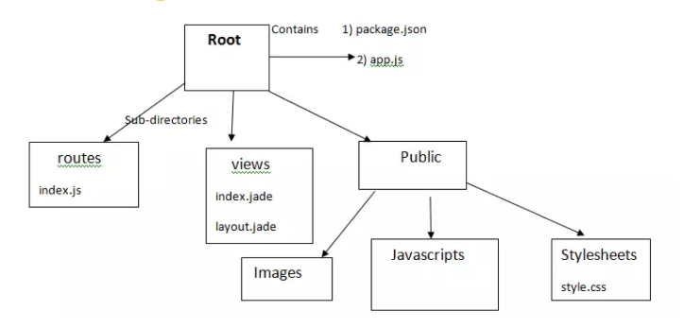

Picture 10 : Express js structure

Root :

* app.js contains information about configuration, declarations, definitions, etc. to make our application run well.
* package.json contains the packages for the application to run. If you've worked with PHP or RoR, this file is functionally similar to composer.json or Gemfile.

Routes folder : contains the routes included in the application.

View folder : contains the view/template for the app.

Public folder : contains css, js, images, files, etc for application.

1. Main components and sample code

REFERENCE

**Vietnamese**

1. Single Page Application là gì? Có phải là xu hướng lập trình web trong tương lai? (<https://phambinh.net/bai-viet/single-page-application-la-gi-co-phai-la-xu-huong-lap-trinh-web-trong-tuong-lai/#:~:text=S%E1%BB%9F%20d%C4%A9%20c%C3%B3%20t%C3%AAn%20l%C3%A0,t%E1%BA%A5t%20c%E1%BA%A3%20c%C3%A1c%20t%C3%ADnh%20n%C4%83ng.&text=Tr%C3%AAn%20l%C3%A0%204%20t%C3%ADnh%20n%C4%83ng,trang%20domain.com%2Fadmin>.)
2. Tại sao chúng ta nên xây dựng một ứng dụng Single-page Application (<https://viblo.asia/p/tai-sao-chung-ta-nen-xay-dung-mot-ung-dung-single-page-application-GrLZDwqeKk0>)
3. SPA - Single Page Application Là Gì? (<https://www.stdio.vn/javascript/spa-single-page-application-la-gi-3jnH51>)
4. Single Page Application Concept (<https://viblo.asia/p/single-page-application-concept-LzD5dDvo5jY>)
5. Single Page Application là gì? Tìm hiểu chi tiết về Single Page Application (<https://wiki.tino.org/single-page-application-la-gi/>)
6. Tự học React 2018 - Bài 1 - Single Page App (<https://www.youtube.com/watch?v=ZDPiVgPqEBU>)
7. Vuejs và những kiến thức cho người mới bắt đầu(P1) (<https://viblo.asia/p/vuejs-va-nhung-kien-thuc-cho-nguoi-moi-bat-daup1-RQqKL03pK7z>)
8. Expressjs là gì? Tất tần tật về Express.js (<https://topdev.vn/blog/express-js-la-gi/>)
9. MongoDB là gì? Tính năng nổi bật từ MongoDB bạn cần biết (<https://wiki.matbao.net/mongodb-la-gi-tinh-nang-noi-bat-tu-mongodb-ban-can-biet/>)

**English**

1. Single-page application (<https://en.wikipedia.org/wiki/Single-page_application>)
2. Single-Page Application vs Multiple-Page Application: Which One To Choose For Your Project (<https://andrejgajdos.com/single-page-application-vs-multiple-page-application/>)
3. Single-Page Applications vs Multi-Page Applications: The Battle of the Web Apps (<https://themindstudios.com/blog/spa-vs-mpa/#whatsanmpa>)
4. Single Page Application (SPA) vs Multi Page Application (MPA) – Two Development Approaches (<https://asperbrothers.com/blog/spa-vs-mpa/>)
5. SPA vs MPA: The definitive guide for decision makers (<https://www.mindk.com/blog/single-page-applications-the-definitive-guide/>)
6. AJAX Introduction (<https://www.w3schools.com/xml/ajax_intro.asp>)
7. What is Vue.js? Vue.js Advantages And Disadvantages (<https://www.spaceo.ca/blog/vue-js-pros-and-cons/>)
8. What is Express.js? (<https://www.besanttechnologies.com/what-is-expressjs>)
9. What is MongoDB – Working and Features (<https://www.geeksforgeeks.org/what-is-mongodb-working-and-features/>)
10. MongoDB (<https://www.techopedia.com/definition/30340/mongodb>)
11. What is MongoDB? (<https://www.educba.com/what-is-mongodb/>)