Combined Chemical Power Plant
Project by Team ANN

Shamima Haque Priya
1620069042
Department of Electrical and Computer Engineering
North South University
Dhaka, Bangladesh
Shamima.priya@northsouth.edu

Nabiul Hoque Khandakar
1631164642
Department of Electrical and Computer Engineering
North South University
Dhaka, Bangladesh
nabiul.khandakar@northsouth.edu

Shadman S. Khan
1611918042
Department of Electrical and Computer Engineering
North South University
Dhaka, Bangladesh shadman.khan@northsouth.edu

Ishrat Jahan Ananya
1631636645
Department of Electrical and Computer Engineering
North South University
Dhaka, Bangladesh
ishrat.jahan16@northsouth.edu

It has been seen that, in today’s time, it is possible to predict the regression relations using artificial networks that has been used to create various model systems to observe changing patterns in non-linear relations. The framework under examination must have enough dataset accessible to prepare the neural system. The point of this work is to apply what's more, explore different choices consequences for feed-foreword artificial neural system (ANN) which is used to get relapse model that will predict electrical yield control (EP) of consolidated cycle power plant dependent on 4 inputs. It indicates additionally higher execution for bigger preparing dataset measure; at the other hand, it demonstrates extraordinary impact of bigger number of factors as the provided information. What's more, two diverse preparing capacities are connected and analyzed.
Keywords: Neural Networks, Regression, Combined Power Cycle

Introduction
Electrical power has been one of the fundamental basic assets to the human exercises. Power plant has been set up to furnish human networks with the required measure of power. Power gave from power plants vacillates during that time because of numerous reasons including the ecological conditions. Of all the scientific methods, displaying the framework's thermodynamics, AI methodologies can be utilized. One of these techniques is artificial neural systems (ANNs). With the capacity of artificial neural systems to address nonlinear connections, natural conditions are contemplated as contributions of the model, what's more, the produced power is titled as the yield of the model. Utilizing this model, we can anticipate the yield intensity of the plant given the ecological conditions. Artificial neural systems (ANNs) were initially proposed in the mid-twentieth century as a computational model of the human cerebrum. Their utilization was constrained because of the restricted computational power accessible at the time, and some unsolved hypothetical issues. Notwithstanding, they have been progressively examined and connected with the ongoing presence of higher computational power and the accessibility of datasets. Investigates have considered ANN to demonstrate numerous different designing frameworks. Numerous scientists revealed the attainability and unwavering quality of ANN models as recreation and examination device for power plant procedures and parts Moderately few examinations have thought about the Steam Turbine (ST) in a consolidated cycle power plant (CCPP) . The fumes steam weight alone is an element of surrounding conditions and isn't a deterministic parameter. In this work, detailed study of regression using ANN model will be used as an approach.

BACKGROUND
- Combined cycle power plant
In electric power generation a combined cycle power plant is an assembly of a joined cycle power plant surfaced together of heating motors that works in a pair from a similar source of heat, changing over it into mechanical energy, which thus for the most part drives electrical generators. The rule is that in the start of finishing its cycle (in the principal motor), the temperature of the working liquid in the framework is still sufficiently high that a second consequent heating motor concentrates vitality from the warmth that the main motor delivers. By joining these numerous surges of work upon a solitary mechanical shaft turning an electric generator, the general net effectiveness of the framework might be expanded by 50–60%.
That is, from a general proficiency of state 34% (straightforward cycle), to perhaps a general productivity of 62% (joined cycle), 84% Theoretical effectiveness (Carnot cycle)

Definition of Artificial Neural Network
Artificial neural systems are one of the primary instruments utilized in AI. Neural systems comprise of information and yield layers, just as (much of the time) a concealed layer comprising of units that change the contribution to something that the yield layer can utilize. They are fantastic devices for discovering designs which are extremely unpredictable or various for a human software engineer to concentrate and show the machine to perceive. Each neural unit is associated with numerous others, and connections can
Improve or repress the enactment condition of bordering neural units. Every individual neural unit registers utilizing summation work. There might be an edge capacity or restricting work on every association and on the unit itself, with the end goal that the sign must outperform the farthest point before spreading to other neurons. These frameworks are self-learning and prepared, rather than unequivocally customized, and exceed expectations in regions where the arrangement or highlight discovery is hard to express in a conventional computer program. The preparation of ANN begins with arbitrary loads and afterward neurons attempts to ensure the mistakes are insignificant.

- Advantages of using Artificial Neural Network
- Data, for example, in traditional writing computer programs is put away on the whole system, not on a database. The vanishing of a couple of pieces of data in a single spot does not stop the system from working
- After preparing the data for ANN, the information may deliver yield even with deficient data. The loss of execution here relies upon the significance of the missing data. Debasement of at least one cells of ANN does not keep it from producing yield. This component makes the systems flaw tolerant.
- A system moderates after some time and experiences relative debasement. The system issue does not promptly erode right away.
- Artificial neural systems learn on occasions and settle on choices by remarking on comparative occasions.

Artificial neural systems thave numerical quality that can perform more than one occupation in a given average time.

- Disadvantages of Using Artificial Neural Networks
- Artificial neural systems require processors with parallel preparing power, as per their structure. Hence, the acknowledgment of the gear is reliant.
- There is no particular principle for deciding the structure of artificial neural systems. Suitable system structure is accomplished through understanding and experimentation.
- The system is decreased to a specific estimation of the mistake on the example implies that the preparation has been finished. This worth does not give us ideal outcomes.
- Regression ANN
Neural systems are great at fitting capacities. Truth be told, there is a confirmation that a genuinely straightforward neural system can fit any down to earth work.

Complete description of collected data with visualization
By an initial scanning of the data, we can see by the help of the Pairplot and the Correlation Chart the two strongest predictors could be Pressure and Humidity.
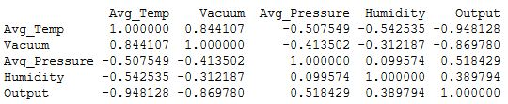
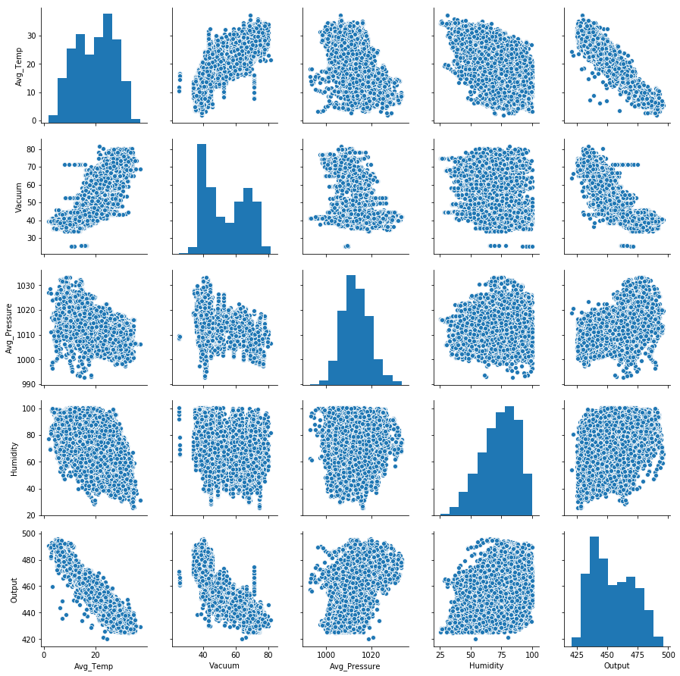
To further affirm the claim, histograms were generated of all the four attributes
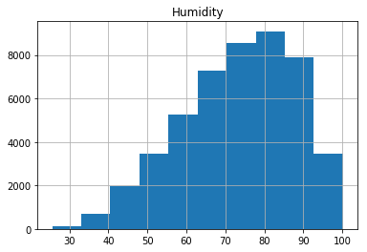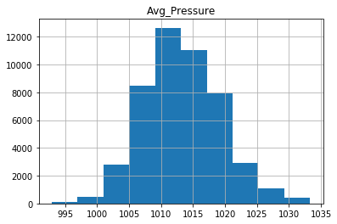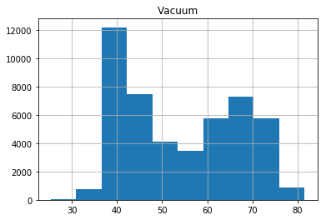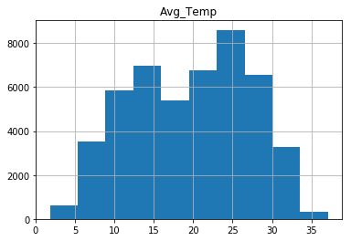
After which, we could settle for the two of the strongest predictors, pressure and humidity, we setup a scatter plot and fit a model to visualize
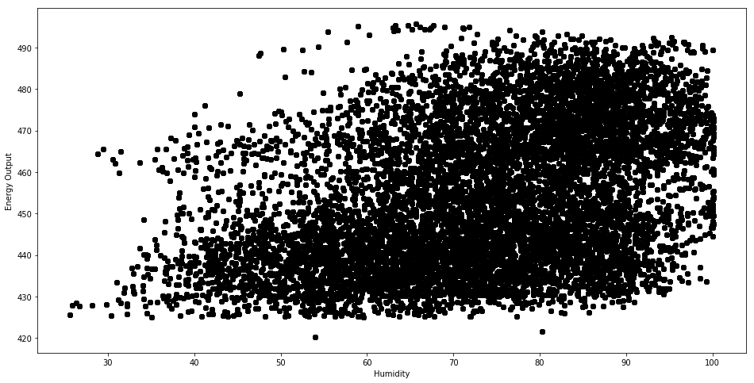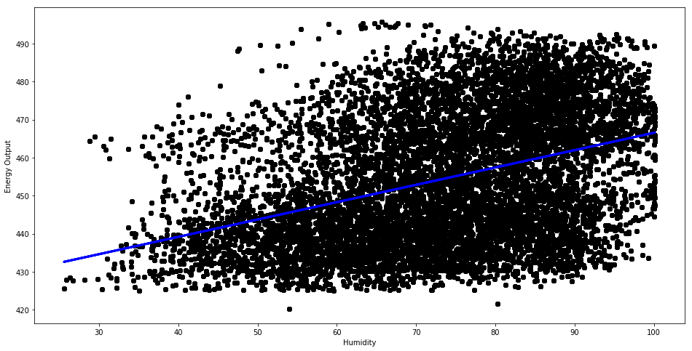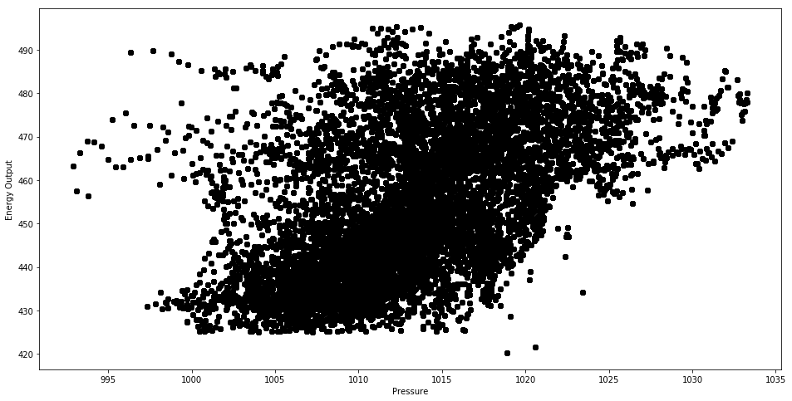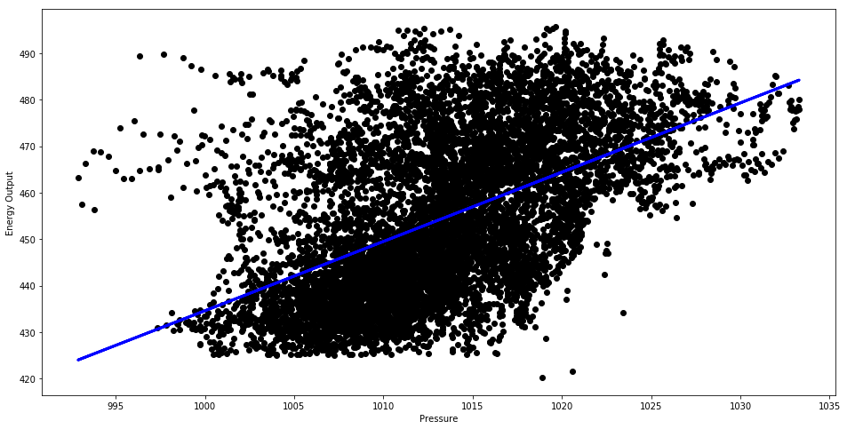
The following models were used
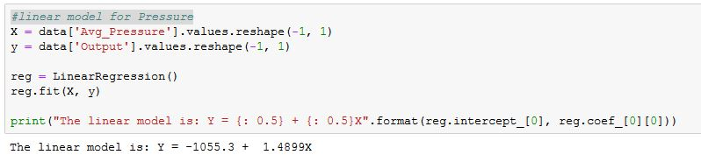
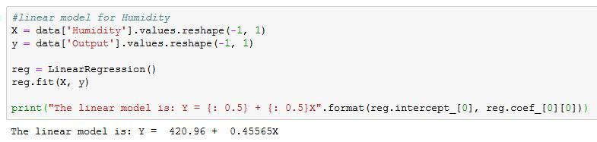
Following this, the regression results were analyzed
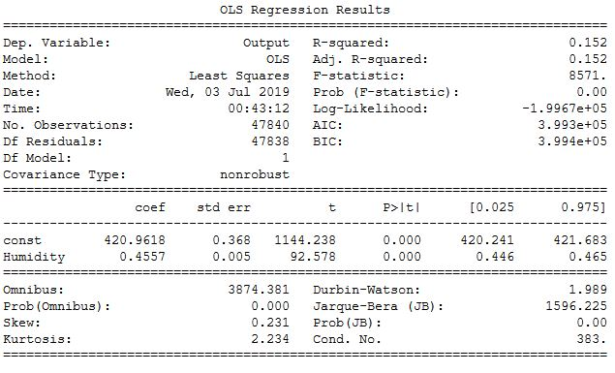
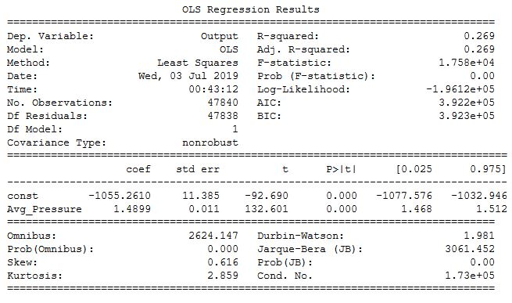
Afterwards, a multi regression approach was taken with first assessing the full model
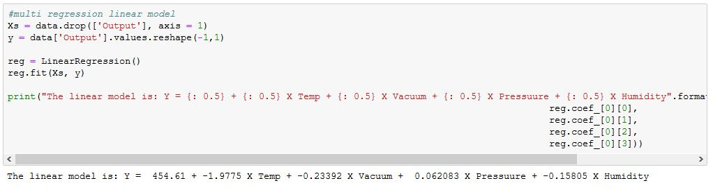
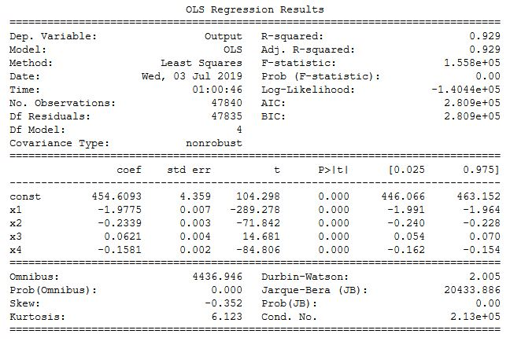
As expected, the one with the highest coefficients came out to be Pressure and Humidity. Which called for a multi regression model containing the two and regression results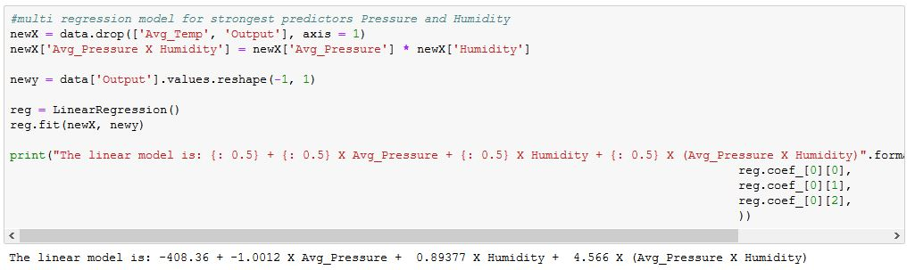 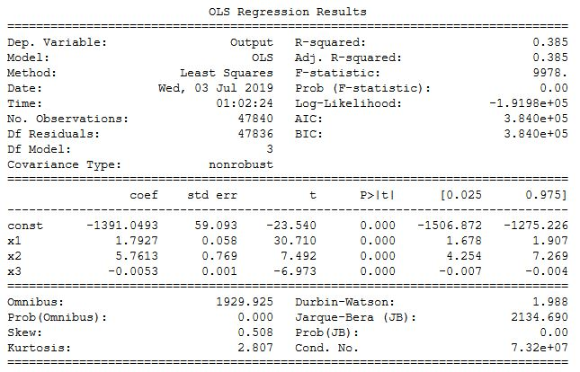

Any preprocessing required
The dataset is already trained with the given sample of data for the model which is needed for this project. No preprocessing is needed as the dataset do not have any extra set of rows and columns showing different attributes that can have a different impact on the dataset or the model

V. Model description

No model has been run on the dataset yet.

