1.Title

2. Group details and responsibility

3. Project Objective

4.Software Process Model : The Waterfall model because The waterfall model is an example of a plan-driven process—in principle, you must plan and schedule all of the process  
activities before starting work on them. Below ss to be edited and used.

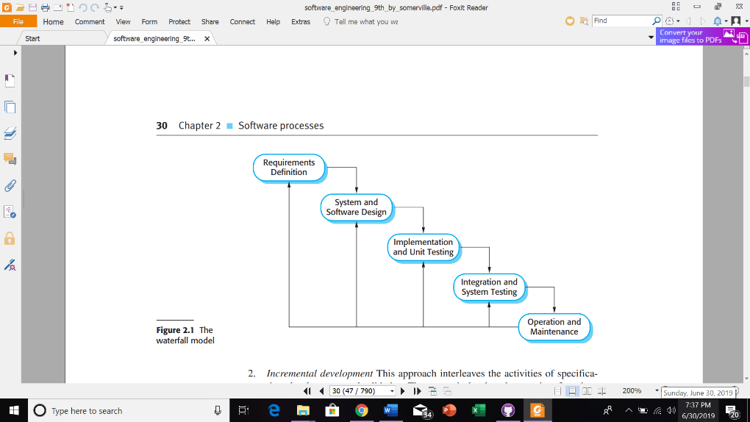

5. Design

6.Implementation

7.Integration