Nucleation Code Portion Explained:

In Li-Air batteries, nucleation begins with the nucleation of LiO₂ particles. Once these particles reach a certain nucleation size, they react with nearby Li⁺ ions to form Li₂O₂ on the surface. The overpotential for this reaction can be calculated from

To be[1]:

Currently nucleation is expressed as [2], [3]

In these equations, D₀ is the diffusion coefficient, aᵢ is the typical length scale of the diffusion, Z is the Zeldovich coefficient, G_crit is the is the critical energy of formation, T is the temperature, N₀ is the number of nucleation sites, and kb is the Boltzmann’s constant. The combined D₀ and aᵢ are theoretically calculated rate coefficient that can be replaced by experimentally derived knuc. The typical length scale can be calculated by

The Zeldovich coefficient can be calculated using the formula

Where φ is heterogenous correction factor, and N_crit is the number of molecules in the critical nucleus

In this equation R_crit is the critical radius, Nₐ is Avogadro’s number, and Vₗ is the molar volume. Then

Where θ is the contact angle of the newly formed nucleus. Finally

In the formula, the number of nucleation sites is determined by

The change in concentration can be found by the following equation

Where V_crit is the volume of the hemisphere based on critical radius and V_elyte is the electrolyte volume. This could be improved by discretizing the electrolyte.

As the radius growth, it averaged using the following equation

The radius growth can either be diffusion limited or surface reaction controlled. If it is both it should grow via the equation[4]

The desorption rate is[1]:

Where A_nuc is area of the nuclei and k_des is found using the following (not implemented):

In total

The change in Area would then be

The current nucleation formula is dependent solely on the change in area and does not include the overpotential equation, yet. Later iterations will include concentration dependence.

|  |  |  |  |  |  |
| --- | --- | --- | --- | --- | --- |
| Variable | Description | Units | Value |  | Ref |
| Equation 1: | | | | | |
| J | frequency of nuclei formation and disintegration at  overpotential | Nuclei[1]/m–2 s–1 | Calculated by model |  | [5] |
| α’ | the charge transfer coefficient of the superoxide formation step | - | 0.549 |  | [5] |
| α | overall charge transfer coefficient | - | 0.656 |  | [5] |
| η₀ | overpotential at the onset of discharge | V | 2.67 |  | [5] |
| η | is the full coverage-dependent overpotential experienced at the carbon surface | V | Calculated by model |  | [5] |
| T | Temperature | K | Ambient |  | [5] |
| Equation 2: | | | | | |
|  | frequency of nuclei formation and disintegration at zero overpotential | Nuclei[2]/m–2 s–1 | 2.8 × 107 |  | [5] |
|  | is the kinetic rate constant for the nucleation reaction | mol.s-1.m-2 | 1 x 10-6 |  | [1][3] |
| Z | Zeldovich factor | - | Thermo/model |  |  |
| Γ | Area Coverage | - | Calculated by model |  |  |
|  | Concentration of LiO₂ | mol. m-3 | Calculated by model |  |  |
|  | energy barrier of the nucleation | J mol.-1 | Thermo |  |  |
| Equation 3: | | | | | |
| i |  | A |  |  |  |
| i₀ |  | A |  |  |  |
| η_kin | The kinetic overpotential may then be written using a modified Tafel equation | V | Calculated by model |  |  |
| Equation 4: | | | | | |
| E | the electrode potential | V | Thermo |  |  |
| E₀ | The standard potential | V | Thermo |  |  |
| n | Electron transfer | - | Thermo |  |  |
|  | Saturated concentration | mol. m-3 | Thermo (0.1) |  | [1] |
| Equation 5: | | | | | |
| Nᵢ | Number of nucleations |  | Calculated by model |  |  |
| A | Electrode area | m | User input |  |  |
| Equation 6: | | | | | |
|  | Angle correction term | - | Thermo (assume 1) |  |  |
|  | is the number of molecules in the critical nucleus of size | - | Thermo |  |  |
|  | critical energy of formation | - | Thermo |  |  |
| Equation 7: | | | | | |
|  | Molar volume | m3 mol⁻¹ | Thermo  1.98E-5 |  | [1] |
|  | Critical radius | M | Thermo |  |  |
| Equation 8: | | | | | |
| θ | Contact angle | ° | Thermo |  |  |
| Equation 9: | | | | | |
| γ | the surface energy of the newly formed crystal phase | J m⁻² | Thermo |  |  |
| Equation 10: | | | | | |
| B | Geometric factor | - | 18 (thermo) |  | [1] |
| σ | Specific surface energy exposed to electrolyte | J m⁻² | Thermo  0.75 |  | [1] |
| E_b | Binding energy of Li₂O₂ on the electrode material | eV | -2.6 |  | [1] |
| nₑ | Numer of electrons transferred |  |  |  |  |
| A₁ | Area of nucleation |  |  |  |  |
| Equation 11: | | | | | |
| Sₖ | Ratio of C/C_sat | - | Determined by the model |  |  |

|  |  |  |
| --- | --- | --- |
| Constant | Name | Value |
|  | Boltzmann’s Constant | 1.380649×10−23 J/K |
|  | Vacuum electric permittivity | 8.854 E-12 F m-1 |
|  | Pi | 3.141529 |
| R |  |  |
|  |  |  |

Nucleation rate may be written as

Where

And the kinetic overpotential

And [5]

However, there are additional nucleation equations:

Alternative:

Actually these basically resolve two each other because

Also[1]:

And the Zeldovich factor[3]

I think nucleation would actually be based on [6], so there should be kinetic equation to figure out what the concentration of LiO₂ should be based on reaction of Li⁺ with O₂⁻. Another note is the definition of θ will differ depending on the paper. I don’t like how [1] doesn’t have the concentration anywhere. But it is the only reference with the parameters used for the modeling.

The

Literature survey of those values:

|  |  |  |
| --- | --- | --- |
| α | 0.656 | [5] |

2.9 nuclei*/*μm2 from SEM imaging of a cathode partially discharged

And growth would depend on Latz

Initial radius = r_critical + additional unit of LiO₂ estimated volume

[1] Y. Yin, A. Torayev, C. Gaya, Y. Mammeri, and A. A. Franco, “Linking the Performances of Li–O2 Batteries to Discharge Rate and Electrode and Electrolyte Properties through the Nucleation Mechanism of Li2O2,” *J. Phys. Chem. C*, vol. 121, no. 36, pp. 19577–19585, Sep. 2017, doi: 10.1021/acs.jpcc.7b05224.

[2] B. Horstmann, T. Danner, and W. G. Bessler, “Precipitation in aqueous lithium–oxygen batteries: a model-based analysis,” *Energy Environ. Sci.*, vol. 6, no. 4, p. 1299, 2013, doi: 10.1039/c3ee24299d.

[3] T. Danner and A. Latz, “On the influence of nucleation and growth of S8 and Li2S in lithium-sulfur batteries,” *Electrochimica Acta*, vol. 322, p. 134719, Nov. 2019, doi: 10.1016/j.electacta.2019.134719.

[4] N. T. K. Thanh, N. Maclean, and S. Mahiddine, “Mechanisms of Nucleation and Growth of Nanoparticles in Solution,” *Chem. Rev.*, vol. 114, no. 15, pp. 7610–7630, Aug. 2014, doi: 10.1021/cr400544s.

[5] S. Lau and L. A. Archer, “Nucleation and Growth of Lithium Peroxide in the Li–O2 Battery,” *Nano Lett.*, vol. 15, no. 9, pp. 5995–6002, Sep. 2015, doi: 10.1021/acs.nanolett.5b02149.

[6] L. Johnson *et al.*, “The role of LiO2 solubility in O2 reduction in aprotic solvents and its consequences for Li–O2 batteries,” *Nat. Chem.*, vol. 6, no. 12, Art. no. 12, Dec. 2014, doi: 10.1038/nchem.2101.

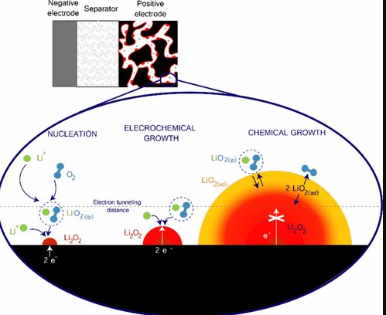

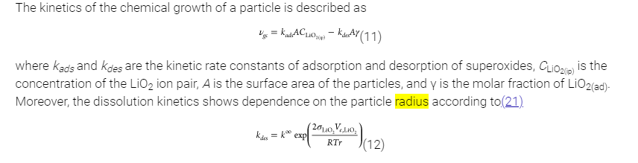

Possible future implementations:

1. <https://pubs.acs.org/doi/10.1021/cr400544s>

Damköhler number to determine where diffusion limited

1. Changing area limitations
   1. <https://pubs.acs.org/doi/full/10.1021/acs.nanolett.5b02149>
   2. Use
2. No nucleation after a certain voltage?
3. Change in reaction kinetics with a certain thickness

1. This unit is not given in the paper. It is give as m–2 s–1  and I assumed nuclei
2. This unit is not given in the paper. It is give as m–2 s–1  and I assumed nuclei
3. The labeling for this is very unclear. In the paper it says “Eq. 4” but equation 4 has no rate constant in both SI and the paper. Maybe mislabeling?