


Project Report
“Sahachari Delivery”
Submitted in Partial Fulfillment of the Requirements for the Award of the Degree, Master of Vocation in Software Application Development
By

MUHAMMED YASIR M S

(Reg.No. 25021400)
Under the guidance of

Dr. Rinu C Varghese

Assistant Professor, DDUKK

DEEN DAYAL UPADHYAY KAUSHAL KENDRA, COCHIN UNIVERSITY OF SCIENCE AND TECHNOLOGY. KOCHI-22
April – 2026

DECLARATION

I, MUHAMMED YASIR M S hereby declare that this internship report entitled “SAHACHARI DELIVERY”, submitted to Cochin University of Science and Technology in partial fulfillment of the requirement for the award of the degree of Master of Vocation in Software Application Development under Corestone Innovations LLP bona-fide record of work done by me under the guidance of Dr. Rinu C Varghese Asst. Professor, DDU Kaushal Kendra, Cochin University of Science and Technology, Kochi-682022.
I also declare that this report has not been submitted anywhere else or the award of any degree, diploma, Internship, fellowship, or other academic recognition.

MUHAMMED YASIR M S
Place : CUSAT 15-6-2026


DEEN DAYAL UPADHYAY KAUSHAL KENDRA COCHIN UNIVERSITY OF SCIENCE AND TECHNOLOGY KOCHI - 682022
CERTIFICATE

Certified that this report “Sahachari Delivery”, done as a part of the internship, submitted to Cochin University of Science and Technology for the fulfillment of the award for the degree, Master of Vocation in Software Application Development under the faculty of DDUKK, is the record of bona-fide work done by Mr. MUHAMMED YASIR MS , under our supervision and guidance during the academic year 2025-2027.

Prof.(Dr) Santhosh Kumar S Guide

Director DDUKK Dr. Rinu C Varghese

CUSAT Assistant Professor

Kochi
15-6-2026

INTERNSHIP CERTIFICATE

ACKNOWLEDGMENT

A successful project is a fruitful culmination of the efforts of many people. Some directly involved and others who have quietly encouraged and extended their invaluable support through its progress.
Hence, I would like to use this opportunity to thank all, who have directly or indirectly helped me to complete my internship successfully. First and foremost, I would like to express my sincere gratitude to Dr. SANTHOSH KUMAR S Director, DDU Kaushal Kendra, CUSAT for allowing me to take up this opportunity to undergo internship with CORESTONE INNOVATIONS, Ernakulam, Kerala.

I convey my earnest gratitude to Mr. Vinayak S, Corestone Innovations LLP, for granting permission for my application development project and encouraging me to go forward with it. I, owe a particular debt of gratitude to my guide Dr. Rinu C Varghese, Asst.Professor DDU Kaushal Kendra, CUSAT for her guidance, monitoring and constant encouragement throughout the course of the project.
I am thankful to all teachers and friends who provided a lot of support for completing this internship.

MUHAMMED YASIR M S

ABSTRACT

Sahachari is a cross-platform mobile and web application ecosystem designed to digitize and empower small business owners, artisans, and household service providers in rural India. The project addresses critical local commerce challenges, including a lack of product visibility, manual inventory tracking errors, and multi-shop oversight risks for business owners. By delivering a dedicated Storekeeper interface alongside a centralized Super Admin dashboard, the platform eliminates information blindspots, prevents operational leakages, and streamlines local order fulfillment.

The application is built on a decoupled full-stack architecture featuring a modular NestJS back-end framework, a MongoDB database, and cloud asset storage via AWS S3. The front-end client is engineered using React Native and Expo, refactored from a mobile-only layout into a highly responsive web interface. To optimize code maintainability and mobile rendering speed, all legacy inline styles were migrated into a centralized external style-sheet directory. Additionally, the administration module integrates advanced management pipelines, including an Excel-based bulk product ingestion tool, user account moderation systems (ban/unban controls), dynamic marketing carousel curation, and multi-tier data filters.

TABLE OF CONTENT

DECLARATION 1
INTERNSHIP CERTIFICATE 3
ACKNOWLEDGMENT 4
ABSTRACT 5
TABLE OF CONTENT 6
1. INTRODUCTION 8
1.1 COMPANY PROFILE 8
1.2 ABOUT THE APPLICATION 9
1.3 OBJECTIVE AND PURPOSE 11
1.4 SCOPE 12
2. REQUIREMENT SPECIFICATION 13
2.0 SOFTWARE REQUIREMENTS 13
2.1 OPERATING SYSTEM – MacOS 13
2.2 MODULE APP DEVELOPMENT: FRONT END 13
2.2.1 Visual Studio Code 14
2.2.2 React.js 14
2.2.3 React Native 14
2.2.4 TypeScript 14
2.2.5 Tailwind CSS 15
2.2.6 Expo 15
2.2.7 Next JS 16
2.2.8 Axios 16
2.2.9 Rechart & React Native Chart 16
2.3 MODULE APP DEVELOPMENT: WEB BUILD / SERVER 17
2.3.1 NodeJS 17
2.3.2 NestJS 17
2.3.3 JSON Web Token (JWT) 17
2.3.4 Git & Github 18
2.3.5 NPM 18
2.3.6 AWS S3 18
2.3.7 MongoDB 19
2.3.8 Mongoose 19
3. DESIGN PRINCIPLES/MODELS 20

3.1 Dataflow Diagram 21
4. IMPLEMENTATION 25
4.1. ARCHITECTUREPATTERN 25
4.2. SUPER ADMIN INTERFACE 26
4.2.1. Carousel Management Screen 26
4.2.2. User Policy Management Screen 27
4.2.3. Analytics Screen 27
4.2.4 Delivery charge Page 28
4.3. STORE KEEPER INTERFACE 29
4.3.1. Login Screen 29
4.3.2. Home Screen 30
4.3.3. Order Screen 30
4.3.4. Analytics Screen 31
4.4 API Specification 31
5. CONCLUSION 32
6. FUTURE SCOPE 33

INTRODUCTION

In partial fulfillment of the requirements for the Second Semester project, I developed Sahachari, a cross-platform mobile and web application designed to digitize and empower small business owners, local artisans, and micro-businesses in rural areas. The application combines localized e-commerce workflows with modern technology to create a reliable digital companion for rural merchants seeking to scale their operations and connect with local consumers.

Sahachari integrates accessible mobile and web layouts with a secure server architecture to manage inventory tracking, process customer orders, and enforce role-based access control. Developed using a modern full-stack architecture, the system features a responsive frontend client optimized for rural network constraints and a modular backend capable of handling real-time data synchronization and transparent financial auditing.

The main objective of the project is to demonstrate how traditional rural trade can be transformed into innovative digital solutions using emerging software development technologies. By blending community-focused design, robust security protocols, and cross-platform framework engineering, Sahachari delivers an engaging marketplace that showcases the practical use of full-stack development in solving real-world socioeconomic challenges.

COMPANY PROFILE

Corestone Innovations LLP is a registered technology services company focused on building digital solutions that bridge the access gap in rural India. Incubated within the innovation ecosystem at Cochin University of Science &

Technology (CUSAT), the company specializes in deploying scalable, cross-platform applications that empower localized micro-businesses, traditional artisans, and neighborhood service providers. Its flagship product, Sahachari, serves as a live, practical example of the company's commitment to creating real-world economic impacts through software engineering.

The company was founded in 2024 by a team of Computer Science graduates from CUSAT (Batch 2024), including Vinayak S (CEO), Anaj Krishna, Nirmal Pradeep, Gokul G Kumar, and Jathavedas. Driven by the mission to provide rural communities with the same digital advantages found in urban tech sectors, the founders established Corestone Innovations LLP to engineer modern full-stack platforms that eliminate operational blindspots, prevent transaction leakages, and revitalize local village economies.

ABOUT THE APPLICATION

Sahachari (Empowering Rural India) is a cross-platform mobile and web application designed to digitize and streamline local commerce, inventory management, and community logistics in rural areas. The system allows small-scale shopkeepers and independent artisans to easily maintain digital stock records, broadcast regional discounts, and manage daily sales workflows.

By combining role-based navigation with secure network layers, the application eliminates business visibility gaps and provides real-time operational transparency for both localized storekeepers and top-level business administrators.

MODULE 1 (STORE KEEPER)

The Storekeeper Module is the operational interface engineered for local shopkeepers, rural merchants, and independent artisans. This module acts as a digital inventory management toolkit, allowing business owners to easily move their traditional paper ledgers onto a secure digital platform. The layout focuses on high readability and rapid data entry, enabling shopkeepers to update their digital storefronts in real time directly from their mobile devices or web browsers.

Using this module, storekeepers can perform complete product catalog operations, such as uploading new item images, setting stock numbers, editing prices, and publishing promotional discounts. The frontend utilizes custom React hooks to manage local component state, allowing shopkeepers to see image previews instantly before uploading files to cloud storage. By offering real-time visibility into stock counts and sales sheets, the Storekeeper Module eliminates inventory blindspots and prevents revenue leakages at the store level.

MODULE 2 (ADMIN )

The Super Admin Module is the central management dashboard built for the business owner who operates and oversees multiple retail shops across the region. This module provides a high-level view of the entire business ecosystem, allowing a single administrator to maintain complete control over separate physical stores without needing to visit them. The user interface focuses on clean data presentation, giving the owner an instant way to monitor business health, track daily transactions, and prevent staff mismanagement or inventory loss.

Through this dashboard, the Super Admin can easily register new storekeepers, assign them to specific shop locations, and grant them secure access keys to use the Storekeeper app. The module features robust analytics tools that fetch real-time sales reports, active stock levels, and revenue streams from every connected branch. By consolidating multi-shop operations into one clear dashboard, the Super Admin Module replaces chaotic manual monitoring with an immutable, data-driven management system.

OBJECTIVE AND PURPOSE

The primary objective of the Sahachari application is to design and deploy a secure, cross-platform full-stack ecosystem that digitizes traditional retail and service trades in rural areas. Technically, the project aims to replace unoptimized development practices by implementing a highly maintainable, feature-based modular frontend architecture paired with a structured, scalable NestJS backend. A key goal of the development phase was to eliminate structural user interface regressions, refactoring the layout from mobile-only configurations into a highly responsive web application that offers unified accessibility across all devices.

The underlying purpose of this project is to address the severe economic and operational vulnerabilities faced by rural merchants and multi-shop business owners. By replacing manual, error-prone paper ledgers with real-time digital databases, the platform eliminates information blindspots, prevents inventory shrinkage, and stops financial leakages caused by employee mismanagement. Ultimately, the purpose of Sahachari is to act as a reliable digital companion that fosters trust, establishes transparent supply chains, and drives sustainable economic growth for small businesses and local artisans.

SCOPE

Sahachari offers an interactive cross-platform network where rural buyers can discover products and services, storekeepers can seamlessly manage their digital inventory, and business owners can track multi-shop operations in real time. The application demonstrates how modern full-stack architectures and responsive web engines can be integrated with localized community commerce to create a secure, transparent, and user-friendly digital marketplace. It also provides a highly scalable foundation for future logistics integration and region-wide expansion.

The scope of the project includes:

- Providing dedicated, role-based interfaces for Customers, Storekeepers, and Super Admins on a unified platform.

- Combining traditional rural trading practices with modern full-stack software development technologies.

- Offering small business owners an engaging, data-driven system to eliminate financial leakages and inventory errors.

- Ensuring cross-platform visual consistency by refactoring mobile layouts into responsive web environments.

- Supporting future technical enhancements such as live GPS tracking pipelines for delivery agents and automated SMS transaction gateways.

- Expanding the marketplace ecosystem to onboard more diverse artisan clusters, palliative care sectors, and regional community events.

REQUIREMENT SPECIFICATION

Requirement specification defines the software resources and development tools required for the successful design, development, and deployment of the Sahachari application. It includes the operating system, frontend technologies, backend technologies, and server tools used in the project.

SOFTWARE REQUIREMENTS

The software requirements of the Sahachari project consist of all the necessary tools, frameworks, and technologies used during the development process. These tools ensure efficient coding, testing, deployment, and smooth functioning of the application.

OPERATING SYSTEM – MacOS

MacOs was used as the primary operating system for developing the Sahachari project. It provides a stable and secure environment with support for modern software development tools, programming languages, and web technologies. Its compatibility with IDEs and servers makes it suitable for application development.

MODULE APP DEVELOPMENT: FRONT END

The frontend module is responsible for designing the user interface and managing user interaction within the Sahachari application. The following technologies were used for frontend development.

Visual Studio Code

Visual Studio Code is a lightweight and powerful source code editor developed by Microsoft. It supports multiple programming languages and provides debugging, syntax highlighting, and Git integration features. It was used as the primary coding environment for the project

React.js

React.js is a popular JavaScript library used for building dynamic and responsive user interfaces. It follows a component-based architecture that allows developers to create reusable UI elements. In the Sahachari project, React.js was utilized to develop the frontend of the Super Admin web application, ensuring a smooth and responsive user experience.

React Native

React Native is a powerful open-source framework developed by Meta that allows developers to build cross-platform mobile applications using JavaScript and React. It compiles directly to native app components, ensuring high-performance user experiences that look and feel like native Android and iOS applications from a single shared codebase.

TypeScript

TypeScript is an open-source, strongly typed programming language developed by Microsoft that builds on top of JavaScript. By adding static typing to the language, It to catch syntax and logic errors early during the development phase rather than when the code is running. This makes the codebase significantly more predictable, easier to debug, and highly maintainable as the project grows.

Tailwind CSS

Tailwind CSS is a utility-first CSS framework designed for rapidly building custom user interfaces. Unlike traditional CSS frameworks that use pre-designed components like buttons or cards, Tailwind provides low-level utility classes—such as for spacing, typography, and color—that can be applied directly within the HTML or React components. This approach eliminates the need to write separate, bulky CSS files, making the styling process faster and highly organized.

In the Sahachari project, Tailwind CSS was used to style the Super Admin web dashboard. It played a crucial role in creating a clean, modern, and fully responsive layout that automatically scales across desktops, tablets, and laptops. By using Tailwind's optimized grid and flexbox classes, the interface remains extremely lightweight, ensuring fast loading speeds and a professional user experience for the administrator.

Expo

Expo is an open-source platform and a framework designed to simplify the development, building, and deployment of React Native applications. It provides a robust suite of tools and deeply integrated services that eliminate the complex native configurations typically required for iOS and Android setups. By using Expo, developers can write JavaScript or TypeScript code and preview changes instantly on physical devices through hot-reloading, which significantly accelerates the overall development workflow.

In the Sahachari project, Expo was utilized to manage and streamline the lifecycle of the Storekeeper mobile application. It allowed for rapid prototyping

and seamless testing of essential mobile features, such as camera integrations for

product photography and local image uploads. By abstracting away complex native build pipelines, Expo ensured that the mobile app remained highly optimized, stable, and easily upgradeable for rural store deployment.

Next JS

Next.js is an advanced React framework used to build enterprise-grade, production-ready web applications. It provides built-in optimization features such as automated routing, server-side rendering, and fast asset compilation. In the Sahachari project, Next.js was chosen as the foundation for the Super Admin web platform to manage dashboard performance, simplify folder-based navigation, and ensure a highly secure environment for business monitoring.

Axios

Axios is a popular, promise-based HTTP client library used to send secure asynchronous network requests from frontend applications to backend servers. It handles the transmission of data headers, automatically transforms JSON payloads, and manages communication lifecycles effortlessly. In this project, Axios acts as the primary data bridge, allowing both the Next.js web panel and the Expo mobile app to securely fetch records and push data updates to the NestJS backend API.

Rechart & React Native Chart

Data visualization is handled by Recharts on the web dashboard and React Native Chart Kit on the mobile interface. These specialized libraries transform complex raw database numbers into interactive, clean visual charts, graphs, and sales trends. In the Sahachari project, these tools enable the Super Admin and Storekeepers to instantly view financial analytics, track inventory levels, and identify top-performing stores at a glance.

MODULE APP DEVELOPMENT: WEB BUILD / SERVER

This module includes the tools used for running, managing, and deploying the web /mobile application.

NodeJS

Node.js is an open-source, cross-platform JavaScript runtime environment that executes JavaScript code outside a web browser, directly on a server machine. It uses an asynchronous, event-driven, non-blocking I/O model, making it exceptionally lightweight and highly efficient for data-heavy, real-time applications. Node.js acts as the fundamental runtime engine that powers and runs the entire NestJS server architecture for Sahachari.

NestJS

NestJS is a progressive Node.js framework used for building scalable, efficient, and enterprise-grade server-side applications. It enforces a strict, modular architectural structure out of the box using TypeScript, which helps developers organize controllers, services, and modules cleanly. In the Sahachari project, NestJS serves as the central backend API engine, orchestrating incoming HTTP requests from the mobile and web clients, handling business logic, and strictly enforcing security policies.

JSON Web Token (JWT)

JSON Web Tokens (JWT) represent a compact, URL-safe means of securely transferring claims and authentication credentials between two parties. In the Sahachari ecosystem, JWT acts as the primary role-based access controller. When

a Super Admin or Storekeeper signs in, the backend generates a signed cryptographic token that the frontend clients securely store. This token verifies the user's identity and permissions for subsequent API requests, preventing unauthorized account actions.

Git & Github

Git is a distributed version control system designed to track changes in source code files during software development, while GitHub is a cloud-based hosting service for Git repositories. In the Sahachari project, Git and GitHub were essential for maintaining codebase stability. They allowed the development team to collaborate on different modules simultaneously through branches, preventing code conflicts and enabling quick version rollbacks if errors occurred during deployment builds.

NPM

npm is the default package manager for the Node.js runtime environment and serves as an automated software registry for installing open-source libraries. In this project, npm was utilized to manage, configure, and update all external project dependencies across both the server and frontend applications. It allowed the team to instantly integrate essential utilities—such as database drivers, encryption tools, and network client libraries—ensuring a unified build environment.

AWS S3

Amazon Web Services S3 is a highly secure, scalable cloud storage service built to store and retrieve any amount of data or files from anywhere on the web. In this project, AWS S3 serves as the primary media repository. When a storekeeper

takes a product photo or uploads an invoice through the mobile application, the asset is transferred to a secure S3 bucket, which returns a lightweight URL .

MongoDB

MongoDB is a source-available, NoSQL document-oriented database system designed to handle large volumes of data with high flexibility. Instead of using traditional, rigid rows and tables found in relational databases, MongoDB stores records as dynamic, JSON-like documents. In the Sahachari ecosystem, MongoDB serves as the core database engine, storing all critical information—including user registration profiles, store inventories, multi-shop sales records, and administrative transaction details—allowing for rapid data retrieval and seamless updates.

Mongoose

Mongoose is an Object Data Modeling (ODM) library specifically built for Node.js and MongoDB. It acts as a bridge between the NestJS server code and the MongoDB database, allowing developers to define strict, structured data schemas and enforce validation rules directly in the application code. In this project, Mongoose ensures data integrity across the system, guaranteeing that information sent from the frontend applications perfectly matches the required database structures before it is saved.

DESIGN PRINCIPLES/MODELS

In app development, the user interface (UI) and user experience (UX) play the most significant roles in app‘s success. Design Principles are standards used to organize and arrange the structural components of Software Engineering design. Methods in which these design principles are applied affect the expressive content and the working process from the start. Design principles are categorised into 3 sections:

ENCHANT USER

- Delight users in surprising and engaging ways.
- Real objects and visual elements are more enjoyable than buttons and menus.
- Allow users to personalize and customize their experience.
- Understand user needs and preferences.

SIMPLIFY USER’S LIFE

- Keep interactions simple and brief.
- Pictures communicate faster than words.
- Make smart decisions for the user, while giving final control to them.
- Show only the necessary information when it is needed.
- Ensure users always know their current location within the system.
- Never lose user data or progress.
- If elements look the same, they should behave the same.
- Interrupt users only when it is important.

MAKE USER AMAZING

- Provide useful shortcuts and tricks that work throughout the system.
- Design the system so users do not feel blamed for mistakes.
- Encourage users with positive feedback.
- Perform complex tasks efficiently on behalf of the user.

Dataflow Diagram

Data flow diagrams are also known as bubble charts. DFD is a designing tool used in the top-down approach to Systems Design. This context-level DFD is next "exploded", to produce a Level 1 DFD that shows some of the detail of the system being modelled. The Level 1 DFD shows how the system is divided into subsystems (processes), each of which deals with one or more of the data flows to or from an external agent, and which together provide all of the functionality of the system as a whole.

It also identifies internal data stores that must be present in order for the system to do its job, and shows the flow of data between the various parts of the system. Data flow diagrams are one of the three essential perspectives of the structured-systems analysis and design method SSADM.

The sponsor of a project and the end users will need to be briefed and consulted through stages of a system's evolution. How any system is developed can be determined through a data flow diagram model.

Basic Data Flow Diagram Symbol

EXPLANATION | SYMBOL

A direct line represents a flow of data
Circles stands for process that converts data into information. A process  represents transformation where incoming data flows are changed into outgoing  dataflows | 

A source is represented by a rectangle / square in a Data Flow Diagram (DFD). It refers to a person, organization, or system that provides data to or receives data from the system, but is considered outside the scope of the data flow model.

open-ended rectangle represents a data store

Level 0

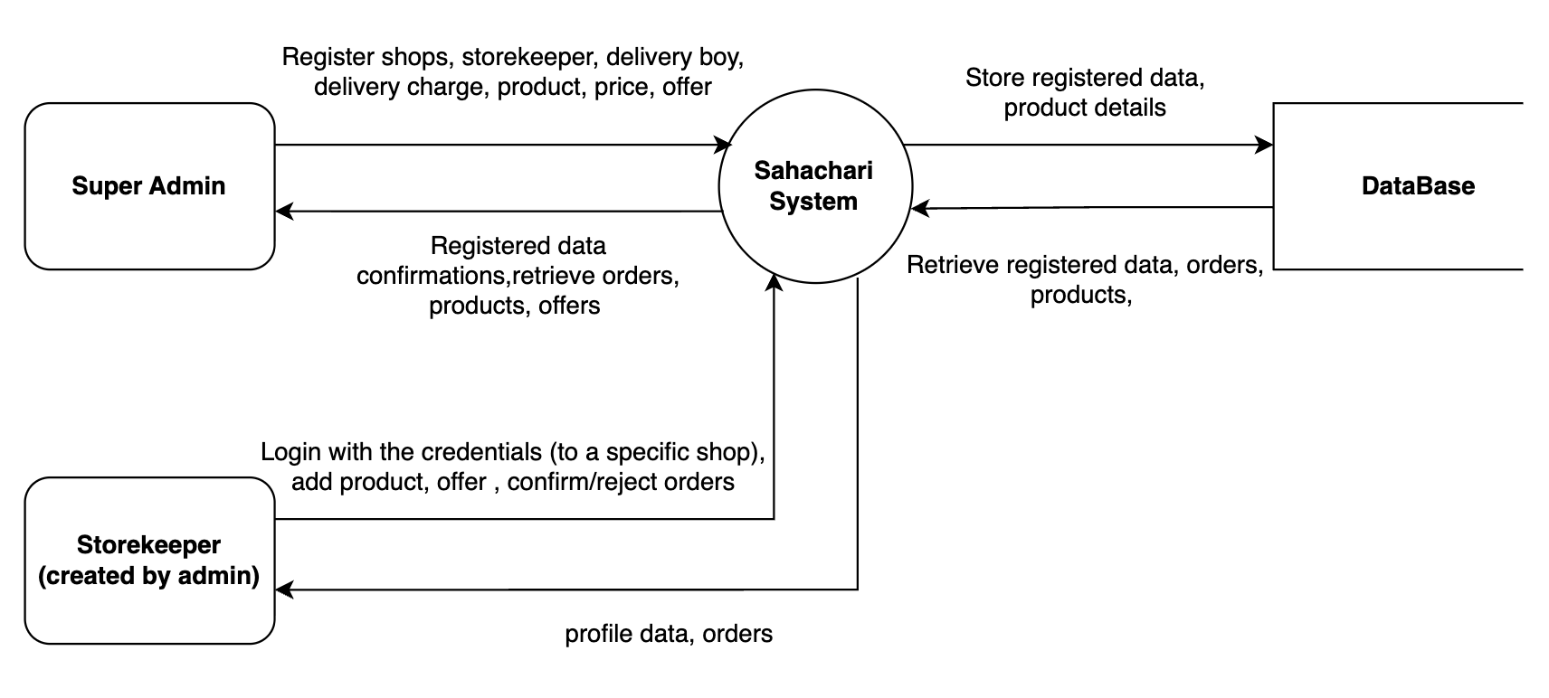

Level 1 ( Super-admin )

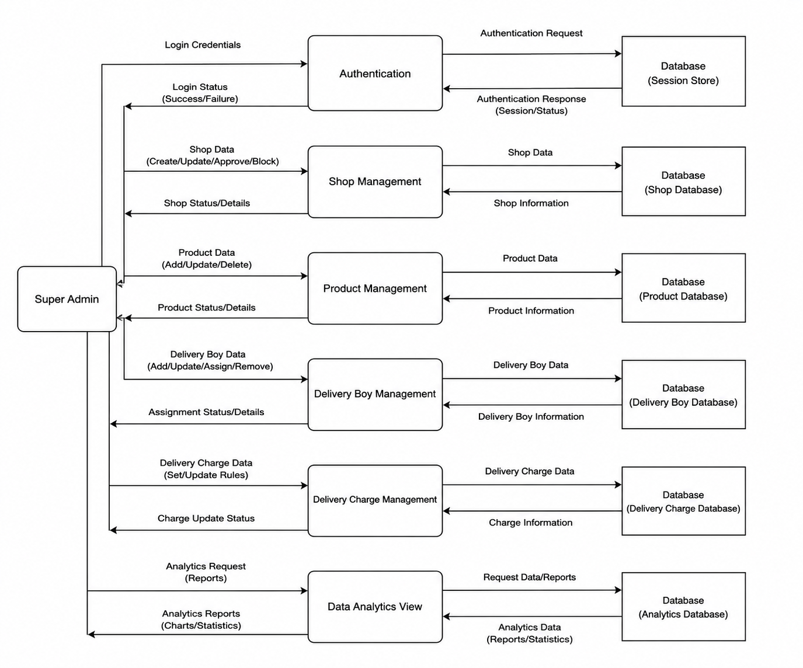

Level 1 ( Store-keeper )

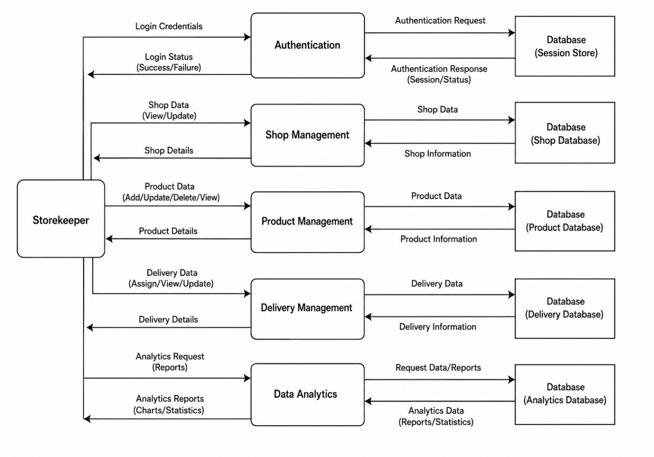

IMPLEMENTATION

The Sahachari application is engineered as a full-stack ecosystem consisting of a Next.js web panel for Super Admins and an Expo/React Native mobile app for Storekeepers, both interacting with a centralized NestJS backend server. This backend engine handles secure data validation, business logic, and role-based access tokens while integrating MongoDB and Mongoose for dynamic database storage. Additionally, Amazon Web Services (AWS) S3 is utilized for secure, cloud-based media hosting, resulting in a responsive, scalable infrastructure that abstracts complex multi-shop operations into a seamless retail management experience.

ARCHITECTUREPATTERN

The Sahachari application follows a modern, decoupled Client-Server architecture optimized for scalability, clean code organization, and efficient data handling. Rather than a traditional monolithic MVC pattern, the system is split into independent frontend user interfaces (Next.js web and Expo mobile clients) and a modular NestJS backend server. The backend adheres to an enterprise-grade Controller-Service-Repository design pattern; the Controllers handle incoming client requests and HTTP routing, the Services isolate the core business and validation logic, and the Data Models/Mongoose Repositories manage the dynamic document schemas with MongoDB. This architectural separation ensures strict type-safety via TypeScript, simplifies automated testing, and allows individual components or client modules to be updated independently without interrupting the core system performance.

SUPER ADMIN INTERFACE

The Super Admin Interface serves as the central command and control dashboard for the entire Sahachari ecosystem. Designed as a web-based portal, it provides the administrator with high-level administrative tools to manage products, user complaints, coordinate delivery boys, and oversee multiple store locations from a single interface. This module abstracts complex backend database operations into intuitive workflows, allowing the administrator to authorize system registrations, track macro performance metrics, and maintain global configurations across all operating territories.

Carousel Management Screen
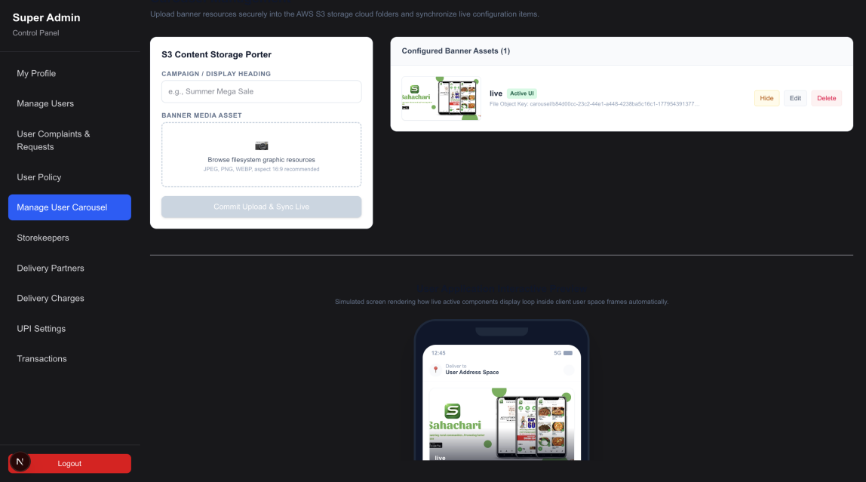

Figure 4.1 : Carousel managment Screen

This screen allows the Super Admin to upload dynamic promotional banner images for the mobile application interface. To maximize marketing efficiency, these banners are geographically targeted to appear only to users residing within the specific pincode of that designated shop.

User Policy Management Screen

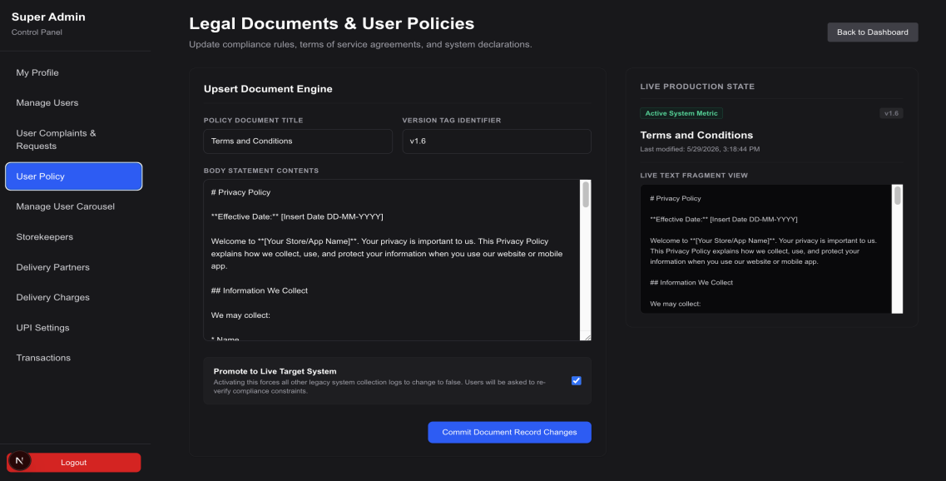

Figure 4.2 : User policy Screen

This interface enables the Super Admin to draft, modify, and publish official store regulations and purchasing policies. The updated terms are dynamically displayed to customers buying from the respective shop, ensuring clear compliance and uniform transactional guidelines.

Analytics Screen
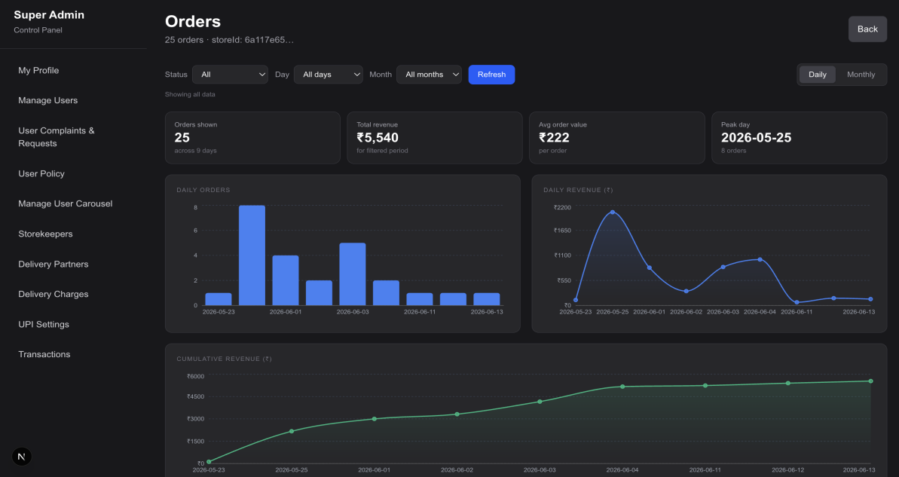

Figure 4.3 : Analytics Screen

This dashboard aggregates multi-shop operational data into intuitive visual charts, graphs, and performance diagrams. It provides real-time tracking of revenue trends, inventory movement, and sales histories, allowing the administrator to assess business health at a glance.

4.2.4 Delivery charge Page

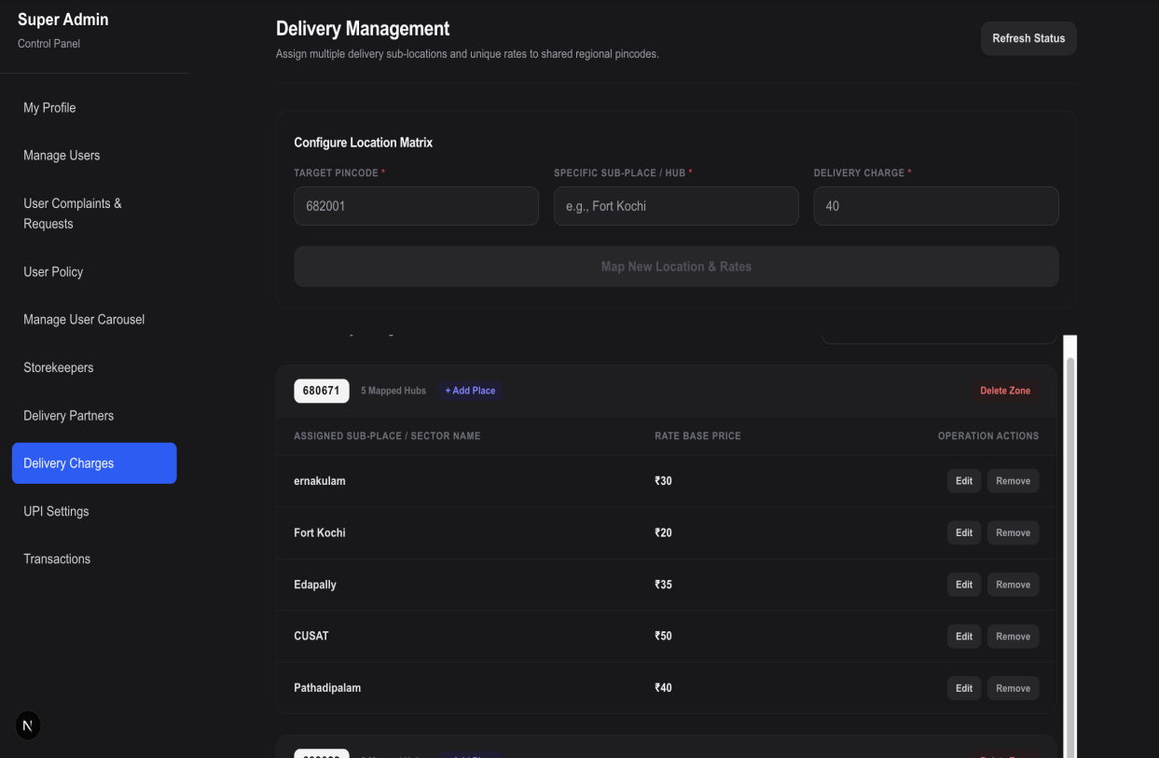

Figure 4.4 : Delivery Screen

This screen gives the Super Admin granular control over localized shipping rates by managing courier fees within specific territories. It allows setting varied delivery charges for different neighborhoods or streets, even if they share the exact same pincode.

STORE KEEPER INTERFACE

The Storekeeper Interface is a mobile-focused module designed to streamline day-to-day retail operations for individual shop managers. It provides localized control over inventory, real-time order processing, and quick performance tracking directly from the shop floor.

Login Screen

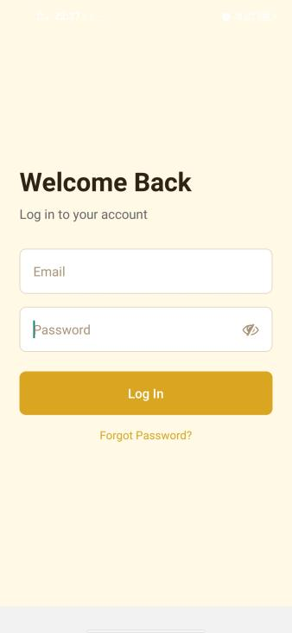

Figure 4.1 : Login Screen

This screen provides a secure entry point for authorized staff to access their specific storefront. Unlike the Super Admin, storekeepers do not have a registration option; they instantly log into their pre-configured shop profiles using the unique credentials previously generated and assigned to them by the Super Admin.

Home Screen
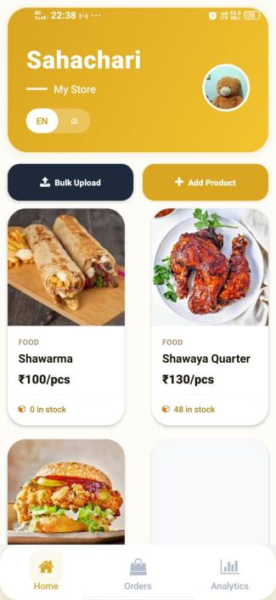
The primary hub for the storekeeper, displaying a comprehensive list of all products belonging exclusively to their shop. This screen provides an instant, clear view of current stock levels, allowing the manager to monitor inventory counts at a glance and quickly identify items that are running low or out of stock.

Figure 4.2 : Home Screen

Order Screen
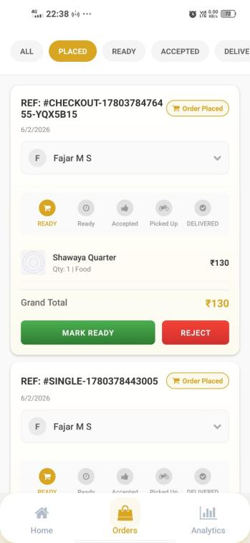
This live interface dynamically lists all incoming customer orders placed at the specific shop. It empowers the storekeeper with full workflow control, allowing them to instantly accept or reject new requests, update the status to "ready" once items are packed, and coordinate seamlessly with the delivery team.

Figure 4.3 : Order Screen

Analytics Screen
A simplified performance tracker that offers the storekeeper a visual breakdown of their specific shop's daily and weekly metrics. Through concise charts and summaries, it highlights transaction volumes, fast-moving items, and revenue trends to help optimize local stock management.

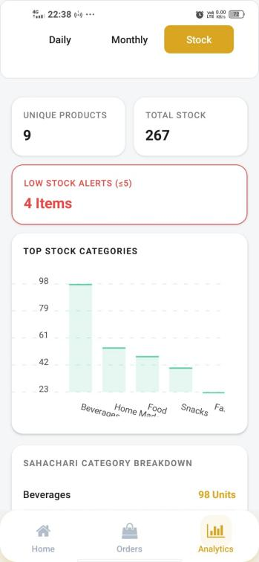

Figure 4.4 : Analytics Screen

4.4 API Specification

Rest API

A REST API (Representational State Transfer Application Programming Interface) is a web service that enables communication between different software systems using standard HTTP methods such as GET, POST, PUT, and DELETE. It allows applications to send and receive data over the internet in a structured and efficient manner.

In the Sahachari application, REST APIs are used to handle communication between the frontend and backend. The frontend sends user requests such as question validation and oracle reading generation to the backend, and the backend processes these requests and returns the appropriate responses. REST architecture is preferred because it is lightweight, scalable, and well suited for modern web applications and cloud-based services.

CONCLUSION

The Sahachari application is a comprehensive full-stack ecosystem that successfully modernizes local retail management by bridging enterprise-grade administration with mobile-first storefront operations. By combining a Next.js web panel for Super Admins, an Expo mobile application for Storekeepers, and a modular NestJS backend, the platform provides a highly secure, responsive, and scalable infrastructure. Ultimately, the project demonstrates how modern decoupled software development can transform complex multi-shop workflows into a seamless, data-driven digital application that empowers localized commerce.

Key outcomes of the project include:

- Dual-Client Commerce Ecosystem: Developed a unified platform featuring a web dashboard for Super Admins and a mobile app for Storekeepers.

- Scalable Full-Stack Architecture: Implemented a responsive, decoupled system using Next.js, Expo, and a modular NestJS backend.

- Location-Based Marketing Engine: Deployed a dynamic carousel banner system targeted strictly by specific shop pincodes.

- Granular Delivery Configuration: Enabled localized logistics management with varying shipping fees for zones within the same pincode.

- Live Order Processing Workflow: Created an intuitive interface for storekeepers to accept, reject, and prepare incoming customer orders in real time.
- Visual Retail Analytics: Integrated graphical charts and diagrams to easily monitor multi-shop sales trends and performance metrics.

FUTURE SCOPE

The Sahachari application can be further enhanced by introducing advanced features and improvements such as:

- Real-Time Delivery Tracking: Implementing live GPS tracking to allow customers and storekeepers to monitor delivery boys en route.

- WhatsApp Notification Engine: Integrating automated WhatsApp alerts to instantly notify customers about order confirmations, dispatch updates, and receipts.

- AI-Driven Demand Forecasting: Embedding predictive analytics within the admin dashboard to forecast inventory needs based on localized shopping trends.

- Offline Retail Support: Developing a local synchronization cache in the mobile application to allow storekeepers to manage orders and stock during internet outages.

REFERENCE

- https://stackoverflow.com/
- https://www.geeksforgeeks.org/
- https://nextjs.org/docs
- https://reactnative.dev/
- https://docs.nestjs.com/
- https://docs.mongodb.com/
- https://docs.aws.amazon.com/s3/

