|  |  |
| --- | --- |
| **Item name** | CRS – Customer requirement specification |
| **Project** | IOT Prototype |
| **Owner** | CoreTech team |
| **Document Status** | Draft |

|  |  |  |
| --- | --- | --- |
| **Document change history** | | |
| **Release** | **Changed by** | **Description** |
| 1.0 | Binh Le | Initial version |
| 1.1 | Binh Le | End user requirement – First round |
|  |  |  |

1. **Introduction and functional overview**

This is customer requirement for IOT prototype , focus on smart farm use case.

In this, the prototype can monitor environment, report/notice information to user , automatically watering, heating, etc

1. **Acronyms and Abbreviations**
2. **Constraints and assumptions**

N.A

1. **Functional specification**

* **Object:** Orchids ( in house)

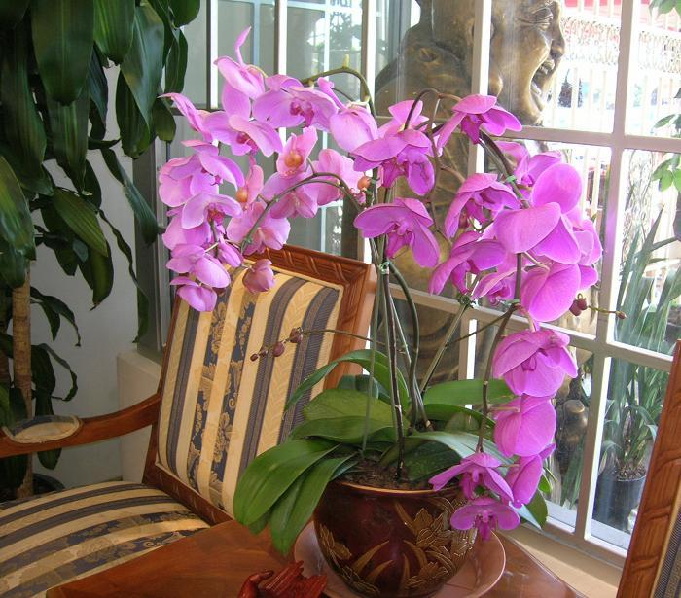

Fig 1. Orchids

* **End user requirement:**

1. When the humidity drops below/over threshold of my Orchids, the system can notify me every time, everywhere (mobile or web….)
2. When the humidity drops below/over threshold of my Orchids, the system can auto heating/watering to keep the humidity in normal range (5% tolerance is acceptable)
3. The system can predict by when my Orchids blooms
4. I also need a current price of Orchids
5. I can schedule the system manually for watering /heating
6. I need the system shall be small enough since my house space is very limited, the best is as small as possible, easy to move and setup also.
7. The system can save my resource like electric, water
8. It must be safe, can be auto cut off in case of over heating / short-circuit
9. Tbd
10. **Misc**