
CORE EXTERIORS
Exterior Cleaning Service Agreement
203 Cambridge St, London ON N6H 1N6 | 519-712-1431 | corexteriors@gmail.com
ON Business No. 1001470729 | HST 745847632 RT0001

Client Full Name: {clientName} | Service Address: {serviceAddress}
Date of Service: {dateOfService}
Service and Quotation
 | Service Description | Quantity | Price
{deckCheck} | Deck Restoration | {deckQty} | ${deckPrice}
{gutterCheck} | Gutter Cleaning | {gutterQty} | ${gutterPrice}
{interlockCheck} | Interlock | {interlockQty} | ${interlockPrice}
{windowCheck} | Windows | {windowQty} | ${windowPrice}
{sidingCheck} | Sidings | {sidingQty} | ${sidingPrice}
{gardenCheck} | Garden | {gardenQty} | ${gardenPrice}
{othersCheck} | Others: | {othersQty} | ${othersPrice}

Contract Price: ${contractPrice} | HST (13%): ${hstAmount} | Total Due: ${totalDue}

Timeline
Start Date: {startDate} | Completion: {completionDate}
25% deposit due at signing. Balance due upon completion.

Terms & Conditions
Insurance & Safety: CORE EXTERIORS maintains $10 million in General Liability Insurance and is fully covered by WSIB, ensuring protection for both the property and our workers.
Weather & Site Conditions: Scheduled dates are subject to change based on weather or site accessibility.
Amendments & Changes: If during the performance of services, the scope of work is found to differ significantly from the initial assessment (e.g., unexpected surface fragility or incorrect measurements), CORE EXTERIORS reserves the right to adjust the contract price. Any changes will be agreed upon with the Client before proceeding.
Liability: CORE EXTERIORS is not responsible for pre-existing defects, loose materials, or water intrusion from prior construction issues. Total liability is limited to the contract amount.
Exclusions: Structural repairs, paint touch-ups, sealing, or landscaping restoration are not included unless specified.
{%clientSig} | {contractorName}  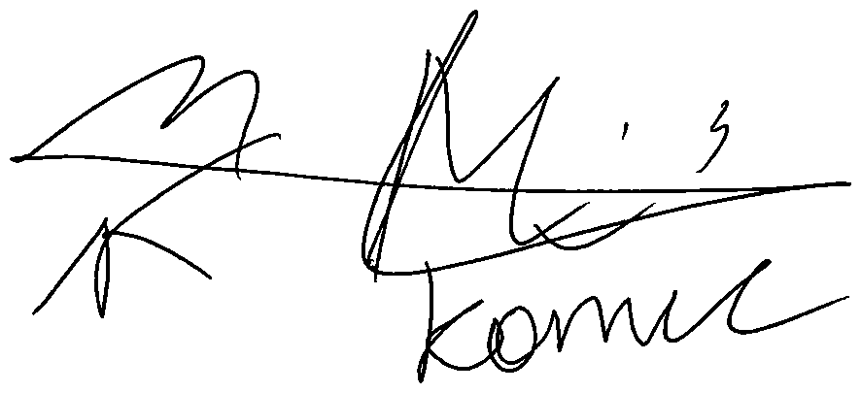
Client Signature Date: {clientSigDate} | Contractor Signature Date: {contractorSigDate}

