Corey Kipp (Student ID: 57723335)

kippc@uci.edu

CS 143A

Homework 1

Problem 1

1. Memory
2. Processor
3. Network Connectivity
4. I/O Devices

Problem 2

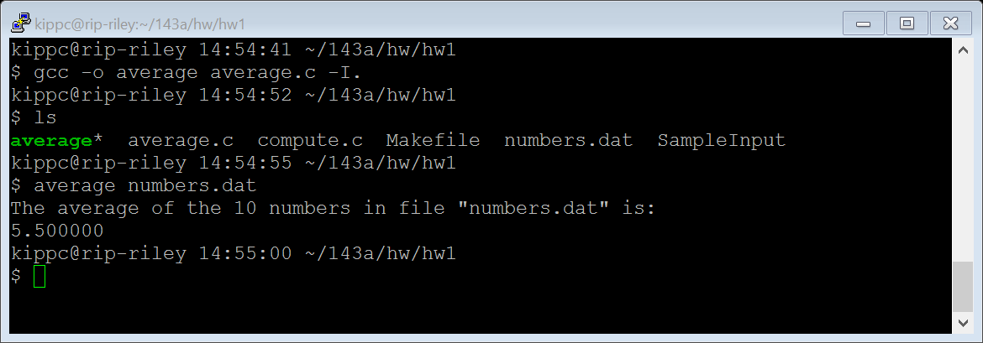

Problem 3

