Corey Kipp (Student ID: 57723335)

kippc@uci.edu

CS 143A

Homework 2

Part 1

Processes are meant for larger tasks and run in unique memory spaces, while threads are meant for smaller tasks and run in a shared memory space. You would want to use threads over processes whenever you want tasks to be done quickly, such as Microsoft Word’s spellchecker and other background tasks. Processes could be used over threads if time wasn’t much of a factor or if you needed more security since there’s no security between threads.

Part 2

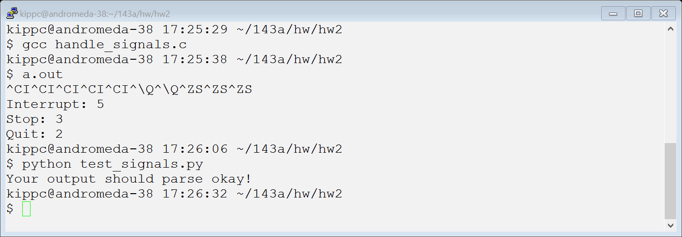

Part 3

