Corey Kipp (Student ID: 57723335)

kippc@uci.edu

CS 143A

Homework 3

Part 1

Concurrency can be useful because it allows for many programs to run concurrently like downloading a file, listening to music, or typing in a word document. It is also helpful when writing parallel programs, such as ones that involve 3D graphics rendering. Concurrency can also be useful on single-CPU machines because of thread blocking/waiting.

Part 2

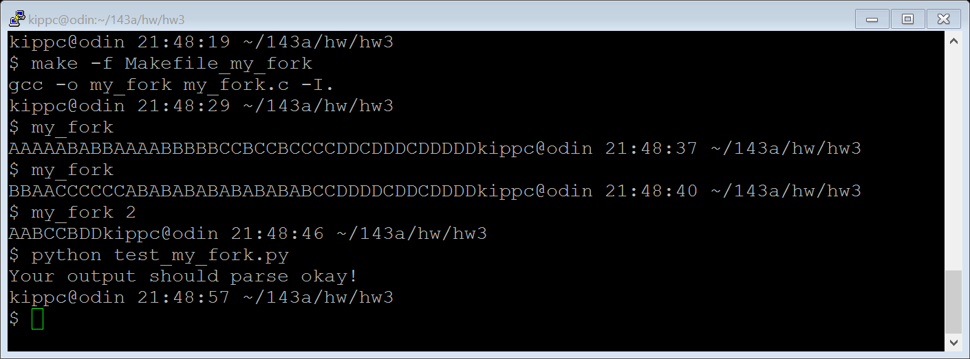

Part 3

