Corey Kipp (Student ID: 57723335)

kippc@uci.edu

CS143A

Homework 4 Write-Up

Problem 1

The first requirement for the critical section is mutual exclusion, meaning that while one thread is in the critical section, no other thread can be. The second requirement is progress, stating that a thread in the critical section will eventuall leave; this prevents threads blocking each other from entering the critical section. The third requirement states that there is bounded waiting, meaning that if a thread is waiting to enter the critical section, eventually it will. The fourth requirements is time efficiency, where the overhead of entering and exiting the critical section is small.

Problem 2

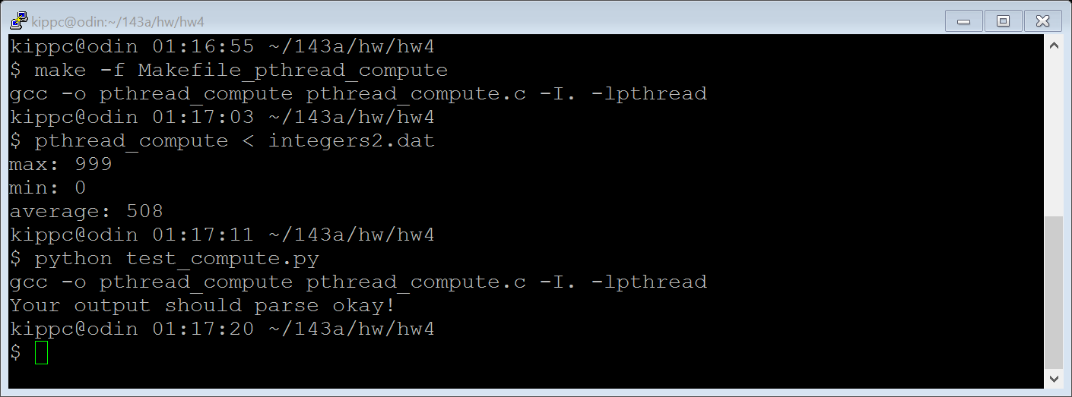

Problem 3

