Corey Kipp (Student ID: 57723335)

kippc@uci.edu

CS 143A

Homework 5

**Part 1**

Shortest Job First (SJF) (Non-preemptive), Shortest Remaining Time First (SRTF) (Preemptive), and Priority are all scheduling algorithms that could lead to starvation. Starvation is most likely to occur in SJF and SRTF when jobs are long, and Priority may starve low priority jobs that end up waiting indefinitely.

**Part 2**

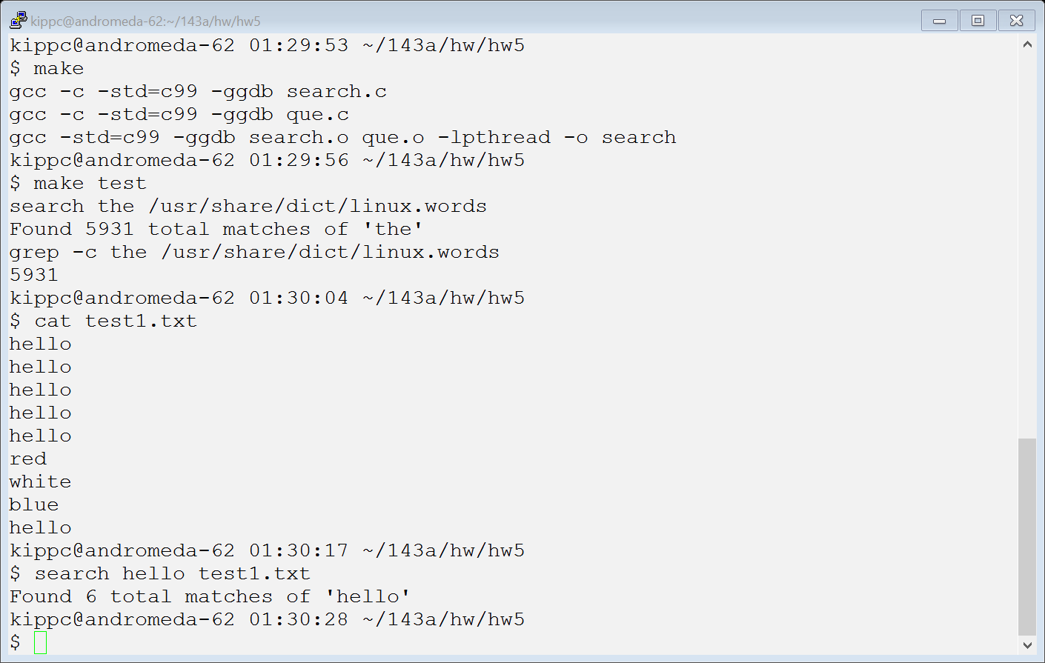

**Part 3**

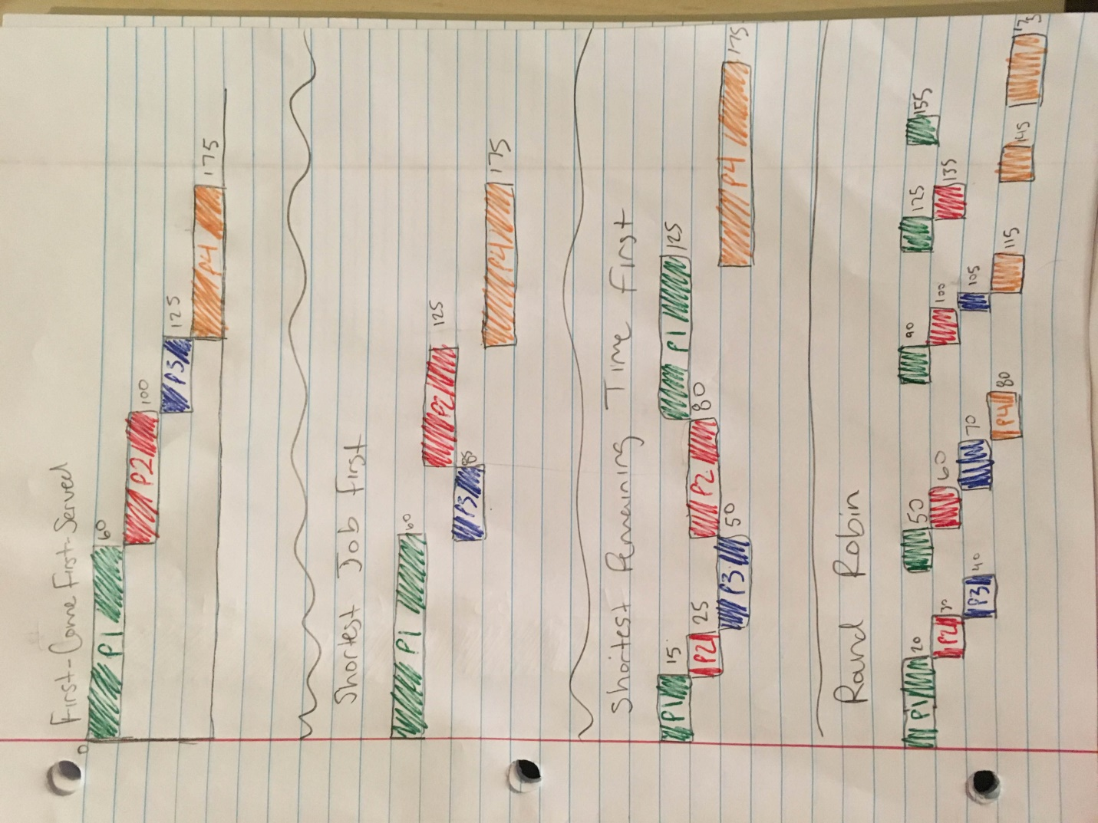



Average Turnaround Time, Average Response Time

91.25,47.5

87.5,43.75

83.75,17.5

118.75,2.5

87.5,43.75