Corey Kipp (Student ID: 57723335)

kippc@uci.edu

CS 143A

Homework 7 Write-Up

Part 1

-Use master block to find inode for “/” on disk

-Open “/”, look for entry “foo”

-This entry gives the disk block number for the inode for “foo”

-Read the inode for “foo” into memory

-The inode says where first data block is on disk

-Read that block into memory to access the data in the file

-Open “/foo”, look for entry “bar”

-This entry gives the disk block number for the inode for “bar”

-Read the inode for “bar” into memory

-The inode says where second data block is on disk

-Read that block into memory to access the data in the file

Meaning there are three disk accesses required. One for the ROOT directory, one for foo, and one for bar.

Part 2

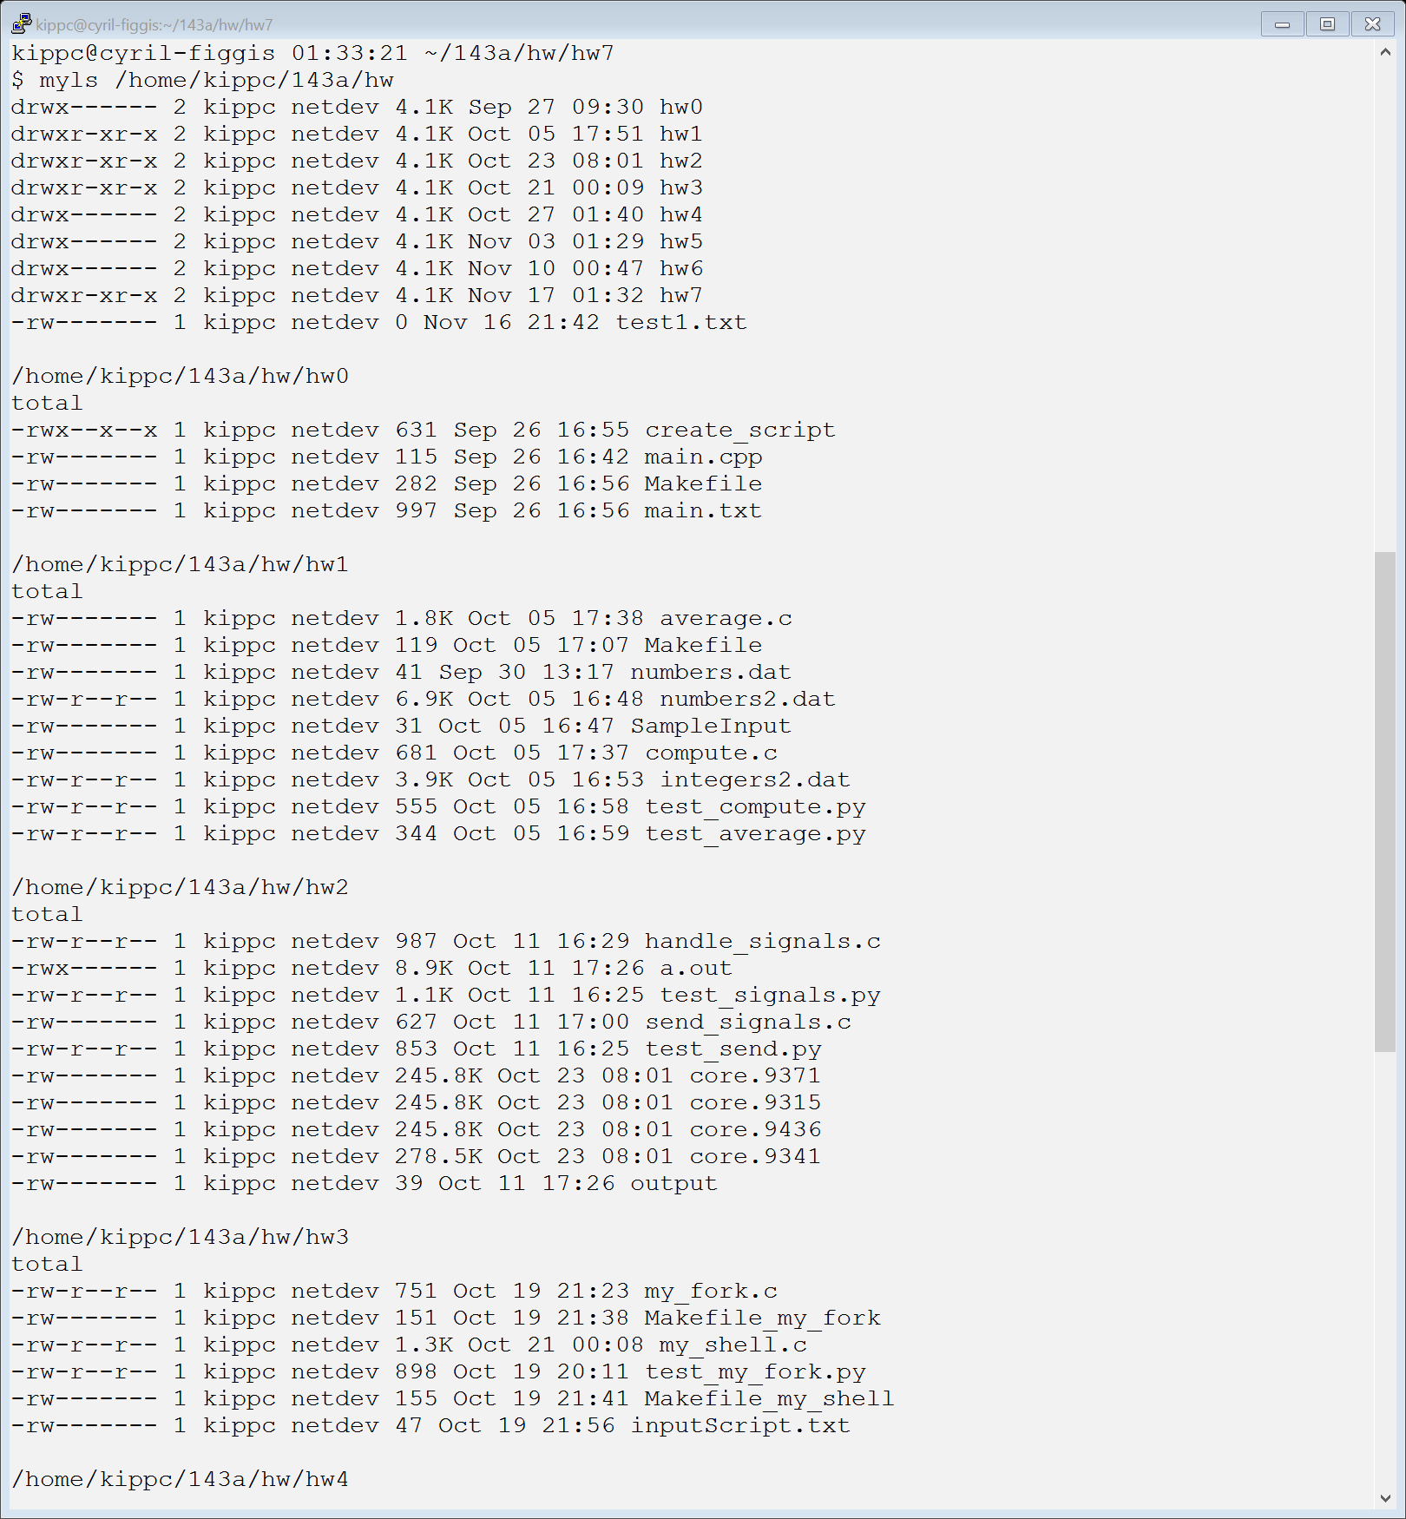

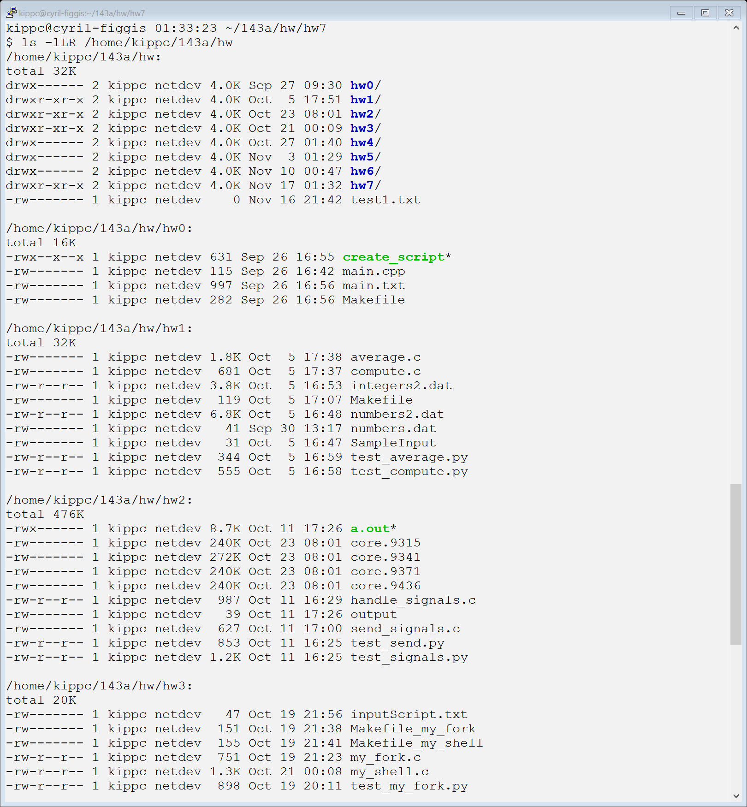

First screenshot shows the output of myls to the directory “/home/kippc/143a/hw”, second is a screenshot of ls –lLR. Unfortunately, I could not properly calculate the total and couldn’t get the syntax to match completely.

Part 3

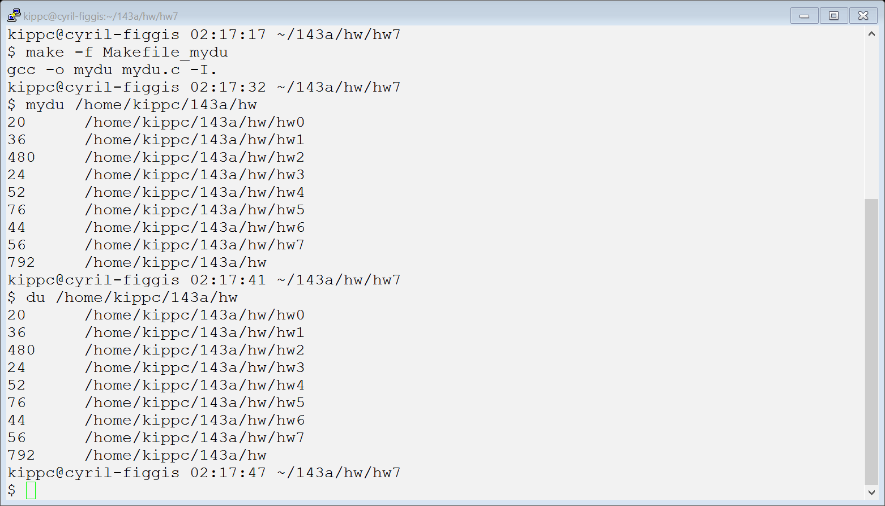

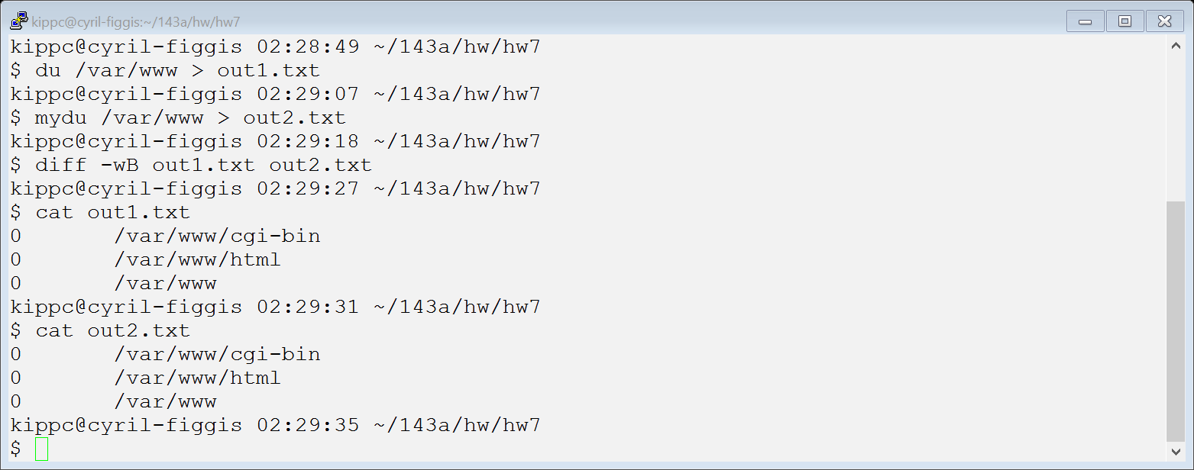

First screenshot shows my call to mydu first with the path “/home/kippc/143a/hw”, and then the call to du showing that they are identical. Second screenshot shows the example case to test on the homework, however I did not use “… | sort –n” because this changed the ordering of the output and made the two files different from each other.