Corey Kipp

Student ID: 57723335

1/19/17

CS 171: Homework 1

* 1. Intelligence- The ability for one to perceive the world around them and the ability to retain this information for furthering their development.
  2. Artificial intelligence- Used to describe the intelligence of machines. There are many different levels but it's most commonly thought of exhibited traits that are rational and show learning for the sake of some goal.
  3. Agent- Something that operates in one’s environment and is able to perceive it in some way in order to make advances toward a goal.
  4. Rationality- A quality that is associated with reason, and making decisions more so based on facts than opinions.
  5. Logical reasoning- The process of reaching a conclusion based on making rational decisions.

1. Some of the objections that Turing made still carry some weight today. The theological objection surely still carries weight, as there are still countless people who believe that man is the creation of God and that our intelligence is special, so of course they would rebuke the idea that machines are or could ever be “intelligent”. I can’t think of any new objections that are arising today, I feel as though most don’t question the intelligence of machines and the inevitable “when” they will become comparable to human intelligence.  In 2014 there was in fact a computer that was able to pass the Turing test, fooling around 33% of the judges. However many believe that Eugene, the computer that passed, isn’t one of true intelligence and many deem it to have passed based on how intelligible some of its answers can be. There are expert who believe that the test will truly be beaten somewhere around the year 2029.

|  |  |  |  |  |
| --- | --- | --- | --- | --- |
| **Agent Type** | **Performance Measure** | **Environment** | **Actuators** | **Sensors** |
| Playing Soccer | +Win  -Lose | Soccer field | Legs, Head, Torso | Eyes, Ears |
| Exploring subsurface oceans of Titan | +New information gained  -Probe lost | Subsurface oceans of TItan | Driving mechanisms, mechanical arms | Camera,Temperature gauge, chemical sensors |
| Shopping for used AI books online | Find book for a good price/quality | Online book stores | Mouse/ keyboard | Eyes |
| Playing a tennis match | +Win  -Lose | Tennis court | Tennis racket, Legs | Eyes, Ears |
| Practicing tennis against a wall | Improved from before starting | Somewhere near a wall | Tennis racket, legs | Eyes, Ears |
| Performing a high jump | +Made the jump  -Didn’t make the jump | Track | Legs | Eyes |
| Knitting a sweater | Finish sweater | Home | Hands, needles | Eyes |
| Bidding on an item at an auction | Win item | Auction House | Arm (to hold up bidding sign) | Eyes, Ears |

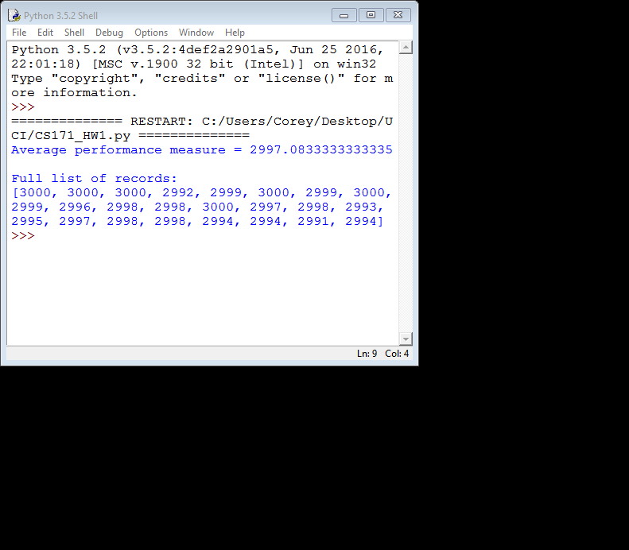

* 1. No a simple reflex agent cannot be perfectly rational for this environment because the agent will continue moving and makes its performance measure drop.
  2. A reflex agent with a state, also known as a Model Based Agent, would be able to be rational for this environment as long as it properly kept track of which rooms were clean or not and then had some sort of measure to determine if all rooms were clean and to stop if that condition is met.
  3. If the agent is able to perceive the status of every square in the environment then it should only move to dirty squares so that it maximizes its performance measure and do so with the minimum amount of movements.