# Example

This document provides an example of the types of materials that could be submitted for a project.

The aim is not to provide you with a complete written report but to provide you with the key headings and examples and hints as to what should be in those sections. Hints are in grey indented text with examples provided in normal text.

The examples have been taken from different degrees so you will find that some sections look at Security whereas others look at games.

## Introduction

You should always provide an introduction to any document. A common error is to place text and images on the document without telling the reader why they are there. A good introduction tells the reader why this report is in existence and what they will find in it. An example could be:

This report presents the project plan for the COMP1004 module coursework. The project has a focus on self-management and the use of time.

Here you might introduce the scenario that you have chosen – for example a hypertext fiction game that pitches the player against time limited puzzles.

Within this report the Software Development Lifecycle (SDLC) is discussed with an explanation of how this is applied to the current project. Following on from the project plan an design document is provided.

Remember to say which type of document you are presenting! GDD or ADD.

## Software Development Lifecycle

This section discusses the Software Development Lifecycle (SDLC) and describes how this is being used in this particular project.

Here there is a discussion about what the SDLC is and then what the author of the project has actually done with it. Below is one example of what might be discussed.

The planning phase for this project took place over a week. Many different ideas were mapped out with topics such as the genre and theme of the game considered. There were many sources of inspiration which were noted down and systematically examined for their suitability. Research was carried out into these sources looking at popularity and relevance. Notes were taken as to key interesting elements to be considered in the analysis and design phase for the project.

Having determined key elements for inclusion in the game an attempt at estimating how long these would take to create was carried out. A rough plan of sprints was made with consideration as to key features for creation in each sprint.

Continuing on from the planning phase focus turned to the requirements phase. User stories were developed and aligned with the sprint plans. These user stories can be found here <link provided to product backlog>.

The rest of the section would then discuss the other aspects of the SDLC as appropriate.

## Design Document

This section provides the key elements of the design documentation.

### Project Vision

For businesses and administrators of IT systems and networks facing security issues and vulnerabilities in their IT systems in the past, this application provides an “at-a-glance” dashboard for monitoring their systems.

Use the format for project visions here

### Background

Lowkey is a 2D pixel art adventure game focusing on problem solving with the player needing to solve the problem presented within a set time frame. Problem solving is a crucial skill and research has found that those who play strategy and precision based games have improved problem solving and motor skills (Granic, 2014). These types of games have also been shown to enhance creativity in young people, improve people’s moods, promote relaxation and ward off anxiety (ibid).

Consideration must be given to legal, social and ethical issues relating to this project. Game assets, characters, sound effects and music for example must be conscious of ensuring the copyright of materials is recognised. Therefore copyright free assets are sought or those with a specific license for use is allowable. The Copyright, Designs and Patents Act 1988 is the UK copyright law which protects creators works from unlawful usage of their material. It allows the creator to decide how their work may be distributed, meaning their work cannot be copied and distributed by another entity without explicit consent (Copyright, Designs and Patents Act 1988).

We might discuss here age ratings for games, effects on health and mental wellbeing. If we were discussing the development of an app we might consider data protection and any algorithms being developed that could perpetuate bias or harm.

Finally, web accessibility is a key aspect to be considered when designing the interface. Good accessibility not only makes sense to allow a wider audience to be able to use the application, but it is also a legal requirement under the UK Equality Act of 2010 (Equality, 2010).

### User stories and Associated Use Case Scenarios

This section examines the user stories identified so far and provides the accompanying use case scenarios.

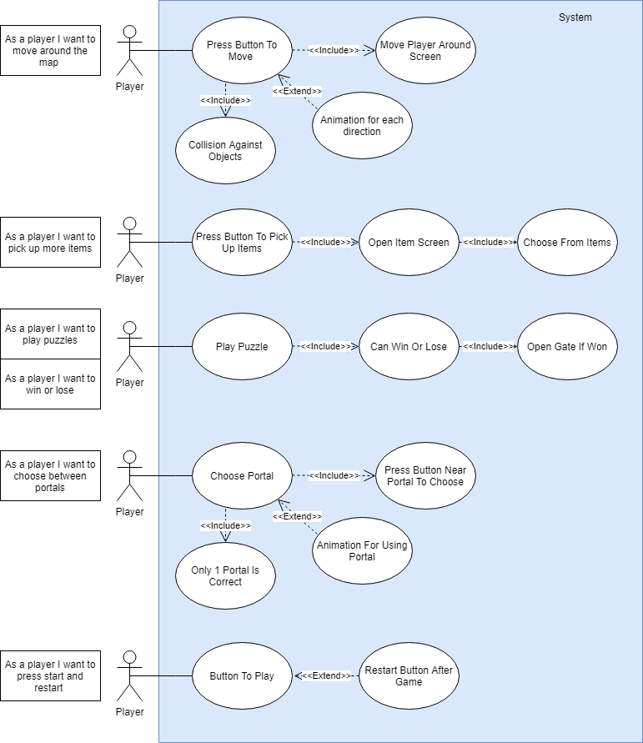

We would then decompose the Use Case Scenarios further with Use Case Descriptions. Those that follow do not match the diagram above but serve to illustrate a different type of scenario.

|  |  |
| --- | --- |
| Name | page9image63141328Amend Booking |
| Short Description | Amend a booking |
| page9image35689536Precondition | page9image35689152Customer has already made a booking |
| Post Condition | Booking amended |
| Error Situations | There is not a free table at amended time |
| System state in the event of an error | Table cannot be booked at this time |
| page9image36638272Actors | page9image36642304Customer |
| page9image36649984Triggers | page9image36530880Customer needs to amend booking |
| Standard Process | 1. Customer enters booking details 2. System finds booking 3. Customer selects new date/time for  booking 4. Customer changes party size (if  needed) 5. System confirms there is a table free 6. Customer confirms booking |
| page9image36442432  Alternative Process | page9image36535296  5’ Table is not available 6’ System gives the next time slot for a free table 7’ Customer selects new time and confirms booking |

### Architecture

This section discusses how the architecture for the single page application is envisaged.

Here you would provide a package diagram to show how the layers of the software are designed before showing a class diagram.

The sequence diagrams below shows how the classes will interact to implement the given use case scenarios.

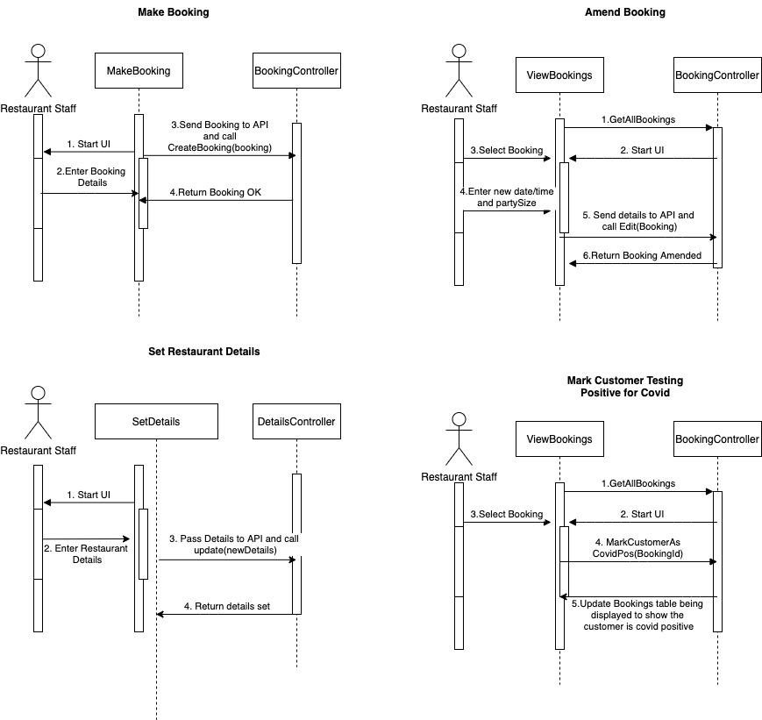

### Sitemap

This section provides an outline of how the application is designed. Whilst this is a single page application, the sitemap indicates how the user will navigate through the topics.

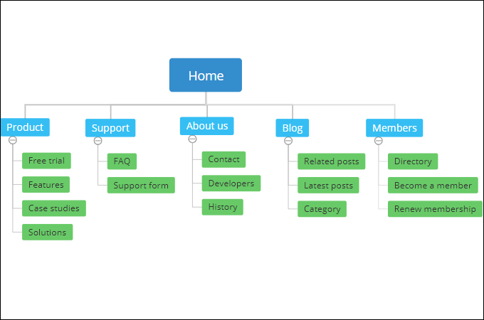

### Wireframes

This section provides an illustration of the wireframes.

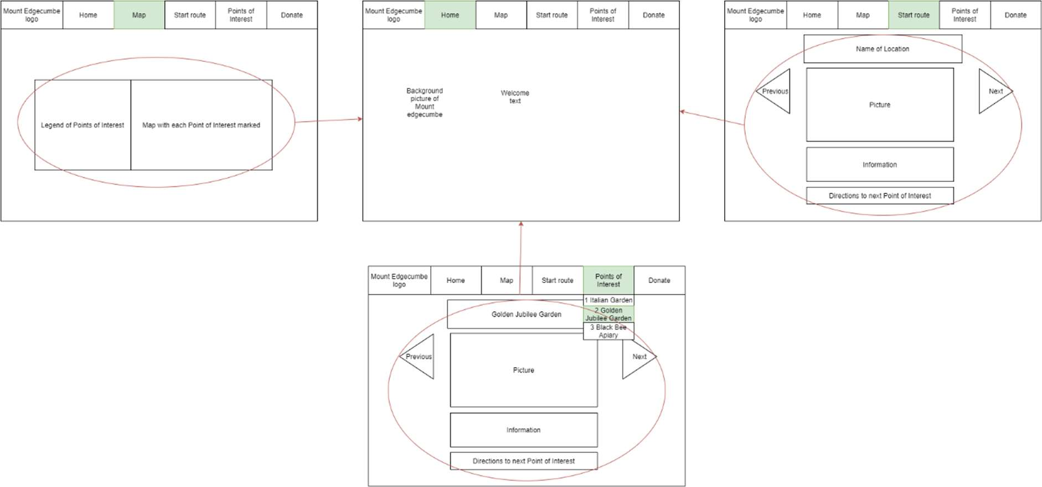

### Noted issues and constraints

This section might discuss issues around learning the technologies, planning the application and the need to account for other modules and their deliverables.

### Github repo link

http:github.classroom.com/giveyourlink

### References

Copyright, Designs and Patents Act 1988*,* c. 1*.* Available at: https://www.legislation.gov.uk/ukpga/1988/48/contents (Accessed: 05 January 2020).

Equality, 2010, Equality Act, 2010 c 15, https://www.legislation.gov.uk/ukpga/2010/15/contents, date last accessed 13/2/2021

Granic, I. (2014) ‘The Benefits of Playing Video Games ‘, *Radboud University Nijmegen.* Available at*:* https://www.apa.org/pubs/journals/releases/amp-a0034857.pdf (Accessed:6 May 2021)