<logo>

Archery Scorekeeper for Records and Club Management
A full stack web application built on the PERN stack to assist archery club officers with the management of club score records and memberships.

COMP3000 Computing Project
University of Plymouth
BSc Computer Science (Software Engineering) 2026

Authored By: Corey Richardson
Project Supervisor: Dr. Vassilis Cutsuridis

Outline

Acknowledgements

Abstract

Contents
Outline 2
Acknowledgements 2
Abstract 2
Table of Contents 3
Word Count 3
Links to Assessment Materials 3
Introduction 4
Project Aims 4
Project Vision 4
Domain-Specific Prior Knowledge 4
Archery Standard Rounds 4
The ArcheryGB Classification and Handicap System 4
Common Archery Club Committee Roles 5
Background and Research 6
A Comparison of Next.js and Supabase with an AWS Stack 6
Tech Stack Selection 7
System Requirements 7
Design 8
Development Environment Architecture 8
Implementation 10
DevOps and Deployment 10
Local to Remote 10
Contnuous Integration Pipeline 11
Continuous Deployment Pipeline 13
AWS Cloud Infrastructure and Deployment Process 17
Testing 22
Evaluation 22
Project Management 22
Reflection 22
Conclusion 22
References 22
Appendices 22

Figure 1: Container Architecture Diagram 10
Figure 2: Continuous Integration / Continuous Deployment Pipeline 11
Figure 3: Continuous Integration Pipeline 13
Figure 4: AWS IAM User 15
Figure 5: AWS IAM User Permission Policies 15
Figure 6: Repository Secrets Management 15
Figure 7: Continuous Deployment Pipeline 17
Figure 8: AWS Infrastructure Architecture 18
Figure 9: ECS Cluster Services 19
Figure 10: Application Load Balancer and Target Group 20
Figure 11: S3 Bucket 21
Figure 12: CloudFront Distribution Dynamic Path Routing Behaviour 22
Figure 13: CloudFront Distribution Alternate Domain Names and SSL Certificate 22

Word Count

Links to Assessment Materials

GitHub Repository | https://github.com/corey-richardson/comp3000
WakaTime Project Statistics | https://wakatime.com/@coreyrichardson/projects/srqcwyspxk?start=2025-09-01&end=2026-05-31
Submission Video | TODO

Introduction
TODO

Project Aims
To design and produce an online system that will assist archery club committee officers in managing scores submitted by the club members, and handling classification level and handicap computation.

Project Vision
The system will be for archery club committee officers and members, providing interfaces for score/record management and member management.
The previous process for score recording at the University of Plymouth's Archery Club is to manually collect scores and scoresheets on paper, and transfer this information over into an Microsoft Excel spreadsheet before performing lookups for classification and handicap levels; a time consuming, laborious, and error-prone process.
The Archery Scorekeeper and Club Management system (working title) is a online score and club management system that makes the process of archery club Records Officers collecting scores from their club members and processing the data simpler than traditional methods.
The project has a unique selling proposition within a highly specific niche, remaining different from established, close-sourced, commercial platforms such as Golden Records or archr.net due to the open-source nature of the project, especially with a planned technology stack of Next.js (MIT License), Supabase (Apache 2.0 License) and Flask (BSD-3-Clause License) - a fully open-sourced technology stack.

Domain-Specific Prior Knowledge

Archery Standard Rounds
There are a standardised set of target archery "rounds”, describing how many arrows are shot at what distance at what target face size. National and international governing bodies, such as Archery GB and World Archery, define these rounds as well as the associated classification and handicap systems that go with them.
"A round is really just a well-defined code name for a certain combination of a number of arrows shot at a particular set of distances on specific target faces." - Archery Geekery. (2023).

The ArcheryGB Classification and Handicap System
Classifications and Handicaps (like in golf), reflect an archers performance level relative to a national benchmark.
Handicaps represent the angular spread of arrows shot as a normal distribution, indicating the probability that an arrow will land on a certain point of a target face, a system originally developed by David Lane between 1978 and 1979, and updated by Jack Atkinson more recently in 2020.
"Within archery there exists a handicap system that allows any quantity of arrows shot at any distance to be given a rating that reflects how good the performance was. This rating depends only on an archer's accuracy i.e. their ability to shoot a tight group." - Atkinson, J. (2020).
Handicaps can be used to compare scores shot of different standard rounds. This can be used for benchmarking performance, as it allows you to know what score you "should" get on the WA 18m standard round based on a known score for a Portsmouth standard round.
They are also useful for benchmarking changes to equipment or technique by seeing how your scores and handicaps change as you make changes.
Archery GB provides a classification scheme as described in SAP7 of the Shooting Administrative Procedures. There are different schemes for different disciplines of archery, but each seeks to provide a progression scheme to reward archers performance as they improve.
For outdoor target shooting there are three tiers: Archer, Bowman and Master Bowman, each with 3 subdivisions per tier for a total of 9 different classification levels available.
For indoor target shooting there are, again, three tiers: Archer, Bowman, and Master Bowman, this time with 8 different classifications available; there is no Elite Master Bowman indoors.

Common Archery Club Committee Roles
Since the system will use role-based access levels to handle Personally Identifiable Information (PII), I will explain some of the Committee Officer roles relevant to the system.
There are four roles the system covers:
- Admin: this covers anyone needing full access to PII to perform the responsibilities and duties of their role, such as Club Chair, Secretary or Membership Secretary.
- Captain or Tournaments Organiser: this role will have access to a subset of the available PII, such as Archery GB membership number and score records shot for submission into postal leagues.
- Records Officers: this role has limited access to PII, overseeing score records and calculating handicap and classification levels as described above.
- Coach: this role has extremely limited access to PII, being able to see the basic demographic information of the archers in their club and being able to see the scores submitted to the system.
- Member

Background and Research

A Comparison of Next.js and Supabase with an AWS Stack

 | Next.js and Supabase | AWS Stack
Hosting and Deployment | Hosting and deployment would be fully managed through Vercel. There would be no (or minimal) DevOps overhead. | It would be a lot more self-managed. I would have to configure the setup, handle load balancing, backups, etc. HIGH DevOps overhead.
CI/CD and DevOps | Git push to deploy with webhook. | Pipeline setup required for GitHub Action -> ECR -> ECS/EC2
Database | Supabase has a PostgreSQL database built in and provides APIs and RBAC Auth methods to interact with the database. Postgres is open-source and FREE. Vercel hosting would be free up to a point. | AWS RDS with Postgres. Would require more initial setup, key management, etc.
Scoresheet Storage | Supabase storage with S3 Compatible Object Store, integrates with Supabase Auth and Postgres easily | AWS S3 directly. Would have to handle IAM, permissions and policies.
Authentication | Superbase Auth built in: JWT-based auth with email or OAuth. | Would probably be handled by NextAuth?
Cost | Free or very low. | Lots of AWS services could add up in cost.

Tech Stack Selection
Based on these factors, my original decision was to work with a Next.js/React frontend, hosted on Vercel, a Supabase backend, using the PostgreSQL, Auth and Storage services, and a Python Flask microservice running the archeryutils library on a separate deployment.
Supabase offers an all-in-one “Backend-as-a-Service” (BaaS), to leverage the ecosystem for Authentication, PostgreSQL hosting and Object Storage.
Integrating a separate Python Flask microservice on Supabase’s API layer introduced complexity with handling the cross-service authentication and communication. As so, I made the engineering decision to refactor the application into a fully containerised PERN (PostgreSQL, Express.js, React, Node.js) stack, using the Prisma ORM, to be hosted on Amazon Web Services (AWS).
This transition allowed the use of Docker for local development and production deployment, ensuring environment parity. By using Amazon’s Cloudfront as the entry point for the product S3 bucket holding the static frontend content, and the Application Load Balancer (ALB) hosting the backend API and Flask microservice, I removed the Cross-Origin Resource Sharing (CORS) complexities that would have been present in the original multi-cloud setup using Vercel and Supabase.

System Requirements

Functional Requirements

Non-Functional Requirements

Technical Requirements

Design

Development Environment Architecture
The local development environment for this project consists of four services, connected via an internal Docker bridge network.
- frontend (React, 81:3000)
- backend (Express.js/Node.js, 82:4000)
- database (PostgreSQL, 83:5432)
- archeryutils-service (Python/Flask, 84:5000)
The database service is used exclusively for development, ensuring data isolation, through the use of Docker Profiles and Environment Variables to manage differences between the local development and AWS deployment.
By running docker compose --profile dev up, the Docker orchestrator loads the local PostgreSQL container, and the DATABASE_URL environment variable points to the local container. When the images are pushed to AWS ECS Fargate, the database is not loaded. Instead, the ECS task connects to the AWS Relational Database Service (RDS) endpoint, with the DATABASE_URL environment variable instead being set by the Task Definition.
This architecture pattern provides a “hot-swappable” database service, where the application logic remains constant, but the data later can easily scale between a local service and a hosted regional service.

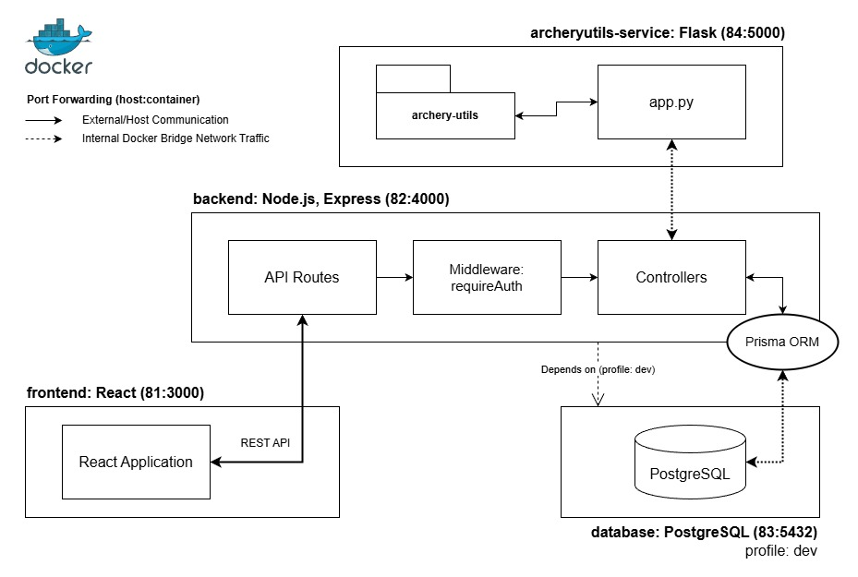
Figure 1: Container Architecture Diagram

System Design
The application follows a modified Model-View-Controller (MVC) architectural pattern to provide a separation of concerns.
The Model (Data) layer is implemented through a PostgreSQL database instance and Prisma ORM. This layer defines the data structures and handles the interactions with the database. Prisma ORM schemas provide the model with type-safety through the generated Prisma Client.
The View (Client) layer serves the React UI.
The Controller (Server) layer
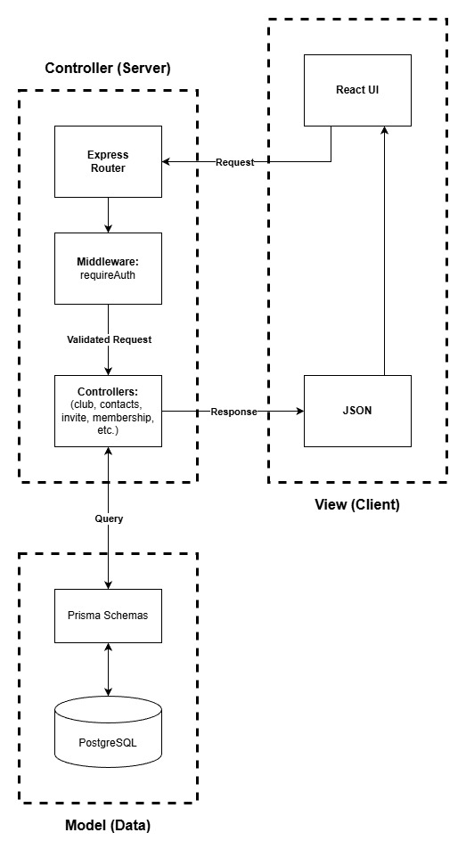
Figure 2: Model-View-Controller Pattern

Context and Reducers to Manage Authentication State

Hooks

Implementation

DevOps and Deployment
To maintain a high code quality across the services, a CD/CD pipeline was implemented. This ensures the poor-quality or failing code never reaches the production environment, through a series of blocking quality gates.

Local to Remote
Local to Remote code integrity is enforced using the Husky development tool, with ESLint and lint-staged. This quality gate prevents code which fails linting conditions from reaching the remote CI pipeline to prevent wasting GitHub Actions runner minutes.
Husky is used to manage a git Pre-commit hook. When a developer attempts to commit code, lint-staged will run ESLint on the staged modified files. If local linting fails, the commit is blocked and must be resolved before the code can be committed.

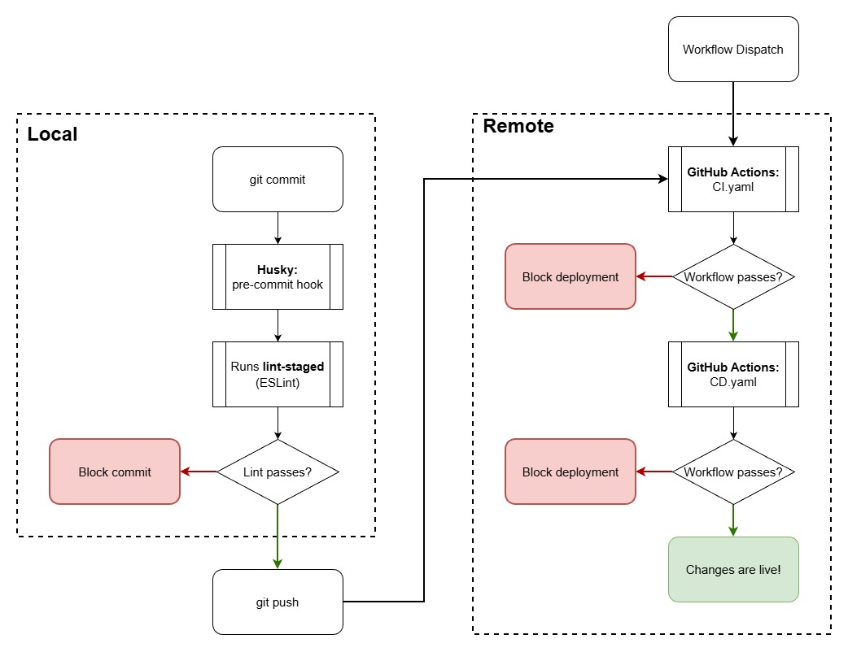
Figure 3: Continuous Integration / Continuous Deployment Pipeline

Contnuous Integration Pipeline
The Continuous Integration Pipeline consist of three stages: linting, testing and building.
The first quality gate runs the linting tools across the entire codebase, running ESLint on the JavaScript and TypeScript files (.js/.jsx/.ts/.tsx), stylelint on the CSS (.css) files, and finally black, flake8 and isort on the Python (.py) files. If the linting succeeds, the pipeline proceeds to the testing stage.
The testing stage of the pipeline runs three concurrent, isolated jobs: test-frontend, test-backend and test-utils. The test suites run in parallel but isolated jobs to reduce the overall deployment time but ensure that the failure of one job does not cause the remaining test suites to fail early, ensuring that the remaining jobs are able to upload their test coverage artifacts. However, the next quality gate will require all previous jobs to have passed before proceeding further.
The build stage attempts to build the containers using the docker compose --profile dev build command. This stage ensures that all containers can successfully build before proceeding to the Continuous Deployment pipeline. It runs the development profile as a final check for syntax or compilation errors before proceeding to the CD Pipeline.
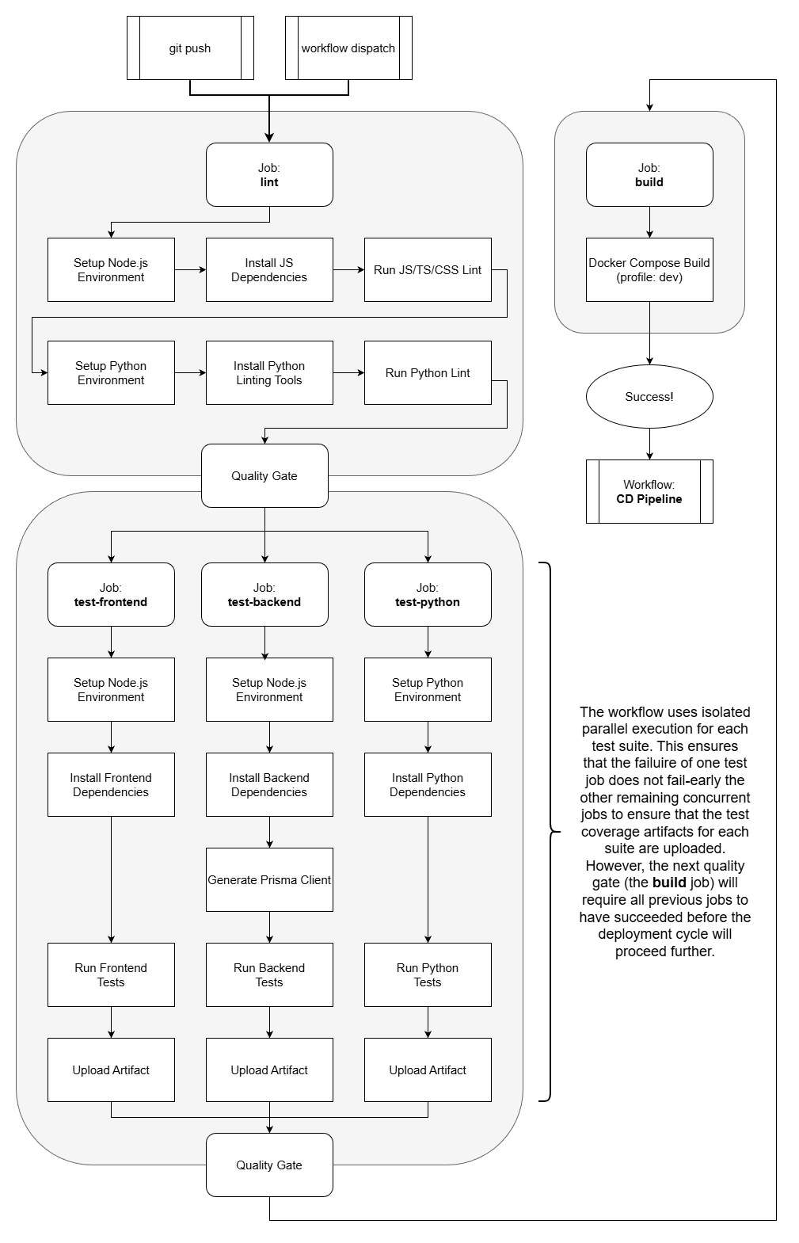
Figure 4: Continuous Integration Pipeline

Continuous Deployment Pipeline
Once the CI Workflow has succeeded, GitHub Actions will now attempt to run the CD Workflow running three jobs: deploy-frontend, deploy-backend and deploy-utils.
Each container is deployed to AWS in parallel. The original intent of using parallel jobs was to reduce the overall run time of the deployment pipeline, allowing for faster development turnaround. However, during the refactoring of the pipeline to move from a sequential to a parallel execution, I also added checks to confirm the AWS ECS services were stable through aw secs wait services-stable.
These checks actually doubled the run time of the workflow when compared to running the jobs sequentially without this check but add a further layer of confidence by changing the pushing of containers to AWS from “fire and forget” to include service validation before marking the workflow as passed.
I believe that the trade-off between deployment time and system reliability has been worth it, as it prevents “partial deployments” where a pipeline ill mark itself as successful, even if the updated ECS tasks are crashing
During this refactor, I also moved a shared step between the deploy-backend and deploy-utils jobs into a single composite action (.github/actions/aws-setup), standardising the steps to configure AWS credentials and Amazon ECR login across the jobs, following a Don’t Repeat Yourself (DRY) software engineering pattern.
The deployment strategy of these jobs involves:
Frontend | Backend and Utils
- Configure AWS credentials  - Build Frontend  - Sync the S3 Bucket  - Invalidate the previous Cloudfront distribution | - Configure AWS credentials  - Login to Amazon ECR  - Build, push and tag the images  - Refresh the ECS services by forcing a new deployment  - Wait for service to be stable

By using the force-new-deployment flag during the AWS ECS service refresh, it performs a rolling update, ensuring zero-downtime during deployment; new containers are created and loaded and health checks are performed before the old containers get drained and stopped.

AWS secrets are managed through a command line AWS IAM user with permissions allowing full access to the EC2, ECS and S3 services, and the Cloudfront distribution.
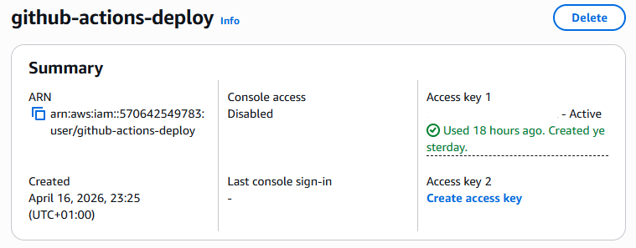
Figure 5: AWS IAM User

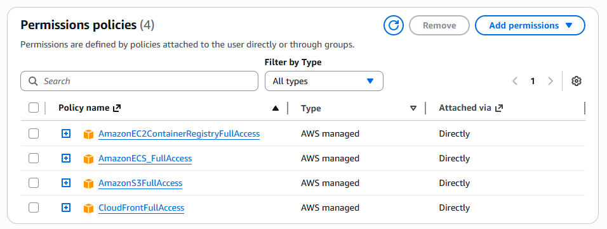
Figure 6: AWS IAM User Permission Policies

Secrets are stored and managed in the GitHub repositories Actions secrets and variables page.

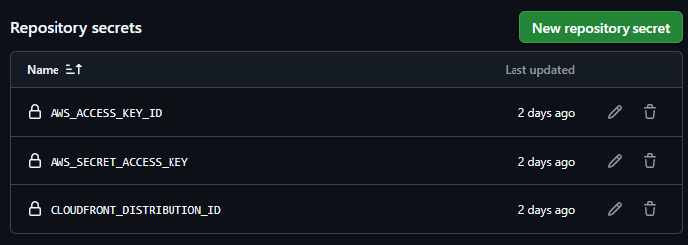
Figure 7: Repository Secrets Management

A security improvement could be made here to instead use OpenID Connect (OIDC), which would use short-lived tokens to validate identity, instead of static, long-lived secrets which could be compromised.
Additionally, the permission policies for the IAM github-actions-deploy user should be tightened to use the Principle of Least Privilege, as opposed to Full Access.
Currently, the deployment process is initiated via a push to the main branch of the repository, or it can be triggered by running a workflow_dispatch on the CI Pipeline action. This could be refined to instead be triggered through a pull_request to a production branch, allowing more control as to when changes are deployed.

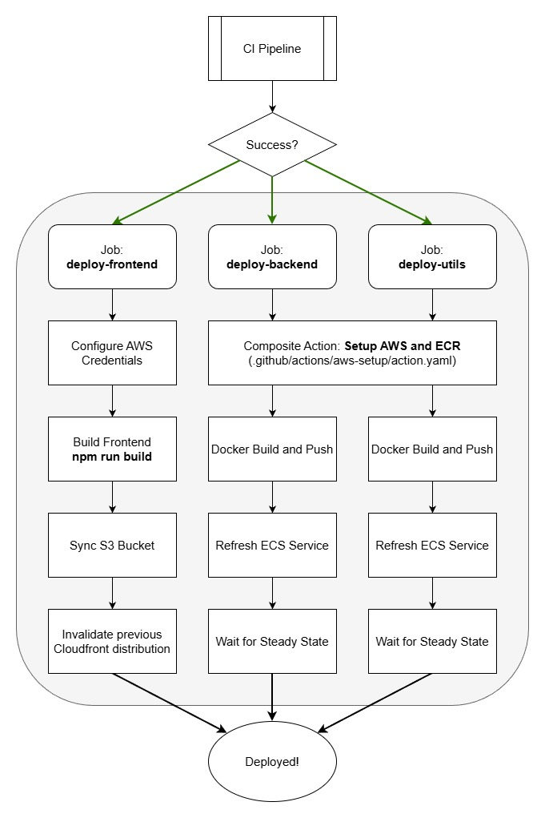
Figure 8: Continuous Deployment Pipeline

AWS Cloud Infrastructure and Deployment Process

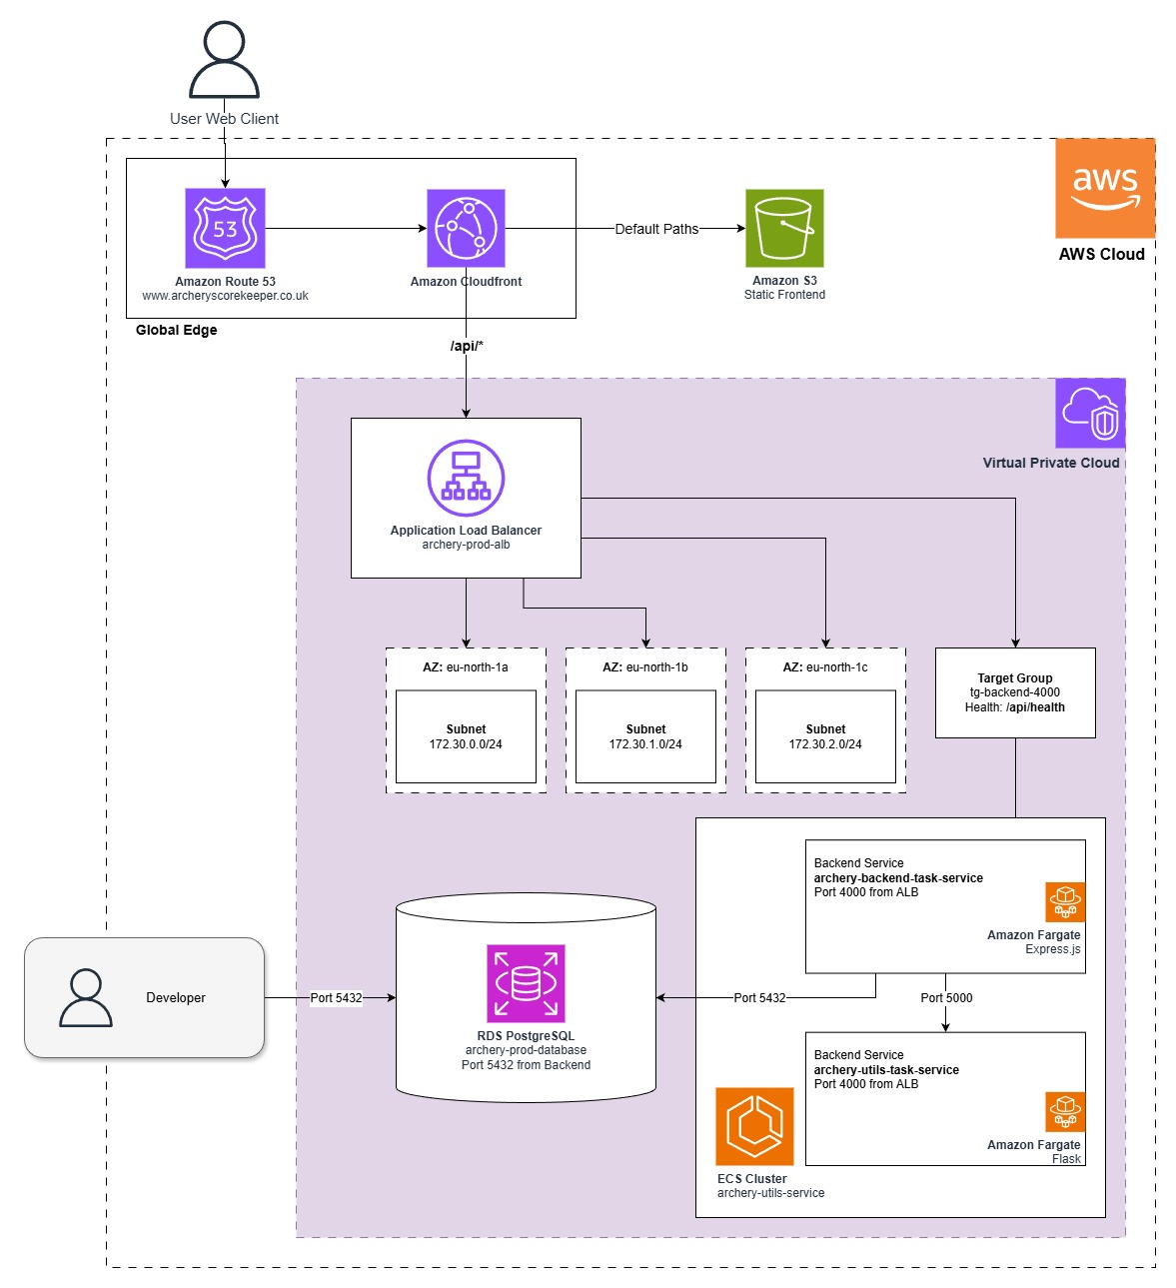
Figure 9: AWS Infrastructure Architecture

To deploy the application, I first created an Amazon RDS PostgreSQL database instance, archery-prod-database. This database instance was initially set up with a default security group to allow developer access on Port 5432 for the initial schema push via Prisma. An additional Inbound Rule was later added to allow the backend service security group access.
Next, I created two private Amazon Elastic Container Registry (ECR) repositories,
archery-backend and archery-utils. Using the provided push commands, I built, tagged and pushed the local containers using the AWS CLI tool.
Once the containers were pushed, I created a new Amazon Fargate (serverless) cluster with Amazon ECS, with the misnomer archery-utils-service. Unfortunately, with ECS, a cluster cannot be renamed once it has been created…
I then created two new Task Definitions, starting with archery-utils-task, as this would be a dependency for the setup of archery-backend-task.
Both tasks use the latest tag of their respective images setup in the previous step and were created using a small Task Size using the .5 vCPU and 1GB memory, which would be more than sufficient for the use case and keeping deployment costs as low as possible. If the system needs to be scaled, new revisions of these tasks could be created which provision more resources.
After creating archery-utils-task, I then set up a service on the cluster called
archery-utils-task-service, using the Service Discovery tab to create a new namespace on the AWS Cloud Map name archery.local, making the utils service locally discoverable on http://utils.archery.local:5000, to be used by the backend task later. This service was given the security group utils-sg, allowing access on Port 5000 from Anywhere (0.0.0.0/0), which was tightened at a later step. The AWS Cloud Map is an internal DNS service which allows the microservices to communicate on static “friendly names” rather than volatile private IP addresses.
Next, I was able to create the archery-backend-task and archery-backend-task-service resources. The backend Task Definition was setup with environment variables for DATABASE_URL, SECRET (for JWT management) and FLASK_ARCHERYUTILS_SERVICE_URL set to http://utils.archery.local:5000, hence why that service needed to be set up first. The backend service was configured with the backend-sg security group, with an Inbound Rule allowing access on Port 4000 from Anywhere (0.0.0.0/0), also to be tightened later.

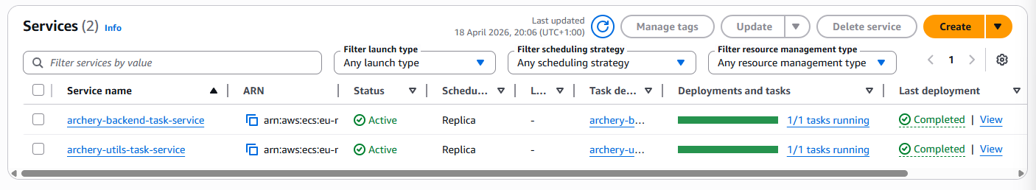
Figure 10: ECS Cluster Services

Now that the services were all setup on the same Virtual Private Cloud (VPC), I was able to add the backend-sg security group onto the Inbound Rules configured for the database and remove the Anywhere (0.0.0.0/0) rule from the utils-sg security group, replacing it with a rule allowing access only from backend-sg. To test this, I got the public IP address of the currently running backend task and performed a health check using the /api/health endpoint, which passed.
The next stage was to set up the Application Load Balancer (ALB) to provide a stable base URL which will not change every time a task is refreshed. On the Amazon EC2 console, I created the tg-backend-4000 Target Group, targeting IP addresses, using Protocol: Port of HTTP:4000, and performing health checks at an interval of 30 seconds to reduce the draining time taken on updates, as it deregisters connections from the existing container and moves them across to the new container. Next, I created the archery-prod-alb load balancer itself. Instances of the load balancer are placed on three different Availability Zones, eu-north-1a/b/c, scaling automatically. I created a new security group, alb-sg, with an Inbound Rule to allow HTTP traffic on Port 80 from Anywhere (0.0.0.0/0), with an action to forward this traffic to the tg-backend-4000 target group.

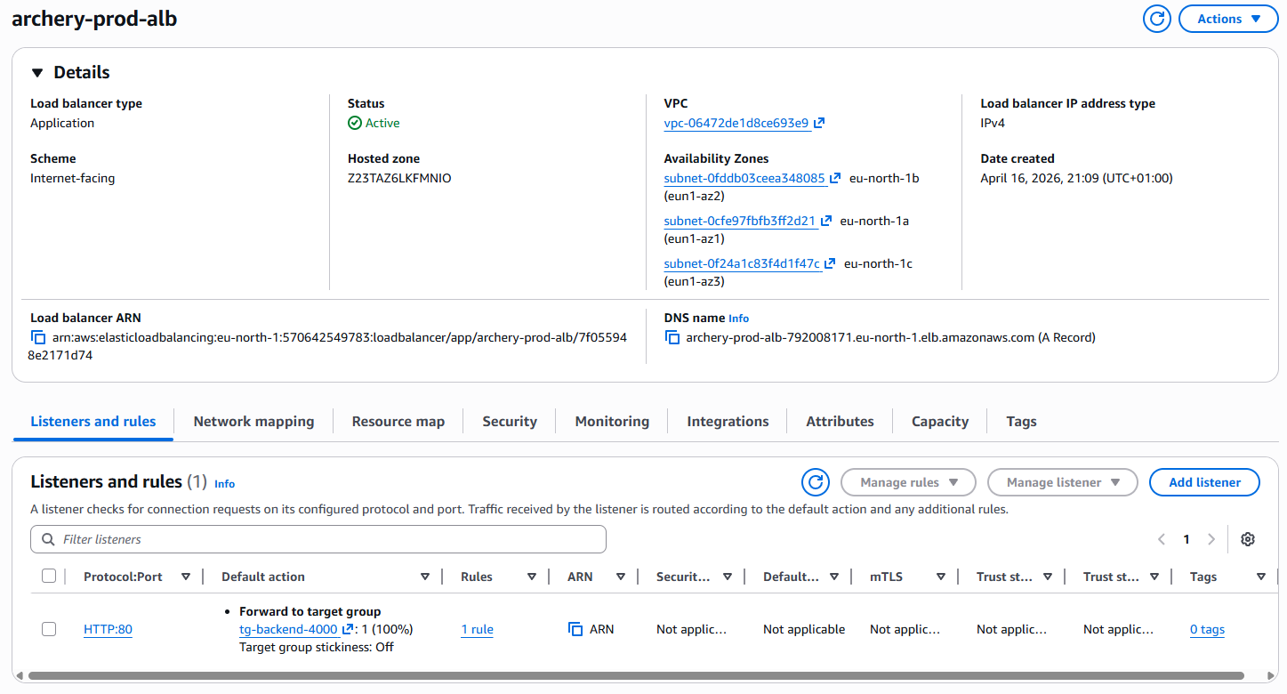
Figure 11: Application Load Balancer and Target Group

Now I had to link my ECS Cluster to the newly created Load Balancer, by updating the
archery-backend-task-service. I enabled “Use load balancing”, configuring it to load balance the incoming traffic to the backend container using the newly created archery-prod-alb load balancer with the tg-backend-4000 target group. The final stage of this step was to update the backend-sg security group to only allow traffic from the ALB, securing it away from the wider internet. To test this step, I performed a health check using the DNS name of the load balancer, showing that it correctly directs traffic to the backend.
http://archery-prod-alb-792008171.eu-north-1.elb.amazonaws.com/api/health

To deploy the frontend, I used a S3 storage to hold the static built frontend code, creating the private archery-frontend-live bucket, hosted in the same eu-north-1 region that the backend is hosted in. A CloudFront Content Distribution Network (CDN) provides the entry point to the system. When creating the distribution, I set the origin to an S3 bucket pointing to the previously created frontend, and the Default Root Object to index.html; the file to load on first access.
Locally, I ran npm run build from inside my SourceCode/frontend directory and uploaded the resultant build/ folder into the archery-frontend-live bucket. As React works through client-side routing by “intercepting” requests to navigate to other pages and instead loads all content on index.html like a Single Page Web Application, I next set up custom Error Pages which will redirect HTTP 403 and 404 status responses back to index.html allowing the React Router to handle updates to the page. Without these custom error responses, on a page refresh on the /profile route, S3 will look for a folder named “profile” which does not exist, throwing a 404 error. By returning index.html with a status of 200, React will parse the URL and load the specified page. Navigating to the distributions domain name in my browser validated that these CloudFront was serving content.

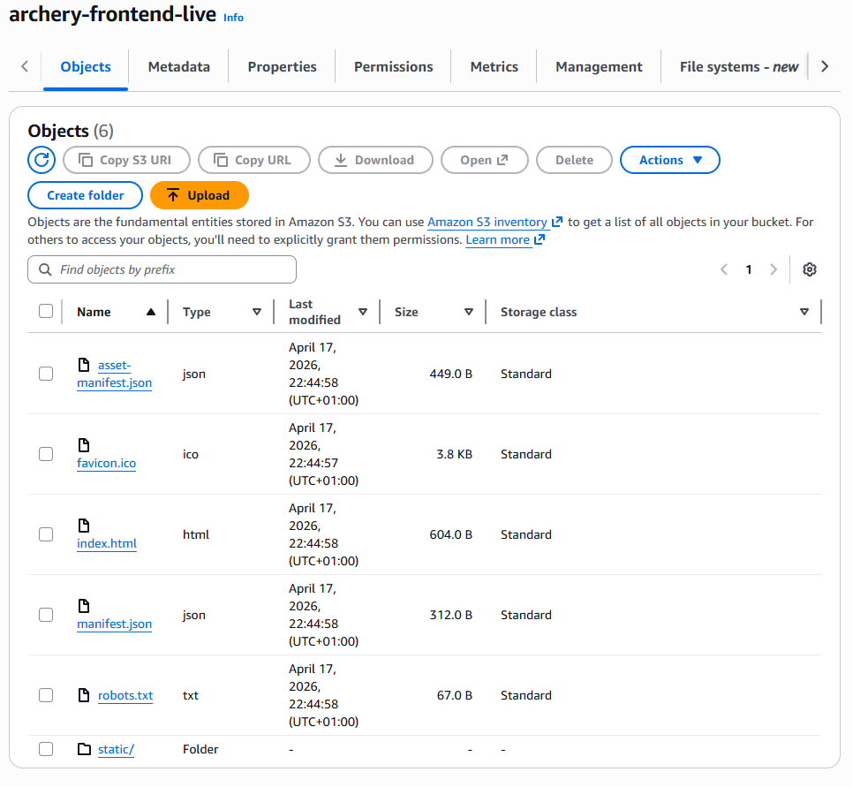
Figure 12: S3 Bucket

To set up path routing for my API, directing /api/* requests to the ALB, I added a new origin to my CloudFront Distribution called alb-backend, which takes the archery-prod-alb load balancer as the origin domain. Next, on the behaviours tab of the distribution, I created a new behaviour policy to direct /api/* requests for all HTTP methods to the alb-backend origin.

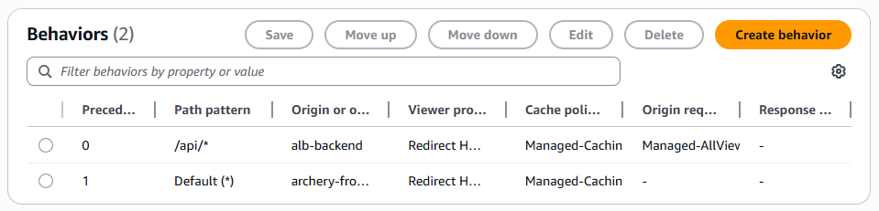
Figure 13: CloudFront Distribution Dynamic Path Routing Behaviour

Rather than having users navigate to a hard-to-remember CloudFront Distribution domain name, I opted to purchase a domain through AWS Route 53.

https://www.archeryscorekeeper.co.uk/

Whilst waiting for the domain to register, I requested public SSL certificates for my domain via DNS Registration, including and excluding the wildcard (*) prefix as a best practice for subdomains.
Once the domain had registered, I was able to update my CloudFront distribution with alternate domain names linking to the registered domain and add the issued SSL certificate.

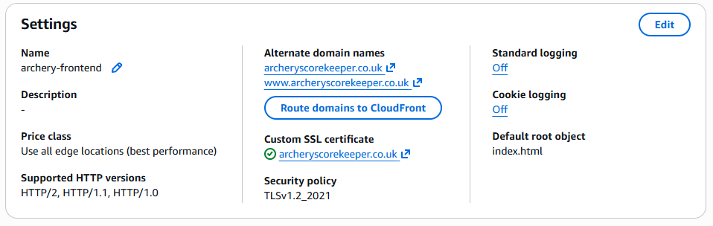
Figure 14: CloudFront Distribution Alternate Domain Names and SSL Certificate

Testing

Project Management

Evaluation

Reflection

Conclusion

References
Archery Geekery. (2023). Beginners Series: Part 1 – Rounds. [online] Available at: https://archerygeekery.co.uk/2023/06/08/beginners-series-part-1-rounds/
Atkinson, J. (2020). The Archery Handicap System. [online] Available at: https://jackatkinson.net/post/archery_handicap/

Appendices

