COMP3007 Short research paper (Coursework C2 Report)
COMP3007 Student
University of Plymouth, Plymouth, UK, PL4 8AA.
Corresponding author email yourname@plymouth.ac.uk

- Module information
The COMP3007 Module Leader is Dr Haoyi Wang. The best way to contact Haoyi is via email to haoyi.wang@plymouth.ac.uk. The assessment for this module is made up of two elements:
- C1 coursework element entitled Set exercises which is worth 30% of the module.
- C2 coursework element called Report worth 70% of the module. This document provides the format of document you should use for C2.
This is not a collaborative piece of work. It is an individual work assignment and must be all your own work. Any plagiarism will be dealt with using the appropriate process; consult your student handbook if you are unaware of this as it could jeopardise your studies[1].
Table 1 This is an example of how you could add a table to the document
Please pay attention to the formatting section of this coursework. It is very important that you carefully format your paper. See Table 1 for an example of how to add a table to this document.

Module Aims
- To develop an awareness of good practice in HCI.
- To create appropriate plans for evaluating the usability of software.
- To introduce students to the concepts and techniques of ‘Information Visualization’ and highlight it as an application area of HCI principles

Assessed Module Learning Outcomes
At the end of the module the learner will be expected to be able to:
- Critically evaluate the usability of a small software system and document the user feedback gathered.
- Redesign the front-end of a small software system in line with good practice in HCI based on user feedback and core HCI principles.
- Apply the techniques of ‘Information Visualization’ and/or devise own techniques to the analysis of data.

Late work
Note that you may submit your work up to 24 hours after the deadline. Late work will be marked but the mark you receive will be capped at 40%. Work submitted more than 24 hours after the deadline will receive an automatic mark of zero.

Extenuating circumstances
If your academic study has been affected by Extenuating Circumstances (EC’s), this can be taken into consideration. To have your circumstances assessed and validated you can submit an ECs form to the faculty office. Full details are available here:
https://www.plymouth.ac.uk/student-life/your-studies/essential-information/exams/exam-rules-and-regulations/extenuating-circumstances.

Applying for an extension
Usually, when submitting ECs, you can choose whether you want to apply for an extension. You can also opt to apply for non-submission. These options are subject to you having experienced extenuating circumstances. You will need to provide evidence to corroborate your claim.

Applying for non-submission
You can apply for non-submission by submitting an EC form to the faculty office. On the form, you must choose which form of referral you want. You can (i) request to be awarded a “Referral” in Summer 2022 or (ii) you can apply to “Repeat” the module in the next academic year, 2022/23. Please think carefully about whether you need a ‘referral’ or to ‘repeat the year. In general, students have two attempts at any module, so be careful to choose wisely!
In my opinion, the referral in the Summer is only sensible for those who have carried out quite a lot of the work during the Semester. It is not suitable for those who have not been able to start work on the module yet. Those students should apply to “Repeat” the module (as opposed to being “Referred”). Sorry about all the internal lingo but, you only get one extra attempt at any module, so be careful to choose wisely! If you experienced extenuating circumstances, you should talk to your personal tutor about submitting these extenuating circumstances[2].
This module has two elements, and it is possible to be referred in one or both elements. Students unable to complete their C1 element, (for example, due to EC’s) should claim their EC’s for non-submission. Providing their referred credits do not exceed the current limit (60 credits), you will be invited to redo the coursework element during the summer. The information of the exact date can be found here:
https://www.plymouth.ac.uk/student-life/your-studies/essential-information/regulations/important-dates
If you experience extenuating circumstances, you should talk to your personal tutor about submitting these extenuating circumstances[2]

Your task
To consolidate your learning on this module, you are required to research, reflect, and innovate. To do this, you will need to complete five different activities specific in the remainder of this section. Once completed you should write up your work as short research paper.

Dataset selection
The first thing you need to do is select your dataset. You will use this dataset throughout the entire assignment, so take your time to do this task well. There are many, many sites[3],[4],[5] where you can get access to free datasets. Have a look, there is data on almost everything.
Alternatively, and provided you are not already doing a final year project based on visualizing my ICU data, you can use my ICU dataset for this coursework. Email me if you are interested in this option.
My top tip for this coursework is to take your time on this step and select a dataset which will provide you with lots of scope; the more the better! As with all research, novelty can create significant impact.

Current state-of-the-art
The next step is to do some in-depth research into what good ideas, systems implementations are already available for the information visualization of your selected dataset. You should “cast your net wide…” for this part of the process. Look at past successes and well as new cutting-edge innovations.

Innovation
The next part of the process is sometimes the most challenging yet always the most interesting part [6][7]. By this stage, you know your dataset in depth. You have also acquired a thorough understanding of current methods that are used to visualize this information. Now it’s your turn to propose your ideas of the information visualization of your chosen dataset!
It is satisfactory if you solely want to propose the novel application of relevant IV techniques, such as Treemaps[8] or Parallel coordinates[9], to your dataset. It would be far superior, if you derived novel, creative techniques of your own. Given all that you now know about your data, and how it is currently visualized, what would you do next? What do you want to see? Where would you go next?

Prototyping
It is entirely up to you how you present your innovative information visualization ideas for evaluation. If you want to simply use sketches and/or a paper prototype to evaluate your ideas, that is satisfactory. If you want to mock-ups the ideas electronically, that would be better. You are not expected to fully code your ideas into a complete software system. That is beyond the scope of this coursework.

Evaluation
Note, that it is impossible for researchers to publish research in this applied area of computing without evaluation. It is entirely up to you how you evaluate your ideas. Refer to all the different techniques for evaluation taught in the module and select the most appropriate method for your investigation.

Tip
Make sure that you refer to any figures you add to your paper (See Figure 1). Use the “Insert Caption” option form eth Reference stab. Then use the “Cross reference! Option from the Insert tab. There is another example in section 3.2.

Writing your short paper
Once you have completed the work, you are required to write up your work and present it as a short research paper. Researchers use short papers to report findings succinctly to the relevant research community. They are between 3 - 5 pages long; including references, diagrams,
figures, and tables. Your paper must not go over the 5-page limit.
In addition, your paper must be professionally formatted. The remainder of this section is the amalgamation of guidelines from a selection of professional research publishers. These are the guidelines that all authors (including myself and many of the staff who teach you) are required to follow to publish their research. Note that the strict formatting rules are required to ensure that the final journal document looks coherent.

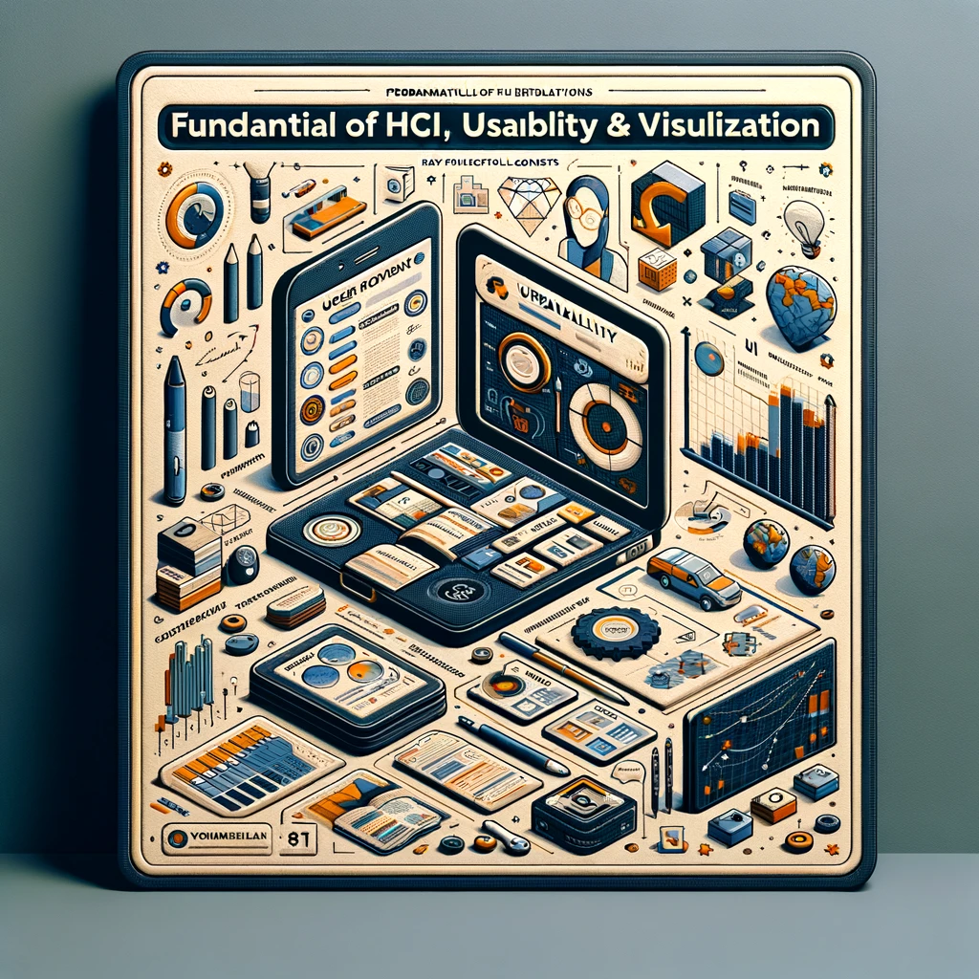
Figure 1 An example of a larger picture added to the paper. By ChatGPT.

Structure
Start your paper by introducing it and put a nomenclature if necessary. The paragraphs continue from there and are only separated by headings, subheadings, images, and formulae. The section headings are arranged by numbers, bold and 14 pt. for main sections and 12 pt. for subsections.
Files must be in MS Word only and should be formatted for submission, using this MS Word style document. Figures and tables should be embedded and not supplied separately.
Please make sure that you use (as much as possible) normal fonts in your documents. Special fonts, such as fonts used in the Far East (Japanese, Chinese, Korean, etc.) may cause problems during processing. To avoid unnecessary errors, you are strongly advised to use the ‘spellchecker’ function of MS Word.
Follow this order when typing manuscripts: Title, Authors, Affiliations, Abstract, Keywords, Main text (including figures and tables), Acknowledgements, References, Appendix. Collate acknowledgements in a separate section at the end of the article and do not include them on the title page, as a footnote to the title or otherwise.
Bulleted lists may be included and should look like this:
- First point
- Second point
- And so on …

Abstract
An abstract summarizes, usually in one paragraph of 300 words or less, the major aspects of the entire paper in a prescribed sequence that includes: a) the overall purpose of the study and the research problem(s) you investigated; b) the basic design of the study; c) major findings or trends found as a result of your analysis; and d) a brief summary of your interpretations and conclusions.

Figure 2 This is an example of a smaller picture added to the paper

Tables
All tables should be numbered with Arabic numerals. Every table should have a caption. Headings should be placed above tables, left justified. Only horizontal lines should be used within a table, to distinguish the column headings from the body of the table, and immediately above and below the table. Tables must be embedded into the text and not supplied separately.

Construction of references
References must be listed at the end of the paper. Do not begin them on a new page unless this is necessary. Authors should ensure that every reference in the text appears in the list of references and vice versa. Indicate references by [1,2] or [1] in the text.
Some examples of how your references should be listed are given at the end of this template in the ‘References’ section, which will allow you to assemble your reference list according to the correct format and font size.

Section headings
Section headings should be left justified, bold, with the first letter capitalized and numbered consecutively, starting with the Introduction. Sub-section headings should be in capital and lower-case italic letters, numbered 1.1, 1.2, etc., and left justified, with second and subsequent lines indented. All headings should have a minimum of three text lines after them before a page or column break. Ensure the text area is not blank except for the last page.

General guidelines for the preparation of your text
Avoid hyphenation at the end of a line. Symbols denoting vectors and matrices should be indicated in bold type. Scalar variable names should normally be expressed using italics. Weights and measures should be expressed in SI units. All non-standard abbreviations or symbols must be defined when first mentioned, or a glossary provided.

Acknowledgements
Acknowledgements and Reference heading should be left justified, bold, with the first letter capitalized but have no numbers. Text below continues as normal.

References
- University of Plymouth, (2020). Assessment and feedback, viewed 23/10/20, https://ec.plymouth.ac.uk/assessment-feedback/
- University of Plymouth, (2020). Extenuating circumstances, viewed 22/10/20, https://www.plymouth.ac.uk/student-life/your-studies/essential-information/exams/exam-rules-and-regulations/extenuating-circumstances,.
- Master of Science in Engineering (2020), ‘Big data analytics, dataset collections’, viewed 23/10/20, http://mse-bda.s3-website-eu-west-1.amazonaws.com/projects%20datasets.html.
- Dataquest (2020), ‘21 places to find free datasets for data science projects’, viewed 23/10/20, https://www.dataquest.io/blog/free-datasets-for-projects/
- Kaggle (2020), ‘Datasets’, viewed 23/10/20, https://www.kaggle.com/datasets
- McCormick, B., DeFanti T.A. and Brown M.D. (1987) ‘Visualization in Scientific Computing’, ACM SIGGRAPH Computer Graphics, 21 (6).
- Shneiderman, B. (1996). ‘The eyes have it: a task by data type taxonomy for information visualization’, Proceedings of IEEE Workshop on Visual Language, IEEE Computer Society Press: Washington, pp. 336 – 343
- Shneiderman, B. (1992). ‘Tree visualization with tree-maps: 2-d space-filling approach’, ACM Transactions on Graphics, 11, pp. 92–99. doi:10.1145/102377.115768.
- Inselberg, A. (1985). ‘The Plane with Parallel Coordinates’, Visual Computer, 1 (4), pp. 69–91. doi:10.1007/BF01898350.

