COMP3007 HCI, Usability and Visualisation (CW2 Report)
COMP3007 Student
University of Plymouth, Plymouth, UK, PL4 8AA.
Corey, Richardson, corey.richardson@students.plymouth.ac.uk

- Introduction
- Dataset Selection
- Current State-of-the-art
  - Visualisations in Archery
Visualisations in archery are commonly found in television broadcasts and training applications.

Target Heatmaps: 2D circular representations showing an average grouping, or clustering of groups representing shot density. These visualisations focus purely on the result and have no consideration or link to variables affecting the result such as wind.

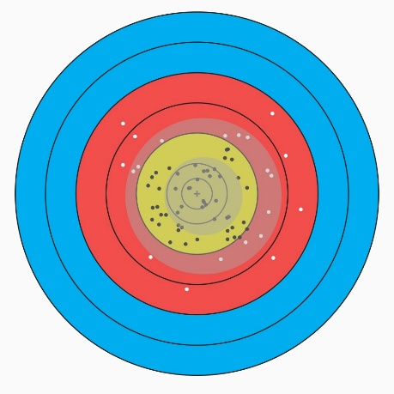
Figure 1: Target Heatmap (Clustering)

Wind Rate: Wind is visualised using a numerical overlay with a vector arrow indication direction. This metric feels disconnected, not demonstrating how the environmental context is impacting the archers physical movement and how it could be relating and contributing to the archers bow_angle_error at the moment of release. This gives the viewer “details-on-demand” [1], however no information regarding the effect of this variable and how it “relates” [1] to the result.
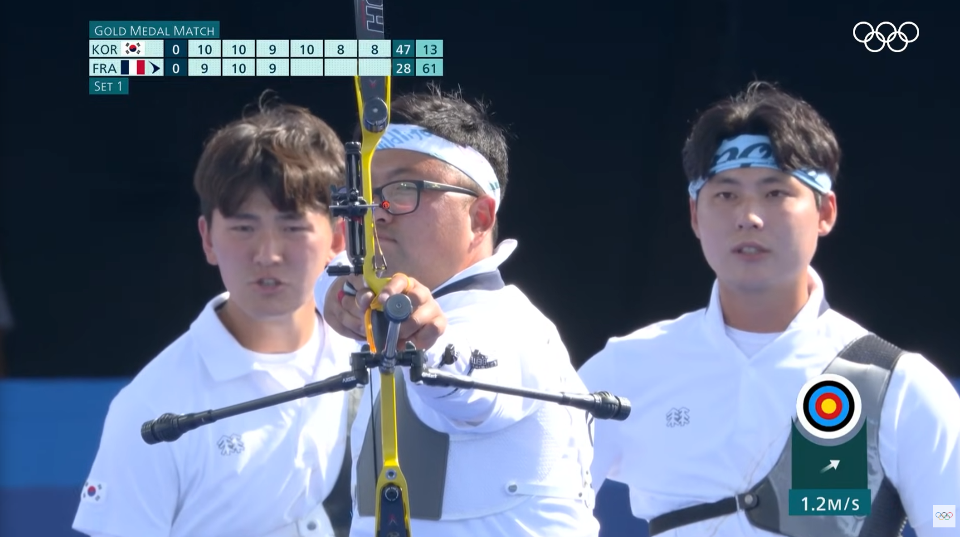
Figure 2: Wind Indicator, Olympic Broadcast (Lower Right)
Arrow Flight Visualisations: Broadcasts use “tracer” technology to render the path taken by an arrow from bow to target. This provides a visualisation of the shot trajectory following Schneiderman’s taxonomy [1]:
- Temporal: The tracer line visualises the flight as a sequence of points plotted over time.
- 3-Dimensional: The flight is mapped through 3-Dimensional (X, Y, Z) space, representing the arrows location relative to the archer and the target during the flight.

Biometric Factors: Broadcasts sometimes display the archers heart rate during the shot process. This is often limited to “high-pressure” situations such as Finals Head-To-Head matches or One Arrow Shoot-offs. Instead, this variable is used to provide “dramatic effect” for TV broadcasts, rather than as a performance metric.

“We want to give the spectator on television the feeling of stress,” said World Archery secretary general Tom Dielen early this week in Japan.” [4]

During the 2021 Tokyo Olympics, World Archery debuted the heart rate graphics [4], using high-frame-rate cameras to identify changes in the shape and colour of the athlete’s face to determine how fast their heart is beating.
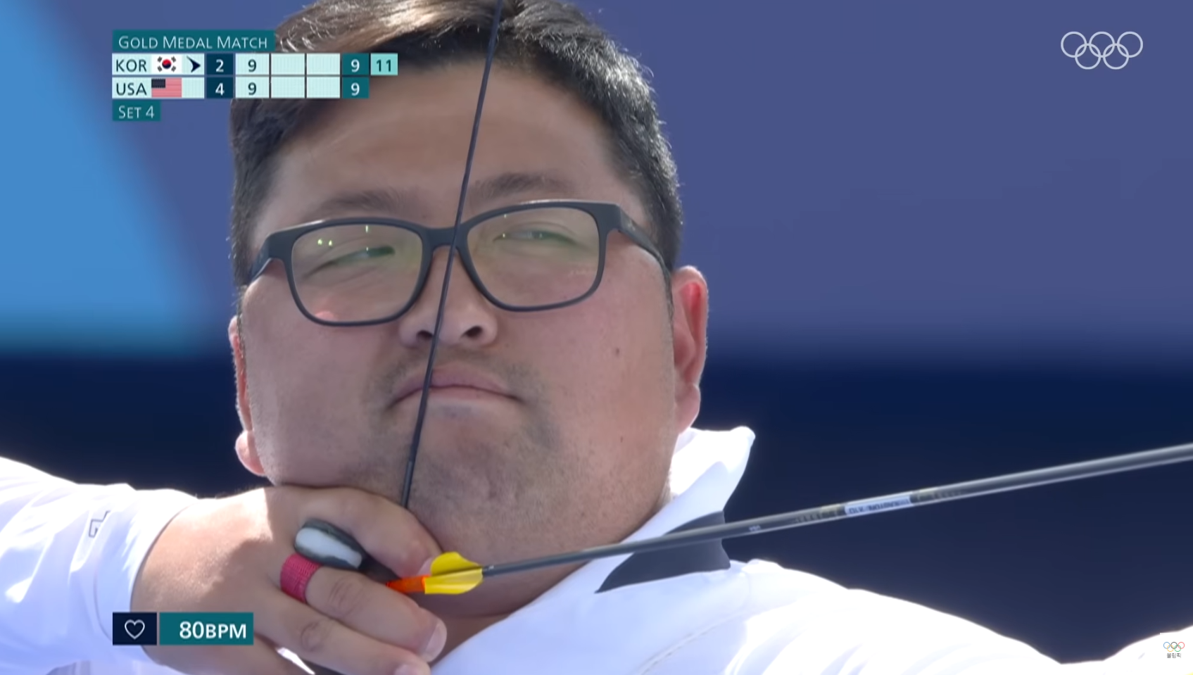
Figure 3: Heart Rate Indicator, Olympic Broadcast (Lower Left)

“London 2012 Olympic Champion Oh Jin Hyek had one of the lowest heart rates of any archer to enter the arena through his first match in Tokyo, averaging in the cool mid-80s.
But during his shoot-off arrow against India's Atanu Das in the second round, which would ultimately eliminate Oh from the competition, it peaked at 143 beats per minute.” [4]

Athletes were given the choice as to whether or not their heart rates were measured and displayed on the broadcast during their matches, but the metrics were not displayed at the live venue to avoid influencing other variables such as the athletes stress-level.
  - Visualisations in Other Shooting Sports
Stability Traces: In rifle shooting, they use a trace of the barrels movement overlayed on the target. This visualises two of Shneidermann’s data types, detailing the temporal and multi-dimensional aspects of the shot process to showcase the aiming, firing and follow through phases of the shot process. Like with the archery visualisation, there is little to no relation [1] to external variables, such as the stress level or wind rate, both of which may have an influence on an athletes holding pattern. It provides an overview [1] of the athletes stability, which is missing from the 2D Heatmap clusters which instead focus purely on outcome.
  - Visualisation in Cricket and Tennis
The Hawk-Eye system [2] is used to provide real-time data visualisations by using multi-camera triangulation to track objects in 3-Dimensional (X, Y, Z) space. A core feature of this system is it’s ability to use ballistics calculations to predict a trajectory and render a “ghost” path, providing “Details on Demand” [1].
The Hawk-Eye Biomechanics system [3] shifts from tracking objects to tracking human movements, relating [1] the kinematic chain of the athletes movements to the resulting output, such as the ball-speed or trajectory.
- Identification of Gaps
By comparing the limitations and gaps identified with archery visualisation methods with the current visualisation methods used by the sports researched, the following improvements could be implemented:
  - Biometric-Kinematics Relation
Physiological data like heart rate is used as an isolated variable used only for dramatic effect during the broadcast, with a failure to relate [1] this data to physical state at the moment of release. Using the heart_rate and stress_level variables, I can map an archers physiological state with their physical output state. This provides a snapshot, allowing the identification of correlations, for example demonstrating that a specific posture_error was coincident with a higher stress_level or heart_rate value.
  - Environmental-Error Relation
Arrow trajectory “tracers” render historical data, showing where an arrow was located but not why it followed that path. I could map wind_speed against bow_angle_error and posture_error to visualise a predicted “impact zone”, providing “Detail on Demand” [1]. This could be used to compare the impact on score from external environmental factors with the impact derived from the archers physical form.
  - Stability Consistency Plot
By mapping movement_x and movement_y across 10,000 rows, I can visualise the archers stability across a large range of shots. Filtering [1] the data across features experience_years or skill_level will provide a comparison of the tightness of groups between beginners and skilled archers. Variable importance could be carried out to evaluate the impact of each feature on the final score result.
- Prototype
- Evaluation
- References
[1] Shneiderman, B. (1996). The eyes have it: a task by data type taxonomy for information visualizations, Proceedings of IEEE Workshop on Visual Languages, IEEE Computer Society Press: Washington. 336-343.
[2] Hawkeyeinnovations.com. (2024). Hawk-Eye | Insights. [online] Available at: https://www.hawkeyeinnovations.com/insights.
[3] Hawkeyeinnovations.com. (2025). Hawkeye | Biomechanics. [online] Available at: https://www.hawkeyeinnovations.com/biomechanics.
[4] World Archery. (2021). Archery debuts heart-rate graphics on broadcast of the Olympic Games. [online] Available at: https://www.worldarchery.sport/news/200395/archery-debuts-heart-rate-graphics-broadcast-olympic-games.

