You have been provided with data from the UK Annual Population Survey from January 2019 to December 2024 in two separate csv files. The UK government wants to understand how the COVID-19 pandemic has impacted employment patterns and regional economies.
To do this you need to use a range of big data analysis techniques. The report should contain commentary on the results of each of the analysis techniques you apply to the data and your final insights and recommendations, with justification.
Your report should include how the data has been pre-processed, at least three different methods for exploratory analysis and at least two methods for predictive modelling, where you need to comment on the suitability and accuracy of each of the methods.
The length of the report should be 3500 words (+/-10%). Include a word count immediately after your report title - *a penalty of 5 marks will be applied for omitting the word count*. Reports exceeding the maximum word length will be penalised. Your reference list is not included in the word count. If you produce appendices, these are not included in the word count.
- Literature review (10 Marks, 500 words)
- Overview of the methods used in report (10 Marks, 500 words)
- Pre-processing of the data (10 Marks, 500 words)
- Application of the methods (20 Marks, 1000 words)
- Results (10 Marks, 500 words)
- Conclusion (5 Marks, 250 words)
- Reference list (5 Marks, 250 words?)
3500 / (10+10+10+20+10+5+5) = ~50 words per mark

COMP3008 CW2 Report

Word Count
Word Count: TODO

Literature Review

Overview of Methods Used
To investigate the impacts of the COVID-19 pandemic on employment patterns and regional economies, this report applied a combination of Exploratory Data Analysis (EDA) methods and Predictive Modelling techniques, using the UK Annual Population Survey covering 2019 to 2024.
The combination of these methods allowed the economic disruption to be analysed, and an estimation of which demographic and employment features most effect the outcomes.

Exploratory Data Analysis (EDA) Methods

Correlation Heatmap

Time-Series Analysis

Regional Comparative Analysis

Pre-Processing of the Data
Before exploratory analysis and predictive analysis could be undertaken, a pre-processing phase was required to orchestrate the unification of the two dataset files, combining the data from January 2019 to December 2021 with the data from January 2022 to December 2024. This stage was necessary to ensure naming consistency between the two files and prepare variables for analysis.
The first stage of pre-processing involved understanding the structure and content of the data present. This was done through the use of the provided Data Dictionary files, through the inspections of the shape and columns dataframe attributes, as well as head() and describe() methods. This informed me that the two datasets had different shapes; the 2019-2021 dataset has 526 columns and the 2022-2024 dataset has 473 columns, indicating structural differences between the datasets and suggesting that some variables are unique to one file, or have different names between the files.
Additionally, differences in variable naming conventions were found, notably the FILEYEAR column, found in the early-pandemic dataset as a lower-case fileyear. The resolution for this was to first cast all column names of each dataset to upper-case before concatenations using Pandas operations, providing the consistency required.
The Population Survey dataset uses negative-float values to represent missing data (-9.0 representing Does not apply, -8.0 representing No answer). Retaining these values into the exploratory analysis and predictive modelling stages would skew analysis results and correlations. Therefore, the codes were handled prior to reaching this stage by replacing coded values with null NaN values, which will be ignored by statistical methods.
df_combined.replace([ -8.0, -9.0 ], np.nan, inplace=True)
To support time-series analysis, new temporal variables were created. Two new features were derived as a single timestamp feature was not present.
- The QUARTER_PERIOD variable would be used to provide a high-level view of trends, with survey noise being smoothed out, and economic shifts over the pandemic, aligning with the standard fiscal-year reporting cycles.
- The MONTHLY_PERIOD variable could be used to provide a higher resolution, with the aim of identifying any “shocks” and showcasing higher levels of economic volatility during this timeframe.
The merged dataframe was sorted chronologically using the MONTHLY_PERIOD variable as the key. By using this variable to sort, the QUARTER_PERIOD would also be inherently sorted due to co-linearity.
df_combined = df_combined.sort_values("MONTHLY_PERIOD")
The final stage of pre-processing involved “feature bridging”. This involved unifying the HIQUL15D feature from the early-pandemic data set with the HIQUL22D feature of the late-pandemic dataset. These variables represent the survey respondent’s highest level of education qualification. The step created the HIQUL_Unified feature, providing continuity across the full pandemic period covered by the datasets.
The dataset was now combined, standardised and ordered chronologically, allowing for exploratory data analysis and predictive modelling to follow.

Application and Analysis of the Methods

Exploratory Data Analysis (EDA) Methods

Correlation Heatmap
The first EDA method conducted was Correlation Analysis, visualised using a heatmap. The heatmap was used to examine the relationship between selected variables measured by the survey. A strong correlation can be an indicator of co-linearity, informing feature selection decisions as to what variables can be removed as part of dimensionality reduction and Principal Component Analysis (PCA) methods. Reducing the amount of data being included in the analysis, whilst keeping the most information that can be found within, improves the efficiency and stability of the statistical models.
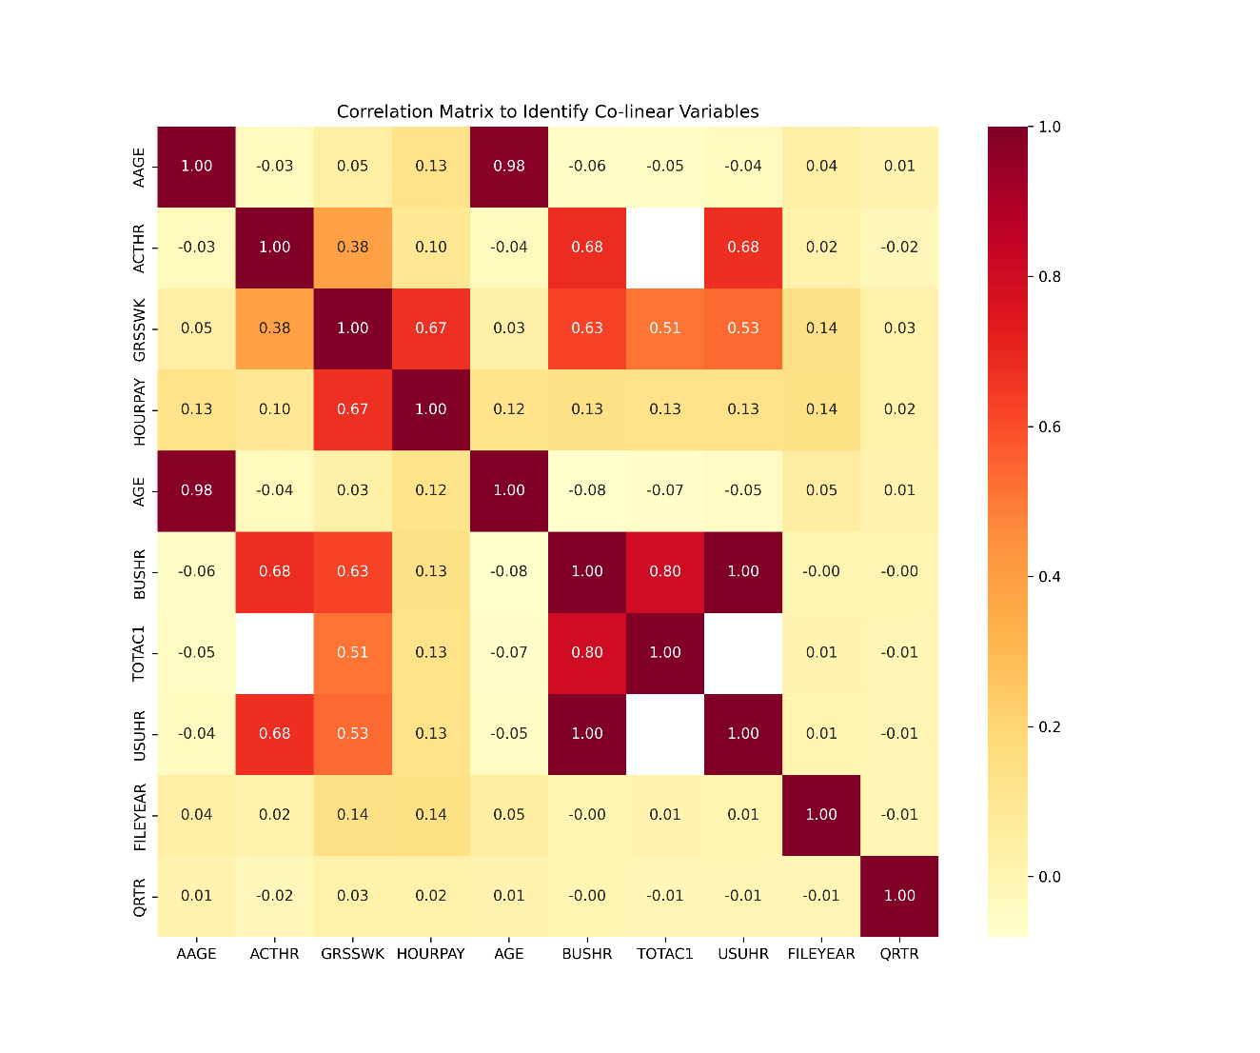

The strongest correlations were found between:
- BUSHR (Basic usual hours) and USUHR (Usual hours excluding overtime) [1.00]
- AGE (Age of respondent) and AAGE (Age Bands) [0.98]
- BUSHR (Basic usual hours) and TOTAC1 (Total actual hours worked no overtime) [0.80]
- ACTHR (Actual hours excluding overtime) and BUSHR (Basic usual hours) [0.68]
- ACTHR Actual hours excluding overtime () and USUHR (Usual hours excluding overtime) [0.68]
- GRSSWK (Gross weekly pay in main job) and HOURPAY (Gross hourly pay) [0.67]
This demonstrates data redundancy, showing a perfect relationship between BUSHR and USUHR, indicating that both variables are capturing the same information and that one could be removed during feature selection to reduce the computational complexity of the models. The same can be said about the relationship between AGE and AAGE, as AAGE is directly derived from the AGE variable.
The BUSHR-TOTAC1 [0.80] relationship shows that usual contracted hours were had a very strong positive relationship (Evans, 1996) with the actual hours worked, although as the relationship is not perfect there is some indication of variation. ACTHR displayed a strong positive relationship (Evans, 1996) with BUSHR/USUHR [0.68], suggesting a varied influence between normal working schedules and actual hours worked. This possibly indicates changes due to reduced working hours or flexible working arrangements derived from the pandemic.

Time-Series Analysis
A Time-Series Analysis using the ACTHR (Actual hours worked) and GRSSWK (Gross Weekly Pay) variables was used to evaluate the impact of the COVID-19 pandemic throughout the period covered by the survey data.
Data was first grouped into quarterly periods to smooth out monthly volatility, instead opting to focus on long-term trends.
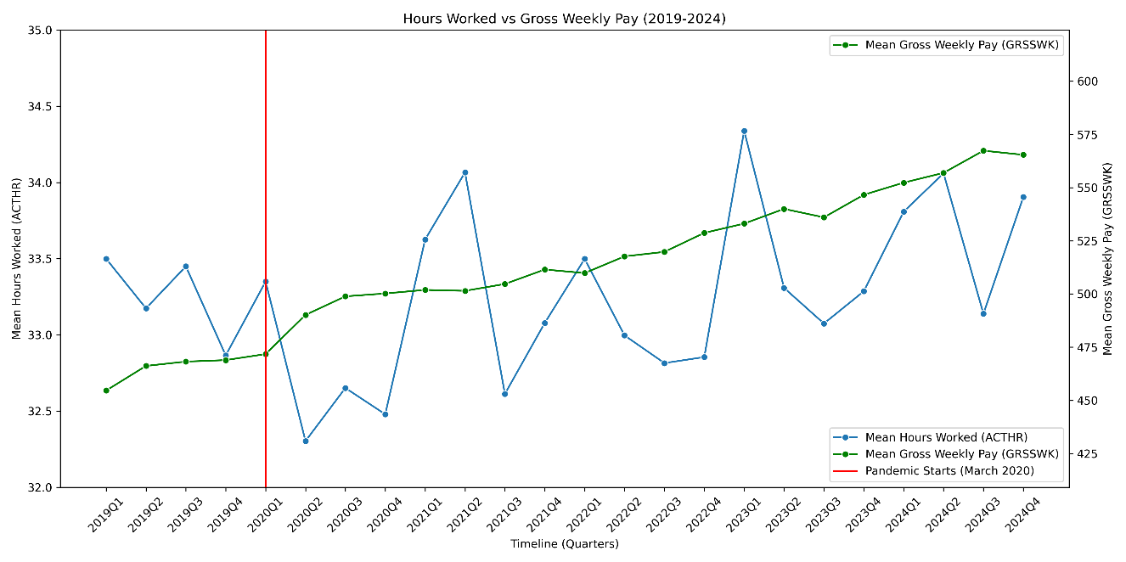
The dual-axis graph shows that there was a sudden decrease in hours worked at the start of the pandemic when the first lockdown was announced. Despite this, gross weekly earnings appear to be independent from hours worked, instead maintaining a steady increase throughout the pandemic. This indicates that the economy may have been protected by government schemes during this period, like the furlough job retention scheme, preventing an economic collapse.
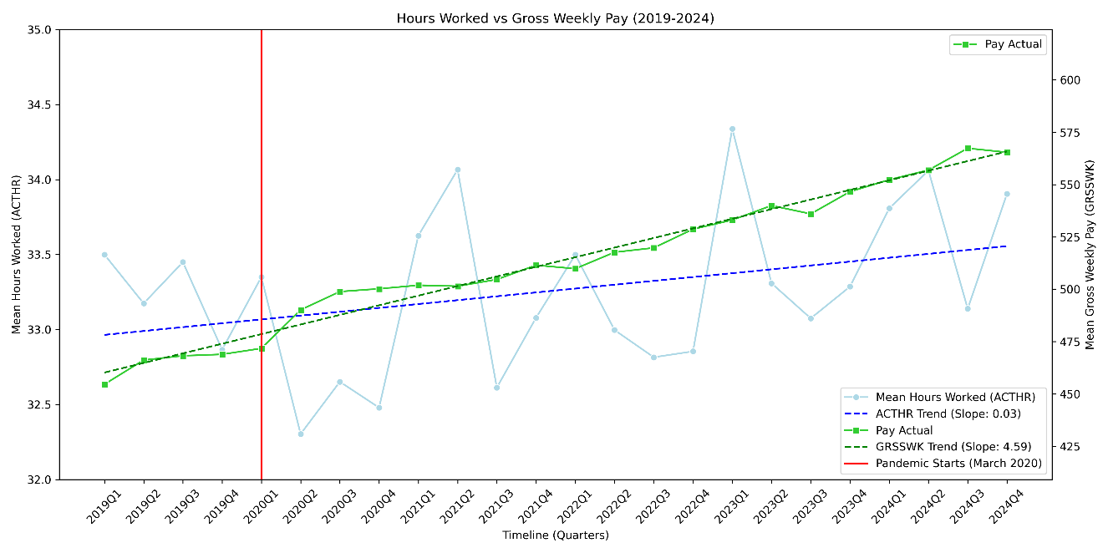
Regression lines were calculated and added to the visualisation. ACTHR produced a slope of +0.03 (hours per quarter), showing how over the entire period there was little impact on the hours worked which remain close to the 2019 baseline GRSSWK showed a slope of +4.59 (£ per quarter). Whilst this initially seems disproportionate compared to ACTHR, it is important to note that these values are measured using different units.
To provide a comparison of growth between hours worked and gross weekly pay, the values must first be normalised.
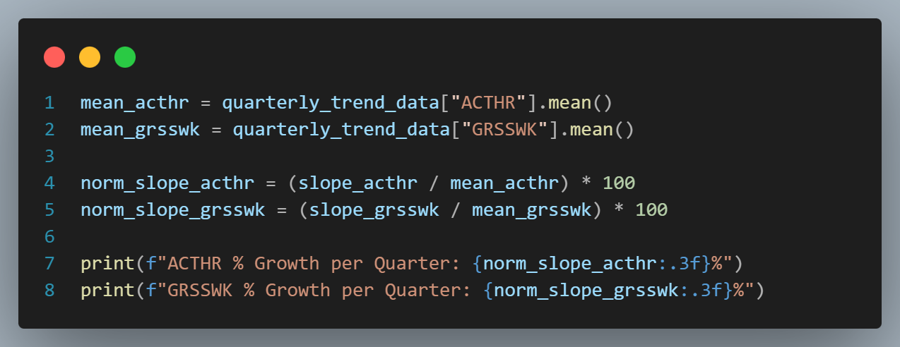

The results here show 0.077% increase per quarter in hours worked, and a 0.895% increase in gross weekly pay, showing that earnings increased by ~11.6x above work hours. It cannot be determined if this increase was a result of pandemic recovery efforts or nominal growth driven by increasing inflation.
The Time-Series Analysis allowed the identification of event-driven impacts, showcasing temporal trends and allowing the visualisation of evidence of recovery efforts.

Regional Comparative Analysis
To evaluate regional differences in the impact of the pandemic, I first had to create custom maps which were applied on the COUNTRY feature, reconciling a difference in regional granularity by combining the data points from Scotland and Scotland North of Caledonian Canal. This preprocessing step was required due to the volatility of the Scotland North data due to its lower sample size.
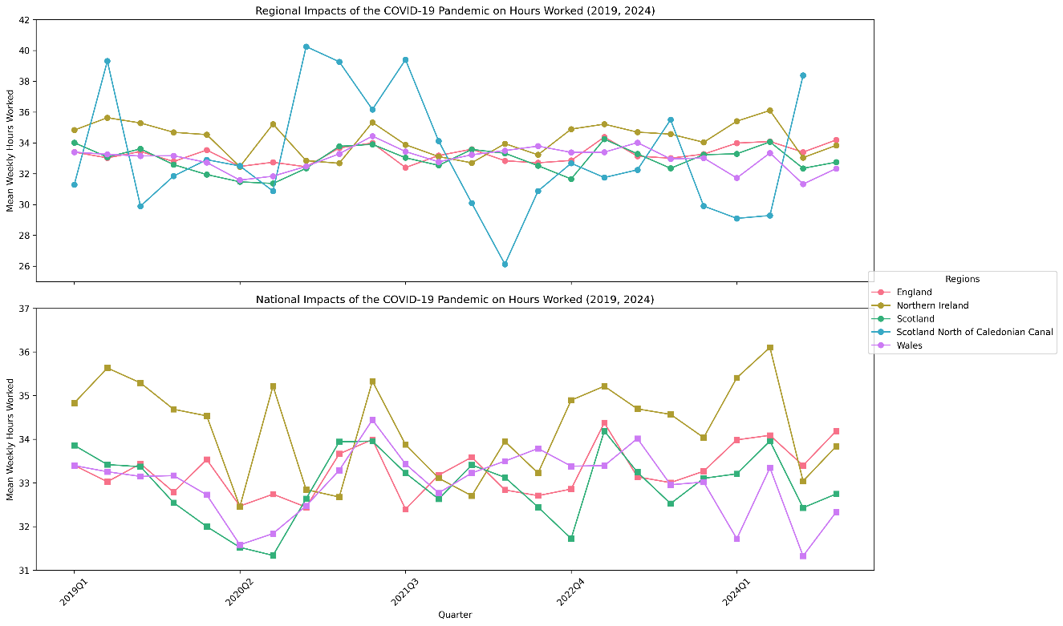

The combination of sub-regions prevented volatile data from skewing the national-level averages, more accurately depicting the national recovery rates.
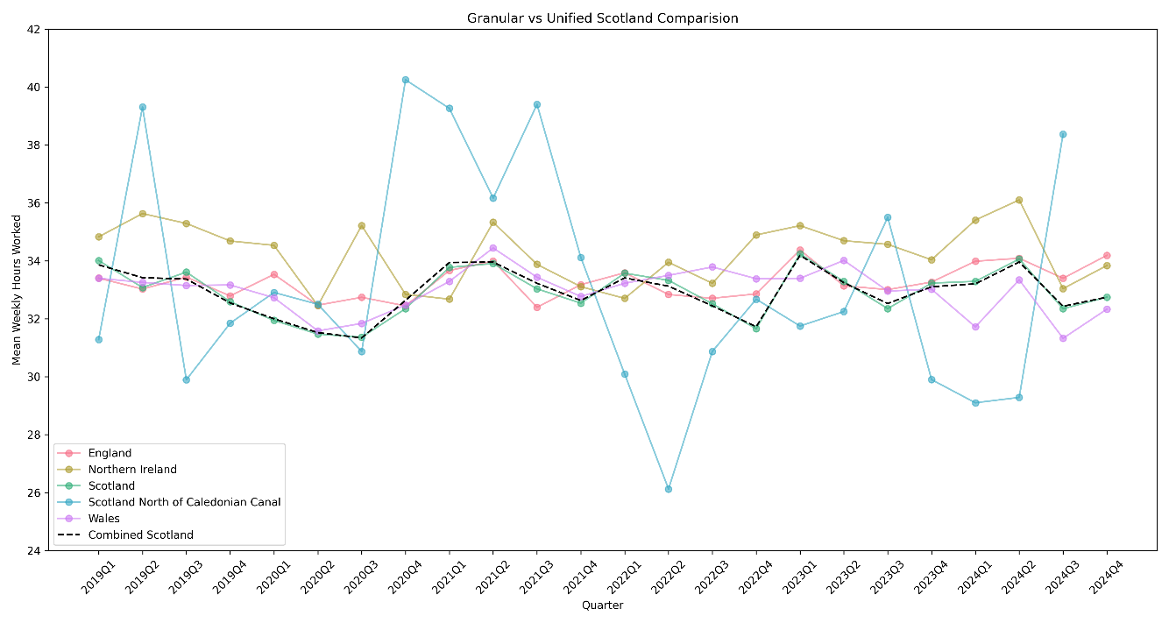

Results

Conclusion

References
Evans, J. D. (1996). Straightforward statistics for the behavioral sciences. Thomson Brooks/Cole Publishing Co.

