An Antidote to Corrupt Collaboration: When Partner Choices and Social Environments Do More Harm Than Good

Sebastian Simon1

1 Social, Economic, and Organizational Psychology, Leiden University

March 2020

Abstract

Social norms guide human behavior and are generally considered desirable to follow. However, people often violate norms giving rise to corruption at the expense of others. Here we show that the relationship between partner choice and rule following is modulated by social environments over time. We conducted a group experiment drawing on a series of game-theoretic tasks. Participants (n = 196) could increase their payoff by the number of partners they chose and the decisions their partners made. Results reveal that rule-following behavior exacerbated from exposure to the first environment to the second. As such, starting out in a prosocial environment enforced norms of prosociality later on. As leaders of all kinds are responsible for top-bottom decisions, people close to these leaders are responsible for their interactions with them. Given our findings, we conclude that to reduce corrupt collaboration people should take responsibility for initiating normatively prosocial contact with others.

*Keywords:* Rule-following, partner choice, social environment, norms

An Antidote to Corruption: When Social Environments and Partner Choices Do More Harm Than Good

Social norms are rules and standards that guide complex behaviors in groups (Cialdini, 2001; Pepitone, 1976) and are unique to humans (Fehr & Fischbacher, 2003; Fehr & Rockenbach, 2004; Gintis, 2003; Ostrom, 2000; Sethi & Somanathan, 1996; Tomasello & Rakoczy, 2003). Importantly, abiding by social norms is generally considered desirable as doing so is associated with good character (Freud, 1977; Hoffman, 1977) and such good character, in turn, helps to build and maintain functioning societies. For instance, policymakers and legislators define guidelines and rules, and individuals who follow such rules then signal moral character and trustworthiness to others (Baumard, Osiurak, Lesourd, & Le Gall, 2014; Everett, Pizarro, & Crockett, 2016; Freud, 1977; Hoffman, 1977). Undoubtedly, trust is key to mutual relationships and social norms are therefore vital for a society to function day in, day out.

Yet, people often choose to violate norms (Köbis, Prooijen, Righetti, & Van Lange, 2016) and engage in corrupt collaboration (Weisel & Shalvi, 2015) such as bribery (Rose-Ackerman & Palifka, 2016), trafficking (Nieto, 2012), crime and fraud (Ades & Tella, 1996) among many others. For instance, Mexico has been the center of drug violence, the killing of thousands of people, and exposing its Mexican society to torture and impunity (Nieto, 2012). Also, the terrorist organization Islamic State in Iraq and Syria (ISIS) caused numerous organized terrorist attacks across Europe over recent years (Farwell, 2014) causing damage and threats of instability to numerous societies. Corruption can, therefore, be fatal for the functioning of societies with consequences such as hindered economic growth (Mauro, 1995) as well as undermined legitimacy and capacity of governments (Rothstein, 2011) being only two of the many downstream effects. We, thus, need to determine under which circumstances people decide to either abide by or break rules.

Trust is a building block of relationships and is vital in determining who a good interaction partner is. People perform costly behavior, such as rule-following, to demonstrate to others that they are moral (Abele & Wojciszke, 2014; Baumard et al., 2014; Cottrell, Neuberg, & Li, 2007; Landy, Piazza, & Goodwin, 2016; Landy & Uhlmann, 2018; Peeters, 1992; Wojciszke, Abele, & Baryla, 2009) and trustworthy (Jordan, Hoffman, Nowak, & Rand, 2016). For instance, companies in the free market like Fairtrade and Tony’s Chocolonely use logos with moral appeals to signal their trustworthiness to others, all of which aim to attract potential partner organizations and customers. Additionally, companies do not often function in isolation; rather in a market with competitors and partners, and it is this competition that can make both companies and individuals both more cooperative and trustworthy. Barclay & Willer (2006), for instance, found that when people have the opportunity to be selected as a partner and benefit from this interaction, people competed against each other in an attempt to signal their superior generosity to selectors and, thus, show that they were better interaction partners than their competitors. Biological markets and the arising partner selection pressures can thus facilitate cooperation mediated by environment-dependent trustworthiness.

Previous research highlighted the importance of morality in rule-following behavior where three dimensions predict behavioral intentions. First, people like to think of themselves as moral beings (Abeler, Becker, & Falk, 2014; Abeler, Nosenzo, & Raymond, 2019; Jordan, Mullen, & Murnighan, 2011; Mazar, Amir, & Ariely, 2008). They care about what others think of them (Gausel & Leach, 2011; Lacetera & Macis, 2010; Utikal & Fischbacher, 2013), and, therefore, when people expect to depend on others, they predict others’ moral intentions (Cottrell et al., 2007; Landy et al., 2016; Landy & Uhlmann, 2018; Peeters, 1992; Wojciszke et al., 2009) and favor cues of trustworthiness and cooperativeness among other less important ones such as sincerity and honesty (Anderson, 1968). Second, people expect others to turn their behavioral intentions into actual behavior and predict how likely others will do so by how competent (i.e., the ability achieve goals; (Fiske, Xu, Cuddy, & Glick, 1999)) and, third, how sociable (i.e., the ease to recruit allies; Brambilla, Rusconi, Sacchi, & Cherubini (2011); Goodwin (2015)) they perceive them to be. For instance, those who are both highly competent and outgoing will be more successful in pursuing their intentions than those who are less skillful and introverted, and all these dimensions together shape how people perceive each other and, ultimately, signal who a ‘good’ interaction partner is.

The effects of partner selection have mainly been investigated in cooperation environments using economic games. In these games, providing people with the freedom to seek out trustworthy partners and abandon free-riders has been shown to develop and safeguard cooperation ([gross]; Efferson, Roca, Vogt, & Helbing, 2016; Rand, Arbesman, & Christakis, 2011), therefore making cooperation more lucrative in the long run than defection. For instance, in hunter-gatherer networks, those who share their spoils form more profitable relationships than those who do not (Gurven, Allen-Arave, Hill, & Hurtado, 2000) where choosing who to share with creates selection asymmetries. Also, the European Union (EU) and the United Nations (UN) represent international alliances where nations collaborate. However, which countries are chosen to join the EU, depends on how able and inclined these countries are to benefit the EU (André & Baumard, 2011; Barclay, 2013; Baumard, André, & Sperber, 2013) where benefits can take on the form of resources, overall wealth, mutual gains, and talents (Hirschman, 1987; Montesquieu, 1951). Those who join forces with others can achieve goals quicker than those who do not.

# How and When People Follow Rules

Societies require individuals to be productive and combine their efforts to benefit the whole. That being said, rules are part of our everyday lives that glue our efforts together and are therefore injunctive social norms (i.e., what should be done). Behavior resulting from such norms is called rule-following behavior, where following rules is generally considered desirable. For instance, policymakers may establish new policies and lawyers enforce the law. Failing to follow these rules entails various forms of juridical punishment. There are less explicit social norms as well such as holding the door open for another person, maximizing the distance to others when being in a public restroom, or being silent in the elevator. Failing to adhere to these norms entails social kinds of punishment. Violating such norms then signal descriptive norms (i.e., what is commonly done) that are incompatible with established injunctive norms (Cialdini, 2001). Surely, societies aim to minimize discrepancies between injunctive and descriptive norms for the sake of certain behavioral outcomes. But in doing so we, as a society, have to know what determines this discrepancy and its consequences.

Following rules, however, is not inherently good as doing so can entail both positive and negative consequences. On an individual level, following rules is associated with moral development or character (Smith, 1759) and moral characteristics such as honesty and trustworthiness, in turn, have a stronger social influence than immoral characteristics (Gross & De Dreu, 2012) for good reasons: morality fuels individuals’ basic needs of structure and predictability of an individual (Merwin et al., 2010; Szechtman & Woody, 2004). On a group level, rule followers are typically perceived as more trustworthy, helping them to be included rather than excluded from societies (Tyler, 1997). In some cases, however, individuals show more goodwill than necessary because they want to appear trustworthy. This may leave them prone to others exploiting them (Jordan et al., 2016) and reveals the flip side of morality.

Individuals and even entire groups often behave immorally and violate rules. For instance, Weisel & Shalvi (2015), have shown that people collaboratively corrupt as a group in a die-rolling game rather than when being alone, with the proportion of reported doubles being 489% higher than the proportion when assuming honesty. Corrupt collaboration like this is commonly seen as rather short-lived but real-life examples show that it can persist for much longer. For instance, Mexico is just one of the many countries that allow political, economic, and social corruption to thrive on a daily basis for more than half a century (Brophy, 2008; Lessing, 2012; Nieto, 2012). Yet, only a few people benefit from corruption given that benefits come at the cost of societies (Gross, Leib, Offerman, & Shalvi, 2018; Weisel & Shalvi, 2015). In Europe, for instance, the terrorist organization Islamic State in Iraq and Syria (ISIS) caused numerous organized attacks over the recent years (Farwell, 2014) in an attempt to raise awareness and shift societies towards the Islamic culture. These are only two examples of the outcomes that corrupt collaboration can cause. We, therefore, have to understand what the causes of corruption are.

# When Partner Choice Determines Rule-Following Behavior

Humans are social animals. They interact in groups and depend on each other. In most settings, however, relational asymmetries are present. Some people, for instance, can choose who to share their resources with to eventually harvest mutual benefits (Fehr & Fischbacher, 2003; Gurven et al., 2000; Trivers, 1971) while others cannot. Also, people want to protect their resources (Williams, 2014) and therefore choose their interaction partners carefully. Potential partners thus have to prove that they are worth an investment (Milinski, Semmann, & Krambeck, 2002). For instance, banks lend money to clients according to predefined criteria and ask for securities, bonds, or other protection instruments to cover their potential exposure. But how do people classify others as good interaction partners when choosing one person over another? And what enables people to choose others in the first place?

People interact with each other and trade goods. This is the concept of a biological market (Noë & Hammerstein, 1995) and when one person has more of a valued resource than another person, that person is in a position of power (French, Raven, & Cartwright, 1959), enabling the person with more of that resource to choose whom to share it with. For instance, Saudi Arabia is on the top in the list of all oil producers worldwide with roughly 9.87 million barrels of oil being produced every day. Therefore, the state enjoys a favorable position for choosing its business partners in trading the resource. Specifically, Saudi Arabia developed a reputation for being the “central bank of oil” with stable and low prices (Hordern, Martin, & Ratcliffe, 2020). But what characterizes the best interaction partner when faced with multiple potential partners?

People prefer some characteristics more than others when evaluating who to interact with and, in general, people seek interaction partners who are most willing, able, and available to benefit others (Barclay, 2016). In the cooperation literature, however, mainly minimal group paradigms are applied, group settings where no social cues are present, so people have to rely on social proxies. Specifically, signaling theory explains how people cooperate without immediate social cues and poses that unrelated members of a group cooperate because they signal their trustworthiness by performing costly behavior (Fehr & Gächter, 2002; Gintis, Smith, & Bowles, 2001). So, in settings without social cues, people seek to understand who plays by the rules in a group. For instance, people have been shown to highly value trustworthiness in others (Cottrell et al., 2007) where others’ morality moderates social judgments (Cottrell et al., 2007; Landy et al., 2016; Landy & Uhlmann, 2018; Peeters, 1992; Wojciszke et al., 2009). But how do people signal their trustworthiness when they have to compete with others for valued resources?

Interestingly, when competition is high, people engage in highly cooperative behavior for the sake of future gains. Barclay & Willer (2006), for instance, found that when people have the opportunity to be selected as a partner and benefit from this interaction, people competed against each other in an attempt to signal their superior generosity to selectors and, thus, show that they were better interaction partners than their competitors. Those who chose then preferred those who appeared to make uncalculating and fair decisions. Therefore, the decisions that selectors make depend on reputation concerns of those signaling their reputation. However, trustworthy people do not always follow the rules but break them when conditions are right (Magee, 2009; Mondillon et al., 2005; Robinson & Reis, 1989; Van Kleef, Homan, Finkenauer, Gündemir, & Stamkou, 2011). Simply following the rules is therefore not always the best option. But when exactly are the conditions right?

# What Our Environments Do to Us

Our social environments shape us - be it our family, friends, colleagues at work, or others in public. All around the globe, people influence each other and with united forces, they can reach goals that they otherwise could not. For instance, the Extinction Rebellion, a movement that aims to combat environmental tipping points such as biodiversity loss and climate change, organized demonstrations that led to the disruption of public structures and forced governments to declare climate and ecological emergency in the UK (Mumby, 2019) and the Netherlands (Desaihttps, 2019; Gulsoken, 2019). This example shows that our social environments can enable us to break rules and research has shown that the mere exposure to people who violate norms increase the chance of others violating norms as well (Keizer, Lindenberg, & Steg, 2008) and that people are more likely to violate rules in countries with increasing levels of corruption (Gächter & Schulz, 2016). We thus investigate which environments hinder rule violations, which foster them, and which partners are preferred?

Yet, in other environments, people choose to be corrupt as a collective, also called corrupt collaboration (Weisel & Shalvi, 2015), the moral goals people have (Baumard et al., 2014; Everett et al., 2016) and the context they are in (Melnikoff & Bailey, 2018) determine whether and how people corrupt. An example of such corruption is the Volkswagen scandal from 2005 where the employees of the company manipulated software to pass key emission tests in the face of time and budget limitations (Goodman, 2015). Also, as if corrupt collaboration itself was not enough, corruption breeds corruption. For instance, countries that are plagued by more corruption have been found to have a higher black market premium (Bahmani-Oskooee & Goswami, 2005) and higher inflation rates (Cukierman, Edwards, & Tabellini, 1989), all of which go at the expense of the poor (Gupta, Davoodi, & Alonso-Terme, 1998). As these examples demonstrate, we have to research the determinants that build societies and those that destroy them.

# The Present Experiment

In this experiment, we argue that a) divergent selective pressures of the social environments people are in determine behaviors that signal ‘being a good partner’ and that b) cooperation is not prosocial per se but critically depends on both the social environment and partner choice.

*H1*: Norms of rule-following will establish. Specifically, rule-following scores will increasingly decrease in the corrupt environment but increase in the fair environment over time.

*H2*: The trend of rule-following scores in the environment shown first will anchor the trend in the environment shown second.

*H3*: In the corrupt environment, rule violators will be selected more often. In the fair environment, rule followers will be selected more.

To test these hypotheses, we conducted an experiment with a series of game-theoretic tasks in one experimental session lasting approximately one hour.

# Methods

## Participants and Ethics

Participants were recruited from the subject pool of the Faculty of Social and Behavioral Sciences at Leiden University. Each of the 212 participants consented digitally to take part in one experimental session lasting approximately one hour and were debriefed after the experiment. Due to incomplete data resulting from server overload we had to exclude … . Therefore, the data of 196 participants were used in our analyses. Participants (mean age = 23.06 +/− 4.25, 155 female) were paid €8.69, on average, and reported on incentives such as money (59.69%), credits (25.51%), and science (14.80%). The experimental tasks were programmed using oTree (Chen, Schonger, & Wickens, 2016). Screenshots of the instructions can be found in the Appendices and Supplemental Material. All materials and anonymized data are uploaded to the open science framework (OSF; <https://osf.io/v4rma/>).

## Experimental Design

We conducted an interactive group experiment involving a series of game-theoretic tasks. Figure 1 summarizes both the timeline and the experimental tasks. We used one between-subjects factor (role: selector vs decider) and one within-subjects factor (environment: trust vs dishonesty). In all experimental sessions, four participants were randomly grouped depending on their availability. Over a total of 30 rounds, participants went through a sequence of three stages per round: a rule-following task (stage one), a partner selection task (stage two), and two environments - a dictator game (DG) and a dyadic die-rolling task (DDT). All participants assigned to the decider role had the chance to be exposed to both environments if they were chosen. After the experimental blocks, all participants did the DDT by themselves and filled in the social value orientation (SVO) scale, their demographics, and answered control questions.

## Experimental Setup and Procedure

The currency in the experiment was points. 100 points were worth €1.00. Participants accumulated their points individually in the repeated three stages. Earnings could range from €6.50 to €14.50. Alternatively, participants could both be given 2 SONA credits and get paid out the bonus. If they collected less than 650 points, they were paid the show-up fee of €6.50 or the 2 credits. However, if they collected more than 650 points, all exceeding points were considered their bonus. To calculate the participants’ final payment, two rounds of the total 30 were randomly selected by the computer and participants were informed about this to ensure they treated all rounds equally. The summed total amount of points participants collected in these two rounds plus the points from the last DDT were converted to Euros and paid out to the participants.

[insert Figure 1]

Participants typically arrived separately at the laboratory and were seated in individual cubicles with computers. At the end of the experiment, they were asked to remain seated inside the cubicles and wait for an experimenter to open the door. We informed the participants that the present study was a group experiment in which they would interact with other participants in a group of four in total. They were also told how many of the group members already arrived and how many were still missing in order to make sure they trusted their own decisions having an impact on other real human individuals. Participants were told that the entire experiment was computerized and the consent and debriefing forms were therefore shown on the computers. This study fell under the no-deception policy of Leiden University. So, there were neither hidden information nor deception in the study, and everything was done as stated in the instructions. After completing the comprehension checks, participants went on to the first task.

### Stage one: The rule-following task.

The key variable of interest was rule-following behavior which we measured using the ball-in-the-bucket task [ref]. Participants were presented with 15 balls they could allocate one-by-one to either a blue or a yellow bucket (by clicking with the cursor on the buckets’ respective buttons on the computer screen). Participants were instructed that the rule was to put the balls in the blue bucket (the costly option) even though they had no reason for following the rule and did not face direct consequences if they did not (see Appendix B; Kimbrough & Vostroknutov, 2018).

The rule-following variable was operationalized as a score of the summed number of balls put in the blue bucket per round and could range from 0 to 15. Instructions read that each ball put in the blue bucket would earn them 5 points and that each ball put in the yellow bucket would earn them 15 points. So, choosing to put all balls in the blue bucket earned participants only a third (75 points) of what they could have earned if they put all balls in the yellow bucket (225 points). A counter below the buckets’ buttons showed the amount of money they accumulated (Kimbrough & Vostroknutov, 2016). Also, participants received feedback about the scores of the other group members but to avoid reputation concerns, in all stages, feedback displays were sorted by the highest rule-following imaging score (i.e. the summed number of balls put in the blue bucket; Wedekind & Milinski (2000)) in descending order and the rule-following scores were reset to 0 (Milinski et al., 2002).

### Stage two: Selecting partners.

Participants were randomly assigned to one of two roles: selector or decider. One of the four group members was assigned to the selector role, the other three to the decider role. Selectors skipped the rule-following task. However, in the second stage, selectors had to select at least one of the deciders - but could also choose two or even all three deciders - for the third stage. Selected deciders, or partners, could then increase their total earnings and determine (in part) the selector’s earnings. Partner selection was operationally defined as the binary choice (i.e., selected vs not selected) for each participant per round. To avoid punishment effects, we excluded the possibility to select zero deciders (Fehr & Gächter, 2002).

When selecting participants, selectors received feedback about all deciders’ rule-following scores. In the meantime, deciders had to wait and, along with the selector, were informed that the selector had to spend 150 points for each partner. If deciders got selected, they had to decide about both their own and the selector’s earnings in stage three. Therefore, it was desirable to get selected as partners inevitably earned more than deciders who were not selected. Importantly, partners interacted with the selector only, not with other partners. Feedback about the selector’s decisions including deciders’ rule-following scores and who got selected, was provided to all deciders. We expected participants to learn from the feedback who got selected, who not and adjust their choices in the next round. Partners continued to stage three and remaining deciders waited until the next round.

### Stage three: Two environments.

There were two environments in the third stage: a dictator game (DG) and a dyadic die-rolling task (DDT). Each environment was repeated for 15 rounds and which one was shown first depended on the condition of the group was assigned to and, therefore, the order of the environments was experimentally counterbalanced.

In one environment, participants played a modified DG in which selectors could not punish partners by rejecting a bad offer and, therefore, punishment could not act as a confound. In the DG, the variable of interest was fairness and it was conceptualized as the number of points that partners gave to selectors. Partners were endowed with $500$ points, had to allocate to the selector, and kept $500-x$ for themselves, where $x$ could take a value between $0$ and $250$ in steps of $50$ points. Options were shown in a drop-down menu in which choosing the maximum of $x=250$ resulted in a fair mutual outcome and choosing the minimum of $x=0$ resulted in a selfish outcome. Selectors received feedback about all partners’ allocations along with their rule-following scores from the first stage. Then, the next round started. In this stage, a decider’s utility function was the sum of points kept to themselves, where *d* = payoff from last reported die-roll, and a selector’s utility function was the sum of all partners’ points given to the selector, where $p=partner_{p}$. The mathematical utility functions are therefore as follows:

$$U_{p}(x)=d+\sum_{i=1}^{30}{(}{500}_{i}-x_{i})$$

$$U_{s}(x)=d+\sum_{i=1}^{30}{\sum_{p=1}^{p}{(}}x_{p})$$

In the other environment, partners played a modified version of the commonly used dyadic die-rolling task (Fischbacher & Föllmi-Heusi, 2013; Weisel & Shalvi, 2015; for a meta-analysis, see Abeler et al., 2019). Instead of two participants having to match their responses, only the partners had to report a die-roll. The reported number determined the earnings of both partners and selectors. The variable of interest was dishonesty in the DDT and participants had to be dishonest about their reported die-roll outcomes if they wanted to receive an amount of points for themselves that was relatively high compared to the DG. Both, partners and selectors earned the same amount of points for the reported die roll so that both earned $x$ points. Earnings ranged from $0$ points (for reporting a 1) to $250$ points (for reporting a 6) in steps of $50$ points. For instance, if a partner reported a 4, the partner and selector both earned $150$ points. However, if a partner reported a 5, both earned $200$ points. At the end of every round, selectors received feedback about all partners’ contributions along with their rule-following score from the first stage. Also, all participants received feedback about their earnings at the end of each round. Then, the next round started. When participants reached the end of round 30, they finished the experimental block and continued to final individual-level measures. Earnings of partners were the directly associated with the number they reported; earnings of selectors were the sum of reports of each partner. The utility functions for both partners and selectors thus remain the same as in the DG.

### Final measures.

We measured a few potential individual-level confounds. First, dishonesty could have had an influence on both the deciders’ as well as the selectors’ decisions and similar to the previous dyadic die-roll task, this time, participants did an individual die-roll. However, this time, participants determined their own outcome only, not that of another participant and, hence, the die-roll only increased participants’ own earnings, not the earnings of any other group member. Second, participants’ concerns for others could have affected their decisions and we, therefore, used a 6-item social value orientation (SVO) scale (Murphy, Ackermann, & Handgraaf, 2011), the slider variant with continuous choices. Last, we asked control questions about participants’ motives to participate, previous experiences with similar experiments, knowledge of this experiment before its start, and whether they believed they interacted with real human individuals. All materials can be found in the Supplemental Material. At the end of the experiment, participants were debriefed and informed about their final earnings digitally. They waited for an experimenter to notify them of the end of the experiment (a means of keeping participants’ identity anonymous and reducing any adverse emotions arisen during the experiment), got paid, and were ultimately thanked for their participation.

# Results

There were no missing observations in the data and boxplots revealed neither present outliers nor observations with high leverage. We used R (Version 3.6.1; R Core Team, 2018) and the R-packages *dplyr* (Version 0.8.3; Wickham, François, Henry, & Müller, 2019), *DT* (Version 0.10; Xie, Cheng, & Tan, 2019), *ggplot2* (Version 3.2.1; Wickham, 2016), *gridExtra* (Version 2.3; Auguie, 2017), *knitr* (Version 1.28; Xie, 2015), *lme4* (Bates, Mächler, Bolker, & Walker, 2015), *Matrix* (Version 1.2.17; Bates & Maechler, 2018), *papaja* (Version 0.1.0.9842; Aust & Barth, 2018), *plyr* (Version 1.8.5; Wickham et al., 2019; Wickham, 2011), *viridis* (Version 0.5.1; Garnier, 2018a, 2018b), *viridisLite* (Version 0.3.0; Garnier, 2018b), and *xtable* (Version 1.8.4; Dahl, Scott, Roosen, Magnusson, & Swinton, 2018) for all our analyses. The data is nested in groups and therefore we use multilevel models with restricted maximum likelihood (REML) taking intraclass correlations into account (Gelman & Hill, 2006). We only use random intercepts (Poisson) regression models for analyzing our data. All statistical models are specified in the Supplemental Material. First, we compare the effects of the two environments (dictator game vs the die-rolling task) and their order on rule-following scores, respectively to test … (H1) and … (H2). Then, we will examine whether and how diverging partner choice pressures arise in the two environments (H3).

## Establishing Norms of Rule-Following Behavior

Incentive structures of social environments determine behavior in groups. In a corrupt environment, for instance, people may abandon rules. However, in a fair environment, people may do the opposite and adhere to rules instead. In the long run, such behaviors can turn into norms and in our experiment, we investigated these norms. But will these norms establish over time? And will these norms differ between the environments?

In line with our expectations, rule-following norms were established in both environments as shown in Figure 1. However, to our surprise, rule-following scores generally decreased over time (*b* = -0.03, 95% confidence interval, or CI = [-0.06, -0.00]) and did not change as a function of the environment (*b* = -0.20, 95% CI[-1.11, 0.70]). Instead, the effect of environment depends on the rounds passed by showing that rule-following scores decreased in the corrupt environment over time (*b* = -0.07, 95% CI[-0.12, -0.01]). However, environment and rounds do not interact per se; rather, the interaction depends on the order of environments (first half vs second half). Specifically, both environment and rounds do not interact in the first half (*b* = -0.04, 95% CI[-0.12, -0.04]), only in the second (*b* = -0.08, 95% CI[-0.15, -0.02]). The main effect of rounds on rule-following scores, however, remains consistent regardless the order with the effect being stronger in the first half [1st: ~ round] (*b* = -0.17, 95% CI[-0.22, -0.11]) than the second (*b* = -0.07, 95% CI[-0.12, -0.03]). The order in which environments are presented therefore seems important for examining spill-over effects and resulting anchoring effects.

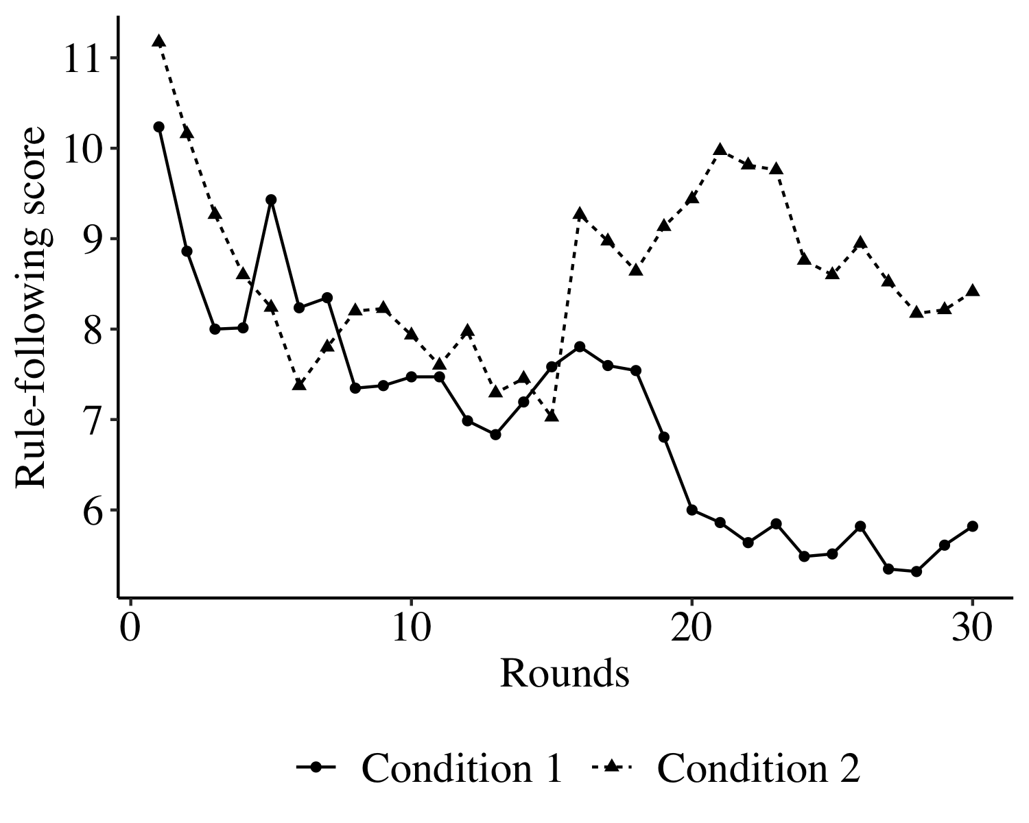 *Figure 1.* Line graph of average rule-following over time. There are two environments (dictator vs die-rolling game) and after 15 rounds, the environments were switched. In condition 1, the die-rolling game was played first, followed by the dictator game. In condition 2, the order was reversed. The graph shows that rule-following generally decreases but that rule-following behavior polarized after transitioning to the second environment.

## Transitioning to Differing Environments

The order of social environments that people find themselves in can introduce spillover effects and shape human behavior. For instance, time trends of rule-following behavior may spill over to another social environment and anchor behavior. If rule-following scores constantly decrease due to a corrupt social environment, for instance, this norm may be carried over to a fair environment in which the opposite behavior may be rewarded (i.e., following rules) and, hence, the opposite norm formed. The norm should then anchor and modify the behavior in the second environment and, over time, render the norm subject to change towards the norm of the current environment. However, do norms of rule-following behavior anchor each other? Or do they exacerbate each other’s properties?

Figure 1 reveals that there were no such expected anchoring effects across conditions and that the spill-over effects of rule-following behavior are more complex than anticipated. However, Figure 1 also shows that rule-following behavior appears to be strongly influenced by the order of environments. More specifically, overall scores were lower in the second half than the first (*b* = -1.83, 95% CI[-2.18, -1.47]) and conditions alone did not show differing rule-following scores. Conditions alone did not differ in rule-following scores (*b* = 0.33, 95% CI[-1.97, 2.63]). Instead, scores were higher in the second half of the second condition - the DG (*b* = 2.51, 95% CI[2.02, 3.01]). This interaction shows that even though there are no anchoring effects per se, merely transitioning from one environment to the next, can evoke differential rule-following behavior between environments. However, rule-following behavior can also be driven by underlying mechanisms of biological markets. Specifically, people may attempt to appear more trustworthy than their competitors for the sake of personal gain.

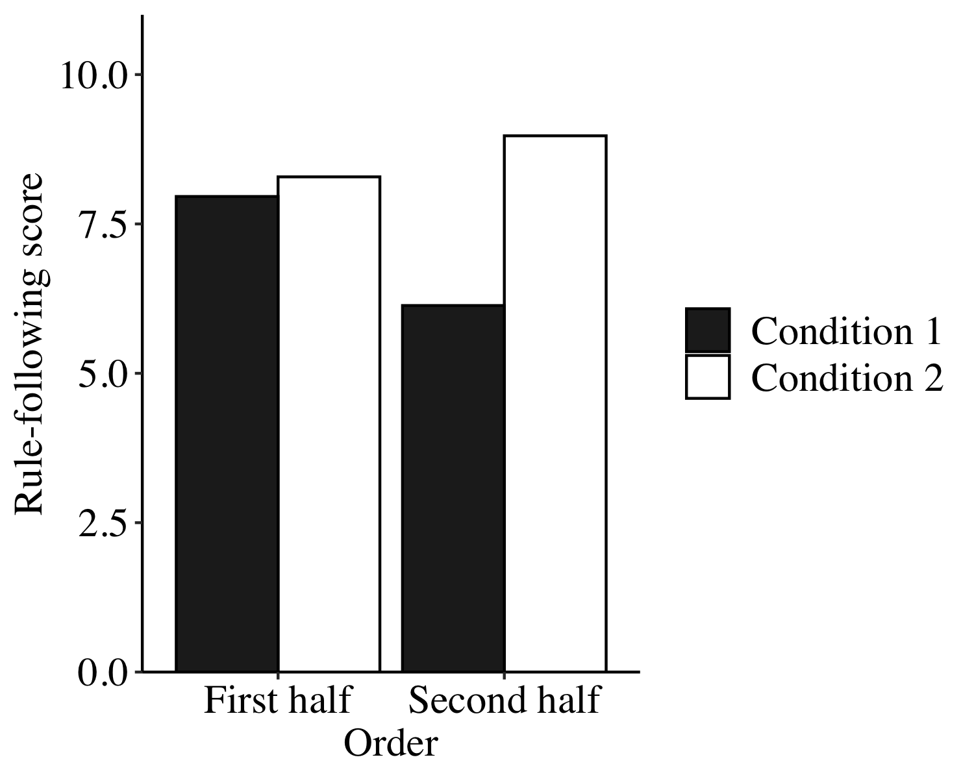 *Figure 2.* Bar graph of rule-following scores by environment and order. Rule-following scores did not differ between conditions (condition 1 = die-rolling game first, condition 2 = dictator game first) but were lower in the second half than the first half. Most importantly, rule-following scores were higher in the second half for condition 2. Hence, while the corrupt environment promoted abandoning rules, the fair environment facilitated following them.

## Choosing the Trustworthy

Biological markets typically make group members subject to selection pressures where being selected is generally more desirable than not being selected due to the potential gains that come with being selected. In addition, the social environment a biological market comes with determines the incentive structure that group members find themselves in and these structures can modify members’ behavioral tendencies. For instance, whereas following rules may be desirable in one environment, doing so may be condemned in another. But how exactly will partner choice influence rule-following behavior? Will people abandon rules for the sake of being selected when they are in a corrupt environment? And will people modify their rule-following behavior over time to get selected?

Figure 3 below shows the partner choice trends that emerged in the two environments over time. People who were selected (61.11%) generally followed rules more often than those who were not (38.89%; *b* = 1.44, 95% CI[0.79, 2.08]) but, by itself, the environments people found themselves in did not modulate whether they would follow or abandon rules (*b* = -0.07, 95% CI[-0.52, 0.38]). Instead and in line with our expectations, partner choice and environment interacted. More specifically, in the corrupt environment, people who were selected (66.12%) as compared to those who were not selected (33.88%) abandoned rules more often (*b* = -2.05, 95% CI[-2.63, -1.47]). In addition, people became less rule-following as experimental rounds progressed (*b* = -0.07, 95% CI[-0.10, -0.05]) but whether participants were selected or not did not make a difference over time (*b* = 0.01, 95% CI[-0.03, 0.04]), indicating that partner choice preferences remained relatively stable over time.

However, the effects of partner choice differed in strength by the order of the environments with the main effect for partner choice being stronger in the second half (64.13% selected; *b* = 2.65, 95% CI[0.66, 4.64]) than the first (58.10% selected; *b* = 1.22, 95% CI[0.29, 2.16]), indicating that selectors discriminated members more after transitioning to the second half. In line with our expectations, the interaction term between partner choice and type of environment can explain the larger CI of the stronger effect. Specifically, in the corrupt environment, selected participants became more rule violating in the first half of the experiment (*b* = -2.45, 95% CI[-3.27, -1.62]) than in the second half (*b* = -0.83, 95% CI[-1.60, -0.06]). Therefore, it appears that in first encounters following rules is the default behavior and does not pose harm to being selected in general but that violating norms in a fair context does. However, when progressing to another environment, these norms are modified so that previous norms blend into currently establishing norms.

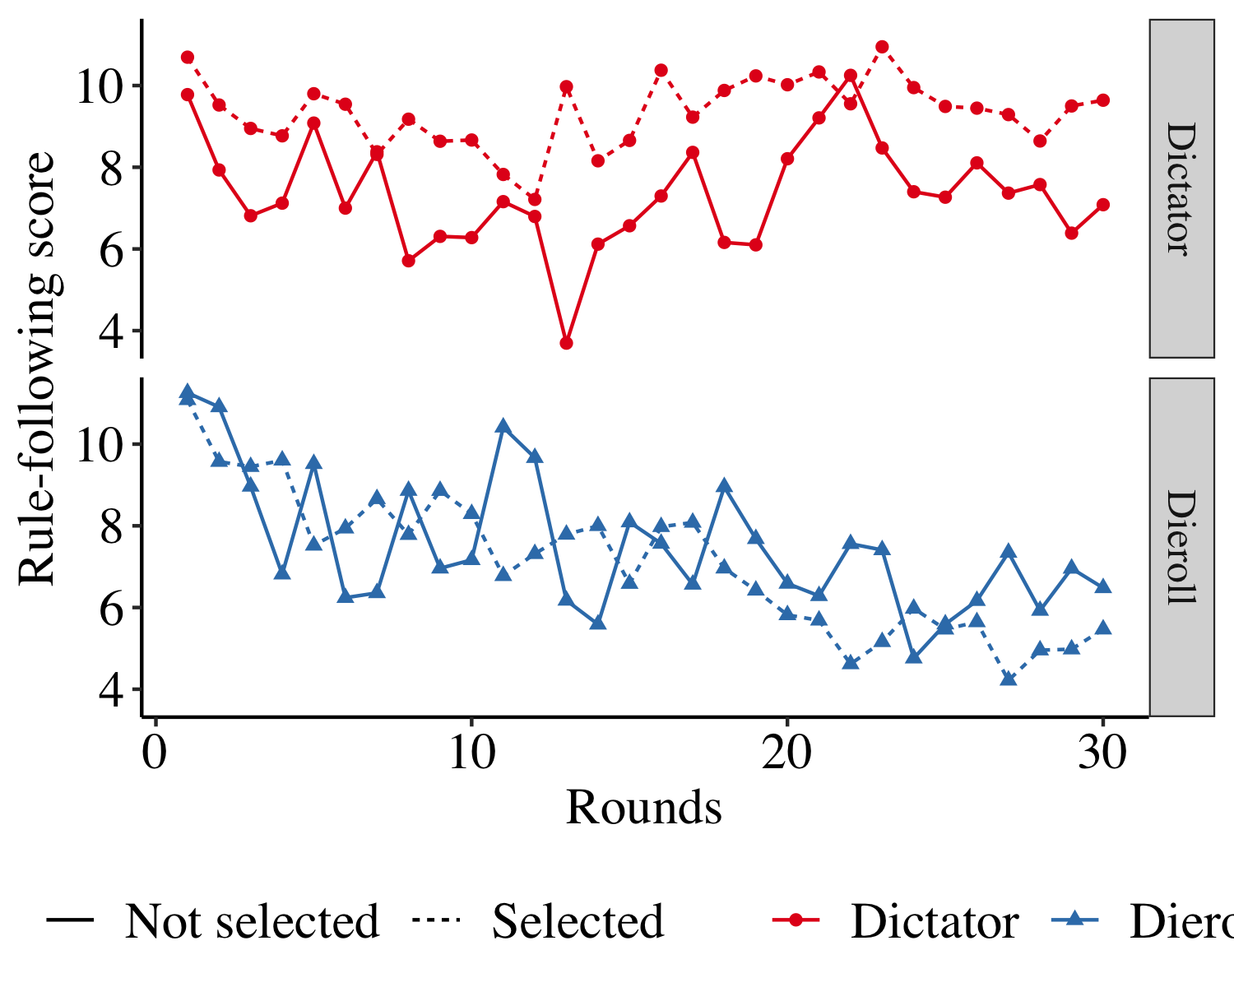 *Figure 3.* Line graphs showing rule-following behavior over time by partner choice and environment. Overall, selectors discriminated rule-following group members from rule-violating members and this distinction was more present across environments with rule-violating members being more selected in the corrupt environment. However, the time passed by did not interact with partner choice indicating that selection preferences remained stable over time. Interestingly, in both environments right before transitioning to the second half, rule-following behavior of not selected members peaks followed by a plummet. So, there may be a lower threshold up to which selectors tolerate rule abidance.

## Who Are the Corrupt, Who the Fair?

The nature of biological markets declares the existence of social hierarchies in which some people can choose interaction partners while others cannot. However, selectors may differ on personality variables which, consequently, influence their decisions. For instance, do selectors perceive themselves to be more fair or more corrupt than those who compete with others to get selected? And if there are differential perceptions, do these perceptions change as the consequence of the environments people find themselves in?

In our experiment, selectors and deciders may have differed in how corrupt they were and in order to assess this, all participants had to report an individual die roll at the end of the experiment, a common measure of corruption [ref]. Selectors and deciders by themselves should theoretically not differ from each other on average because participants were randomly allocated to roles and groups. Rather, differences should emerge as a result of being assigned a particular role. Random intercepts Poisson regression (McElduff, Cortina-Borja, Chan, & Wade, 2010) revealed that selectors and deciders did not significantly differ in their die roll reports (*b* = -0.01, 95% CI[-0.16, 0.15]) indicating that the experimentally assigned roles did not change participants’ cheating behavior.

Furthermore, selectors and deciders may have differed in how fair they perceived themselves to be and these perceptions may have influenced their behavior as there is ample evidence, especially in behavioral economics, showing that prosociality can drive economic decision-making (Jordan et al., 2016; Kimbrough, Miller, & Vostroknutov, 2014; Trivers, 1971). To assess this in our experiment, all participants completed the social value orientation (SVO) scale right after the individual die roll mentioned above. Random intercepts regression revealed that selectors perceived themselves to be more prosocial than did deciders (see Figure 4; *b* = 1.35, 95% CI[0.70, 2.00]) and reciprocal altruism may explain this finding (Trivers, 1971). As biological markets introduce resource asymmetries with selectors being able to confer benefits on the selected. In this context, selectors act as discriminators to counterbalance defectors who would otherwise prevail. Therefore, selectors have to be more prosocial and discriminate justly while deciders cooperate when necessary and defect if possible.

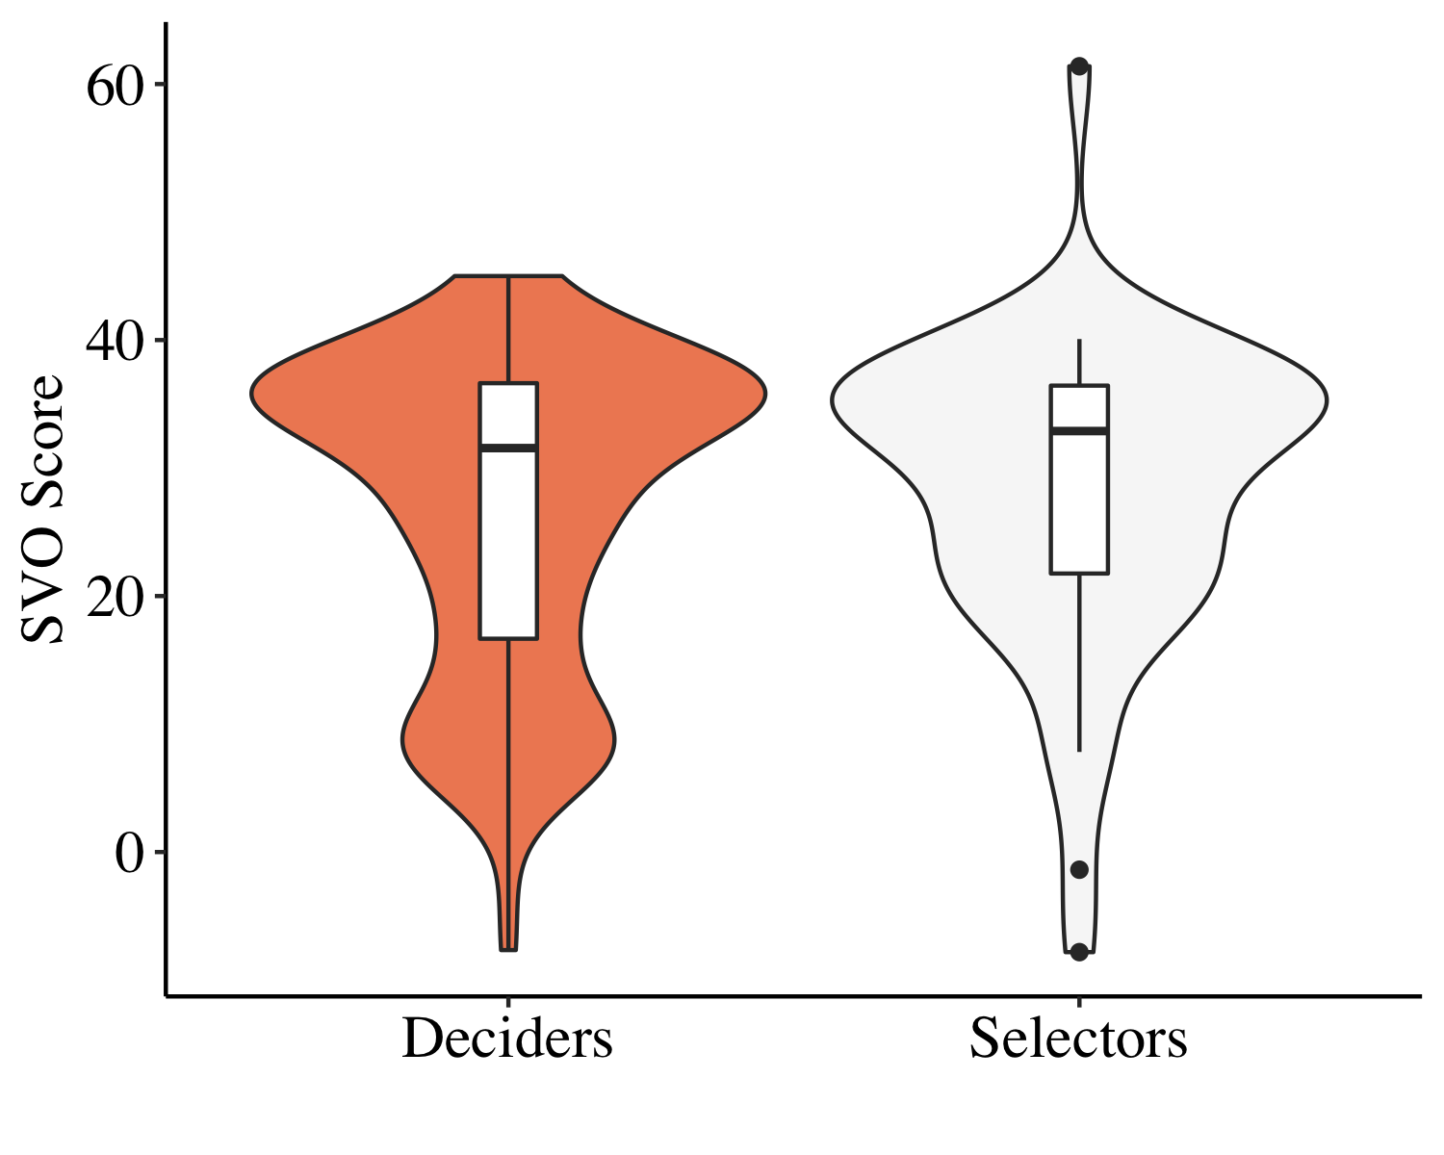 *Figure 4.* Violin and boxplots showing the social value orientation (SVO) scores obtained from all participants by role. Random intercepts regression revealed that selectors perceived themselves to be more prosocial than did deciders.

# Discussion

* As deciders repeatedly completed the die-rolling task in previous experimental blocks, we would expect their responses to differ from selectors’ responses.
* feedback from participants
  + terms ‘selector’ and ‘decider’ confusing
* methods
  + die rolling game in the end confounding the svo

# References

Abele, A. E., & Wojciszke, B. (2014). Communal and agentic content in social cognition: A dual perspective model. In *Advances in experimental social psychology* (Vol. 50, pp. 195–255). Elsevier.

Abeler, J., Becker, A., & Falk, A. (2014). Representative evidence on lying costs. *Journal of Public Economics*, *113*, 96–104.

Abeler, J., Nosenzo, D., & Raymond, C. (2019). Preferences for truth-telling. *Econometrica*, *87*(4), 1115–1153.

Ades, A., & Tella, R. D. (1996). The causes and consequences of corruption: A review of recent empirical contributions. *IDs Bulletin*, *27*(2), 6–11.

Anderson, N. H. (1968). Likableness ratings of 555 personality-trait words. *Journal of Personality and Social Psychology*, *9*(3), 272.

André, J.-B., & Baumard, N. (2011). The evolution of fairness in a biological market. *Evolution: International Journal of Organic Evolution*, *65*(5), 1447–1456.

Auguie, B. (2017). *GridExtra: Miscellaneous functions for "grid" graphics*. Retrieved from <https://CRAN.R-project.org/package=gridExtra>

Aust, F., & Barth, M. (2018). *papaja: Create APA manuscripts with R Markdown*. Retrieved from <https://github.com/crsh/papaja>

Bahmani-Oskooee, M., & Goswami, G. G. (2005). The impact of corruption on the black market premium. *Southern Economic Journal*, 483–493.

Barclay, P. (2013). Strategies for cooperation in biological markets, especially for humans. *Evolution and Human Behavior*, *34*(3), 164–175.

Barclay, P. (2016). Biological markets and the effects of partner choice on cooperation and friendship. *Current Opinion in Psychology*, *7*, 33–38.

Barclay, P., & Willer, R. (2006). Partner choice creates competitive altruism in humans. *Proceedings of the Royal Society B: Biological Sciences*, *274*(1610), 749–753.

Bates, D., & Maechler, M. (2018). *Matrix: Sparse and dense matrix classes and methods*. Retrieved from <https://CRAN.R-project.org/package=Matrix>

Bates, D., Mächler, M., Bolker, B., & Walker, S. (2015). Fitting linear mixed-effects models using lme4. *Journal of Statistical Software*, *67*(1), 1–48. doi:[10.18637/jss.v067.i01](https://doi.org/10.18637/jss.v067.i01)

Baumard, J., Osiurak, F., Lesourd, M., & Le Gall, D. (2014). Tool use disorders after left brain damage. *Frontiers in Psychology*, *5*, 473.

Baumard, N., André, J.-B., & Sperber, D. (2013). A mutualistic approach to morality: The evolution of fairness by partner choice. *Behavioral and Brain Sciences*, *36*(1), 59–78.

Brambilla, M., Rusconi, P., Sacchi, S., & Cherubini, P. (2011). Looking for honesty: The primary role of morality (vs. Sociability and competence) in information gathering. *European Journal of Social Psychology*, *41*(2), 135–143.

Brophy, S. (2008). Mexico: Cartels, corruption and cocaine: A profile of the gulf cartel. *Global Crime*, *9*(3), 248–261.

Chen, D. L., Schonger, M., & Wickens, C. (2016). OTree—an open-source platform for laboratory, online, and field experiments. *Journal of Behavioral and Experimental Finance*, *9*, 88–97.

Cialdini, R. B. (2001). Harnessing the science of persuasion. *Harvard Business Review*, *79*(9), 72–81.

Cottrell, C. A., Neuberg, S. L., & Li, N. P. (2007). What do people desire in others? A sociofunctional perspective on the importance of different valued characteristics. *Journal of Personality and Social Psychology*, *92*(2), 208.

Cukierman, A., Edwards, S., & Tabellini, G. (1989). *Seigniorage and political instability*. National Bureau of Economic Research.

Dahl, D. B., Scott, D., Roosen, C., Magnusson, A., & Swinton, J. (2018). *Xtable: Export tables to latex or html*. Retrieved from <https://CRAN.R-project.org/package=xtable>

Desaihttps, K. (2019, July). Utrecht becomes third dutch city to declare a state of climate emergency. *DutchReview*. Retrieved from <https://dutchreview.com/cities/utrecht/utrecht-becomes-third-dutch-city-to-declare-a-state-of-climate-emergency/>

Efferson, C., Roca, C. P., Vogt, S., & Helbing, D. (2016). Sustained cooperation by running away from bad behavior. *Evolution and Human Behavior*, *37*(1), 1–9.

Everett, J. A., Pizarro, D. A., & Crockett, M. (2016). Inference of trustworthiness from intuitive moral judgments. *Journal of Experimental Psychology: General*, *145*(6), 772.

Farwell, J. P. (2014). The media strategy of isis. *Survival*, *56*(6), 49–55.

Fehr, E., & Fischbacher, U. (2003). The nature of human altruism. *Nature*, *425*(6960), 785.

Fehr, E., & Gächter, S. (2002). Altruistic punishment in humans. *Nature*, *415*(6868), 137.

Fehr, E., & Rockenbach, B. (2004). Human altruism: Economic, neural, and evolutionary perspectives. *Current Opinion in Neurobiology*, *14*(6), 784–790.

Fischbacher, U., & Föllmi-Heusi, F. (2013). Lies in disguise—an experimental study on cheating. *Journal of the European Economic Association*, *11*(3), 525–547.

Fiske, S. T., Xu, J., Cuddy, A. C., & Glick, P. (1999). (Dis) respecting versus (dis) liking: Status and interdependence predict ambivalent stereotypes of competence and warmth. *Journal of Social Issues*, *55*(3), 473–489.

French, J., Raven, B., & Cartwright, D. (1959). The bases of social power. *Classics of Organization Theory*, *7*, 311–320.

Freud, S. (1977). *Introductory lectures on psychoanalysis*. WW Norton & Company.

Garnier, S. (2018a). *Viridis: Default color maps from ’matplotlib’*. Retrieved from <https://CRAN.R-project.org/package=viridis>

Garnier, S. (2018b). *ViridisLite: Default color maps from ’matplotlib’ (lite version)*. Retrieved from <https://CRAN.R-project.org/package=viridisLite>

Gausel, N., & Leach, C. W. (2011). Concern for self-image and social image in the management of moral failure: Rethinking shame. *European Journal of Social Psychology*, *41*(4), 468–478.

Gächter, S., & Schulz, J. F. (2016). Intrinsic honesty and the prevalence of rule violations across societies. *Nature*, *531*(7595), 496–499.

Gelman, A., & Hill, J. (2006). *Data analysis using regression and multilevel/hierarchical models*. Cambridge university press.

Gintis, H. (2003). Solving the puzzle of prosociality. *Rationality and Society*, *15*(2), 155–187.

Gintis, H., Smith, E. A., & Bowles, S. (2001). Costly signaling and cooperation. *Journal of Theoretical Biology*, *213*(1), 103–119.

Goodman, L. M. (2015). Why volkswagen cheated. *Newsweek Global*, *165*(23), 14.

Goodwin, G. P. (2015). Moral character in person perception. *Current Directions in Psychological Science*, *24*(1), 38–44.

Gross, J. A., & De Dreu, C. K. W. (2012). Contagiously honest: Rule following minorities enforce norm-abidance and mitigate corrupt collaboration jörg. *In Press*.

Gross, J., Leib, M., Offerman, T., & Shalvi, S. (2018). Ethical free riding: When honest people find dishonest partners. *Psychological Science*, *29*(12), 1956–1968.

Gulsoken, D. (2019, June). Amsterdam becomes the first dutch municipality to recognise the climate crisis. *Kinder World*. Retrieved from <https://kinder.world/articles/solutions/amsterdam-becomes-the-first-dutch-municipality-to-recognise-the-climate-crisis-20940>

Gupta, J. dSanjeev, Davoodi, H., & Alonso-Terme, R. (1998). *Does corruption affect income inequality and poverty?* International Monetary Fund.

Gurven, M., Allen-Arave, W., Hill, K., & Hurtado, M. (2000). “It’s a wonderful life”: Signaling generosity among the ache of paraguay. *Evolution and Human Behavior*, *21*(4), 263–282.

Hirschman, E. C. (1987). People as products: Analysis of a complex marketing exchange. *Journal of Marketing*, *51*(1), 98–108.

Hoffman, M. L. (1977). Moral internalization: Current theory and research. In *Advances in experimental social psychology* (Vol. 10, pp. 85–133). Elsevier.

Hordern, A., Martin, M., & Ratcliffe, V. (2020, January). Aramco ceo says oil’s “central bank” can handle any disruption. *Bloomberg.com*. Bloomberg. Retrieved from <https://www.bloomberg.com/news/articles/2020-01-13/aramco-s-ability-to-withstand-disruptions-is-unmatched-says-ceo>

Jordan, J. J., Hoffman, M., Nowak, M. A., & Rand, D. G. (2016). Uncalculating cooperation is used to signal trustworthiness. *Proceedings of the National Academy of Sciences*, *113*(31), 8658–8663.

Jordan, J., Mullen, E., & Murnighan, J. K. (2011). Striving for the moral self: The effects of recalling past moral actions on future moral behavior. *Personality and Social Psychology Bulletin*, *37*(5), 701–713.

Keizer, K., Lindenberg, S., & Steg, L. (2008). The spreading of disorder. *Science*, *322*(5908), 1681–1685.

Kimbrough, E. O., Miller, J. B., & Vostroknutov, A. (2014). *Norms, frames and prosocial behavior in games*. mimeo, Simon Fraser University, Bocconi University, University of Trento.

Kimbrough, E. O., & Vostroknutov, A. (2016). Norms make preferences social. *Journal of the European Economic Association*, *14*(3), 608–638.

Kimbrough, E. O., & Vostroknutov, A. (2018). A portable method of eliciting respect for social norms. *Economics Letters*, *168*, 147–150.

Köbis, N. C., Prooijen, J.-W. van, Righetti, F., & Van Lange, P. A. (2016). Prospection in individual and interpersonal corruption dilemmas. *Review of General Psychology*, *20*(1), 71–85.

Lacetera, N., & Macis, M. (2010). Social image concerns and prosocial behavior: Field evidence from a nonlinear incentive scheme. *Journal of Economic Behavior & Organization*, *76*(2), 225–237.

Landy, J. F., Piazza, J., & Goodwin, G. P. (2016). When it’s bad to be friendly and smart: The desirability of sociability and competence depends on morality. *Personality and Social Psychology Bulletin*, *42*(9), 1272–1290.

Landy, J. F., & Uhlmann, E. L. (2018). Morality is personal. *Atlas of Moral Psychology*, 121.

Lessing, B. (2012). *The logic of violence in criminal war: Cartel-state conflict in mexico, colombia, and brazil* (PhD thesis). UC Berkeley.

Magee, J. C. (2009). Seeing power in action: The roles of deliberation, implementation, and action in inferences of power. *Journal of Experimental Social Psychology*, *45*(1), 1–14.

Mauro, P. (1995). Corruption and growth. *The Quarterly Journal of Economics*, *110*(3), 681–712.

Mazar, N., Amir, O., & Ariely, D. (2008). The dishonesty of honest people: A theory of self-concept maintenance. *Journal of Marketing Research*, *45*(6), 633–644.

McElduff, F., Cortina-Borja, M., Chan, S.-K., & Wade, A. (2010). When t-tests or wilcoxon-mann-whitney tests won’t do. *Advances in Physiology Education*, *34*(3), 128–133.

Melnikoff, D. E., & Bailey, A. H. (2018). Preferences for moral vs. Immoral traits in others are conditional. *Proceedings of the National Academy of Sciences*, *115*(4), E592–E600.

Merwin, R. M., Timko, C. A., Moskovich, A. A., Ingle, K. K., Bulik, C. M., & Zucker, N. L. (2010). Psychological inflexibility and symptom expression in anorexia nervosa. *Eating Disorders*, *19*(1), 62–82.

Milinski, M., Semmann, D., & Krambeck, H.-J. (2002). Reputation helps solve the “tragedy of the commons”. *Nature*, *415*(6870), 424.

Mondillon, L., Niedenthal, P. M., Brauer, M., Rohmann, A., Dalle, N., & Uchida, Y. (2005). Beliefs about power and its relation to emotional experience: A comparison of japan, france, germany, and the united states. *Personality and Social Psychology Bulletin*, *31*(8), 1112–1122.

Montesquieu, C. L. (1951). Oeuvres completes (2 vols.). *Paris: Pl6iade*.

Mumby, D. (2019, February). Climate emergency declared to applause from protesters. *somersetlive*. Retrieved from <https://www.somersetlive.co.uk/climate-emergency-declared-somerset-county-2572346>

Murphy, R. O., Ackermann, K. A., & Handgraaf, M. (2011). Measuring social value orientation. *Judgment and Decision Making*, *6*(8), 771–781.

Nieto, N. (2012). Political corruption and narcotrafficking in mexico. *Transcience*, *3*(2), 24–26.

Noë, R., & Hammerstein, P. (1995). Biological markets. *Trends in Ecology & Evolution*, *10*(8), 336–339.

Ostrom, E. (2000). Collective action and the evolution of social norms. *Journal of Economic Perspectives*, *14*(3), 137–158.

Peeters, G. (1992). Evaluative meanings of adjectives invitro and in context-some theoretical implications and practical consequences of positive-negative asymmetry and behavioral-adaptive concepts of evaluation. *Psychologica Belgica*, *32*(2), 211–231.

Pepitone, A. (1976). Toward a normative and comparative biocultural social psychology. *Journal of Personality and Social Psychology*, *34*(4), 641.

Rand, D. G., Arbesman, S., & Christakis, N. A. (2011). Dynamic social networks promote cooperation in experiments with humans. *Proceedings of the National Academy of Sciences*, *108*(48), 19193–19198.

R Core Team. (2018). *R: A language and environment for statistical computing*. Vienna, Austria: R Foundation for Statistical Computing. Retrieved from <https://www.R-project.org/>

Robinson, L. F., & Reis, H. T. (1989). The effects of interruption, gender, and status on interpersonal perceptions. *Journal of Nonverbal Behavior*, *13*(3), 141–153.

Rose-Ackerman, S., & Palifka, B. J. (2016). *Corruption and government: Causes, consequences, and reform*. Cambridge university press.

Rothstein, B. (2011). *The quality of government: Corruption, social trust, and inequality in international perspective*. University of Chicago Press.

Sethi, R., & Somanathan, E. (1996). The evolution of social norms in common property resource use. *The American Economic Review*, 766–788.

Simmons, J. P., Nelson, L. D., & Simonsohn, U. (2012). A 21 word solution. *Available at SSRN 2160588*.

Smith, A. (1759). *The theory of moral sentiments: By adam smith...* A. Millar.

Szechtman, H., & Woody, E. (2004). Obsessive-compulsive disorder as a disturbance of security motivation. *Psychological Review*, *111*(1), 111.

Tomasello, M., & Rakoczy, H. (2003). What makes human cognition unique? From individual to shared to collective intentionality. *Mind & Language*, *18*(2), 121–147.

Trivers, R. L. (1971). The evolution of reciprocal altruism. *The Quarterly Review of Biology*, *46*(1), 35–57.

Tyler, T. R. (1997). The psychology of legitimacy: A relational perspective on voluntary deference to authorities. *Personality and Social Psychology Review*, *1*(4), 323–345.

Utikal, V., & Fischbacher, U. (2013). Disadvantageous lies in individual decisions. *Journal of Economic Behavior & Organization*, *85*, 108–111.

Van Kleef, G. A., Homan, A. C., Finkenauer, C., Gündemir, S., & Stamkou, E. (2011). Breaking the rules to rise to power: How norm violators gain power in the eyes of others. *Social Psychological and Personality Science*, *2*(5), 500–507.

Wedekind, C., & Milinski, M. (2000). Cooperation through image scoring in humans. *Science*, *288*(5467), 850–852.

Weisel, O., & Shalvi, S. (2015). The collaborative roots of corruption. *Proceedings of the National Academy of Sciences*, *112*(34), 10651–10656.

Wickham, H. (2011). The split-apply-combine strategy for data analysis. *Journal of Statistical Software*, *40*(1), 1–29. Retrieved from <http://www.jstatsoft.org/v40/i01/>

Wickham, H. (2016). *Ggplot2: Elegant graphics for data analysis*. Springer-Verlag New York. Retrieved from <https://ggplot2.tidyverse.org>

Wickham, H., François, R., Henry, L., & Müller, K. (2019). *Dplyr: A grammar of data manipulation*. Retrieved from <https://CRAN.R-project.org/package=dplyr>

Williams, M. J. (2014). Serving the self from the seat of power: Goals and threats predict leaders’ self-interested behavior. *Journal of Management*, *40*(5), 1365–1395.

Wojciszke, B., Abele, A. E., & Baryla, W. (2009). Two dimensions of interpersonal attitudes: Liking depends on communion, respect depends on agency. *European Journal of Social Psychology*, *39*(6), 973–990.

Xie, Y. (2015). *Dynamic documents with R and knitr* (2nd ed.). Boca Raton, Florida: Chapman; Hall/CRC. Retrieved from <https://yihui.name/knitr/>

Xie, Y., Cheng, J., & Tan, X. (2019). *DT: A wrapper of the javascript library ’datatables’*. Retrieved from <https://CRAN.R-project.org/package=DT>

Abele, A. E., & Wojciszke, B. (2014). Communal and agentic content in social cognition: A dual perspective model. In *Advances in experimental social psychology* (Vol. 50, pp. 195–255). Elsevier.

Abeler, J., Becker, A., & Falk, A. (2014). Representative evidence on lying costs. *Journal of Public Economics*, *113*, 96–104.

Abeler, J., Nosenzo, D., & Raymond, C. (2019). Preferences for truth-telling. *Econometrica*, *87*(4), 1115–1153.

Ades, A., & Tella, R. D. (1996). The causes and consequences of corruption: A review of recent empirical contributions. *IDs Bulletin*, *27*(2), 6–11.

Anderson, N. H. (1968). Likableness ratings of 555 personality-trait words. *Journal of Personality and Social Psychology*, *9*(3), 272.

André, J.-B., & Baumard, N. (2011). The evolution of fairness in a biological market. *Evolution: International Journal of Organic Evolution*, *65*(5), 1447–1456.

Auguie, B. (2017). *GridExtra: Miscellaneous functions for "grid" graphics*. Retrieved from <https://CRAN.R-project.org/package=gridExtra>

Aust, F., & Barth, M. (2018). *papaja: Create APA manuscripts with R Markdown*. Retrieved from <https://github.com/crsh/papaja>

Bahmani-Oskooee, M., & Goswami, G. G. (2005). The impact of corruption on the black market premium. *Southern Economic Journal*, 483–493.

Barclay, P. (2013). Strategies for cooperation in biological markets, especially for humans. *Evolution and Human Behavior*, *34*(3), 164–175.

Barclay, P. (2016). Biological markets and the effects of partner choice on cooperation and friendship. *Current Opinion in Psychology*, *7*, 33–38.

Barclay, P., & Willer, R. (2006). Partner choice creates competitive altruism in humans. *Proceedings of the Royal Society B: Biological Sciences*, *274*(1610), 749–753.

Bates, D., & Maechler, M. (2018). *Matrix: Sparse and dense matrix classes and methods*. Retrieved from <https://CRAN.R-project.org/package=Matrix>

Bates, D., Mächler, M., Bolker, B., & Walker, S. (2015). Fitting linear mixed-effects models using lme4. *Journal of Statistical Software*, *67*(1), 1–48. doi:[10.18637/jss.v067.i01](https://doi.org/10.18637/jss.v067.i01)

Baumard, J., Osiurak, F., Lesourd, M., & Le Gall, D. (2014). Tool use disorders after left brain damage. *Frontiers in Psychology*, *5*, 473.

Baumard, N., André, J.-B., & Sperber, D. (2013). A mutualistic approach to morality: The evolution of fairness by partner choice. *Behavioral and Brain Sciences*, *36*(1), 59–78.

Brambilla, M., Rusconi, P., Sacchi, S., & Cherubini, P. (2011). Looking for honesty: The primary role of morality (vs. Sociability and competence) in information gathering. *European Journal of Social Psychology*, *41*(2), 135–143.

Brophy, S. (2008). Mexico: Cartels, corruption and cocaine: A profile of the gulf cartel. *Global Crime*, *9*(3), 248–261.

Chen, D. L., Schonger, M., & Wickens, C. (2016). OTree—an open-source platform for laboratory, online, and field experiments. *Journal of Behavioral and Experimental Finance*, *9*, 88–97.

Cialdini, R. B. (2001). Harnessing the science of persuasion. *Harvard Business Review*, *79*(9), 72–81.

Cottrell, C. A., Neuberg, S. L., & Li, N. P. (2007). What do people desire in others? A sociofunctional perspective on the importance of different valued characteristics. *Journal of Personality and Social Psychology*, *92*(2), 208.

Cukierman, A., Edwards, S., & Tabellini, G. (1989). *Seigniorage and political instability*. National Bureau of Economic Research.

Dahl, D. B., Scott, D., Roosen, C., Magnusson, A., & Swinton, J. (2018). *Xtable: Export tables to latex or html*. Retrieved from <https://CRAN.R-project.org/package=xtable>

Desaihttps, K. (2019, July). Utrecht becomes third dutch city to declare a state of climate emergency. *DutchReview*. Retrieved from <https://dutchreview.com/cities/utrecht/utrecht-becomes-third-dutch-city-to-declare-a-state-of-climate-emergency/>

Efferson, C., Roca, C. P., Vogt, S., & Helbing, D. (2016). Sustained cooperation by running away from bad behavior. *Evolution and Human Behavior*, *37*(1), 1–9.

Everett, J. A., Pizarro, D. A., & Crockett, M. (2016). Inference of trustworthiness from intuitive moral judgments. *Journal of Experimental Psychology: General*, *145*(6), 772.

Farwell, J. P. (2014). The media strategy of isis. *Survival*, *56*(6), 49–55.

Fehr, E., & Fischbacher, U. (2003). The nature of human altruism. *Nature*, *425*(6960), 785.

Fehr, E., & Gächter, S. (2002). Altruistic punishment in humans. *Nature*, *415*(6868), 137.

Fehr, E., & Rockenbach, B. (2004). Human altruism: Economic, neural, and evolutionary perspectives. *Current Opinion in Neurobiology*, *14*(6), 784–790.

Fischbacher, U., & Föllmi-Heusi, F. (2013). Lies in disguise—an experimental study on cheating. *Journal of the European Economic Association*, *11*(3), 525–547.

Fiske, S. T., Xu, J., Cuddy, A. C., & Glick, P. (1999). (Dis) respecting versus (dis) liking: Status and interdependence predict ambivalent stereotypes of competence and warmth. *Journal of Social Issues*, *55*(3), 473–489.

French, J., Raven, B., & Cartwright, D. (1959). The bases of social power. *Classics of Organization Theory*, *7*, 311–320.

Freud, S. (1977). *Introductory lectures on psychoanalysis*. WW Norton & Company.

Garnier, S. (2018a). *Viridis: Default color maps from ’matplotlib’*. Retrieved from <https://CRAN.R-project.org/package=viridis>

Garnier, S. (2018b). *ViridisLite: Default color maps from ’matplotlib’ (lite version)*. Retrieved from <https://CRAN.R-project.org/package=viridisLite>

Gausel, N., & Leach, C. W. (2011). Concern for self-image and social image in the management of moral failure: Rethinking shame. *European Journal of Social Psychology*, *41*(4), 468–478.

Gächter, S., & Schulz, J. F. (2016). Intrinsic honesty and the prevalence of rule violations across societies. *Nature*, *531*(7595), 496–499.

Gelman, A., & Hill, J. (2006). *Data analysis using regression and multilevel/hierarchical models*. Cambridge university press.

Gintis, H. (2003). Solving the puzzle of prosociality. *Rationality and Society*, *15*(2), 155–187.

Gintis, H., Smith, E. A., & Bowles, S. (2001). Costly signaling and cooperation. *Journal of Theoretical Biology*, *213*(1), 103–119.

Goodman, L. M. (2015). Why volkswagen cheated. *Newsweek Global*, *165*(23), 14.

Goodwin, G. P. (2015). Moral character in person perception. *Current Directions in Psychological Science*, *24*(1), 38–44.

Gross, J. A., & De Dreu, C. K. W. (2012). Contagiously honest: Rule following minorities enforce norm-abidance and mitigate corrupt collaboration jörg. *In Press*.

Gross, J., Leib, M., Offerman, T., & Shalvi, S. (2018). Ethical free riding: When honest people find dishonest partners. *Psychological Science*, *29*(12), 1956–1968.

Gulsoken, D. (2019, June). Amsterdam becomes the first dutch municipality to recognise the climate crisis. *Kinder World*. Retrieved from <https://kinder.world/articles/solutions/amsterdam-becomes-the-first-dutch-municipality-to-recognise-the-climate-crisis-20940>

Gupta, J. dSanjeev, Davoodi, H., & Alonso-Terme, R. (1998). *Does corruption affect income inequality and poverty?* International Monetary Fund.

Gurven, M., Allen-Arave, W., Hill, K., & Hurtado, M. (2000). “It’s a wonderful life”: Signaling generosity among the ache of paraguay. *Evolution and Human Behavior*, *21*(4), 263–282.

Hirschman, E. C. (1987). People as products: Analysis of a complex marketing exchange. *Journal of Marketing*, *51*(1), 98–108.

Hoffman, M. L. (1977). Moral internalization: Current theory and research. In *Advances in experimental social psychology* (Vol. 10, pp. 85–133). Elsevier.

Hordern, A., Martin, M., & Ratcliffe, V. (2020, January). Aramco ceo says oil’s “central bank” can handle any disruption. *Bloomberg.com*. Bloomberg. Retrieved from <https://www.bloomberg.com/news/articles/2020-01-13/aramco-s-ability-to-withstand-disruptions-is-unmatched-says-ceo>

Jordan, J. J., Hoffman, M., Nowak, M. A., & Rand, D. G. (2016). Uncalculating cooperation is used to signal trustworthiness. *Proceedings of the National Academy of Sciences*, *113*(31), 8658–8663.

Jordan, J., Mullen, E., & Murnighan, J. K. (2011). Striving for the moral self: The effects of recalling past moral actions on future moral behavior. *Personality and Social Psychology Bulletin*, *37*(5), 701–713.

Keizer, K., Lindenberg, S., & Steg, L. (2008). The spreading of disorder. *Science*, *322*(5908), 1681–1685.

Kimbrough, E. O., Miller, J. B., & Vostroknutov, A. (2014). *Norms, frames and prosocial behavior in games*. mimeo, Simon Fraser University, Bocconi University, University of Trento.

Kimbrough, E. O., & Vostroknutov, A. (2016). Norms make preferences social. *Journal of the European Economic Association*, *14*(3), 608–638.

Kimbrough, E. O., & Vostroknutov, A. (2018). A portable method of eliciting respect for social norms. *Economics Letters*, *168*, 147–150.

Köbis, N. C., Prooijen, J.-W. van, Righetti, F., & Van Lange, P. A. (2016). Prospection in individual and interpersonal corruption dilemmas. *Review of General Psychology*, *20*(1), 71–85.

Lacetera, N., & Macis, M. (2010). Social image concerns and prosocial behavior: Field evidence from a nonlinear incentive scheme. *Journal of Economic Behavior & Organization*, *76*(2), 225–237.

Landy, J. F., Piazza, J., & Goodwin, G. P. (2016). When it’s bad to be friendly and smart: The desirability of sociability and competence depends on morality. *Personality and Social Psychology Bulletin*, *42*(9), 1272–1290.

Landy, J. F., & Uhlmann, E. L. (2018). Morality is personal. *Atlas of Moral Psychology*, 121.

Lessing, B. (2012). *The logic of violence in criminal war: Cartel-state conflict in mexico, colombia, and brazil* (PhD thesis). UC Berkeley.

Magee, J. C. (2009). Seeing power in action: The roles of deliberation, implementation, and action in inferences of power. *Journal of Experimental Social Psychology*, *45*(1), 1–14.

Mauro, P. (1995). Corruption and growth. *The Quarterly Journal of Economics*, *110*(3), 681–712.

Mazar, N., Amir, O., & Ariely, D. (2008). The dishonesty of honest people: A theory of self-concept maintenance. *Journal of Marketing Research*, *45*(6), 633–644.

McElduff, F., Cortina-Borja, M., Chan, S.-K., & Wade, A. (2010). When t-tests or wilcoxon-mann-whitney tests won’t do. *Advances in Physiology Education*, *34*(3), 128–133.

Melnikoff, D. E., & Bailey, A. H. (2018). Preferences for moral vs. Immoral traits in others are conditional. *Proceedings of the National Academy of Sciences*, *115*(4), E592–E600.

Merwin, R. M., Timko, C. A., Moskovich, A. A., Ingle, K. K., Bulik, C. M., & Zucker, N. L. (2010). Psychological inflexibility and symptom expression in anorexia nervosa. *Eating Disorders*, *19*(1), 62–82.

Milinski, M., Semmann, D., & Krambeck, H.-J. (2002). Reputation helps solve the “tragedy of the commons”. *Nature*, *415*(6870), 424.

Mondillon, L., Niedenthal, P. M., Brauer, M., Rohmann, A., Dalle, N., & Uchida, Y. (2005). Beliefs about power and its relation to emotional experience: A comparison of japan, france, germany, and the united states. *Personality and Social Psychology Bulletin*, *31*(8), 1112–1122.

Montesquieu, C. L. (1951). Oeuvres completes (2 vols.). *Paris: Pl6iade*.

Mumby, D. (2019, February). Climate emergency declared to applause from protesters. *somersetlive*. Retrieved from <https://www.somersetlive.co.uk/climate-emergency-declared-somerset-county-2572346>

Murphy, R. O., Ackermann, K. A., & Handgraaf, M. (2011). Measuring social value orientation. *Judgment and Decision Making*, *6*(8), 771–781.

Nieto, N. (2012). Political corruption and narcotrafficking in mexico. *Transcience*, *3*(2), 24–26.

Noë, R., & Hammerstein, P. (1995). Biological markets. *Trends in Ecology & Evolution*, *10*(8), 336–339.

Ostrom, E. (2000). Collective action and the evolution of social norms. *Journal of Economic Perspectives*, *14*(3), 137–158.

Peeters, G. (1992). Evaluative meanings of adjectives invitro and in context-some theoretical implications and practical consequences of positive-negative asymmetry and behavioral-adaptive concepts of evaluation. *Psychologica Belgica*, *32*(2), 211–231.

Pepitone, A. (1976). Toward a normative and comparative biocultural social psychology. *Journal of Personality and Social Psychology*, *34*(4), 641.

Rand, D. G., Arbesman, S., & Christakis, N. A. (2011). Dynamic social networks promote cooperation in experiments with humans. *Proceedings of the National Academy of Sciences*, *108*(48), 19193–19198.

R Core Team. (2018). *R: A language and environment for statistical computing*. Vienna, Austria: R Foundation for Statistical Computing. Retrieved from <https://www.R-project.org/>

Robinson, L. F., & Reis, H. T. (1989). The effects of interruption, gender, and status on interpersonal perceptions. *Journal of Nonverbal Behavior*, *13*(3), 141–153.

Rose-Ackerman, S., & Palifka, B. J. (2016). *Corruption and government: Causes, consequences, and reform*. Cambridge university press.

Rothstein, B. (2011). *The quality of government: Corruption, social trust, and inequality in international perspective*. University of Chicago Press.

Sethi, R., & Somanathan, E. (1996). The evolution of social norms in common property resource use. *The American Economic Review*, 766–788.

Simmons, J. P., Nelson, L. D., & Simonsohn, U. (2012). A 21 word solution. *Available at SSRN 2160588*.

Smith, A. (1759). *The theory of moral sentiments: By adam smith...* A. Millar.

Szechtman, H., & Woody, E. (2004). Obsessive-compulsive disorder as a disturbance of security motivation. *Psychological Review*, *111*(1), 111.

Tomasello, M., & Rakoczy, H. (2003). What makes human cognition unique? From individual to shared to collective intentionality. *Mind & Language*, *18*(2), 121–147.

Trivers, R. L. (1971). The evolution of reciprocal altruism. *The Quarterly Review of Biology*, *46*(1), 35–57.

Tyler, T. R. (1997). The psychology of legitimacy: A relational perspective on voluntary deference to authorities. *Personality and Social Psychology Review*, *1*(4), 323–345.

Utikal, V., & Fischbacher, U. (2013). Disadvantageous lies in individual decisions. *Journal of Economic Behavior & Organization*, *85*, 108–111.

Van Kleef, G. A., Homan, A. C., Finkenauer, C., Gündemir, S., & Stamkou, E. (2011). Breaking the rules to rise to power: How norm violators gain power in the eyes of others. *Social Psychological and Personality Science*, *2*(5), 500–507.

Wedekind, C., & Milinski, M. (2000). Cooperation through image scoring in humans. *Science*, *288*(5467), 850–852.

Weisel, O., & Shalvi, S. (2015). The collaborative roots of corruption. *Proceedings of the National Academy of Sciences*, *112*(34), 10651–10656.

Wickham, H. (2011). The split-apply-combine strategy for data analysis. *Journal of Statistical Software*, *40*(1), 1–29. Retrieved from <http://www.jstatsoft.org/v40/i01/>

Wickham, H. (2016). *Ggplot2: Elegant graphics for data analysis*. Springer-Verlag New York. Retrieved from <https://ggplot2.tidyverse.org>

Wickham, H., François, R., Henry, L., & Müller, K. (2019). *Dplyr: A grammar of data manipulation*. Retrieved from <https://CRAN.R-project.org/package=dplyr>

Williams, M. J. (2014). Serving the self from the seat of power: Goals and threats predict leaders’ self-interested behavior. *Journal of Management*, *40*(5), 1365–1395.

Wojciszke, B., Abele, A. E., & Baryla, W. (2009). Two dimensions of interpersonal attitudes: Liking depends on communion, respect depends on agency. *European Journal of Social Psychology*, *39*(6), 973–990.

Xie, Y. (2015). *Dynamic documents with R and knitr* (2nd ed.). Boca Raton, Florida: Chapman; Hall/CRC. Retrieved from <https://yihui.name/knitr/>

Xie, Y., Cheng, J., & Tan, X. (2019). *DT: A wrapper of the javascript library ’datatables’*. Retrieved from <https://CRAN.R-project.org/package=DT>

# Appendix A

## Information Brochure

Dear participant, this brochure provides you with information about the type and methods of the study in which you are about to participate. It is therefore important that you read this document closely.

### Purpose of the Study

People constantly make decisions, sometimes to improve their situation and sometimes to prevent it from worsening. In this study we will let you make a series of decisions, in which you can increase or decrease your starting capital. Whatever you have earned from your decisions during the task will be paid out to you in the end. We expect that the decision task is involving and that we get a good insight into the kind of investments you make.

### What is going to happen?

After you have read this introduction and signed the informed consent form, you will be briefed and trained in the task. It is important for you to know that you can leave the experiment at any point without providing a justification and without consequences. In this experiment, you will make a number of decisions. Each time, performance and earnings will be measured. At the end of this study, you will receive debriefing and eventual earnings. We will not provide your personal information to anybody else, only use these for scientific purposes, and will only report results averaged over all participants and not about individual cases.

### Financial reward

In this experiment, you participate in 1 session of about 60 minutes. You will receive a participation fee of 6,50 Euros (or 2 credits if you prefer) independent of your performance. In addition, depending on your decisions you may earn up to 6,50 Euros for your participation. You may thus earn up to 13 Euros in total. Your earnings will be calculated after the conclusion of the experiment and paid out to you after the second session.

### Voluntary participation

If you now decide not to participate in this experiment, this shall have no consequences for you. If you decide during the experiment to withdraw from the study, this shall have no consequences for you. In addition, up to 24 hours after the study you can still withdraw your consent for use of your personal information. You can thus withdraw your participation at any point. You are free to do so without providing any justification. If you now or within the next 24 hours want to withdraw your consent, your personal information will be removed from our database.

### Confidentiality of study results

All information from this study will remain coded. The principal investigator has no insight into your identity and will transfer any sum to be transferred to you to the research assistants in sealed envelopes. Thus, the experimenters do not know how much money you earned.

### Debriefing

At the end of this session, you will receive a short summary of the purpose of this study. You can always direct questions about the experiment to the experimenters or per email to Dr. Jörg Gross ([j.a.j.gross@fsw.leidenuniv.nl](mailto:j.a.j.gross@fsw.leidenuniv.nl)).

### Informed Consent

This study involves the reading of instructions and making a series of decisions that can affect your payment. All instructions, decisions, and questionnaires will be presented to you on the computer. At the end of the experiment, you will receive a debriefing with background information on the study, along with the additional earnings you obtained during the experiment. The additional earnings depend on your decisions and can range between 2 and 6,50 Euros. How much you have earned will be paid out to you in cash after the session.

The study involves one session and you will be compensated 6,50 Euros or 2 credits. In addition, you can earn more during the study itself. All measures taken in this study are for scientific purposes only and will be stored in a coded way. Participation is voluntary and at your own discretion. This means that you can withdraw from the study at any time and without having to explain or justify why. You will still receive the show-up fee of 6,50 Euros or 2 credits. All information collected during this study is confidential and the data will be stored in such a way that responses cannot be traced back to your identity. The study is coordinated by Dr. Jörg Gross ([j.a.j.gross@fsw.leidenuniv.nl](mailto:j.a.j.gross@fsw.leidenuniv.nl)). Questions or complaints can be addressed to him.

I herewith confirm that I have read and understood the information brochure and that I consent with participating in this study.

# Appendix B

## Instructions

Welcome to the experiment! Below you will find detailed information about the study and a short test to check whether you understood the general setup. It is therefore important that you read the instructions closely. Click the blue headings to collapse the subsections. There is no deception and no hidden information in this study. Please do not hesitate to call the experimenter if anything remains unclear to you. Note: Tick the check boxes in the subsections below to show that you have read and understood the instructions. Otherwise, you will not be able to proceed.

In this study, you will be assigned to one of two roles and you will remain in this role throughout the experiment. You will either be playing in the role of the “selector” or in the role of a “decider”. In total, there is one selector and there are three deciders. You will find out about your role at the start of the experiment.

## Part 1

This study consists of two parts. Below, we will explain the first part in detail. After you have completed the first part of the experiment, we will give you instructions about the second part. At the end of the experiment, one round of part 1 will be selected randomly by the computer. Since you do not know which round will count for real, you should treat each round independently and as if every round is the one that counts. The points you earn in a round will be converted to money at a conversion rate of 100 points = 1 Euro. Hence, your decisions have real consequences for your earnings and, potentially, the earnings of other participants. You will start with 0 points and if your point total is below 650 points at the end of the experiment, you will still get paid 6.50 Euros. Therefore, you can earn a bonus if your point total is above 650 points.

### Stage 1.

The first part of the study consists of 15 rounds. Each round has three stages. Each decider will decide how to allocate 15 balls between two buckets on the computer screen. The deciders’ task is to put each ball, one-by-one, into one of the two buckets: the blue bucket or the yellow bucket. For each ball the decider puts in the blue bucket he or she will receive 5 points and for each ball the decider puts in the yellow bucket he or she will receive 15 points. The rule is to put the balls in the blue bucket. The deciders’ payments in this stage will be based on the sum of the points of the blue bucket and the yellow bucket. The selector will not take part in stage 1.

### Stage 2.

The selector will start by receiving 450 points. The selector will then learn about the decisions of all three deciders. Specifically, the selector will be told how many balls each decider placed in the blue bucket. The selector can then choose which decider to interact with for stage 3. The selector has to select at least one decider to interact with but can also choose to interact with two deciders in stage 3 - or even with all three. For every decider that the selector chooses, the selector has to pay a cost of 150 points. If a decider is not selected for stage 3, he or she will skip this stage, wait for the others to finish, and not earn be able to earn more. Importantly, the selector will not be able to identify the deciders across rounds, but only learn about their behavior in stage 1 (the bucket task). Specifically, the selector will be told how many balls each decider placed in the blue bucket.

### Stage 3.

If a decider is selected as interaction partner, he or she will receive 500 points. The decider is then asked how many points he or she wants to keep and how many points he or she wants to give to the selector. Hence, the decision of the decider determines the earnings of the decider as well as the earnings of the selector in this stage. After the decider has made his or her decision, the selector will learn about the outcome.

### Feedback in part 1.

After stage 3, the round is over, and you will receive a summary of this round. In the role of the decider, you receive a summary of: (a) your payoff from stage 1, (b) whether you were selected as interaction partner for stage 3 (c) how many points you decided to keep for yourself and give to the selector (d) your total sum of points you earned in this round In the role of the selector, you receive a summary of: (a) the deciders you chose as interaction partners for stage 3 (b) how many points the deciders you interacted with decided to keep for themselves and give to you (c) your total sum of points you earned in this round. Then, you move to the next round starting with stage 1.

## Part 2

In this part, everything will stay the same as in part 1, except for stage 3 and the feedback. You will also stay in your role (decider or selector) from part 1. Again, this part consists of 15 rounds. For your convenience, we repeat the instructions for stage 1 and 2 below. Again, click the blue headings to collapse the subsections. Note: Tick the check boxes in the subsections below to show that you have read and understood the instructions. Otherwise, you will not be able to proceed.

In this stage the selected deciders will use the die and the cup. The deciders have to roll the die using the cup, peek under the cup, and report the die-roll outcome. The payoff for the decider and the selector will be determined by the result that the decider reports. Specifically: If a decider reports a 1, both the decider and the selector will earn 0 points. If a decider reports a 2, both the decider and the selector will earn 50 points. If a decider reports a 3, both the decider and the selector will earn 100 points. If a decider reports a 4, both the decider and the selector will earn 150 points. If a decider reports a 5, both the decider and the selector will earn 200 points. If a decider reports a 6, both the decider and the selector will earn 250 points.

### Feedback in part 2.

After stage 3, the round is over, and you will receive a summary of this round. In the role of the decider, you receive a summary of: (a) your payoff from stage 1 (b) whether you were selected as interaction partner for stage 3, and (c) your die-roll report and how many points you and the selector earned, accordingly In the role of the selector, you receive a summary of: (a) the deciders you chose as interaction partners for stage 3 and (b) the die-roll report and resulting earnings for each decider you interacted with. Then, you move on to the next round starting with stage 1.

## Debriefing

In this study, you were part of a four-person group and made a series of decisions that could affect your final payoff. In one part of the experiment you were confronted with a rule of how to make decisions. We were interested in how many people and to what extent they follow this rule. In another part, one person of your group had to decide who to interact with based on the decisions that you and others made before. We are interested in when people choose to interact with others based on others’ previous decisions in the rule-task. In the last part, there were two contexts: you were assigned to either report the rolls of a die or divide money among yourself and a partner. If you had to report the rolls of a die, by not reporting truthfully, you were able to earn more money. We are interested to what extent over-reporting in this task is related to following the rule in the first task and being chosen as a partner. If you had to divide money among yourself and a partner, by giving more to yourself, you were able to earn more money. We are interested to what extent people make fair allocations and how this is related to getting chosen as a partner and signaling to follow rules in the rule-task. The study will help us better understand when and why individuals choose to interact with other people and follow or break rules.

The study did not involve any deception – everything that was told to you did in fact happen and/or will be implemented upon completion of the study. For further information, please contact the coordinator the study, Dr Jörg Gross ([j.a.j.gross@fsw.leidenuniv.nl](mailto:j.a.j.gross@fsw.leidenuniv.nl)). Thank you for your participation!