**Obvious user experience errors to avoid:**

**A brief heuristic evaluation of a job application website**

Corey Chen

Note: This article only represents one evolution of a product, rather than the ability of persons behind the product, for the educational purpose.

Severity Ratings (Nielsen):

**0**= I don't agree that this is a usability problem at all  
**1**= Cosmetic problem only: need not be fixed unless extra time is available on project  
**2**= Minor usability problem: fixing this should be given low priority  
**3**= Major usability problem: important to fix, so should be given high priority  
**4**= Usability catastrophe: imperative to fix this before product can be released

Recently I encountered one job seeking website. I think it could be a case with classical educating values in user experience. It looks very nice and modern by appearance for many parts, but here I mostly focus on the negative parts for the educational purpose.

One nice good point to start with,

**1. Displayed the interview process with the job posting, which is very nice and follows the visibility of system status rule**.

The user has more informed -> happy -> more likely to apply.

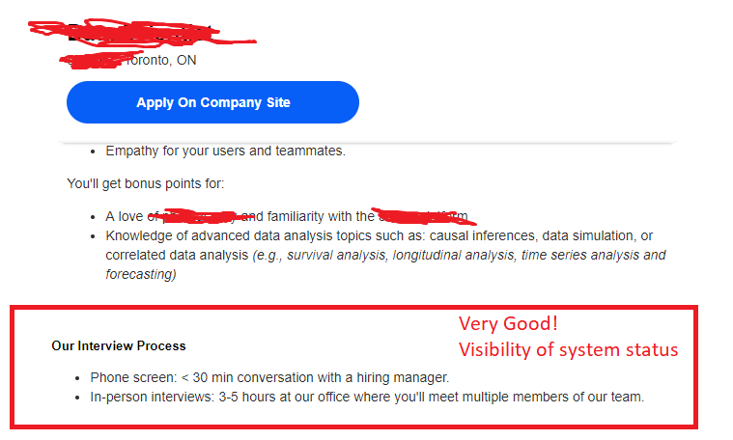

After click Apply on Company Site, problems start to begin:

**2. Why does many websites requires an account for some one-time thing? Severity Rating: 3**

Account sign up -> Wasting user’s time.

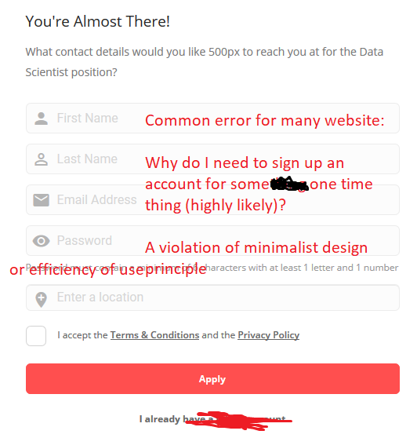

One could say, in any case, most of the information here is need for a job application. Fine, let’s move on. Right after signing up,

**3. A unnecessary alert appeared. Severity Rating: 2**

Of course, application is not finished from the previous screen (e.g., not resume so far).

Extra reading and click for no purpose -> Wasting user’s time.

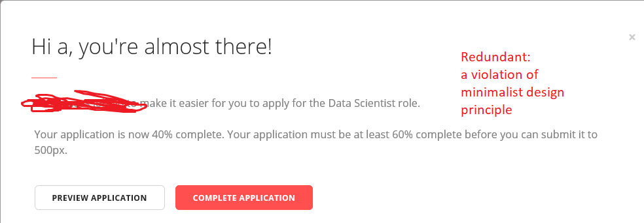

Afterwards,

**4. Please do not use the function to auto parse the Resume uploaded! Severity Rating: 3**

The automatic parsing function, may be fancy by appearance, is always terribly inaccurate, and required many corrections -> Wasting user’s time.

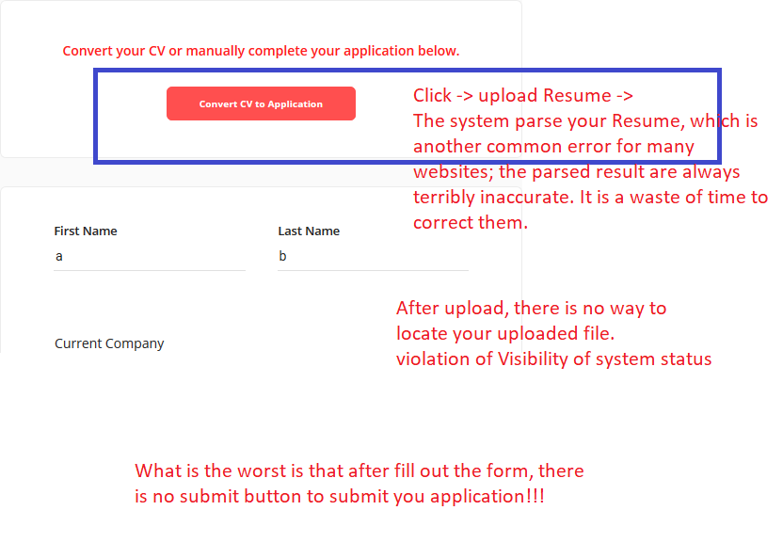

After upload,

5. **No way to check the uploaded file. Severity Rating: 3**

How does user check the uploaded file? -> no control or freedom.

Lastly, and most importantly:

6. **The submit button somehow disappeared after filling out the long form!!! Severity Rating: 4**

The is a tragedy.

On the opposite, indeed did a very good job.

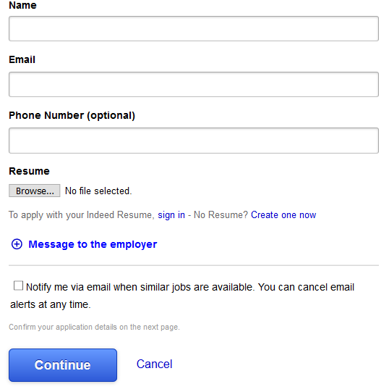

That’s all you need for the job application and it takes seconds to complete!