Stock Data Analysis with MPI
Big Data Applications and Analytics
Corey Abshire  Indiana University  dcabshir@indiana.edu | Asimansu Bera  Indiana University  beraa@indiana.edu | Orlando Warren  Indiana University  ojwarren@indiana.edu

Introduction
This paper describes our software project for the Big Data Applications and Analytics course at Indiana University during the Fall 2016 semester. Our goal with the project was to execute the suggested Stock Data Analysis with MPI project from the original project list [1]. Specifically, we wanted to execute the entire flow described at the GitHub site for the project [2], converting the Wharton stock price dataset [12] to a three-dimensional dataset from which we could create various information visualizations. We wanted to do so on Future Systems [13], taking advantage of the opportunity to learn more about parallel computing with Open MPI [5], message passing in general, the multidimensional scaling (MDS) algorithm, and how MDS is implemented over MPI.
This report represents our primary deliverable for the project. The structure of our report is as follows. We begin by defining the underlying problem that the stock analysis project is actually trying to solve and its broader implications and usefulness. We then describe the technologies and software that enables the project to solve this problem. From there we describe the results and some additional details about how we obtained them. After this we describe the keys steps to allow the results to be reproducible by others. Finally, we conclude with a description of the many challenges we faced and opportunities for future work in this area.

Define problem
Information visualization enables the discovery of hidden structure and relationships in large and complex data sets. A central problem is finding an effective way to reduce the number of dimensions to 2 or 3 in such a way that important similarities between the data elements are preserved so that it can be visualized. MDS is a set of algorithms used in some fields to achieve this dimension reduction [6]. For example, MDS is used in bioinformatics to visualize gene sequence clustering. Pairs of sequences that may vary in length can be assigned a dissimilarity score through sequence alignment. Through this process, evolutionary relationships can be discovered which may prove beneficial in many ways. Other applications include geostatistics, where spatial variability is reduced to points in a lower dimensional map, marketing, where respondent’s preferences can be reduced to points on a perceptual map, and many more. [8]
The stock analysis project [7] aims to visualize similarities between US stocks over an eleven year period. Stocks are treated as points in a high dimensional space with each price datum treated as a dimension. These dimensions are mapped to 3D using MDS and the results are visualized via PlotViz. Combined with clustering, this work enables financial analysts and other stakeholders to better understand similarities and differences among stocks in the market or in a given portfolio and how those relationships change over time. The primary use of this work from our perspective is as a test case for various types of algorithms and techniques, and it appears in the original work that it served as a proof of concept for a new web enabled version of PlotViz.

Define software
Now that we’ve defined the problem, we now describe various software and other technologies we used for this project, beginning with Open MPI [5]. MPI, or Message Passing Interface, is a specification for a message-passing system that is used in parallel computing. Open MPI is an open source implementation of MPI that comes with support for Java in more recent versions. It is used by many Top500 supercomputers and includes code developed at Indiana University [9]. In the stock analysis project, Open MPI is used via Java to perform large matrix algorithms such as conjugate gradient (CG) which is forms part of the backbone of the MDS algorithm we’re using. It does so in a way that distributes the work over multiple processes over multiple nodes. In our case, we were able to run as many as 144 independent cores (12 nodes x 12 independent processes / cores running on each node), greatly speeding up the work over what can be achieved on a single core on a single VM.
We ran our software on Future Systems. Future Systems is a computing grid and cloud test-bed provided for scientific and academic research. Future Systems provided the compute infrastructure for this project. One of the core technologies used at Future Systems is OpenStack. OpenStack is a Infrastructure As A Service (IAAS) platform for managing virtual environments [10]. This is the technology we used to provision and manage our VM and its associated network.
The Multidimensional Scaling algorithm and its associated implementation and application to stock analysis was another set of technology that was critical in this project. As previously mentioned, MDS is a set of techniques for reducing the dimension of the problem space to some lower number. A distance matrix (dissimilarity matrix) is defined between all pairs of points. In our project the correlation between stock prices is used to calculate these matrix elements. MDS tries to preserve the distance relationships as much as possible by minimizing a function (usually called the stress). We note that for our project each pair-wise term in the stress is weighted by a function that depends on the pair’s market capitalization. Another algorithmic optimization used is Deterministic Annealing (DA). DA enables MDS to select the global minimum, instead of getting stuck in a local minimum.
Java is a popular language created at Sun Microsystems and was also critical for our project. Source code is compiled to Java bytecode which runs on the Java Virtual Machine. Traditionally the JVM enabled class files to be portable at the expense of performance. However over the last 20 years extensive optimizations on the JVM (for example just-in-time compilation) have enabled Java performance to be comparable to that of languages that compile down to native machine code. This, in turn, makes Java an attractive choice for high performance computing. In this project, the main parts of the pre-processing code, the main MDS algorithm as implemented over Open MPI, and parts of the post-processing code are all implemented in Java. Shell scripting helped glue the software stack components together, and SLURM [4] helped manage the resources available and get the jobs distributed out to the nodes of the cluster where they could begin processing the MPI workload.
Lastly we look at the various information visualization tools we used for this project. PlotViz is the 3D visualization software, developed at Indiana University, used in this project. [11] It allows us to visualize the resulting 3D space that is output by the MDS reduction. With PlotViz, we are able to interactively rotate, translate, and scale the points in real-time, highlighting interesting stock clusters and identifying individual stocks. Others that we used included gnuplot for checking the performance of the dimensional reduction mapping via heat map visualizations and histograms. Finally, we used R for some basic time series plots of the stock prices listed in the original input data.

Produce results
There are three main phases the stock analysis project executes: a pre-processing phase, the main computation phase, and a post-processing phase. It is helpful to understand the results of each phase in order to better understand the overall process and the end results. In this section, we take a brief look at the results we were able to produce at each phase by executing the process as described by its authors. It is also helpful to begin with a brief description of the input, which is where we begin here, followed by a brief description of each of the interim phases, and concluding with a description of the final results.
The input to the process is a download of the CRSP dataset from WRDS. While we did go through the process ourselves of registering for WRDS and learned enough of its interface to be able to successfully download a copy of the dataset for ourselves, once we learned that there was a VM available that already had the dataset on it, we decided to use that instead. The input data consists of a time series of around 7,000 stocks, with a monthly snapshot of the price and volume, along with information to help account for splits.
The pre-processing converts this input data into a set of vectors, with one vector per stock and with the dimensions of the vector as the dates on which the price snapshots were collected. It then uses these vectors to compute the distance and weight matrices that are needed by the MDS algorithm we are using. This process causes the size of the data to grow substantially. Whereas the original input data is only around 35 MB, the complete set of pre-processed data is around 8 GB. Aspects of the pre-processing step do take advantage of parallel processing afforded by the cluster.
The main processing step takes the distance and weight matrices and applies MDS to output a set of 3 dimensional points that capture as much of the similarity of the input data set as possible. There are two major opportunities for parallelism in this problem that the stock analysis code takes advantage of. First, the computation of the conjugate gradient and the stress function both rely on matrix operations that can be parallelized by processing the matrices in blocks, and the stock analysis and DAMDS [3] software do this it seems by using common matrix operations implemented as part of SPIDAL that execute over MPI.
Second, the approach taken in the stock analysis project uses a sliding weekly window over the data to help understand how the relationships among the stocks change over time. This requires computing the entire algorithm separately for each year long dataset starting on different range of 52 weeks, by week. This forms a natural pleasingly parallel situation where we can process each of the week’s years in parallel over the cluster. This is accomplished in the stock analysis code by submitting all the weekly jobs to SLURM’s job queue and let it assign resources as they come available.
These two forms of parallelism are in a way competing. If you increase the number of nodes or tasks available to MPI for computing the matrix operations you decrease the run time for an individual week, but you also decrease the amount of resources assignable to the individual week datasets. We chose to assign 12 tasks on a single node for computing the individual datasets, allowing the jobs to complete within a reasonable time, but then using each of the 12 nodes separately for processing the week datasets.
We did this because primarily because of some problems we were having with InfiniBand running on two of the twelve nodes that was causing jobs to fail, but also because it was intuitive that if we avoided network communication for MPI altogether but were still able to take advantage of all nodes using the pleasingly parallel week splits, that we would avoid network latency altogether and have highest possible performance. We ran it multiple ways, but felt a more comprehensive study to prove this out was beyond the scope of this work.
The post-processing step is able to take advantage of the pleasingly parallel nature of the week starting points for the yearly set as well. This step does some rotation and translation as described in the stock analysis paper by selecting a set of stocks to serve as anchors, and adjusting all the other points according to them. Then it generates the various visualization input files required.
There are two main sets of visualizations produced by the software. The first and main visualization is a set of PlotViz files. These visualizations are depictions of all of the roughly 7,000 stocks in 3-d, scaled down from the high dimensionality of treating every day for which we have a price as a dimension. The colors are assigned via a clustering algorithm. Points are the same color and are closer if the stocks they represent have similar time series. Note also that a few of the stocks are given unique shapes larger than all the other points. These are used to give a frame of reference for the other points as they change over time. There are one weekly PlotViz file produced per week, in addition to a separate PlotViz file generated for the entire global dataset. Some examples views taken as screenshots from PlotViz are shown in Figure 1.
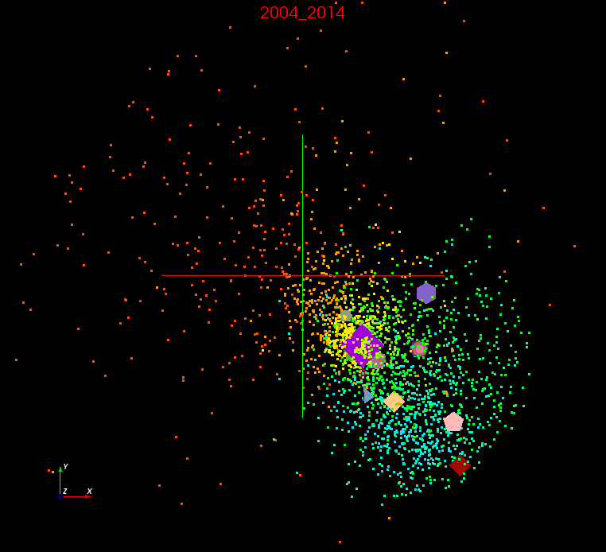 | 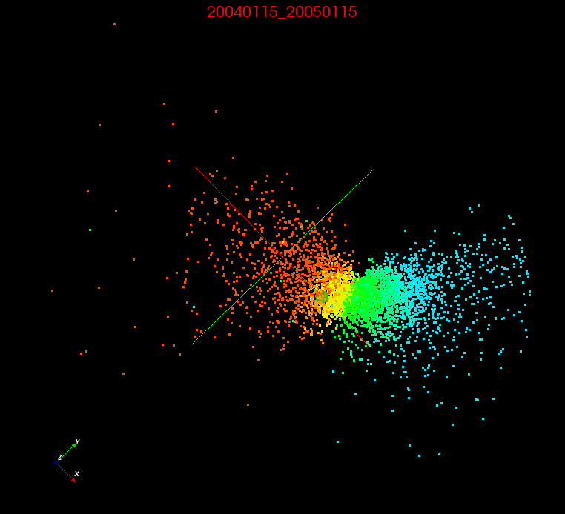

Another type of visualization that is produced as part of the post processing are heatmaps that represent a comparison of the distances obtained before and after the processing. An small example from the global dataset is given in Figure 2. The significance of this figure is that since the hottest area shows on the diagonal, that the MDS algorithm was relatively successful in reducing the dimensionality of the data while preserving the relative distances between the points. The histogram accompanying the heatmap gives a similar meaning.
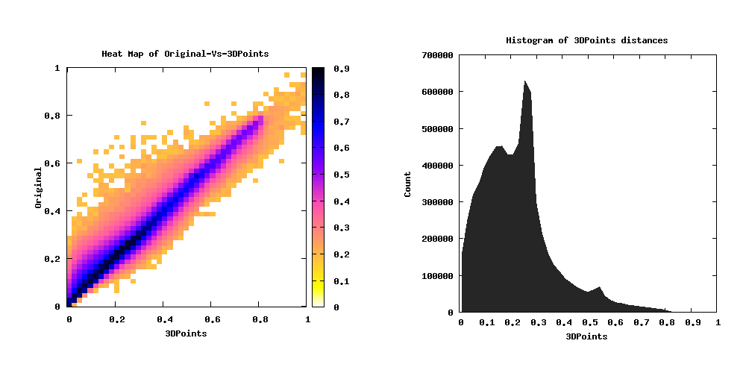

Check reproducibility
Now we provide a set of high level instructions that augment the original instructions that came with the original project that others can use to reproduce this work on Future Systems. These instructions do assume some degree of familiarity with Future Systems and are intended to augment the documentation there and that is already provided with the stock analysis project. The goal is to supplement the other work to help others avoid all the problems we ran into when using those other documentation sources alone.
Step 1. Launch VM
Log in to india and start the stock analysis VM. Be sure to execute the kilo script to change your Open Stack environment settings. Also, be sure to assign a public IP address to your VM so that you’ll be able to log into it, as it doesn’t appear to be accessible via its private IP.
Step 2. Copy files from VM to login node
We don’t recommend using the VM directly to try to run the software, because it doesn’t have SLURM installed or configured, the software builds don’t appear to work, and many of the scripts are set up to run from your home path on india. Instead, copy the source code and data out of the VM into your home directory in india. Specifically, copy the entire ~/git and STOCK_ANALYSIS directories. At this point you don’t need the VM and can shut it down.
Step 3. Build external software on india login node
Download and build Maven, JDK 1.8.0 and Open MPI 1.8.1 as specified in the stock analysis instructions. Do this on india, in your home directory. Do not try to use any package manager to install it. Download the source to your directory and build and install it there in the same directory.
Step 4. Update repos and build main software
Also, update the source of each of the projects in the git folder and rebuild and install them as well using maven. Use the weightfix branch of DAMDS and the ompi181 branch of MDSasChiSq. Remove the stock-analysis folder and replace it with a copy cloned from the bdaa34717 branch of our copy available at https://github.com/coreyabshire/stock-analysis/tree/bdaa34717.
Step 5. Adjust scripts and environment variables
The account name used for accounting in SLURM is currently embedded in the top of each script. For now, we recommend just editing those by hand to be your own username. A simple grep through the bin directory of the stock analysis code can identify all the files to be updated easily enough.
In addition to that, it may be helpful to set some environment variables as noted in the main documentation for stock-analysis. Here is a snippet from my .bashrc containing the ones that are relevant to this project which may be useful in reproducing this work:
HOME=/N/u/dcabshir # change to yours of course
export HOME

PATH=$HOME/bin:$PATH
export PATH

JAVA_HOME=$HOME/opt/jdk1.8.0 # adjust based on where you install the software
PATH=$JAVA_HOME/bin:$PATH
export JAVA_HOME PATH

MVN_HOME=$HOME/opt/apache-maven-3.3.9 # likewise
PATH=$MVN_HOME/bin:$PATH
export MVN_HOME PATH

# User specific aliases and functions
OMPI_181=$HOME/opt/openmpi-1.8.1 # likewise
BUILD=$OMPI_181/build
PATH=$BUILD/bin:$PATH
LD_LIBRARY_PATH=$BUILD/lib:$LD_LIBRARY_PATH
LD_LIBRARY_PATH=/usr/lib64:/usr/local/lib:$LD_LIBRARY_PATH
LD_LIBRARY_PATH=/opt/torque-2.5.5/lib:$LD_LIBRARY_PATH
export BUILD OMPI_181 PATH LD_LIBRARY_PATH

Step 6. Run pre-processing
Run the pre-processing steps. Be sure to delete the header line in the input data file. There is only the one script to submit to sbatch, so the parallelism is controlled there alone. You will want to exclude nodes 3 and 10 if you run on the delta partition.
Step 7. Run MDS
When running MDS, note that there are main scripts that call the internal scripts in a loop. These are submitted to the SLURM cluster via sbatch. This is the part that takes awhile, and represents the one half of the pleasingly parallel aspect of the code. The other aspect is controlled within the internal script, where you specify how many resources in terms of nodes and tasks per node each gets. As mentioned elsewhere, we went with single nodes running each individual job, with 12 tasks per node. You can adjust these to experiment with other runtime characteristics.
Step 8. Run post-processing
There were several post-processing steps that had been commented out, and we uncommented them in a hopefully correct way. There is an additional aspect of post processing that is not covered by the main post processing script, the generation of the heatmaps.
Step 9. View the results
At this point you will find all the visualization files in whatever directory you passed to each of the programs. The main heatmap files will be under $DATADIR/postproc/weighted/yearly/heatmap/ and another in a global directory under weighted. If you run the unweighted version, you can also find a similar directory tree under postproc for that. You will also find two sets of pviz files for each of the global/yearly and weighted/unweighted combinations. We used the ones under $DATADIR/(un)weighted/(global|yearly)/rotate/points/labeled/byhist/pviz_translated.

Challenges and opportunities
We encountered numerous challenges as we tried to run this software, which was not entirely unexpected. We chose to solve the problems on our own as much as possible as opposed to reaching out directly to the course support staff because we knew this would force us to learn the technologies better and deeper, even though it perhaps took a bit longer and required a more intense effort on our part. Following is a list of some of the issues we faced.
Issue 1. Trouble launching the VM
The course pointed us to a custom VM that had already been prepared specifically for this project, and our very first challenge was in simply trying to launch this VM. Eventually we identified that kilo was the initial configuration script to resolve to move forward. Specifically, we had to run the following command before using “nova” commands:
source ~/.cloudmesh/clouds/india/kilo/openrc.sh
This script helped us visible the “stock-analysis-02Nov2015” image from nova list and we were successful to launch an m1.medium VM.
Issue 2. Trouble accessing the launched VM
Our next challenge was accessing the VM as we were unable to access the VM at all using the internal network. We anticipated there was some basic aspect of Open Stack we’re missing and eventually figured out that VM was not being associated with any floating IP address as noted in the instructions at Cloudmesh documentation as below:
http://cloudmesh.github.io/introduction_to_cloud_computing/class/lesson/iaas/openstack.html#floating-ip-address
Issue 3. VM missing SLURM
Once the VM was fully launched and had its public IP address, we were able to successfully SSH into it and browse the Stock Analysis project source code and associated tools. Unfortunately, most of the software did not work as smoothly as we had hoped it would, but were eventually able to get it to work. For instance, the provided shell scripts and instructions seem to be written to work with SLURM, but we found that SLURM wasn’t installed at all on the VM. Once we installed SLURM, we then had to configure it which took quite a bit of time because it involved a rather steep learning curve for all of us. While trying to execute the preproc, we encountered error “Batch job submission failed: Unable to contact slurm controller” indicating issues with slurm.conf setup.
Also, during the process of troubleshooting why the scripts weren’t working, we realized that some of the scripts were intended to run from the india cluster to be queued on one of the partitions for its SLURM controlled cluster. In addition to the clue of SLURM not being installed on the VM, another clue was that some of the path names in the scripts were referring to mount points not on the VM, such as /N/u/$USER, which we recognized as being our home path when we login to india. Through this we learned to use the squeue and sinfo commands to check what jobs were running and what resources were available on india, and found that there were 3 partitions we could potentially use. At this point we also started to focus some effort on getting the software to run on india in addition to our VM, because those clusters seemed to have sufficient computational power already available without us having to spin up that many VMs separately.
The instructions mention the specific software needed and build instructions which generally worked. However, the context was not totally clear. We found there to be at least three different contexts that we had to consider, especially once we started understanding more about SLURM: the VM image that had been provided that was supposed to have everything preinstalled and configured for us, the india cluster login node that we used for login and that seemed to be acting as a SLURM controller for three active partitions of nodes, and the SLURM nodes that were being hosted by india. Eventually we got the software working in all three contexts, but for this section and project we’ll focus on the controller and worker nodes on India.
Issue 4. Trouble building the required software
We installed all software freshly in our own home directory in india which includes java 1.8, Maven, and Open MPI 1.8.1 from GitHub. When we investigated the version of Open MPI installed on india, we discovered that it was 1.4 though per project requirement, it must be 1.8.1 and that lead us to download and build all software required ourselves.
Now, we installed stock analysis, DAMDS, and MDSasChisq following instruction from GitHub and encountered problem on DAMDS and realized that there was one mandatory software called “common” missing in the documentation. VM image helped us figuring that out. We installed “common” from GitHub.
We encountered another problem with while compiling with dads where compilation didn’t go through due to error at program.java with matrixMultiplyWithThreadOffset class. We eventually figured out a Maven issue as compiling the code “mvn clean install” helped to sort this out.
Issue 5. Software doesn’t expect header line
Another issue we faced was in the preprocessing step with the input data. Preprocessing was failing in the beginning with an issue we could not understand. Because we faced it early on in the project, we weren’t clear on whether it was failing due to the way we were running it within SLURM, or something to do with our MPI build, or something else entirely with the stock analysis code itself. It turns out that it was just a simple issue with the data file. Once we started digging through the stack trace and the stock analysis source code to read it, we realized that the data file provided in the VM, and our separate copy we downloaded from WRDS, had a header that the source code was not expecting. Simply deleting this header from the input file allowed the pre-processing step to execute successfully.
Issue 6. WRDS requires registration
Before we realized that there was already a copy of the data on the VM, or even that there was a VM available, we tried to download the data ourselves from the link given in the project list. The link goes to the main WRDS site, from where we could find the data we wanted, but we ran into a registration wall. This registration was available to us, but the process itself was quite time consuming, and seemingly manual somewhere within, and so it took us all several days before we had full access. Once in, it was difficult to understand exactly how to generate just the right file for the program, and to understand all the various fields and which ones to include and exclude. Eventually we found the right combination, but by that point we realized that the data had already been downloaded onto the VM and we started using that instead, since we figured it had a higher probability of just working with the programs in question.
Issue 7. Stock analysis script issues
The stock analysis scripts had several bugs and configuration parameters that had to be fixed before they could be used.
First, in many, but not all of the scripts, the SBATCH account name had been hardcoded into the script as the scripts author’s username, skamburu. We considered keeping this the same a bad idea even if it worked, because then everyone who runs it would show up with the same account name when inspecting the job lists in SLURM’s queue via the squeue command. At first, we hardcoded this ourselves to our own login usernames on a script by script basis. This is of course difficult an error prone, and isn’t a very good long-term solution. It doesn’t appear that SLURM will allow as to directly reference environment variables such as $USER, so instead it may be better to remove the hard-coded account names from the scripts altogether and create a new environment variable called SLURM_ACCOUNT_NAME. According to the documentation, this one should be used with priority over any listed within the scripts anyway. The only thing that would take priority would be passing an account name in the call to sbatch, so it may be necessary to go back through the scripts and corrected those calls to account for this as well if we went that path.
Issue 8. Choosing a partition
Due to our lack of experience with SLURM, we were unaware that a cluster could be partitioned into different sets of nodes, and it took us a bit of investigation to finally figure this out. The problem was that none of the scripts mentioned any partition, but it seems SLURM on india did not have a default partition, so it complained any time we tried to run the script as written. Eventually we figured out how to use the sinfo command and were able to list the available partitions and choose one.
Issue 9. Batch partition fully utilized
Once we figured out how to list partitions, we found three available: batch, delta, and bravo. The batch partition by name alone seemed to be the most appropriate for our intended purpose so we initially tried launching it there. However, after launching it there appeared to be nothing happening. Eventually we figured out to use the squeue command to list all the jobs that were queued or running on SLURM and saw that there was a massive backlog of extremely long-running jobs on the batch partition. Once we realized how long that was going to take to complete, we decided to switch to the delta partition, since it had the next highest number of nodes available. We did notice at some point that delta nodes apparently have GPU’s available, so perhaps this was a bit wasteful since the stock analysis and DAMDS code doesn’t make use of GPU computing for parallel processing at all. It would be interesting for future work to adapt the DAMDS code to take advantage of GPU processing via CUDA for instance if GPU’s are available, as the type of processing being done should lend itself well to the performance benefits it offers.
Issue 10. InfiniBand issues on nodes 3 and 10
One of the problems we had in running the stock analysis code on the VM occurred whenever we let the MPI talk across multiple nodes in such a way that included nodes 3 or 10. For instance, whenever we tried to execute a single MPI job across all 12 nodes it failed, but if we tried with all nodes except 3 and 10 then it worked. Similarly, if we split the job up to run on 6 pairs of 2 nodes, then any jobs assigned to the pair including nodes 3 and 10 failed, but all the others succeeded. The error messages seemed to indicate some sort of InfiniBand issue on those 2 nodes. Our primary workaround for this was to adjust our SBATCH settings so that the jobs so that they were constrained to a single node, but still executing across 12 parallel processes on that node. This avoided network latency altogether and this issue, and the pleasingly parallel nature of the multiple year files starting on unique week offsets allowed us to still utilize all 12 nodes of the cluster effectively. Any jobs assigned to nodes 3 and 10 when they were the only nodes used were successful.
Issue 11. Memory restriction carry-over
After making it through several other issues but before we had it successfully running on india, one of the most confounding issues had to do with memory limitations. We know from the login message and various documentation that india is to be used only for launching VM’s, general administrative tasks, compilation, and similar light processing tasks, not for running large compute intensive jobs. What we didn’t realize that one of the ways it seems this is enforced is that there is a hard setting for the maximum amount of memory that can be allocated to a process via the shell, typically configurable via the ulimit -l command. This caused us difficult to debug problems because this setting was apparently carrying over from our login environment into the worker nodes via SLURM when the job was executing, and the running tasks were running under that same restriction. We were able to workaround this by making sure to adjust this parameter within the script that executes on the node. Note that some scripts from the instructions run locally while some run on the worker nodes and this setting must be changed on the ones that run on the worker nodes only. That is, the ones you eventually submit via sbatch, not the ones you run with sh alone.
One thing we learned while doing this was that after SLURM assigns you a resource, you can ssh directly into it. This is in part how we were able to figure out the above. Once SLURM assigned us a node we logged in and were able to run the same MPI commands successfully that the script was trying to run. We wrote the entire environment to a file from this login, and then inserted into the script a command to write the entire environment to a file from that context as well. We went through all the differences between the two environments and eventually narrowed it down to this, even though it wasn’t directly in the environment file. We added a separate command to the script to check ulimit config while we were logged in directly to the worker node vs. when our script was running via SLURM. There were several other changes, in particular to LD_LIBRARY_PATH and PATH that we made as part of this process as well, along with some directory searches in the commands to track down library locations, some of which may be extraneous given the above solution. We have not gone back and minimized it at this point, since what we have now is at least working and thus achieving our goal. Future work would certainly include cleaning that aspect up.
Issue 12. Ran out of space on india cluster
The mount point used for users’ home drives on india ran out of space for us during the execution of this project. When fully expanded and ran with all the data and software mentioned above, this project only uses about 10 GB, which is negligible considering the mount point has about 16 TB of space, so we don’t feel we were a significant cause of this outage. After submitting a ticket to Future Systems support, around 12% of the 16 TB, about 2 TB, was available for use and we were able to resume our work.
Issue 13. Project under active development
We are working completely independent of the main stock analysis project team in this course, and sometime during the project we learned that they are still actively developing it. This helps explains some of the errors that we received early on, along with the original lack of documentation. As the project unfolded, the other team made a lot of updates and greatly improved the documentation by publishing a paper and a poster to the site. While we had done a pull from the VM to get to the latest version on GitHub around when we first started on November 11, 2015, we did not pull all the many changes they made afterwards. We focused on getting the version that we had from that point in time working. This was mostly because we weren’t aware at that time they were actively making so many changes until near the end after we had made our changes to get it working. To account for this, we forked our own separate copy on GitHub and created a branch from the commit from where we started our work and synched our copy to that branch. At some point it would be nice to do the work to merge the two branches, but we don’t see that as necessary to be successful with this particular project.

Conclusion
We were initially concerned when we started this project that it would be too easy and that we would struggle to come up with ways to extend it. It turns out that’s not how it went at all. This project was difficult for all of us partly because of the unpolished nature of the code and documentation we were working with, but mostly because of our lack of experience with SLURM and MPI. However, we consider that a good thing. By working through the troubleshooting required to make this project execute, and watching it run and deliver results, we now have a very good understanding of both SLURM and MPI, and to some degree HPC in general, and of course MDS, which we feel is precisely the intended outcome of this learning experience. This type of practical experience in applying machine learning and data analytics, on a cloud, collaboratively, in financial informatics (our X-informatics for this project), is exactly what we needed to have confidence tackling our own X-informatics in the future with other teams.

Acknowledgements
We would like to acknowledge the Future Systems project for providing the cyberinfrastructure that made this work possible. We also recognize the work the original project team put into the main stock analysis project, giving us a great example from which to learn about MPI, Open Stack, and SLURM in a practical matter as part of this course. Finally, we thank the course staff of Big Data Applications and Analytics and Professor Fox for his inspiring videos which not only introduce us to tons of technology, but also show us a huge range of ways we can apply it and encouraging us to go out and apply it to new areas.

References
[1] Final Project Guidelines, http://openedx.scholargrid.org/c4x/SoIC/INFO590/asset/FinalProjectGuidelines-bdaafall2015.pdf

[2] Stock Analysis
https://github.com/DSC-SPIDAL/stock-analysis

[3] DAMDS
https://github.com/DSC-SPIDAL/damds.git

[4] Slurm Workload Manager
http://slurm.schedmd.com/

[5] Open MPI: Open Source High Performance Computing
http://www.open-mpi.org/

[6] Y. Ruan and G. Fox, "A Robust and Scalable Solution for Interpolative Multidimensional Scaling with Weighting," in eScience (eScience), 2013 IEEE 9th International Conference on, 2013, pp. 61-69.

[7] S. Kamburugamuve, et. al, “Dimension Reduction and Visualization of the Structure of Financial Systems,” 2015, https://github.com/DSC-SPIDAL/publications/raw/master/stocks/stocks_visualization.pdf

[8] Multidimensional scaling
http://en.wikipedia.org/wiki/Multidimensional_scaling

[9] Open MPI
https://en.wikipedia.org/wiki/Open_MPI

[10] Welcome to Open Stack Documentation
http://docs.openstack.org/

[11] PlotViz
http://salsahpc.indiana.edu/pviz3/

[12] The Center for Research in Security Prices (CRSP). Wharton. 2015.
https://wrds-web.wharton.upenn.edu/wrds/ds/crsp/index.cfm

[13] Future Systems
https://portal.futuresystems.org/

