
Release Candidate Documentation

Table of Contents

Table of Contents 2
Overview & Features 3
Dashboard 4
Computer Tracking 4
Computer Properties 5
Computer Applications 5
Change Log 6
Computer Notes 6
Reporting 7
Report Archive 7
Add-On Modules 7
Getting Started 8
Requirements 8
Requirement FAQ 8
Installing AssetTracker 9
Installation Steps Preview: What to Expect 10
Customizing AssetTracker 12
Security 12
Reports 13
Adding Custom Reports 14
Dashboard Modifications 15
Labels & Properties 15
Adding New Modules AFTER Installation 16
Troubleshooting 17
Installation 17
Active Directory Configuration: Authorization Failure 17
Active Directory Configuration: SSL & Ports 20
Database Setup: Security 20
Database Setup: Configuring for an Existing CF DSN 20
General Errors 21
Encryption has failed 21
Screen Hangs on Load 21

Overview & Features

AssetTracker is a web-based documentation tool that tracks changing information about physical infrastructure assets. This includes information about desktops, servers, and any other network devices. The tool was designed for small to mid size environments (~5-100 servers), such as small businesses & development labs. However; it could be used in almost any situation where the footprint of the infrastructure changes regularly.

AssetTracker provides the following features:

- Active Directory Integration
- Track Custom Computer Properties (ex: IP, KVM Switch #, Prod/Dev)
- Application Tracking (i.e. what’s on each computer)
- Change Log/Computer History
- Remote Desktop (RDP - Currently Windows Only)
- Server & Network Reports
- Custom Reporting
- Ability to add your own custom modules
- Flexible Licensing (Open Source & Commercial)
- Easy Installation Wizard

Optional add-on modules provide:

- Backup Scheduling & Reporting
- Server Update Tracking

The remainder of this section will provide a short walk-through of the features (including screenshots). The main page is shown below.

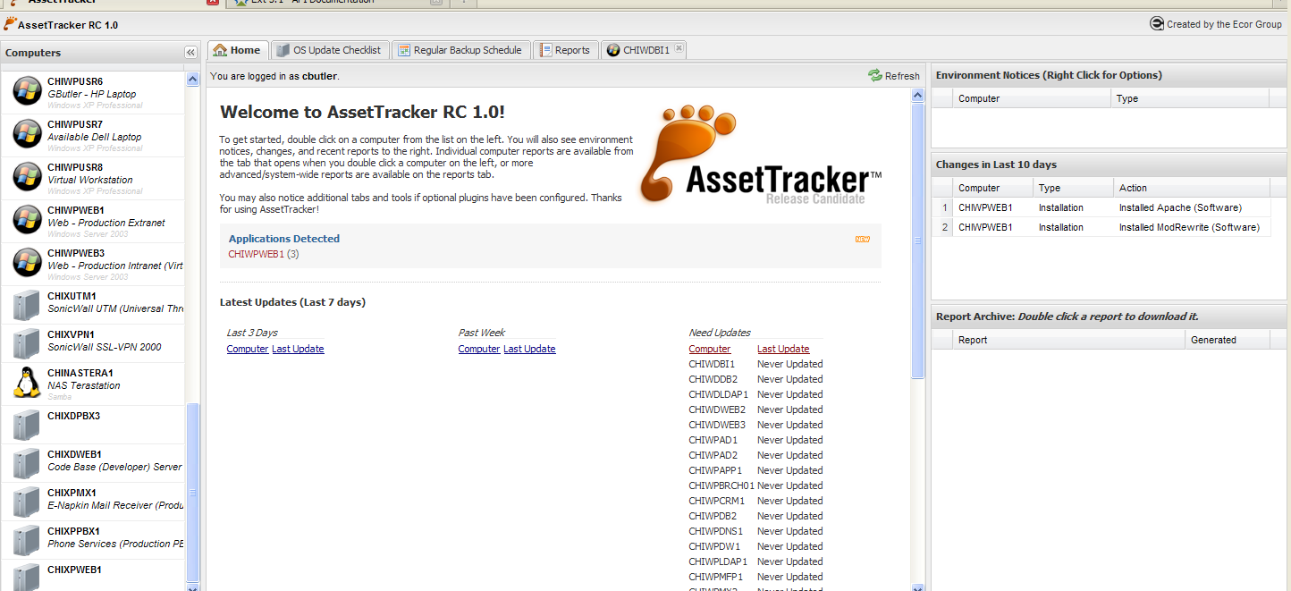

Dashboard

The dashboard is the primary screen which users are greeted with upon login. The left-hand side of the screen lists all of the devices found in the Active Directory domain. Double clicking or right-clicking on a device will open its properties in a new tab. Alternatively; there are several standard tabs available with additional tools.

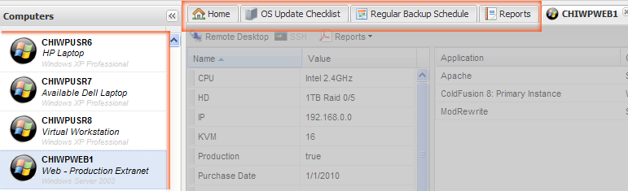

Tip: Right-click on a tab to close multiple tabs at once.

Computer Tracking

The tab that opens when a computer is double clicked is the primary documentation tool within AssetTracker. The screenshot below shows the basic layout.

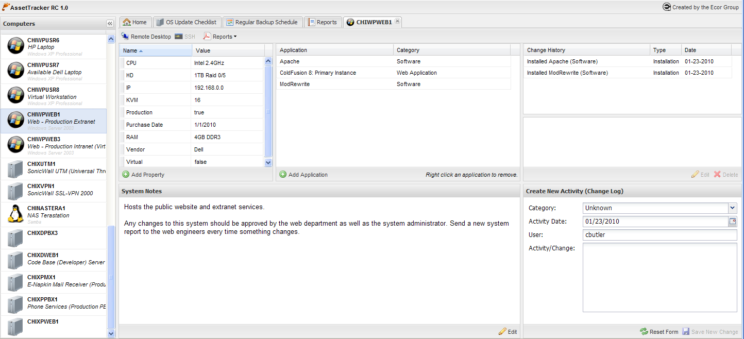

Computer Properties

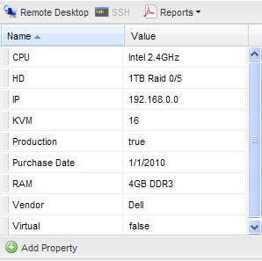
The image to the left shows part of the computer tab toolbar just above the properties pane. If the computer is Windows-based, clicking the Remote Desktop link will launch the system. There are 3 types of reports that can be generated for an individual computer, including:

- Full System Report
- Computer Properties & Applications
- Computer Change History Report

Properties can be changed in real time by clicking on the property name/value. A text editor will open in-row to make the changes. They are auto-saved the moment you click somewhere else (or press enter).

Clicking the “Add Property” button will launch a form.

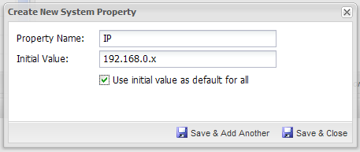
When a property is created, it is available for all computers. It is possible to use the initial value as the default for all systems. For example, setting an IP property to default to 192.168.0.x for all servers will save time typing in the IP address for every computer. Instead of typing a complete IP, only the x needs to be replaced.

Computer Applications
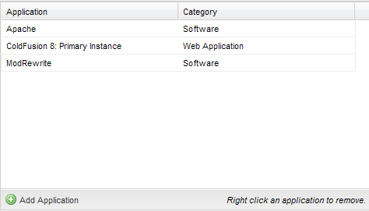
Applications can be associated with a specific computer using the Applications section. This is primarily useful for keeping track of specific instances. For example, a multi-server J2EE CF environment may have multiple servers with multiple instances of CF running on them. This tool helps keep track of what is running on each server. When adding a new application, a checkbox will allow you to automatically create a change record in the log if you add/remove an application.

Change Log

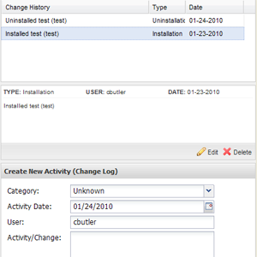
Each computer has its own change log tracking abilities. This can be found on the right side of the screen. New entries can be added using the form on the bottom, and existing entries can be viewed by selecting one from the list at the top.

Tip: If you’re searching through the logs, you can cycle through using the up/down keys instead of clicking each item with the mouse.

Though it is not recommended, the ability to edit a change is available. This is useful if you need to fix typos or correct an entry.

Individual change log reports are available (see Computer Properties) or a complete history can be generated from the Reports tab.

Computer Notes

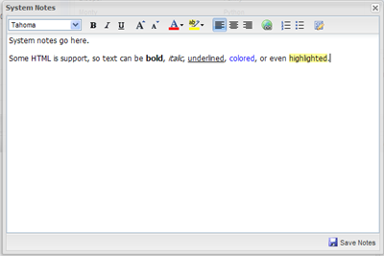
Notes can be shared about an individual computer. The system has a rich text editor capable of accepting limited HTML. These notes show up in reports and are shared amongst all users who use the system.

Reporting

The reporting system comes with two reports. The first is the Administrative Guide, which is a complete environment overview. This report generates a list of all computers and any properties you wish to include. You may also list applications, notes, and the physical location (as defined in Active Directory). As with all reports, it can be run and optionally saved to the report archive.

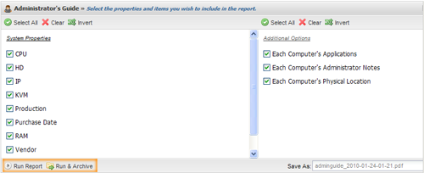

The other report is a basic change log, which can also be archived.

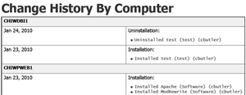

Report Archive

The report archive is a directory on the server where reports are saved. If your reports are not run frequently or take a long time to generate due to the amount of content, the archive will serve as a storage point. Users can access this from the Home tab or the Reports tab.

Add-On Modules

Please see the website for a review of add-on modules. http://open.ecorgroup.com.
Getting Started

AssetTracker has fairly minimal requirements to get started. However; it is important to review the requirements and follow the installation steps.

Requirements

- Microsoft Active Directory
- Adobe ColdFusion 8+
- MySQL or PostgreSQL database
- ExtJS 3.1 (Full Edition)

Requirement FAQ

Microsoft Active Directory

Active Directory does NOT need to be installed on the same server as ColdFusion. We do not recommend running ColdFusion or any web server on an Active Directory server.

File System Security

AssetTracker creates and removes several temporary files during the installation. Therefore, ColdFusion requires both read and write permissions. The use of the report archive feature also requires these permissions. By default, most ColdFusion instances are setup this way. However; if you’re leveraging network shares, DFS, or other remote disk space, it is important to make sure the account used for running ColdFusion has read/write permissions on these remote locations.

ColdFusion Alternatives

Railo and Blue Dragon may be viable alternatives to ColdFusion. However; AssetTracker has not been tested on these platforms (yet). If anyone does this, please share your results at http://open.ecorgroup.com.

Installing AssetTracker

AssetTracker comes bundled with a web-based installation wizard. To use the wizard, extract the zip file to your web root.

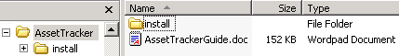

Point your browser to the install folder: http://<mydomain>/<myroot>/install.

In our example, the contents of the zip file were extracted to a folder called AssetTracker, which we created in the web accessible C:\Inetpub\wwwroot. We then point our browser to http://my.domain.com/AssetTracker/install.

If you are using Apache, you’ll likely place the files in the htdocs directory.

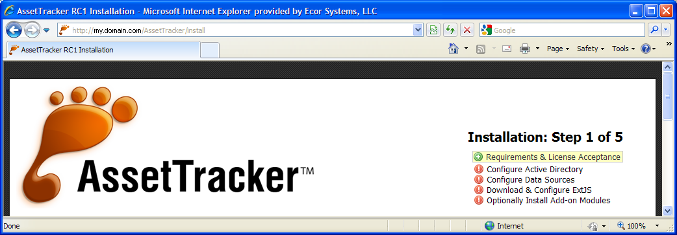

Follow the steps in the online wizard to complete the installation. If you have any problems, please use the troubleshooting section of this guide.

Installation Steps Preview: What to Expect

The installation consists of five straight-forward steps. Details of these steps have been outlined below:

- Requirements & License Acceptance
Read the license and accept the terms to continue.

- Configure Active Directory Connection
You will be asked for information to connect to Active Directory. This includes the IP address or DNS name of the Active Directory server, the Active Directory domain you’ll be connecting to, and a username/password with permissions to bind to and query Active Directory.

The Administrator account has appropriate permissions to do this, but connecting with a less privileged account is recommended. The password must be stored in plain text within the main.ini configuration file that’s generated during the installation. Most organizations create an account specifically for connecting to Active Directory, which has bind and read-only permission.

- Configure Data Sources
This tool was designed to use PostgreSQL or MySQL. It is possible alternative databases will work, but as of this writing, they have not been tested.

The installation wizard will automatically create a new data source for you in the ColdFusion administrator. Therefore, you must have your ColdFusion login and password available. You will be able to select the name for the new data source, but it does not support use of an existing ColdFusion DSN at this time. However; there are no restrictions regarding which database the DSN connects to.

If you wish to use an existing ColdFusion DSN, it is simplest to use the wizard to create a new DSN that points to the existing database you wish to use. Then follow the instructions in the troubleshooting guide entitled “Database Setup: Configuring for an Existing CF DSN”.

NOTICE: If you are reinstalling, the database install scripts will drop and recreate any existing tables. This means any data in these tables will be lost.

- Download & Configure ExtJS
If you already use ExtJS, you’ll be given the opportunity to specify its location. This is typically a relative path to the web root, or a complete URL (ex: http://my.domain.com/ext).

NOTICE: The FULL edition of ExtJS is required. The “core” edition does not contain the files necessary for AssetTracker to function properly.

By far, the simplest way to configure ExtJS is to let the installer download and install it for you. It will create a local directory in the <webroot>/js folder and configure everything for you.

- Optionally Install Add-on Modules
At the time of this writing, AssetTracker contains two add-on modules, including an update tracker and backup schedule tool. Both are simple documentation tools.

Update Tracker

This is not a network monitoring tool and therefore cannot recognize system updates applied to Windows or UNIX servers. However; many administrators still have to check servers to make sure updates are applied, perform system restarts, or simply check updates made by another administrator. This is especially true in smaller organizations and development environments. This tool is meant to help administrators keep track of their manual checks/updates.

Adding this component will add a tab to the interface. This tab contains a big checklist of all the systems found in Active Directory. Initially, all computers will all be marked as “Not Updated”. Administrators can click a button to mark a system as updated. If a system is not manually checked or updated within 30 days, it will be marked as outdated (showing up in red).

The tool also provides a “personal” list. You can drag and drop servers into a different order. For example, perhaps all virtual servers should be updated before physical servers. This list allows you to prioritize things in any order you like, allowing you to go through the systems in order, checking them off one by one. There is also a personal notes feature to store any additional information to help the individual administrator. These lists and notes are not shared with anyone else, but the main list of computers and whether they’ve been updated or not are.

Backup Schedule

Like the update tracker, this is not a network monitoring tool. It is a tool for administrators to document their backup schedule and share it with whoever needs the information. We suspect people will use this to check when backups are supposed to run.

This add-on creates another tab on the screen with an online list of backups. Reports come in two flavors, either a list or calendar view of the entire schedule. It is possible to keep track of notes as well, such as “Backs up C drive to the SAN”.
Customizing AssetTracker

AssetTracker can be customized in many ways. A Developer’s Guide will be included in the future (at http://open.ecorgroup.com) for those who wish to extend its functionality, but the purpose of this section is to provide information for those who want to customize the existing installation.

Security

The default security system uses Active Directory to validate a username/password. All authenticated users will be granted access by default. If you wish to restrict who can access the system to a specific group of users, you will need to change the Authentication function found in <webroot>/data/index.cfm, at approximately line 382.

A function called isAuthentic is defined in this page:

<cffunction name="isAuthentic" access="private" returntype="Boolean">
<cfscript>
return application.ldap.bind(f.usr,f.pwd);
</cfscript>
</cffunction>

This function calls the bind function of the LDAP object (<webroot>/data/ldap.cfc), which is cached in the Application scope (defined in <webroot>/Application.cfc).

Any custom authentication code can replace this functionality. As long as the function returns a true/false value, it will work.

If you want to limit access to a specific group of Active Directory users, it may be simpler to modify the bind function in ldap.cfc. This function contains a variable called filter, which is responsible for limiting the results of an Active Directory bind/login.

//Filter
filter = "distinguishedName="&dn;

This value can be changed to restrict access to a specific group. The following example restricts access to a user who is a member of the Domain Admins group.

//Filter
filter = "(&(distinguishedName=#dn#)(memberOf=CN=Domain Admins,CN=Builtin,DC=domain,DC=local))";

The filter is fundamentally an LDAP query, which is somewhat based on Scheme. Some good examples can be found at http://www.petri.co.il/ldap_search_samples_for_windows_2003_and_exchange.htm.

Reports

Several reports are included in the default installation. However; there may be situations where you want to create your own reports. Reports are written in standard ColdFusion (CFML/CFSCRIPT) and stored in the <webroot>/data/reports directory as .cfm files.

General.cfm (Report Template)

The simplest way to create a new report is to make a copy of the file located at <webroot>/data/reports/general.cfm. This file contains inline documentation that will help leverage the built-in report generator. The generator will create HTML or PDF output depending on the URL parameters defined. The content is defined in the variable request.out.

URL Variables

Variable | Values/Purpose
Format | Values: html, pdf  Determines whether the report will be displayed on screen or whether the user will be prompted to download a PDF file.
Save | Values: true/false  Defaults to false. Setting this to true will save a copy of the report as a PDF file in the report archive, regardless of which format it is being displayed as. If the report format is HTML, it will still be displayed on screen, but an additional PDF will be created. If the format is PDF, the file will be saved to the report archive prior to prompting the user to download it.
File | Values: Anything  This is a custom file name for a PDF report.

Example: Generate a PDF file called report.pdf and save it to the report archive:

http://domain.com/AssetTracker/data/reports/myreport.cfm?format=pdf&save=true&file=report.pdf

Report Formatting Variables

Several formatting features have been included for PDF files. These are also stored in the request scope and are defined in your report CFM file. These can be used to ignore URL variables or force specific layouts such as page orientation. The following variables can be set:

request.filename, request.format, request.save (true/false), request.overwrite (true/false), request.orientation (portrait/landscape), request.marginleft, request.marginright, request.marginbottom, request.margintop (margins default to .25)

Adding Custom Reports

The reports tab contains several stock reports.

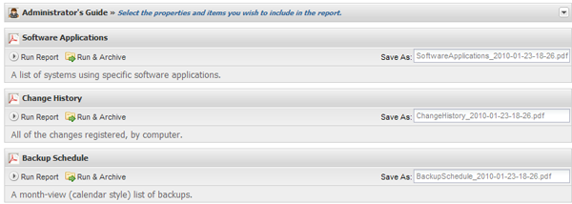

Once you have completed your new CFM report page (as described in the prior section) and placed it in the reports directory, you will need to update the configuration file located at <webroot>/config/addons.js. The contents of this file are shown below:

var reports = [{
title:'Administrator\'s Guide',
action:'networkinventory.cfm',
active:true,
ui:'report_networkinventory.js'
},{
title:'Software Applications',
action:'applicationreport.cfm',
active:true,
description:'A list of systems using specific software applications.'
},{
title:'Change History',
action:'changelog.cfm',
active:true,
description:'All of the changes registered, by computer.'
}];

If you created a backup report called backup.cfm, it needs to be added as shown below:

var reports = [{
title:'Administrator\'s Guide',
action:'networkinventory.cfm',
active:true,
ui:'report_networkinventory.js'
},{
title:'Software Applications',
action:'applicationreport.cfm',
active:true,
description:'A list of systems using specific software applications.'
},{
title:'Change History',
action:'changelog.cfm',
active:true,
description:'All of the changes registered, by computer.'
},{
title:'Backup Schedule',
action:'backup.cfm?format=pdf',
active:true,
description:'A month-view (calendar style) list of backups.'
}];
more….
Once you have saved the addons.js file, the reports section will contain your new report.

Dashboard Modifications

The dashboard is a simple CFM page that is included when AssetTracker is opened. You may change the content of this page to meet your needs.

There are a few limitations to be aware of. This page is loaded by JavaScript (ExtJS/AJAX) and is subject to the CSS styles of ExtJS. Certain CSS styles may cause the page not to work properly. This can occur when tags like CFDUMP are used, because they overwrite CSS and use HTML tags that cause ExtJS errors. It is also not (easily) possible to use new tags that leverage ColdFusion 9 JavaScript functionality, such as CFMESSAGEBOX.

The dashboard should generate standard HTML with no JavaScript. Any special styles should be included in the main.css file found in the <webroot>/style directory. The non-minified version of this file is available in <webroot>/SOURCE/styles.

Labels & Properties

If you wish to change the labels for any of the visual elements, you will need to modify the language resource bundle. The primary bundle can be found in <webroot>/config/rb.js. This is a non-compressed JavaScript file that can be edited to suit your needs.

Add-on modules use the Extended Resource Bundle object (xrb). This is defined at the top of each add-on’s JavaScript file. These files are minified by default, but the source code is available in the <webroot>/SOURCE/ directory.

If you create a resource bundle for other languages, please contribute the code to the project at http://open.ecorgroup.com.

Adding New Modules AFTER Installation

If you want to add a module, such as the update tracker or backup schedule tool, the <webroot>/config/addons.js file will require modification.

This JavaScript file contains an array of objects called modules, which is included at runtime. This variable is responsible for determining any additional tabs included in the main application.

var modules = [
{module:'updatetracker.js',active:false,dashboard:'updates.cfm'},
{module:'backup.js',active:false,dashboard:'backups.cfm',ux:'RowExpander.js,Spotlight.js'}
];

If you simply want to enable one of the built-in modules, change the active attribute from false to true. If you want to add another module, you will need to add a new object to the array that identifies the add-on.

A “module object” contains a minimum of two attributes and a maximum of 4. The following table provides a breakdown:

Object Attribute | Required | Purpose
module | Yes | Identifies the module’s JavaScript file. This file should be an ExtJS extension of the Panel class. All modules are stored in the <webroot>/js/modules directory.
active | Yes | true/false. Indicates that the module is “on”. If set to true, AssetTracker will try to include the module JavaScript file included above as a new tab.
dashboard | No | This is the name of a .cfm file located in <webroot>/data/dashboard. If defined, this file will be automatically included on the Home tab. For more information about the dashboard, please review the Dashboard Modifications section.
ux | No | This is a comma delimited list of ExtJS-based user extensions found in <webroot>/js/ux. This is most commonly used when a custom module requires plug-in or additional resources. These files are included before the file defined in the module attribute.

The following example would add a custom module with a dashboard element and make it active. Once complete, save the file and open AssetTracker.

var modules = [
{module:'updatetracker.js',active:false,dashboard:'updates.cfm'},
{module:'backup.js',active:false,dashboard:'backups.cfm',ux:'RowExpander.js,Spotlight.js'},
{module:'custom.js',active:false,dashboard:'custom.cfm'}
];

Tip: Notice the placement of the comma.

Troubleshooting

This section is meant to be a reference for getting started with AssetTracker and using its features. Questions and feedback can be asked/answered at http://open.ecorgroup.com.

Installation

Active Directory Configuration: Authorization Failure

Associated Error:
LDAP Error Code 49. User is not authorized.

Unlike LDAP, Active Directory requires a bind to occur before it can be queried. A bind is similar to a login, wherein a username and password is required before any connections will be established. However; sometimes the “username” is not enough depending on the configuration and version of Active Directory. In Active Directory terms, the “username” is actually the sAMAccountName attribute. The LDAP equivalent is UID. However; most bind actions use the distinguishedName attribute for the “username”, which is sort of like the primary key or unique ID in an AD/LDAP environment.

AssetTracker tries to determine the distinguishedName of the username entered on the AD configuration step of the wizard, but due to idiosyncrasies in account names, it is sometimes impossible to determine. In this case, you can enter the distinguishedName manually into the AssetTracker installation wizard.

Acquiring the distinguishedName value

The distinguishedName can be found using ADSI Edit on the Active Directory server. This is a FREE MMC Snap-in. The following steps will guide you through the setup and use of ADSI Edit. Depending on the version of Windows you’re using, it may be necessary to download these additions, which are often part of the Windows Server Resource Toolkits.

Step 1: Launch MMC
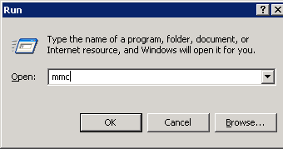
Go to Start→Run and type mmc.
This will launch the MMC tool. From the file menu, select Add/Remove Snap-In.
Step 2: Add ADSI Edit

Click the Add button shown below.  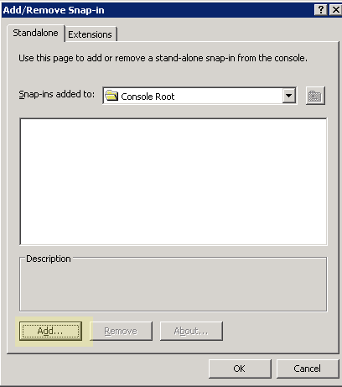 | Select ADSI Edit from the list and click Add.  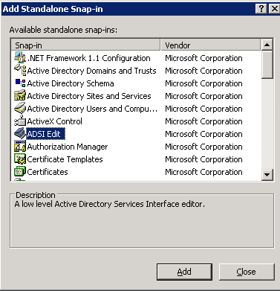

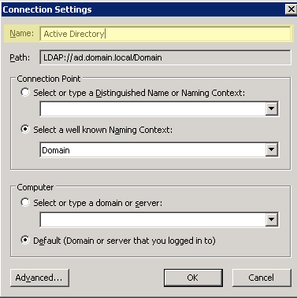
Step 3: Connect to Active Directory

Right click on ADSI Edit and select Connect to. This will bring up the connection settings window shown on the right. If you intend to save this snap in for future use, give it a meaningful name in the highlighted area shown to the right.

If you are logged onto the server as an administrator, simply click OK and it should connect to Active Directory.
Step 4: Find the User

Expand the folders until you find one called CN=Users (or whichever OU/CN where your bind account has been saved). The first screen below shows the Administrator account in its default location. Once you have found the user account you wish to connect with, right click on it and select properties. This will bring up the properties menu shown in the second screen below. Select the distinguishedName attribute and click the Edit button. You can then copy the value from the edit box that pops up (Last screenshot).

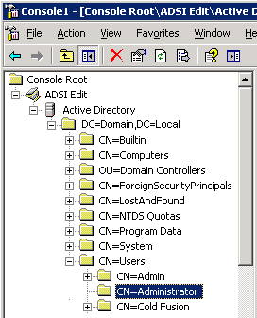 | 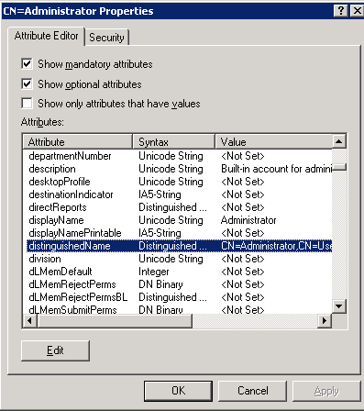

Copy the distinguishedName value and paste this into the Username field in the installation wizard.

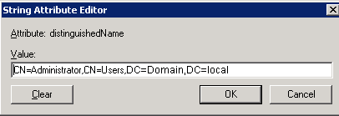

You can save the snap-in if you wish, but this should be all the information you need to complete the Active Directory portion of the wizard.

Active Directory Configuration: SSL & Ports

The AssetTracker installation uses the default port values for connecting to Active Directory. This is port 389, or port 689 for SSL. If you’ve configured a different port, you’ll need to update the installation source file called install/ad.cfm.

Change line #22 from

customport = form.port;

to

customport = “your_port_number”;

Then restart the installation.

Database Setup: Security

If you are receiving errors when creating the data source, make sure you check the permissions on the database user. This account must have permission to create and drop tables, alter them, add keys, etc.

If you are operating a high-security environment, it is recommended to grant the database user account full permissions for the install. Once the installation is complete, the only permissions required to run AssetTracker are INSERT, UPDATE, DELETE, and SELECT.

Database Setup: Configuring for an Existing CF DSN

The installation wizard creates a new data source by default. If you pointed this data source to an existing database, then you will have two data sources in the ColdFusion administrator that both point to the same database. In order to use a single data source, you’ll need to make a change in the AssetTracker configuration. A directory called config is generated under the web root upon completion of the installation. In this directory, a file called main.ini exists. Open this file and find the DNS section. It should be set to whatever data source you specified in the installation. Change this setting to the data source you wish to use and save the file.

If you have already launched AssetTracker, you may need to restart the application. A special page has been created to do this. Launch it using http://<mydomain>/<myroot>/start.cfm. This will reset all of the application variables so the application uses the new values in the main.ini file.

After this is complete, it is safe to remove the unused data source from the ColdFusion administrator.

General Errors

Encryption has failed

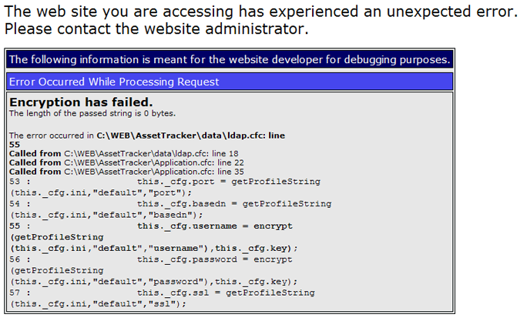
If you receive this error, double check the first section in <webroot>/config/main.ini. It is likely a value is missing (typically username). This is an uncommon error, but has occurred during reinstallation processes that occur within close proximity of the original/failed installation. Once the file is corrected, the application should run (no need to reinstall again).

If the username is not blank, you may have the wrong syntax. The username should be the distinguishedName of the user, not the sAMAccountName. For more information about finding the distinguishedName of an Active Directory user, please see the Acquiring distinguishedName section in Active Directory Configuration: Authorization Failure.

Screen Hangs on Load

In rare occasions, the screen fails to load and throws JavaScript errors. If this occurs, it is typically the very first time the page has been loaded (i.e. immediately after installation). A simple page refresh should fix the issue, or a browser restart. This has only been seen during testing with Microsoft IE 8 using compatibility mode.

The installation wizard has an option to automatically download and install ExtJS 3.1. This process requires an active internet connection in order to reach extjs.com

