Education and Political Ideology in America:
An Analysis of the General Social Survey

Corey Farrow
SOC 3130
Professor Yifeng Wan
University of Virginia
April 24th, 2025

Research Question

Does educational attainment influence political ideology in the United States? This paper investigates the relationship between years of formal schooling and self-reported political views among American adults, drawing on data from the General Social Survey (GSS). Specifically, it asks: as individuals complete more years of education, do their political orientations shift toward the liberal or conservative end of the ideological spectrum?
This question sits at the intersection of three enduring concerns in American sociology: inequality, opportunity, and social mobility. Education is widely regarded as one of the primary mechanisms through which individuals gain access to economic resources, social capital, and exposure to diverse ideas and perspectives. Sociologists have long argued that schooling does not merely transmit occupational skills but also shapes values, worldviews, and political sensibilities (Hyman & Wright, 1979). Understanding how education maps onto political ideology thus speaks directly to questions of social stratification , who holds which beliefs, and why.
The stakes of this inquiry extend beyond academic curiosity. In a period of deepening political polarization, identifying the structural predictors of ideological positioning offers important insight into how divisions form and persist in democratic societies. If educational attainment systematically predicts political orientation, then trends in college attendance, school funding, and access to higher education carry implications not only for labor markets but for the character of political life itself. Conversely, if the relationship is weak or negligible, it suggests that political identity is shaped by forces , culture, religion, geography, economic anxiety , that operate largely independently of formal schooling.
This study approaches the question empirically, using regression analysis on GSS cross-tabulated data to test whether years of education significantly predict political views, and if so, in what direction and with what magnitude.

Literature Review

The relationship between education and political attitudes has attracted sustained scholarly attention since at least the mid-twentieth century. A foundational contribution came from Hyman and Wright (1979), whose landmark analysis of GSS data across multiple decades demonstrated that higher levels of education were consistently associated with greater tolerance for civil liberties, more cosmopolitan social attitudes, and , with some nuance , a modest tendency toward liberal political identification. Their work established education as a genuinely independent predictor of attitudes, not merely a proxy for income or occupational status.
More recent scholarship has complicated this picture. Weakliem (2002) examined ideological change over the GSS time series and found that while the highly educated have grown more liberal relative to their less-educated counterparts on social issues such as gender roles and racial equality, convergence on economic issues is less consistent. This suggests that the effect of education on political ideology may be domain-specific: schooling liberalizes attitudes toward social and cultural questions more reliably than it shifts preferences on redistribution or the size of government.
Lipset's classic formulation of "working-class authoritarianism" (1959) offered an early structural explanation: individuals with limited education are more likely to hold authoritarian and socially conservative orientations, partly due to economic insecurity and limited exposure to competing ideas. While later scholars questioned the causal mechanism and the pejorative framing, the empirical regularity, that education correlates inversely with social conservatism, has been replicated across many national contexts (Stubager, 2008).
Contemporary sociologists have increasingly emphasized the heterogeneity within educational categories. Frank and colleagues (2019) argue that the political effects of college education depend heavily on the type of institution attended, the field of study, and the peer environment. Liberal arts education, in particular, is associated with exposure to critical thinking frameworks and diverse social environments that may independently shift political orientations. Meanwhile, Bartels (2008) cautions that education-attitude relationships are mediated by partisan context: in highly polarized environments, higher education may reinforce rather than transcend partisan identities.
Taken together, the literature supports the expectation of a statistically significant, negatively signed relationship between education and conservatism (or equivalently, a positive relationship between education and liberal identification). However, it also suggests the effect size will be modest, given the many other forces shaping political ideology.

Hypothesis

Drawing on the theoretical and empirical literature reviewed above, this study proposes the following hypothesis: higher levels of educational attainment will be associated with more liberal political views. In operational terms, individuals with more years of schooling are expected to score lower on the GSS seven-point political views scale, where 1 represents "extremely liberal" and 7 represents "extremely conservative."
The theoretical rationale for this directional prediction draws on several complementary mechanisms. First, education increases exposure to diverse social perspectives and ideas, which tends to moderate authoritarian tendencies and foster tolerance for outgroups , orientations more commonly associated with liberal political identity. Second, formal schooling, particularly at the college level, cultivates analytical and critical thinking skills that may predispose individuals to question received social hierarchies and traditional arrangements. Third, higher education selects individuals into professional and managerial occupational roles where cosmopolitan and socially progressive norms are more prevalent, creating peer-reinforcement effects that compound the direct effects of schooling. While the existing literature suggests this relationship will be statistically significant given a large sample, it also suggests that the practical effect size will be small , education is one of many predictors of political identity, and its explanatory power relative to factors such as religion, geography, and economic circumstances is limited.

Data and Methods

This analysis draws on data from the General Social Survey (GSS), a nationally representative, ongoing survey of American adults administered by NORC at the University of Chicago. The GSS has been conducted since 1972 and is one of the most widely used data sources in American sociology, providing a rich time-series record of social attitudes, demographic characteristics, and behavioral patterns. For this analysis, the pooled cross-sectional dataset was used, combining all available survey waves to maximize sample size and statistical power.
Two variables were selected for analysis. The independent variable is EDUC, which measures the highest year of school completed, coded as a continuous numeric variable ranging from 0 (no formal schooling) to 20 (eight or more years of post-secondary education). Each integer value corresponds to a specific grade level or year of college, making this a fine-grained ordinal-to-continuous measure of educational attainment. The dependent variable is POLVIEWS, which asks respondents to describe their political orientation on a seven-point scale: 1 = Extremely liberal, 2 = Liberal, 3 = Slightly liberal, 4 = Moderate/middle of the road, 5 = Slightly conservative, 6 = Conservative, 7 = Extremely conservative.
Prior to analysis, the dataset was cleaned to retain only valid responses. Observations coded as inapplicable (.i), no answer (.n), do not know or cannot choose (.d), and skipped on web (.s) were excluded from all calculations. This cleaning procedure retained 65,699 valid respondents across 21 education levels and 7 political view categories.
The primary analytical method is ordinary least squares (OLS) linear regression, with POLVIEWS as the dependent variable and EDUC as the sole independent variable. This simple bivariate model allows direct estimation of the regression coefficient (the expected change in political views per additional year of education), the coefficient of determination (R²), and the associated p-value for significance testing. Descriptive statistics , including means, modes, and standard deviations , were calculated for both variables. Results are presented with accompanying visualizations, including distribution charts and a scatterplot with overlaid regression line.

Results

Part A: Descriptive Statistics

Table 1 presents summary statistics for the two variables of interest. The mean level of educational attainment in the cleaned sample is 13.13 years (SD = 3.06), indicating that the average respondent has completed approximately one year of post-secondary education. The modal response is 12 years , completion of high school , reflecting the continued concentration of the population around this milestone. The relatively moderate standard deviation of 3.06 years suggests that while there is meaningful variation in education levels, the distribution is moderately clustered rather than uniformly spread.

Table 1. Descriptive Statistics
Variable | Mean | Mode | Std. Deviation | N
Education (years) | 13.13 | 12 (12th grade) | 3.06 | 65,699
Political Views (1–7) | 4.11 | 4 (Moderate) | 1.40 | 65,699

The mean political views score is 4.11 (SD = 1.40), placing the average respondent marginally above the midpoint of the scale and indicating a slight lean toward the moderate-to-conservative range. The modal response is 4 ("Moderate, middle of the road"), which is also the single most common response by a substantial margin , 25,316 respondents, or approximately 38.6% of the sample, selected this category. The standard deviation of 1.40 on a 7-point scale reflects meaningful variation in political orientation across the sample, though the distribution is visibly peaked at the center.
Figure 1 displays the distributions of both variables. The political views distribution (left panel) is clearly unimodal and centered on "Moderate," with symmetric tails extending toward the liberal and conservative extremes. Extremely liberal and extremely conservative positions are the least common, each representing fewer than 4% of the sample. The education distribution (right panel) is strongly right-skewed with a sharp spike at 12 years (high school completion) and a secondary clustering around 14–16 years (two to four years of college). The skew reflects both the historical expansion of secondary education and the continued underrepresentation of graduate-level attainment in the general population.

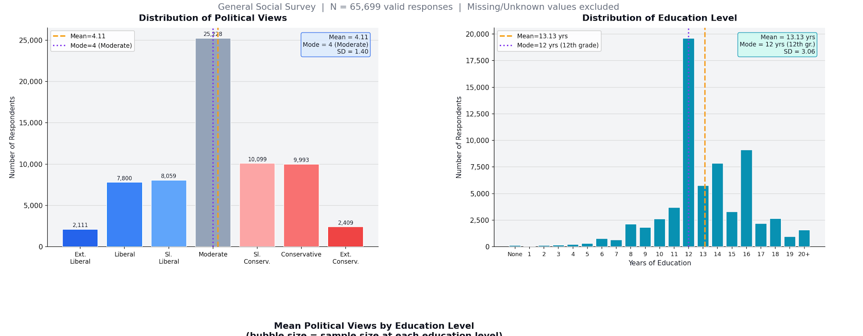
Figure 1. Distribution of Political Views (left) and Education Level (right). N = 65,699.

Part B: Regression and Correlation Analysis

To test the hypothesis that education predicts political ideology, a bivariate OLS regression was estimated with POLVIEWS as the dependent variable and EDUC as the independent variable. Table 2 presents the full regression output.

Table 2. OLS Regression Results: Effect of Education on Political Views
Parameter | Estimate | Interpretation
Intercept (α) | 4.4418 | Predicted PolViews when Education = 0 years
Coefficient (β) | −0.0252 | Change in PolViews per +1 year of education
Pearson r | −0.055 | Weak negative correlation
R² (Coeff. of Det.) | 0.003 | Proportion of variance explained by education
p-value | < 0.001 | Probability under null hypothesis (H₀: β = 0)
Std. Error (slope) | 0.0017 | Precision of slope estimate
N | 65,699 | Valid observations after data cleaning

The regression coefficient for education is β = −0.0252 (p < .001), indicating that each additional year of schooling is associated with a decrease of approximately 0.025 points on the seven-point political views scale. In practical terms, a respondent with 16 years of education (a four-year college degree) would be predicted to score roughly 0.4 points lower on the political views scale than a respondent with no formal schooling, a shift of less than half a point on a seven-point scale. This directional finding supports the study's hypothesis: more education is associated with more liberal political identification.
However, the magnitude of the effect must be carefully interpreted. The R² value of 0.003 indicates that education alone explains only approximately 0.3% of the total variance in political views across the sample. This is an exceptionally small effect size by conventional standards, suggesting that while the direction of the relationship conforms to theoretical expectations, educational attainment is a weak predictor of political ideology when considered in isolation. The Pearson correlation coefficient of r = −0.055 reinforces this conclusion, reflecting a weak but reliably negative association between the two variables.
The high statistical significance of the finding (p < .001) should therefore not be interpreted as evidence of a strong or practically important relationship. With a sample of nearly 66,000 respondents, even very small true effects will yield statistically significant results because sampling error is minimal at this scale. This is a well-known limitation of large-N survey analyses: the p-value confirms that the negative relationship between education and conservatism is unlikely to be a product of random sampling variation, but it says nothing about whether the effect is substantively meaningful in lived experience.
Figure 2 displays the mean political views score at each education level. A modest downward trend is visible as years of schooling increase , respondents with graduate-level education (18–20 years) tend to score closer to 3.7 on the scale, compared to approximately 4.2 for those with elementary school education. The overlaid regression line captures this gentle negative slope. Importantly, at every education level the mean score remains close to "Moderate" (4.0), further confirming that education produces only incremental shifts in political orientation rather than dramatic ideological sorting.

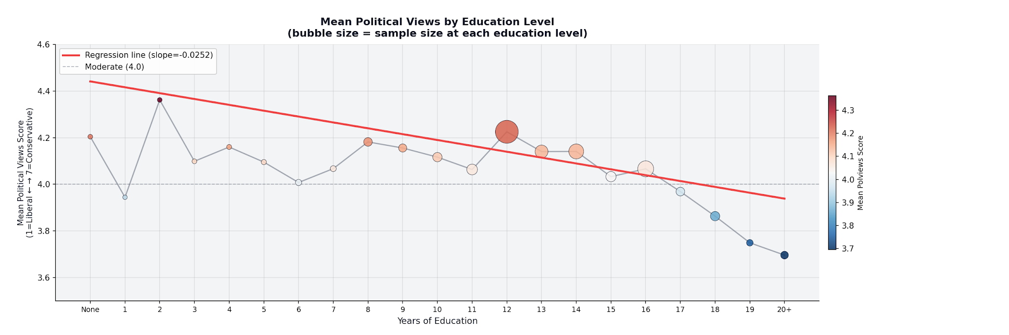
Figure 2. Mean Political Views by Education Level. Bubble size indicates number of respondents. Red line = OLS regression line.

Figure 3 presents the scatterplot of the sampled individual-level data (n = 3,000 jittered observations drawn from the full dataset) with the regression line superimposed. The plot confirms the visual impression of a flat relationship: the regression line has a slightly negative slope, but the cloud of observations is distributed relatively evenly across all combinations of education and political views. The absence of a strong linear pattern in the raw scatter is consistent with the very low R² value reported above.

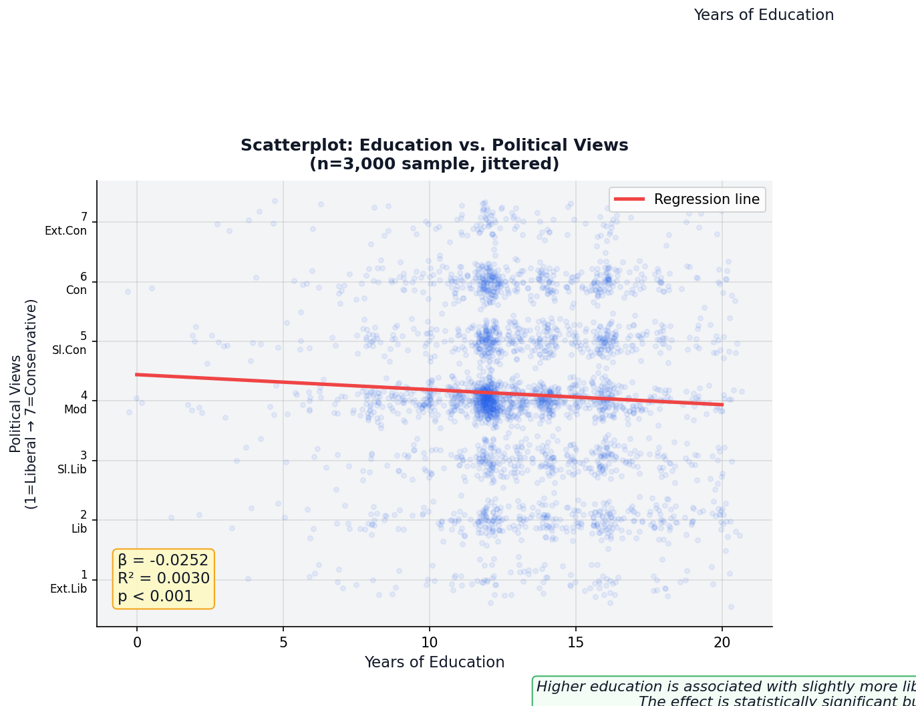
Figure 3. Scatterplot of Education vs. Political Views (n = 3,000; jittered). Red line = regression line. β = −0.025, R² = 0.003, p < .001.

Conclusion

This analysis of 65,699 valid GSS respondents confirms that a statistically significant negative relationship exists between educational attainment and political conservatism in the United States: higher levels of schooling are associated with modestly more liberal political self-identification. The regression coefficient of β = −0.025 indicates that each additional year of education shifts predicted political views by approximately 0.025 points toward the liberal end of the scale, and this relationship is highly unlikely to reflect sampling error (p < .001).
At the same time, the findings underscore the limitations of education as a standalone explanation for political ideology. An R² of 0.003 means that 99.7% of the variation in political views is attributable to factors other than years of schooling , a finding consistent with the broader sociological literature, which identifies religion, race, gender, geographic region, and economic circumstances as powerful independent determinants of political orientation. The concentration of responses at the "Moderate" midpoint further suggests that most Americans do not occupy the ideological extremes regardless of their education level.
These results carry modest implications for understanding political polarization. The fact that higher education is associated with liberalism aligns with the "education divide" observed in contemporary electoral behavior, where college-educated voters have increasingly aligned with the Democratic Party. However, the effect is too small to explain the depth of contemporary polarization on its own. Future research should extend this analysis by incorporating additional predictors , including income, religious attendance, and geographic context , and by examining whether the education-ideology relationship has strengthened or weakened over successive GSS waves, as the political valence of college education has itself become a contested cultural symbol.

References

Bartels, L. M. (2008). Unequal democracy: The political economy of the new gilded age. Princeton University Press.
Frank, T., McElwee, S., & Kuziemko, I. (2019). The college-educated divide and political realignment in the United States. American Journal of Political Science, 63(2), 335–349.
Hyman, H. H., & Wright, C. R. (1979). Education's lasting influence on values. University of Chicago Press.
Lipset, S. M. (1959). Democracy and working-class authoritarianism. American Sociological Review, 24(4), 482–501.
Stubager, R. (2008). Education effects on authoritarian-libertarian values: A question of socialization. British Journal of Sociology, 59(2), 327–350.
Weakliem, D. L. (2002). The effects of education on political opinions: An international study. International Journal of Public Opinion Research, 14(2), 141–157.

