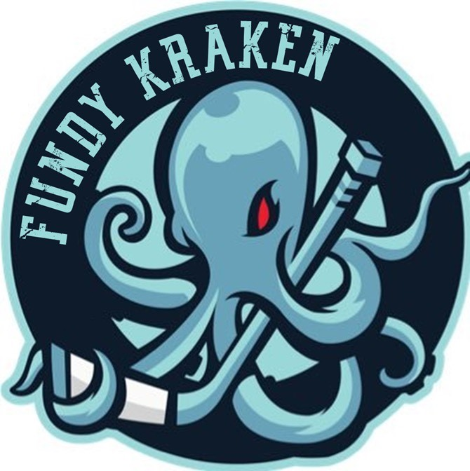
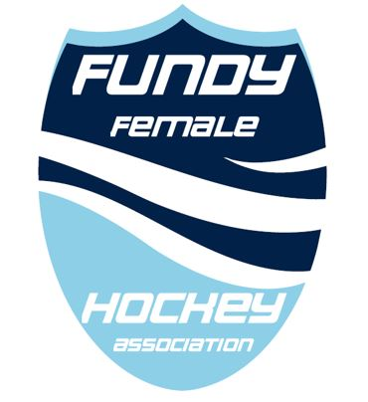
“DEVELOP A CLEAN, FUN, PROFESSIONAL BRAND OF FEMALE HOCKEY THROUGH GOOD SPORTSMANSHIP, FAIR PLAY AND GOOD CITIZENSHIP”
Tanya Boyer  Team Manager – Female U15 AA  tanyaaboyer@gmail.com  506-653-7353  www.fundyfemalehockey.ca |  | To Whom It May Concern,  The Fundy Female Hockey Association is an initiative that aims to provide the absolute best of programming for aspiring young female hockey players. FFHA’s target membership is all female hockey players, from the grassroots level to competitive U18, within the Southern New Brunswick Region (Sussex – St. Stephen).  FFHA strives to grow the female game through uniting under a common set of ideals. Our focus will be on wellness and development.  The U13 AA Kraken is a group of 13 and 14 year old hard working, dedicated young women that want to strive to be the best they can be both on and off the ice. This team will be playing in the newly formed Provincial U15 AA league where they will be playing against the top U15 female players in New Brunswick.  This group is asking for your support to offset tournament fees, travel expenses and to purchase team attire.  Thank you for your consideration,  Tanya Boyer

