Risktionary User Manual
A guide for researchers and hosts running Risktionary sessions, including studies of AI-generated feedback. The host can use it to explain the game to players.
Screenshots were taken from the current version of the application. Player names are examples, and the host's name and email are shown as "Host Researcher" and "host@example.com".

1. What Risktionary is
Risktionary is Pictionary for software project risks. In each round one player draws a risk, such as Burnout, and everyone else races to guess it in a chat. The group then rates how likely and how severe the risk is, the risk and its description are revealed, and points are awarded.
The game practises three risk management activities:
Activity | Where it happens in a round
Identify what could go wrong | Guessing the drawn risk
Assess how likely and how serious it is | Rating likelihood and severity
Respond: what would we do about it? | Word review: the risk's description, and class discussion

While players guess, an AI gives each player personal feedback on their wrong guesses (see Section 5).

Roles
Role | Who | Needs an account?
Host | The researcher or teacher running the session. Creates the game, picks the drawer, controls the pace. Does not guess. | Yes: signs in with Google or Microsoft
Drawer | One player per round, picked by the host from volunteers | No
Guessers | Every other player | No: joins with the game code and a display name

2. Before a session (host)

2.1 Sign in
Open the Risktionary website and sign in with Google or Microsoft at the bottom of the home page. Once you're signed in, the home page shows a Create Game link, and the top bar shows Manage Words and Create Game.
Not signed in (what players see) | Signed in as host
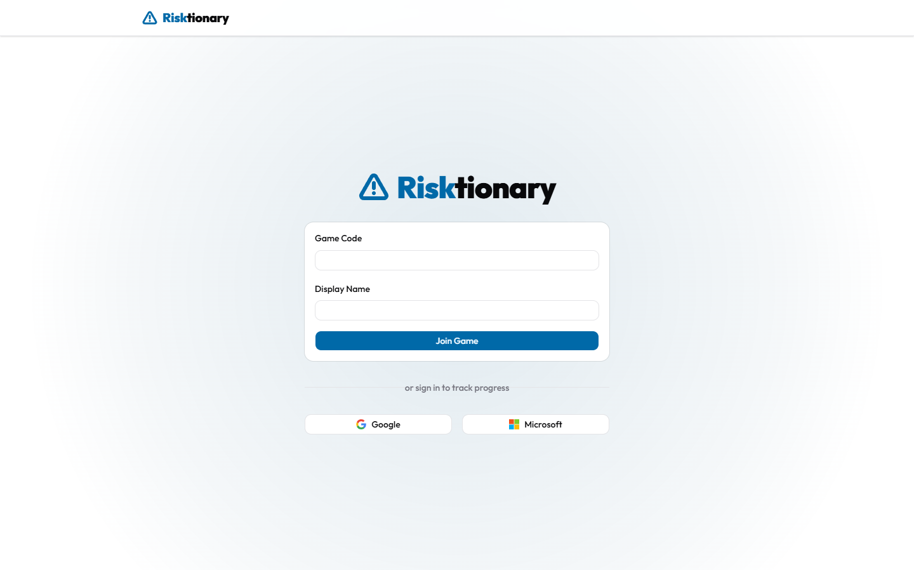 | 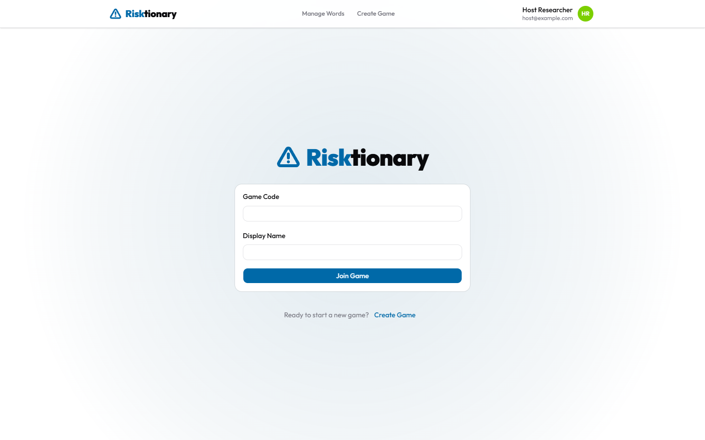

2.2 Prepare the word bank
Each round uses one risk from the word bank. Open Manage Words to see the Word Library.
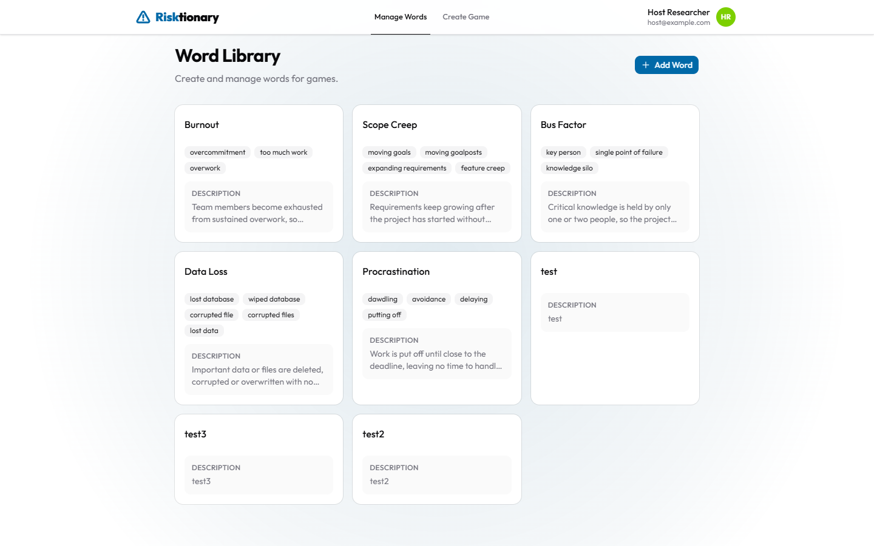
- Add a word: click Add Word, then fill in:
- Word: the risk players must guess (e.g. Scope Creep).
- Synonyms/Close Matches: other answers that also count as correct (e.g. feature creep, moving goalposts). Type one and press +. Guesses are matched exactly, ignoring capital letters, so add common variants and spellings.
- Description: shown to everyone after the round, during the word review. Explain what the risk is and how to deal with it. The AI also uses the description when writing feedback.
- Edit or delete a word: click ⋯ on its card, then choose Edit or Delete.
Word card menu | Editing a word
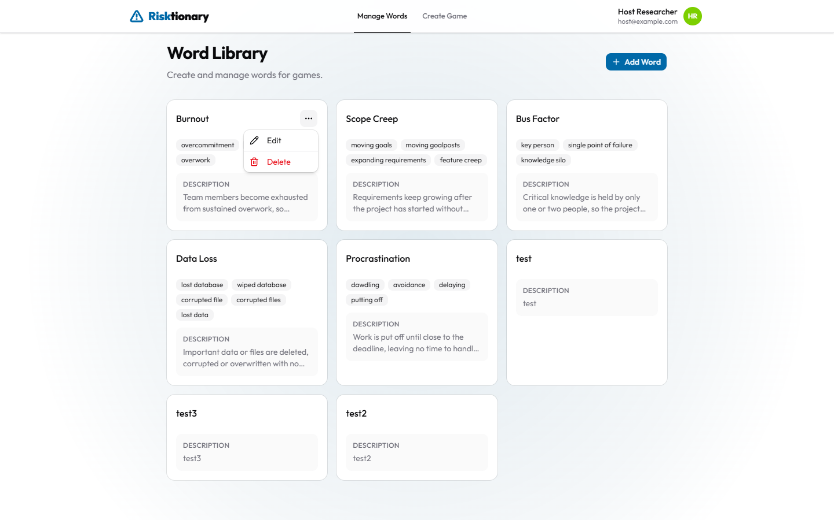 | 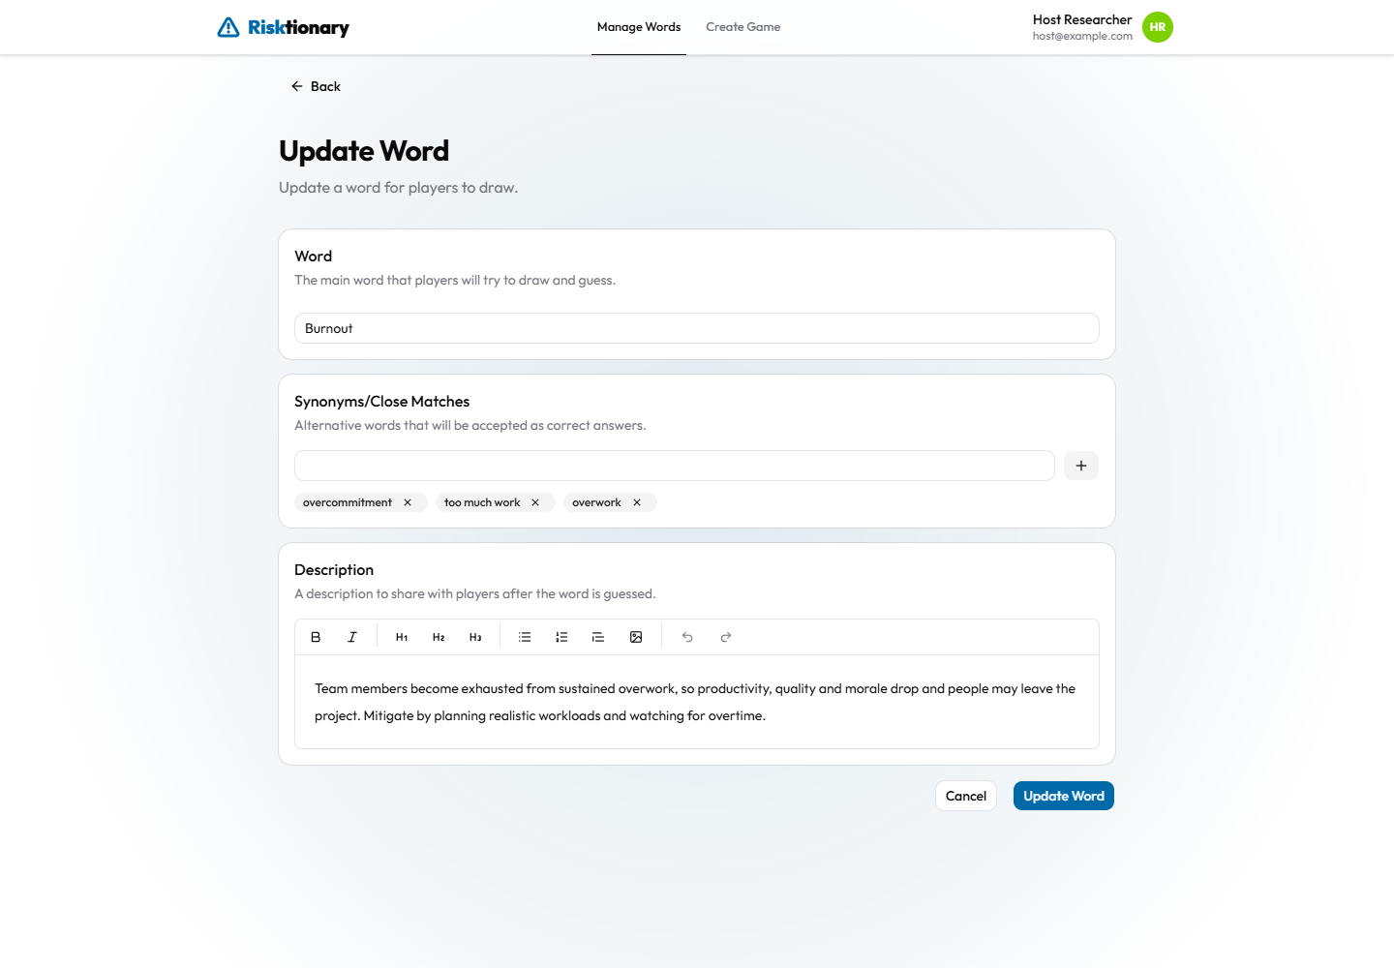

Tip: good synonyms matter. In the pilot study, about one in five wrong guesses were typos or close variants (for example "eaerthquake"), and they were marked wrong.

3. Creating a game (host)
Click Create Game. The form has three sections, with a summary card on the right.
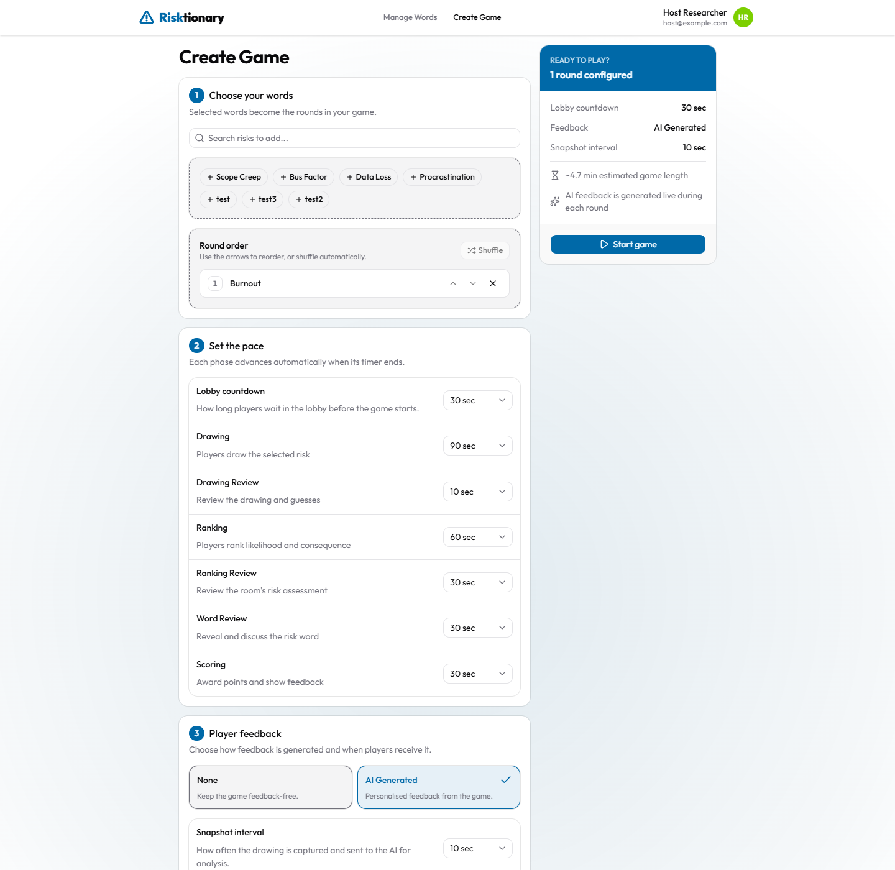
1. Choose your words. Search for risks and click them to add them. Each word becomes one round. Use the arrows to reorder the rounds, or Shuffle them.
2. Set the pace. Choose how long each phase lasts:
Setting | What it controls | Default
Lobby countdown | Countdown after you press Start Game | 30 s
Drawing | Time to draw and guess | 90 s
Drawing Review | Answer shown with the chat | 10 s
Ranking | Time to rate likelihood and severity | 60 s
Ranking Review | Group results on the risk matrix | 30 s
Word Review | Risk description shown, for discussion | 30 s
Scoring | Round results and feedback | 30 s

Choosing No timer makes a phase wait until you press Skip. The summary card estimates the game's total length.
3. Player feedback. Choose AI Generated for a feedback study.
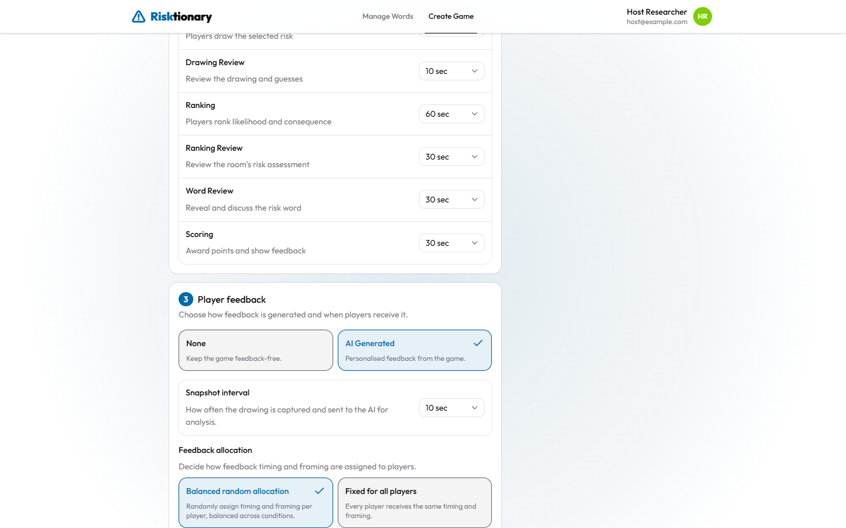
Important: the feedback options currently have no effect. The backend always uses AI-generated feedback with balanced random allocation, whatever this section says. Choosing None, or Fixed for all players with a particular timing and framing, is ignored. Select AI Generated and Balanced random allocation so the form matches what actually happens. This is a known gap in the code (see the backend docs/architecture.md, "Known gaps").
Click Start game to open the lobby.

4. Running a game

4.1 Lobby: players join
The host's screen shows a large game code. Display it on the projector.
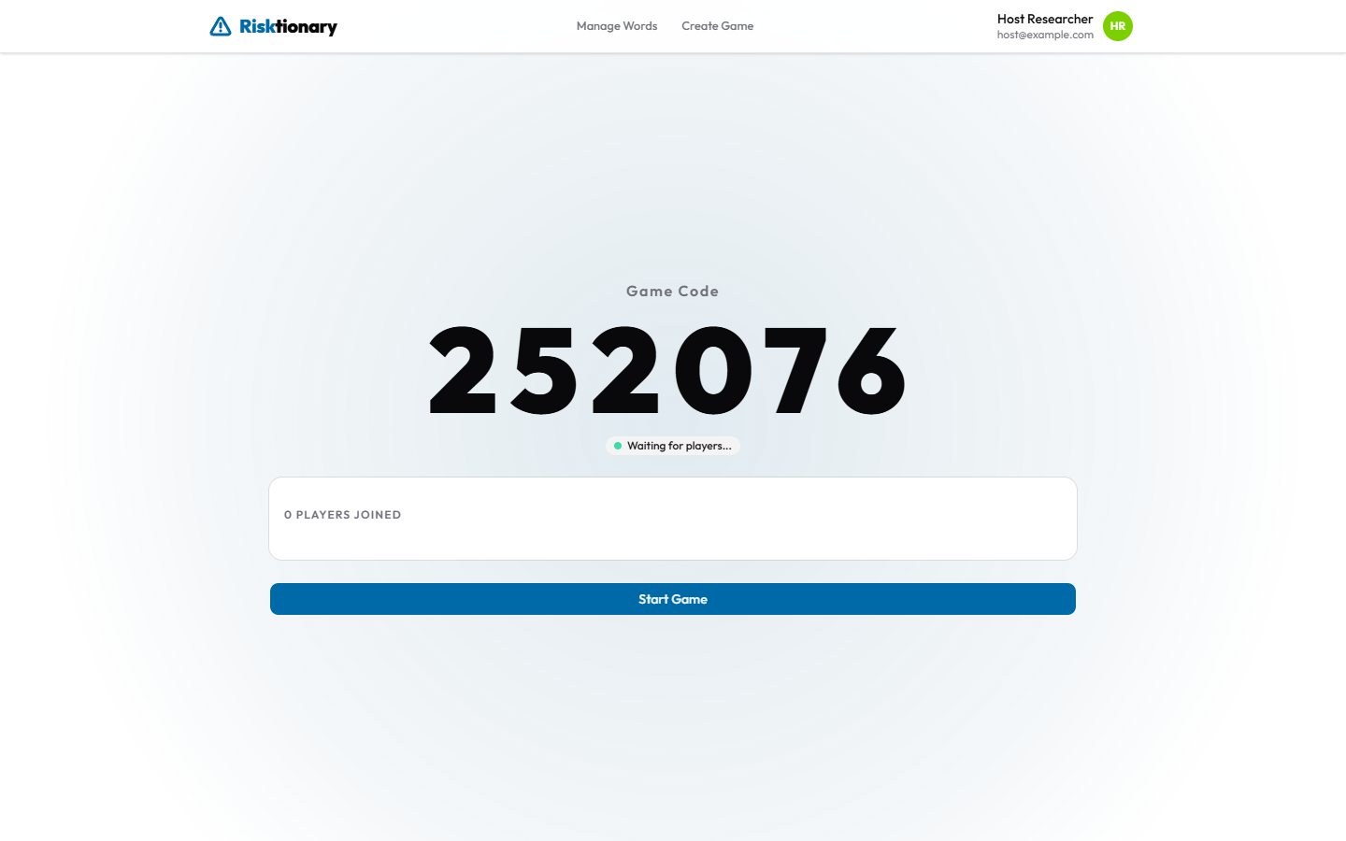
Players open the website on their own device, enter the Game Code and a Display Name, and press Join Game. They don't need an account. Each player appears in the lobby as they join.
Player joining | Host lobby with 5 players
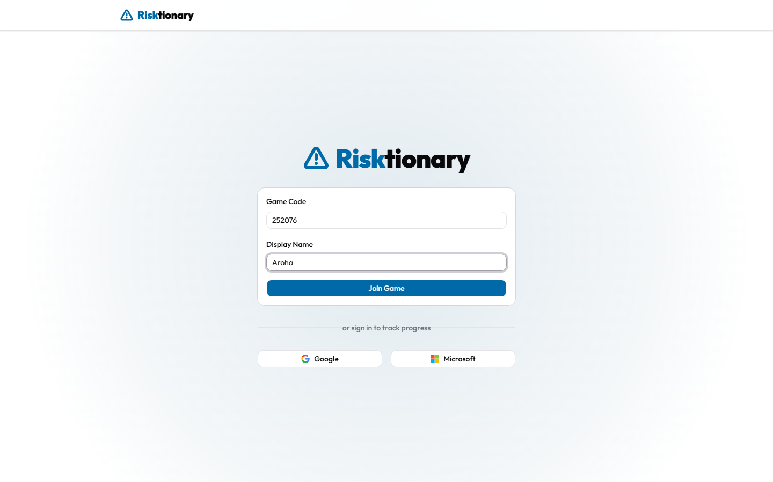 | 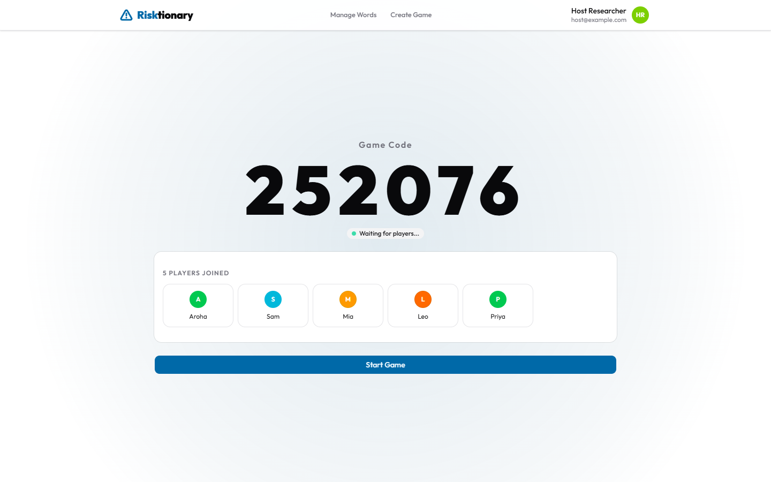

When everyone has joined, the host presses Start Game. A countdown runs (the host can Skip it), during which late players can still join.
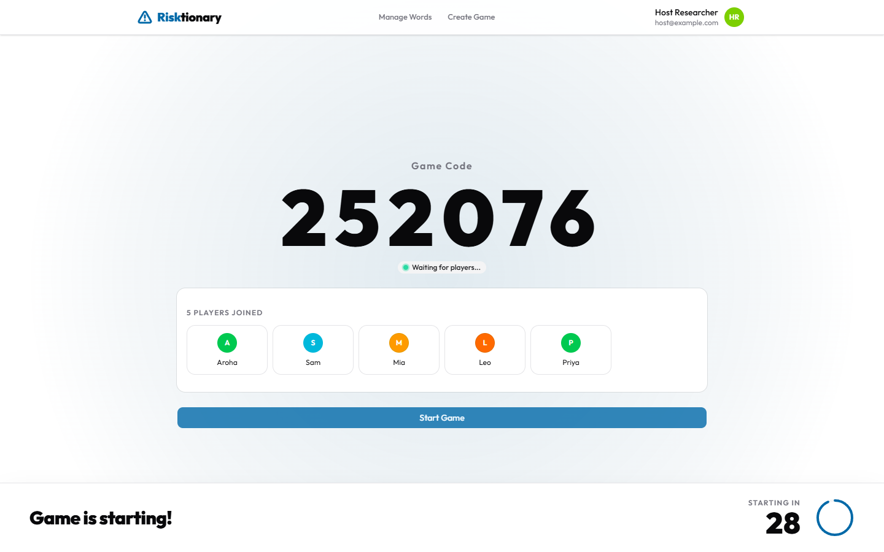
Study note: each player's feedback condition is assigned when they join (see Section 5.1).

4.2 Choosing the drawer
At the start of each round, players who want to draw press Raise Hand. The host sees the volunteers, selects one, and presses Pick _name_.
Player: Raise Hand | Player: volunteered | Host: picking the drawer
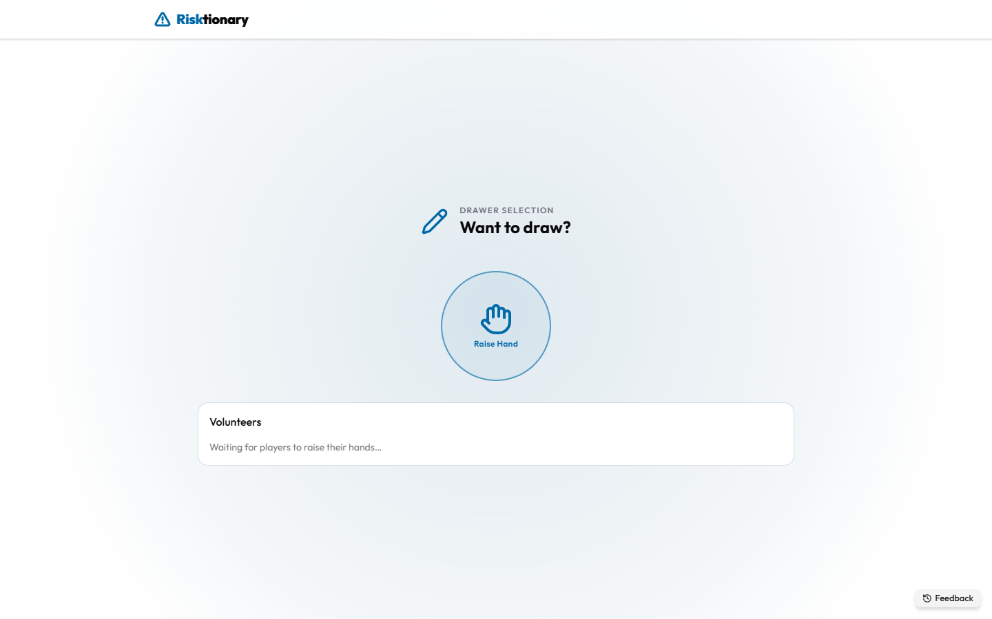 | 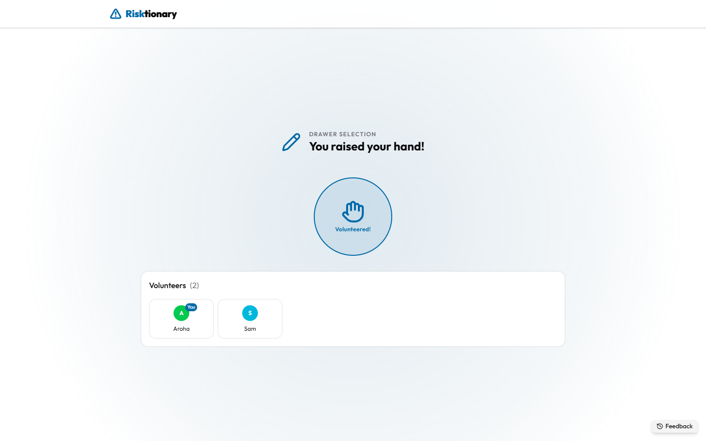 | 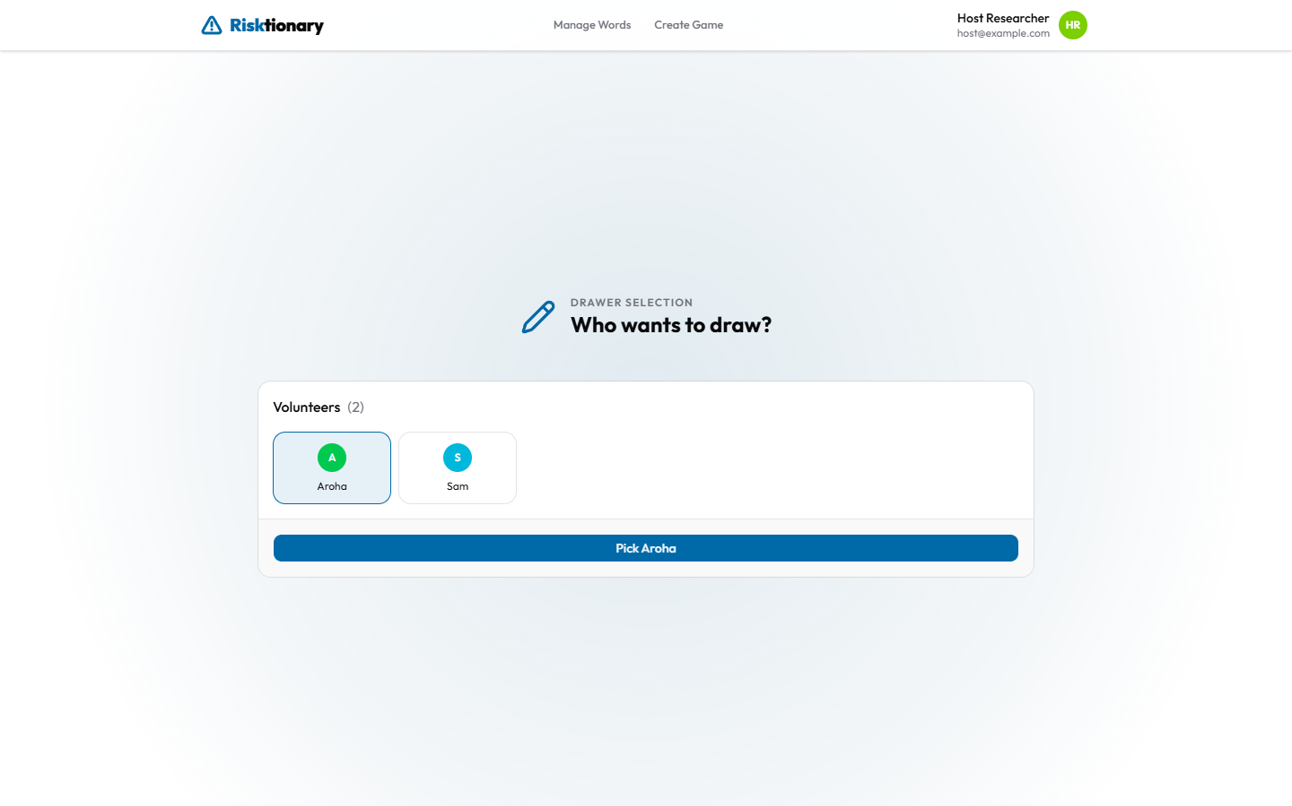

4.3 Drawing and guessing
Drawer. Only the drawer sees the word (top centre). They draw on the canvas with the pen, eraser and colour palette below it. They can't type guesses.
Drawer before drawing | Drawer while drawing
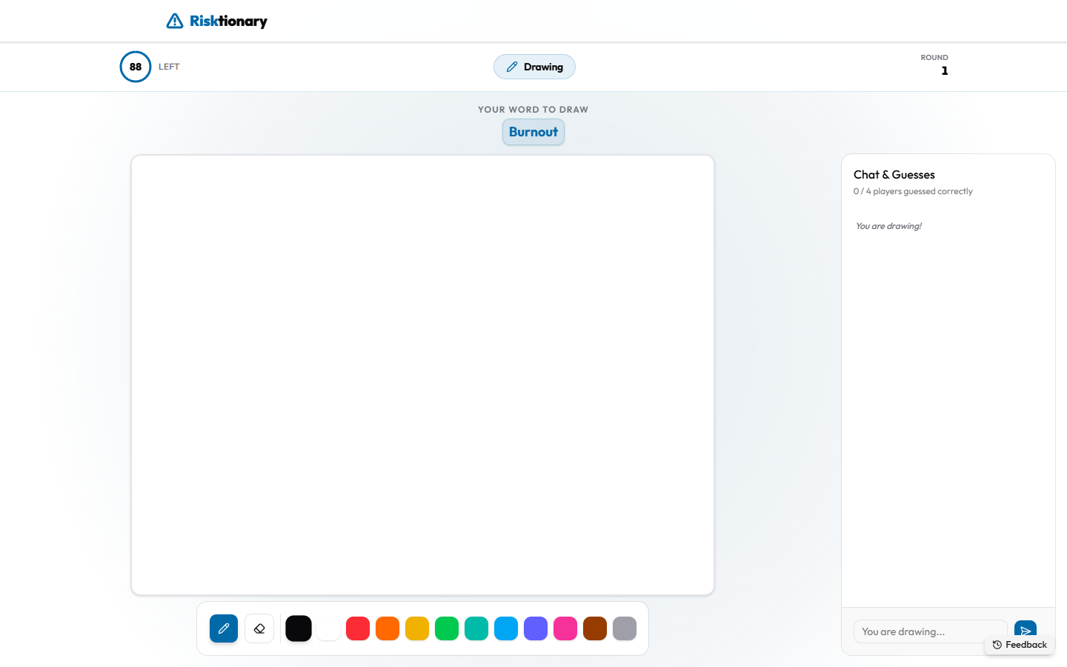 | 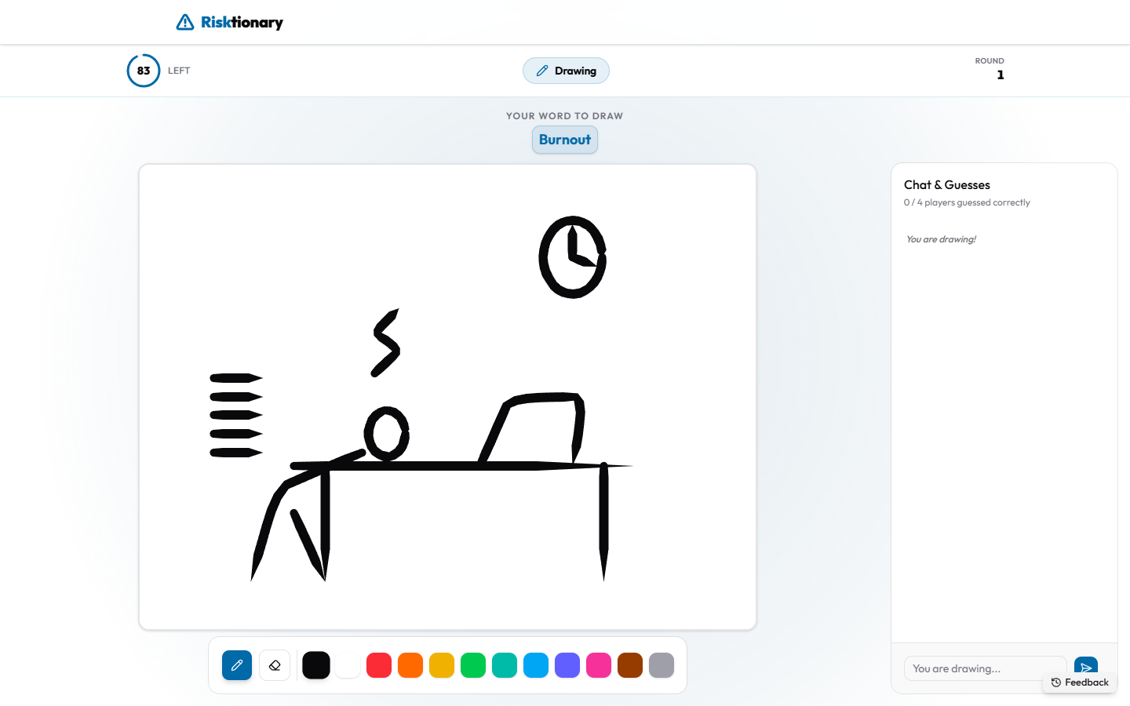

Guessers see the drawing live. The word is shown as blank boxes, one per letter. They type guesses in Type a guess... and press Enter. Every guess appears in the Chat & Guesses panel for everyone.
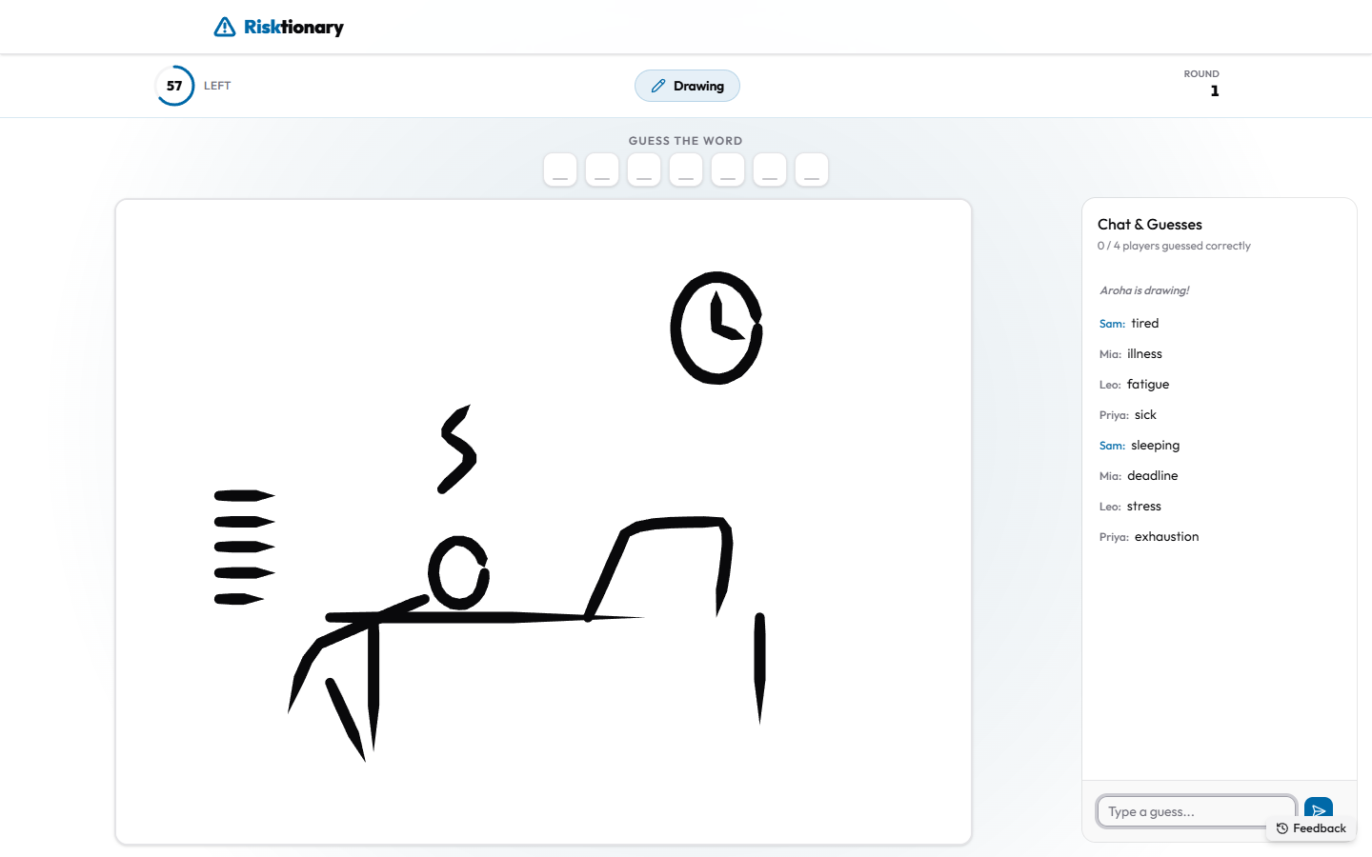
A correct guess shows a Correct! pop-up with the points earned. The word itself is not shown to other players. Faster correct guesses earn more points, and the drawer earns the average of the correct guessers' points.
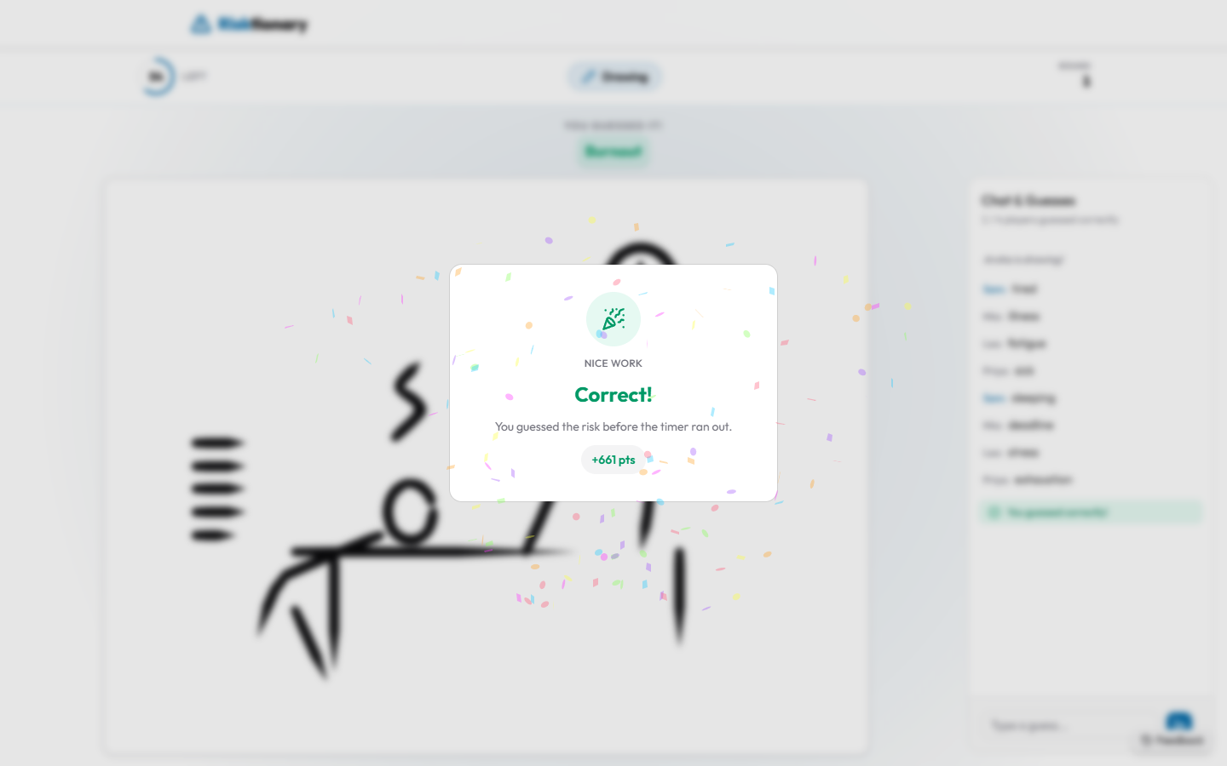
Host. The host sees the drawing, the chat, the timer (top left) and Skip (top right). The drawing phase ends when the timer runs out, when every guesser has guessed correctly, or when the host presses Skip.
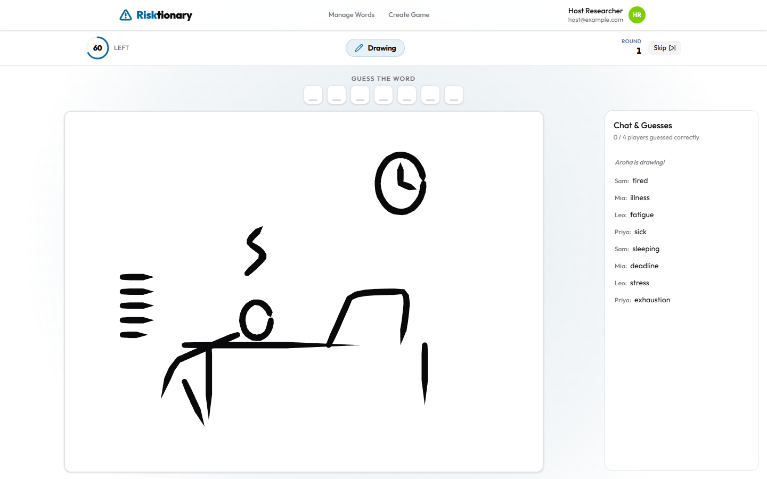
Keep the host screen open throughout the drawing phase. The host's browser sends snapshots of the drawing for the AI to interpret. If the host tab is closed or minimised for a long time, feedback can't refer to the drawing.

4.4 Drawing review
Players who didn't guess the word see a Time's up! pop-up. The chat then reveals the answer ("Time's up! The word was ...").
Time's up pop-up | Drawing review (host)
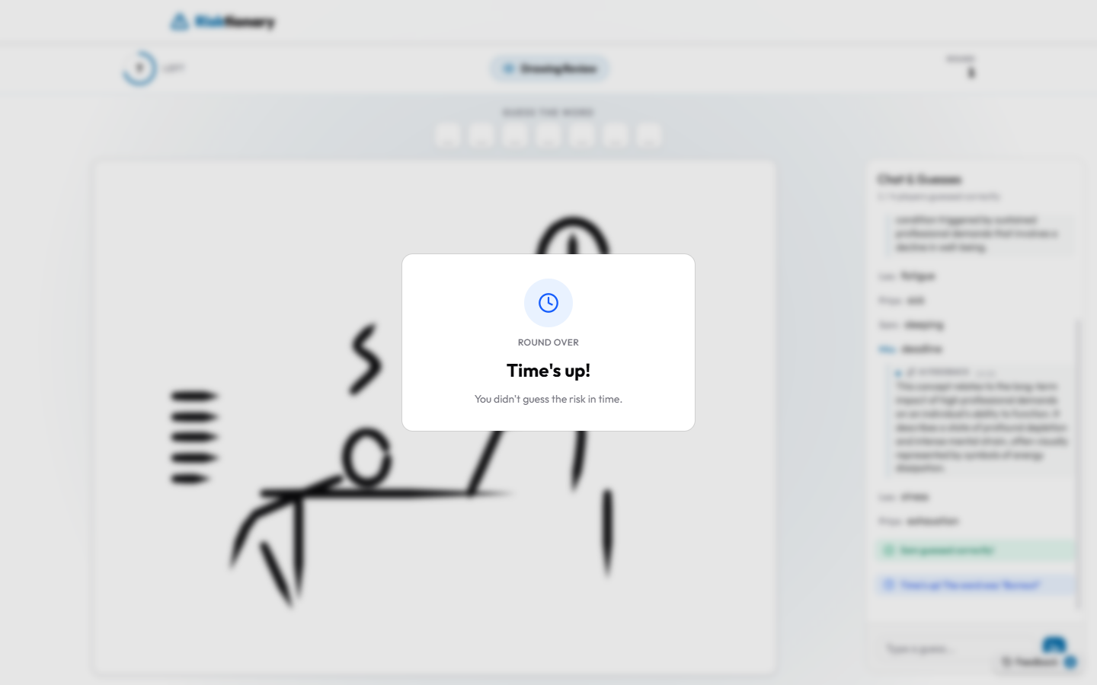 | 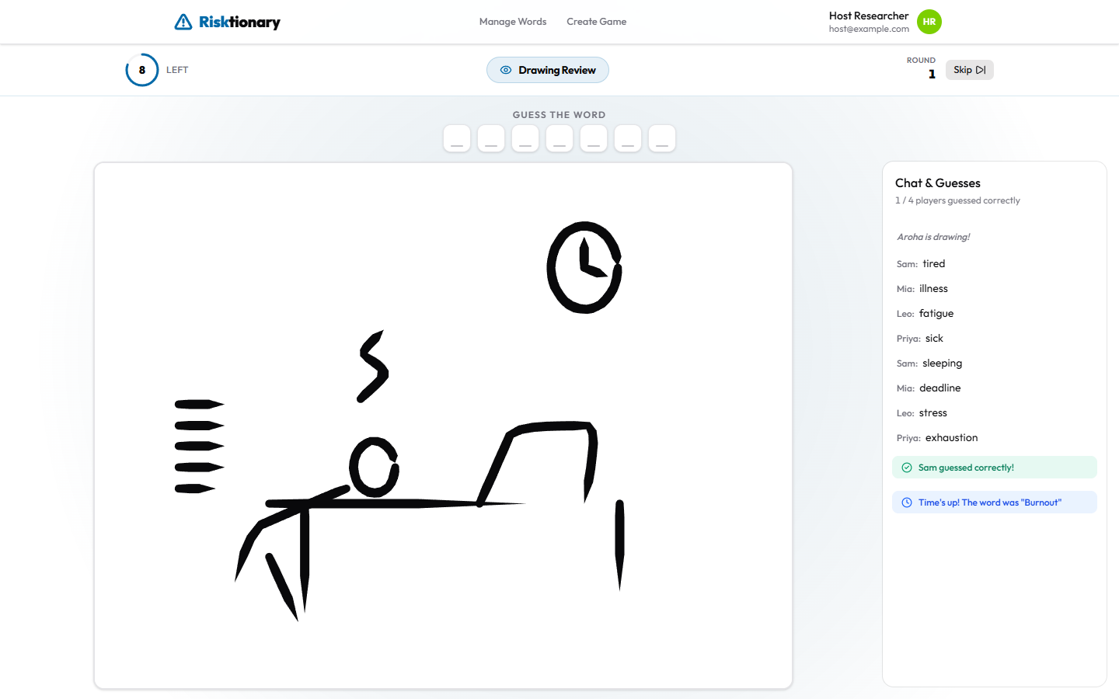

4.5 Rating the risk
Each player rates how likely the risk is to occur (Rare to Almost Certain) and how severe its impact would be (Insignificant to Catastrophic), then presses Lock in vote. When everyone has voted, the game moves on.
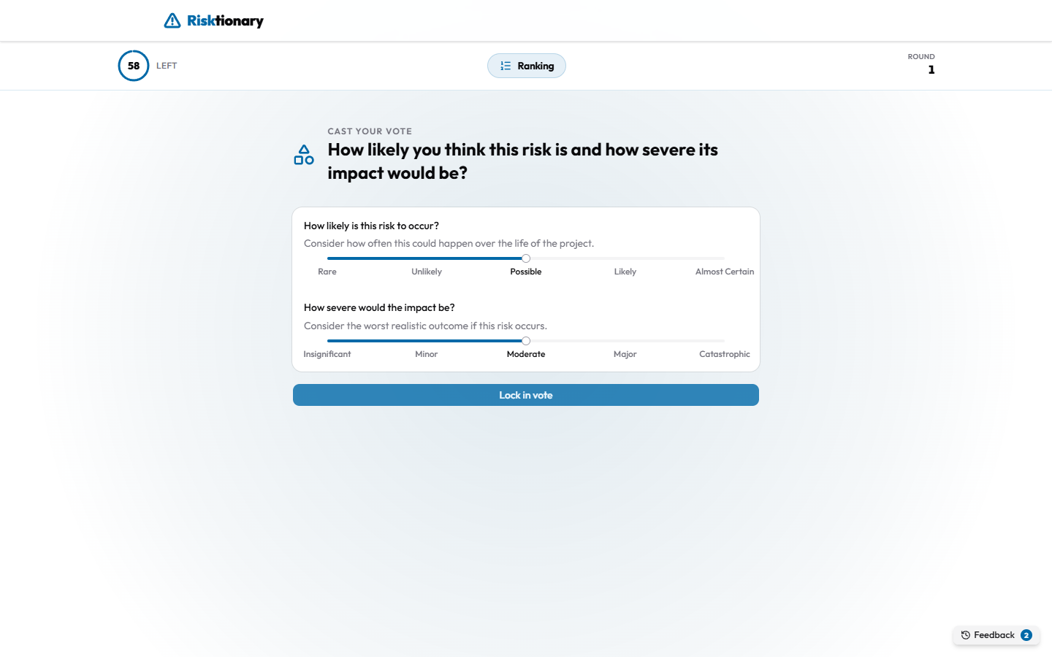
Ranking review shows how the room voted on a likelihood × severity risk matrix. The number in each cell is how many players chose it. This is a good moment for discussion: why did people disagree?
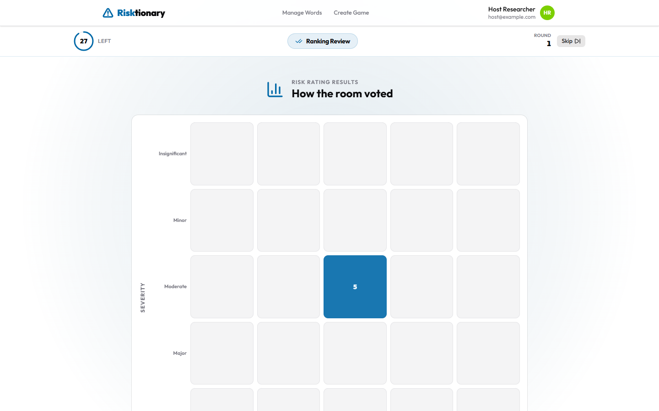

4.6 Word review
Everyone sees the risk, its synonyms and its description. Use it to discuss how a team would respond to the risk.
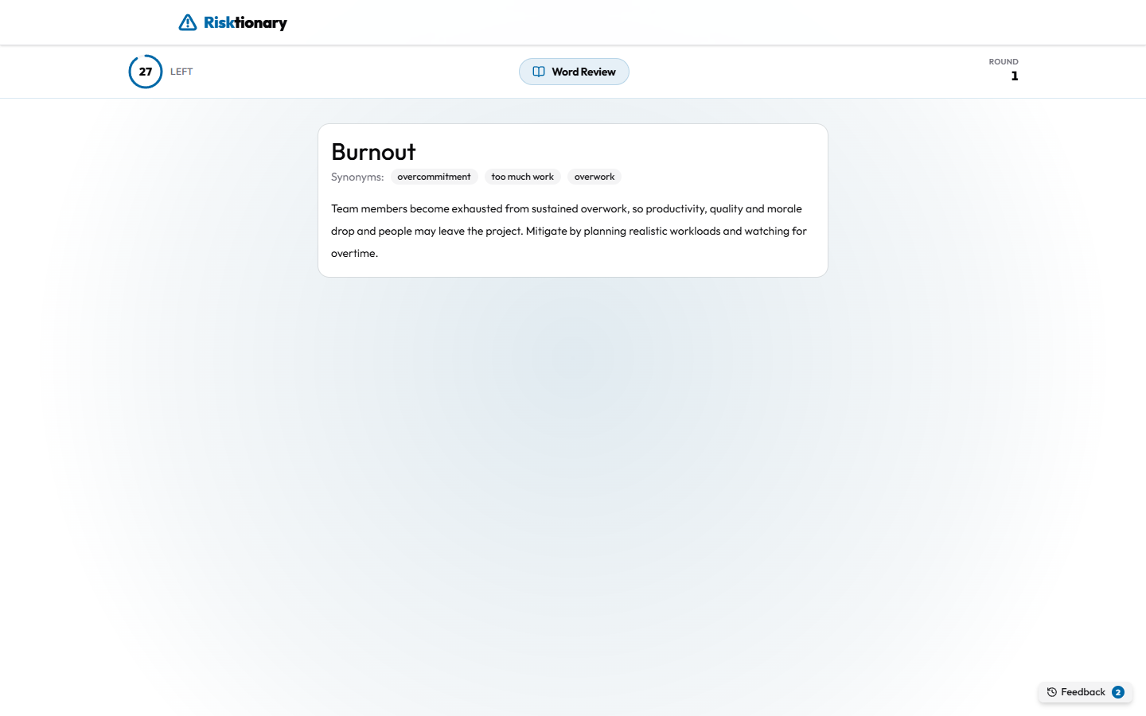

4.7 Scoring
The round results show the podium and everyone's points. Players with AI feedback also see an AI feedback card below the results (see Section 5). The next round then starts with drawer selection.
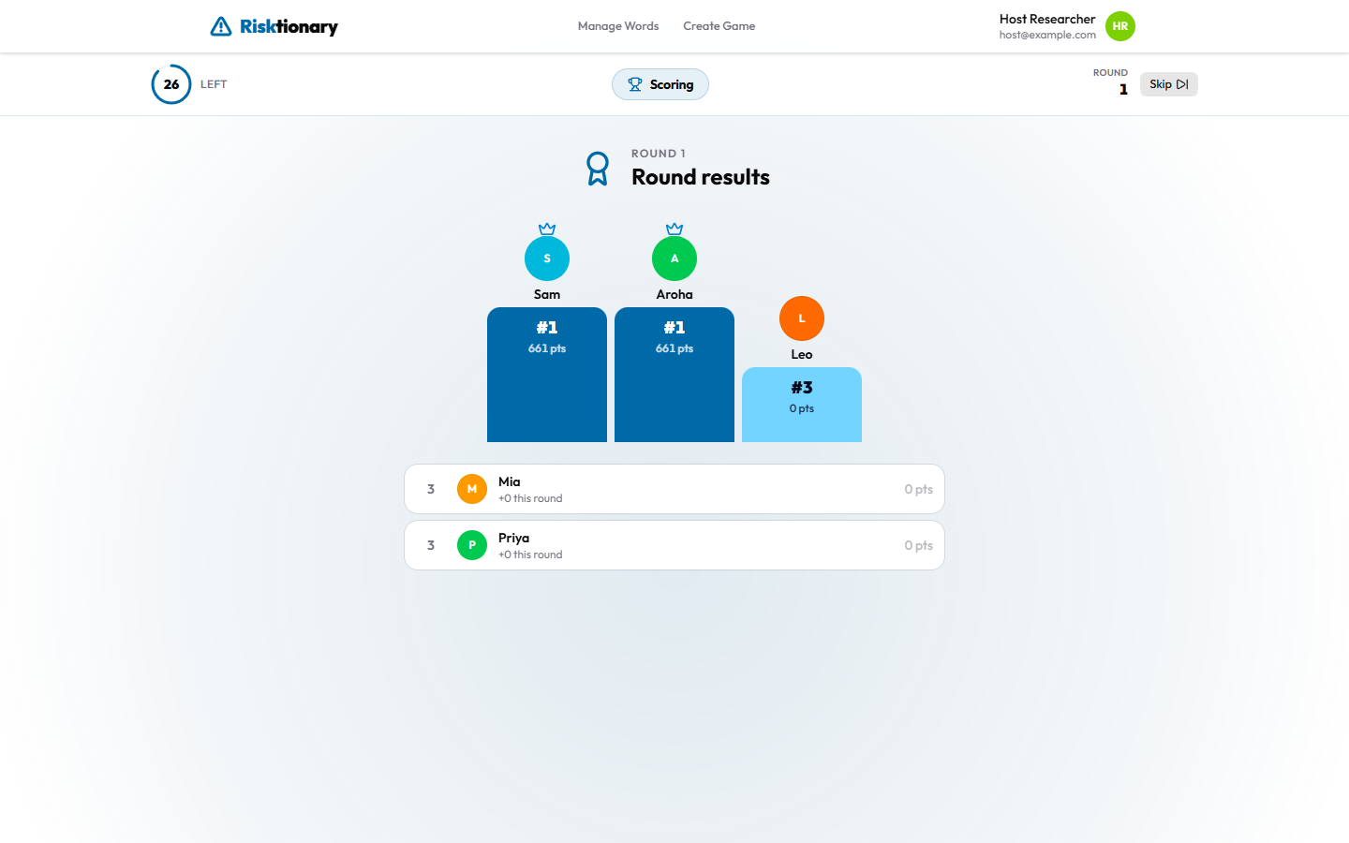

4.8 End of the game
After the last round, everyone sees Final standings. Players also see a "You're part of a study" card with a Take the survey button, if a survey link has been configured (see Section 6.3).
Host | Player
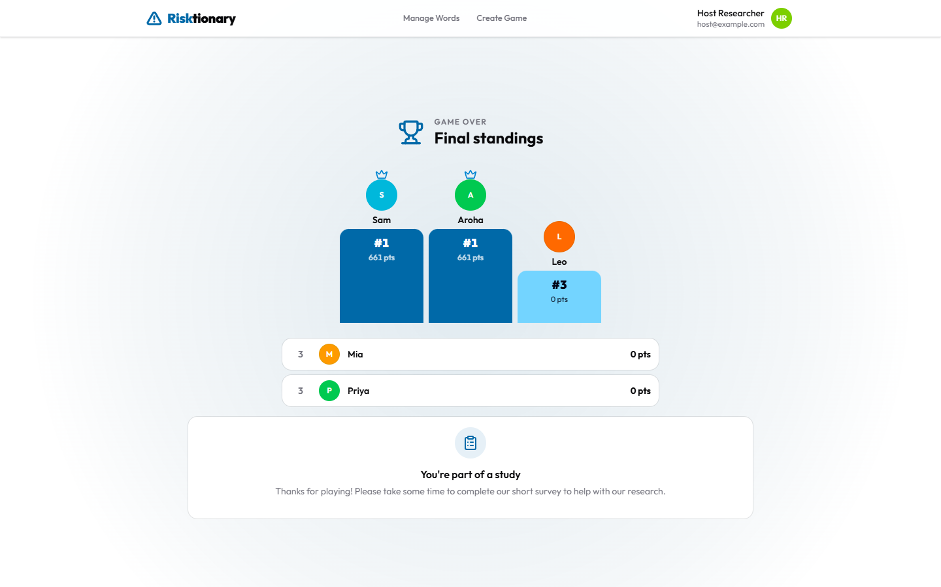 | 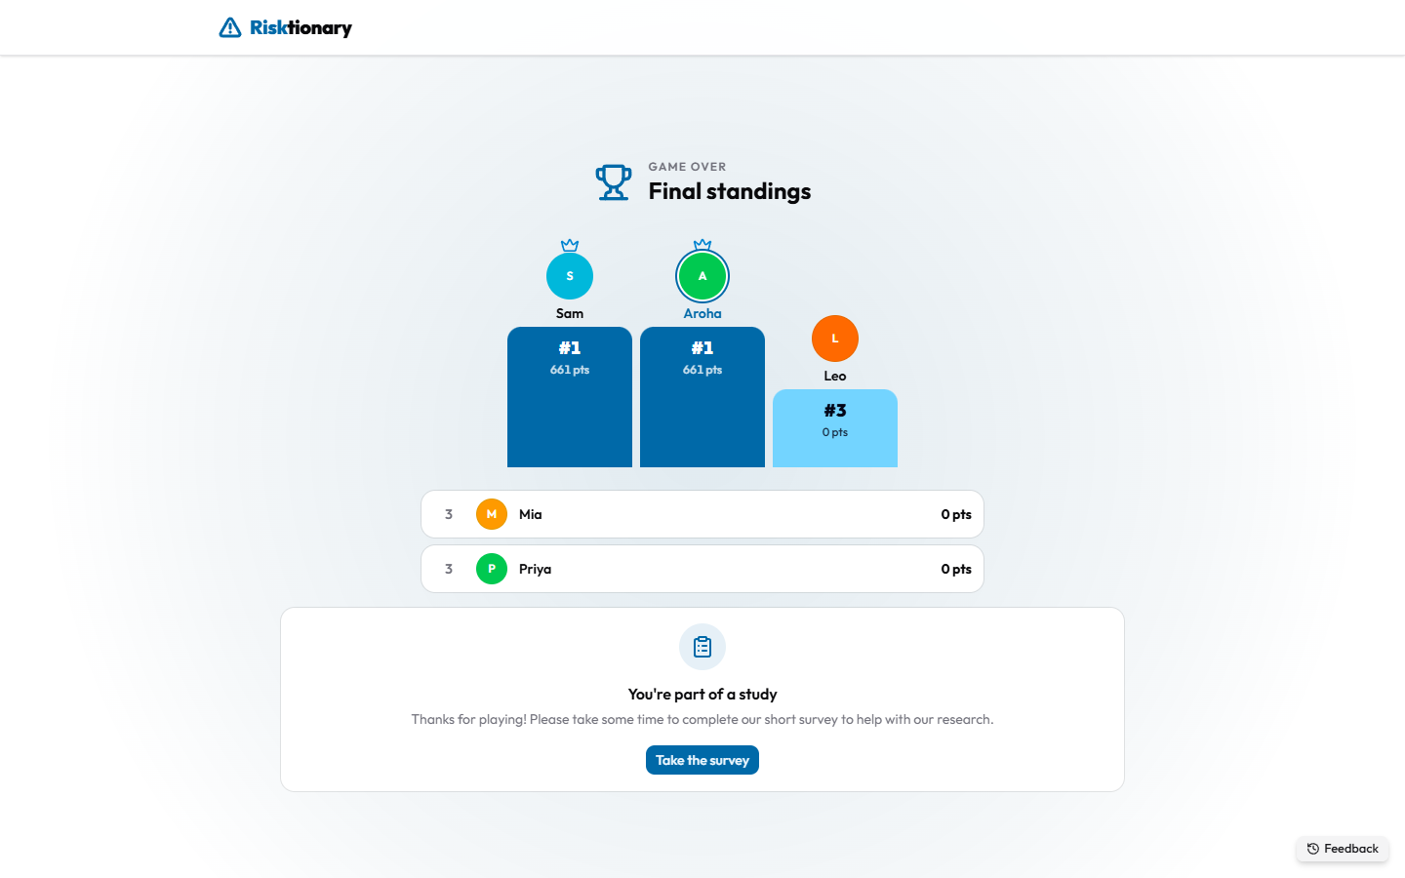

5. AI feedback
When a player guesses wrong, the game uses an AI model to write feedback that helps them understand the risk without giving the answer away. Feedback is private: each player sees only their own. Every message is labelled AI feedback.
The AI never decides whether a guess is right. That is a plain text match against the word and its synonyms (ignoring capital letters). The AI only writes the explanation.

5.1 How feedback conditions are assigned
Each player is given one of six combinations of timing and framing when they join a game. The game picks at random among the combinations with the fewest players so far, so the groups stay balanced. A player keeps their combination for the whole game. In a new game they may get a different one.
 | Positive | Corrective | Neutral
Instant: a reply under each wrong guess | 1 | 2 | 3
Delayed: one summary at the end of the round | 4 | 5 | 6

- Positive acknowledges the guess as a reasonable attempt before pointing in the right direction.
- Corrective states plainly how the guess differs from the answer.
- Neutral states the same facts without reacting to the guess.
Players can't see their own combination. Researchers can find it in the database (see Section 6.4).

5.2 Instant feedback
A few seconds after a wrong guess, a reply appears directly under the player's own guess in the chat. It never names the answer, and it gets more specific as time runs out.
Instant feedback in the chat | Close-up
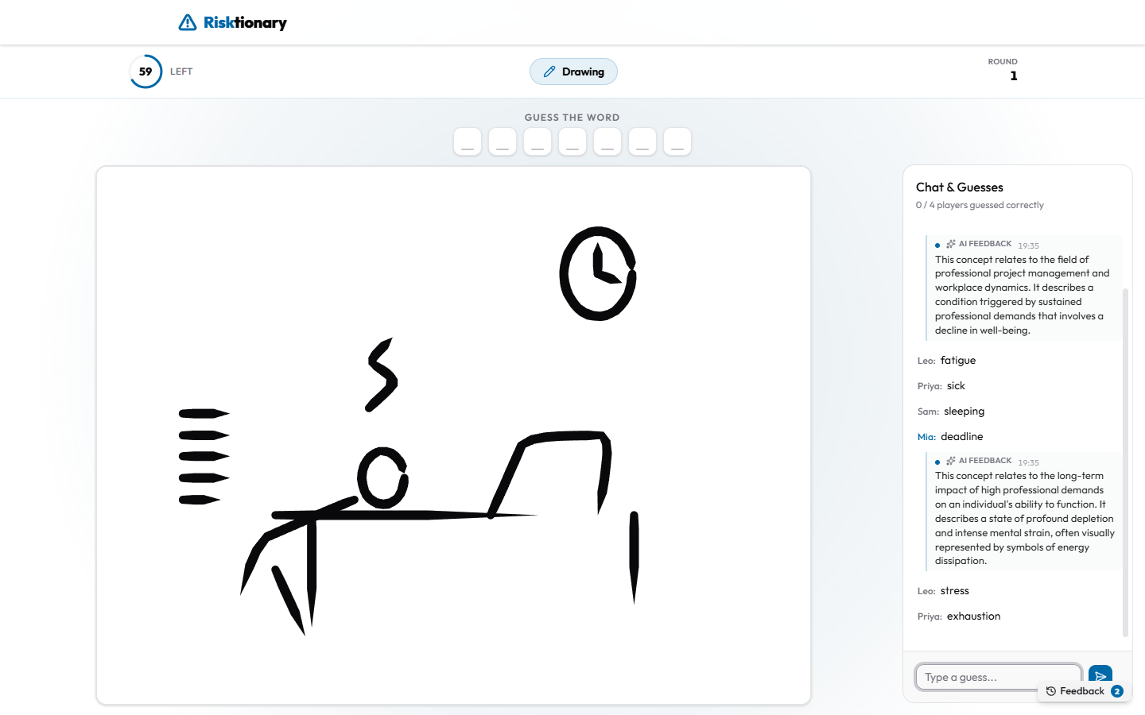 | 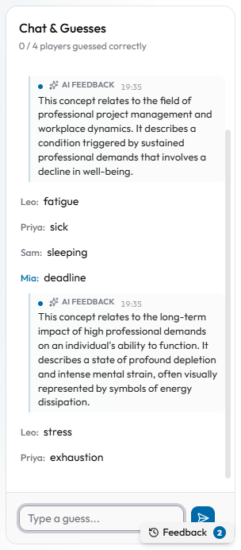

5.3 Delayed feedback
Players with delayed feedback get nothing during drawing. At Scoring, their AI feedback card shows a Round summary that names the answer and explains how their guesses related to it.
Delayed: round summary | Instant: the round's messages again
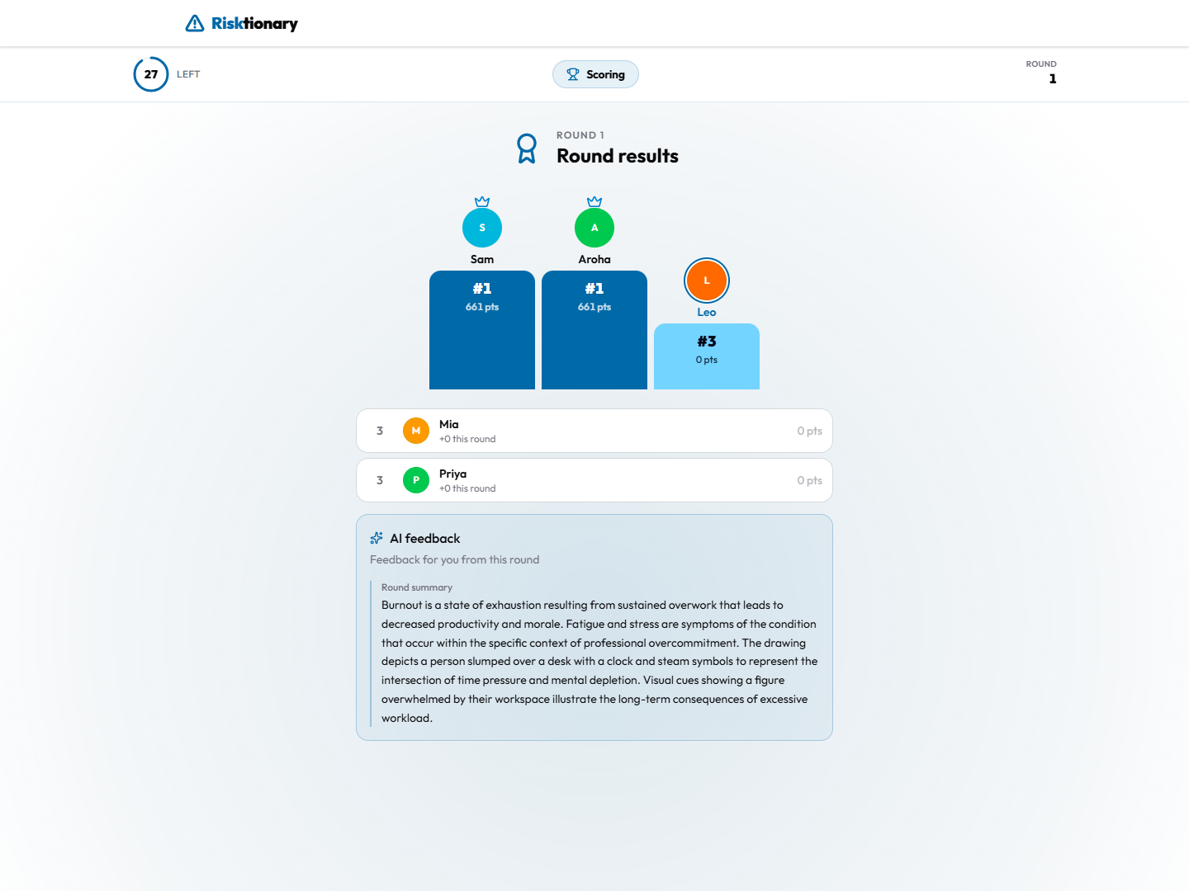 | 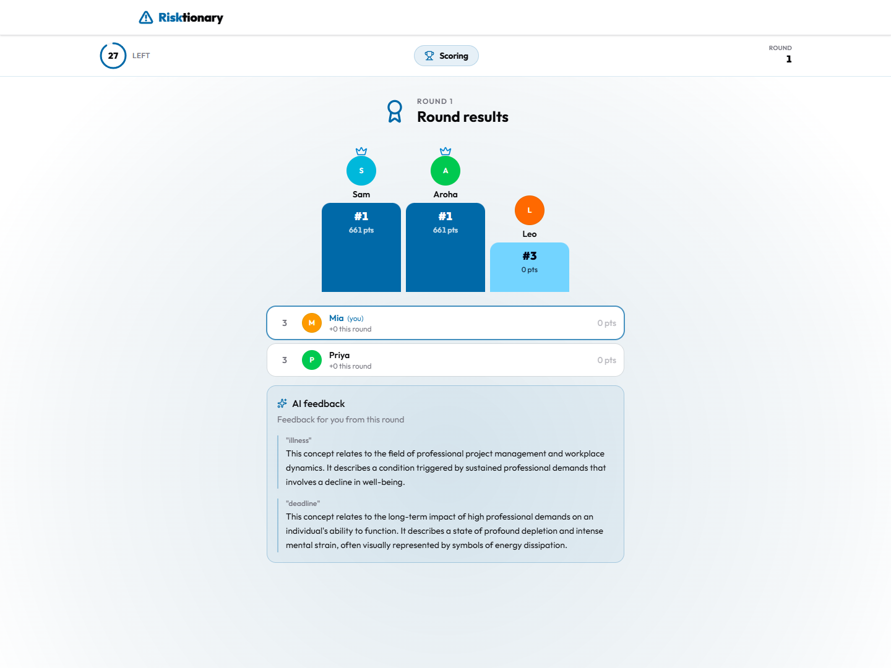

5.4 Feedback history
The Feedback button (bottom right, with a count of unread messages) opens the Feedback history: every message the player has received, grouped by round. Instant messages scroll out of view in a busy chat, so remind players it is there.
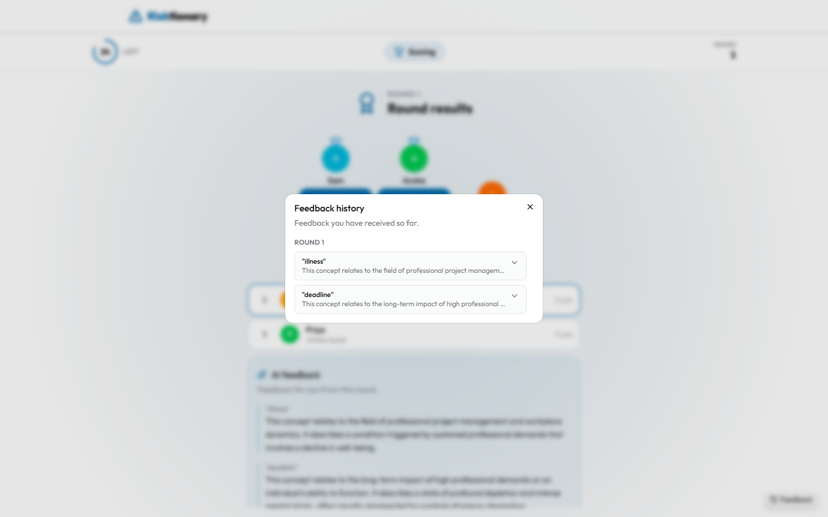
Players who guess correctly straight away receive no feedback, because feedback is only written for wrong guesses.

6. Running a study session

6.1 Checklist
Before the session
- ☐ Ethics approval covers the session, and participant information and consent are ready.
- ☐ The site is up, and you can sign in as host.
- ☐ The AI provider key has credit. One game of about 8 rounds used roughly 200k tokens in the pilot.
- ☐ The word bank has the risks you want, with synonyms and descriptions.
- ☐ The survey link is configured (Section 6.3).
- ☐ The backend was restarted, or no other game has been hosted from your account in the last 5 minutes (see Section 7).
- ☐ Create the game: AI Generated, Balanced random allocation, and suitable timers.
During the session
- ☐ Project the host screen and keep it open in the foreground.
- ☐ Explain the game using Sections 1 and 4, and point out the Feedback button.
- ☐ Wait until everyone has joined before pressing Start Game. Players who join late still get a condition, but miss rounds.
- ☐ Encourage players to keep guessing. Feedback only comes from wrong guesses.
After the session
- ☐ Give players time for the survey on the final screen.
- ☐ Export the data (Section 6.4).

6.2 Several games in one session
Each game assigns conditions afresh, so a returning player may get a different combination in the second game. If your study needs each player to keep the same condition, run one game with more rounds.

6.3 Survey link
The Take the survey button is set when the frontend is built and deployed. It isn't set in the app:
- NEXT_PUBLIC_SURVEY_URL: build-time setting that shows the survey prompt.
- SURVEY_REDIRECT_URL: run-time setting giving where /survey redirects.
See the backend docs/deployment.md. To link survey answers to conditions, the survey needs a way to identify the player, which the current version doesn't provide. Plan this before the study (for example, ask players to enter their display name and game code in the survey).

6.4 Getting the data out
Everything is saved to the database during play: every guess and its time, chat, ratings, drawing snapshots with the AI's interpretation, each feedback message (the neutral fact note and the final text) with the player's condition, and AI token use. Players are stored only as a random ID per game. Display names are not saved.
- Through the website (researcher role): GET /api/v1/game lists games, and GET /api/v1/game/{gameId}/details returns everything for one game as JSON.
- From PostgreSQL directly, which is best for analysis. Conditions are in risktionary_game_player (feedback_timing_condition, feedback_framing_condition), and the feedback text is in risktionary_game_round_feedback.
Full details, including how to grant the researcher role, are in the backend docs/deployment.md, section 9.

7. Troubleshooting and known issues
Problem | Cause and fix
After creating a new game, the host's screen shows the previous game (e.g. its final standings) | A known bug: the backend finds the host's game by account, and finished games are only removed 5 minutes after the host leaves. Fix: close the old game's tab and wait 5 minutes before creating a new game, or restart the backend.
No feedback appears | Feedback is only written for wrong guesses, and only instant players see it during drawing. Check the AI key has credit. Restarting the backend ends all running games.
A player can't join ("display name in use") | Two players in a game can't have the same display name. Ask them to add an initial.
A sensible guess was marked wrong | Matching is exact (ignoring capital letters). Add the variant as a synonym for next time.
A player's screen is stuck or disconnected | Refreshing the page reconnects them to the same game in the same browser tab.
Feedback refers to the drawing oddly or not at all | Drawing snapshots come from the host's browser. Keep the host tab open and visible.
The create-game feedback settings didn't apply | Known gap: the backend always uses AI feedback with balanced random allocation (Section 3).
Restarting the backend during a session | All games in progress end. Data from completed rounds has already been saved.

8. Quick reference for explaining the game to players
1. Go to the website, and enter the game code on the screen and a name. No account is needed.
2. Each round: Raise Hand if you want to draw. The host picks one drawer.
3. Drawer: draw the risk shown at the top. No letters or words.
4. Everyone else: type guesses in the chat. Faster correct guesses score more.
5. Wrong guesses may get AI feedback, either straight away under your guess or as a summary after the round. Open Feedback (bottom right) to see it all again.
6. Rate how likely and how severe the risk is, see how the room voted, and read the risk's description.
7. At the end, please take the survey.

