Nvidia Jetson Nano Home Setup

This document contains 3 parts:
- How to get your Voice Assistant to work without a monitor and keyboard
- How to get your Voice Assistant to work with the terminal
- Setting up your openai account in order to generate your own secret key

For additional help, you can check out my github page where all the source code and installation instructions can be found. You can download all code from here. Also, if you “watch” this github project, you will get notified of updates. Make sure if you download the code, that you put it in the standard location for all of the scripts and installation details to work correctly

https://github.com/coreylgorman/chatGPTVoiceAssistant

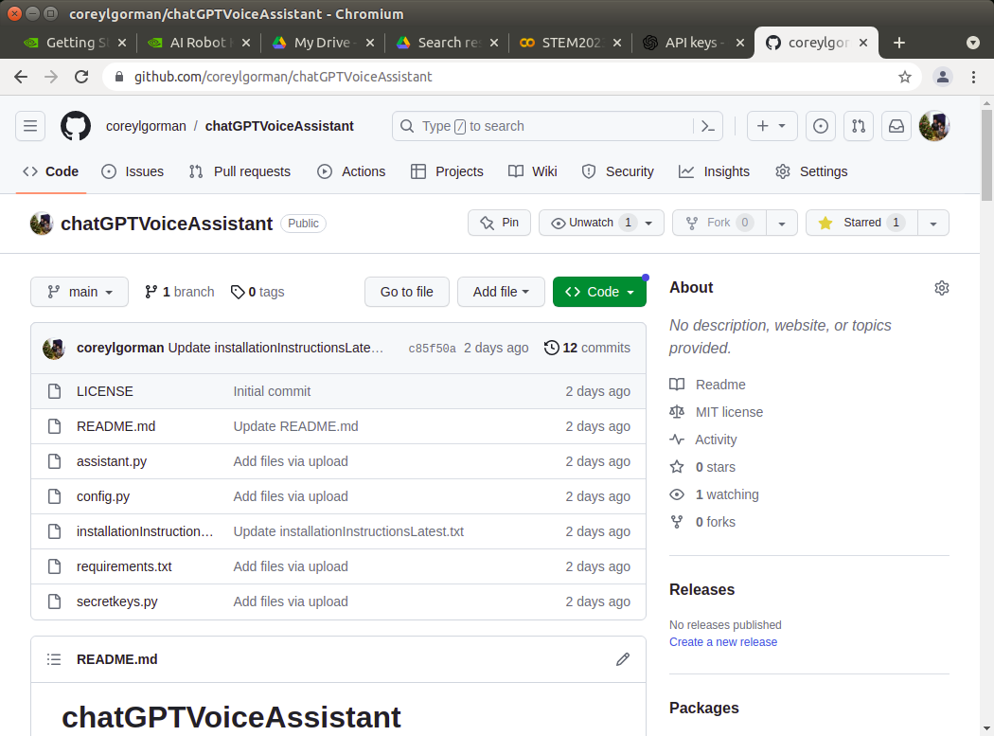

Please keep in mind that you should turn off your voice assistant when not in use as it will exhaust your credits! :-)

1. Voice Assistant without monitor/keyboard

- Set up wifi network and password
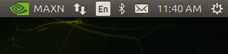

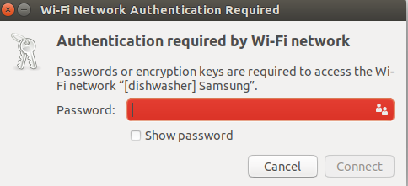

- We need to make sure the speaker and microphone are properly configured (this appears to be the issue several folks had today)
- Select the sound adjustment setting in the top right corner

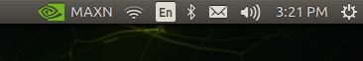

- With the speaker “on”, make sure that the Analog Output – USB Composite Device is selected
- Use the “Test Sound” Button to make sure the audio is coming from the spaker
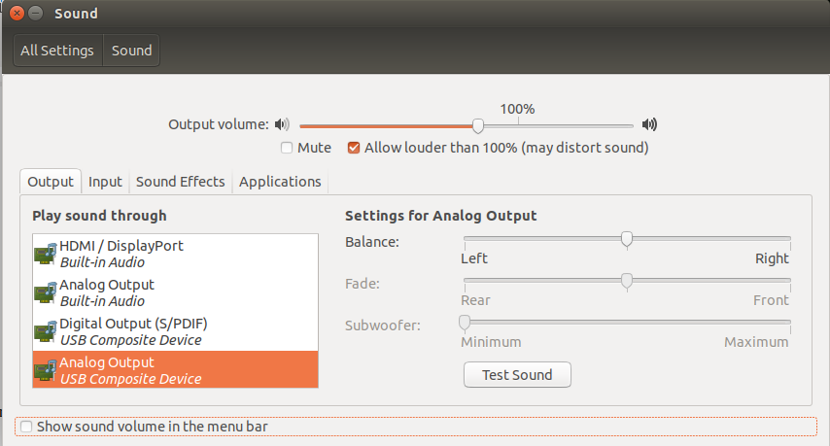
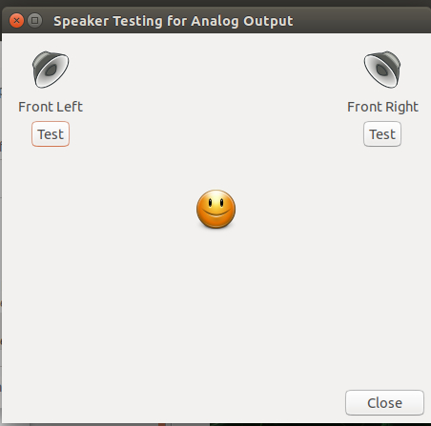

- In the same sound test menu – go to the Input tab and select it
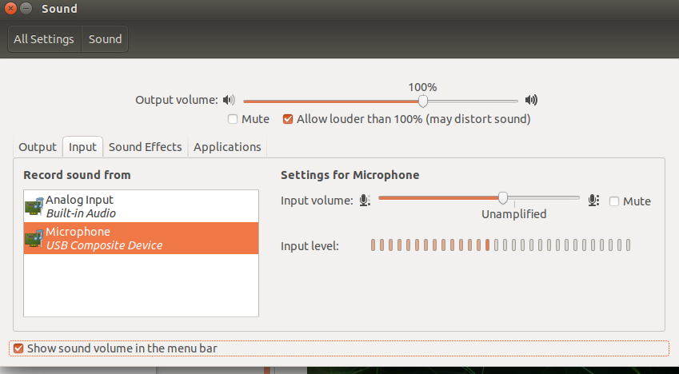
- Make sure Microphone-USB Composite Device is selected. With it “on” you should see the volume at the Input level change as you speak into it

This should be all that you should need to do to get it to run with only the power cable and speaker connected to your Jetson Nano

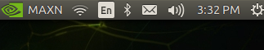
You can now restart the Jetson Nano

When re-starting, make sure to hold down the speaker “on” button right after plugging in the power cable.

Your personal chatGPT Voice Assistant should be ready to go!

2. Voice Assistant without monitor/keyboard

- Open up a Terminal window

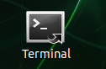

- We will need to stop the assistant.service service:
  - At the command line, type sudo systemctl stop assistant.service

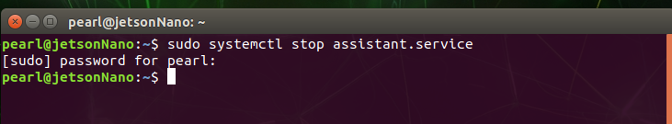
  - Enter password if it asks you for one (STEM2023 is the default password)

  - We can check the status to make sure the service is inactive:
    - At the command line, type sudo systemctl stop assistant.service
    - You should see that it is inactive
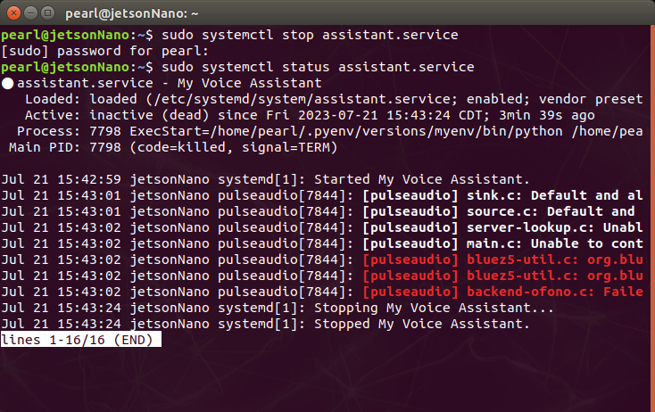
    - Close that terminal window with the “red x”

  - Open a new terminal window
    - We need to activate our python environment with the following command (This will activate the “myenv” environment and you will now see (myenv) to the left of the command line
pyenv activate myenv

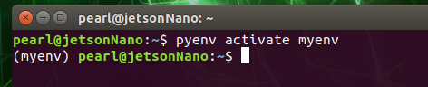

    - We need to change the directory to where our software is kept:

cd Projects/STEM2023/chatGPTVoiceAssistant/

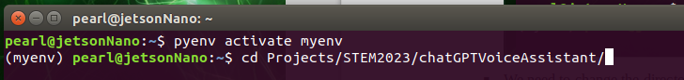

    - To run out assistant, type the following command:

python3 assistant.py

Your voice assistant should now be running!!!

To stop your assistant, press “ctl+c” on the keyboard
3. Set up your own “secret key” for openai
(If my tutorial is insufficient, there is a lot of good videos on youtube that provide an overview on setting up your own openai API key)

- Go to the following link:
https://platform.openai.com/

- You will need to either log in or sign up for a new account (I use my gmail address to log in)
- After creating or logging in to your account, you can now get your secret key
  - Click on the “Personal” icon in the top right hand corner (your picture will be different


  - Select “Manage Account”

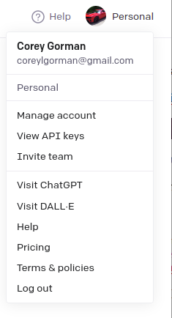

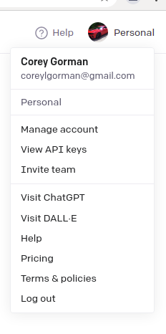

- Add billing method as needed (FYI - I have used it extensively for the last 7 months and have only spent $6; I also can set spending limits so as to not exceed a monthly limit)
- After setting up payment method, select “API keys”

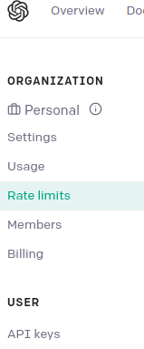

- Click on “Create new secret key:


- Create secret key and copy it to the clipboard.
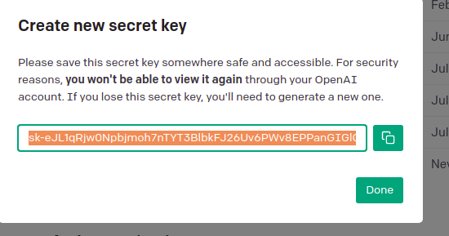

- You will now need to open the secretkeys.py in your project directory to insert your new key
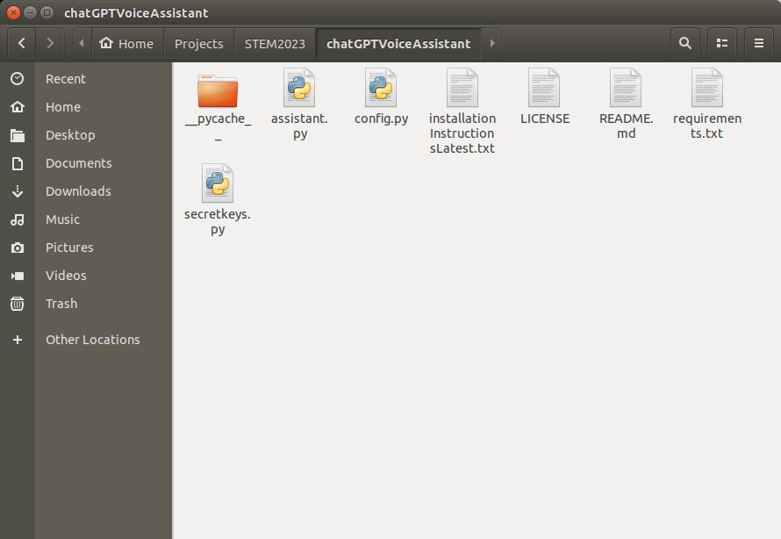
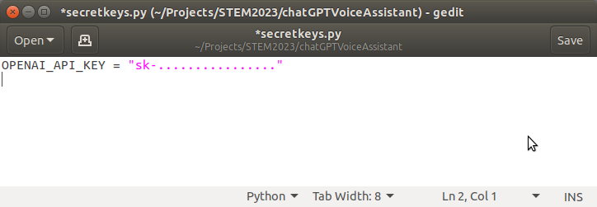
- Insert your new key (keep the quotes on either side of your new secret key)
ALL DONE! Congratulations, you have your own secret key, now!

