**Project Management**

*Name: Corey Lynch*

*Student ID: R00154863*

*Class: SD2-A*

*Lecturer: Byron Treacy*



The **objective** of this assignment is to develop a robust, standalone application using procedural language which uses an external DBMS to store data. I must document the research and the strategy/planning that was required to achieve this objective.

**This document contains all information regarding the planning and development of the application, as well as an activity log of all actions that were taken during the development of the application.**

## Table Of Contents:

**Table Of Contents:** **2**

**Application:** **2**

**Communication:** **2**

**Activity Log:** **4**

**Trello Milestones:** **6**

**Pseudocode:** **10**

**Declaration:** **11**

## 

## Application:

***I will be making a database for a Car ECU Remapping Company located in Ireland. The company takes customer cars and remaps the ECU to increase the vehicle performance.***

**E.G:**

|  |  |  |  |  |  |
| --- | --- | --- | --- | --- | --- |
| fName | lName | telNo | carReg | carMake | carModel |
| Corey | Lynch | 083030303 | 152C6947 | BMW | 420D |
| Rory | Dineen | 083202020 | 141D4012 | Volkswagen | Golf R |
| Eric | McGowan | 083404040 | 151C2101 | Mercedes | A180D |

**Data Types for Table:**

**fName: varchar(32)**

**lName: varchar(32)**

**telNo: varchar(32)**

**carReg: varchar(32)**

**carMake: varchar(32)**

**carModel: varchar(32)**

## Communication:

* ***CL: 5th Oct****: Hi Byron, I emailed you yesterday in regards to using an application such as Trello in order to complete the project management section of my database project. I feel like an application like this could be very beneficial as it allows you to visually represent your goals and milestones and allows you to physically interact with them in the form of “cards”. Thanks.*

*Link to Trello:* [*https://trello.com/en*](https://trello.com/en)

* ***BT: 6th Oct****: Trello is an excellent S/W dev proj mgmt tool. It is used extensively in 4th year projects in CIT. My only issue is that, having a uniform, consistent approach simplifies my project supervision and marking ( otherwise I’m chopping and changing depending on each student).*

*Would you consider using trello for the project, but just use the snipping tool to take and paste screenshots into the Google Doc?*

*In your report, you can have a section on proj mgmt and the use of tools like trello.*

* ***CL: 7th Oct****: Yeah, that’s no problem. I will use Trello as well as using the default Project Management layout that you have specified for the project.. and as you said, I can include a section in my report outlining Trello with screenshots of it. Thank you!*
* ***CL: 2nd Nov****: Hi Byron, I just had a quick question in regards to the design of the project. I have begun implementing code so I want to finalise the design for my application. I couldn’t find a definitive answer in the project specs. Essentially the application design I have in mind is the following;*

*The application will consist of a menu with 3 options*

1. *Enter new data (Customer Name, Car Reg, Car Make, etc.)*

*(The data that is input will be written to an external file which will act as the database)*

1. *View database (This will read from the external file which is acting as the database and display the data to the user)*
2. *Exit application (This will close the application)*

*The menu will ask the user for an input and depending on the input, it will carry out the task. I just wanted to make sure I am on the right track with this design and would a menu system such as this suffice or have I got the wrong idea? Thank you.*

* ***Nov 3rd: BT:*** *Not sure what you mean by design of the application. We have only one table to implement, so it’s not a design project. Students were asked on a number of occasions to submit a data table they were going to use with 4 attributes. You appear to be using Customer( Customer Name, Car Reg, Car Make etc) .*
* *The spec is clear and described by text and video as well in class recordings that you must use a remote DBMS server for storing your data. Do not use a standard external file in python. This is what defines an embedded SQL 2 tier (client -server) application. Similarly, the processing requirements of Read (select) and write( Insert/update) are well specified in the deliverables section of the project spec.a. “ a) SQL insert of data input from keyboard, update of data using data input from the keyboard. A Graphic user interface is not required.*
* *b. select (display rows) “*

## Activity Log:

* Nov 26th: Today is the last full day before my project is due. Today I finished off writing my report. I also tested the code again. I will review all aspects of the project in detail and make any necessary changes before uploading my work. I must create a screen recording giving a demonstration of my code.
* Nov 24th: Today I finished writing the code for my application and tested the code extensively to ensure there are no bugs. I have all aspects of the menu system working as I anticipated and I have included error handling to make my application more robust.
* Nov 23rd: Today, I began writing my technical report of the project so far. I did this by referencing back to this activity log and my Trello board to get an idea as to what order I completed technical tasks such as installing required software, implementing code and any issues I had with either along the way.
* Nov 22nd: Today I replanned my approach to my database issue. I have carried out a lot of research and I have decided to use the SQLite library within Python to execute the SQL code and store it on a local database.
* Nov 21st: I am still having issues with creating my database with MySQL. I have spent hours researching the issue and troubleshooting but to no avail. It appears the issue is coming from a MySQL config file. I believed the issue only existed on my Linux machine. Maybe a compatibility issue? However, this was not the case as the issue is also occurring on my Windows machine. I have been forced to rethink my approach to the project and I am wasting valuable time troubleshooting MySQL and there are other viable options available.
* Nov 19th: Today I updated my Trello board and attached a new screenshot of it below. NOTE: I have created some rough pseudocode and I have begun implementing the code within PyCharm. However both the pseudocode and python code are subject to change as I am still researching embedded SQL within PyCharm and may opt for an alternate approach if I find it more suitable.I am also having some issues with MySQL I cannot seem to create a database. I will have to follow up on this issue this weekend. I believe it is only an issue with my Linux machine.
* Nov 15th: Today I looked into using MySQL Workbench for my project. I am familiar with this application as I used it in first year. However, I needed to familiarize myself with the application again.
* Nov 13th: Today I continued working on the code for my project as well as researching embedded SQL with Python to help me achieve my goal of completing the project.
* Nov 12th: Over the past week and a half my project was put on hold due to other college commitments. We have reached the mid-way point of the semester and I had a lot of exams and other projects due which hindered my progress with this project. However I am back on track as of today and feel as if I am in a good position to have the project complete and submitted before the deadline.
* Nov 3rd: I have clarified the issues I was having with my project with my lecturer. I have now been pointed in the right direction. It turns out I was slightly over-complicating the situation for myself. I had initially planned on creating a GUI for the user with multiple functionalities which are not what is required in the spec having looked at it again.
* Nov 2nd: I began creating the pseudocode for the project. This is an early on, high level representation of the code that will be used to make the application. I found myself in difficulty with the design of the code and getting started as I wasn’t fully confident in what is expected in terms of the application. For example, should I interpret a GUI or the ability to add user inputs, ect. I have contacted my lecturer in order to clarify.
* Oct 28th: Today I created a rough sketch as to how I am going to develop the application and write the code. I am a little bit behind schedule but I will begin developing the code by the morning.
* Oct 25th: Today I looked back at the MP4 video regarding the use of embedded SQL in Python and did some research of my own on YouTube just to further expand my knowledge.

The link to the video: https://www.youtube.com/watch?v=pd-0G0MigUA

* Oct 22nd: Today I created my Trello board. I have created 4 lists which divide a number of tasks which need to be completed. I have set due dates for some of these tasks in order to get the ball rolling. I also invited my lecturer to my “Trello team” in order for him to see up-to-date changes on my Trello board.

I had also planned on having a better understanding of Embedded SQL in Python by now by researching it further but due to other commitments I am behind schedule on that task.

* Oct 21st: I have been busy the past week studying for up-coming tests as well as catching up on some other projects for other modules. Tomorrow I will create a Trello board with a list of tasks which are to be completed and on-going in order to get a better visualisation as to what tasks need to be completed and when.

*BT: 19th OCt: that's very good work week to week but can you include your overall plan/milestones from trello? This can be rough but at least state what the major milestones/stages are, and when you think you’ll get to them.* **DONE**

* Oct 14th: Today I researched SQL data types just to familiarize myself with them again. Once I was comfortable with the data types, I selected the datatypes I would use for my attributes in my program.
* Oct 13th: I have decided what I am going to base my application on. I will be developing a database for a Car ECU Remapping company in Ireland. I have created a mock-up table above detailing what the initial design will look like.

*BT: 13th Oct: table is good. You can fill in data types for each attribute next*. **DONE**

* Oct 12th: I had an issue with getting PyCharm to function properly. I could not find a specified PATH to the base Python interpreter. I managed to research the issue and found a solution online. Issue resolved.
* The error was occurring because PyCharm could not find the Python base interpreter.

To resolve the issue I had to find where I installed the base interpreter. Once I found the interpreter I had to specify the PATH on PyCharm so it could find the interpreter. This resolved the problem.

*BT: 13th Oct: you might include a short description of the solution:* **DONE**

* Oct 12th: I have installed all necessary software to develop the application. I have installed MySQL Workbench, Python and an IDE for Python. The IDE I chose is PyCharm.
* Oct 11th: Over the weekend I managed to catch up on some labs from other modules that I missed last week when I was ill. This gives me time to start focusing on the functionality of this application. I will review the Embedded SQL video on canvas and I will begin planning how I will code the application.
* Oct 7th: Began planning how I will keep track of my milestones. I have decided I would use a combination of a Google Docs word file and a visual representation tool such as Trello to create milestones/objectives and assign them as High or Lesser priority activities to maximise productivity.

## 

## Trello Milestones:

*As of 22/10/2020:*

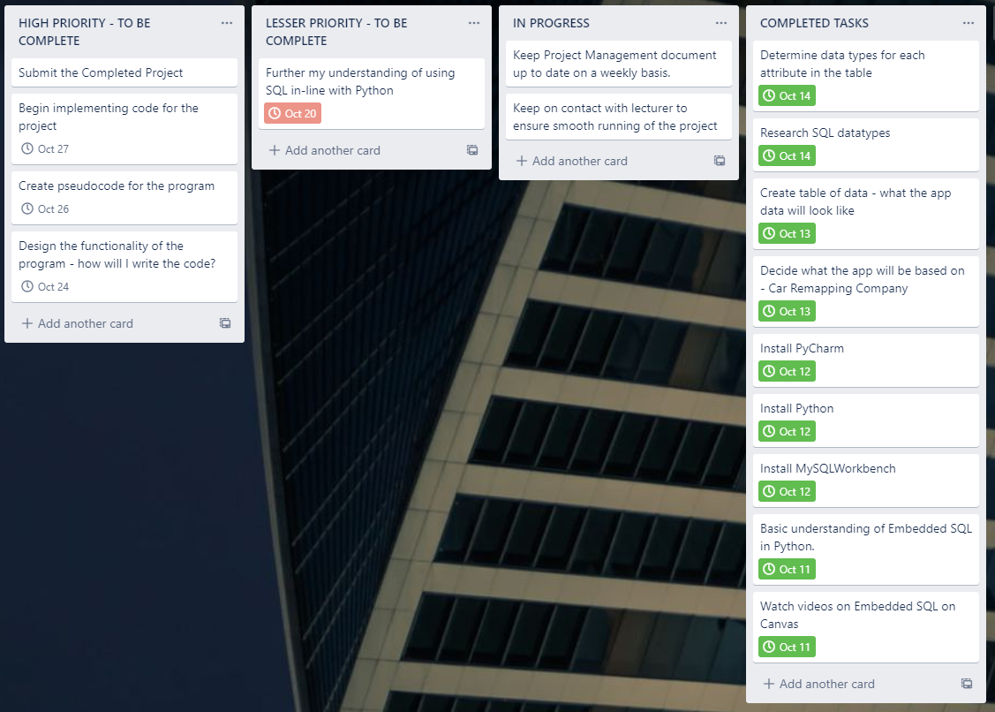

*As of 28/10/2020:*

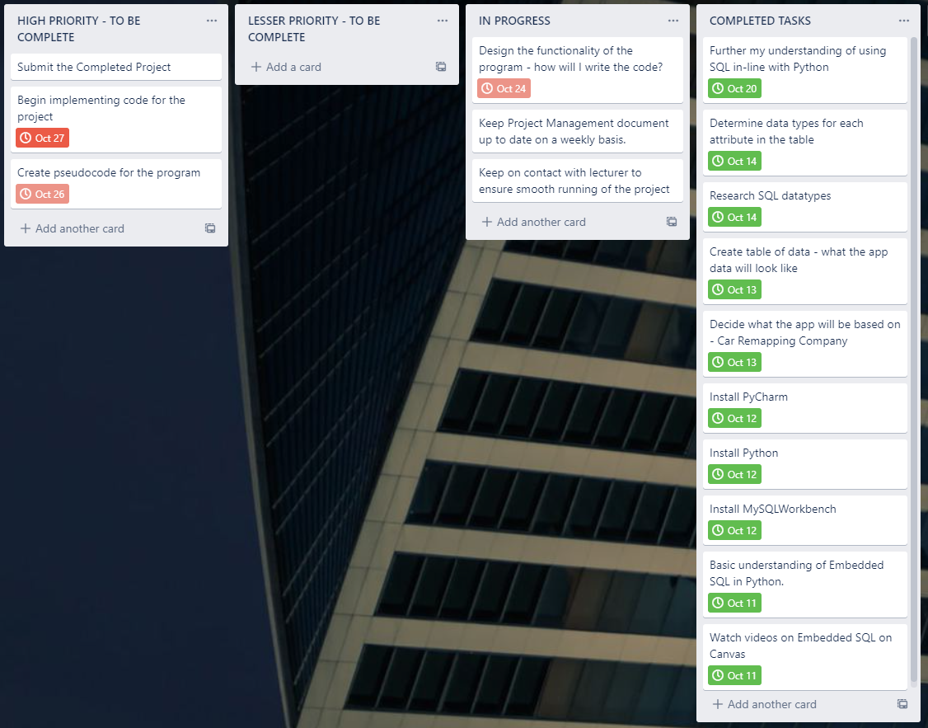

*As of 19/11/20:*

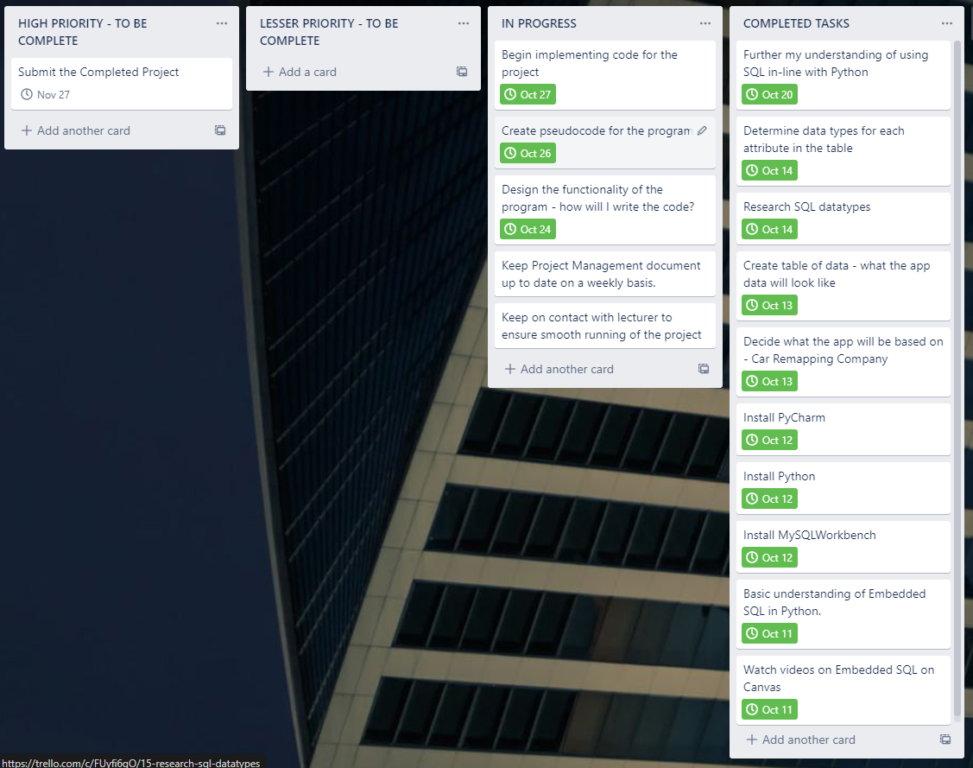

*As of 26/11/20:*

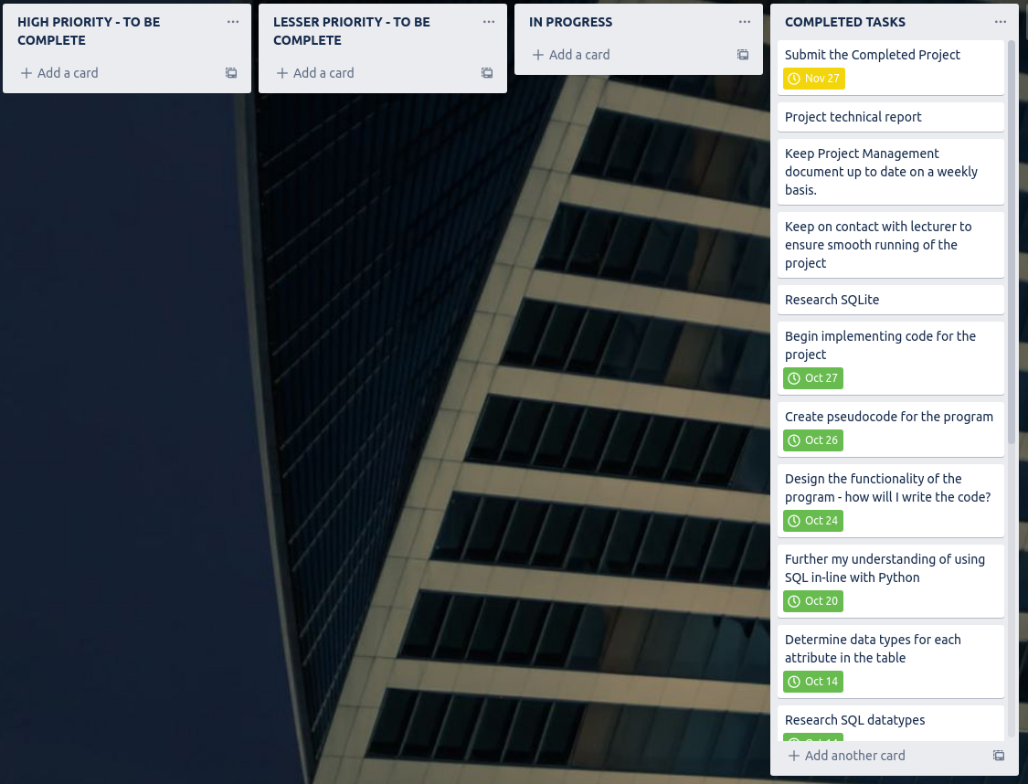

## Pseudocode:

***Initialisation:***

* Import sqlite module
* Make connection to database
* Create cursor in order to execute SQL statements within program

***User Menu:***

* Print menu to screen with menu options
* Ask user to input their menu option
  + 1. Edit Table
  + 2. View Table
  + 3. Quit Table
  + User Input >>>

***If Menu Choice = 1:***

* User selects edit table
* Print menu asking how user would like to edit table
  + 1. Insert
  + 2. Delete
    - If Menu Choice = 1
      * User wants to insert new data
      * Ask user for user input & assign input to variable
      * Call cursor to execute SQL
      * “INSERT INTO table(colName) VALUES(?)”, (data_input)
      * DB-API parameter substitution to prevent SQL injection attacks
      * Commit changes
      * Print success message
      * Close connection
    - If Menu Choice = 2
      * User wants to delete data
      * Use primary key to delete row of data
      * Primary key => carReg
      * Ask user for car reg & assign to variable
      * Call cursor to execute SQL command
      * DELETE FROM table WHERE colName=(?),(user input,)
      * Assign user input to a tuple, DB-API parameter substitution for security purposes. Prevent SQL injections.
      * Commit changes
      * Print success message
      * Close connection
    - Error handling

***If Menu Choice = 2:***

* User selects to view table
* Print table to screen
* Call cursor to execute SQL command
* SELECT *(all) FROM table
* Use fetchall function and assign return value to variable
* Use for loop to iterate through tables
* Print return variable to screen, in turn will print table

***If Menu Choice = 3:***

* Quit program
* Print goodbye message to user

***Error Handling***

* Else statement - Error if user input int other than 1/2/3
* ValueError - Error if user input other than int 1/2/3

## Declaration:

I hereby certify that this material which I now submit for assessment, is entirely my own work and has not been taken from the work of others, save and to the extent, that such work has been cited and acknowledged within the text of my work. I confirm that I have read and abided by the CIT policy on plagiarism.

Signed: Corey Lynch