**Corey Marcus**

**Satellite Control Systems**

**Final Exam**

The following graph shows attitude estimate errors. I chose double the vector component of the error quaternion as my error parameterization.

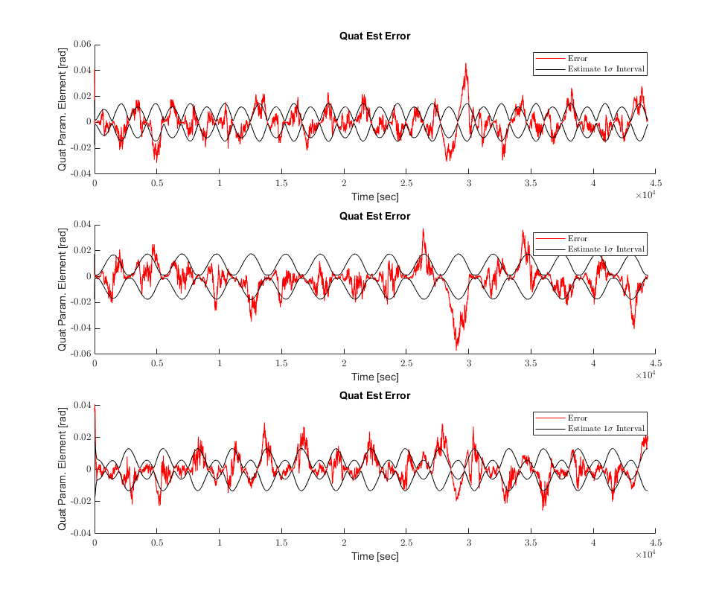

The next figure shows my bias estimate errors.

