Corey Munk

COMP 4432

Assignment 3

**Output:**



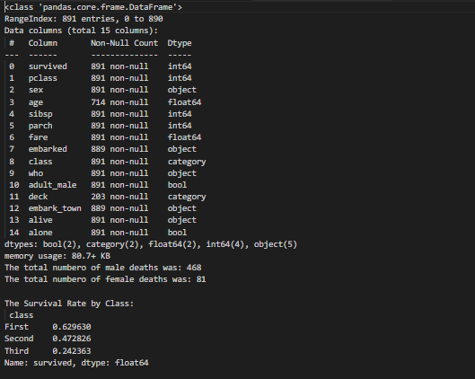

**Script:**

