Corey Osher

2/22/2021

Foundations of Database MGMT

Assignment Six

SQL Views & More

# Introduction

This paper discusses uses for SQL Views and a comparison between SQL Views, Functions, and Stored Procedures. All three have good functionality and are very useful as shortcuts to using more complex Select statements. Views are especially useful as an abstraction layer to protect the data within the database.

# SQL View Uses

The simplest SQL View use is to save a select statement for future use. Saving a complex Select statement for future use saves time. Views can also act as a layer of security also known as an abstraction layer. By denying access to the database’s tables and allowing access to table views instead, you allow database data to be visible but untouchable by users. Saving views with your database makes sense if you think you will ever want to use the same select statement more than once. The question is really, “When would you NOT want to utilize Views?” Figure 1 shows a simple select statement turned into a View. Even simple select statements take time to write that could be time saved using a view.

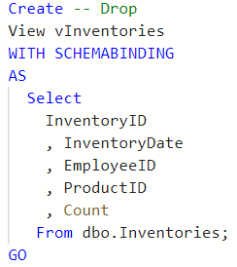Fig. 1

Views can also be used to visually partition data horizontally by rows, see Figure 2.

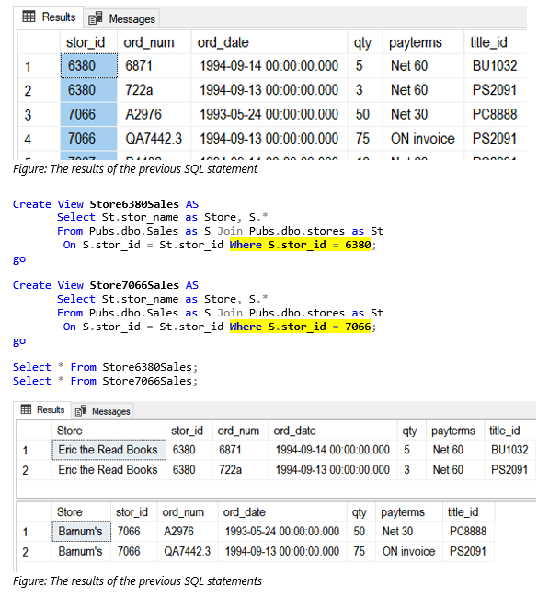Fig. 2

You can also vertically partition tables using views by selecting all the columns in 2 or more select statements within your view. This is helpful if some data is sensitive, and you would like to hide it from the public. Figure 3 shows the results of two view select statements, one accessible to the public and one for HR showing sensitive information.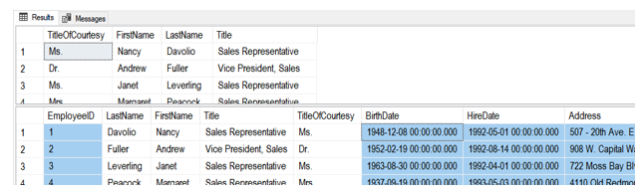Fig.3

# Views, Functions, & Stored Procedures

Views, Functions, and Stored Procedures are similar in that they all *CAN BE* saved select statements stored within the database. Figure 4 shows how all three can be used to acquire the same result.

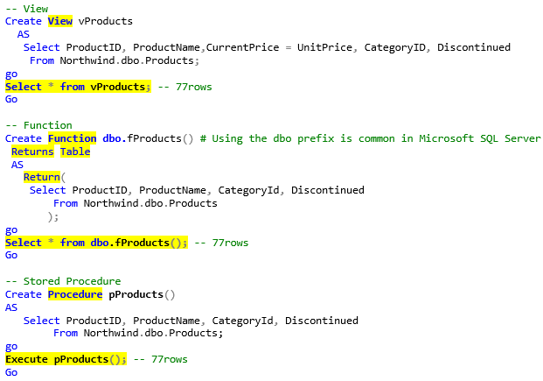Fig.4

Functions can filter retrieved data using a parameter in the select statement, aiding with ease of use and differentiation. This result is attainable using a view but would require and re-written “WHERE” clause with each select. Figure 5 shows a function filtering its results to a CategoryID of 1.

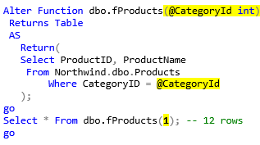Fig.5

Stored procedures or SProcs for short are not limited to select statements like views and functions. Stored procedures can use multiple parameters for filtering. See Figure 6 to see a stored procedure using multiple parameters.

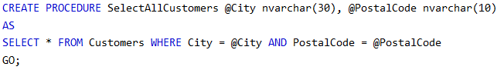Fig. 6

# Summary

I discussed the similarities and differences of views, functions, and stored procedures. All three store select statements to be used again and have a slightly different use. Storing select statements as a view, function or stored procedure can save substantial time writing the select statements again. Views can also act as an abstraction layer protecting the database from unintended manipulation.