Corey Schulz

CS 3200 – Spring 2020

April 20, 2020

**Homework 6** Report

*Least Squares and Image Processing*

**Question 1**

> All parts of this question can be viewed in Matlab by running `question_1.m`.

**A**

I modified the given NIST data, now in `input_data_nist.txt`, and got rid of the excess words at the top and the variable spacing between the `y` and `x` values. Then, I used the Matlab reader code to go line-by-line and store the values.

Here’s what they look like, plotted:

*NIST Data*

**B**

Using the supplied code as somewhat of a starting point, after I learned how the given method worked, I translated its functionality using provided methods in the Matlab API. In doing so, I plotted 1,001 points in an approximation to the given data, based on the dimensionality of the produced function. Here’s what those graphs looked like! (*And, sorry, there are a lot of them for this question*.*)*

…As you can see, each of these graphs have a *very* similar shape, with minor variations dependent on the degree of polynomial. Just from eyeballing the images, which one’s closer to the actual thing is *too hard to tell.* In fact, I’m surprised this method was able to get such a good approximation to the actual at all, given the resulting Vandermonde matrix is ill-conditioned, and even singular in some cases. Read on for the errors of each approximation.

**C**

Using Matlab’s implementation of the following error equation:

…We can gather the average least squares error of the approximations from Part B. That data is included below.

**Least Squares Error (NIST Data)**

|  |  |
| --- | --- |
| Polynomial degree | Average error for approximation |
| 9 | 0.0040 |
| 11 | 0.0034 |
| 13 | 0.0034 |
| 15 | 0.0032 |
| 17 | 0.0033 |
| 19 | 0.0034 |
| 21 | 0.0037 |
| 23 | 0.0044 |
| 25 | 0.0047 |

So, the lowest error hovers around .32, with a degree 15 approximation. This is as I would expect, given that a higher polynomial degree might tend to overfit to the existing data, where a lower polynomial degree might be *too* general to get the job done. Looking at the graphs in the previous question, this does appear to be the case. So, using *these* values of X and Y with no additional scaling, I’d say that an approximation using polynomial degree 15 is the best bet, though as most other questions in this class the *real* answer comes down to a tradeoff between computation time and accuracy.

**D**

Doing all the same work as in Parts B and C, but this time scaling the X and Y values to both be in the range [-1, 1], we get the following graphs this time:

Here, as in the first parts of this question, it’s rather inconclusive by looking at the graphs which one is the best. The higher rank polynomial graphs *seem to be* a lot smoother and less willing to overfit to the given data. *However,* we can see the gathered errors in the table below:

**Least Squares Error (NIST Data, scaled [-1, 1])**

|  |  |
| --- | --- |
| Polynomial degree | Average error for approximation |
| 9 | 0.0502 |
| 11 | 0.0429 |
| 13 | 0.0422 |
| 15 | 0.0407 |
| 17 | 0.0411 |
| 19 | 0.0423 |
| 21 | 0.0441 |
| 23 | 0.0475 |
| 25 | 0.0541 |

Again, like in the first parts of this problem, the degree `m` of which estimated polynomial is more accurate remains the same – the polynomial with the lowest error overall is of degree 15.

**E**

So, then, on the basis of these experiments the value of `m` that proved to be the best in terms of accuracy and desired results was 15.

Here, the polynomial appears to be the closest fit to the data *and* has the lowest error. It’s also in the middle ground of computation time between all the given polynomial degrees, too, so it would seem that it’s the best in terms of accuracy *and* computation!

**Question 2**

> Code for this question is contained in the files `question_2_durer.m` and `question_2_mandrill.m` respectively for each image.

**A**

For the purposes of this question, I modified the given Gatlin image code, changed the colormap to grey, and made a `for` loop to go over the requisite image ranks {2, 4, 8, 16, 32, 64, 128}.

Below are the results for each of the images.

**Mandrill**

As you can see, the SVD of the image drop rapidly, slow down in the middle and then continue dropping exponentially as K surpasses a certain threshold, sort of like an odd logarithm.

*Mandrill True Image*

*Mandrill Rank 128 Image*

*Mandrill Rank 64 Image*

*Mandrill Rank 32 Image*

*Mandrill Rank 16 Image*

*Mandrill Rank 8 Image*

*Mandrill Rank 4 Image*

*Mandrill Rank 2 Image*

There’s a steady drop in image quality from Rank 32 and down, *however,* the Rank 32 and below images save potentially drastically in terms of file size on disk. See part B for more details!

**Durer**

Here, the drops in SVD of the image follow a similar trend as the Mandrill image, but with a *slightly* different shape.

*Durer True Image*

*Durer Rank 128 Image*

*Durer Rank 64 Image*

*Durer Rank 32 Image*

*Durer Rank 16 Image*

*Durer Rank 8 Image*

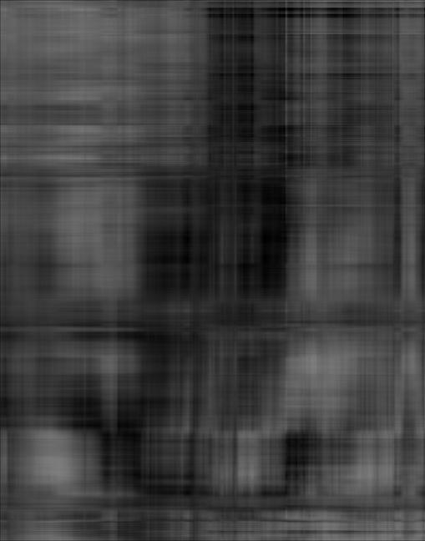

*Durer Rank 4 Image*

*Durer Rank 2 Image*

There’s a steady drop in image quality from Rank 32 and down, *however,* the Rank 32 and below images save potentially drastically in terms of file size on disk. See part B for more details!

**B**

For this part of the problem, I saved each image to the disk as a `.jpg` image. Of course, the size of these images depends on the filetype used – in this case, I chose JPG, a common enough standard, but the same trends *did* apply when I tried the images in a PNG format.

So, as the rank changes, the following tables describe the filesize of the respective images:

**Mandrill .jpg**

|  |  |  |
| --- | --- | --- |
| Image Rank | Image Filesize | Size Difference v. Previous |
| 2 | 24 KB | ~ |
| 4 | 28 KB | 4 KB |
| 8 | 35 KB | 7 KB |
| 16 | 44 KB | 9 KB |
| 32 | 55 KB | 11 KB |
| 64 | 66 KB | 11 KB |
| 128 | 76 KB | 10 KB |

**Durer .jpg**

|  |  |  |
| --- | --- | --- |
| Image Rank | Image Filesize | Size Difference vs Previous |
| 2 | 23 KB | ~ |
| 4 | 27 KB | 4 KB |
| 8 | 32 KB | 5 KB |
| 16 | 38 KB | 6 KB |
| 32 | 45 KB | 7 KB |
| 64 | 53 KB | 8 KB |
| 128 | 60 KB | 7 KB |

…As the rank doubles, roughly a constant is added to the filesize for each file each time. Speaking in terms of Big O, this is *roughly in the ballpark* O(log(n)) complexity – as the input size doubles, a roughly constant amount of work is added. Of course, it isn’t exactly the same principle here, but it’s comparable.

There are diminishing returns in how much you can compress an image using this method, however – after a certain point, only the skeleton remains and the image is unrecognizable as its former self. *However,* as is the case with many other problems presented in this class, it’s a tradeoff between space and efficiency that has to be decided given the circumstances surrounding the problem.