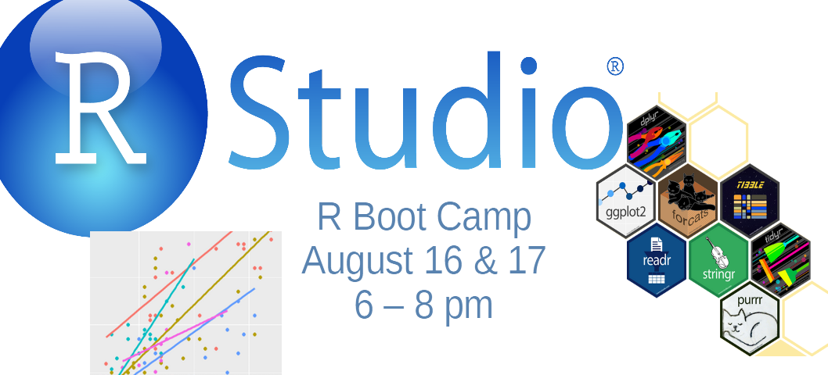
R Boot Camp for Graduate Students

What we will do:
This will be a short introduction to the R statistical programming language. This is intended to ease the anxiety over using R for your statistics courses. We realize that many incoming students have not used R or any programming language.
What you'll get from this:
This boot camp will get you set up on your personal computer using R. This includes installing R, Rstudio and any other associated software, and getting you oriented with where things are, and how to use core tools of the tidyverse for statistical graphics and programming with data.
Link to Session via Zoom
Agenda
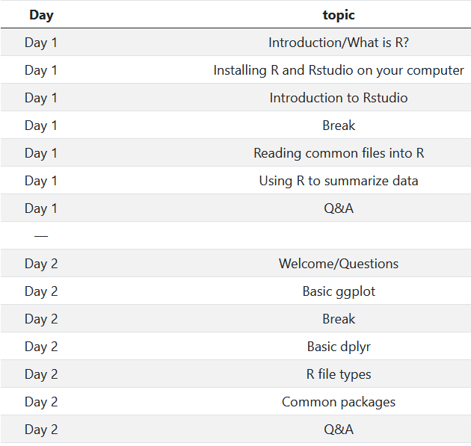


Instructor:
Dr. Corey S. Sparks
UTSA Department of Demography
corey.sparks@utsa.edu

To Register: You can register for the session at https://forms.gle/6nkocMjQuLTcg8oS6

