Introduction to R for Social and Behavioral Sciences

Corey Sparks, PhD - UTSA Department of Demography

October 19, 2017

Table of Contents

# Welcome to R.

R is an interpreted languages, not a compiled one. This means, you type something into R and it does it.

If you're coming to R from SAS, there is no data step. There are no procs. The [SAS and R book](https://www.amazon.com/gp/product/1466584491/ref=as_li_tl?ie=UTF8&camp=1789&creative=390957&creativeASIN=1466584491&linkCode=as2&tag=sasandrblog-20) is very useful for going between the two programs.

If you're coming from SPSS and you've been using the button clicking method, be prepared for a steep learning curve. If you've been writing syntax in SPSS, you're at least used to having to code. There's a good book for SAS and SPSS users by Bob Meunchen at the Univ. of Tennessee [here](https://www.amazon.com/SAS-SPSS-Users-Statistics-Computing/dp/1461406846), which may be of some help.

## R and Rstudio

The Rgui is the base version of R, but is not very good to program in. Rstudio is much better, as it gives you a true integrated development environment (IDE), where you can write code in on window, see results in others, see locations of files, see objects you've created

### R file types

*.R files* R uses a basic script file with the .R extension. This type of file is useful if you're going to write a function or do some analysis and don't want to have formatted output or text.

*.Rmd files* Rstudio uses a form of the markdown formatting language, called Rmarkdown, for creating formatted documents that include code chunks, tables, figures and statistical output. **This entire example is written in Rmarkdown!**

Rmarkdown is nice for lots of reasons, such as the abiltity to insert latex equations into documents

$$y_i \sim Normal (x` \beta, \sigma_2)$$

or to include output tables directly into a document:

|  |  |  |  |  |
| --- | --- | --- | --- | --- |
| term | estimate | std.error | statistic | p.value |
| (Intercept) | 18.78 | 9.803 | 1.916 | 0.05723 |
| tfr | 13.56 | 2.227 | 6.089 | 8.807e-09 |
| percurban | -0.263 | 0.06675 | -3.94 | 0.0001236 |
| percpoplt15 | 0.1949 | 0.2951 | 0.6604 | 0.51 |
| percmarwomcontraall | -0.2579 | 0.09202 | -2.803 | 0.005724 |

without having to make tables in Word or some other program. You can basically do your entire anlaysis and slideshow or paper writeup, including bibliography in Rstudio.

*R Notebooks* In recent versions of Rstudio, another kind of document, called a R Notebook has been created. This is nice because, like a Rmarkdown document, R notebooks include code, text and formatted output, but you can also show and hide code chunks throughout the document.

## Getting help in R

I wish I had a nickel for every time I ran into a problem trying to do something in R, that would be a lot of nickles. Here are some good tips for finding help:

1. If you know the name of a function you want to use, but just need help using it, try ?

?lm

1. If you need to find a function to do something, try ??

??"linear model"

1. If you want to search among other R users' questions to the R list serve, try RSiteSearch()

RSiteSearch("heteroskedasticity")

1. Speaking of which, there are multiple [R user email list serves](https://www.r-project.org/mail.html) that you can ask questions on, but they typically want an example of what you're trying to do. I wish I also had nickles for each question i've asked and answered on these forums.
2. A good source for all things programming is the statistics branch of [Stack Exchange](https://stats.stackexchange.com), which has lots of contributed questions and answers, although many answers are either very snarky or wrong or for an old version of a library, so *caveat emptor*.
3. Your local R guru or R user group UTSA is

# Using R

## Getting around in R

When you begin an R session (open R) you will begin in your home directory. This is traditionally on Windows at 'C:/Users/yourusername/Documents' and on Mac, is '/Users/yourusername'.

If you're not sure where you are you can type getwd(), for get working directory, and R will tell you:

getwd()

## [1] "C:/Users/ozd504/Documents/GitHub/r_courses"

If you don't like where you start, you can change it, by using setwd(), to set your working directory to a new location.

setwd("C:/Users/ozd504/Google Drive/")  
getwd()

## R libraries

R uses libraries to do different types of analysis, so we will need to install lots of different libraries to do different things. There are around 10,000 different packages currently for R. These are also organized into *Task Views*, where packages are organized into thematic areas.

Libraries/packages need to be downloaded from the internet, using the install.packages() command. You only need to install a package once. E.g.

install.packages("car")

will install the car library. To use the functions within it, type

library(car)

Now you have access to those functions. You don't need to install the package again, unless you update your R software.

I strongly recommend you install several packages prior to us beginning. I've written a short script on Github you can use it by running:

source("https://raw.githubusercontent.com/coreysparks/Rcode/master/install_first_short.R")

This will install a few dozen R packages that are commonly used for social science analysis.

# R examples

Below we will go through a simple R session where we introduce some concepts that are important for R.

### R is a calculator

#addition and subtraction  
3+7

## [1] 10

3-7

## [1] -4

#multiplication and division  
3*7

## [1] 21

3/7

## [1] 0.4285714

#powers  
3^2

## [1] 9

3^3

## [1] 27

#sommon math functions  
log(3/7)

## [1] -0.8472979

exp(3/7)

## [1] 1.535063

sin(3/7)

## [1] 0.4155719

#custom functions  
myfun<-function(x){  
 sqrt(x)^x  
}  
  
myfun(5)

## [1] 55.9017

### Variables and objects

In R we assign values to objects (object-oriented programming). These can generally have any name, but some names are reserved for R. For instance you probably wouldn't want to call something 'mean' because there's a 'mean()' function already in R. For instance:

x<-3  
y<-7  
x+y

## [1] 10

x*y

## [1] 21

log(x*y)

## [1] 3.044522

## vectors

R thinks everything is a matrix, or a vector, meaning a row or column of numbers, or characters. One of R's big selling points is that much of it is completely vectorized. Meaning, I can apply an operation along all elements of a vector without having to write a loop. For example, if I want to multiply a vector of numbers by a constant, in SAS, I could do:

for (i in 1 to 5) x[i]<-y[i]*5 end

but in R, I can just do:

x<-c(3, 4, 5, 6, 7)  
#c() makes a vector  
y<-7  
  
x*y

## [1] 21 28 35 42 49

R is also very good about using vectors, let's say I wanted to find the third element of x:

x[3]

## [1] 5

#or if I want to test if this element is 10  
x[3]==10

## [1] FALSE

x[3]!=10

## [1] TRUE

#of is it larger than another number:  
x[3]>3

## [1] TRUE

#or is any element of the whole vector greater than 3  
x>3

## [1] FALSE TRUE TRUE TRUE TRUE

If you want to see what's in an object, use str(), for structure

str(x)

## num [1:5] 3 4 5 6 7

and we see that x is numeric, and has those values.

We can also see different characteristics of x

#how long is x?  
length(x)

## [1] 5

#is x numeric?  
is.numeric(x)

## [1] TRUE

#is x full of characters?  
is.character(x)

## [1] FALSE

#is any element of x missing?  
is.na(x)

## [1] FALSE FALSE FALSE FALSE FALSE

xc<-c("1","2")  
  
#now i'll modify x  
x<-c(x, NA) #combine x and a missing value ==NA  
x

## [1] 3 4 5 6 7 NA

#Now ask if any x's are missing  
is.na(x)

## [1] FALSE FALSE FALSE FALSE FALSE TRUE

## replacing elements of vectors

Above, we had a missing value in X, let's say we want to replace it with another value:

x<-ifelse(test = is.na(x)==T, yes = sqrt(7.2), no = x)  
x

## [1] 3.000000 4.000000 5.000000 6.000000 7.000000 2.683282

Done!

## Dataframes

Traditionally, R organizes variables into data frames, these are like a spreadsheet. The columns can have names, and the dataframe itself can have data of different types. Here we make a short data frame with three columns, two numeric and one character:

mydat<-data.frame(  
 x=c(1,2,3,4,5),  
 y=c(10, 20, 35, 57, 37),  
 group=c("A", "A" ,"A", "B", "B")  
)  
  
#See the size of the dataframe  
dim(mydat)

## [1] 5 3

length(mydat$x)

## [1] 5

#Open the dataframe in a viewer and just print it  
View(mydat)  
print(mydat)

## x y group  
## 1 1 10 A  
## 2 2 20 A  
## 3 3 35 A  
## 4 4 57 B  
## 5 5 37 B

## Real data

Now let's open a 'real' data file. This is the [2008 World population data sheet](http://www.prb.org/Publications/Datasheets/2008/2008wpds.aspx) from the [Population Reference Bureau](http://www.prb.org). It contains summary information on many demographic and population level characteristics of nations around the world in 2008.

I've had this entered into a **Comma Separated Values** file by some poor previous GRA of mine and it lives happily on Github now for all the world to see. CSV files are a good way to store data coming out of a spreadsheet. R can read Excel files, but it digests text files easier. Save something from Excel as CSV.

I can read it from github directly by using a function in the readr library:

That's handy. If the file lived on our computer, I could read it in like so: *note, please make a folder on your computer so you can store things for this class in a single location!!!! Organization is Key to Success in Graduate School*

prb<-read_csv("C:/Users/ozd504/Documents/GitHub/r_courses/PRB2008_All.csv")

## Parsed with column specification:  
## cols(  
## .default = col_integer(),  
## Country = col_character(),  
## Continent = col_character(),  
## Region = col_character(),  
## Population. = col_double(),  
## Rate.of.natural.increase = col_double(),  
## ProjectedPopMid2025 = col_double(),  
## ProjectedPopMid2050 = col_double(),  
## IMR = col_double(),  
## TFR = col_double(),  
## PercPop1549HIVAIDS2001 = col_double(),  
## PercPop1549HIVAIDS2007 = col_double(),  
## PercPpUnderNourished0204 = col_double(),  
## PopDensPerSqMile = col_double()  
## )

## See spec(...) for full column specifications.

Same result.

The haven library can read files from other statistical packages easily, so if you have data in Stata, SAS or SPSS, you can read it into R using those functions, for example, the read_dta() function reads stata files, read_sav() to read spss data files.

I would not recommend you store data in Excel files for many reasons, but if you do, save the files as a CSV file and use the read_csv() function above to read it in.

library(haven)  
prb_stata<-read_dta("C:/Users/ozd504/Documents/GitHub/r_courses/prb2008.dta")  
  
prb_spss<-read_sav("C:/Users/ozd504/Documents/GitHub/r_courses/prb_2008.sav")

Don't know what a function's called use ??

??stata ??csv

and Rstudio will show you a list of functions that have these strings in them.

What if you know the function name, like read_csv() but you want to see all the function arguments?

?read_csv

will open up the help file for that specific function

### Save a file

Want to save something as a R data file? Use save()

save(prb, file="C:/Users/ozd504/Documents/GitHub/r_courses/prb_2008_saved.Rdata")

If you have an R data file, use load() to open it:

load("C:/Users/ozd504/Documents/GitHub/r_courses/prb_2008.Rdata")

### Descriptive analysis

Let's have a look at some descriptive information about the data:

#Frequency Table of # of Contries by Continent  
table(prb$Continent)

##   
## Africa Asia Europe North America Oceania   
## 56 51 45 27 17   
## South America   
## 13

#basic summary statistics for the fertility rate  
summary(prb$TFR)

## Min. 1st Qu. Median Mean 3rd Qu. Max. NA's   
## 1.000 1.775 2.500 3.032 4.000 7.100 1

From this summary, we see that the mean is 3.023, there is one country missing the Total fertility rate variable. The minimum is 1 and the maximum is 7.1 children per woman.

Now, we will cover some basic descriptive statistical analysis. We will describe measures of central tendency and variability and how these are affected by outliers in our data.

### Measures of central tendency

We can use graphical methods to describe what data 'look like' in a visual sense, but graphical methods are rarely useful for comparative purposes. In order to make comparisons, you need to rely on a numerical summary of data vs. a graphical one (I'm not saying statistical graphics aren't useful, they are!)

Numerical measures tell us a lot about the form of a distribution without resorting to graphical methods. The first kind of summary statistics we will see are those related to the measure of *central tendency*. Measures of central tendency tell us about the central part of the distribution

## Mean and median

Here is an example from the PRB data. R has a few different ways to get a variable from a dataset. One way is the $ notation, used like dataset$variable

mean(prb$TFR)

## [1] NA

Whoops! What happened? This means that R can't calculate the mean because there's a missing value, which we saw before. We can tell R to automatically remove missing values by:

mean(prb$TFR, na.rm = T)

## [1] 3.032212

Which is correct.

# Measures of variation

One typical set of descriptive statistics that is very frequently used is the so-called **five number summary** and it consists of : the Minimum, lower quartile, median, upper quartile and maximum values. This is often useful if the data are not symmetric or skewed. This is what you get when you use the fivenum() function, or we can include the mean if we use the summary() function.

?fivenum

## starting httpd help server ... done

fivenum(prb$TFR)

## [1] 1.00 1.75 2.50 4.00 7.10

summary(prb$TFR)

## Min. 1st Qu. Median Mean 3rd Qu. Max. NA's   
## 1.000 1.775 2.500 3.032 4.000 7.100 1

### Variance

To calculate the variance and standard deviation of a variable:

var(x)

## [1] 2.894531

sd(x)

## [1] 1.701332

sqrt(var(x))#same as using sd()

## [1] 1.701332

## Really Real data example

Now let's open a 'really real' data file. This is a sample from the 2015 1-year [American Community Survey](https://www.census.gov/programs-surveys/acs/) microdata, meaning that each row in these data is a person who responded to the survey in 2015. I get these, and you should too from the [Minnesota Population Center](https://pop.umn.edu) IPUMS data. The [IPUMS](https://usa.ipums.org/usa/) stands for "Integrated Public Use Microdata Series", and consists of individual person responses to decennial census returns going back to 1850, and the American Community Survey data from 2001 to the present.

I'm using data from the US, but there is an [IPUMS International](https://international.ipums.org/international/) data series too, which has data from 85 countries and over 300 censuses.

I've done an extract (do example in class) and stored the data in a R data (.Rdata) format on [my github data site](https://github.com/coreysparks/r_courses). The file we are using is called [census.Rdata](https://github.com/coreysparks/r_courses/blob/master/census_data.Rdata?raw=true). This extract is small by demographic data standards and is only about 300,000 people.

There is also a codebook that describes the data and all the response levels for each variable in the data. They are also on my github data page, and called [Codebook_census_data](https://github.com/coreysparks/r_courses/blob/master/Codebook_census_data.pdf).

I can read it from my github repository directly by using the load() function combined with the url() function, to tell R that the file is on the web. If the file were, say, in my documents folder, I could likewise load the data from disk.

load(file=url("https://github.com/coreysparks/r_courses/blob/master/census_data.Rdata?raw=true"))  
  
#from disk  
#load("C:/Users/ozd504/Documents/census_data.Rdata")  
  
#print the column names  
names(census)

## [1] "year" "datanum" "serial" "hhwt" "statefip"   
## [6] "met2013" "puma" "gq" "pernum" "perwt"   
## [11] "famsize" "nchild" "nchlt5" "eldch" "nsibs"   
## [16] "relate" "related" "sex" "age" "marst"   
## [21] "birthyr" "fertyr" "race" "raced" "hispan"   
## [26] "hispand" "bpl" "bpld" "citizen" "yrsusa1"   
## [31] "language" "languaged" "speakeng" "educ" "educd"   
## [36] "empstat" "empstatd" "labforce" "occ" "ind"   
## [41] "inctot" "incwage" "poverty" "hwsei" "migrate1"   
## [46] "migrate1d" "carpool" "trantime"

## Pipes

The dplyr library is a portion of a suite of libraries known as the [*tidyverse*](https://www.tidyverse.org), which are oriented towards reproducible, intelligible coding for data science. There are too many things within the tidyverse to cover them all here, but I will introduce you to two aspects: 1) dplyr verbs and pipes 2) the ggplot2 library for producing graphs

### Basic tidyverse verbs

The dplyr library has many verbs (action words) that are used to do various things. The neat thing about dplyr is it allows you to tell R what data source you want to do something to at the top of a *pipe*, then you can execute as many verbs as you need within the pipe without referring to the dataset by name again.

For instance, in the census data, let's say we want to calculate the median income for adult, men and women who are in the labor force, in Texas. Sounds easy, right? In base R we would have to do some subsetting of the data first ( to limit our analysis to adults, in the labor force, who live in Texas), then use another function to calculate the median income for men and women.

dplyr allows us to do this in one fell swoop of code. We will use a few verbs, notably filter() to subset our cases, based on the conditions we describe, mutate() to recode our income variable, group_by() to let R know that the summaries we want will be for specific groups and summarise() to calculate the numeric summaries we want.

Now, most variables in the IPUMS can't be used out of the box. For example open the pdf codebook and find the variable "incwage", which is person's income from wages in the previous year.

We are specifically wanting to pay attention to the "Coder Instructions" *you're the coder*. Notice two codes (values) that are of special note. *Specific Variable Codes 999999 = N/A and 999998=Missing*. So if we want to use this variable, we need to do a basic recode of these values to tell R that they represent missing values.

### Pipes

The second thing we need to know about are *pipes*. Pipes can be used to chain together verbs so that the code executes on the same dataset in sequence. They are identified by a %>% at the end of each verb statement. Here's our example in action:

library(dplyr)

##   
## Attaching package: 'dplyr'

## The following objects are masked from 'package:stats':  
##   
## filter, lag

## The following objects are masked from 'package:base':  
##   
## intersect, setdiff, setequal, union

census%>%  
 filter(age>18, statefip==48, labforce==2)%>%  
 mutate(newwage= ifelse(incwage%in%c(999998,999999), NA, incwage),  
 newsex=ifelse(sex==1, "male", "female" ))%>%  
 group_by(newsex)%>%  
 summarise(med_income= median(newwage, na.rm=T))

## # A tibble: 2 x 2  
## newsex med_income  
## <chr> <dbl>  
## 1 female 26100  
## 2 male 38000

and we see a difference of about $12,000 between men and women in Texas.

Notice in the code above, I did two three different filters in a single filter() statement and two recodes in a single mutate() statement, this is totally legal, and in general you can do several operations within a single verb statement. Otherwise I would have to do:

library(dplyr)  
  
census%>%  
 filter(age>18)%>%  
 filter(statefip==48)%>%  
 filter(labforce==2)%>%  
 mutate(newwage= ifelse(incwage%in%c(999998,999999), NA, incwage))%>%  
 mutate(newsex=ifelse(sex==1, "male", "female" ))%>%  
 group_by(newsex)%>%  
 summarise(med_income= median(newwage, na.rm=T))

## # A tibble: 2 x 2  
## newsex med_income  
## <chr> <dbl>  
## 1 female 26100  
## 2 male 38000

So we get to the same place. It's up to you which way you do it, always go with the route that you understand better and that is more readable and explicable to someone else.

I always say that in R, there's **always** more than one way to do anything!

We could also see how incomes are different in San Antonio (variable met2013==41700) compared to Dallas (variable met2013==19100).

census%>%  
 filter(labforce==2, met2013%in%c(41700, 19100), age>18) %>%  
 mutate(newwage= ifelse(incwage%in%c(999998,999999), NA, incwage),  
 sexrecode=ifelse(sex==1, "male", "female"),  
 city=ifelse(met2013==41700, "San Antonio", "Dallas")) %>%  
 group_by(sexrecode, city)%>%  
 summarise(med_income=median(newwage, na.rm=T), n=n())

## # A tibble: 4 x 4  
## # Groups: sexrecode [?]  
## sexrecode city med_income n  
## <chr> <chr> <dbl> <int>  
## 1 female Dallas 32000 1437  
## 2 female San Antonio 25000 424  
## 3 male Dallas 40000 1744  
## 4 male San Antonio 36000 466

So, we see that men in Dallas make about $4000 more than men in San Antonio, and women in Dallas make about $7000 more than women in San Antonio

### Basic ggplot()

Let's say that we want to compare the distributions of income from the above examples graphically. Since the ggplot2 library is part of the tidyverse, it integrates directly with dplyr and we can do plots within pipes too.

In generally, ggplot() has a few core statements.

1. ggplot() statement - This tells R the data and the basic aesthetic that will be plotted, think x and y axis of a graph
2. Define the geometries you want to use to plot your data, there are many types of plots you can do, some are more appropriate for certain types of data
3. Plot annotations - Titles, labels etc.

Now I will illustrate some basic ggplot examples, and I'm going to use the PRB data for now because it's much prettier than the ACS data for plotting.

library(ggplot2)  
  
ggplot(data=prb, mapping=aes(TFR))+  
 geom_histogram( bins=10)+  
 ggtitle(label = "Distribution of the Total Fertility Rate ", subtitle = "2008 Estimates")+  
 xlab(label = "TFR")+  
 ylab(label="Frequency")

## Warning: Removed 1 rows containing non-finite values (stat_bin).

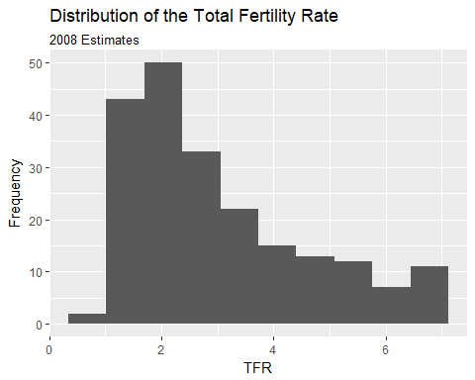

There is also a nice geometry called freqpoly that will draw polygons instead of bars for a histogram. I will use this to produce histograms for each continent.

ggplot(data=prb,mapping = aes(TFR, colour=Continent))+  
 geom_freqpoly( bins=10)+  
 ggtitle(label = "Distribution of the Total Fertility Rate by Continent", subtitle = "2008 Estimates")+  
 xlab(label = "TFR")+  
 ylab(label="Frequency")

## Warning: Removed 1 rows containing non-finite values (stat_bin).

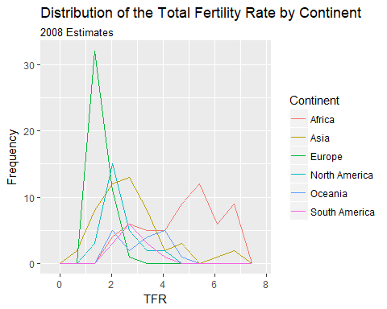

Also, we can plot the relative frequency , or density, instead of the count by including the ..density.. argument in the aesthetic aes().

ggplot(data=prb,mapping = aes(TFR, colour=Continent, ..density..))+  
 geom_freqpoly( bins=10)+  
 ggtitle(label = "Distribution of the Total Fertility Rate by Continent", subtitle = "2008 Estimates")+  
 xlab(label = "TFR")+  
 ylab(label="Frequency")

## Warning: Removed 1 rows containing non-finite values (stat_bin).

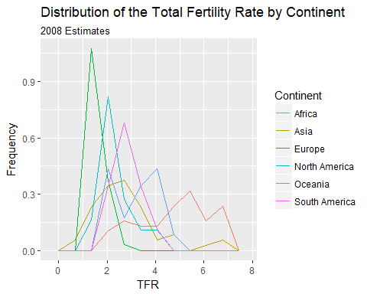

# Stem and leaf plots/Box and Whisker plots

Another visualization method is the stem and leaf plot, or box and whisker plot. This is useful when you have a continuous variable you want to display the distribution of across levels of a categorical variable. This is basically a graphical display of Tukey's 5 number summary of data.

ggplot(prb, mapping = aes(x= Continent, y =TFR))+  
 geom_boxplot()+  
 ggtitle(label = "Distribution of the Total Fertility Rate by Continent", subtitle = "2008 Estimates")

## Warning: Removed 1 rows containing non-finite values (stat_boxplot).

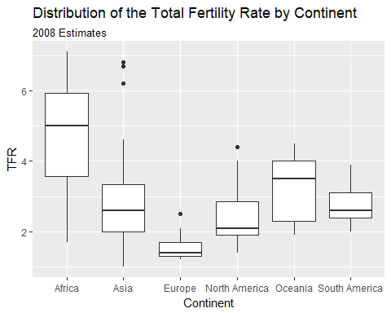 You can flip the axes, by adding coord_flip()

ggplot(prb, mapping = aes(x= Continent, y =TFR))+  
 geom_boxplot()+  
 ggtitle(label = "Distribution of the Total Fertility Rate by Continent", subtitle = "2008 Estimates")+coord_flip()

## Warning: Removed 1 rows containing non-finite values (stat_boxplot).

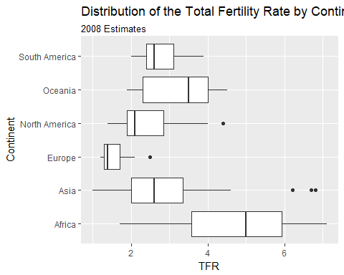 You can also color the boxes by a variable, Here, I will make a new variable that is the combination of the continent variable with the region variable, using the paste() function. It's useful for combining values of two strings.

prb%>%  
 mutate(newname = paste(Continent, Region, sep="-"))%>%  
 ggplot(aes(x= newname, y =TFR,fill=Continent))+  
 geom_boxplot()+coord_flip()+  
 ggtitle(label = "Distribution of the Total Fertility Rate by Continent", subtitle = "2008 Estimates")

## Warning: Removed 1 rows containing non-finite values (stat_boxplot).

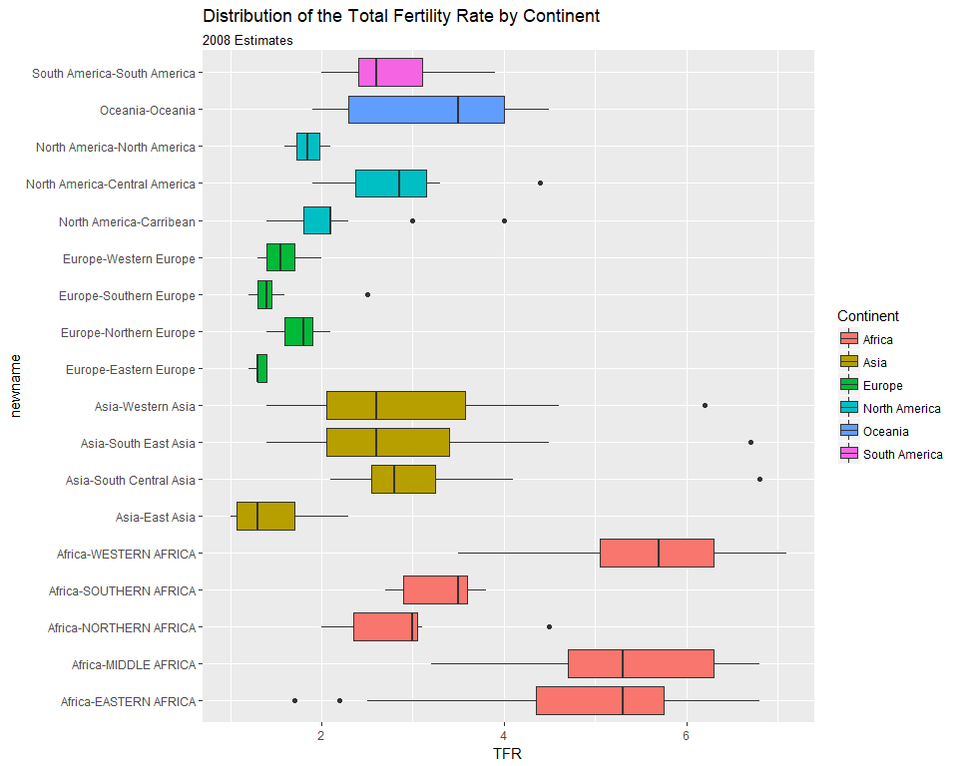

### X-Y Scatter plots

These are useful for finding relationships among two or more continuous variables. ggplot() can really make these pretty.

Here are a few riffs using the PRB data:

ggplot(data=prb,mapping= aes(x=TFR, y=IMR))+  
 geom_point()+  
 ggtitle(label = "Relationship between Total Fertility and Infant Mortality", subtitle = "2008 Estimates")+  
 xlab(label = "TFR")+  
 ylab(label="IMR")

## Warning: Removed 2 rows containing missing values (geom_point).

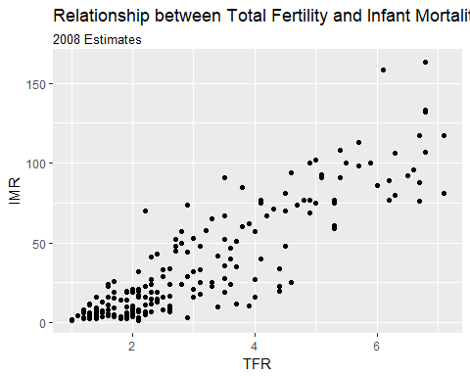

Now we color varies by continent

ggplot(data=prb,mapping= aes(x=TFR, y=IMR, color=Continent))+  
 geom_point()+  
 ggtitle(label = "Relationship between Total Fertility and Infant Mortality", subtitle = "2008 Estimates")+  
 xlab(label = "TFR")+  
 ylab(label="IMR")

## Warning: Removed 2 rows containing missing values (geom_point).

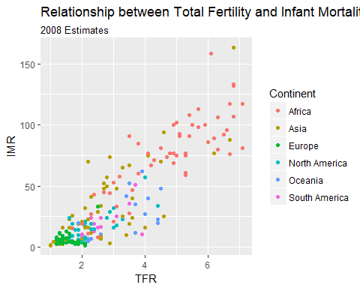

Now we vary the shape of the point by continent

#shape varies by continent  
ggplot(data=prb,mapping= aes(x=TFR, y=IMR, shape=Continent))+  
 geom_point()+  
 ggtitle(label = "Relationship between Total Fertility and Infant Mortality", subtitle = "2008 Estimates")+  
 xlab(label = "TFR")+  
 ylab(label="IMR")

## Warning: Removed 2 rows containing missing values (geom_point).

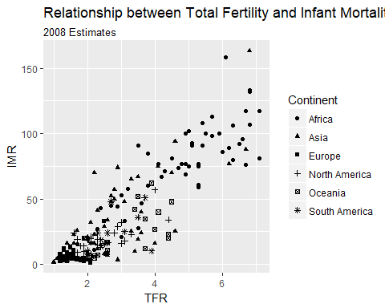

## Facet plots

Facet plots are nice, if you want to create a plot separately for a series of groups. This allows you to visualize if the relationship is constant across those groups, well at least graphically.

ggplot(data=prb,mapping= aes(x=TFR, y=IMR, color=Continent))+  
 geom_point()+  
 facet_wrap(~Continent)+  
 ggtitle(label = "Relationship between Total Fertility and Infant Mortality", subtitle = "2008 Estimates")+  
 xlab(label = "TFR")+  
 ylab(label="IMR")

## Warning: Removed 2 rows containing missing values (geom_point).

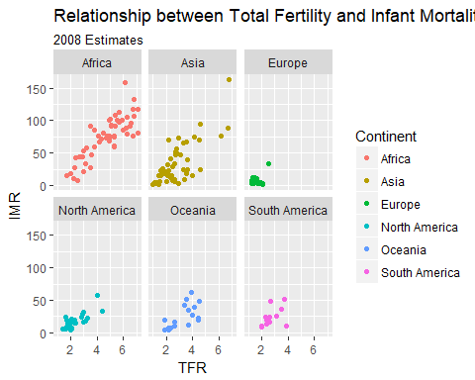

## Plotting relationships with some line fits

ggplot allows you to make some very nice line-fit plots for scatter plots. While the math behind these lines is not what we are talking about, they do produce a nice graphical summary of the relationships.

ggplot(data=prb,mapping= aes(x=TFR, y=IMR))+  
 geom_point()+  
 geom_smooth( method = "lm")+  
 ggtitle(label = "Relationship between Total Fertility and Infant Mortality", subtitle = "2008 Estimates-linear fit")+  
 xlab(label = "TFR")+  
 ylab(label="IMR")

## Warning: Removed 2 rows containing non-finite values (stat_smooth).

## Warning: Removed 2 rows containing missing values (geom_point).

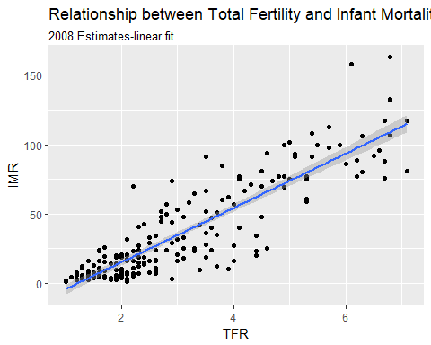

ggplot(data=prb)+  
 geom_point(mapping= aes(x=TFR, y=IMR))+  
 geom_smooth(mapping= aes(x=TFR, y=IMR) , method = "loess")+  
 ggtitle(label = "Relationship between Total Fertility and Infant Mortality", subtitle = "2008 Estimates")+  
 xlab(label = "TFR")+  
 ylab(label="IMR")

## Warning: Removed 2 rows containing non-finite values (stat_smooth).  
  
## Warning: Removed 2 rows containing missing values (geom_point).

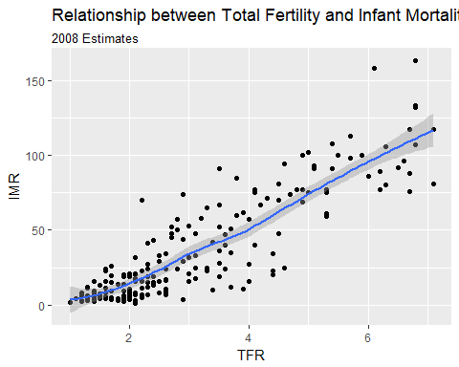

Another example, this time of a bad linear plot!

ggplot(data=prb,mapping= aes(x=TFR, y=PercPopLT15))+  
 geom_point()+  
 geom_smooth( method = "lm")+  
 ggtitle(label = "Relationship between Total Fertility and Percent under age 15", subtitle = "2008 Estimates-linear fit")+  
 xlab(label = "Percent under age 15")+  
 ylab(label="IMR")

## Warning: Removed 1 rows containing non-finite values (stat_smooth).

## Warning: Removed 1 rows containing missing values (geom_point).

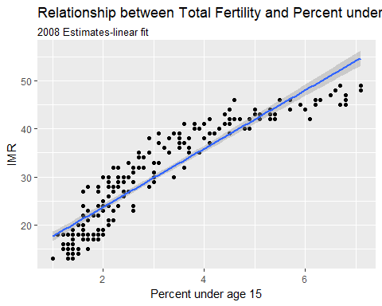

So instead, us a nonlinear fit, a la a loess regression:

ggplot(data=prb, mapping= aes(x=TFR, y=PercPopLT15))+  
 geom_point()+  
 geom_smooth( method = "loess")+  
 ggtitle(label = "Relationship between Total Fertility and Percent under age 15", subtitle = "2008 Estimates- loess fit")+  
 xlab(label = "Percent under age 15")+  
 ylab(label="IMR")

## Warning: Removed 1 rows containing non-finite values (stat_smooth).

## Warning: Removed 1 rows containing missing values (geom_point).

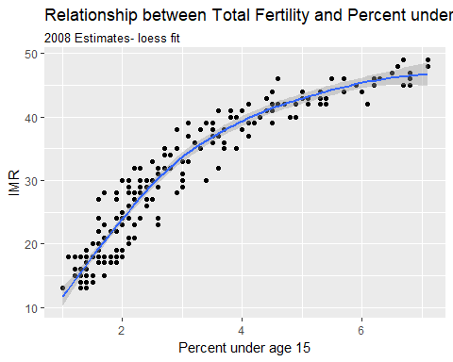

# Other Resources

### Miktek

To build pdf's you'll need a version of Latex installed, [Miktek](https://miktex.org/download) is a good option

### R-markdown cheat sheets

Rstudio keeps a variety of [cheat sheets](https://www.rstudio.com/resources/cheatsheets/) for various topics, they can be helpful in a pinch

### UCLA Statistical computing help

[This page](http://www.ats.ucla.edu/stat/) has lots of examples of using R for various types of analysis.

### Other examples

On [my Rpubs page](http://rpubs.com/corey_sparks) I have lots of examples of various types of analysis using R and you can get the data for these on [my Github data page](https://github.com/coreysparks/data)

### R on Shamu

The UTSA [High performance computing group](https://www.utsa.edu/oit/AboutUs/RCSG/HPC.html) maintains a computational cluster named Shamu, and R is installed on it. You can [contact them](mailto:RCSG@utsa.edu) for assistance. We are also working on starting a R user group for the UTSA community.