METHODS

*FIA*

XXXXXX

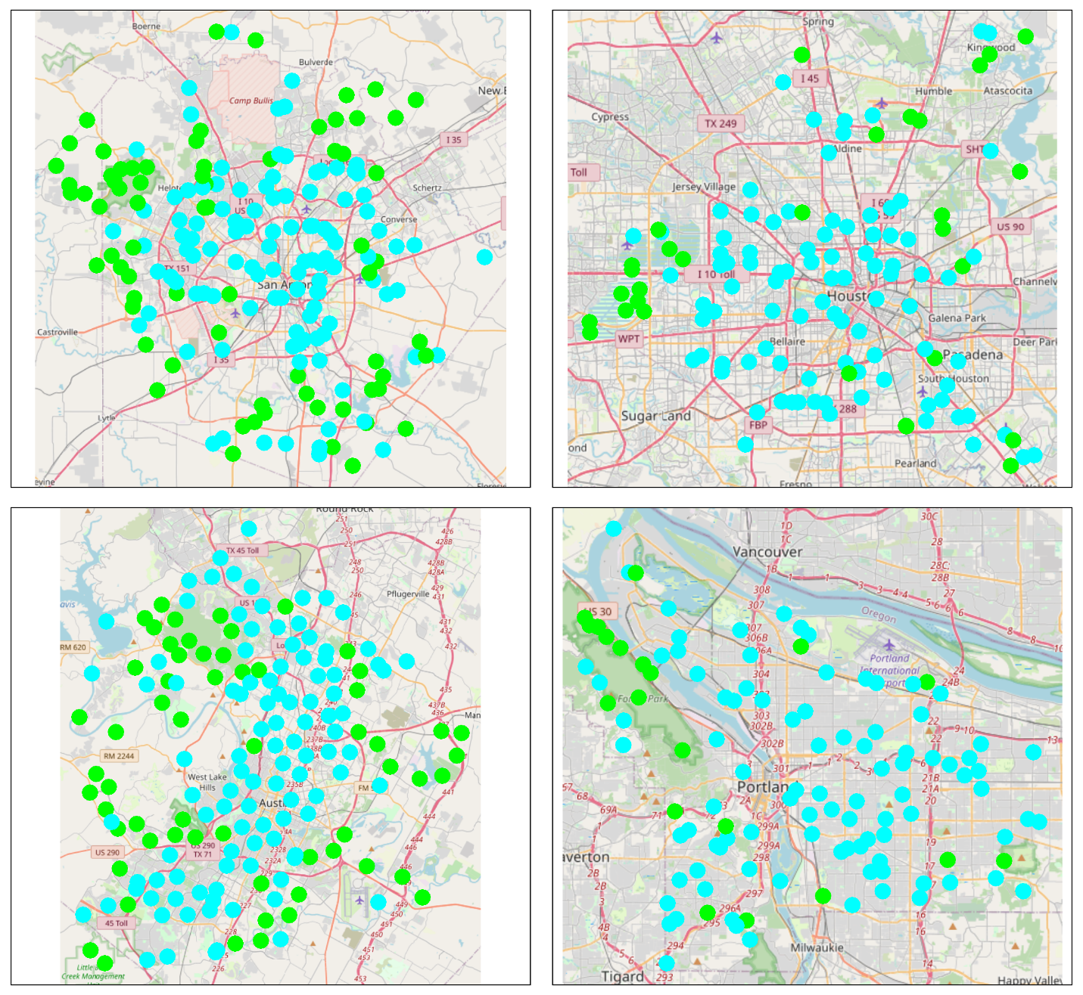

*Beta diversity*

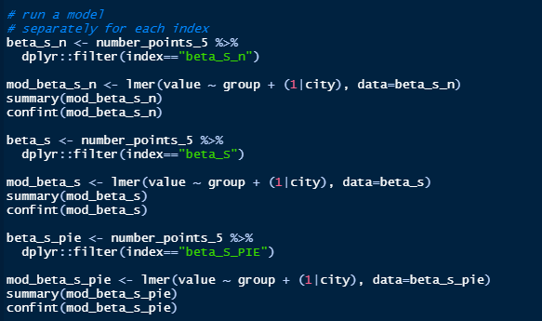

RESULTS

A total of 581 sites across four cities.

For Austin, Houston, Portland, and San Antonio there were 165, 122, 113, and 181 sites respectively, and a total species richness of 63, 70, 90, and 64.

There was consistently more species richness across the ‘other’ sites than the Forest sites for each city.

