Corey Welborn

Stubbing Project

CSC 414

9.22.2020

This is a simple HTML page that displays 10 buttons and has a body to display text. The functionality of the page is written in JavaScript. When a client clicks a button in the left column, a corresponding function is called in scripts.js. These functions are the stubs of the Stubbing Project, and inform that it hasn't been implemented. There is a default body for when no button has been selected. Also included is an exit button to return to the default body via the defaultBody function. Below is a screenshot of the Stubbing Project:

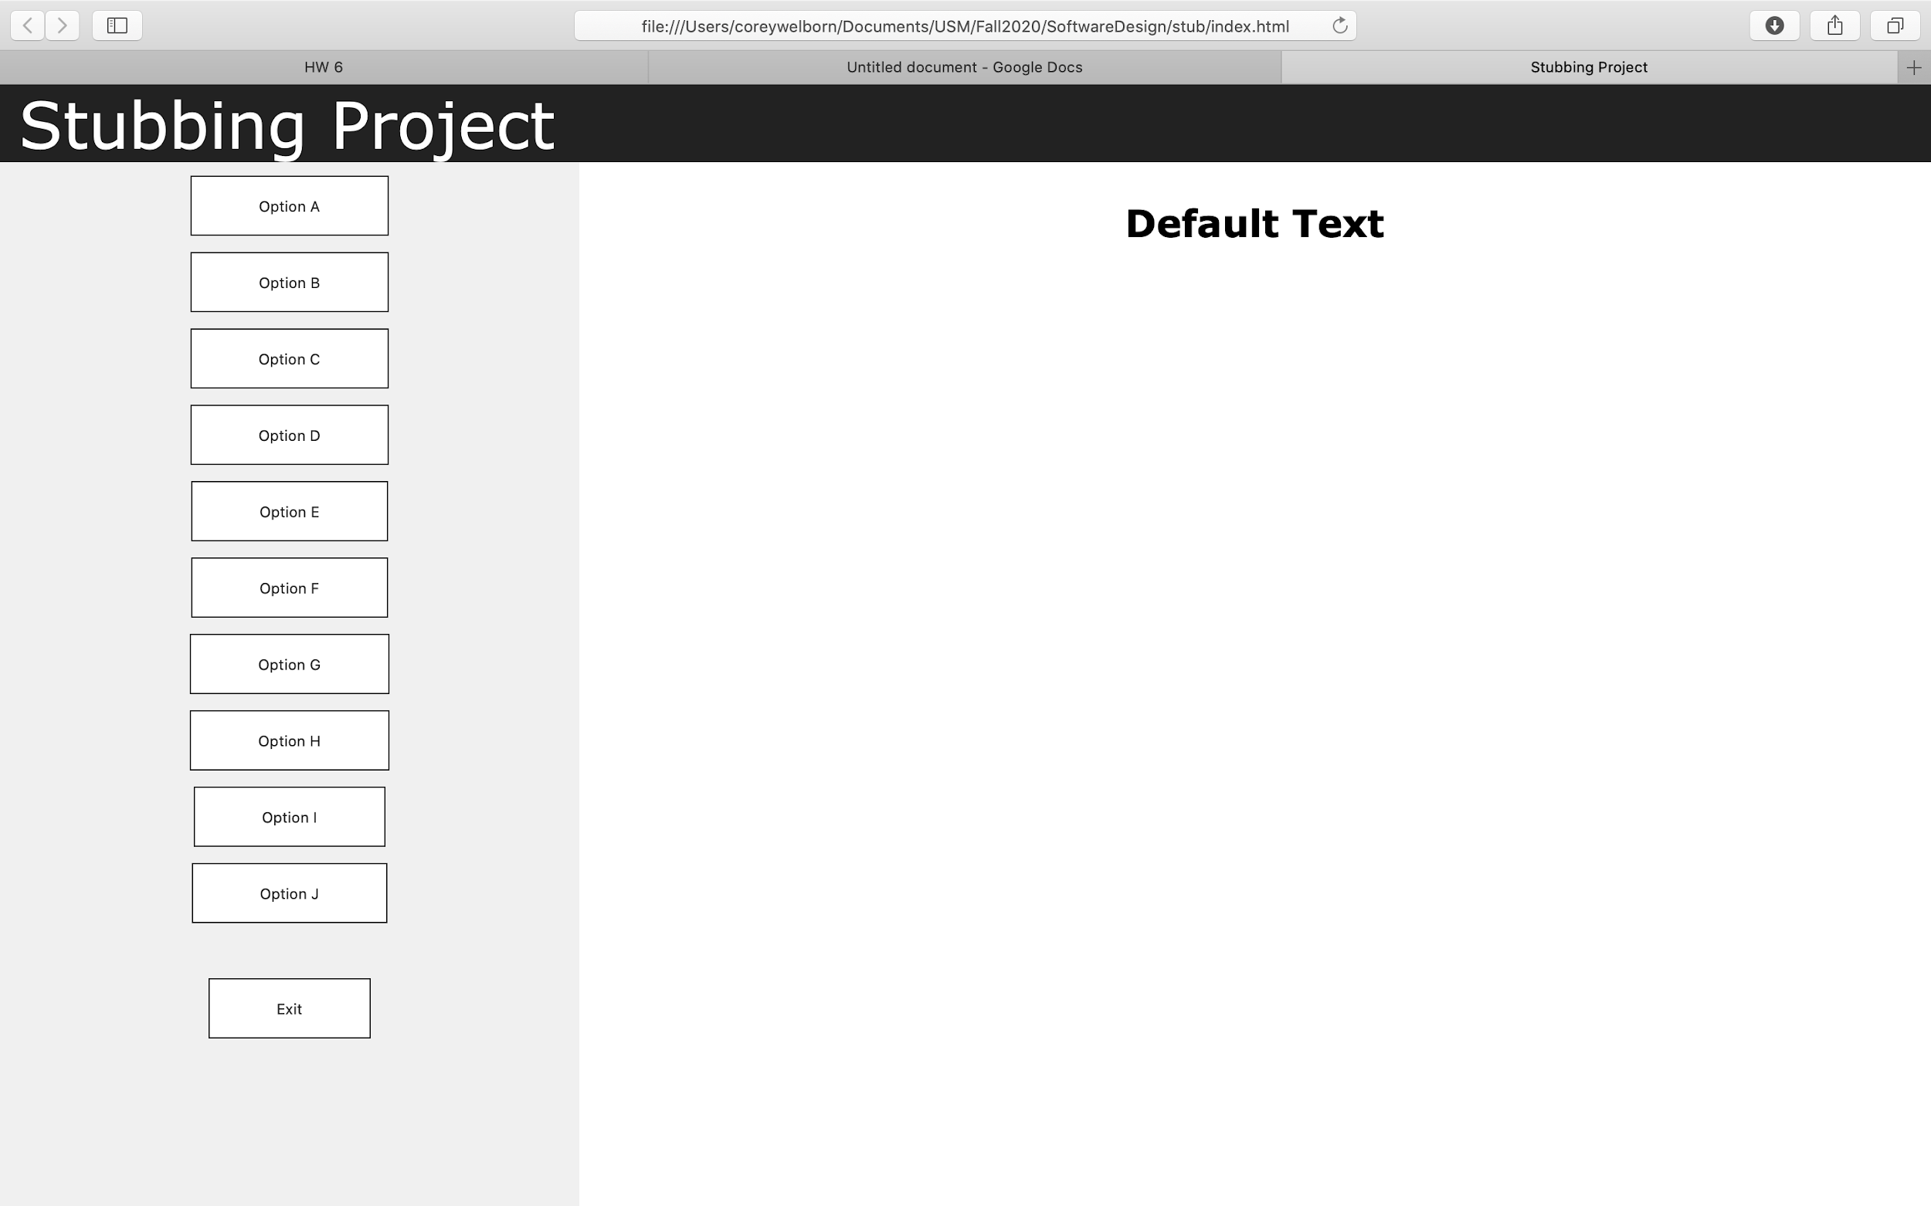

Anytime a user clicks a button from the menu, the body is updated displayed here:

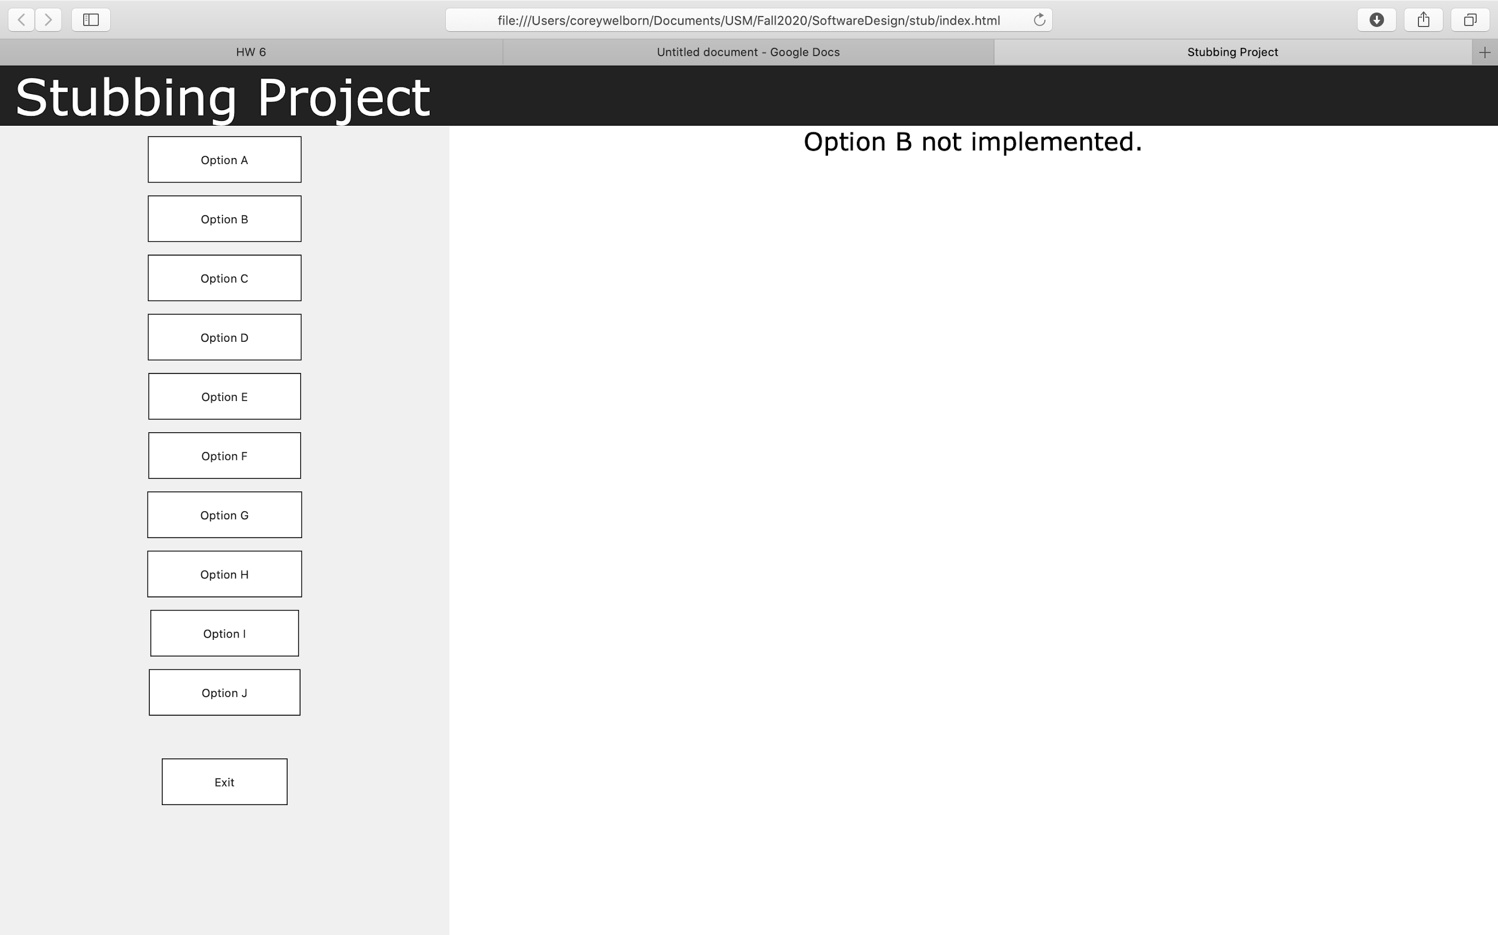

The user clicked Option B

Exit returns the user to the default screen.