PRODUCT REQUIREMENTS DOCUMENT

Vibe-Code Platform
No-Code POC PRD & Delivery Plan
A business-readable definition of the Stage 1 conversational application-builder POC. Technical implementation is specified separately.
Field | Value
Status | DRAFT
Boundary | Stage 1 POC
Version | 1.1
POC deadline | 30 September 2026
Tentative contingency | 9 October 2026
Related technical document | vibe-code-poc-technical-design-and-runtime-architecture.docx

Contents
Static page index for the issued document. Section headings remain available in the Word navigation pane.
Section | Page
1. Executive summary | 3
2. Scope and stage boundary | 4
3. Actors | 5
4. Feature list | 6
5. Epic table | 7
6. User Story table | 8
7. Use Case summary and details | 10
8. Security baseline | 16
9. Acceptance criteria | 17
10. Delivery Plan | 18
11. Risks and decisions | 19
12. Traceability and related artifacts | 20

1. Executive summary
Vibe Code lets a non-technical user create and improve a small application by describing business outcomes in a chatbot. The user reviews proposed changes, sees an authenticated live preview, accepts or rejects the result, saves numbered whole-app versions and can restore an earlier healthy version. Source code, runtime operations and infrastructure details remain behind the product boundary.
Stage 1 proves the complete create → chat → change → review → live preview → accept/reject → recover journey. It does not include a Deploy button or production release lifecycle.

Product outcomes
Outcome | Evidence
Clear no-code journey | A user completes the primary journey without seeing an IDE, terminal or infrastructure configuration.
Controlled change | Every proposed change has visible progress, review, explicit decision and recoverable history.
Real live preview | Eligible frontend and backend source edits update automatically; unsupported changes are classified honestly.
Safe multi-user boundary | Project, chat, run, checkpoint and preview ownership tests fail closed.
Operational honesty | Single-node K3s is described as process-level recovery, not hardware high availability.

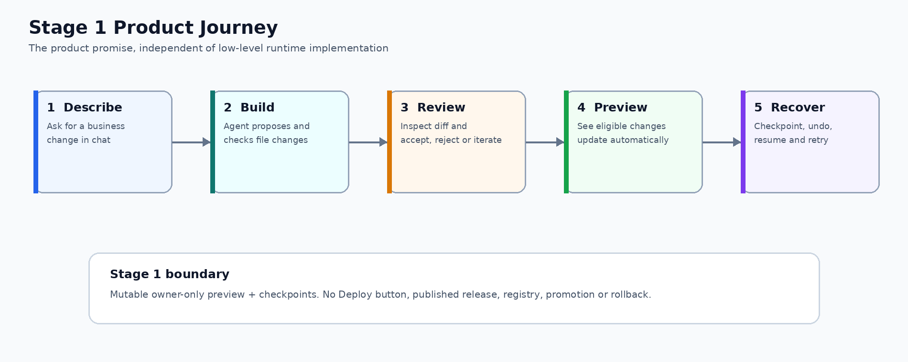
Figure 1 — Stage 1 product journey and the boundary between mutable preview and Stage 2 deployment.

2. Scope and stage boundary
Stage | Included | Excluded / gate
Stage 1 — POC | Chatbot, generated edits, diff/accept/reject, rolling autosave, numbered whole-app Save/Restore, owner-only live preview, automatic frontend/backend refresh, preview lifecycle, queue and idle stop. | Deploy button; immutable production release; stable published application URL; promotion/rollback; multi-node HA.
Stage 2 — release lifecycle | Deploy button, controlled immutable release, stable application route, health gate, promotion and rollback. | Only starts after separate scope, security, operating-model and capacity approval.

Stage 1 product principles
- Conversation is the primary interface; implementation detail is hidden from normal users.
- The fixed template reduces generation, preview, security and support variability.
- A mutable preview is not a deployed or published application.
- A saved version binds code and approved SQLite data as one recoverable whole; a running preview is disposable.
- Unknown, unsupported or unsafe changes fail closed with an actionable status.
- Platform restrictions are visible and explainable rather than silently enforced.

Explicit Stage 1 non-goals
- No Deploy button, production release publication, stable application subdomain, promotion or rollback.
- No user-supplied infrastructure definition or privileged host access.
- No custom admin portal; restricted AdminJS is a developer/break-glass tool only.
- No multi-node high availability, service mesh, GitOps controller, custom operator or CRD.
- No simultaneous multi-user editing of one project and no multi-replica mutable preview.

3. Actors
ID | Actor | Goal / responsibility | Boundary
ACT-01 | Vibe user | Creates and continues owned projects through conversation, review and preview. | Own projects only; no infrastructure or privileged administration.
ACT-02 | Platform administrator | Supports users, reviews safe operational evidence and performs bounded recovery. | Restricted AdminJS; explicit permissions; break-glass actions are audited.

Normal product boundary
User sees | User does not see
Projects, chatbot, progress, diff, preview, checkpoints, statuses and recovery actions | Source editor, terminal, infrastructure objects, raw ports, hostnames, commands, stack traces, provider credentials
Plain-language restart/rebuild status | Runtime commands or infrastructure definitions
Usage/cost estimate and approval prompts | Provider master key or unrestricted model configuration

Vibe page layout
The Vibe page is a deliberate two-pane product experience: durable conversation and change control on the left, authenticated generated-application preview on the right, with project/version status above. The picture is an interaction contract, not a promise of final visual styling.
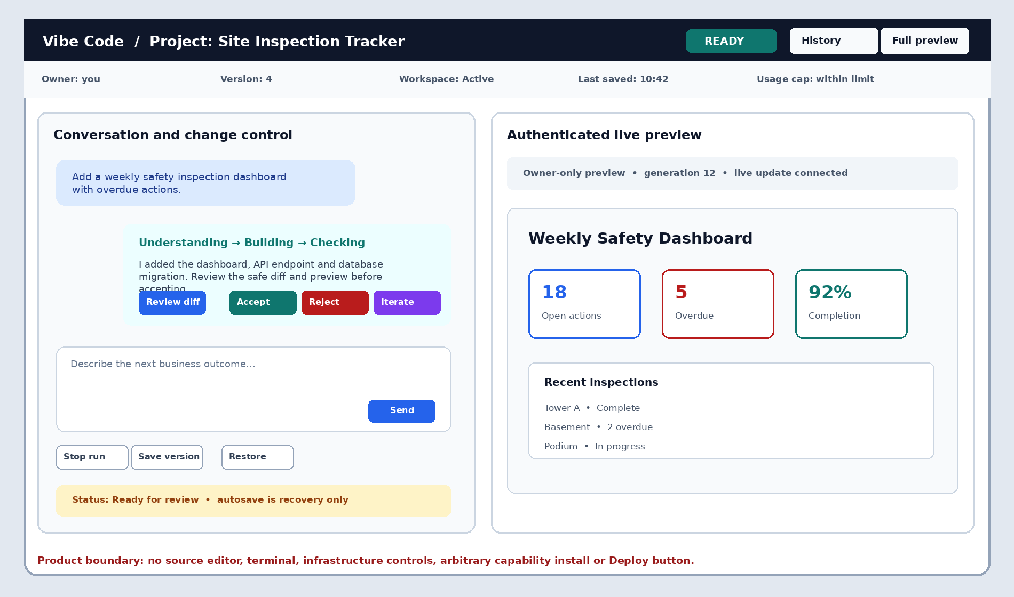
Figure 2 — Vibe page layout: metadata, conversation, progress and decisions beside the owner-only live preview.
Region | Required content | Forbidden content
Project header | Project identity, owner-safe status, current numbered version, last Save, History and full-preview action. | Raw namespace, Pod, host, port, command or infrastructure state.
Conversation pane | Durable messages/events, prompt guidance, progress, Stop, safe diff decision, Save and Restore. | Source editor, terminal, unrestricted tool output or provider credential.
Preview pane | Owner-only generated UI, readiness/live-update state and fixed application/API routes. | Arbitrary upstream, platform session cookie or Deploy/publish control.
Status and recovery | Waiting, Recovering, Action required, autosave-versus-version distinction and correlation reference. | Generic success when a required verification is incomplete.

4. Feature list
This is the Stage 1 product feature catalogue. Technical implementation references are intentionally kept in the separate Technical Design.
ID | Feature | User outcome
F-01 | Authentication and project ownership | Sign in and access only owned projects.
F-02 | Project creation from fixed template | Start from one approved generated-application template.
F-03 | Chatbot sessions | Create, continue, archive and branch durable conversations.
F-04 | Streamed progress and Stop | See plain-language progress and stop an active run.
F-05 | Generated file changes | Agent proposes bounded project-file changes.
F-06 | Diff, accept and reject | Review changes before accepting, rejecting or iterating.
F-07 | Whole-app versions and recovery | Initialize each project with Version 1, autosave a rolling recovery state, save numbered code-and-data versions and restore either as one verified unit.
F-08 | Live frontend preview | Eligible frontend edits update automatically in the authenticated preview.
F-09 | Automatic backend refresh | Supported backend source edits reload automatically; the UI reconnects safely.
F-10 | Preview lifecycle | Start, stop, resume and idle-stop previews without losing durable work.
F-11 | Queue, limits and recovery | Show Waiting, Recovering and Action required rather than generic failure.
F-12 | Restricted operations | Permit only audited, bounded administrative recovery and configuration.
F-13 | Cline session continuity and recovery | Refreshing the web page reconnects to the same run; a stalled Cline session can be terminated and recovered safely.
F-14 | Future-ready organization placement | Assign each POC user to the default Organization, OU and Department without changing owner-only project access.

5. Epic table
ID | Epic | Outcome | Features
EP-01 | Identity and owned projects | Users can sign in, receive a default organization placement, create projects and see only their own work. | F-01, F-02, F-14
EP-02 | Conversational project sessions | Users can describe outcomes, retain context and control or recover an active run. | F-03, F-04, F-13
EP-03 | Generate, review and accept changes | Users can inspect a proposal before accepting, rejecting or iterating. | F-05, F-06
EP-04 | Mutable live preview | Accepted or proposed eligible source changes appear in an authenticated preview. | F-08, F-09
EP-05 | Checkpoints and recovery | Accepted work is recoverable and failed/rejected work cannot silently replace it. | F-07
EP-06 | Preview lifecycle and capacity | Preview resources start when needed, stop when idle and queue when capacity is full. | F-10, F-11
EP-07 | Security and governance | Ownership, isolation, least privilege, secrets and audit controls fail closed. | F-12
EP-08 | Guidance and operational clarity | Users understand status and recovery; administrators receive safe evidence. | F-11, F-12, F-13

Dependency direction: owned project → durable conversation → generated proposal → review/live preview → checkpoint/recovery → operational evidence.

6. User Story table
Stories are short, user-visible outcomes. Runtime resources, live-update configuration and command details are tracked in the Technical Design.
ID | Epic | Priority | User Story | Acceptance
US-01 | EP-01 | Must | As a Vibe user, I can sign in and receive a secure session. | AC-ID-01
US-02 | EP-01 | Must | As a Vibe user, I can see and open only projects I own. | AC-ID-02
US-03 | EP-01 | Must | As a Vibe user, I can create a project from the approved fixed template. | AC-PRJ-01
US-04 | EP-01 | Must | As a Vibe user, I can rename, stop, reopen and soft-delete my project. | AC-PRJ-02
US-05 | EP-02 | Must | As a Vibe user, I can create, continue and archive a chatbot session. | AC-CHAT-01
US-06 | EP-02 | Must | As a Vibe user, I see streamed plain-language progress and can stop the run. | AC-CHAT-02
US-07 | EP-02 | Must | As a Vibe user, I can branch from an earlier message without overwriting history. | AC-CHAT-03
US-08 | EP-02 | Must | As a Vibe user, I am warned before context compaction and can continue without silent loss. | AC-CHAT-04
US-09 | EP-03 | Must | As a Vibe user, I can inspect a safe diff and preview before accepting a change. | AC-CHG-01
US-10 | EP-03 | Must | As a Vibe user, I can accept, reject or request another iteration. | AC-CHG-02
US-11 | EP-03 | Must | As a Vibe user, destructive changes require explicit approval. | AC-CHG-03
US-12 | EP-04 | Must | As a Vibe user, eligible frontend edits appear automatically in the current preview. | AC-PRV-01
US-13 | EP-04 | Must | As a Vibe user, supported backend source edits refresh automatically and reconnect safely. | AC-PRV-02
US-14 | EP-04 | Must | As a Vibe user, I am told when a change requires restart, rebuild or approval. | AC-PRV-03
US-15 | EP-05 | Must | As a Vibe user, a new project starts at Version 1 and Save creates the next numbered whole-app version. | AC-VER-01, AC-VER-02
US-16 | EP-05 | Must | As a Vibe user, I can restore code and project data together from a healthy saved version without erasing history. | AC-VER-04
US-17 | EP-06 | Must | As a Vibe user, opening a stopped project resumes its preview without losing source. | AC-LFC-01
US-18 | EP-06 | Must | As a Vibe user, capacity exhaustion shows Waiting instead of an unexplained error. | AC-CAP-01
US-19 | EP-06 | Should | As a Vibe user, an inactive preview stops automatically and resumes explicitly. | AC-LFC-02
US-20 | EP-07 | Must | As a Vibe user, my preview and live-update channel cannot be opened by another owner. | AC-SEC-01
US-21 | EP-07 | Must | As a Platform administrator, I can inspect audited lifecycle and recovery evidence. | AC-OPS-01
US-22 | EP-07 | Must | As a Platform administrator, I can change only allowlisted non-secret configuration. | AC-OPS-02
US-23 | EP-08 | Should | As a Vibe user, I see plain-language statuses and actionable recovery choices. | AC-UX-01
US-24 | EP-08 | Should | As a first-time user, I receive concise guidance and prompt starters. | AC-UX-02
US-25 | EP-02 | Must | As a Vibe user, refreshing the web page reconnects to the current Cline run without starting a duplicate session. | AC-CHAT-05
US-26 | EP-02 | Must | As a Vibe user, I can recover an unresponsive Cline session while preserving the last healthy project state. | AC-CHAT-06
US-27 | EP-01 | Must | As a provisioned POC user, I am assigned to the default Organization, OU and Department while my project list remains owner-only. | AC-ID-03
US-28 | EP-05 | Must | As a Vibe user, my active project has a rolling whole-app autosave for crash recovery without creating a new visible version every interval. | AC-VER-03

7. Use Case summary
ID | Use Case | Actors | Stories
UC-01 | Sign in and view projects | ACT-01 | US-01, US-02, US-27
UC-02 | Create and open project | ACT-01 | US-03, US-04
UC-03 | Use and recover Vibe Code chatbot | ACT-01 | US-05–US-08, US-24–US-26
UC-04 | Review and decide a change | ACT-01 | US-09–US-11
UC-05 | Observe live preview update | ACT-01 | US-12–US-14, US-20
UC-06 | Save and restore a whole-app version | ACT-01 | US-15, US-16, US-28
UC-07 | Stop, idle-stop and resume | ACT-01 | US-17–US-19
UC-08 | Recover a failed operation | ACT-01  ACT-02 | US-21, US-23, US-26
UC-09 | Perform restricted administration | ACT-02 | US-21, US-22

Each detailed Use Case is a ten-field executable product contract. Business Rules are canonical BR references, not hidden prose in the flow.

Detailed Use Cases

UC-01 — Sign in and view projects
Field | Definition
Actors | ACT-01
Module | M01 — Identity, organization placement and owned projects
Layer | Presentation + Application + Domain
Preconditions | Active account with one current primary default organization membership.
Main flow | Sign in → validate organization placement → create secure session → show owner-scoped project list.
Business Rules | BR-01, BR-02, BR-17
Security Guard | Secure session, CSRF, session rotation and object-level owner authorization.
Failure / Recovery | Invalid membership fails provisioning closed; same OU/Department never reveals another owner’s project.
Acceptance evidence | Authenticated session; default Organization/OU/Department exists; no cross-owner project visibility.
Story trace | US-01, US-02, US-27

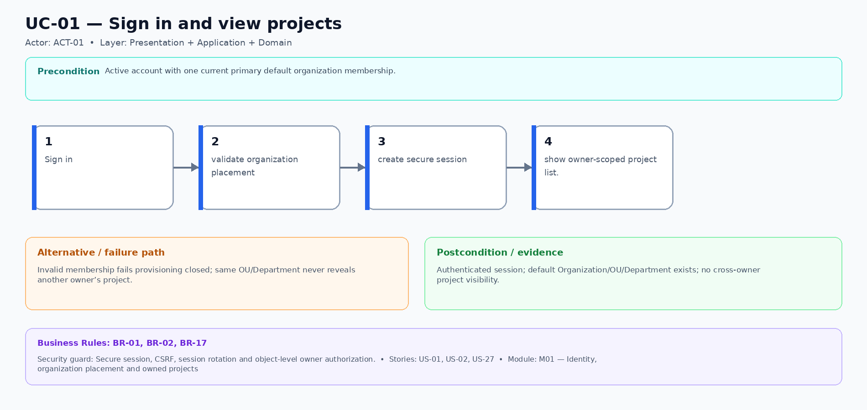
Figure UC-01 — Main, alternative/failure and evidence flow for Sign in and view projects.

UC-02 — Create and open project
Field | Definition
Actors | ACT-01
Module | M02 — Project and immutable template registry
Layer | Presentation + Application + Domain + Runtime
Preconditions | Authenticated owner; approved template available; idempotency key allocated.
Main flow | Enter project name and goal → create once → pin template → initialize Git/SQLite/workspace → open project.
Business Rules | BR-01, BR-03, BR-13, BR-17
Security Guard | Owner command, idempotency uniqueness, template allowlist and path-safe initialization.
Failure / Recovery | Initialization remains recoverable and retry returns the same project rather than creating a duplicate.
Acceptance evidence | Project owns one template lock, generated repository, workspace and preview identity.
Story trace | US-03, US-04

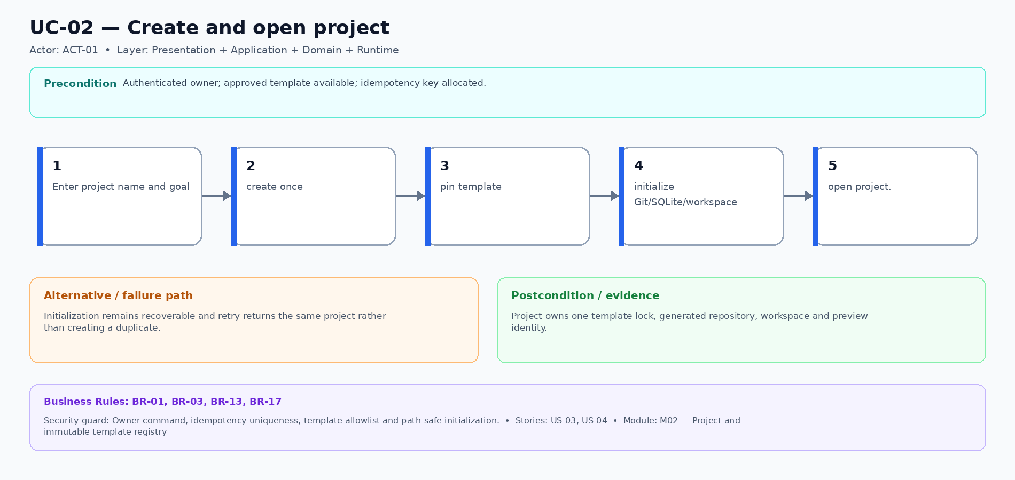
Figure UC-02 — Main, alternative/failure and evidence flow for Create and open project.

UC-03 — Use and recover Vibe Code chatbot
Field | Definition
Actors | ACT-01
Module | M03 — Conversation, Agent adapter and Agent Job
Layer | Presentation + Application + Runtime
Preconditions | Owned project; durable chat session exists or may be created; mutation slot is available or queueable.
Main flow | Open prompt guidance → submit outcome → persist message → admit one run → stream progress → reconnect or recover → show result and usage.
Business Rules | BR-01, BR-04, BR-05, BR-06, BR-13, BR-17
Security Guard | Owner/session checks, one mutation lease, admitted Job identity, heartbeat and UID-bound old-writer revocation.
Failure / Recovery | Refresh reconnects without duplication. A stale heartbeat exposes recovery; uncertain old writers keep mutation blocked.
Acceptance evidence | Ordered messages/events survive reconnect; linked attempts and runtime evidence remain immutable and attributable.
Story trace | US-05–US-08, US-24–US-26

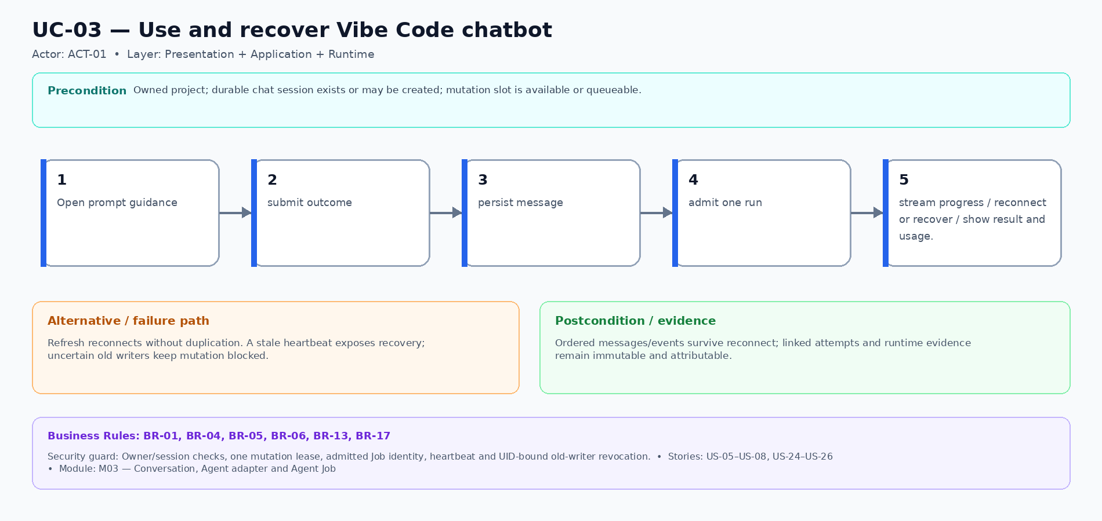
Figure UC-03 — Main, alternative/failure and evidence flow for Use and recover Vibe Code chatbot.

UC-04 — Review and decide a change
Field | Definition
Actors | ACT-01
Module | M04 — Change proposal, diff, approval and decision
Layer | Presentation + Application + Domain
Preconditions | Agent produced a validated proposal tied to the owned project and run.
Main flow | Open safe diff and preview → inspect impact → accept, reject or iterate → persist one decision → checkpoint accepted result.
Business Rules | BR-01, BR-04, BR-07, BR-09, BR-13, BR-17
Security Guard | Owner authorization, safe path/diff redaction, explicit destructive approval and decision idempotency.
Failure / Recovery | Rejected or failed work never replaces the last healthy accepted version; approval denial is terminal evidence.
Acceptance evidence | Decision, audit evidence, run and accepted checkpoint are linked exactly once.
Story trace | US-09–US-11

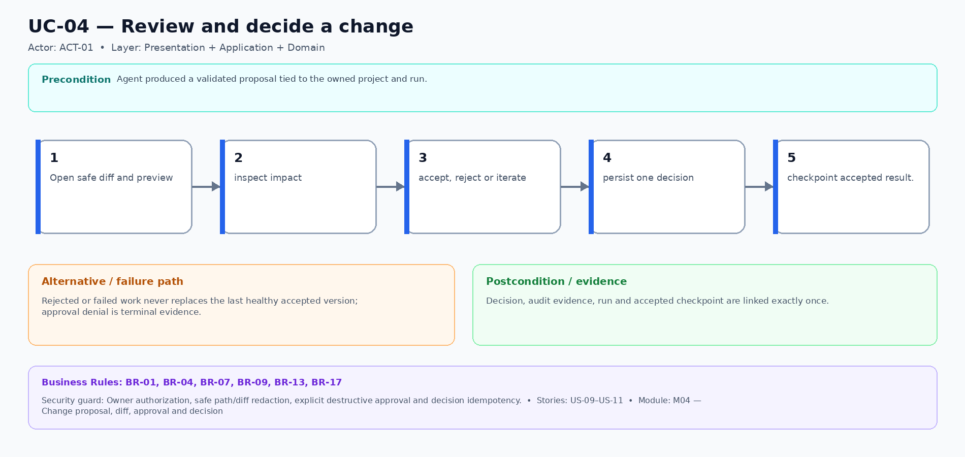
Figure UC-04 — Main, alternative/failure and evidence flow for Review and decide a change.

UC-05 — Observe live preview update
Field | Definition
Actors | ACT-01
Module | M05 — Preview Gateway, route and mutable Preview Pod
Layer | Presentation + Gateway + Runtime
Preconditions | Owned preview is admitted and healthy; proposed edit is eligible for the classified update path.
Main flow | Request owner preview → exchange the one-time exact-audience JWT → load preview → apply eligible source change → HMR/reload or bounded restart → confirm Ready for review.
Business Rules | BR-01, BR-04, BR-08, BR-09, BR-13, BR-17
Security Guard | Active kid/signature, exact JWT claims, hashed-jti CAS consume, host-only cookie and fixed-target routing.
Failure / Recovery | Unsupported change is classified as restart, rebuild, approval required or unsupported; stale/replayed/cross-owner route is denied.
Acceptance evidence | Frontend/backend update and WSS paths use the authenticated owner route with safe readiness evidence.
Story trace | US-12–US-14, US-20

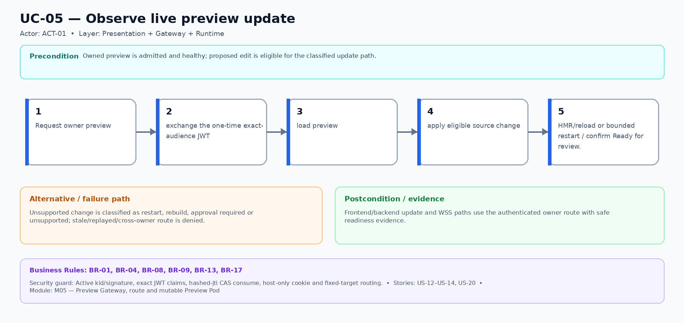
Figure UC-05 — Main, alternative/failure and evidence flow for Observe live preview update.

UC-06 — Save and restore a whole-app version
Field | Definition
Actors | ACT-01
Module | M06 — Git workspace, snapshot and Restore transaction
Layer | Presentation + Application + Persistence + Runtime
Preconditions | Owned project; no conflicting mutation; target snapshot is AVAILABLE and same-project for Restore.
Main flow | Capture rotating autosave when changed → user selects Save → verify next numbered whole-app version → select earlier version → stage and verify Restore → atomically switch current pointers.
Business Rules | BR-01, BR-04, BR-10, BR-11, BR-12, BR-13, BR-17
Security Guard | Owner-only idempotent command, project lease, path-safe Git, SQLite online backup, hashes, before-images and pointer CAS.
Failure / Recovery | No-change autosave is skipped. Any code, DB, lock, hash, health or cutover failure protects the previous current generation and enters verified rollback/manual intervention.
Acceptance evidence | Manifest binds Git, SQLite, migration/lock/template metadata and actor; successful Restore creates new history and healthy preview.
Story trace | US-15, US-16, US-28

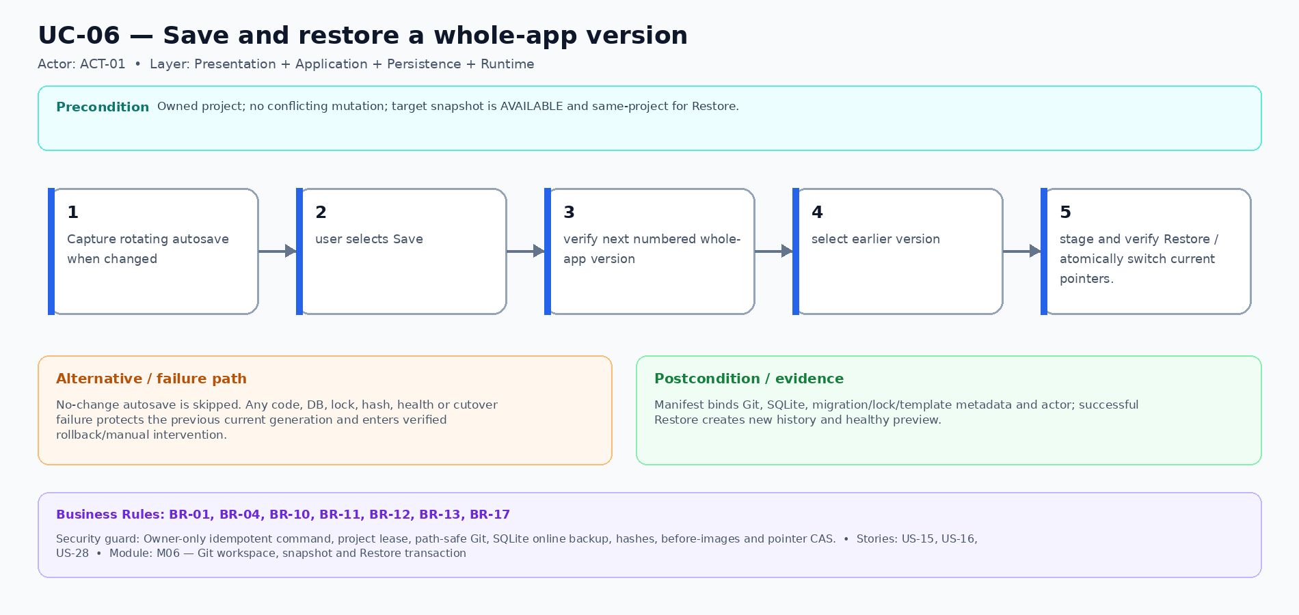
Figure UC-06 — Main, alternative/failure and evidence flow for Save and restore a whole-app version.

UC-07 — Stop, idle-stop and resume
Field | Definition
Actors | ACT-01
Module | M07 — Workspace lifecycle and capacity admission
Layer | Presentation + Application + Runtime
Preconditions | Owned active, queued or stopped project; current mutation and capacity state are known.
Main flow | Warn on idle → verify no active mutation → withdraw route and stop → retain durable workspace → owner opens project → fair admission → readiness confirmed.
Business Rules | BR-01, BR-04, BR-13, BR-14, BR-15, BR-17
Security Guard | Owner command, pool row lock, slot/reserve checks, durable fairness cursor, lease check and generation-safe route.
Failure / Recovery | Active mutation blocks idle-stop; full queue shows bounded Waiting/cancel/timeout; failed start/stop remains recoverable.
Acceptance evidence | Source, SQLite and checkpoints persist while disposable runtime is stopped or recreated.
Story trace | US-17–US-19

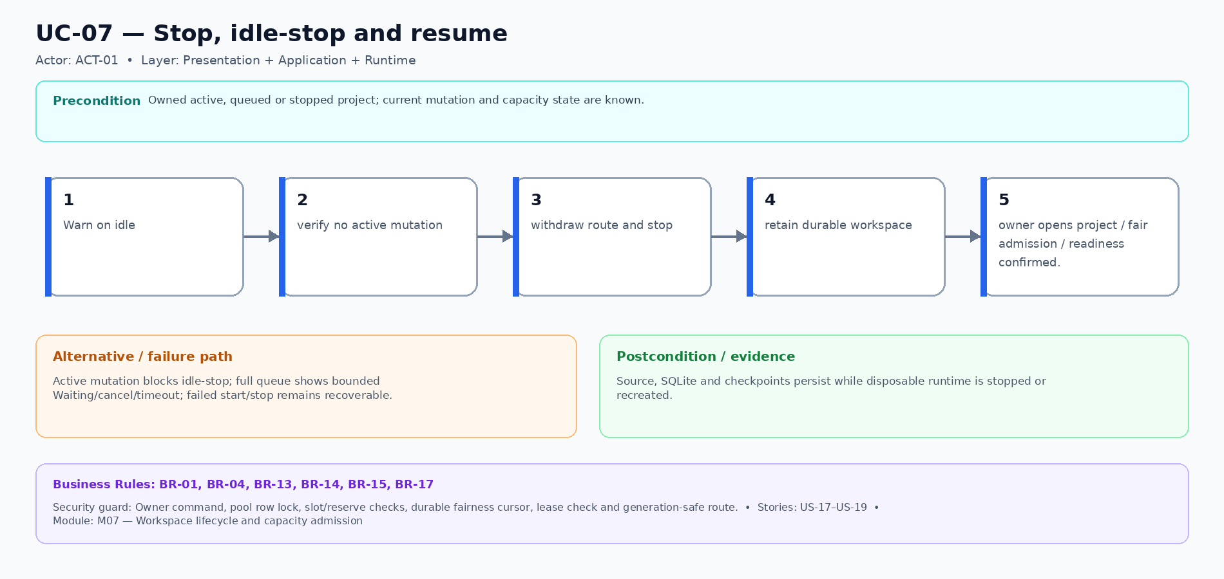
Figure UC-07 — Main, alternative/failure and evidence flow for Stop, idle-stop and resume.

UC-08 — Recover a failed operation
Field | Definition
Actors | ACT-01  ACT-02
Module | M08 — Recovery controller, errors, evidence and audit
Layer | Presentation + Application + Runtime + Operations
Preconditions | Stable safe error/reference exists; actor owns the project or has explicit bounded administrator permission.
Main flow | Inspect safe status → choose retry, revert, recover agent or bounded reconcile → validate prior terminal state and proof → create linked attempt → verify healthy result.
Business Rules | BR-01, BR-04, BR-06, BR-12, BR-13, BR-16, BR-17
Security Guard | Owner or explicit admin permission, idempotency, prior-attempt UID proof, mutation serialization and redacted audit.
Failure / Recovery | No automatic replay of uncertain mutation. Missing or mismatched proof fails closed and keeps route withdrawn/mutation blocked.
Acceptance evidence | New linked attempt and correlation evidence exist; prior terminal history and last healthy version remain unchanged.
Story trace | US-21, US-23, US-26

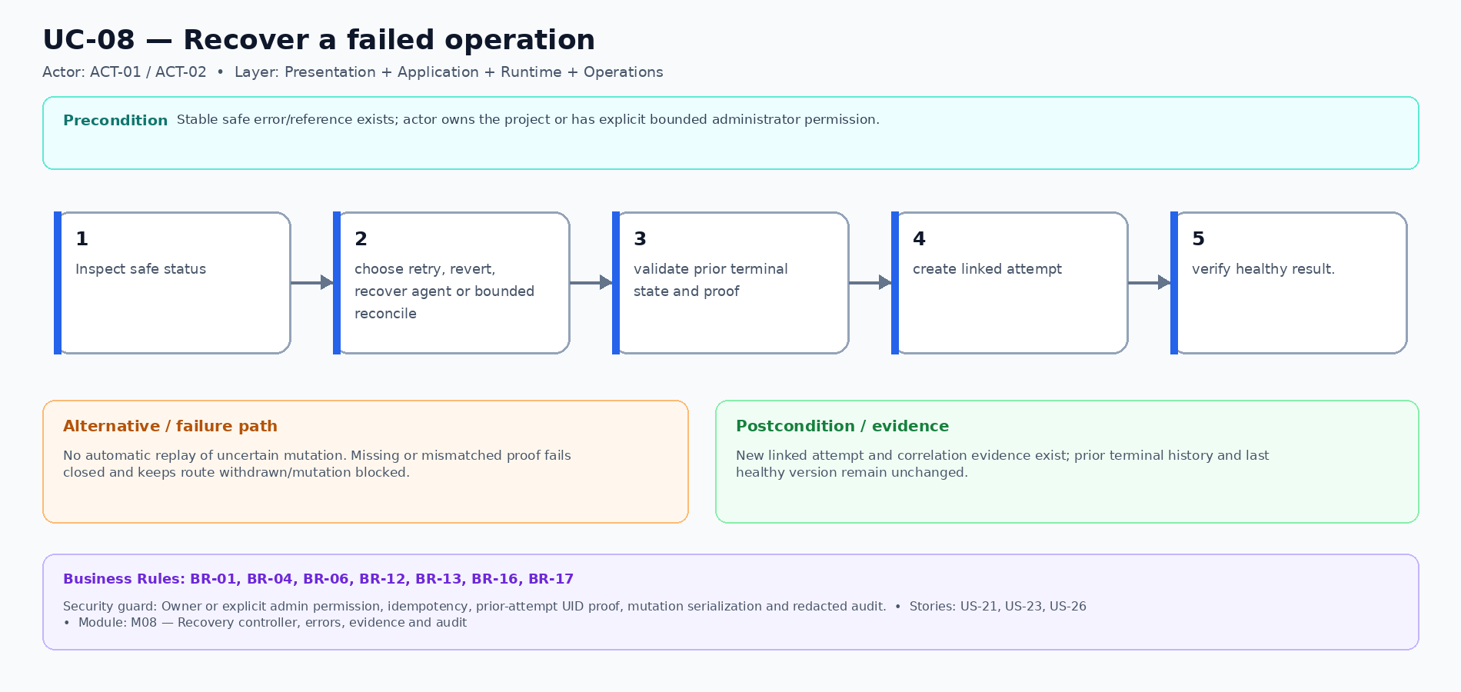
Figure UC-08 — Main, alternative/failure and evidence flow for Recover a failed operation.

UC-09 — Perform restricted administration
Field | Definition
Actors | ACT-02
Module | M09 — Restricted administration and typed configuration
Layer | Presentation + Application + Operations
Preconditions | Active administrator session; explicit role/permission; expected aggregate row version loaded.
Main flow | Inspect safe state → choose named allowlisted command or config key → validate permission/type/range/version → commit CAS and audit → show safe result.
Business Rules | BR-01, BR-13, BR-16, BR-17
Security Guard | Restricted AdminJS, explicit permission, last-admin protection, typed non-secret allowlist and atomic CAS plus command dedup.
Failure / Recovery | Unknown command/key, secret value, wrong type/range, stale row or direct-state attempt is rejected atomically and audited.
Acceptance evidence | Accepted and denied privileged actions are attributable, redacted and reviewable.
Story trace | US-21, US-22

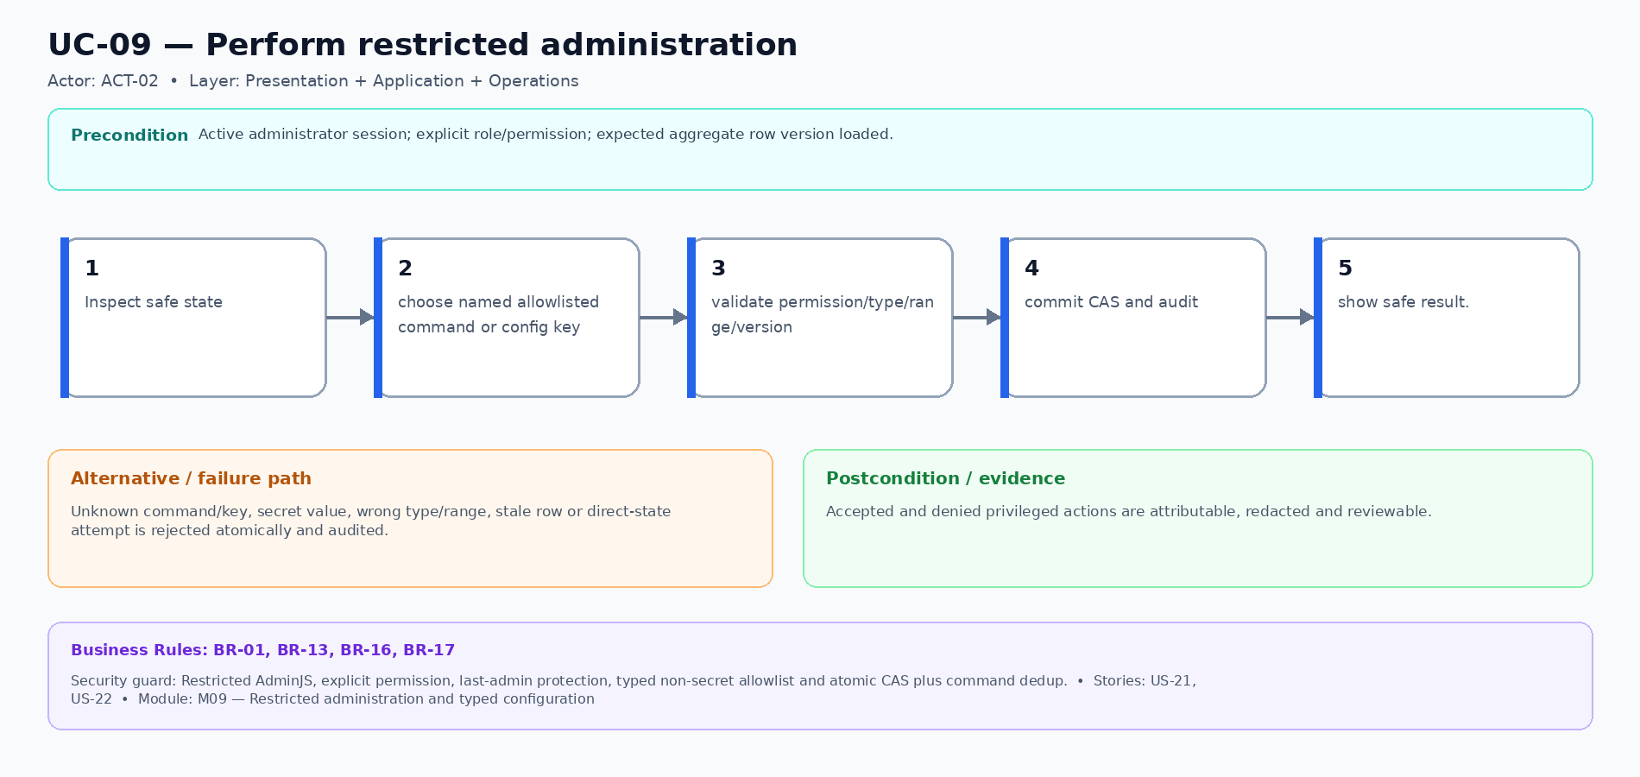
Figure UC-09 — Main, alternative/failure and evidence flow for Perform restricted administration.

Business Rule Register
Business Rules constrain every Use Case independently of screen wording. A Use Case may reference only IDs in this register; Technical realization must trace the same IDs rather than redefine them.
ID | Rule | Applies to | Enforcement / evidence
BR-01 | Every project, conversation, run, snapshot, route and command is owner-scoped; direct-ID and cross-owner access fail closed. | UC-01, UC-02, UC-03, UC-04, UC-05, UC-06, UC-07, UC-08, UC-09 | Object authorization on every command/query plus cross-owner negative tests.
BR-02 | Organization, OU and Department placement is administrative metadata and never grants Stage 1 project access. | UC-01 | Provision one current primary membership; same-unit users still fail project access tests.
BR-03 | Project creation is idempotent and pins exactly one approved immutable template version. | UC-02 | Unique idempotency key, atomic project/workspace initialization and retry evidence.
BR-04 | Only one mutating operation may hold the project mutation lease; terminal attempts are immutable. | UC-03, UC-04, UC-05, UC-06, UC-07, UC-08 | Lease/CAS checks and linked retry rather than in-place history rewrite.
BR-05 | Browser refresh reconnects to the existing run and persisted event stream; it never creates a duplicate run, Job or lease. | UC-03 | Run identity and event cursor survive reconnect; duplicate-creation probes fail.
BR-06 | Stalled-agent recovery starts a linked retry only after prior Job/Pod deletion and failed write-probe evidence proves the old attempt cannot write. | UC-03, UC-08 | UID-bound runtime-resource evidence; metadata lease expiry alone is rejected.
BR-07 | A proposal becomes accepted only through one explicit durable decision; destructive changes require explicit approval. | UC-04 | Decision idempotency, approval gate and pre-change checkpoint evidence.
BR-08 | Mutable preview is owner-only and uses a one-time short-lived asymmetric JWT with exact-host audience, exchanged for a short-lived host-only cookie. | UC-05 | Active kid/signature, exact claims, hashed-jti CAS consume and replay/revocation tests.
BR-09 | Changes are classified honestly as hot update, reload, restart, rebuild, approval required or unsupported. | UC-04, UC-05 | Change matrix tests; unsupported changes never report Ready/HMR.
BR-10 | Project initialization creates Version 1; autosave is rotating recovery only; User Save and successful Restore create immutable numbered whole-app history. | UC-06 | Kind/number/idempotency checks across Git, SQLite and snapshot records.
BR-11 | A whole-app snapshot is AVAILABLE only when Git, SQLite online backup, migration/lock/template manifests and hashes verify together. | UC-06 | No raw live SQLite copy; partial or mismatched capture remains unavailable.
BR-12 | Restore is owner-only, serialized, idempotent and generation-staged; current pointers switch atomically only after code, DB, lock and health verification. | UC-06, UC-08 | Before-images, provisional result, journal decision and pointer CAS; failure protects prior current state.
BR-13 | Only transitions listed in the authoritative state contract are legal; unknown or unlisted transitions fail closed and are audited. | UC-02, UC-03, UC-04, UC-05, UC-06, UC-07, UC-08, UC-09 | State/edge equality against Data Specification plus illegal-edge mutation tests.
BR-14 | Capacity admission is durable, bounded and fair: owner round-robin across owners, FIFO within owner, explicit slot charges and deterministic timeout/cancel. | UC-07 | CAPACITY_POOL row lock, queue sequence, durable cursor and slot-sum tests.
BR-15 | Preview idle-stop never interrupts an active mutation and never deletes durable source, SQLite data or checkpoints. | UC-07 | Lease check, route withdrawal, scale-to-zero and resume evidence.
BR-16 | Administrative changes are restricted to named commands and typed allowlisted non-secret configuration; no shell or direct state forgery. | UC-08, UC-09 | Permission, type/range, stale-write, secret-canary and immutable audit tests.
BR-17 | Stage 1 has no Deploy button, published release, stable application URL, registry promotion or production rollback. | UC-01, UC-02, UC-03, UC-04, UC-05, UC-06, UC-07, UC-08, UC-09 | UI/content scan and route/runtime acceptance tests reject hidden release behavior.

Authoritative state diagrams
These diagrams are rendered from the repository state contract that must exactly match Data Specification sheets “Enum Catalogue” and “State Transitions”. Filled dots mark initial states; ringed dots mark terminal states. Every unlisted edge fails closed.

PROJECT.lifecycle_status
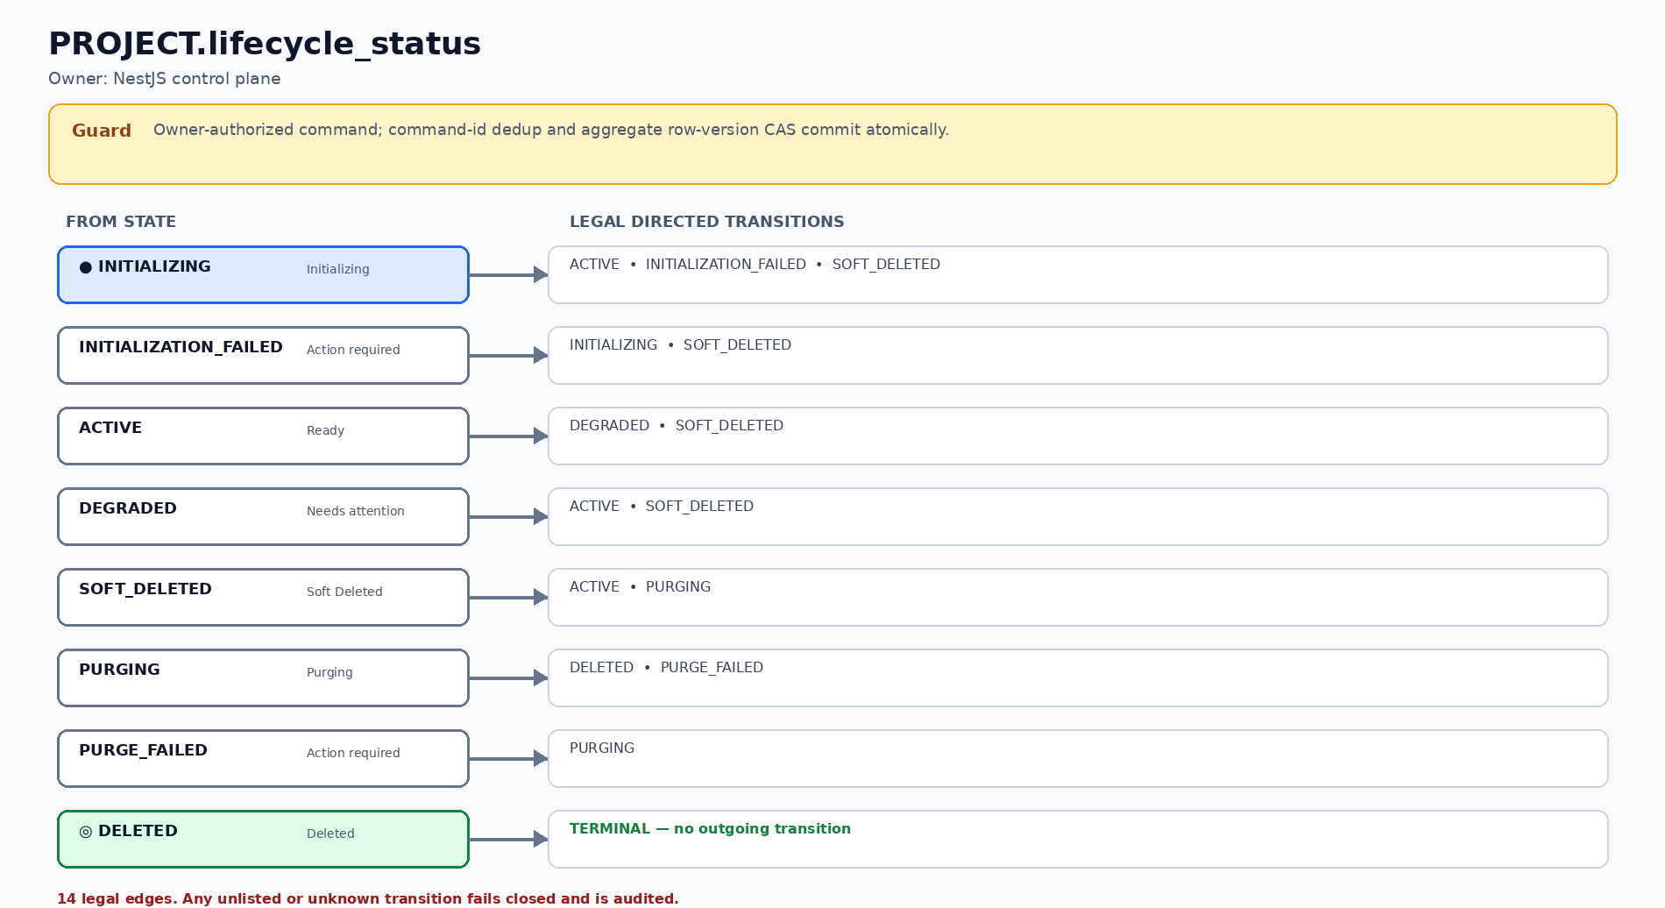
Figure S-01 — PROJECT.lifecycle_status: 8 states and 14 legal directed transitions.

WORKSPACE.desired_status
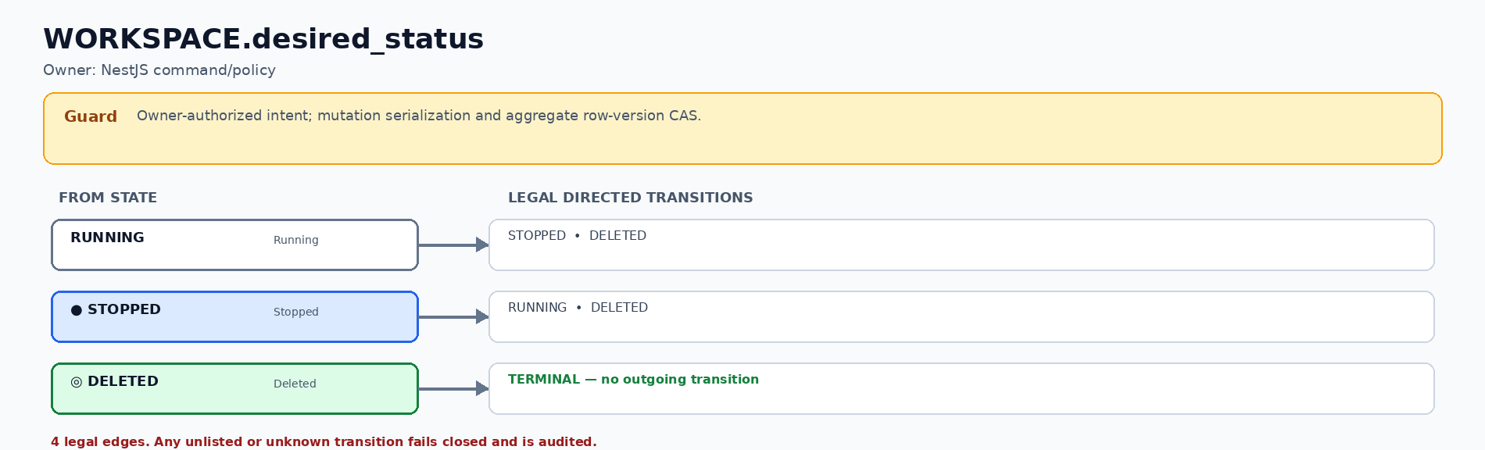
Figure S-02 — WORKSPACE.desired_status: 3 states and 4 legal directed transitions.

WORKSPACE.observed_status
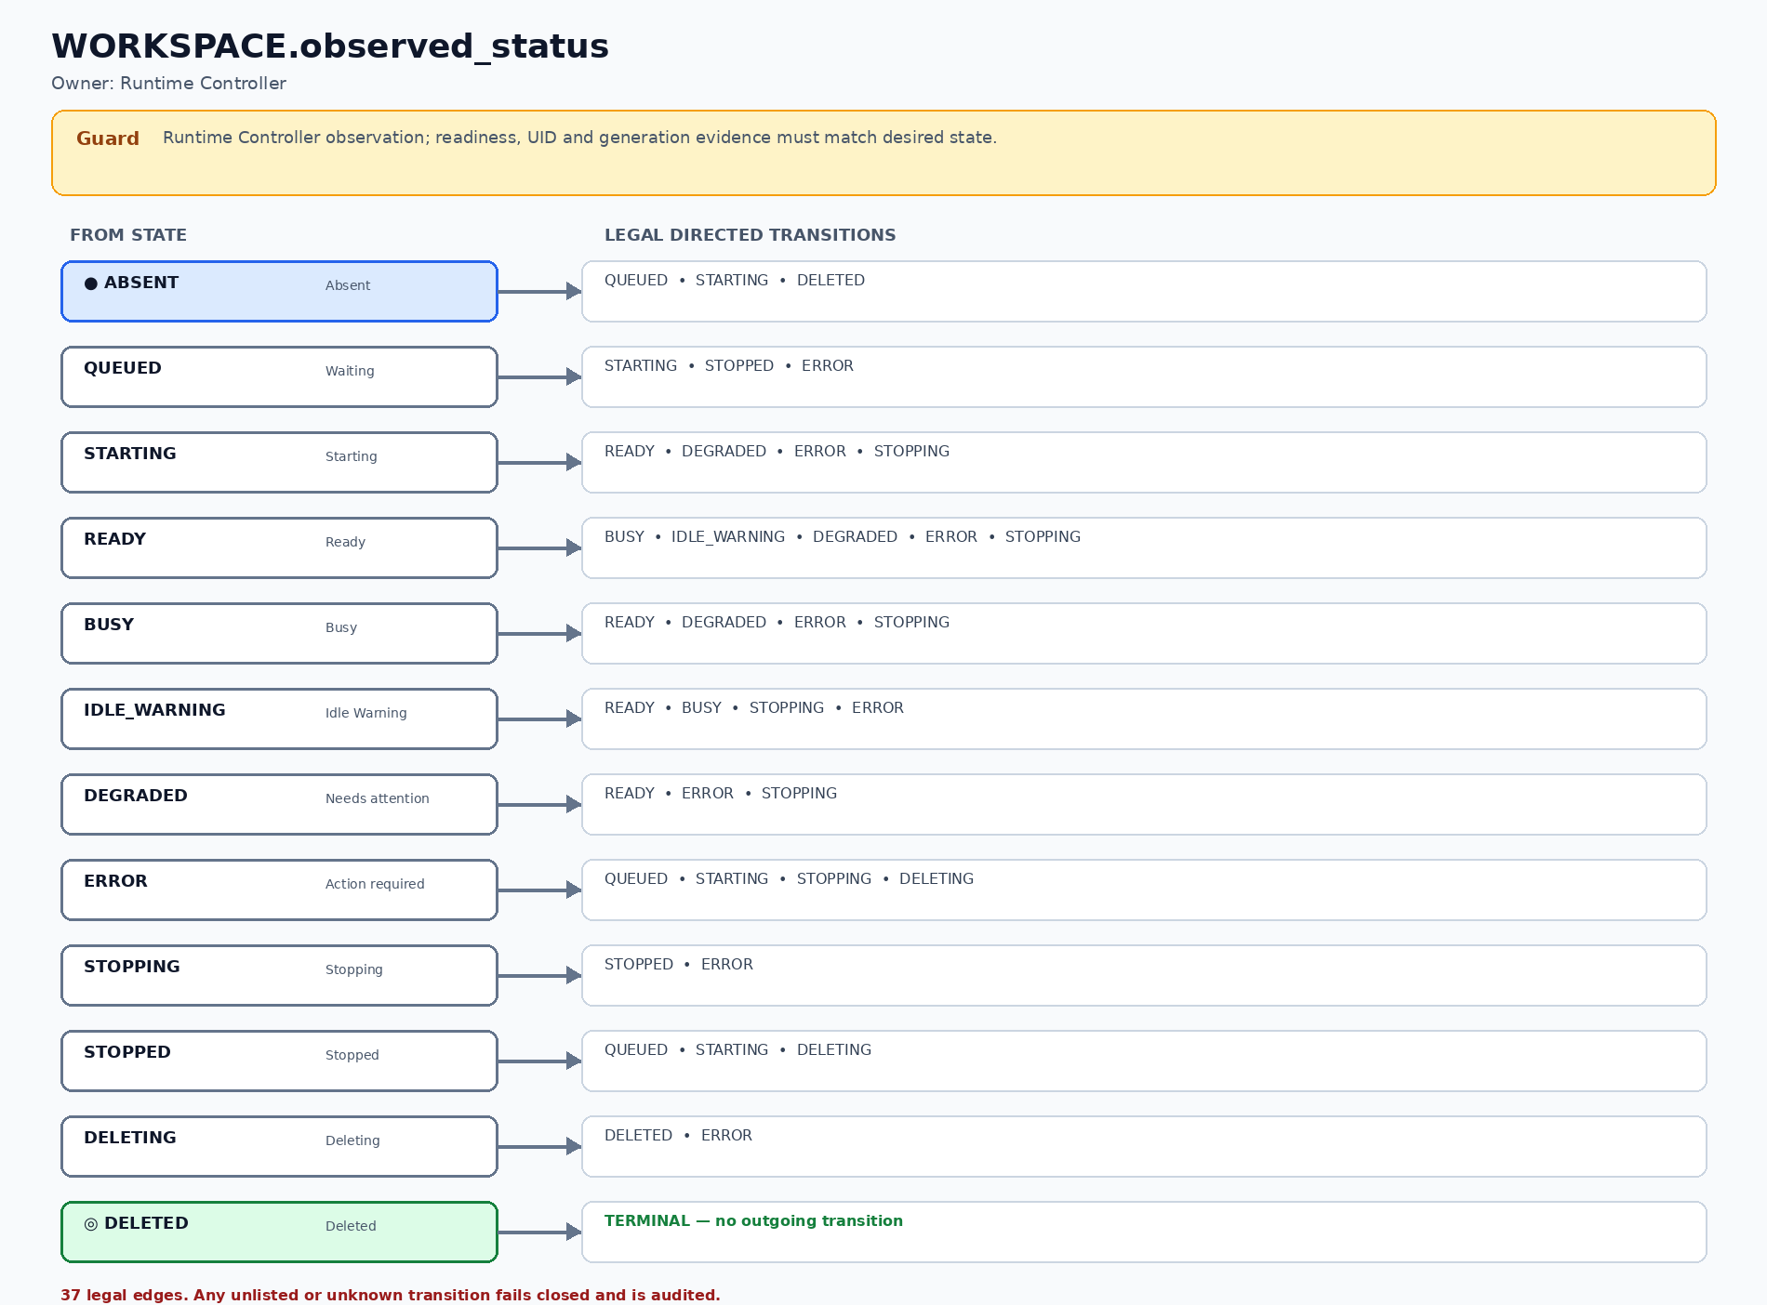
Figure S-03 — WORKSPACE.observed_status: 12 states and 37 legal directed transitions.

AGENT_RUN.execution_status
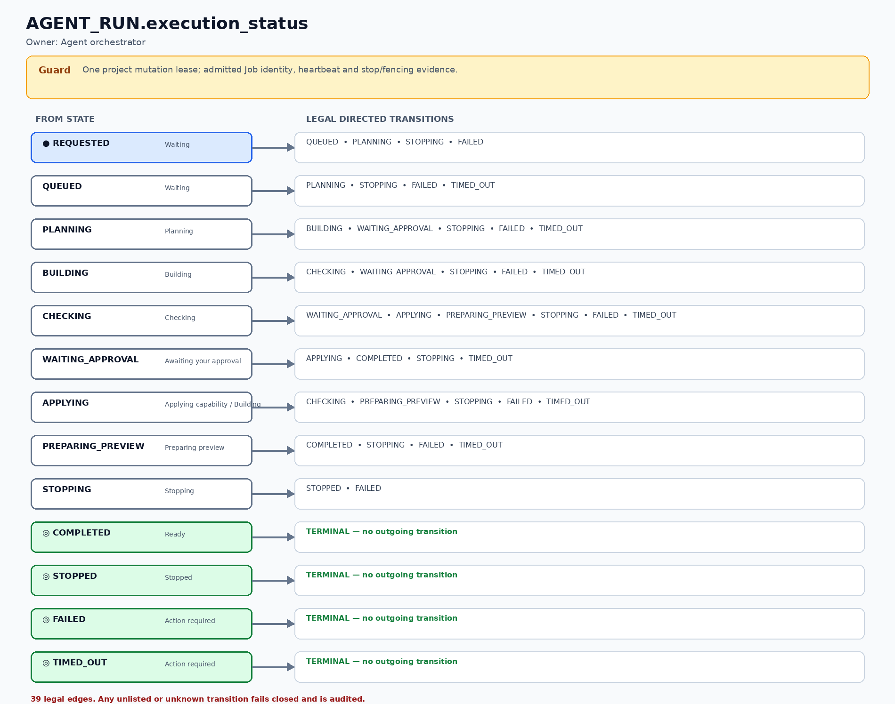
Figure S-04 — AGENT_RUN.execution_status: 13 states and 39 legal directed transitions.

AGENT_RUN.outcome_status
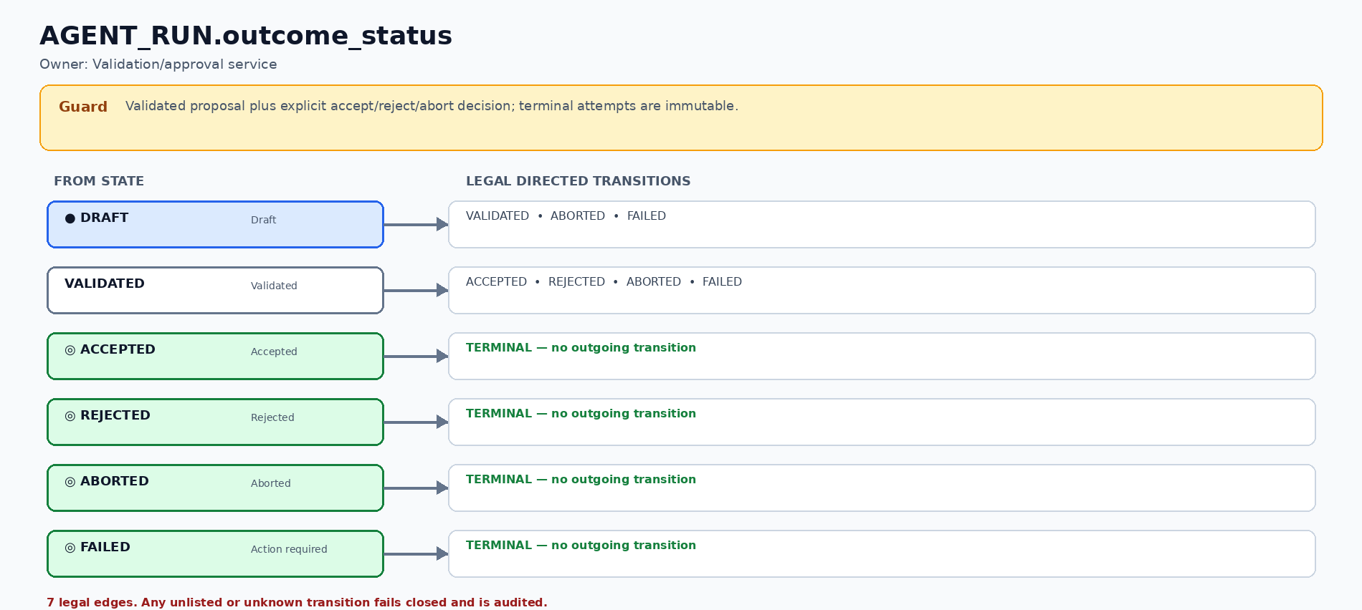
Figure S-05 — AGENT_RUN.outcome_status: 6 states and 7 legal directed transitions.

PREVIEW_AUTH_GRANT.grant_status
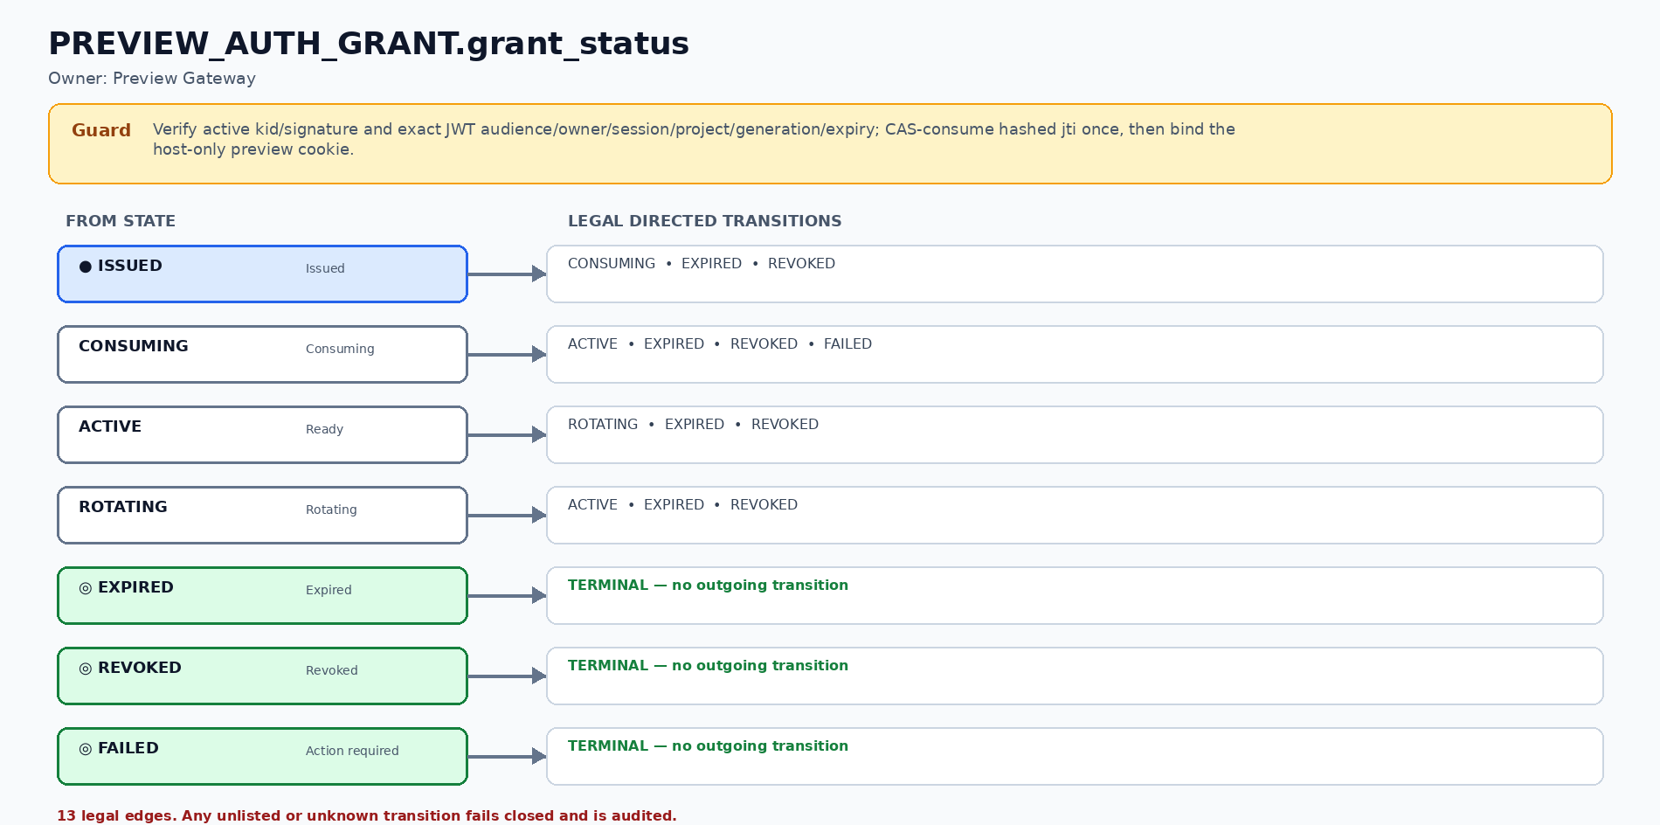
Figure S-06 — PREVIEW_AUTH_GRANT.grant_status: 7 states and 13 legal directed transitions.

SNAPSHOT.snapshot_status
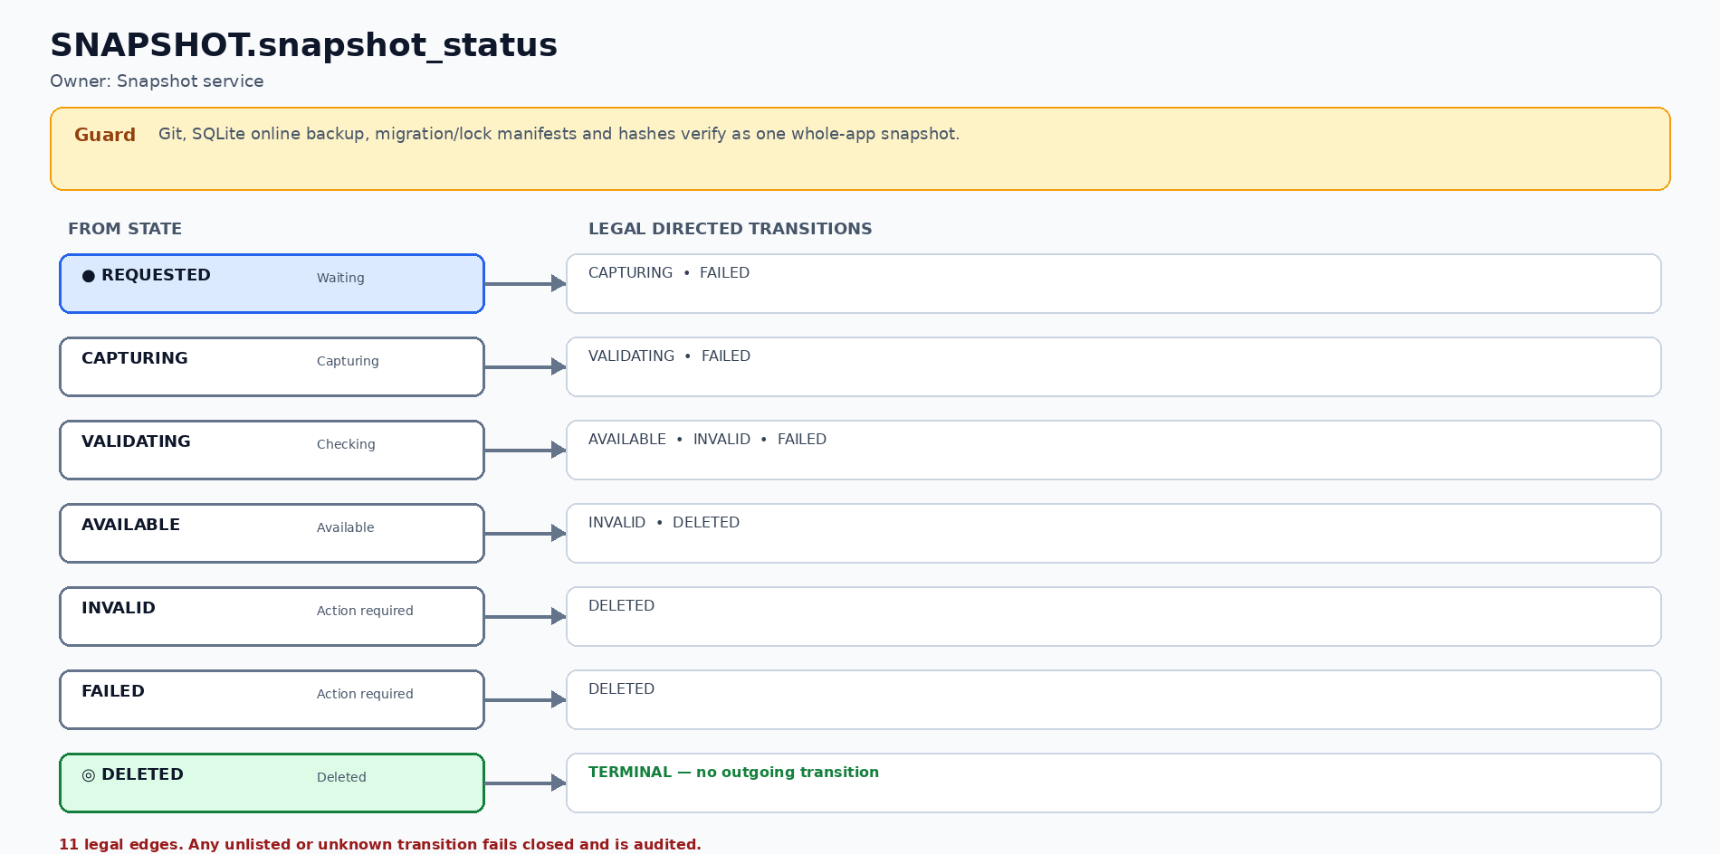
Figure S-07 — SNAPSHOT.snapshot_status: 7 states and 11 legal directed transitions.

RESTORE_JOB.restore_status
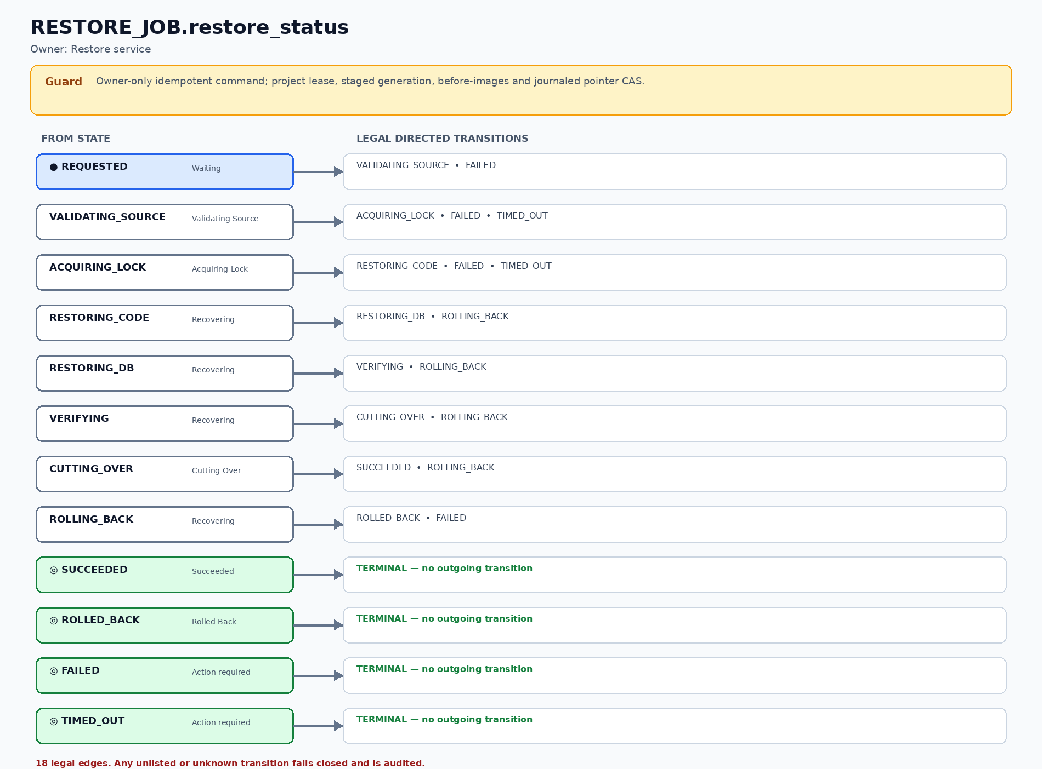
Figure S-08 — RESTORE_JOB.restore_status: 12 states and 18 legal directed transitions.

PREVIEW_ROUTE.route_status
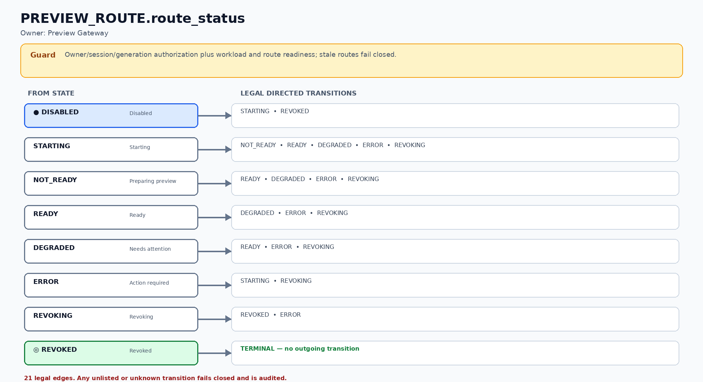
Figure S-09 — PREVIEW_ROUTE.route_status: 8 states and 21 legal directed transitions.

JOB_RUN.run_status
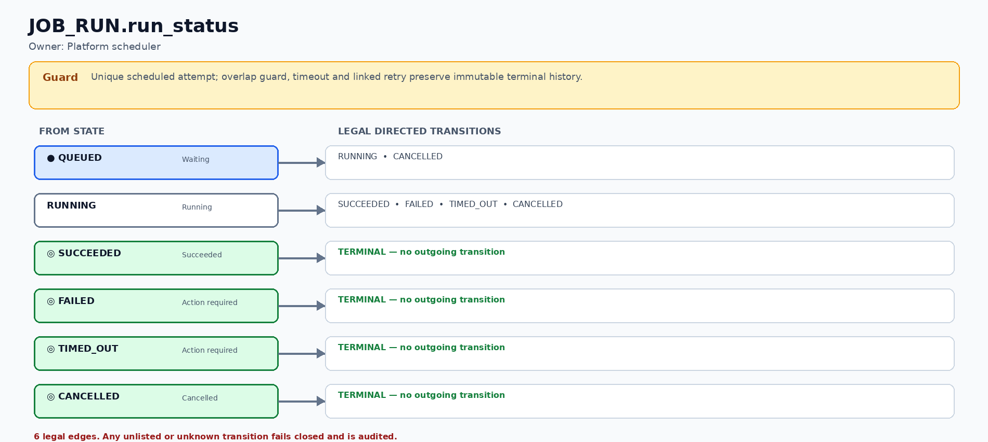
Figure S-10 — JOB_RUN.run_status: 6 states and 6 legal directed transitions.

8. Security baseline
The baseline is written as observable controls. Detailed runtime, container and network implementation belongs in the Technical Design.
ID | Control area | Baseline requirement | Acceptance evidence
SEC-01 | Identity, organization and ownership | Every user has one current primary organization placement, while every project, chat, run, checkpoint and preview remains owner-scoped in Stage 1. | Default membership validation plus same/cross-Department negative tests for list, direct URL, API, preview and live update.
SEC-02 | Authenticated preview | Mutable previews are private and require the owner’s active session. | Anonymous, expired-session and wrong-owner requests fail closed.
SEC-03 | Project isolation | One project cannot read or change another project’s files, data or runtime. | Cross-project filesystem, service and route tests are denied, including absolute/parent paths, symlink ancestors/leaves, broken links, special nodes and concurrent path-swap probes before Git/snapshot/restore reads.
SEC-04 | Least privilege | Generated workloads run without privileged host access or unrestricted administration. | Isolation and privilege-escape negative tests pass.
SEC-05 | Resource protection | Each project has bounded CPU, memory, process and storage use; capacity is admitted. | Limit and exhaustion tests show Waiting or controlled failure.
SEC-06 | Network control | Preview routes expose only intended application traffic; internal services remain private. | No database/debug host exposure; blocked private/metadata destinations.
SEC-07 | Secret handling | Credentials never enter generated source, chat display, logs, exports or non-secret configuration. | Secret scans and redaction tests pass with synthetic canaries.
SEC-08 | Change and recovery safety | Destructive/unsupported changes require approval; stalled-session recovery cannot overlap two mutating Cline attempts; snapshot capture and restore run under one project mutation lock. | Approval, proven old-Pod write revocation, generation staging, journaled pointer cutover and crash recovery preserve the last healthy checkpoint; metadata lease fencing alone is insufficient.
SEC-09 | Audit and evidence | Privileged actions, security decisions and lifecycle changes have actor, action, result and correlation reference. | Accepted, denied and failed actions appear in immutable audit evidence.
SEC-10 | Retention and recovery | Project source, rolling autosave and numbered whole-app versions survive ordinary stop/restart; SQLite is captured through a consistent backup operation, not by copying a live database file. | Code+database restore drill passes; autosave/version retention remains an approved configurable policy.

Any unknown route, ownership, quota, secret, startup or lifecycle condition fails closed. The platform must not guess a successful state.

Product architecture boundary
Concern | Approved Stage 1 boundary
Platform control plane | NestJS + Prisma + PostgreSQL. This is the product platform, not generated-app code.
Restricted administration | AdminJS exposes only allowlisted properties and named NestJS commands behind the same RBAC/CSRF/owner checks; no unrestricted direct CRUD.
Browser identity | An opaque HttpOnly Secure session cookie references Redis server-side session state. Long-lived browser JWT/localStorage authentication is prohibited; Redis session loss requires fresh sign-in.
Preview/service exchange | Only short-lived, audience-bound asymmetric JWTs with kid/jti/replay/revocation controls may cross a service boundary; generated preview code never receives platform session/JWT credentials.
Generated application | React/Vite + FastAPI + SQLite in the project workspace. It cannot access platform PostgreSQL or Redis.

9. Acceptance criteria
ID | Acceptance evidence
AC-ID-01 | Login/logout, secure session, CSRF and session rotation pass.
AC-ID-02 | User A cannot list, open, run, preview or delete User B’s project.
AC-PRJ-01 | A duplicate create request returns one project pinned to the approved template.
AC-PRJ-02 | Rename, stop, reopen and soft-delete show correct durable state.
AC-CHAT-01 | Chat sessions can be created, continued and archived without deleting history.
AC-CHAT-02 | Progress streams in plain language; Stop prevents new agent actions and reaches a safe terminal state.
AC-CHAT-03 | Editing a prior message creates traceable branch lineage.
AC-CHAT-04 | Pre-compaction notice and persisted summary prevent silent context loss.
AC-CHG-01 | Diff and preview are safe, owner-scoped and tied to the proposed run.
AC-CHG-02 | Accept, reject and iterate produce one explicit durable decision.
AC-CHG-03 | A destructive change cannot proceed without explicit user approval.
AC-PRV-01 | A React/TypeScript/CSS edit updates the current preview through live frontend hot reload without deployment.
AC-PRV-02 | A supported Python source edit reloads the backend preview and the product reconnects safely.
AC-PRV-03 | Dependency, environment, migration and runtime-contract changes show the correct restart/rebuild/approval state.
AC-VER-01 | Project creation initializes Git on main, creates an initial commit and exposes Version 1 only after a matching SQLite backup and manifest are verified.
AC-VER-02 | Each successful Save creates exactly one next numbered immutable version linked to a Git commit, private SQLite backup, hashes, locks and actor; an idempotent retry creates no duplicate version.
AC-VER-03 | While a project is active, the configured interval captures a rotating whole-app recovery autosave only when state changed; autosaves do not increment or clutter the user-visible version number.
AC-VER-04 | Before any code/DB mutation, idempotent Restore atomically captures PRE_RESTORE, prior generation/snapshot/route generation/exact route status, target generation and one provisional RESTORE_RESULT. Early or late rollback marks that result INVALID; cutover or verified rollback uses one PostgreSQL pointer transaction. Failure keeps route withdrawn and mutation blocked.
AC-LFC-01 | Stopping/recreating a preview does not lose Git source, checkpoints or approved persistent data.
AC-CAP-01 | Capacity exhaustion creates a durable bounded Waiting request with retry/cancel/timeout, owner-round-robin then FIFO order and separate Preview/Agent reservations; it never becomes login failure, generic 500 or silent oversubscription.
AC-LFC-02 | Idle stop does not interrupt an active mutation and requires explicit resume.
AC-SEC-01 | Owner, anonymous and cross-owner preview/live-update authorization tests pass.
AC-OPS-01 | Injected startup, agent, preview and restore failures produce safe recovery and correlation evidence.
AC-OPS-02 | Only typed allowlisted non-secret configuration can be changed; stale and invalid writes fail atomically.
AC-UX-01 | Normal users never see raw commands, ports, hostnames, stack traces, infrastructure manifests or credentials.
AC-UX-02 | Prompt starters and a concise first-run guide are available.
AC-CHAT-05 | Refreshing the browser during an active run reconnects to persisted messages/events and does not create a second AGENT_RUN, Agent Job or mutation lease.
AC-CHAT-06 | After the approved heartbeat threshold, Recover agent session persists one unique Agent Job resource reference whose agent_run_id equals the stopped/prior attempt, plus old Job/Pod UID, deletion observation and failed-closed write probe. STOPPED/retry reject missing, duplicate or other-attempt proof; lease expiry never authorizes overlap.
AC-ID-03 | Account provisioning creates one current primary Default Organization → Default OU → Default Department membership; users in the same unit still see only projects they own.

Capacity acceptance assumptions
Measure | Planning target | Launch posture
Registered users | 100 | Named accounts; not 100 simultaneous previews
Concurrent active users | 50 | Validate representative control-plane activity
Active previews | 25 planning target | Begin with 10 admitted previews
Concurrent agent runs | 8 planning target | Begin with 3 admitted runs
Peak platform API | 75 RPS | Load-test hypothesis, not production SLA
Idle stop | 60 minutes candidate | Confirm from usability and capacity evidence

The planning targets are not procurement proof. Measured results must record host profile, test script, workload mix, duration, latency, error rate and resource use.

10. Delivery Plan
Week | Dates | Business-readable outcome
W1 | 24–28 Aug | Runtime feasibility, Cline integration/recovery gate, authenticated preview route and security spike evidence.
W2 | 31 Aug–4 Sep | Authentication, project ownership, fixed template, durable project/workspace metadata and restricted administration foundation.
W3 | 7–11 Sep | Chat sessions, streamed events, mutation control, Agent Job and workspace persistence.
W4 | 14–18 Sep | Owner preview gateway, frontend hot reload, backend source reload and lifecycle reconciliation.
W5 | 21–25 Sep | Diff/review, accept/reject, Git workspace autosave, whole-app Save/Restore and failure recovery.
W6 | 28 Sep–2 Oct | Integrated beta by 30 Sep; security baseline, load evidence and remediation continue through 2 Oct.
W7 | 5–9 Oct | Contingency close: operational guidance, final evidence, traceability and POC acceptance.

Planning envelope
Item | Value | Meaning
Team | 2 developers | Capacity assumption
Weekly capacity | 64 team SP | 32 SP per developer per week
30 Sep capacity | 358.4 SP | Integrated beta target; not the full seven-week allocation
Full planning envelope | 448 SP | Seven team-weeks
Contingency date | 9 Oct 2026 | Used only if final planned week is required

Technical delivery enablers
ID | Enabler | Business exit evidence
EN-01 | Cline SDK compatibility and recovery gate | Pinned integration supports progress, stop, page reconnect, heartbeat, stuck detection, bounded termination, isolation and file mutation.
EN-02 | Preview runtime foundation | Project preview and agent work can start, stop, recover and preserve durable work.
EN-03 | Authenticated preview gateway | Owner route supports application, progress and live-update traffic.
EN-04 | Live-update classification | Frontend refresh, backend refresh and restart/rebuild paths are demonstrably distinct.
EN-05 | Security baseline | Ownership, isolation, least privilege, network, secret and audit tests pass.
EN-06 | Load and recovery evidence | Admission, idle stop, Pod failure, restart and restore evidence is reproducible.

Detailed runtime resources, commands, library versions and spike procedures are defined in the Technical Design, not duplicated here.

11. Risks and decisions

Top risks
Risk | Likelihood / impact | Response
Runtime details not proven | High / High | Time-box runtime, storage, live update, routing and isolation spikes before locking the implementation.
Cline SDK compatibility | High / High | Pin 0.0.79 and prove events, cancel, reconnect, isolation and file mutation early.
Cline session stalls | Medium / High | Persist events, monitor heartbeat/lease, expose bounded Recover agent session and prove no overlapping mutation.
Live update overstated | Medium / High | Use explicit classification; dependency, data and runtime changes must show restart/rebuild/approval honestly.
Single-node outage | Medium / High | State clearly: process recovery only; durable backup and restore evidence required.
Runtime isolation | Medium / Critical | Apply the Technical Design isolation baseline and verify cross-project/privilege-escape tests.
Mutable preview conflict | High / High | Keep each mutable preview at zero or one active instance.
Code/data version skew | High / High | Bind Git commit and SQLite online backup in one verified manifest; expose no version until all parts validate.
Deadline pressure | High / High | Prioritize the 30 Sep integrated beta; use 9 Oct only as contingency.

Decision register
ID | Decision area | Current decision | Status
DEC-01 | Stage 1 orchestration | Single-node K3s | CONFIRMED
DEC-02 | Stage 1 runtime detail | Single-node K3s; container/runtime mechanics are owned by the Technical Design | CONFIRMED
DEC-03 | Preview routing | Authenticated preview gateway; exact routing technology is owned by the Technical Design | CONFIRMED
DEC-04 | Generated-app template | One approved fixed generated-application template; exact stack is owned by the Technical Design | CONFIRMED
DEC-05 | Published deployment | Deploy button and release lifecycle start in Stage 2 | CONFIRMED
DEC-06 | Live update | Automatic eligible frontend/backend refresh and honest restart/rebuild classification are mandatory | CONFIRMED
DEC-07 | Cline SDK target | Pin @cline/sdk@0.0.79; compatibility evidence required | CONFIRMED TARGET
DEC-08 | Namespace/storage/network implementation | Defined by Technical Design spikes | DECISION REQUIRED
DEC-09 | Retention and backup policy | Per data class; no invented duration | DECISION REQUIRED
DEC-10 | Launch admission limits | Start conservatively; raise only after load evidence | PROVISIONAL
DEC-11 | Cline stuck-session recovery | Page refresh reconnects only; watchdog/owner cancels and proves the old Job/Pod can no longer write before an in-place linked retry. Lease fencing metadata alone is insufficient; generation-staged retries require controller-only CAS promotion. | CONFIRMED DIRECTION
DEC-12 | Organization hierarchy | Seed Default Organization → Default OU → Default Department; Stage 1 project access remains owner-only and organization placement grants no project access | CONFIRMED DIRECTION
DEC-13 | Whole-app version model | main mirrors the latest saved version; workspace/<project-id> holds active work; interval autosave is rotating recovery state; Save creates a numbered immutable code+SQLite version; Restore creates new history | CONFIRMED DIRECTION

Open product decisions
- Approved model gateway/provider, residency and hard cost cap.
- Project, chat, audit, checkpoint, workspace and backup retention durations.
- Exact launch admission limits after measured runtime load evidence.
- Any future Stage 2 sharing or delegated authorization model requires a separate product and security decision; Stage 1 remains owner-only.
- Future team workspace and project membership roles; OU/Department placement must never become an implicit sharing rule.

12. Traceability and related artifacts
Artifact | Authority
This PRD & Delivery Plan | Product scope, actors, features, Epics, Stories, Use Cases, security baseline and acceptance.
Technical Design & Runtime Architecture DOCX | K3s/runtime implementation, live-update mechanics, versions, networking, security implementation and spike evidence.
Data Specification XLSX | Entities, columns, relationships, enums, transitions, error registry and governance contract.

Traceability rule
Technical sections and tests reference Feature, Story, Use Case, Security and Acceptance IDs from this document. They do not redefine the product requirement independently.

