AI DEVELOPMENT WORKSPACE PLATFORM

Vibe-Code Platform
Final Production Architecture & Delivery Plan
Hong Kong production topology, scaling, user-data placement, staged roadmap and Stage 0 decision package
Production-grade platform. Proof-of-concept applications. Reviewed IT handover is the only supported path into enterprise delivery.

Purpose
Provide a pragmatic architecture and investment sequence for a freedom-first internal Vibe-Code platform. The design prioritises a complete user journey, isolation, portability, traceability and operational reality over an all-at-once “north-star” build.
Document field | Value
Status | Planning baseline — components are staged, not all deployed
Prepared | 24 August 2026
Primary source | wiki/raw/vibe-code-platform-plan.md
Current implementation | Local React/NestJS/PostgreSQL POC documented separately
Decision requested | Approve or reject the bounded Stage 0 feasibility spike

1. Executive recommendation
Do not rebuild Lovable, Base44 or a browser IDE. Assemble proven workspace and model-gateway components, then build only the company-specific control plane and handover workflow.
- Coder owns workspace provisioning, templates and lifecycle; code-server provides the browser IDE.
- A thin React/Vite portal and NestJS/Fastify modular monolith own projects, policy, cost, audit and handover.
- LiteLLM is the approved model entry point; Langfuse provides privacy-aware traces, not invoice truth.
- Git and an OCI registry provide immutable, exportable source and template artifacts.
- Kubernetes/K3s provides scheduling and isolation, but does not force early microservices.
- RabbitMQ, asynchronous agents, mobile PWA and detached preview are later product stages, not MVP prerequisites.

Recommended product position
Present the initiative as an AI Development Workspace Platform that produces traceable proof-of-concepts and a governed IT handover package. Do not market it as a citizen-developer production platform.

What makes it differentiated
Capability | Practical value
Project Passport | Machine-readable template, source, dependency, preview, usage and handover identity.
Template Delta Update | Upgrade branch and semantic diff rather than silent overwrite of user code.
Prompt-to-Handover Time Machine | Links request metadata, agent actions, Git changes, tests, preview and handover evidence.
Rescue Workspace / Failure Capsule | Preserves source and a repair path when builds, images or previews fail.
App Package Catalog | Composes reviewed cross-stack capabilities without a combinatorial template explosion.

Decision rule
Approve Stage 0 only if management accepts five explicit feasibility questions, 2–5 test users and a go/no-go gate. Do not approve the full target architecture as one MVP.

2. Final production architecture
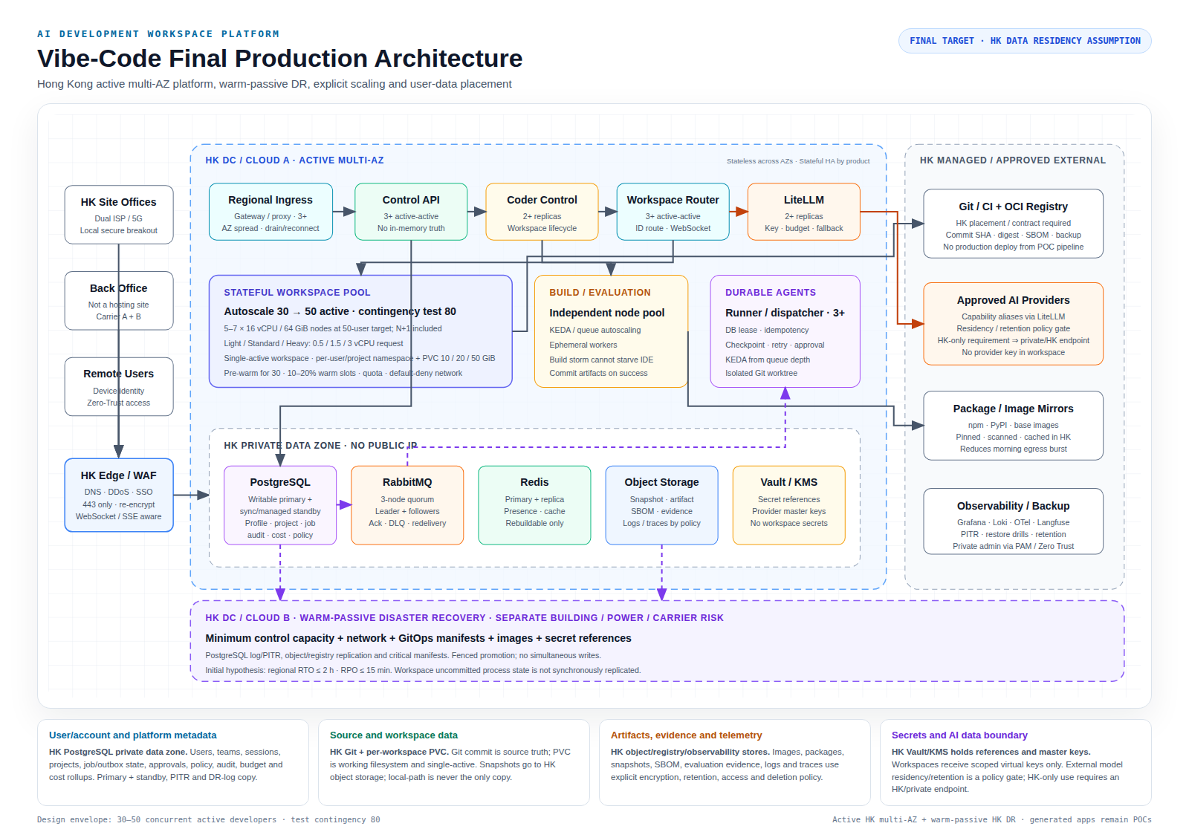
Figure 1 — Final HK production target with active multi-AZ scaling, warm-passive DR and explicit data placement. Stages 0–1 deploy only a subset.

3. Architecture responsibilities
Plane | Responsibility | Stage
Experience | Portal, project journey, workspace entry, cost and handover surfaces | 0–1
Control | Identity boundary, ownership, lifecycle, audit and transparent policy | 0–1
Workspace | Isolated IDE/agent environment, source, persistent volume and preview | 0–1
AI | Scoped gateway keys, model policy, routing, fallback, usage and traces | 0–2
Supply chain | Git/CI, immutable templates, OCI digests, SBOM and scans | 1–2
Durable execution | Job truth, outbox, broker, leases, retries and isolated runners | 4
Delivery | POC preview, evidence collection and reviewed IT handover | 1–3
Observability | Metrics, logs, traces, SLOs, capacity, cost and recovery | 2–3

Core component choices
Component | Role | Guardrail
Coder | Workspace foundation | Verify edition boundaries; do not duplicate its scheduler/UI.
code-server + Cline | Interactive browser coding | Pin versions and prove full browser workflow.
React/Vite portal | Company experience | Thin orchestration surface, not a second IDE.
NestJS/Fastify | Control-plane modular monolith | Split only for real scale/security/ownership reasons.
PostgreSQL | Business, audit and job truth | No platform SQLite; use migrations for shared environments.
LiteLLM | Approved AI gateway | Per-user/workspace scopes; no provider keys in source/images.
RabbitMQ | Asynchronous execution delivery | Introduce only at Stage 4; require owned operations.
Git + OCI | Source/template artifact truth | Immutable versions, digests, scans and exportability.

4. Production topology, scaling and data placement
The final target keeps users, active infrastructure, warm-passive DR and platform data in Hong Kong. Back office is an access site rather than the platform host; offices use local secure breakout to the HK edge. The active facility is multi-AZ, while a physically separate HK facility provides fenced warm-passive recovery.

Scaling and high availability
Area | Production model | Initial envelope
Edge / ingress | Managed WAF/LB plus 3+ ingress/proxy replicas across AZs | 443 only; no sticky API; WebSocket drain/reconnect and soak tests.
Portal / Control API | 3+ stateless active-active replicas with topology spread and PDB | 99.9% initial monthly SLO; 99.95% only after failover evidence.
Coder / LiteLLM | 2+ replicas with state and credentials externalized | Per-workspace keys, budget and fallback; no master key in workspaces.
Workspace Router | 3+ active-active proxies routed by workspace ID | Connections may reconnect; new sessions use healthy replicas.
Workspace pool | Single-active workspace + PVC; autoscaling node pool with N+1 | Pre-warm 30, autoscale 50, contingency test 80; 10–20% warm slots.
50-active capacity | Separate workspace/build/system pools | About 7 × 16/64 nodes, or 4–5 × 32/128 nodes after burst/fragmentation tests.
Build / evaluation | Separate ephemeral pool; queue/KEDA scaling | Build storm queues and cannot starve interactive IDEs.
Durable agents | 3+ dispatcher/runners with DB lease, idempotency and checkpoint | PostgreSQL outbox → 3-node RabbitMQ quorum → isolated runner.
PostgreSQL | Writable primary + synchronous/managed standby; PITR | Strong truth for identity, project, job, approval, audit, budget and policy.
Regional DR | Warm-passive second HK facility with fenced promotion | Initial RTO ≤ 2 h and RPO ≤ 15 min; prove by restore/failover drill.

Capacity assumptions are load-test starting points, not supplier guarantees. Weighted workspace demand is 1.15 vCPU, 3.6 GiB RAM and 18 GiB disk. One hundred registered workspaces require about 2.29 TiB after a 30% buffer, before registry, object-store and database capacity. When full, the API returns CAPACITY_QUEUED; login and administration remain available.

User and platform data locations
Data class | Authoritative location | Durability / policy
Identity, teams, sessions, roles | HK private PostgreSQL | Primary + standby, encrypted backup and PITR; identity/platform owner access.
Projects, jobs/outbox, approvals, policy, audit, budget | HK private PostgreSQL | Transactional truth, no public endpoint, PITR and DR-log copy.
Source and checkpoints | Approved HK Git service | Commit SHA is truth; protected branches, backup and exportability.
Live workspace filesystem | Per-workspace PVC in active HK facility | Single-active 10/20/50 GiB; snapshot to HK object storage; no local-path-only copy.
Snapshots, POC artifacts, SBOM, evidence, handover | HK object storage / OCI registry | Digest, encryption, lifecycle/deletion policy and warm-passive HK replication.
Presence and cache | HK Redis private endpoint | Primary/replica; rebuildable; never durable job or approval truth.
Logs, metrics and privacy-aware traces | HK observability stores | Explicit retention, RBAC, redaction and deletion; identity stays out of metric labels.
Secrets and provider keys | HK Vault/KMS or approved secret manager | References only; scoped expiring virtual keys in workspaces.
AI prompts/responses | Policy-approved model endpoint | Residency/retention/training-use gate; HK-only requires HK/private endpoint or route block.
DR copies | Separate HK DC/cloud failure domain | PITR/log, object/registry, GitOps, images and secret references; no dual writers.

Residual risk: an HK-only active/DR design does not survive a territory-wide Hong Kong outage. If policy forbids overseas DR, record and accept that limitation instead of claiming unsupported multi-region HA.

5. Staged delivery roadmap
The full target spans workspace, AI gateway, asynchronous agents, security/evaluation, handover and availability streams. A fully funded programme may require a dedicated 6–9 person team and roughly 9–18 months. The first useful product should arrive much earlier by cutting scope.
Stage | Duration | Primary outcome | Gate / exclusion
0 — Feasibility | 4–6 weeks | Prove workspace, IDE/agent, model flow, preview, persistence and isolation for 2–5 users. | No mobile, RabbitMQ, arbitrary Compose, detached preview, DR or 50-user load.
1 — V0 pilot | +4–6 weeks | 5–10 users complete the portal → workspace → preview → handover journey. | Thin portal; no custom scheduler; PostgreSQL is enough.
2 — V1 internal | +6–8 weeks | Templates, app packages, scans, usage, backup/restore and handover for 10–20 users. | No server-side async agent or mobile PWA.
3 — V1.5 hardening | +4–8 weeks | Measured 30–50 user capacity, network controls, failure drills, SLO and recovery. | Fund scale only after adoption evidence.
4 — V2 async agents | +8–12 weeks | Outbox + RabbitMQ, isolated runners, approvals, checkpoints, replay and PRs. | Broker becomes a requirement here.
5 — V2.5 mobile | +4–6 weeks | Task-first PWA, stop/follow-up, mobile review and notifications. | Not a browser IDE clone.
6 — V3 evidence-led | Variable | Detached preview, stronger sandbox, richer packages, graph evidence and DR. | Only where usage and risk justify it.

Funding gate
Each stage must present adoption, failure, cost, security and support evidence before the next stage is funded. Scope must not expand merely because a component appears in the target diagram.

6. Stage 0 feasibility spike
Goal: prove the five questions that can invalidate the whole approach before funding a platform build.
- Can Coder reliably create, start, stop and recreate workspaces on the intended managed Kubernetes or small K3s environment?
- Does the pinned code-server + Cline workflow actually support activation, webview, edits, diff, terminal approval, checkpoint, attachment, OAuth callback and failure/retry?
- Can Cline stream large-context and tool-calling requests through LiteLLM with scoped-key creation and revocation?
- Can one React/Vite + FastAPI golden POC run through authenticated frontend/API Coder Apps previews?
- Do Git/source, persistent data, workspace isolation and basic egress boundaries survive stop/start/recreate?

Required evidence
- Pinned component versions and licence/edition matrix.
- Reproducible setup and acceptance scripts.
- Real browser recording or screenshots of the complete workflow.
- Failure logs and visible retry/recovery paths.
- Workspace startup, image-pull, idle/active memory, build peak and AI latency/cost measurements.
- Cross-user access-denial and credential-isolation tests.

Stage 0 exit decision
Outcome | Condition
GO | All five questions pass and at least two named users repeat the journey without manual repair.
CONDITIONAL GO | Only non-security usability/performance gaps remain, each with owner and date.
NO-GO / redesign | Browser agent is unusable; data/source is lost; isolation fails; credentials must be exposed; or required edition cost is unacceptable.

7. Security and operational boundaries
- Backend-enforced ownership; hiding projects in the UI is not access control.
- Non-root, resource-limited workspaces with dropped capabilities and no host mounts or shared Docker socket.
- Authenticated preview routes; no direct host-port publication.
- Per-user/workspace model credentials through an approved gateway; no shared employee OAuth profile.
- Metadata-only prompt audit by default; full capture requires explicit retention, encryption, RBAC and deletion controls.
- Protected branches and isolated worktrees for agent/package changes; completion does not imply merge approval.
- Generated apps carry explicit POC status, known gaps, test/scan evidence and no production credentials.
- Administrative actions, budget changes, suspension and break-glass operations are auditable.

Failure containment
Failure | Expected platform behaviour
Preview/app crash | Keep IDE, Git and agent available; expose logs and restart action.
Build/test failure | Preserve stage, command, exit code and source; retry only failed stage.
LLM provider failure | Use approved fallback, then preserve manual IDE mode.
Workspace/pod failure | Reschedule and reattach persistent storage; provide rescue workspace if image fails.
Capacity exhausted | Return queued status and notification, not a generic 500.
Control-plane database unavailable | Fail new state changes closed while existing workspaces continue where safe.

8. Key risks and decision owners
Risk | Required decision / evidence | Owner
Browser compatibility | Pinned real-browser workflow; do not infer from extension listing. | Platform lead
Coder edition | OSS/commercial matrix for SSO, RBAC, audit and HA. | Architecture / procurement
Compose isolation | Remote build or sandbox decision; host Docker remains prohibited. | Security / platform
Prompt privacy | Retention, encryption, RBAC, redaction and deletion policy. | Security / privacy
Template conflicts | Upgrade branch/PR or codemod; no silent overwrite. | Template owner
Cost accuracy | Reconcile gateway/traces with provider invoices. | FinOps / platform
Package supply chain | Digest, SBOM, signature, permissions, canary and kill switch. | Security / package owner
Broker operations | Managed or owned RabbitMQ with failure and recovery drills. | Operations
Scope inflation | Stage gates based on measured adoption, failures and support load. | Product sponsor

9. Immediate decision package
Management should answer these questions before implementation expands beyond the current local POC:
- Approve a bounded 4–6 week Stage 0 spike with 2–3 experienced engineers and 2–5 named users?
- Use an existing managed Kubernetes test environment or a small K3s spike cluster?
- Which identity provider, Git organisation and approved model route may be used for the spike?
- Which Coder edition features are mandatory, and what commercial ceiling is acceptable?
- Who owns platform, security/privacy, model gateway, template and operational decisions?
- What evidence threshold constitutes GO, CONDITIONAL GO and NO-GO?

Recommended next actions
- Pin Coder, code-server, Cline, LiteLLM and model versions.
- Prepare one golden React/Vite + FastAPI/SQLAlchemy/SQLite project.
- Execute browser, workspace lifecycle, Git recovery, PVC, isolation and egress tests.
- Measure resource and AI cost baselines instead of estimating 30–50 user capacity.
- Produce a Stage 0 go/no-go report and a 5–10 user V0 pilot backlog.
- Keep mobile, RabbitMQ, multi-agent, app-package composer, detached preview, graph scoring and DR in their evidence-led stages.

10. Repository references
Artifact | Repository path
Target architecture baseline | wiki/architecture/baseline/vibe-code-platform-target-architecture.md
Editable architecture diagram | wiki/architecture/diagrams/vibe-code-platform-target-architecture.html
PNG architecture diagram | wiki/architecture/diagrams/vibe-code-platform-target-architecture.png
Raw platform planning source | wiki/raw/vibe-code-platform-plan.md
Current local POC baseline | wiki/architecture/baseline/README.md
Current local POC ADR | wiki/architecture/decisions/ADR-0001-local-poc-stack.md
POC feature package | wiki/delivery/features/FTR-001-poc-platform/feature.md

External technology references are maintained in the source plan so URLs and product claims can be updated independently from this management document.

