DIP Project 1

電信碩 沈衍薰 309513047

1. **Source code**

image = imread('Bird feeding 3 low contrast.tif');

image_double = double(image);

figure(1);

imshow(image);

figure(2);

imhist(image);

im_after_transfer = zeros(512);

im_after_transfer = transformation(image_double);

figure(3);

imshow(uint8(im_after_transfer));

figure(4);

imhist(uint8(im_after_transfer));

function output = transformation(im)

for i = 1:512

for j = 1:512

output(i, j) = (atan((im(i, j)-128)/32));

range = ((atan((255-128)/32))-(atan((0-128)/32)));

output(i, j) = (255/range)*(output(i, j)-(atan((0-128)/32))); %h{}

end

end

end

1. **Figures of s=T(r)**

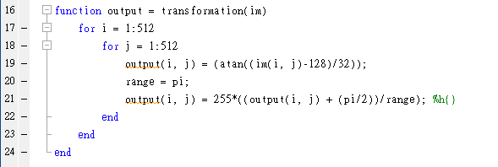

1. **Table of transformation function to show the mapping from the input gray level r to the output gray level s**

|  |  |  |  |  |  |  |  |  |  |
| --- | --- | --- | --- | --- | --- | --- | --- | --- | --- |
| 0 | 1 | 2 | 3 | 4 | 5 | 6 | 7 | 8 | 9 |
| 0 | 0 | 1 | 1 | 1 | 1 | 1 | 2 | 2 | 2 |

|  |  |  |  |  |  |  |  |  |  |
| --- | --- | --- | --- | --- | --- | --- | --- | --- | --- |
| 10 | 11 | 12 | 13 | 14 | 15 | 16 | 17 | 18 | 19 |
| 2 | 2 | 3 | 3 | 3 | 3 | 3 | 4 | 4 | 4 |

|  |  |  |  |  |  |  |  |  |  |
| --- | --- | --- | --- | --- | --- | --- | --- | --- | --- |
| 20 | 21 | 22 | 23 | 24 | 25 | 26 | 27 | 28 | 29 |
| 4 | 5 | 5 | 5 | 5 | 6 | 6 | 6 | 7 | 7 |

|  |  |  |  |  |  |  |  |  |  |
| --- | --- | --- | --- | --- | --- | --- | --- | --- | --- |
| 30 | 31 | 32 | 33 | 34 | 35 | 36 | 37 | 38 | 39 |
| 7 | 7 | 8 | 8 | 8 | 9 | 9 | 9 | 10 | 10 |

|  |  |  |  |  |  |  |  |  |  |
| --- | --- | --- | --- | --- | --- | --- | --- | --- | --- |
| 40 | 41 | 42 | 43 | 44 | 45 | 46 | 47 | 48 | 49 |
| 10 | 11 | 11 | 11 | 12 | 12 | 13 | 13 | 13 | 14 |

|  |  |  |  |  |  |  |  |  |  |
| --- | --- | --- | --- | --- | --- | --- | --- | --- | --- |
| 50 | 51 | 52 | 53 | 54 | 55 | 56 | 57 | 58 | 59 |
| 14 | 15 | 15 | 16 | 16 | 17 | 17 | 18 | 18 | 19 |

|  |  |  |  |  |  |  |  |  |  |
| --- | --- | --- | --- | --- | --- | --- | --- | --- | --- |
| 60 | 61 | 62 | 63 | 64 | 65 | 66 | 67 | 68 | 69 |
| 19 | 20 | 20 | 21 | 22 | 22 | 23 | 24 | 24 | 25 |

|  |  |  |  |  |  |  |  |  |  |
| --- | --- | --- | --- | --- | --- | --- | --- | --- | --- |
| 70 | 71 | 72 | 73 | 74 | 75 | 76 | 77 | 78 | 79 |
| 26 | 26 | 27 | 28 | 29 | 30 | 30 | 31 | 32 | 33 |

|  |  |  |  |  |  |  |  |  |  |
| --- | --- | --- | --- | --- | --- | --- | --- | --- | --- |
| 80 | 81 | 82 | 83 | 84 | 85 | 86 | 87 | 88 | 89 |
| 34 | 35 | 36 | 37 | 38 | 39 | 40 | 41 | 43 | 44 |

|  |  |  |  |  |  |  |  |  |  |
| --- | --- | --- | --- | --- | --- | --- | --- | --- | --- |
| 90 | 91 | 92 | 93 | 94 | 95 | 96 | 97 | 98 | 99 |
| 45 | 46 | 48 | 49 | 51 | 52 | 54 | 55 | 57 | 58 |

|  |  |  |  |  |  |  |  |  |  |
| --- | --- | --- | --- | --- | --- | --- | --- | --- | --- |
| 100 | 101 | 102 | 103 | 104 | 105 | 106 | 107 | 108 | 109 |
| 60 | 62 | 64 | 66 | 68 | 70 | 72 | 74 | 76 | 78 |

|  |  |  |  |  |  |  |  |  |  |
| --- | --- | --- | --- | --- | --- | --- | --- | --- | --- |
| 110 | 111 | 112 | 113 | 114 | 115 | 116 | 117 | 118 | 119 |
| 81 | 83 | 85 | 88 | 90 | 93 | 96 | 98 | 101 | 104 |

|  |  |  |  |  |  |  |  |  |  |
| --- | --- | --- | --- | --- | --- | --- | --- | --- | --- |
| 120 | 121 | 122 | 123 | 124 | 125 | 126 | 127 | 128 | 129 |
| 107 | 110 | 113 | 116 | 119 | 122 | 125 | 128 | 131 | 134 |

|  |  |  |  |  |  |  |  |  |  |
| --- | --- | --- | --- | --- | --- | --- | --- | --- | --- |
| 130 | 131 | 132 | 133 | 134 | 135 | 136 | 137 | 138 | 139 |
| 137 | 140 | 143 | 145 | 148 | 151 | 154 | 157 | 159 | 162 |

|  |  |  |  |  |  |  |  |  |  |
| --- | --- | --- | --- | --- | --- | --- | --- | --- | --- |
| 140 | 141 | 142 | 143 | 144 | 145 | 146 | 147 | 148 | 149 |
| 165 | 167 | 170 | 172 | 175 | 177 | 179 | 181 | 183 | 186 |

|  |  |  |  |  |  |  |  |  |  |
| --- | --- | --- | --- | --- | --- | --- | --- | --- | --- |
| 150 | 151 | 152 | 153 | 154 | 155 | 156 | 157 | 158 | 159 |
| 188 | 190 | 191 | 193 | 195 | 197 | 198 | 200 | 202 | 203 |

|  |  |  |  |  |  |  |  |  |  |
| --- | --- | --- | --- | --- | --- | --- | --- | --- | --- |
| 160 | 161 | 162 | 163 | 164 | 165 | 166 | 167 | 168 | 169 |
| 205 | 206 | 207 | 209 | 210 | 211 | 213 | 214 | 215 | 216 |

|  |  |  |  |  |  |  |  |  |  |
| --- | --- | --- | --- | --- | --- | --- | --- | --- | --- |
| 170 | 171 | 172 | 173 | 174 | 175 | 176 | 177 | 178 | 179 |
| 217 | 218 | 219 | 220 | 221 | 222 | 223 | 224 | 225 | 226 |

|  |  |  |  |  |  |  |  |  |  |
| --- | --- | --- | --- | --- | --- | --- | --- | --- | --- |
| 180 | 181 | 182 | 183 | 184 | 185 | 186 | 187 | 188 | 189 |
| 226 | 227 | 228 | 229 | 230 | 230 | 231 | 232 | 232 | 233 |

|  |  |  |  |  |  |  |  |  |  |
| --- | --- | --- | --- | --- | --- | --- | --- | --- | --- |
| 190 | 191 | 192 | 193 | 194 | 195 | 196 | 197 | 198 | 199 |
| 234 | 234 | 235 | 235 | 236 | 236 | 237 | 237 | 238 | 239 |

|  |  |  |  |  |  |  |  |  |  |
| --- | --- | --- | --- | --- | --- | --- | --- | --- | --- |
| 200 | 201 | 202 | 203 | 204 | 205 | 206 | 207 | 208 | 209 |
| 239 | 239 | 240 | 240 | 241 | 241 | 242 | 242 | 243 | 243 |

|  |  |  |  |  |  |  |  |  |  |
| --- | --- | --- | --- | --- | --- | --- | --- | --- | --- |
| 210 | 211 | 212 | 213 | 214 | 215 | 216 | 217 | 218 | 219 |
| 243 | 244 | 244 | 244 | 245 | 245 | 246 | 246 | 246 | 247 |

|  |  |  |  |  |  |  |  |  |  |
| --- | --- | --- | --- | --- | --- | --- | --- | --- | --- |
| 220 | 221 | 222 | 223 | 224 | 225 | 226 | 227 | 228 | 229 |
| 247 | 247 | 247 | 248 | 248 | 248 | 249 | 249 | 249 | 249 |

|  |  |  |  |  |  |  |  |  |  |
| --- | --- | --- | --- | --- | --- | --- | --- | --- | --- |
| 230 | 231 | 232 | 233 | 234 | 235 | 236 | 237 | 238 | 239 |
| 250 | 250 | 250 | 251 | 251 | 251 | 251 | 252 | 252 | 252 |

|  |  |  |  |  |  |  |  |  |  |
| --- | --- | --- | --- | --- | --- | --- | --- | --- | --- |
| 240 | 241 | 242 | 243 | 244 | 245 | 246 | 247 | 248 | 249 |
| 252 | 252 | 253 | 253 | 253 | 253 | 253 | 254 | 254 | 254 |

|  |  |  |  |  |  |
| --- | --- | --- | --- | --- | --- |
| 250 | 251 | 252 | 253 | 254 | 255 |
| 254 | 254 | 255 | 255 | 255 | 255 |

1. **Figure of the output image after applying the intensity transformation function**

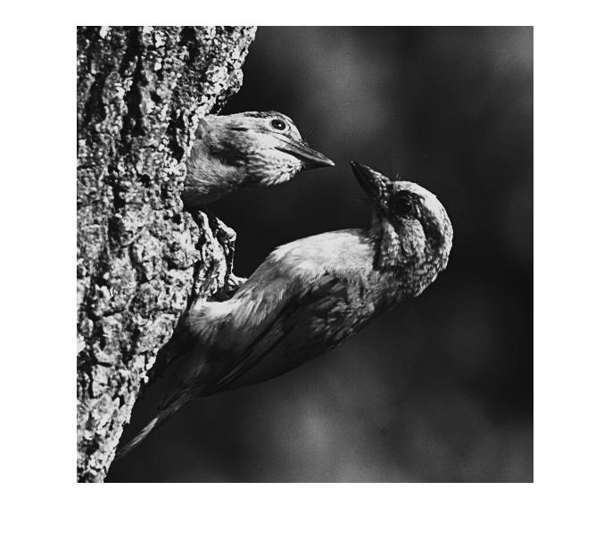

1. **Figures of the original and output histograms**

Original histogram:

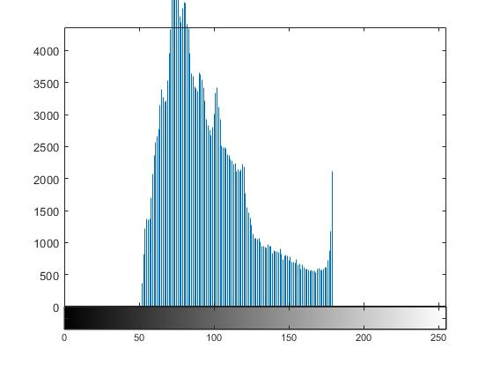

Output histogram:

