DIP Project2

309513047

電信碩 沈衍薰

1. Source code

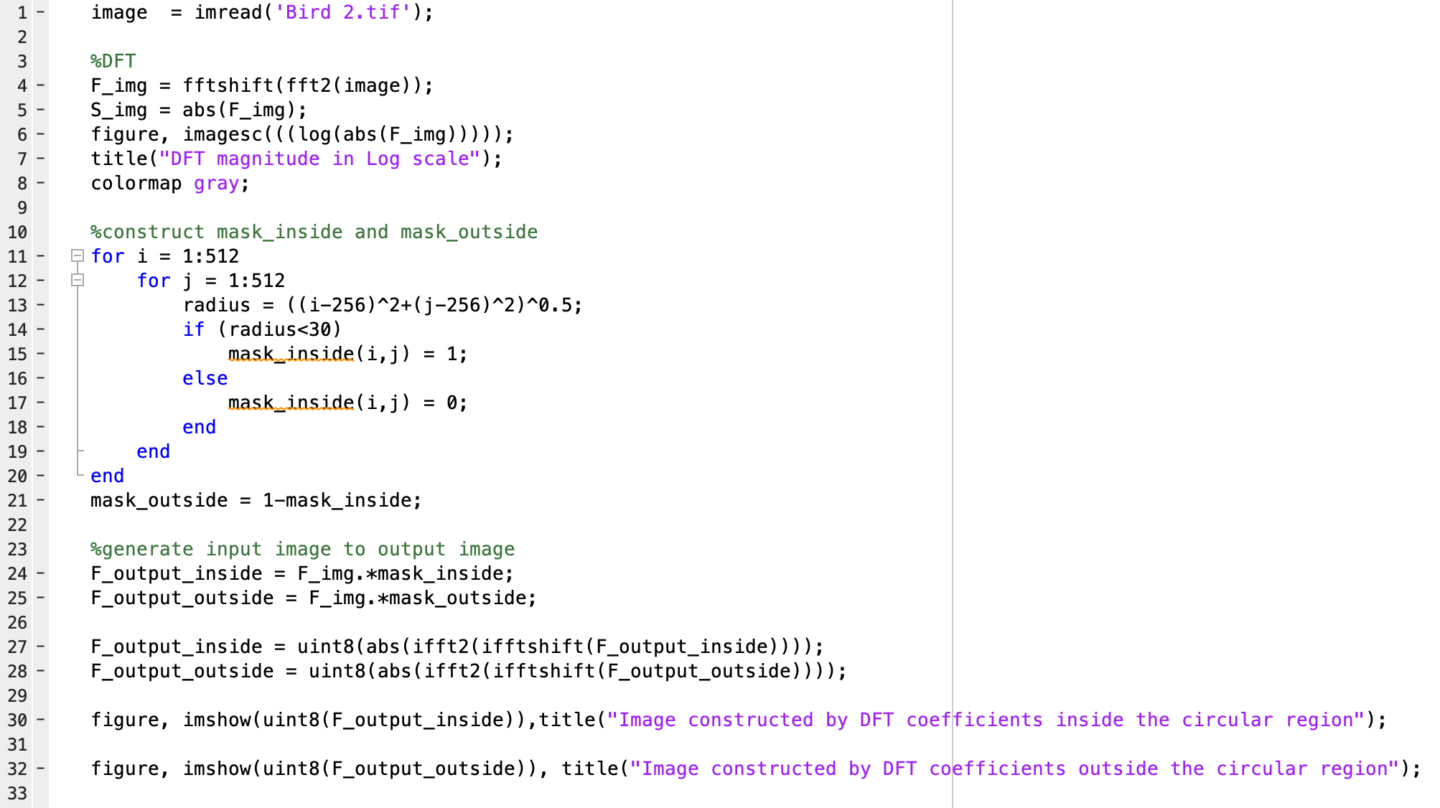

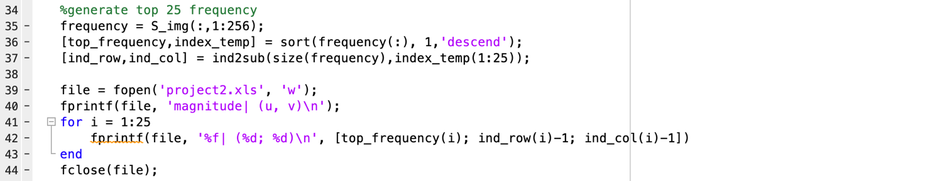

1. Plot of DFT magnitude in Log scale

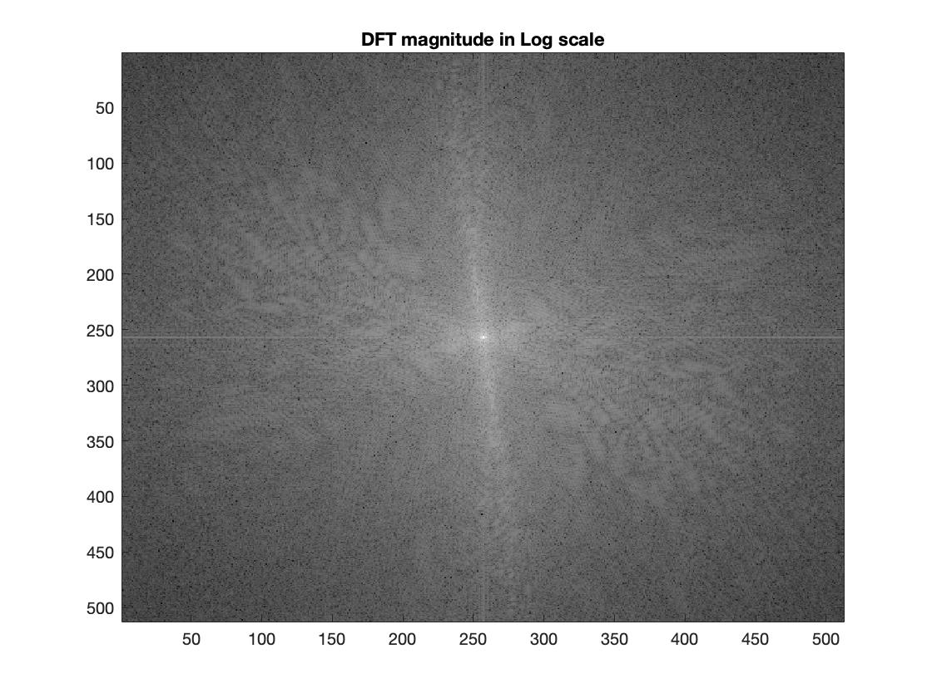







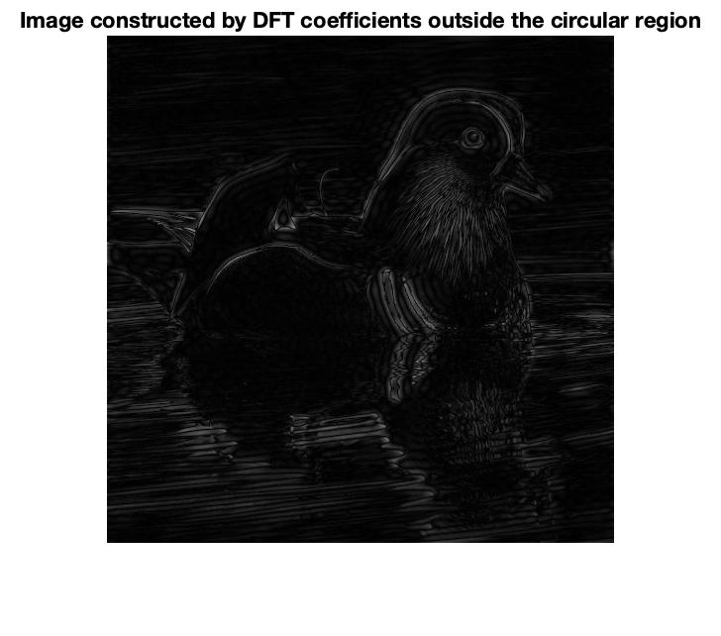



|  |
| --- |
| magnitude | (u, v) |
| 3353201.026467 | (256; 254) |
| 3153898.623519 | (256; 255) |
| 1911080.227144 | (255; 255) |
| 1763699.344797 | (257; 255) |
| 1389293.496565 | (257; 254) |
| 1295463.995486 | (253; 255) |
| 1126762.521342 | (259; 254) |
| 965729.916640 | (258; 255) |
| 810353.144458 | (259; 255) |
| 685227.770241 | (253; 254) |
| 680877.275464 | (256; 253) |
| 646195.720664 | (258; 252) |
| 633484.345235 | (254; 254) |
| 616688.108608 | (258; 253) |
| 592982.049759 | (252; 253) |
| 579739.473801 | (248; 255) |
| 544777.894049 | (254; 255) |
| 540892.332654 | (254; 252) |
| 524469.411627 | (260; 254) |
| 523638.811559 | (262; 255) |
| 507827.764565 | (254; 253) |
| 484987.833445 | (255; 252) |
| 477167.099535 | (255; 254) |
| 459230.015923 | (252; 255) |
| 448247.705128 | (261; 254) |