**Straight-Through-Processing   
in the OTC Swaps Market**

Submitted 4/3/2007

**Executive Summary**

The OTC Swaps market has witnessed tremendous growth in the last few years. The adoption of straight-through-processing (STP) in equities and fixed income has delivered operational efficiencies, reduced risk, market transparency, and lower costs. However, STP in the OTC Swaps market has been relatively slow to catch on despite derivatives playing a larger role in global financial markets. This paper examines the technological, legal, and financial roadblocks hampering adoption as well as the major players, their initiatives, and the proposed electronic trading flow. STP of OTC Swaps is closer then you think…

**Introduction**

It all started in the magical year of 1981. It was a year of tremendous innovation. Musical pioneers like Juice Newton and Rick Springfield dominated the airwaves. Porky’s brought a certain level of sophistication to our cinema we had never seen. 1981 was also the year in which there were tremendous advances in the field of technology. DOS made its first appearance in the marketplace, as well as a little-known software company known as Microsoft.

In 1981 an employee from Salomon Brothers named David Swensen created an “interest rate swap”, the first of its kind, which would transform financial derivatives into a trillion dollar market. According to ISDA’s 2006 Mid-Year Market Survey, “Notional amount outstanding of interest rate swaps and options and cross-currency swaps grew by 18 percent to $250.8 trillion from $213.2 trillion.”1 (See Statistics and Growth in Appendix).

Swensen’s interest rate swap concept was engineered in response to IBM’s wish to convert its current bond debt from Swiss Francs into Dollars. Swensen made the shrewd observation that there might be a counterparty in the same exact boat, who would be willing to exchange obligations. It so happens that World Bank was looking for such a swap.

World Bank is an entity created and owned by over 100 countries (all members of the United Nations) of the world. They are dedicated to many efforts, one of which is

economic and knowledge assistance in developing countries around the globe. Because their industry is worldwide, they hold debt in a variety of different currencies. As it turns out, World Bank was interested in issuing debt in dollars, assuming IBM gave them a rate that was better than the market rate. IBM was more than willing to pay the discounted dollar interest payments to World Bank, and vice-versa, with Salomon taking a piece of each pie.

This sounds like a win-win situation for all parties, but there was a real problem with the concept. Assume you are in IBM’s situation, how do you find a counterparty with the same exact circumstances as you? There is only one World Bank, and there is no guarantee that World Bank will always be in a position to swap future cash flows.

Over time, however, there was enough interest in the swaps market for banks to take notice. They needed to look at the industry and see if it was profitable to get involved in the process to find the counterparty. They, like Salomon in the World Bank-IBM example, would take a finder’s fee.

Another problem resulted from banks taking on increasing numbers of swap contracts, trying to find counterparties. Now since a swap is pretty much a forward contract over many payment periods, each swap ran the risk of counterparty default, leaving the banks with what are called “warehouse swaps”. This is another term for a swap that is unmatched, for which the bank is now responsible. They have now shifted the risk from “interest rate risk” to “counterparty default risk”.

In the World Bank-IBM example, however, there was little counterparty risk. World Bank has nearly zero competition, and was not likely to default on its payments. Likewise, IBM’s dominance in the technology world, made them a very safe bet as well..

Since then, there has been a tremendous growth in swap contracts. However, Straight-Through Processing (STP) for swaps contracts has not been embraced in the same way as other trading types. This paper will attempt to address the myriad of issues with implementing STP for swaps. This paper will also attempt to outline the entire life-cycle of STP, from Master Agreements to clearing and settlement at the Depository Trust and Clearing Corporation. Finally it will attempt to address the current STP issues in the OTC swaps market and help to explain why its adoption hasn’t been more prevelant.

**History**

The OTC derivatives market is at an interesting stage in its development. OTC derivatives have experienced exponential growth in recent years as new derivative products are constantly being created. According to the International Swaps and Derivatives Association there were $250,829.99 billion US Dollars in outstanding Interest Rate and Currency Swaps. Adding to the growth in the OTC derivative market are Credit Default Swaps, which as of 2006 totaled $26,005.72 billion. Swaps, along with forwards and options make up the OTC derivatives market. Swaps differ from exchange-traded derivatives, known as futures, in terms of specificity and standardization. Swaps are essentially a negotiated agreement between two parties that negotiate their terms bilaterally as opposed to futures contracts where negotiation characteristics are standardized. There is much greater risk in a swap contract because exposure to default risk is assumed by the counterparty and not the clearinghouse. Because swap trades are negotiated agreements they resemble a legal contract. The ISDA created a Master Agreement, which solves this issue of credit legality between counterparties in a swap trade. This critical standardized legal document allows swaps to be traded on the OTC markets without the need to constantly re-negotiate the legal terms of a contract which in the past could take up to thirty days.

**Manual life cycle of an OTC swap trade**

The life cycle of a swap trade is typically highly manual, especially within certain phases of a trade (verification, confirmation, and legal execution). The swap usually begins with the front office traders. Trade execution occurs when two counterparties agree to a transaction, historically accomplished via telephone. Verification of the trade was usually handled by back office operations where they would record the main details of the trade usually via the telephone or by an exchange of spreadsheets. Risk reduction was inadequate and timeframes for settlement varied depending upon whether a broker was involved. After the trade is executed, a written or electronic record had to be created to record the trade details (trade capture). Historically confirmations were paper documents sent by both counterparties by fax, email, telex, or by courier. Obviously larger trade volumes and complex deals delayed confirmation, increasing risk exposure. A unique aspect of an OTC derivative trade is the legal execution of the confirmation. This occurs when both parties agree to the full terms of the trade, which is a separate process from the original oral agreement the traders make. Legal execution consisted of two manual processes: Checking, which basically is reconciling the counterparty’s record against your internal records, and Query Resolution, which corrects any trade detail or legal language discrepancies. This process, especially legal language discrepancies, accounted for the longest delays. In the antiquated manual environment agreement of all the terms of a trade could take up to 30 days. Signing and matching finalized a legal execution. The post trade phase in the manual environment was equally as redundant and prolonged as the other parts of the trade life cycle. Rate fixing, cash flow reconciliation, settlement, and portfolio reconciliation are some of the manual post trade functions which complicate trades and boost risk. For example in an interest rate or currency swap rate spot fixing occurs at regular intervals throughout the life of the trade. Rate reset notices were often exchanged between dealers, but rarely checked. The lack of automation in rate resets effected cash flow reconciliation. It was simply a very messy process where the back office of swaps dealers would constantly call each other to confirm payment amounts and payment dates. Settlements between counterparties were often done individually by instructing their respective custodian banks. Additionally, the ability to net payments was often not an option. Also market events such as mergers, the exercise of an option, and defaults, affected trades usually resulting in trade rebooks or terminations.

**Current OTC Swaps Market**

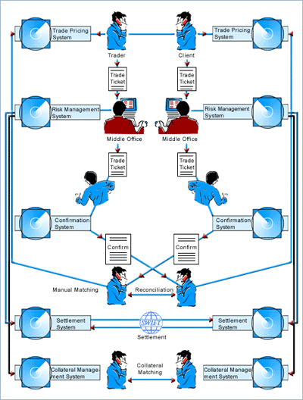 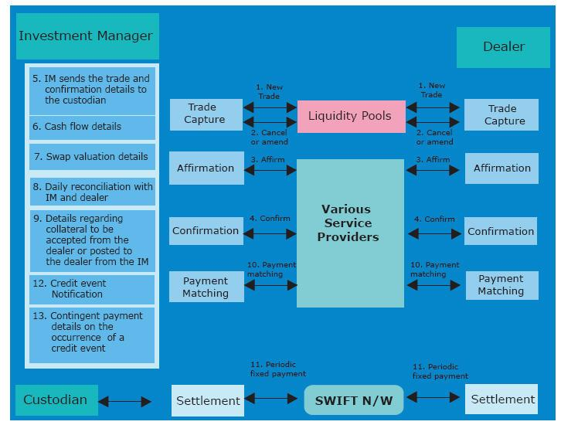

Source: ISDA Source: Tata Consultancy Services

**Adoption**

Technology has helped foster faster adoption of trading platforms across almost all asset classes. The STP promise of reduced risk, lower costs, less errors, and increased operational efficiency has transformed the way equities and fixed income products are traded. However, the proliferation of OTC derivatives, and specifically swaps, has been uncharacteristically slow given the staggering growth of this instrument class.

Slow adoption of OTC swap platforms has been due to a number of reasons. Foremost, the complexity of derivative instruments themselves makes trade capture relatively difficult to design. An interest rate swap, for example, requires a myriad of data points such as amortization schedules, business day conventions, and most importantly an underlying interest rate variable such as LIBOR. With the floating side changing over time, a trading platform must be linked to a risk platform to ensure mark-to-market analytics can be processed. Each of these trade details become overwhelmingly complex to design and track in a trading application.

Counterparty creditworthiness is also an invaluable trade component that is often difficult to track and measure. ISDA, which requires the master agreement to be established before counterparties can transact, various credit risks will often impact the pricing of a deal. Calculating this risk proves somewhat difficult in an arena with changing credit worthiness. The pricing of such creditworthiness requires transparency in electronic trading systems. “Showing your hand” (revealing prices) is often counter intuitive to most firms, whereas the less trading strategy disclosed to the street, the better.

Standardization of identifiers is another roadblock that has yet to be conquered. Whereas equities and fixed income securities uses CUSIPs, ISINs, SEDOLs, and TICKERs to identify various instruments, there is a lack of single identifier for the OTC derivative. This presents various issues further downstream when trying to connect various systems or match the other side of the trade.

The ability to interface with other systems has been one of the most restrictive factors preventing adoption. While FmPL (XML Standard for OTC Derivatives) has existed for 8+ years, the ability to connect to other systems to invoke true STP has been limited. The industry has struggled to patch together the execution products with the confirm/matching products while incorporating risk analytics along the way. Just as in the equity and the fixed income arenas, as operational overhead and error rates are reduced, adoption will follow.

Finally, a behavioral variable must also be recognized in understanding why adoption has been slow. Financial firms often suffer from first mover syndrome while their traders are also intrinsically technologically averse. While this has been changing in recent years, the learning curve still presents a formidable opponent for new platform adoption. In the minds of the traders, it’s still easier to pick up the phone, price a deal and close it within a few minutes then to spend time clicking or tabbing through half a screen of fields to complete a trade. “The failure of Blackbird (Reuters joint venture circa 1999), one of the most technologically advanced systems on the market, remains the industry's cautionary tale about pursuing a build-it-and-they-will-come strategy” (Smith, p1).

While many of these speed bumps have been conquered recently, it’s important to understand how the industry has had to navigate. Trading systems have become richer in functionality and more efficient in trade capture, while providing the necessary support to overcome learning curve dynamics. As the ability to interface various systems through standardized APIs matures, the benefits of STP will shine brighter. In looking at the current application providers we can see how the industry has evolved and where the gaps remain.

**Applications**

The financial software industry is an ever evolving landscape of niche start-ups, established vendors, strategic conglomerates, and established financial service firms. As in the equity industry, we can separate the STP trade flow for an OTC derivative into a few stages. Pre-Trade analytics and compliance usually precede deal origination or trade entry. Trade entry and execution are then linked to a transport protocol which will link the buyer to a dealer or crossing system. Once a trade is completed, post trade analytics and compliance might run before post-trade processing ensues. Post trade processing is dependent on a matching and confirmation system in which the buyer and seller receive affirmation of an agreed upon trade. Upon match, the trade will flow to clearance and settlement. In attempts to dissect the current applications used in the OTC Swaps market, we’ve chosen to break it out by stage.

Order management systems, whether vender based or proprietary, have been the cornerstone of traders desks for years. Originally built to handle trade capture and execution (See Trade Capture in Appendix), these systems have morphed into 1 stop shopping as compliance, performance measurement, FIX, and accounting systems have been integrated into a single application. Additionally, with the proliferation of ECNs, DMAs, and Algo trading, the trader’s desktop has become cluttered with a myriad of new screens. In efforts to integrate 3rd party functionality, vendors and proprietary order management systems had implement flexible APIs (Application Programming Interface). The ability to “talk” to other systems is crucial in recognizing STP. (See Platforms in Appendix)

# **Life Cycle of current OTC swap trade**

The typical life cycle of a swap trade in the more automated environment includes all the same aforementioned phases however most of these phases are now automated. Trade execution mostly occurs electronically for the shorter dated interest rate swaps such as overnight index swaps. Some of the inter-dealer market platforms are ICAP’s I-Swap and e-Mider and some of the dealers to customer platforms are Bloomberg’s Swap Trader, Thomson Trade Web, and Swapstream. Trade capture is usually automated where a trader enters the trade details directly into a front office trading system and the trade details flow downstream to the next phase. The next phase trade verification is usually done electronically through various messaging systems like Bloomberg. Trade affirmation or matching is automated through vendors such as SwapsWire and Deriv/SERV respectively. Therefore the trade execution and pieces of the confirmation process is a highly automated element of the lifecycle of a swap trade. As mentioned before post trade phases such as collateral, payments, and portfolio management are not fully automated or are currently fragmented with lack of agreement on standardization. It appears that STP is achievable as long as trades are processed electronically. The post trade elements cannot be integrated if there is manual intervention during the trade to confirmation phase. The post trade environment seems to be the biggest inhibitor of full STP for a swap trade.

**Liquidity Pools**

Liquidity pools bring together both dealers and investment managers in an electronic marketplace. In a market where contracts are highly customized, these pools allow buyers and sellers a view into standardized instruments. Execution is facilitated via pricing transparency, which was nearly impossible in the past. Liquidity pools should have downstream connections to additional STP services such as matching, clearance, and settlement. The biggest liquidity providers for the OTC swaps market are Trade Web and MarketAxess.

**Matching and Confirmation**

Once a trade is executed, a record of the agreed transaction is produced which is confirmed and settled bilaterally by the counterparties. The confirmation lists all the economic terms of the transaction and its primary purpose is to ensure that the counterparties agree on these economic terms of the trade. For trades between dealers, both parties usually issue a confirmation, while end-users typically review confirmations prepared by dealers. Most dealers use the standard confirmation templates developed by ISDA. Confirmations are generally prepared by back office staff with help from legal and operational staff. Almost all of the OTC derivatives transactions are executed by telephone including confirmations, which are usually sent out by fax or telex within one to five days after the trade date. Places where confirmation processing is automated, confirmation are issued on the same day as the trade. When a firm receives a confirmation, it typically checks all the terms against its own confirmation, which reflects its internal record of the trade. Any discrepancy between the two has to be reconciled and the confirmations reissued for signature by both counterparties. S.W.I.F.T. started a service, Accord, for matching OTC derivatives confirmations but few dealers are using it. This is because most dealers do not have automated links between their OTC derivatives back office and their connection to the S.W.I.F.T. system. Also S.W.I.F.T. can be used only for confirming trades with other S.W.I.F.T. members.

There are several issues with this matching and confirmation process

* Dealers have unconfirmed transactions outstanding meaning that the confirmation is not returned by the counterparty or for which a confirmation received from the counterparty does not match the dealer’s own confirmation.
* Slow confirmation response by some counterparties, especially buy-side counterparties with low operational capacity.
* High percentage of confirmation mismatches resulting in backlogs of hundreds of unconfirmed trades (90 days or more). Average discrepancies reported are between 5 to 10% of confirmations received. In some cases percentages are as high as 30% to 50%.
* Failure to confirm trades increases legal, market and credit risks, even though trader’s telephone conversations are recorded and that these oral contracts are legally enforceable.
* Due to the complexity of some OTC derivatives trades and the number of economic parameters, resolution of disagreements over economic terms can take considerable time. This complexity also makes it difficult to automate the processing of many OTC derivatives transactions.
* ISDA has determined that this causes 14 percent of OTC derivatives trades to require rebooking because of missing information.

**Clearance and Settlement**

In most firms, the processing of plain vanilla transactions is highly automated, but more complex transactions invariably require significant manual intervention at many stages of the processing. Depending on the product and contract terms, OTC derivatives contracts may require payments periodically throughout the life of a trade. Counterparties exchange the standard settlement instructions, which set out the agreed details of settlement arrangements. Master agreements, including the 1992 ISDA master agreement, provide for netting of payment obligations between the parties, in the same currency on the same value date. Some firms confirm settlements several days in advance of the payment date. Some firms maintain a database of standard settlement instructions which automatically feeds into settlement systems and systems that generate settlement confirmations. However system constraints such as incomplete systems integration, limit the extent of payment netting and it makes it difficult for dealers to calculate and administer net payments, particularly where multiple products or more than one branch office of the counterparty are involved. Most payments are therefore made on a gross basis. . Settlement procedures for OTC derivatives are the same as those for firm’s other payments. The cash management or reconciliation groups undertake a reconciliation process to confirm that expected payments have been received. For most firms, payments relating to OTC derivatives constitute a small share of total payments value, typically around 5%.

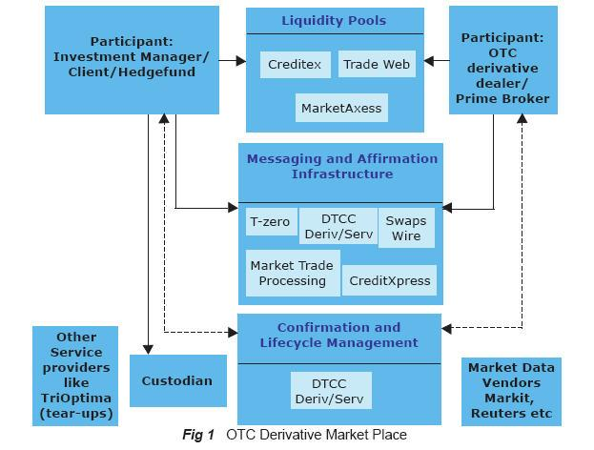Source: Tata Consultancy Services

**Protocols**

FpML stands for Financial Products Markup Language. It is a “data-description” protocol based on XML that is specifically geared towards messages in the financial derivatives markets.

Why even invent a protocol for OTC derivatives? Isn’t this what the FIX protocol was designed for? Well, no. FIX was designed as a protocol between systems for listed securities. FpML was designed in order to "... transcribe the contract terms electronically in a format that supports the complexity and variety of derivative product features.”2 Simply stated, FpML attempts to handle the more complex and non-standardized derivative types.

An example of one of the issues associated with using FIX for an interest rate swap is the fact that each FIX message needs a unique identifier of the underlying security. What is the listed security on an interest rate swap? Or on a commodity? The problem is that there is no standard “CUSIP” or Stock Symbol that will uniquely identify all underlying assets.

What applications use the FpML protocol? Thomson’s TradeWeb application is an on-line marketplace for securities and derivatives, and it uses FpML in order to handle derivatives messaging.

As mentioned before, the derivatives market is getting more and more complex each day. According to the [www.fpml.org](http://www.fpml.org) website, FpML’s future uses include structuring and negotiating the terms of a transaction, executing and confirming the transaction, and communicating settlement details about the transaction.

Consider how the data for a currency swap might be described. What is needed? 2 parties and their identifiers are needed, a type (currency swap), the payment amount for buyer and receiver, the exchange rate, etc. the following picture is a very simple example of what a currency swap between two counterparties might look like using FpML’s data description. This example was taken directly from the “FpML: What it is and Why it is Important” paper published on [www.ideaaliance.org](http://www.ideaaliance.org) website.3

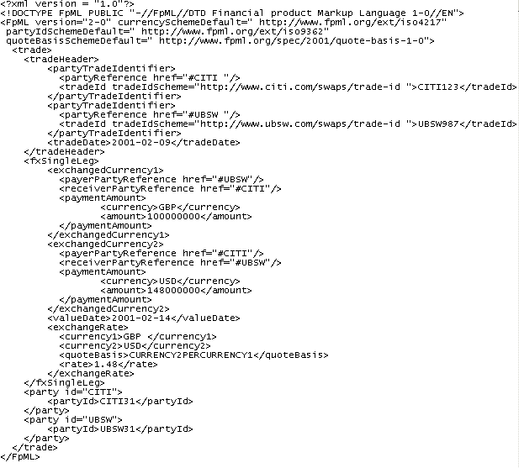

One currency swap is pretty straightforward to describe. However, can’t a currency rate increase or decrease over time? The increasing complexity of derivative instruments makes trade capture relatively difficult to design. An interest rate swap is even more complex. It requires a myriad of data points such as amortization schedules, business day conventions, and most importantly an underlying interest rate variable such as LIBOR. With the floating side changing over time, a trading platform must be linked to a risk platform to ensure mark-to-market analytics can be processed. Each of the various fields becomes overwhelmingly complex to design and utilize.

This paper argues that a protocol was necessary to create data description called FpML in order to handle the complexities of trading that FIX wasn’t designed to do. What is the future of FpML? According to fpml.org’s fact sheet, future uses should include: “structuring and negotiating the terms of a transaction, executing and confirming the transaction, and communicating settlement details about the transaction.”4

FpML.org is not the only organization to think about the future of protocols. Swapsdata’s SwapsGen application has attempted to solve this problem by a seamless interface to all three (SWIFT, FpML, and its own proprietary) protocols to allow for two companies using differing protocols to communicate. Let’s think about how many protocols there are on the market: FIX, FIXML, FpML, SWIFT, MDDL, etc. The list can go on for a while. If there are too many protocols on the market, it negates the concept of having a protocol in the first place.

Although SwapsGen is a reasonable solution to the problem, the adoption of UNIFI – “Universal Financial Industry Message Scheme”, also known as ISO 20022, attempts to go even further than Swapsdata’s efforts. The long-term goal is to have one protocol to handle all financial products. It will combine the efforts of each protocol consortium to provide one universal protocol which will replace FIX, FXML, XBRL, FpML, TWIST, SWIFT, etc.

**Challenges**

Over-the-counter (OTC) derivatives are one of the most flexible and useful tools for financial services companies in managing risk, encouraging capital formation and generally providing ways for investors to enhance returns, if they can overcome the challenges presented by this increased trading volume, including:

* Eliminating manual processing which adds costs and delays by implementing a straight through processing for real time information flows across enterprise boundaries to reduce transaction costs, improve margins, and eliminate rework. This includes flowing trades automatically to payments, confirmations, and accounting systems, without the need for manual intervention and to support computer-to-computer messaging with DTCC for payments matching, and comprehensive real-time MIS on details such as payment-matching, confirmation-matching, and cash breaks. This would also allow Operations to manage the OTC derivatives business without regard to volume growth, allowing them to provide a greater level of control for those trades.
* Generating and tracking documentation for large numbers of highly complex, varied financial products including complex data required to describe derivatives trades
* Automating the communication and confirmation of details of transactions between counterparties to minimize expense and operational risk
* Achieving faster time-to-trade to fully capitalize on lucrative market opportunities
* Integrating information from disparate sources inside and outside the firewall with existing systems including communicating between different processing systems both inside and outside the enterprise
* Overcoming the poor scalability and reliability of the outdated technologies and manual processes commonly used to settle complex trades
* Eliminating operational risk from manual processing errors, deviation from firm guidelines, and the inability to effectively track outstanding confirmations
* Assuring full compliance with regulatory requirements for the auditability of trading operations

**Future ISDA requirement**

The OTC market is the one of the most dynamic and most important securities markets in the world. The volume of deals, including interest rate swaps, currency swaps, and credit default swap, end other exotic derivatives are increasing in volume exponentially. In 2003 the ISDA set forth very high standards in their strategy paper entitled “Going Forward: A Strategic Plan” that essentially lays the foundation for STP and shorter settlement timeframes such as T+0 for vanilla swaps. Since then the players in the market have continued to dialogue on best practices and ways to achieve STP. The Federal Reserve has become involved over the growing concern of outstanding confirms and the backlog of credit default swaps. This has had the effect of expediting the effort to achieve STP.

**Conclusion**

The vendors in the OTC market place are converging and implementing various initiatives that will automate all aspects of the marketplace. DTCC is implementing a Trade Information Warehouse which will store matched records and expand into the cash flow schedule of those records. This forces confirmations and settlements into the same workflow to increase efficiency. Previously confirmations and settlements teams investigated breaks independently, even though the route cause of the problem was often the same.

T-Zero is linking with Deriv/SERV which will electronically capture all trade details and allow same day legal execution. Omgeo is connecting with Deriv/SERV creating a central hub (Omgeo Connect) for communication via messaging standards such as FpML. Swift and the ISDA are addressing the post trade environment promoting SwiftNet and standardizing messaging services. Ultimately, the industry is connecting and converging, applications are becoming increasingly robust, the infrastructure is in place, and the major players are proactively engaged. Straight-through-processing of OTC Swaps has become reality, adoption won’t be far behind.

**Appendix**

**Platforms**

|  |  |  |  |  |
| --- | --- | --- | --- | --- |
| **Name** | **Type** | **Links** | **Protocol** | **Strengths** |
| Creditex | Liquidity Pools | T-Zero --> Deriv/Serv | FpML | Strong European Credit Derivatives player |
| GFI Group | Liquidity Pools | Swapswire;AffirmExpress;Deriv/Serv | FpML | Established innovator in complex instrument markets |
| ICAP | Liquidity Pools | Swapswire;AffirmExpress;Deriv/Serv | FpML | Largest electronic inter-dealer platform |
| MarketAxess | Liquidity Pools | Deriv/Serv | FpML | Strong partnership with Charles River Development |
| Swapstream | Liquidity Pools | Swapswire | Swift | Chicago Mercantile Exchange as owner. Ability to leverage existing clearing functionality |
| TradeWeb | Liquidity Pools | Omgeo, DTCC’s Deriv/SERV; SwapsWire | FIX, XML, FpML | Establish Fixed income leader. Very Strong client and vendor partnerships |
| Tullet Prebon | Liquidity Pools | Affirm Express --> Deriv/Serv | FpML | Strong data and pricing aggregate. |
| Omgeo Connect | Matching | Deriv/Serv | FpML | Multi platform aggregator |
| SwapWire | Matching | Deriv/Serv | FpML | Ability to do give-up trades attracts Hedge Funds. Owned by 21 Major Derivatives Dealers |
| DTCC Deriv/Serv | Clearance/Settlement | Most Liquidity and Matching providers | FpML, Swift | Major Clearance and Settlement Player |
| DTCC Trade Warehouse | Warehouse | Deriv/Serv | n/a | Master list of all transactions |
| T-Zero | Infrastructure | Deriv/Serv | FpML | Provides audit trail |

**Trade Capture**

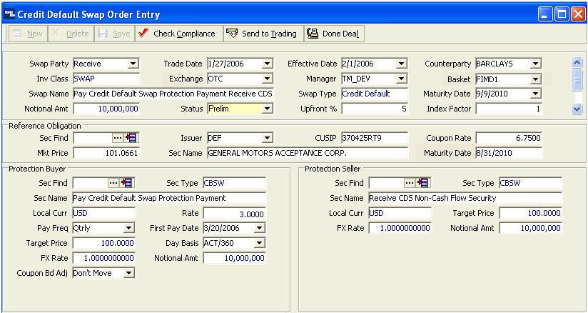

Credit Default Swap Trade Entry

Source: Charles River Investment Management System

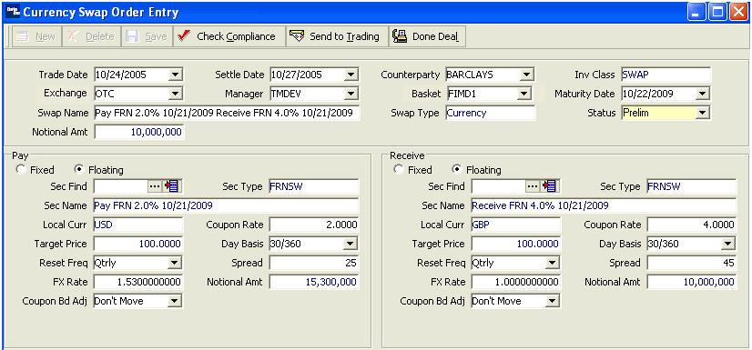

Currency Swap Trade Entry

Source: Charles River Investment Management System

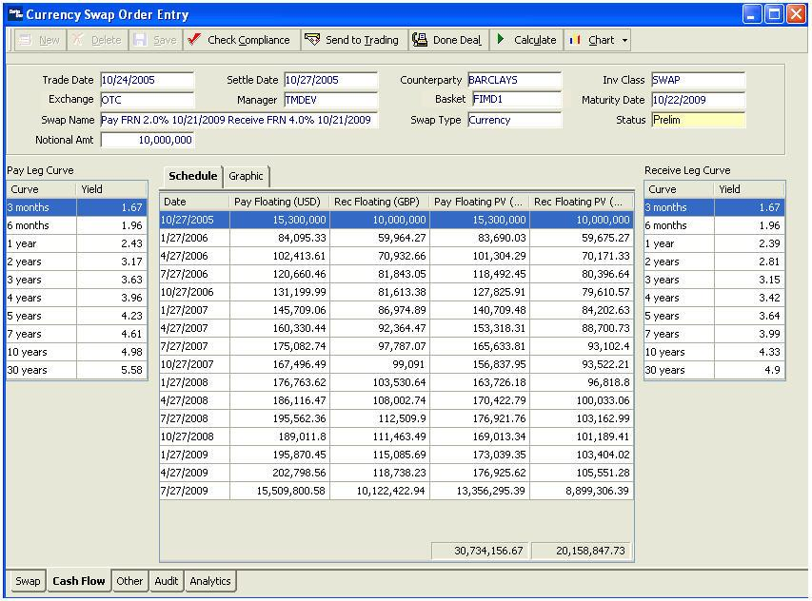

Currency Swap Cash Flows

Source: Charles River Investment Management System

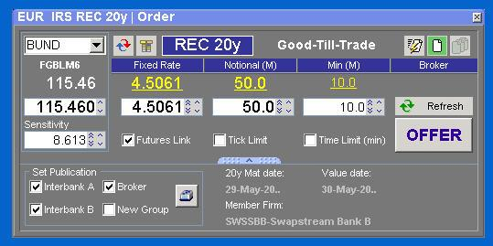

SwapsStream Interest Rate Swap Trade Entry

Source: Swapstream Website

**Order Flows**

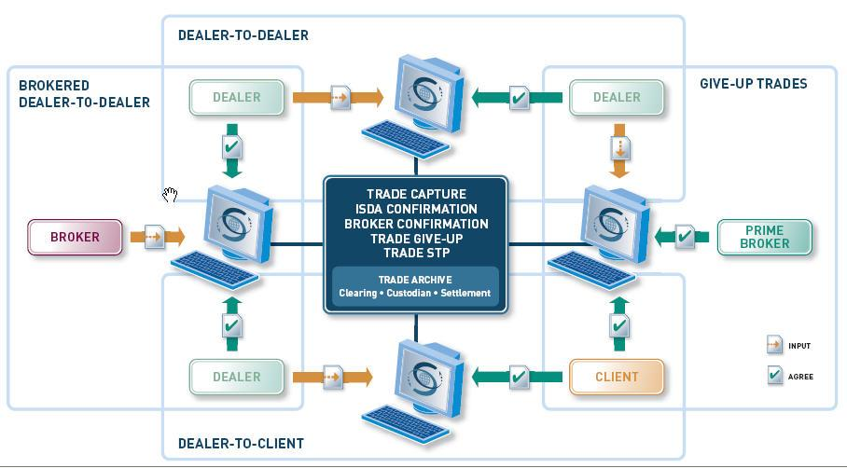

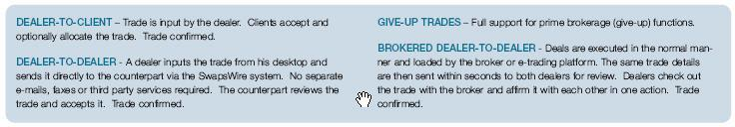

Swapswire Flows

Source: Swapswire Website

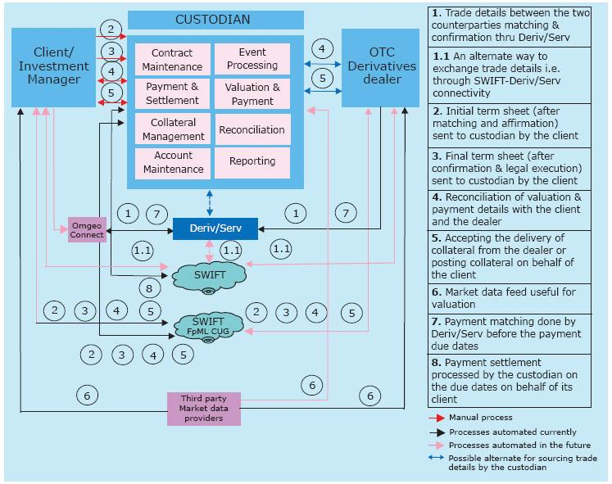

Almost a reality!

Source: Tata Consultancy Services

**Statistics and Growth**

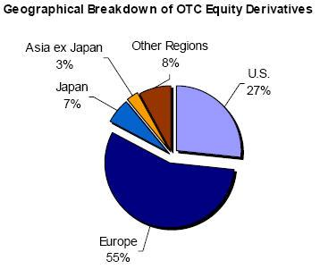

Source: BIS

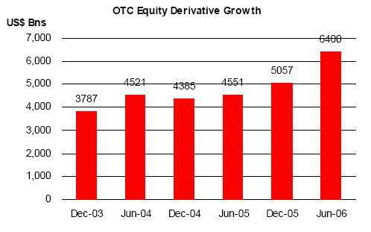

Source: ISDA

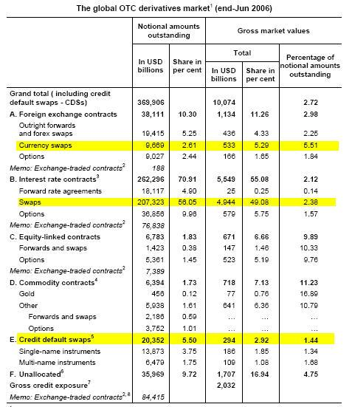

Source: BIS website

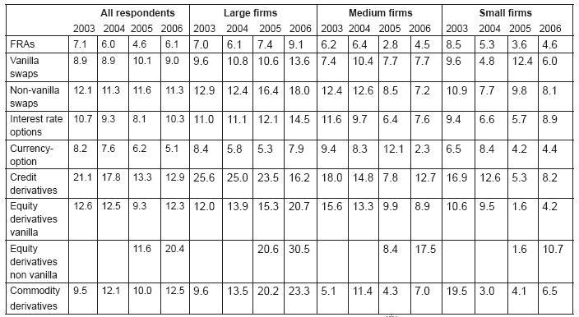

Days Confirmation Outstanding

Source: Tata Consultancy Services

Footnotes:

1 <http://www.isda.org/statistics/recent.html> - ISDA’s 2006 Mid-Year Market Survey

2 Direct quote from fpml.org’s fact sheet at: <http://www.fpml.org/news/factsheet.html>

3 Picture taken from

<http://www.idealliance.org/papers/xml2001/papers/html/04-03-03.html>,

Author Rick Schumacher, Wall Street Systems.

4 Direct quote from fpml.org’s fact sheet at: <http://www.fpml.org/news/factsheet.html>

**Works Cited**

DerivServ, <http://www.dtcc.com/ProductsAndServices/derivserv/DerivSERV.pdf>

Harrell Smith, Swaps: has the time finally come for electronic trading? Building an Edge 24 May 2005 Volume 6, Number 5

<http://www-03.ibm.com/industries/financialservices/doc/content/resource/thought/1596215103.html>

J. Brant Arseneau, Electronic Trading of SWAPS: Are we ready now? Electronic Market Microstructure

July 18, 2006 <http://jbarseneau.wordpress.com/2006/07/18/electronic-trading-of-swaps-are-we-ready-now/>

Interest Rate Swaps – Application to Tax-Exempt Financing

<http://www.orrick.com/fileupload/430.pdf>

Trends in OTC Equity Derivatives

<http://www.dtcc.com/Publications/Trends-in-OTC-Equity-Derivatives.pdf>

New Developments on Clearance and Settlement Arrangement of OTC Derivatives, Bank of International Settlements. March 2007 http://www.bis.org/publ/cpss77.htm

Credit Derivatives In Crisis: Alleviating The Backlog : Bearing Point

[www.idealliance.org/papers/xml2001papers/slides/Gurden/FpMLatSwapsWireFinal.ppt](http://www.idealliance.org/papers/xml2001papers/slides/Gurden/FpMLatSwapsWireFinal.ppt)

<http://www.idealliance.org/papers/xml2001/papers/html/04-03-03.html>

<http://www-03.ibm.com/industries/financialservices/doc/content/resource/thought/1596215103.html>

[www.tcs.com/0_whitepapers/htdocs/Custodian_in_OTC_201206.pdf](http://www.tcs.com/0_whitepapers/htdocs/Custodian_in_OTC_201206.pdf)

<http://jbarseneau.wordpress.com/>

<http://jbarseneau.wordpress.com/2006/07/18/>

<http://www.interwoven.com/solutions/otc_derivatives/index.html>

<http://www.systemwire.com/solutions/mediator_case_study.html>

[www.fisd.net/wfic/2005/presentations/jones.pdf](http://www.fisd.net/wfic/2005/presentations/jones.pdf)

[www.ubs.com/.../news/published_articles?contentId=88280&name=Article_Euromoney](http://www.ubs.com/.../news/published_articles?contentId=88280&name=Article_Euromoney) sept2005.pdf

<http://www.stpinfo.com/stp_journal/sample/issue82/features/feature2.htm>

<http://www.bis.org/publ/cpss27.pdf>

[www.cme.com/files/CME%20Clearing360_FAQ.pdf](http://www.cme.com/files/CME%20Clearing360_FAQ.pdf)

<http://derivserv.dtcc.com/binary/201412005%2002%2028%20DerivSERV%20web%20demo%20v0.2.pdf>

<http://www.fpml.org/news/factsheet.html>

<http://www.ipedo.com/html/solutions_otc_derivatives.html>

<http://www.isda.org/c_and_a/pdf/ISDA-Operations-Survey-2006.pdf>

<http://www.dtcc.com/PressRoom/2006/trade_information_warehouse.html?shell=false>

<http://www.bondmarkets.com/assets/files/2006eCommerceSurveyFinal120606><http://www.isda.org/c_and_a/pdf/ISDA-Operations-Survey-2006.pdf>   
<http://www.bondmarkets.com/assets/files/2006eCommerceSurveyFinal120606.pdf>

An Introduction to Global Financial Markets, 4th Edition by Stephen Valdez.  Published by Palgrave Macmillan, 2003.  Original publication 1993.

When Genius Failed: The Rise and Fall of Long-Term Capital Management, by Roger Lowenstein.  Published by Random House, 2000.

<http://en.wikipedia.org/wiki/Derivative_%28finance%29#OTC_and_exchange-traded>

<http://www.sfe.com.au/content/austraclear/brochures/ir_swaps.pdf>

<http://jbarseneau.wordpress.com/2006/07/18/electronic-trading-of-swaps-are-we-ready-now>

<http://www.thomson.com/content/pr/tf/tf_fixed_income/2005_09_19_TW_Live_US_Dollar_Dem>

<http://www.pearsoned.co.uk/bookshop/detail.asp?item=100000000232371>

<http://www.bobsguide.com/cgi-bin/guide/newsitem.pl?ID=bg&seq=17918&mode=s&m=54875>

<http://www-03.ibm.com/industries/financialservices/doc/content/resource/thought/1596215103.html>

<http://www.swapswire.com/pdfs/overview-diagram.pdf>

<http://www.fpml.org/news/factsheet.html>