Corinna Hartinger

Final Coding Project
Automatic Crystal Detection using Python

Abstract

X-ray crystallography is a method to find out about a protein’s structure, which in turn can be useful to learn about the protein’s properties and functions. Of the many wells set up for the crystallisation process, only very few may contain the necessary crystals of the protein. A quick and simple method to find those wells with the desired crystals is by using automatic image processing. My code, written in Python, processes the images to find contours to evaluate whether a crystal is present in the picture or not. 77% of the images were correctly classified as containing crystals or containing no crystals. The program additionally offers an easy setup for a human to manually classify the remaining, unclassified images.

Introduction

Finding the structure of a protein can offer scientists valuable insights into the protein’s function. Diffraction patterns, generated by firing X-rays at crystallised proteins, are a useful method to elucidate the protein structure. Producing the crystals, however, can be a laborious task, which may necessitate trying many different combinations of conditions (such as pH, temperature, protein concentration etc.)(McPherson and Gavira, 2013). Of the many wells of a plate filled with crystallisation solution, only very few may yield crystals. It is therefore desirable to have a quick and simple method to detect which of the wells contain a crystal which can be used for crystallography. Robots can be set to automatically acquire images of each well.
The Python programming language, including its many libraries, offers sufficient tools to process and analyse images. Here, I show how a program may apply these tools to draw contours around objects in an image, which will ultimately be used to determine whether a crystal is present.

I chose this project as many research projects in biology will require taking myriads of pictures and analysing them. Being able to write a script for automatic image analysis allows the users to quickly sort images according to specified properties whilst avoiding biases brought in by humans during manual processing.

Methods

I used Python 3 to write a code that can be executed from the Linux terminal. The code was tested using 18 example images (.jpg format) of single protein crystallisation wells.

The code was designed to first make a list of all the .jpg files contained in a folder specified by the user, either on the command line or as input after a prompt. Using this list the code then iterates through the images to process them one after the other and the output will be three lists containing the appropriate image names based on whether they were classified to have crystals, have no crystals or they could not be determined and should be analysed by a human.

Automatic image processing

A visual description of the sequence of steps for image processing by this code is shown in Fig.1.

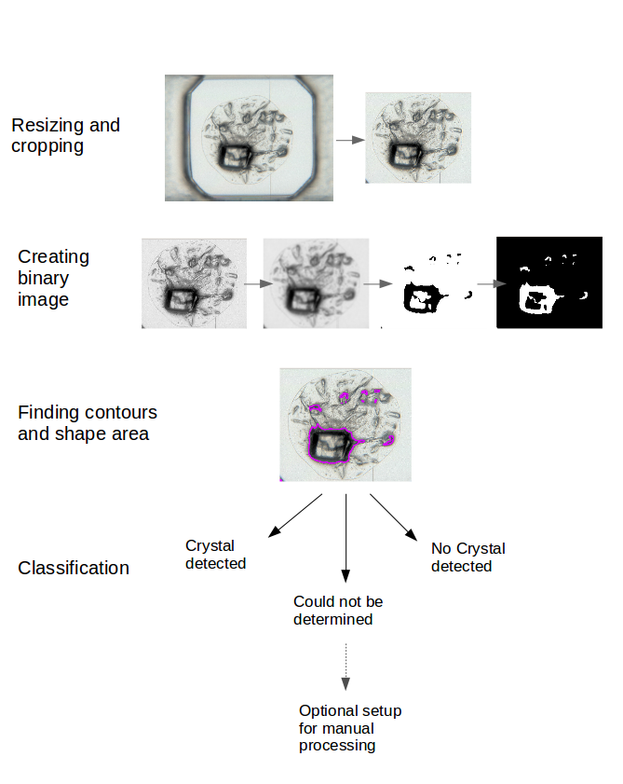
Figure 1: Steps in image processing to detect contours of objects

Firstly, the image is resized to 512x384pixels to fit on the users screen. To remove the edges of the wells, a portion from the middle of the image is cropped.

Next, the cropped image is passed to a function to convert the image to grayscale and apply Gaussian Blur, which removes noise. The resulting image is then converted to a binary image, which means that pixels will be turned either black or white depending on a specified threshold value. This binary image is then inverted.

Using the processed image, the program finds contours to fit around each shape in the image. The area for every shape is calculated. Because bubbles or darker areas in the image may also be recognised as shapes, I used the area of the largest shape to decide whether the image contains a crystal or not by applying certain sizes - determined by testing - as cutoffs. There is also a range of sizes in which the image will be classified as potentially containing a crystal, which should be checked manually by a human.

As the code iterates through the images, their names will be added to one of three lists: Crystals_detected, No_crystals detected or Check_for_crystals. Each outcome is printed to the terminal and a summary of the results is given at the end (Fig.2).

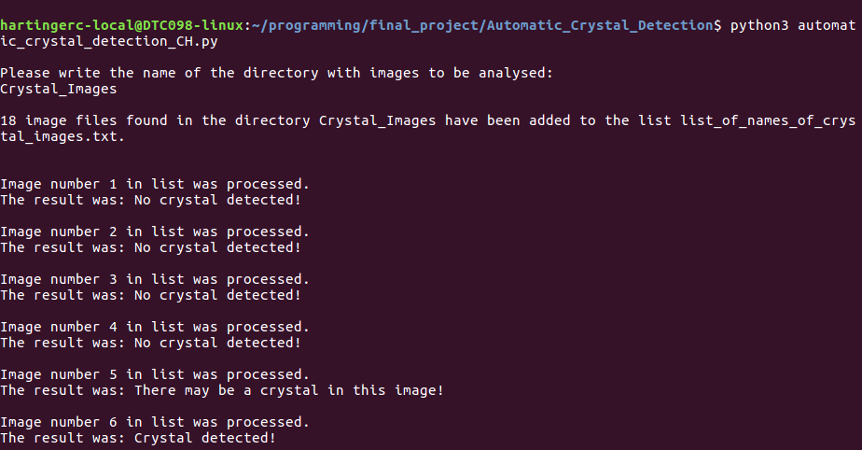
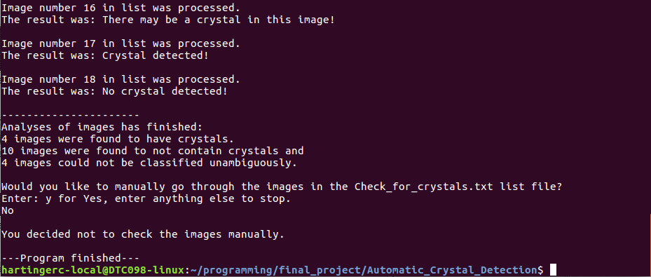
Figure 2: Automatic processing of images

Manual processing of ambiguous images

If there are images that could not be classified unambiguously, the user will be asked whether they would like to go through those images manually to classify them (Fig.3). If the user confirms, the images from the Check_for_crystals list will be displayed one after the other and by pressing the ‘y’ or the ‘n’ key, the user decides to add these image names to either the Manually_crystals_detected or Manually_no_crystals_detected list.

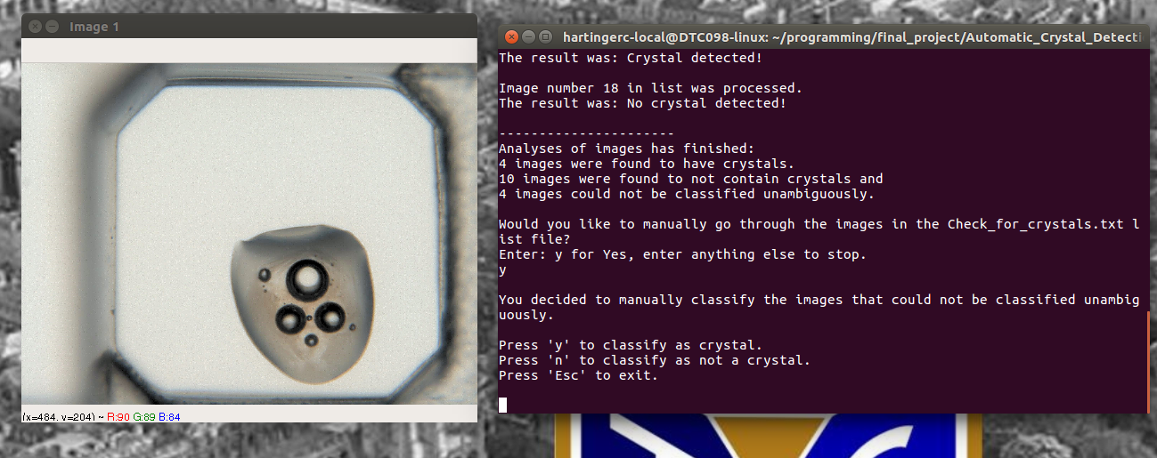
Figure 3: Presenting user with ambiguous image for manual processing
Results

Out of the 18 example images of protein crystallisation wells provided, seven showed large, approximately rectangular crystals. Some of the images contained bubbles.
Using the code, the 18 example images provided were processed and classified within 1.2 seconds.
Four of these were correctly classified to contain crystals and ten were correctly classified as not containing crystals. Four images could not be classified unambiguouly, of which three contained crystals and one contained large bubbles.
Therefore 77% of the images were automatically correctly classified as either positives or negatives. The unclassified images are presented in Fig.4. For all three crystals in this category, the program failed to classify the whole crystal as a single object. For the image containing bubbles, the detected object extend beyond the bubble into an area with a dark shade.

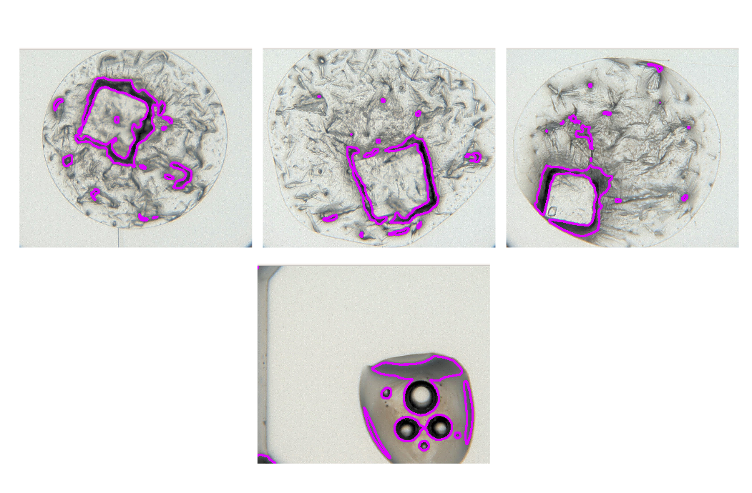
Figure 4: Examples of contours failing to surround the objects correctly

Discussion

As the majority of images was automatically classified correctly, the code can save the user a lot of time by finding which wells actually contain the desired protein crystals for further analysis by X-ray crystallography.
However, some images which contain crystals could not be classified as such with certainty. In this program, the same value for thresholding is applied to all images, which can result in some crystals with lighter outlines to not be perceived as a single shape. On top of that, some empty areas in the images will have contours drawn around them if they are dark enough. It would therefore be desirable to have additional or modified object detection mechanisms or classification mechanisms, which we sadly enough did not have the time to implement.

At present, the output of the program are text files, which the user can use to select the correct images for further processing or discarding by iterating through the lines and extracting the file name. Another useful feature to add on to the code would be to sort the images into different folders according to their classification or if the positions of the wells in a plate with usable crystals could be listed instead of image names.

The code was useful for the example images supplied but in a different facility the images taken of each well may be of a different size, brightness or may display multiple wells in one image. Adding image processing that recognises the wells and is able to apply the object detection only to the insides of the wells would make the code more broadly useful to users with images of different properties.

References

McPherson, A. and Gavira, J. (2013). Introduction to protein crystallization. Acta Crystallographica Section F Structural Biology Communications, 70(1), pp.2-20.

Appendix

For the code for automatic crystal detection, see the file hartinger-programming-2019-CODE.py.

