Step 1 – Select the test project for your group

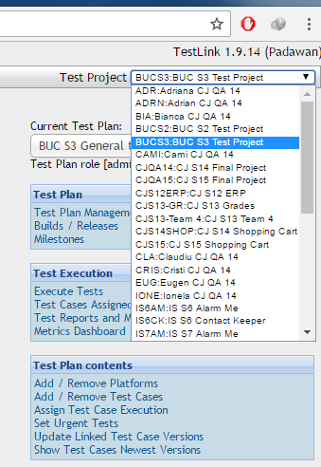

(Optional) From Test Plan -> Test plan management create a test plan for you (only once), otherwise use the general test project available. Mark test plan as active (light bulb) and from main page select your project in the “Current test plan”

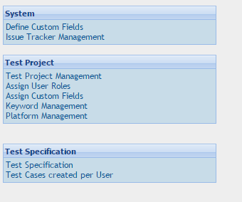

From test specification -> select first option (test specification)

Create a test suite from the cog icon under the test project area and then on the + green sign:

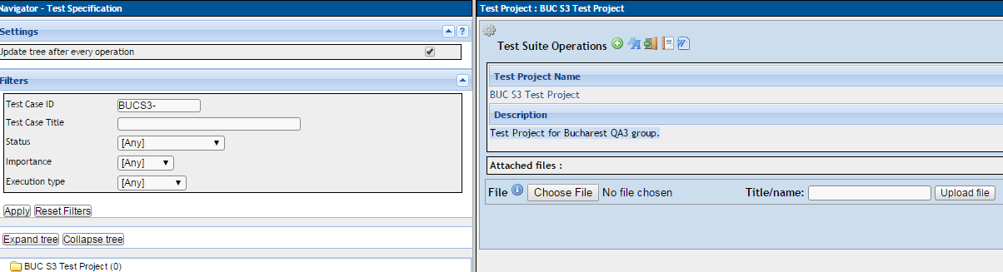

The test suite name can be your name.

(Optional) You can create a sub-suite under the suite (with your name) which can be an area of the product

To create test cases, select from the left the suite or sub-suite and on the same cog icon the the right select the + green icon from Test cases operations.

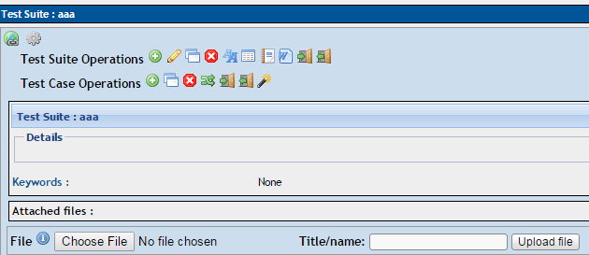

Complete the test case title, summary and pre-conditions (things that are needed before starting the test):

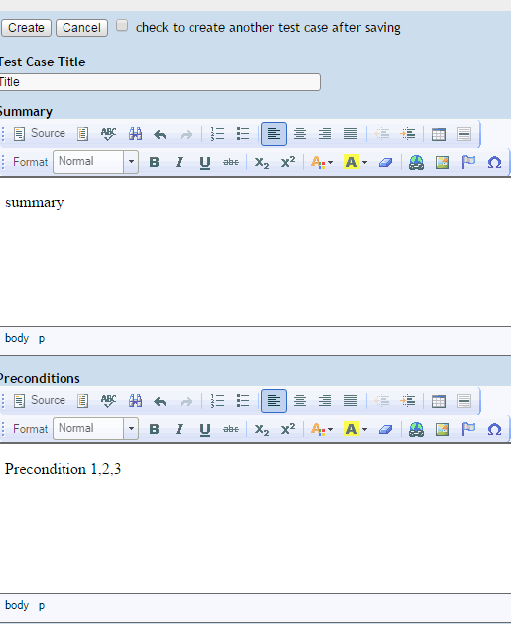

Then add steps for the test case:

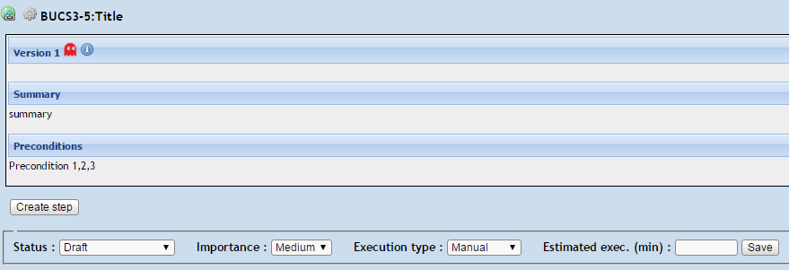

Add as many steps are required and for each of them add expected results.