Black and White Life Expectancy Differences in 4 US States, 1969-2013

Below is the code for the paper entitled “Black and White Life Expectancy Differences in 4 US States, 1969-2013”. The analysis for this paper builds on the analysis from our previous paper that is described in this repository. To conduct these analysis, we import and manipulate tables of results from the previous paper and web application.

Load the libraries and a set of functions created by C Riddell:

Load the results’ tables from the previous paper and tidy these data for analysis/visualization:

Load mortality tables for the states of interest:

Take a look at population counts for these states, and the proportion of missing data:

Previously, the age groups were coded using 5-year age bands. We collapse this to wider bands as follows:

The following code prepares the data for plotting.

Here is the code to create the first figure:

**Figure 1: Black-white life expectancy gap in four US states, by gender 1969-2013**

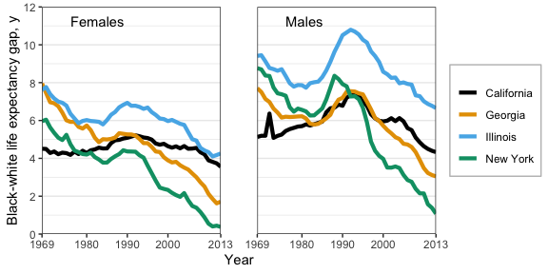

Some code to prepare to create Figure 2:

**Figure 2: Contribution of age and cause categories to the black-white life expectancy gap in women, 1969-2013**

##   
## <1 year ≥ 85 years 1-19 years 20-39 years 40-64 years 65-84 years   
## 21600 21600 86400 86400 108000 86400

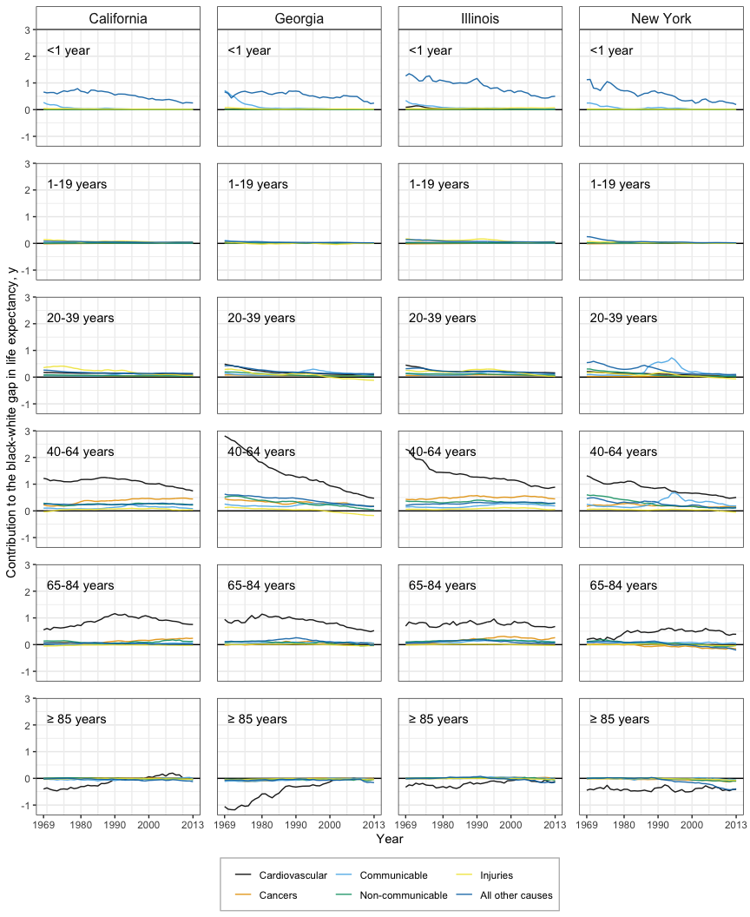

**Figure 3: Contribution of age and cause categories to the black-white life expectancy gap in men, 1969-2013**

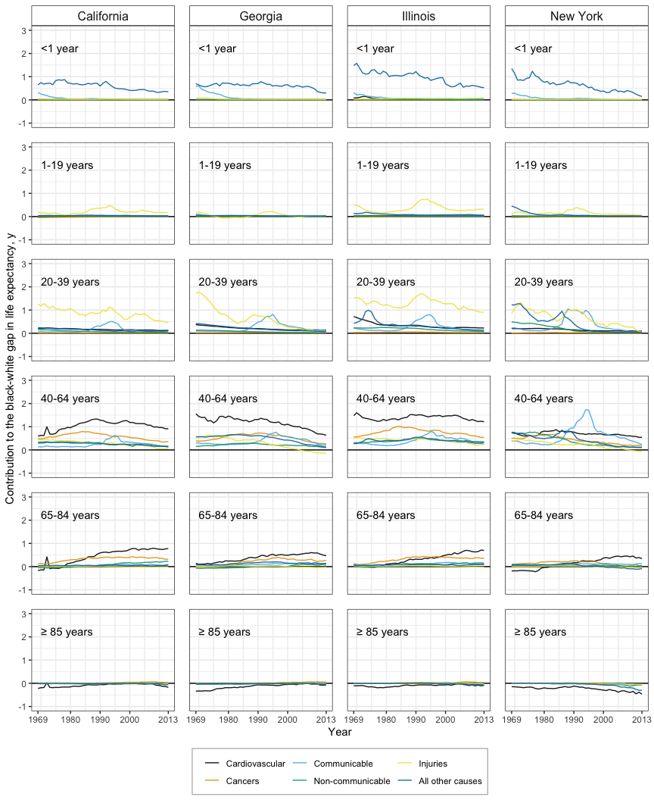

Save the first three figures.

Code to create Figure 4:

**Figure 4: …**

*left panel*

dat.2013 <- BlackWhite_results %>% filter(year == 2013 & state %in% c(included_states))  
  
LE.2013 <- ggplot(dat.2013, aes(x = LE_white_mean, y = state)) +   
 facet_wrap(~sex, nrow = 2) +  
 geom_segment(aes(xend = LE_black_mean, yend = state)) +  
 geom_point(aes(col = "white")) +  
 geom_point(aes(x = LE_black_mean, col = "black")) +  
 scale_color_manual(values = c('#a6cee3','#1f78b4'), labels = c("Black", "White")) +   
 geom_text(aes(label = round(LE_white_mean, 1)), nudge_y = 0.25, size = 4) +   
 geom_text(aes(label = round(LE_black_mean, 1), x = LE_black_mean), nudge_y = -0.25, size = 4) +  
 theme_minimal(base_size = 15) + xlab("") + ylab("") +  
 theme(legend.position = c(0.9, 0.15), panel.grid.minor = element_blank(),  
 legend.title = element_blank(),  
 legend.background = element_rect(colour = 'grey', fill = 'white', linetype='solid')) +  
 ggtitle("(A) Gap in life expectancy, y") +  
 scale_x_continuous(breaks = seq(71, 83, 2), labels = seq(71, 83, 2)) +   
 scale_y_discrete(limits = c("New York", "Illinois", "Georgia","California"))

*right panel*

cod.2013 <- cod_decomp_results %>% filter(year == 2013 & state %in% c(included_states)) %>%  
 select(-X.1, -X.2, -X.3, -X.4, -Census_Region, -Census_Division, -X)  
  
cod.graph <- ggplot(data = cod.2013,  
 aes(x=state, y = COD_cont_yrs_mean, fill = COD)) +  
 geom_bar(stat = "identity", col = "white", width = 0.5) +   
 coord_flip() +  
 theme_minimal(base_size = 15) + #guides(fill=FALSE) +   
 geom_hline(yintercept = 0, col = "black") +  
 theme(legend.title = element_blank(), #legend.position = "bottom",  
 panel.background = element_rect(fill = "transparent", colour = NA),   
 plot.background = element_rect(fill = "transparent", colour = NA),  
 #legend.background = element_rect(fill = "transparent", colour = NA),   
 panel.grid.minor = element_blank(),  
 legend.background = element_rect(colour = 'grey', fill = 'white', linetype='solid')) +  
 ylab("") +  
 xlab("") +  
 scale_y_continuous(breaks = c(-0.5, 0:7), labels = c(-0.5, 0:7)) +  
 scale_fill_colorblind() +  
 facet_wrap(~sex, nrow = 2) +  
 ggtitle("(B) Cause-of-death contributions to the gap in life expectancy, y") +   
 scale_x_discrete(limits = c("New York", "Illinois", "Georgia","California"))  
  
figure4 <- grid.arrange(LE.2013, cod.graph, ncol=1)

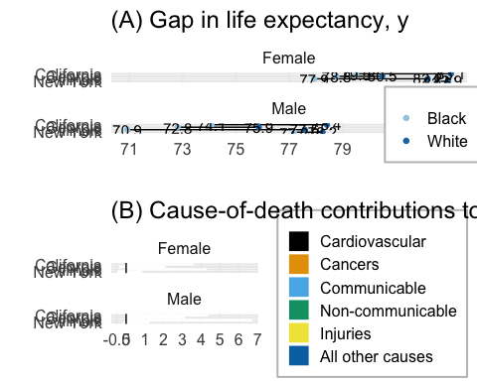

ggsave(filename = here("Manuscript2", "Images", "figure4.jpeg"),   
 plot = figure4, device = "jpeg", width = 8.5, height = 9, units = "in", dpi = 1200)

**Men**

**Women**

**Figure 5: second option: men**

temp <- data.frame(subset(cod_decomp_results, sex == "Male" &   
 year == 2013 & state %in% c("California", "Georgia", "Illinois", "New York")))  
 temp["state.reorder2"] <- reorder(temp$state, temp$LE_black_mean, max, na.rm = T)  
 temp["state.reorder2.n"] <- as.numeric(temp[["state.reorder2"]])  
   
ggplot(temp, aes(x = new.start, y = state.reorder2.n)) +   
 geom_rect(aes(xmin = new.start,   
 ymin = state.reorder2.n - 0.44,   
 ymax = state.reorder2.n + 0.44,   
 xmax = new.finish, fill = COD)) +  
 geom_segment(aes(x = LE_black_mean,   
 xend = LE_white_mean,   
 y = state.reorder2.n,   
 yend = state.reorder2.n), lwd = 1) +   
 scale_y_continuous(breaks = 1:length(levels(factor(temp$state.reorder2))),   
 labels = levels(factor(temp$state.reorder2))) +  
 theme_minimal() + xlab(" ") +   
 theme(legend.title = element_blank(),  
 panel.background = element_rect(fill = "transparent", colour = NA),   
 plot.background = element_rect(fill = "transparent", colour = NA),  
 legend.background = element_rect(fill = "transparent", colour = NA)) +  
 geom_segment(aes(x = LE_white_mean,   
 xend = LE_white_mean,   
 y = state.reorder2.n - 0.46,   
 yend = state.reorder2.n + 0.46), lwd = 1) +  
 geom_segment(aes(x = LE_black_mean,   
 xend = LE_black_mean,   
 y = state.reorder2.n - 0.46,   
 yend = state.reorder2.n + 0.46), lty = 3, lwd = 1) +  
 ylab("") + xlab("Life expectancy (years)")

## Warning: Removed 20 rows containing missing values (geom_segment).  
  
## Warning: Removed 20 rows containing missing values (geom_segment).  
  
## Warning: Removed 20 rows containing missing values (geom_segment).

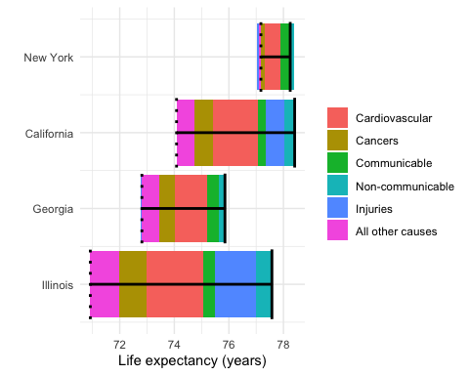

**Figure 5: second option: women**

temp <- data.frame(subset(cod_decomp_results, sex == "Female" &   
 year == 2013 & state %in% c("California", "Georgia", "Illinois", "New York")))  
temp["state.reorder2"] <- reorder(temp$state, temp$LE_black_mean, max, na.rm = T)  
temp["state.reorder2.n"] <- as.numeric(temp[["state.reorder2"]])  
  
ggplot(temp, aes(x = new.start, y = state.reorder2.n)) +   
 geom_rect(aes(xmin = new.start,   
 ymin = state.reorder2.n - 0.44,   
 ymax = state.reorder2.n + 0.44,   
 xmax = new.finish, fill = COD)) +  
 geom_segment(aes(x = LE_black_mean,   
 xend = LE_white_mean,   
 y = state.reorder2.n,   
 yend = state.reorder2.n), lwd = 1) +   
 scale_y_continuous(breaks = 1:length(levels(factor(temp$state.reorder2))),   
 labels = levels(factor(temp$state.reorder2))) +  
 theme_minimal() + xlab(" ") +   
 theme(legend.title = element_blank(),  
 panel.background = element_rect(fill = "transparent", colour = NA),   
 plot.background = element_rect(fill = "transparent", colour = NA),  
 legend.background = element_rect(fill = "transparent", colour = NA)) +  
 geom_segment(aes(x = LE_white_mean,   
 xend = LE_white_mean,   
 y = state.reorder2.n - 0.46,   
 yend = state.reorder2.n + 0.46), lwd = 1) +  
 geom_segment(aes(x = LE_black_mean,   
 xend = LE_black_mean,   
 y = state.reorder2.n - 0.46,   
 yend = state.reorder2.n + 0.46), lty = 3, lwd = 1) +  
 ylab("") + xlab("Life expectancy (years)")

## Warning: Removed 20 rows containing missing values (geom_segment).  
  
## Warning: Removed 20 rows containing missing values (geom_segment).  
  
## Warning: Removed 20 rows containing missing values (geom_segment).

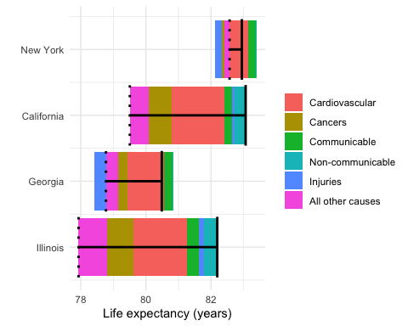

# Appendix 1: Trends in age-specific mortality rate by sex, race, and cause of death

**Figure S15: Population sizes**

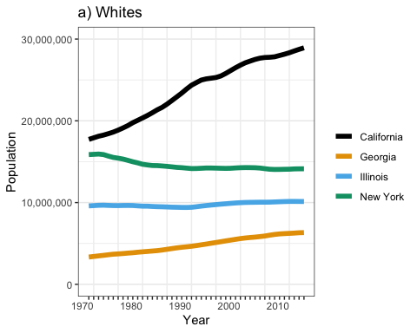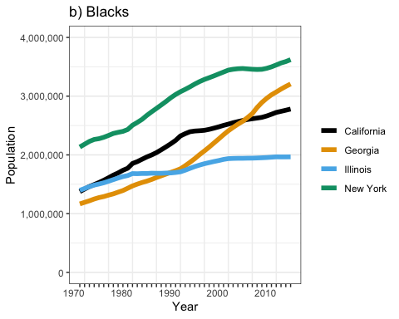

**Figure S1: Age-specific trends in CVD-related mortality in black and white men, 20 years and older, 1969-2013**

**Figure S2: Age-specific trends in CVD-related mortality in black and white women, 20 years and older, 1969-2013**

Not shown: <1 year olds, and 1-19 year olds, because very few deaths in those age bands. Note that there appears to be a measurement error in the data for Illinois in 1972 and 1973 for both males and females showing a much higher rate of death.

**Figure S3: Age-specific trends in cancer-related mortality in black and white men, 20 years and older, 1969-2013**

**Figure S4: Age-specific trends in cancer-related mortality in black and white women, 20 years and older, 1969-2013**

**Figure S5: Age-specific trends in mortality due to non communicable disease in black and white men, 20 years and older, 1969-2013**

**Figure S6: Age-specific trends in mortality due to non communicable disease in black and white women, 20 years and older, 1969-2013**

**Figure S7: Age-specific trends in injury-related mortality in black and white men, all age groups, 1969-2013**

**Figure S8: Age-specific trends in injury-related mortality in black and white women, all age groups, 1969-2013**

**Figure S9: Age-specific trends in communicable-related mortality in black and white men, all age groups, 1969-2013**

**Figure S10: Age-specific trends in communicable-related mortality in black and white women, all age groups, 1969-2013**

**Figure S11: Age-specific trends in mortality due to all other causes in black and white men, all age groups, 1969-2013**

**Figure S12: Age-specific trends in mortality due to all other causes in black and white women, all age groups, 1969-2013**

# women  
ggsave(filename = here("Manuscript2", "supp_figures", "other_female.jpeg"),   
 plot = other_female, device = "jpeg", width = 7, height = 8, units = "in")  
ggsave(filename = here("Manuscript2", "supp_figures", "cvd_female.jpeg"),   
 plot = cvd_females, device = "jpeg", width = 7, height = 6, units = "in")  
ggsave(filename = here("Manuscript2", "supp_figures", "cancer_female.jpeg"),   
 plot = cancer_females, device = "jpeg", width = 7, height = 6, units = "in")  
ggsave(filename = here("Manuscript2", "supp_figures", "nc_female.jpeg"),   
 plot = nc_males, device = "jpeg", width = 7, height = 6, units = "in")  
ggsave(filename = here("Manuscript2", "supp_figures", "comm_female.jpeg"),   
 plot = comm_female, device = "jpeg", width = 7, height = 8, units = "in")  
ggsave(filename = here("Manuscript2", "supp_figures", "inj_female.jpeg"),   
 plot = inj_females, device = "jpeg", width = 7, height = 8, units = "in")  
  
# men  
ggsave(filename = here("Manuscript2", "supp_figures", "other_male.jpeg"),  
 plot = other_male, device = "jpeg", width = 7, height = 8, units = "in")  
ggsave(filename = here("Manuscript2", "supp_figures", "cvd_male.jpeg"),   
 plot = cvd_males, device = "jpeg", width = 7, height = 6, units = "in")  
ggsave(filename = here("Manuscript2", "supp_figures", "cancer_male.jpeg"),   
 plot = cancer_males, device = "jpeg", width = 7, height = 6, units = "in")  
ggsave(filename = here("Manuscript2", "supp_figures", "nc_male.jpeg"),   
 plot = nc_males, device = "jpeg", width = 7, height = 6, units = "in")  
ggsave(filename = here("Manuscript2", "supp_figures", "comm_male.jpeg"),   
 plot = comm_males, device = "jpeg", width = 7, height = 8, units = "in")  
ggsave(filename = here("Manuscript2", "supp_figures", "inj_male.jpeg"),   
 plot = injury_males, device = "jpeg", width = 7, height = 8, units = "in")