Using change in a seat belt law to study racially-biased policing in South Carolina

Corinne A. Riddell, PhD1

Jay S. Kaufman, PhD2

Jacqueline M. Torres, PhD3

Sam Harper, PhD2

1. Department of Epidemiology & Biostatistics, School of Public Health, UC Berkeley, 2121 Berkeley Way West, Berkeley, CA 94704, United States
2. Department of Epidemiology, Biostatistics & Occupational Health, McGill University, 1020 Pine Avenue West, Room 27, Montreal, QC H3A 1A2, Canada.
3. Department of Epidemiology & Biostatistics, UC San Francisco, 550 16th Street, San Francisco, CA 94143, USA.

Address correspondence to: Corinne Riddell, PhD, Department of Epidemiology & Biostatistics, School of Public Health, University of California, Berkeley, 2121 Berkeley Way West, Room 5404, Berkeley, CA 94704, United States. Email: [corinne.riddell@berkeley.edu](mailto:corinne.riddell@berkeley.edu). Phone: +1-510-642-4618

Manuscript word count: 3362

Abstract word count: 247

##### page break

## Abstract

Seat belt laws have increased seat belt use in the US and contributed to reduced fatalities and injuries. However, these policies provide the potential for increased discrimination. The objective of this study is to determine whether a change in seat belt use enforcement led to a differential change in the number of stops, arrests, and searches to White, Black and Hispanic drivers in one US state. We used data on 1,091,424 traffic stops conducted by state troopers in South Carolina in 2005 and 2006 to examine how the change from secondary to primary enforcement of seat belt use in December 2005 affected the number of stops, arrests, and searches to White, Black, and Hispanic drivers using quasi-Poisson and logistic regressions. We found that the policy change led to a 50% increase in the number of non-speeding stops for White drivers, and that this increase was 5% larger among Black drivers [RR (95% CI) = 1.05 (1.00, 1.10)], but not larger among Hispanic drivers [1.00 (0.93, 1.08)]. The policy change decreased arrests and searches among non-speeding stops, with larger decreases for Black vs. White drivers [RR searches = 0.86 (0.81, 0.91) and RR arrests = 0.90 (0.85, 0.96)]. For Hispanic drivers, effects of the policy change were also found among stops for speeding, which failed the falsification test and suggested that other changes likely affected this group. These findings may support the hypothesis of differential enforcement of seat belt policy in South Carolina for Black and White drivers.

##### pb

##### page break

## Introduction

Increasing seat belt use has been a key mechanism for improving the safety of motor vehicle drivers and passengers, and has contributed to a profound reduction in deaths from motor vehicle crashes in the United States.1 Currently, seat belt use is nearly 90%, with 34 states and DC having primary enforcement of seat belt laws, and 15 states having secondary enforcement; only New Hampshire does not enforce seat belt use among adults.2 Under primary enforcement, a driver can be pulled over and ticketed for this violation if anyone in a front seat—or in any seat in some states—is not wearing a seat belt.3 Under secondary enforcement, failure to use a seat belt can only result in a charge after another traffic violation has been committed.3 As seat belt use has plateaued at high levels, there is evidence that recent policy upgrades from secondary to primary enforcement have had considerably weaker impacts on motor vehicle accident mortality.4,5

Despite their potential for reducing traffic crash deaths, there is concern that primary enforcement laws may lead to racial profiling,6 whereby minorities are at increased risk of interrogation, arrest, and search because of their perceived race and ethnicity.7 In this context, the ability to pull over drivers in the absence of a moving violation (e.g. speeding) may increase the likelihood of police harassment of minority drivers. Officers and state troopers may have lower thresholds for pulling over Black and Hispanic drivers compared to White drivers, without necessarily being conscious of bias. Moreover, under primary enforcement, observed violations of seat belt laws may be used to pull a driver over and then conduct a search or make an arrest that would not have occurred under secondary enforcement. At worst, such policies may endanger historically marginalized groups. The fatal police shooting of Philando Castile in Minnesota after he was pulled over for a broken tail light is one example of the potentially grave repercussions of minor traffic infractions that need to be considered when assessing the overall effects of these policies on health and discrimination.

Previous studies examining discrimination in the enforcement of motor vehicle laws have found that Black drivers are stopped, ticketed, searched, and arrested more frequently than White drivers.7-9 The largest study found that Hispanic drivers were stopped less frequently than White drivers; however, once stopped, Hispanic drivers were more likely to be ticketed, searched, and arrested.9 One the other hand, a report by the National Highway Traffic Safety Commission analyzed data from four U.S. states and found that the proportion of seat belt citations to minorities in the two years preceding primary enforcement was similar to the proportion after the policy change.6 However the report did not examine whether the change differentially affected the number of stops, arrests, or searches to individuals of different races and ethnicities.

Evaluation of the impact of primary enforcement upgrades on discriminatory police practices has been hampered by the absence of comprehensive and reliable data on traffic stops by race/ethnicity. The recent publication of the Stanford Open Policing Project data provides a unique opportunity to evaluate more recent primary enforcement upgrades.9

On December 9th, 2005, South Carolina upgraded its seat belt law from secondary to primary enforcement.10 The first objective of this study is to determine whether the change in enforcement led to a greater increase in the number of stops among Black and Hispanic drivers compared to White drivers. The second objective is to estimate how the change to seat belt policy affected search and arrest rates. We hypothesized that overall stops increased in the state after the change, and that the magnitude of the increase was higher for Black and Hispanic drivers. Given an expected increase in the number of stops, we hypothesized that the search and arrest rates would decrease overall after the policy change. We were interested in estimating whether the change in search and arrest rates varied by race and ethnicity, as differential impacts may indicate that stops for seat belt enforcement served as a premise for racially motivated arrests and/or searches.

## Methods

### The Stanford Open Policing Project

The Stanford Open Policing Project includes data on more than 136 million state patrol stops from 32 states.9,11 The time period of data availability varies by state, with data representing a variable number of years between 1996 and 2018. These data were assembled by Stanford University through public record requests to state law enforcement agencies. These agencies maintained electronic traffic stop records, with data on driver and officer demographics, and stop details. There were 8,440,934 stops im South Carolina between 2005 and 2016.11 We used data on the date of the traffic stop, driver race/ethnicity (Black, Hispanic, or White), driver age (in years), driver gender (male or female), stop outcome (citation, warning, or arrest), and stop purpose (“radar triggered” or “violation observed”). “Radar triggered” stops are for breaking the speed limit, and “violation observed” stops included seat belt violations, failing to stop at a red light, etc. The dataset also contained information on whether the stop led to a search of the vehicle, whether the stop resulted in an arrest or felony arrest, and the police department of the officer making the stop.

### Inclusion criteria

Given prior work indicating that the effects of primary enforcement upgrades on seat belt use have little delay,12 we limited the time frame to 2005-2006– approximately one calendar year before and after the law change. To be included in the analytic dataset, drivers had to be identified in the dataset as Black, Hispanic, or White, and the stop had to be conducted by the South Carolina Highway Patrol as opposed to the limited number of stops made by either the Bureau of Protective Services, the State Transport Police, or with missing department information.

### Identification strategy

Our primary interest is in the contrast between the observed outcome rates after the upgrade to primary enforcement and the counterfactual rates had South Carolina not upgraded their law. We rely on an identification strategy that treats the precise timing of South Carolina’s policy change as an exogenous source of variation in traffic stops. We used quasi-Poisson regression to estimate whether the policy change led to a disproportionate increase in the daily number of stops among Hispanic and Black drivers compared with White drivers. This model includes an indicator term for before/after the policy change (), indicators for Black and Hispanic race/ethnicity (), and product terms between the policy and race variables (). This model also included binary indicators for day of the week (), month (), and holidays (), to absorb variation in the time series related to increased risk of experiencing traffic stops associated with those factors independently of the policy change. To account for overdispersion, the quasi-Poisson model lets the variance of the number of stops be a linear function of the mean.13 The full model is:

We did not include a population denominator offset because it is impossible to enumerate the denominator population of persons actively driving (or person-miles driven) in South Carolina by race. Vehicles stopped may be from out of state, so there is no well-defined population at risk. Because we focus on changes in stops induced by the policy shift, we reduce bias from the lack of denominators.14 This invokes the plausible assumption that unknown denominators were roughly constant during 2005-2006 rather than discontinuous around December 2005.

We used logistic regression to estimate the differential effect of the policy change on the risk of arrest for Black and Hispanic drivers vs. White drivers, conditional on being stopped. Because this model is at the individual-level and the risk of being arrested or searched is higher among young men, we expanded the list of covariates from the previous model to include categorical gender and a restricted cubic spline for age with internal knots by decade between ages 20 and 60 years. The full model for the risk of arrest can be written as:

Here, represents the resticted cubic spline for age.

A similar model was employed for search rate and used to estimate whether the change in policy was associated with an additional proportional increase in the search rate for Hispanic and Black. For the arrest and search models, the data set contains one row of data for each traffic stop, while the quasi-Poisson model for the daily number of stops had one row of data for each race-day combination.

### Marginal standardization

To calculate whether Black and Hispanic drivers experienced disproportionately more stops, arrests and searches, we calculated relative risks using marginal standardization.15 We used the percentile bootstrap method to estimate 95% confidence intervals for the relative risks based on 1,000 bootstrap replicates.

### Falsification test

All models were run within strata of stops that were coded as being for “Violations oberserved” or “Radar triggered” (speeding). The enactment of the seat belt policy change should not lead to a change in the number of people pulled over for speeding, since the number of speeders is expected to be the same directly before and after the policy change.16 Any change in the number of stops for speeding (overall, or differentially by race/ethnicity) could imply the presence of a factor other than the seat belt policy change leading to more stops. We therefore used stops for speeding as a falsification test for our identification strategy.

Analyses were conducted using R 3.5.3.17 The code to reproduce the analyses is contained in an online repository on the lead author’s GitHub: <https://github.com/corinne-riddell/SCTrafficStops>. This study did not require institutional review because it is considered repository research of deidentified information.18

## Results

### Descriptive Statistics

There were 1,189,328 traffic stops in South Carolina during 2005-2006 included in the Stanford Open Policing Project dataset. We excluded 12,949 (1.1%) of individuals with missing or “other” race/ethnicity and 80,325 (6.8%) stops conducted by officers from departments other than the highway patrol. This included 1,614 stops conducted by the Bureau of Protective Services, 78,613 stops by the State Transport Police and 98 stops with missing department information. We also excluded 27,261 (0.3%) stops for purposes other than “Violation observed” or “Radar triggered”. After exclusions, 1,091,424 stops remained. Of stopped drivers, 691,290 were White, 351,599 were Black, and 48,535 were Hispanic. Of traffic stops, 474,175 occurred in 2005 and 617,249 occurred in 2006, illustrating an increase in overall number of traffic stops (**Figure 1**). On average, there were 1,277 traffic stops per day before the upgrade to primary enforcement and 1,687 traffic stops after, for a daily increase of 410 traffic stops (32.1% increase). Seventy percent of stops were for observed violations, and 30% were for speeding.

### Impact on traffic stops

For White drivers, the average number of daily traffic stops for observed violations before the policy change was 523. The number of traffic stops increased by 50% for White drivers after primary enforcement [RR (95% CI) = 1.50 (1.45, 1.55)]. For Black drivers, the number of stops for observed violations before the policy change was 260, which went up by 58% after primary enforcement [RR (95% CI) =1.58 (1.52 to 1.64)]. This corresponded to an additional relative risk of being stopped of 1.05 [95% CI= 1.00 to 1.10] for Black drivers compared to White drivers (**Figure 2**). For Hispanic drivers, the average number of stops for observed violations before the policy change was 41, which went up by the same degree as experienced by White drivers, and resulted in no additional relative risk of being stopped among Hispanic vs. White drivers for observed violations [RR (95% CI)= 1.00 (0.93, 1.08)].

Among stops for speeding, there was no additional relative risk of being stopped after the change to primary enforcement for Black drivers vs. White drivers [RR (95% CI)= 1.00 (0.95, 1.06)], while Hispanic drivers showed a 13% additional relative increase in their number of stops vs. White drivers [RR (95% CI)= 1.13 (1.03, 1.23)]. The regression outputs for these models are contained in **Tables S1 and S2**.

### Impact on the risk of arrest and search

Prior to primary enforcement, Hispanic drivers faced higher risks of search and arrest than White and Black drivers (**Figure 3 and Figure 4**). Hispanic drivers were arrested during 7.4% of stops and searched during 6.2% of stops. The corresponding risks of arrest and search for Black drivers were both less than 2.7% and for White drivers were both less than 1.8%.

Because the policy change led to a 30% increase in the number of traffic stops overall, the denominator for the arrest rate increased substantially after the policy change. Among stops for observed violations, the arrest rate to White drivers was not materially affected by primary enforcement, but it decreased for Black drivers, and increased for Hispanic drivers. These resulted in a reduced risk ratio for Black drivers [RR (95% CI) = 0.86 (0.81, 0.91)] and an excess risk ratio for Hispanic drivers [RR (95% CI) = 1.13 (1.05, 1.22)] compared to White drivers (**Figure 3**). Among stops for speeding, neither White or Black drivers experienced a change in the rate of arrest after the policy change, while the arrest rate for Hispanic drivers increased from 4.1% to 5.9%, yielding a risk ratio of 1.49 [95%CI = 1.22, 1.80]. The regression outputs for these models are contained in **Tables S3 and S4**.

The results for the effect of the policy change on search rates was similar to the results presented for arrest rates (**Figure 4**). Hispanic drivers experienced a larger increase to their search rate, especially among those who were stopped for speeding [RR (95%CI)= 1.45 (1.19, 1.79)]. Black drivers had a reduction to their search rate compared to White drivers among stops for observed violations [RR (95%CI)= 0.90 (0.85, 0.96)] (**Tables S5 and S6**).

## Discussion

The goal of this paper was to investigate whether the enactment of primary enforcement of seat belt policy in South Carolina had differential effects on the number of stops, searches, and arrests for White, Black, and Hispanic drivers. We found that the policy change led to an abrupt increase to the number of traffic stops for non-speeding violations. While the number of stops increased by 50% for White drivers, Black drivers were estimated to experience an additional 5% increase above that seen for Whites. This led to 1,931 more stops in the post-policy period for Black drivers relative to what they would have experienced had the size of the increase to Black and White drivers been the same. This observation on its own may not be indicative of differential enforcement, if seat belt use varies by race/ethnicity. The closest estimates in time of the difference in seat belt use between Whites and Blacks are from the Behavioral Risk Factor Surveillance System (BRFSS) 1995 and 2010 versions, about eleven years before and four years after the policy change. Surveyed White respondents used seat belts at slightly higher rates than surveyed Black respondents in South Carolina during both years.19

Although the seat belt policy increased traffic stops, we were not surprised that the arrest and search rates decreased after its enactment. Stops primarily for seat belt violations should not usually result in an arrest or vehicle search. Our analysis indicates that this decrease in the arrest and search rates was larger for Black drivers, as they were estimated to experience an additional 15% reduction in arrests and additional 10% reduction in vehicle search beyond what was estimated for White drivers. Taken together with the additional increase to the number of stops of Black drivers compared to White drivers, these results suggest differential enforcement of the seat belt policy for Black and White drivers.

The findings for Hispanic drivers are more difficult to interpret because the largest effects of the policy were estimated for speeding stops. Given that stops for speeding should not have been affected by the seat belt policy, these results raised a concern that a concurrent change may have occurred for Hispanic drivers that did not impact others. One explanation may have been increased collaboration between local law enforcement and federal immigration authorities under the Section 287(g) program. Although Section 287(g) was added to the Immigration and Nationality Act in 1996—much earlier than the seat belt policy change in South Carolina—90% of partnerships betwen local law enforcement agencies and federal immigration authorities were formed in the 2007 and 2008 fiscal years.^20, 21^ While these formations occurred 1-2 years after the seat belt policy change, it is possible that South Carolina began implementing changes in anticipation of a formal partnership. Indeed, a document for their Sheriff’s office describes that the state had applied for participation in 287(g) in 2006, though approval was only granted to York county in 2007, and not to other counties because of federal budget constraints.22 Further, 2007 data (not included in our analysis) also includes the addition of the immigration enforcement unit.23 For these reasons, we cannot conclude that the changes observed for Hispanic drivers were driven entirely by the seat belt policy change.

Our results need to be considered alongside what else is known about the effects of seat belt policies on motor vehicle injuries. Historically, when seat belt use was lower, switching to primary enforcement was an effective means for increasing seat belt use and decreasing fatalities from vehicle crashes.16,24 The most recent states to switch their policies have not experienced the same magnitude of effects on mortality,4,5 likely because seat belt use is at an all-time high, with all states reporting prevalences of always wearing a seat belt between 67% and 98% (nationwide average 90%) in 2017 based on observational data.25

Only a few studies have looked at seat belt policy and discrimination. A study conducted by the National Highway Safety Administration found no difference in the proportion of citations issued to minorities when comparing pre-policy to post-policy years in four states with data.6 On the other hand, the American Civil Liberties Union (ACLU) looked specifically at Florida and found that Black drivers were nearly twice as likely than White drivers to be stopped for a seat belt violation, and that this difference varied by county; Black drivers in Escambia, Palm Beach and Orange Counties were 4, 3, and 2.8 times more likely to be stopped and ticketed for seat belt violations than White drivers.7

Our findings are subject to limitations. These data do not identify which specific stops were for seat belt violations, only the broader category of observed violations. The dataset only contained stops conducted by state troopers, not local law enforcement. An investigation by the Los Angeles (LA) Times found that 69% of stops by the sheriff’s office in LA county were to Hispanic drivers compared to 40% of stops by the California Highway Patrol (CHP) and that the search rate for Hispanic drivers was 67% for the sheriff’s office vs. 3% for the CHP.26 Thus, our findings may not apply to stops conducted by local law enforcement. We only used data from South Carolina, in order to estimate the impact of a policy change. While this may improve this study’s internal validity, our findings may not generalize to other parts of the United States with different historical contexts and racial/ethnic compositions. We did not attempt to comment on the presence or absence of discrimination based on baseline differences between the number of stops, arrests, and searches across races/ethnicities; we only comment on the portion that we think is causally attributable to a policy change.

This study found that enacting a primary enforcement seat belt law in South Carolina led to a larger relative increase in the number of stops to Black drivers beyond that experienced by White drivers, coupled with a larger relative decrease in the arrest and search rates for Black drivers compared to White drivers. The impact on Hispanic drivers is more difficult to interpret because of potentially concurrent policy changes that enabled local law enforcement to precipitate federal immigration actions with mundane stops, including seat belt violations. Evaluation of how structural systems may perpetuate racism are needed, especially policies intended to improve public health that may have unintended consequences or be differentially enforced across race and ethnic groups.27

Funding: This research did not receive any specific grant from funding agencies in the public, commercial, or not-for-profit sectors.

##### page break

## References

1. Insurance Institute for Highway Safety, Highway Loss Data Institute. General Statistics [Internet]. 2018 [cited March 11, 2019]. Available from: <https://www.iihs.org/iihs/topics/t/general-statistics/fatalityfacts/overview-of-fatality-facts>
2. Insurance Institute for Highway Safety, Highway Loss Data Institute. Safety Belts [Internet]. 2019 [cited March 11, 2019]. Available from: <https://www.iihs.org/iihs/topics/laws/safetybeltuse/mapbeltenforcement>
3. Goodwin, A., Thomas, L., Kirley, B., Hall, W., O’Brien, N., & Hill, K. Countermeasures that work: A highway safety countermeasure guide for State highway safety offices, Eighth edition. (Report No. DOT HS 812 202) [Internet]. 2015 [cited March 11, 2019]. Available from: <https://www.nhtsa.gov/sites/nhtsa.dot.gov/files/documents/812202-countermeasuresthatwork8th.pdf>
4. Harper S, Strumpf EC. Primary enforcement of mandatory seat belt laws and motor vehicle crash deaths. American Journal of Preventive Medicine. 2017;53(2):176-83.
5. Harper S. Would Stronger Seat Belt Laws Reduce Motor Vehicle Crash Deaths? A Semi-Bayesian Analysis. Epidemiology 2019;30(3):380–387.
6. Tison J, Williams AF, Chaudhary NK, Nichols JL. (2011, September). Determining the Relationship of Primary Seat Belt Laws to Minority Ticketing. (Final Report. Report No. DOT HS 811 535). Washington, DC: National Highway Traffic Safety Administration.
7. The American Civil Liberties Union Racial Justice Program and The American Civil Liberties Union of Florida. Racial disparities in Florida safety belt law enforcement. 2016 [cited March 11, 2019]. Available from: <https://www.aclu.org/report/racial-disparities-florida-safety-belt-law-enforcement>
8. Harris DA. The stories, the statistics, and the law: Why driving while Black matters. Minnesota Law Review. 1999; 84:265.
9. Pierson E, Simoiu C, Overgoor J, Corbett-Davies S, Ramachandran V, Phillips C, Goel S. A large-scale analysis of racial disparities in police stops across the United States. arXiv preprint arXiv:1706.05678. 2017 Jun 18.
10. South Carolina Department of Public Safety. SC Safety belt law [Internet]. 2019 [cited March 11, 2019]. Available from: <https://scdps.sc.gov/buckleupsc/safety_belt_law>
11. The Stanford Open Policing Project. Data. 2019 [cited March 11, 2019]. Available from: <https://openpolicing.stanford.edu/data/>
12. Harper S, Strumpf EC, Burris S, Smith GD, Lynch J. The effect of mandatory seat belt laws on seat belt use by socioeconomic position. Journal of Policy Analysis and Management. 2014;33(1):141–161.
13. Zeileis A, Kleiber C, Jackman S. Regression models for count data in R. [cited March 11, 2019]. Available from: <https://cran.r-project.org/web/packages/pscl/vignettes/countreg.pdf>
14. Ridgeway G, MacDonald JM. 2010. Methods for assessing racially biased policing. In Race, Ethnicity, and Policing, ed. SK Rice, MD White, pp. 180–204. New York: NYU Press.
15. Muller CJ, MacLehose RJ. Estimating predicted probabilities from logistic regression: different methods correspond to different target populations. International Journal of Epidemiology. 2014;43(3):962-970.
16. Cohen A, Einav L. The effects of mandatory seat belt laws on driving behavior and traffic fatalities. Review of Economics and Statistics. 2003;85(4):828-43.
17. R Core Team (2018). R: A language and environment for statistical computing. R Foundation for Statistical Computing, Vienna, Austria. URL <https://www.R-project.org/>.
18. Berkeley Human Research Protection Program. What needs CPHS/OPHS Review [Internet]. 2019 [cited March 11, 2019]. Available from: <https://cphs.berkeley.edu/review.html>
19. Centers for Disease Control and Prevention, National Center for Chronic Disease Prevention and Health Promotion, Division of Population Health. BRFSS Prevalence & Trends Data [Internet]. 2015. [cited March 13, 2019]. Available from: <https://www.cdc.gov/brfss/brfssprevalence/>.
20. U.S. Immigration and Customs Enforcement. Delegation of Immigration Authority Section 287(g) Immigration and Nationality Act [Internet]. 2018 [cited March 11, 2019]. Available from: <https://www.ice.gov/287g>
21. Examining 287(G): The role of state and local law enforcement in immigration law: hearing on S.111-3 before the Committee on homeland security house of representatives, 111th Con., 3rd sess. (2009)
22. Beaufort County Sheriff’s Office. South Carolina proposal 287(g) program [Internet]. 2008 [cited March 11, 2019]. Available from: <http://citeseerx.ist.psu.edu/viewdoc/download;jsessionid=03288D84E6DA13EB1AE20E982462EA45?doi=10.1.1.174.192&rep=rep1&type=pdf>
23. South Carolina Department of Safety. Immigration Enforcement Unit. 2019 [cited March 11, 2019]. Available from: <https://scdps.sc.gov/ieu>
24. Dinh-Zarr TB, Sleet DA, Shults RA, Zaza S, Elder RW, Nichols JL, Thompson RS, Sosin DM, Task Force on Community Preventive Services. Reviews of evidence regarding interventions to increase the use of safety belts. American Journal of Preventive Medicine. 2001;21(4):48-65.
25. Seat Belt Use in 2017–Use Rates in the States and Territories [Internet]. 2018 [cited May 7, 2019]. Available from: <https://crashstats.nhtsa.dot.gov/Api/Public/ViewPublication/812546>
26. Rubin, J and Poston B. L.A. County deputies stopped thousands of innocent Latinos on the 5 Freeway in hopes of their next drug bust. LA Times [newspaper on the Internet]. 2018 Oct 4 [cited 2019 April 10]. Available from: <https://www.latimes.com/local/lanow/la-me-sheriff-latino-drug-stops-grapevine-20181004-htmlstory.html>.
27. Bailey ZD, Krieger N, Agénor M, Graves J, Linos N, Bassett MT. Structural racism and health inequities in the USA: evidence and interventions. The Lancet. 2017;389(10077):1453-63.

##### page break

## Tables and Figures

**Figure 1: Daily number of traffic stops in South Carolina by the highway patrol to White, Black, and Hispanic drivers, stratified by stop purpose, 2005-2006**

##   
## FALSE TRUE   
## 2190 2189

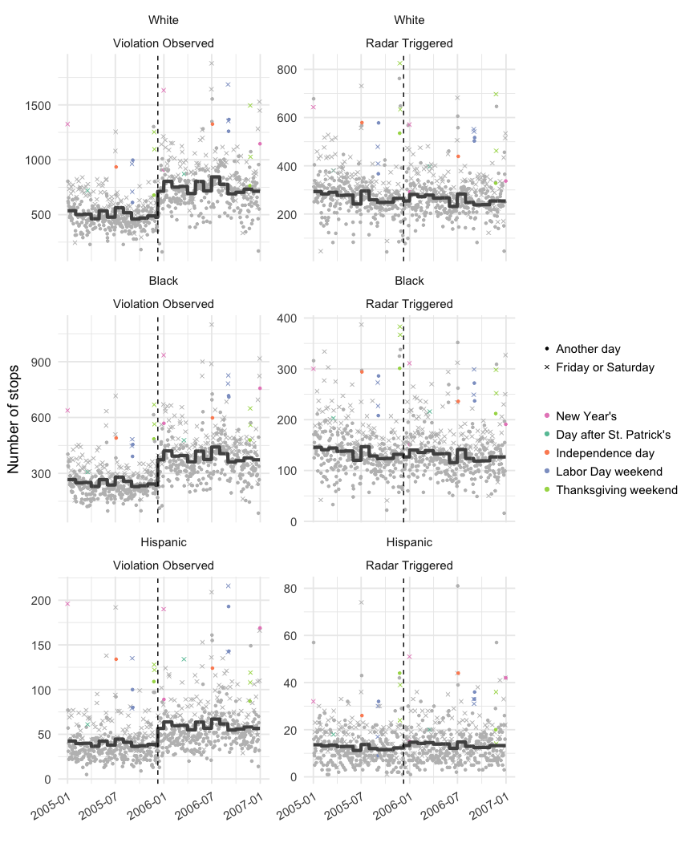

**Figure 1 Caption:** Stops for “Violation Observed” encapsulated the majority of non-speeding violations such as not wearing a seat belt, failing to stop at a red light, crossing the center line into oncoming traffic, and so on. Stops for “Radar Triggered” included all stops for breaking the speed limit. Each point is the number of stops for a specific day. The dashed vertical line indicates the day of the change from secondary to primary enforcement of seat belt use. The solid line is the predicted line from the quasi-Poisson model, with the “day” covariate set to Wednesday (the day with a near-average number of stops) and the indicators for holidays held at 0 to illustrate the expected number of stops over time for an average day after accounting for month, race, the policy change, and the interaction between race and policy.

##### page break

**Figure 2: Estimated additional relative increase and 95% confidence intervals for the number of traffic stops for Black and Hispanic drivers following the upgrade to primary seatbelt enforcement, compared to White drivers, according to stop purpose**

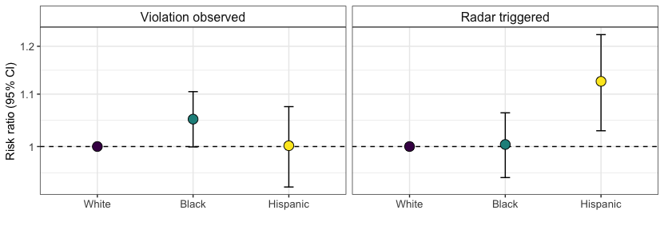

**Figure 2 caption:** This plot displays the marginal risk ratios for the additional relative increase to the number of stops among Black and Hispanic drivers compared to White drivers, after the policy enactment, stratified by stop type. These risk ratios were computed using marginal prediction and the confidence intervals calculated using the percentile bootstrap method based on 1,000 replicates. Stops for “Violation observed” included the majority of non-speeding violations such as not wearing a seat belt, failing to stop at a red light, etc. Stops for “Radar triggered” included all stops for breaking the speed limit.

##### page break

## Warning: Unknown levels in `f`: All stops

**Figure 3: Estimated additional relative increase (risk ratios) and 95% confidence intervals for the arrest rates for Black and Hispanic drivers following the upgrade to primary seatbelt enforcement, compared to White drivers, according to stop purpose**

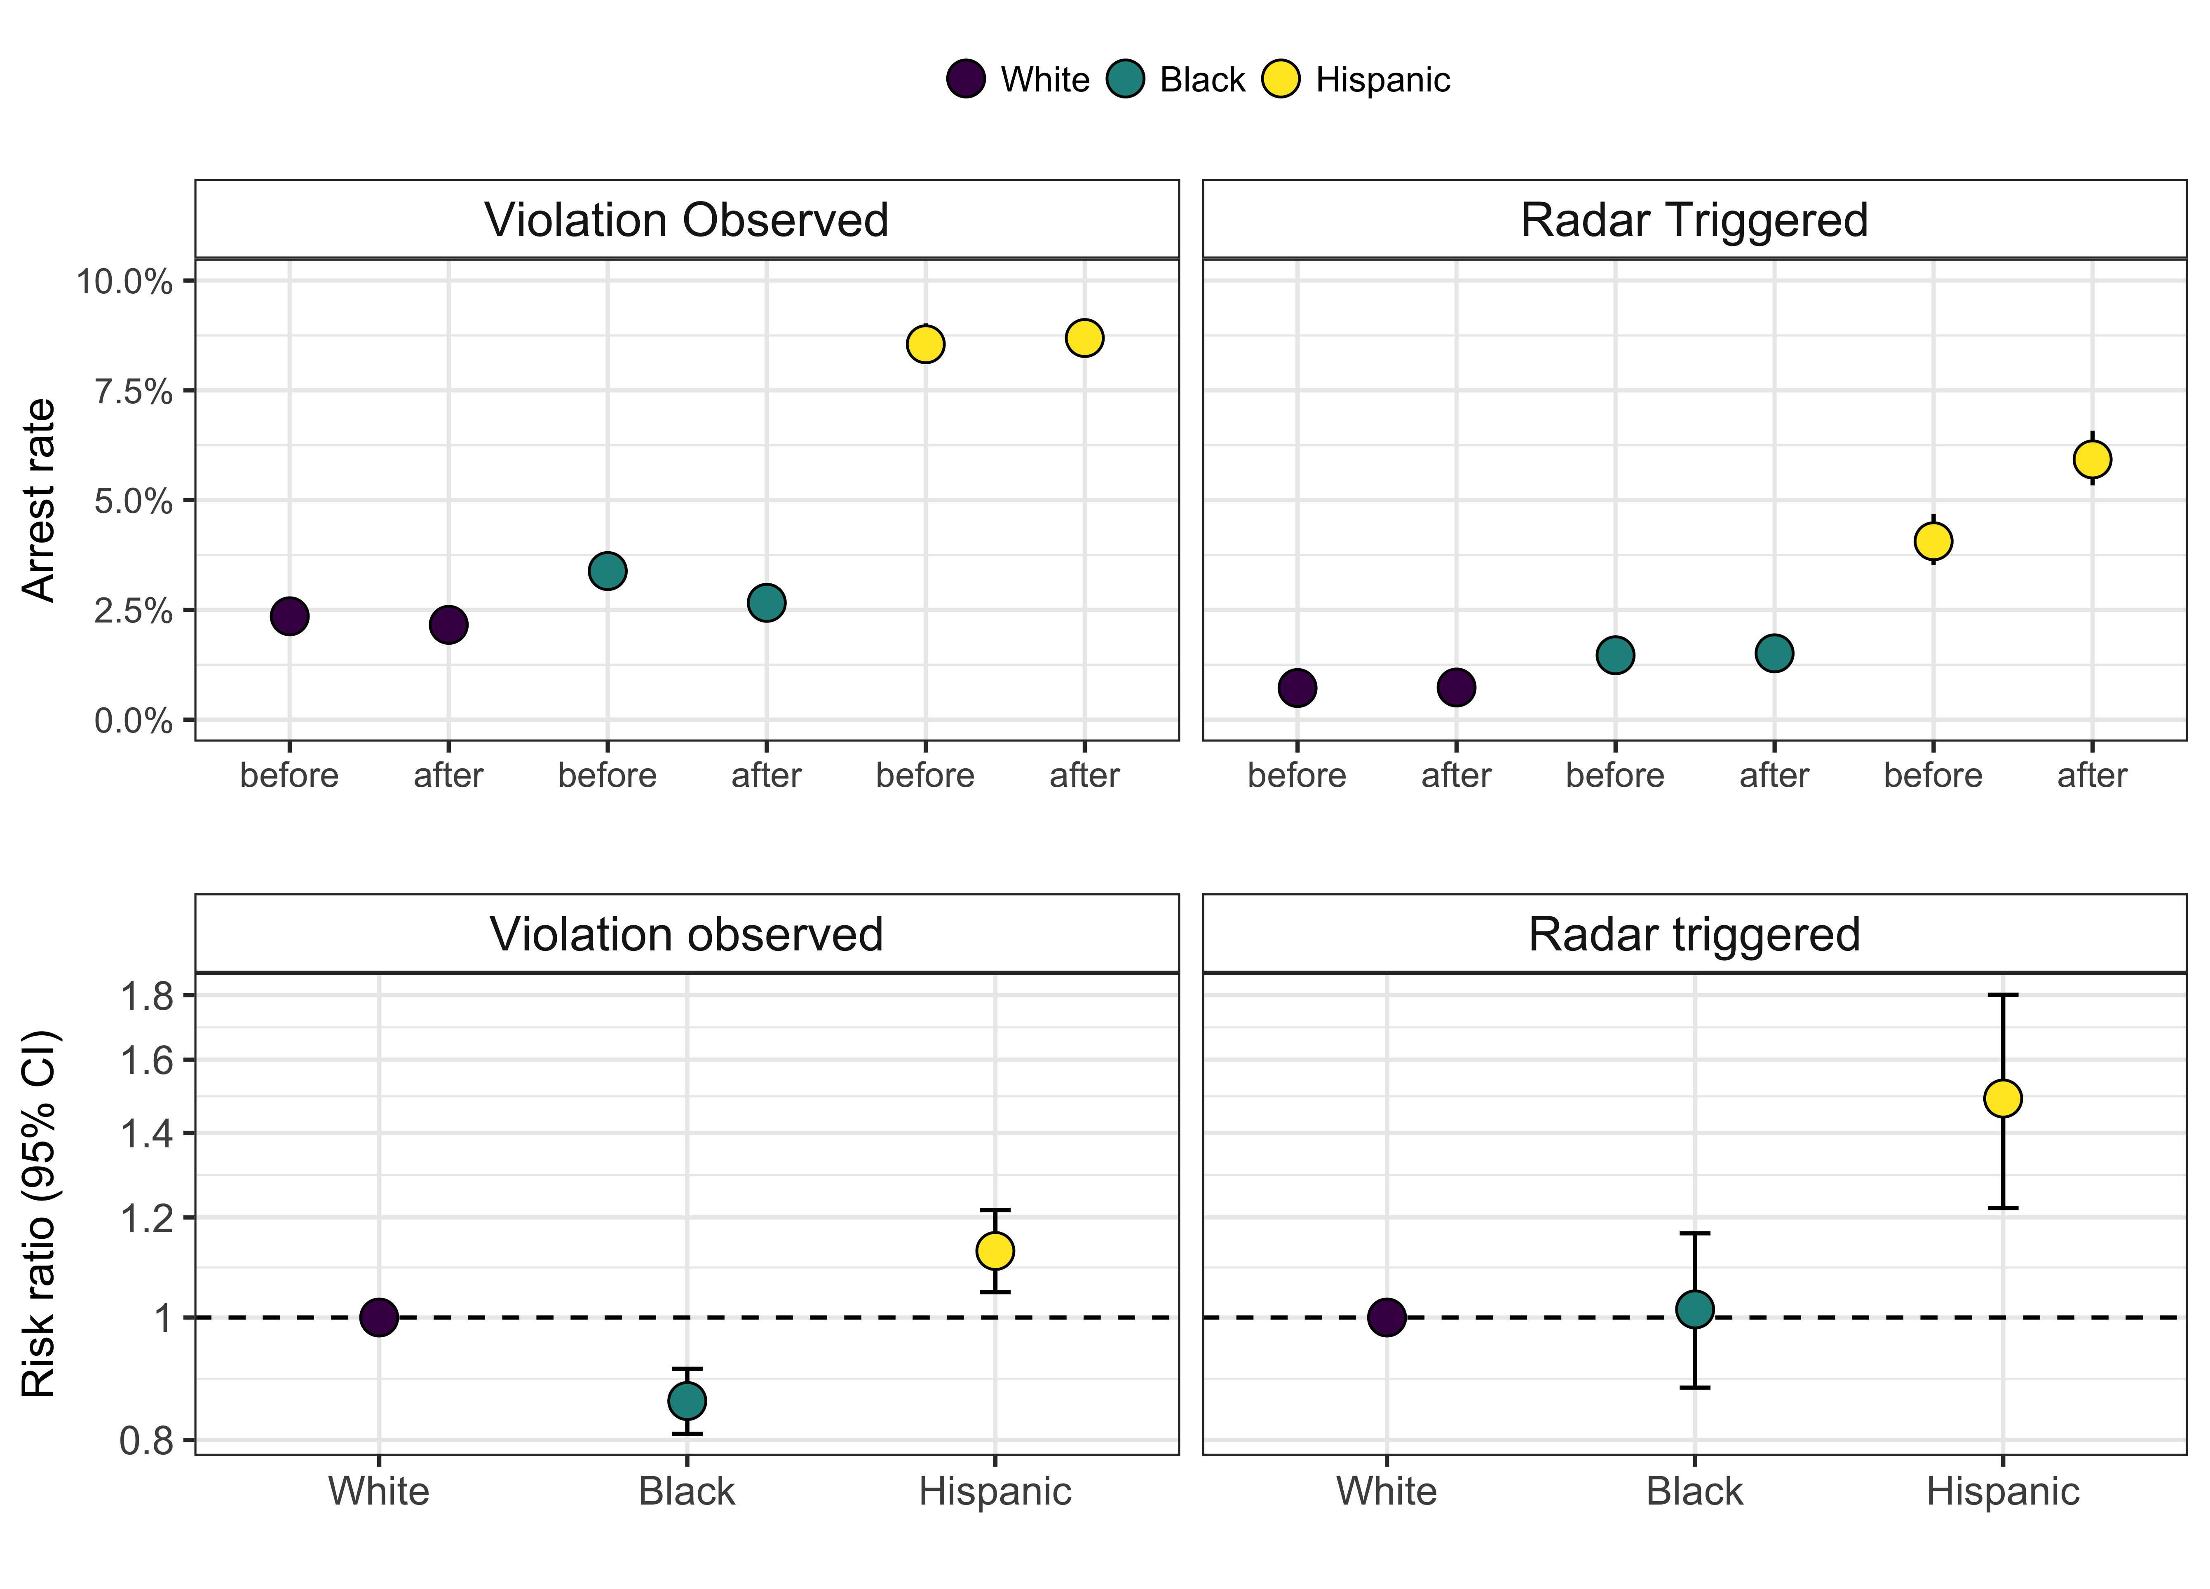

**Figure 3 caption:** This plot displays the marginal risk ratios for the additional relative increase to the risk of arrest among Black and Hispanic drivers compared to White drivers, after the policy enactment, stratified by stop type. These risk ratios were computed using marginal prediction and the confidence intervals calculated using the percentile bootstrap method based on 1,000 replicates. Stops for “Violation observed” encapsulated the majority of non-speeding violations such as not wearing a seat belt, failing to stop at a red light, crossing the center line into oncoming traffic, and so on. Stops for “Radar triggered” included all stops for breaking the speed limit.

##### page break

##### page break

**Figure 4: Estimated additional relative increase (risk ratios) and 95% confidence intervals for the search rates for Black and Hispanic drivers following the upgrade to primary seatbelt enforcement, compared to White drivers, according to stop purpose**

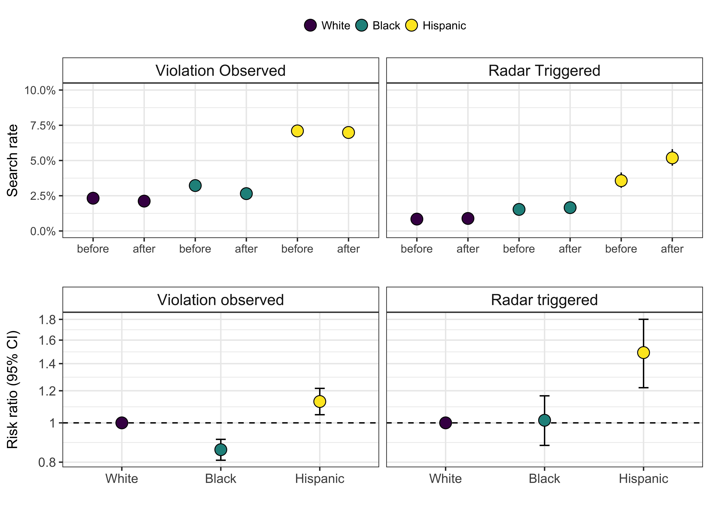

**Figure 4 caption:** This plot displays the marginal risk ratios for the additional relative increase to the risk of search among Black and Hispanic drivers compared to White drivers, after the policy enactment, stratified by stop type. These risk ratios were computed using marginal prediction and the confidence intervals calculated using the percentile bootstrap method based on 1,000 replicates. Stops for “Violation observed” encapsulated the majority of non-speeding violations such as not wearing a seat belt, failing to stop at a red light, crossing the center line into oncoming traffic, and so on. Stops for “Radar triggered” included all stops for breaking the speed limit.

##### pb

# Supplementary appendix to “Using change in a seat belt law to study racially-biased policing in South Carolina”

Corinne A. Riddell, Jay S. Kaufman, Jacqueline M. Torres, Sam Harper

**Contents:**

Table S1: Quasi-Poisson regression of the number of daily traffic stops in South Carolina by highway traffic patrol to drivers with observed violations, 2005-2006

Table S2: Quasi-Poisson regression of the number of daily traffic stops in South Carolina by highway traffic patrol to speeding drivers, 2005-2006

Table S3: Logistic regression of arrests in South Carolina by the highway traffic patrol among stops for observed violations only, 2005-2006

Table S4: Logistic regression of arrests in South Carolina by the highway traffic patrol among stops for speeding, 2005-2006

Table S5: Logistic regression of searches conducted in South Carolina by the highway traffic patrol among stops for observed violations only, 2005-2006

Table S6: Logistic regression of searches conducted in South Carolina by the highway traffic patrol among stops for speeding, 2005-2006

##### page break

##### page break

**Table S1: Quasi-Poisson regression of the number of daily traffic stops in South Carolina by highway traffic patrol to drivers with observed violations, 2005-2006**

|  |  |  |  |  |
| --- | --- | --- | --- | --- |
| Term | Estimate | Estimated RR* | lower CI | upper CI |
| Intercept | 6.11 | NA | NA | NA |
| Black (ref: White) | -0.70 | 0.50 | 0.48 | 0.52 |
| Hispanic | -2.54 | 0.08 | 0.07 | 0.09 |
| post policy | 0.41 | 1.50 | 1.46 | 1.54 |
| February (ref: January) | -0.07 | 0.93 | 0.89 | 0.98 |
| March | -0.06 | 0.94 | 0.90 | 0.99 |
| April | -0.15 | 0.86 | 0.82 | 0.91 |
| May | 0.00 | 1.00 | 0.95 | 1.05 |
| June | -0.12 | 0.89 | 0.85 | 0.94 |
| July | 0.05 | 1.05 | 1.00 | 1.10 |
| August | -0.03 | 0.97 | 0.92 | 1.01 |
| September | -0.15 | 0.86 | 0.81 | 0.90 |
| October | -0.13 | 0.88 | 0.83 | 0.92 |
| November | -0.09 | 0.91 | 0.87 | 0.96 |
| December | -0.12 | 0.89 | 0.85 | 0.93 |
| Monday (ref: Sunday) | 0.15 | 1.17 | 1.12 | 1.21 |
| Tuesday | 0.08 | 1.08 | 1.04 | 1.13 |
| Wednesday | 0.17 | 1.19 | 1.14 | 1.23 |
| Thursday | 0.06 | 1.06 | 1.02 | 1.11 |
| Friday | 0.41 | 1.51 | 1.45 | 1.57 |
| Saturday | 0.39 | 1.48 | 1.42 | 1.53 |
| Day after St. Patrick’s Day | 0.02 | 1.02 | 0.85 | 1.22 |
| Independence Day | 0.54 | 1.71 | 1.47 | 1.99 |
| Labor Day weekend | 0.62 | 1.87 | 1.72 | 2.03 |
| New Year’s | 0.64 | 1.89 | 1.71 | 2.09 |
| Thanksgiving | 0.45 | 1.57 | 1.42 | 1.72 |
| Black * policy interaction | 0.05 | 1.05 | 1.00 | 1.10 |
| Hispanic * policy interaction | 0.00 | 1.00 | 0.91 | 1.10 |

* The Estimated Relative Risk (RR) shown in this table is the exponentiated coefficient estimate. It is not equal to the estimated RRs reported in the main text, which we calculated using marginal standardization.

##### page break

**Table S2: Quasi-Poisson regression of the number of daily traffic stops in South Carolina by highway traffic patrol to speeding drivers, 2005-2006**

|  |  |  |  |  |
| --- | --- | --- | --- | --- |
| Term | Estimate | Estimated RR | lower CI | upper CI |
| Intercept | 5.71 | NA | NA | NA |
| Black (ref: White) | -0.70 | 0.50 | 0.48 | 0.52 |
| Hispanic | -3.07 | 0.05 | 0.04 | 0.05 |
| post policy | -0.04 | 0.96 | 0.93 | 0.99 |
| February (ref: January) | -0.03 | 0.97 | 0.91 | 1.03 |
| March | -0.01 | 0.99 | 0.93 | 1.05 |
| April | -0.06 | 0.95 | 0.89 | 1.00 |
| May | -0.05 | 0.95 | 0.90 | 1.01 |
| June | -0.19 | 0.82 | 0.78 | 0.88 |
| July | 0.01 | 1.01 | 0.95 | 1.07 |
| August | -0.13 | 0.88 | 0.83 | 0.94 |
| September | -0.17 | 0.85 | 0.79 | 0.90 |
| October | -0.16 | 0.85 | 0.80 | 0.90 |
| November | -0.10 | 0.90 | 0.85 | 0.96 |
| December | -0.10 | 0.90 | 0.85 | 0.96 |
| Monday (ref: Sunday) | -0.02 | 0.98 | 0.93 | 1.02 |
| Tuesday | -0.13 | 0.88 | 0.84 | 0.92 |
| Wednesday | -0.03 | 0.97 | 0.92 | 1.01 |
| Thursday | -0.13 | 0.88 | 0.84 | 0.92 |
| Friday | 0.20 | 1.23 | 1.17 | 1.28 |
| Saturday | 0.23 | 1.26 | 1.21 | 1.31 |
| Day after St. Patrick’s Day | 0.09 | 1.09 | 0.89 | 1.34 |
| Independence Day | 0.63 | 1.88 | 1.58 | 2.25 |
| Labor Day weekend | 0.59 | 1.80 | 1.62 | 1.98 |
| New Year’s | 0.40 | 1.50 | 1.31 | 1.71 |
| Thanksgiving | 0.67 | 1.96 | 1.77 | 2.18 |
| Black * policy interaction | 0.00 | 1.00 | 0.95 | 1.06 |
| Hispanic * policy interaction | 0.12 | 1.13 | 0.98 | 1.29 |

* The Estimated Relative Risk (RR) shown in this table is the exponentiated coefficient estimate. It is not equal to the estimated RRs reported in the main text, which we calculated using marginal standardization.

##### page break

**Table S3: Logistic regression of arrests in South Carolina by the highway traffic patrol among stops for observed violations only, 2005-2006**

|  |  |  |  |  |
| --- | --- | --- | --- | --- |
| Term | Estimate | Estimated OR* | lower CI | upper CI |
| Intercept | -5.62 | NA | NA | NA |
| Black (ref: White) | 0.38 | 1.46 | 1.39 | 1.53 |
| Hispanic | 1.00 | 2.72 | 2.54 | 2.91 |
| Male (ref: Female) | 1.16 | 3.19 | 3.07 | 3.32 |
| Age spline term: <20 years | 0.99 | 2.70 | 2.44 | 2.99 |
| Age spline term: 20-30 years | 1.37 | 3.95 | 3.42 | 4.56 |
| Age spline term: 30-40 years | 1.34 | 3.83 | 3.37 | 4.35 |
| Age spline term: 40-50 years | -1.21 | 0.30 | 0.23 | 0.40 |
| Age spline term: 50-60 years | -0.22 | 0.81 | 0.40 | 1.64 |
| Age spline term: >60 years | -3.54 | 0.03 | 0.01 | 0.11 |
| post policy | -0.10 | 0.90 | 0.87 | 0.94 |
| February (ref: January) | 0.02 | 1.02 | 0.95 | 1.09 |
| March | -0.05 | 0.95 | 0.89 | 1.02 |
| April | -0.04 | 0.97 | 0.90 | 1.03 |
| May | -0.07 | 0.93 | 0.87 | 0.99 |
| June | -0.05 | 0.96 | 0.89 | 1.02 |
| July | -0.01 | 0.99 | 0.93 | 1.06 |
| August | 0.03 | 1.03 | 0.96 | 1.10 |
| September | -0.03 | 0.97 | 0.90 | 1.04 |
| October | -0.02 | 0.98 | 0.92 | 1.05 |
| November | -0.05 | 0.95 | 0.89 | 1.03 |
| December | 0.12 | 1.13 | 1.06 | 1.20 |
| Friday | 0.02 | 1.02 | 0.97 | 1.07 |
| Monday (ref: Sunday) | -0.42 | 0.66 | 0.62 | 0.70 |
| Saturday | 0.21 | 1.23 | 1.18 | 1.29 |
| Thursday | -0.29 | 0.75 | 0.71 | 0.80 |
| Tuesday | -0.41 | 0.66 | 0.63 | 0.70 |
| Wednesday | -0.46 | 0.63 | 0.59 | 0.67 |
| Day after St. Patrick’s Day | -0.22 | 0.80 | 0.64 | 1.02 |
| Independence Day | 0.25 | 1.29 | 1.05 | 1.58 |
| Labor Day weekend | 0.08 | 1.08 | 0.98 | 1.21 |
| New Year’s | 0.22 | 1.24 | 1.12 | 1.38 |
| Thanksgiving | -0.07 | 0.94 | 0.83 | 1.06 |
| Black * policy interaction | -0.16 | 0.85 | 0.80 | 0.91 |
| Hispanic * policy interaction | 0.13 | 1.13 | 1.04 | 1.23 |

* The Estimated Odds Ratio (OR) shown in this table is the exponentiated coefficient estimate. It is not equal to the estimated RRs reported in the main text, which we calculated using marginal standardization.

##### page break

**Table S4: Logistic regression of arrests in South Carolina by the highway traffic patrol among stops for speeding, 2005-2006**

|  |  |  |  |  |
| --- | --- | --- | --- | --- |
| Term | Estimate | Estimated OR* | lower CI | upper CI |
| Intercept | -6.88 | NA | NA | NA |
| Black (ref: White) | 0.70 | 2.02 | 1.82 | 2.24 |
| Hispanic | 1.25 | 3.50 | 2.97 | 4.13 |
| Male (ref: Female) | 1.40 | 4.06 | 3.68 | 4.49 |
| Age spline term: <20 years | 0.76 | 2.14 | 1.70 | 2.68 |
| Age spline term: 20-30 years | 0.74 | 2.09 | 1.47 | 2.99 |
| Age spline term: 30-40 years | 0.23 | 1.26 | 0.89 | 1.79 |
| Age spline term: 40-50 years | -1.59 | 0.20 | 0.06 | 0.72 |
| Age spline term: 50-60 years | -11.13 | 0.00 | 0.00 | 0.04 |
| Age spline term: >60 years | -22.62 | 0.00 | 0.00 | 0.00 |
| post policy | -0.03 | 0.97 | 0.88 | 1.08 |
| February (ref: January) | 0.16 | 1.17 | 1.00 | 1.37 |
| March | 0.17 | 1.19 | 1.02 | 1.39 |
| April | 0.01 | 1.01 | 0.85 | 1.18 |
| May | 0.14 | 1.15 | 0.98 | 1.34 |
| June | -0.05 | 0.95 | 0.80 | 1.13 |
| July | -0.28 | 0.76 | 0.64 | 0.90 |
| August | -0.14 | 0.87 | 0.73 | 1.03 |
| September | 0.07 | 1.08 | 0.91 | 1.28 |
| October | 0.18 | 1.20 | 1.02 | 1.41 |
| November | 0.07 | 1.07 | 0.90 | 1.27 |
| December | 0.24 | 1.28 | 1.09 | 1.49 |
| Friday | 0.10 | 1.11 | 0.98 | 1.25 |
| Monday (ref: Sunday) | -0.12 | 0.89 | 0.77 | 1.02 |
| Saturday | 0.37 | 1.45 | 1.29 | 1.62 |
| Thursday | 0.02 | 1.02 | 0.89 | 1.17 |
| Tuesday | 0.11 | 1.12 | 0.98 | 1.28 |
| Wednesday | 0.06 | 1.06 | 0.93 | 1.21 |
| Day after St. Patrick’s Day | 0.01 | 1.01 | 0.62 | 1.64 |
| Labor Day weekend | -0.02 | 0.98 | 0.74 | 1.28 |
| New Year’s | -0.15 | 0.86 | 0.62 | 1.20 |
| Thanksgiving | 0.05 | 1.05 | 0.80 | 1.37 |
| Black * policy interaction | 0.01 | 1.01 | 0.88 | 1.17 |
| Hispanic * policy interaction | 0.42 | 1.52 | 1.23 | 1.87 |

* The Estimated Odds Ratio (OR) shown in this table is the exponentiated coefficient estimate. It is not equal to the estimated RRs reported in the main text, which we calculated using marginal standardization.

This model does not include an indicator variable for Independence day. This is because there are no arrests among stops for speeding on this day, so it could not be included in this model.

##### page break

**Table S5: Logistic regression of searches conducted in South Carolina by the highway traffic patrol among stops for observed violations only, 2005-2006**

|  |  |  |  |  |
| --- | --- | --- | --- | --- |
| Term | Estimate | Estimated OR* | lower CI | upper CI |
| Intercept | -5.15 | NA | NA | NA |
| Black (ref: White) | 0.35 | 1.42 | 1.35 | 1.49 |
| Hispanic | 0.80 | 2.24 | 2.08 | 2.40 |
| Male (ref: Female) | 1.21 | 3.36 | 3.22 | 3.50 |
| Age spline term: <20 years | 0.43 | 1.54 | 1.40 | 1.68 |
| Age spline term: 20-30 years | 0.71 | 2.03 | 1.78 | 2.33 |
| Age spline term: 30-40 years | 0.64 | 1.90 | 1.68 | 2.14 |
| Age spline term: 40-50 years | -1.77 | 0.17 | 0.13 | 0.23 |
| Age spline term: 50-60 years | -1.31 | 0.27 | 0.13 | 0.56 |
| Age spline term: >60 years | -3.58 | 0.03 | 0.01 | 0.11 |
| post policy | -0.11 | 0.89 | 0.86 | 0.93 |
| February (ref: January) | 0.10 | 1.10 | 1.03 | 1.18 |
| March | 0.05 | 1.05 | 0.98 | 1.13 |
| April | -0.09 | 0.92 | 0.85 | 0.99 |
| May | -0.05 | 0.95 | 0.89 | 1.02 |
| June | -0.01 | 0.99 | 0.92 | 1.06 |
| July | 0.01 | 1.01 | 0.94 | 1.08 |
| August | 0.04 | 1.04 | 0.97 | 1.11 |
| September | 0.00 | 1.00 | 0.93 | 1.08 |
| October | 0.03 | 1.03 | 0.96 | 1.10 |
| November | -0.01 | 0.99 | 0.92 | 1.07 |
| December | 0.15 | 1.16 | 1.09 | 1.24 |
| Friday | 0.03 | 1.03 | 0.98 | 1.08 |
| Monday (ref: Sunday) | -0.37 | 0.69 | 0.65 | 0.73 |
| Saturday | 0.18 | 1.20 | 1.14 | 1.26 |
| Thursday | -0.22 | 0.81 | 0.76 | 0.85 |
| Tuesday | -0.31 | 0.73 | 0.69 | 0.78 |
| Wednesday | -0.34 | 0.71 | 0.67 | 0.75 |
| Day after St. Patrick’s Day | -0.20 | 0.82 | 0.65 | 1.04 |
| Independence Day | 0.27 | 1.31 | 1.07 | 1.60 |
| Labor Day weekend | -0.03 | 0.97 | 0.87 | 1.09 |
| New Year’s | 0.36 | 1.43 | 1.29 | 1.59 |
| Thanksgiving | -0.08 | 0.92 | 0.81 | 1.05 |
| Black * policy interaction | -0.11 | 0.90 | 0.84 | 0.95 |
| Hispanic * policy interaction | 0.10 | 1.10 | 1.01 | 1.21 |

* The Estimated Odds Ratio (OR) shown in this table is the exponentiated coefficient estimate. It is not equal to the estimated RRs reported in the main text, which we calculated using marginal standardization.

##### page break

**Table S6: Logistic regression of searches conducted in South Carolina by the highway traffic patrol among stops for speeding, 2005-2006**

|  |  |  |  |  |
| --- | --- | --- | --- | --- |
| Term | Estimate | Estimated OR* | lower CI | upper CI |
| Intercept | -6.07 | NA | NA | NA |
| Black (ref: White) | 0.60 | 1.82 | 1.65 | 2.01 |
| Hispanic | 0.95 | 2.59 | 2.18 | 3.08 |
| Male (ref: Female) | 1.41 | 4.10 | 3.73 | 4.51 |
| Age spline term: <20 years | 0.17 | 1.18 | 0.97 | 1.44 |
| Age spline term: 20-30 years | -0.08 | 0.92 | 0.68 | 1.27 |
| Age spline term: 30-40 years | -0.27 | 0.76 | 0.56 | 1.05 |
| Age spline term: 40-50 years | -2.96 | 0.05 | 0.02 | 0.17 |
| Age spline term: 50-60 years | -9.45 | 0.00 | 0.00 | 0.07 |
| Age spline term: >60 years | -16.74 | 0.00 | 0.00 | 0.02 |
| post policy | 0.02 | 1.02 | 0.93 | 1.13 |
| February (ref: January) | 0.17 | 1.19 | 1.02 | 1.38 |
| March | 0.15 | 1.17 | 1.01 | 1.35 |
| April | 0.03 | 1.03 | 0.88 | 1.20 |
| May | 0.00 | 1.00 | 0.86 | 1.17 |
| June | -0.06 | 0.94 | 0.80 | 1.11 |
| July | -0.20 | 0.82 | 0.70 | 0.96 |
| August | -0.26 | 0.77 | 0.65 | 0.91 |
| September | 0.02 | 1.02 | 0.87 | 1.21 |
| October | 0.15 | 1.17 | 1.00 | 1.36 |
| November | 0.15 | 1.16 | 0.99 | 1.35 |
| December | 0.15 | 1.17 | 1.00 | 1.36 |
| Friday | 0.03 | 1.03 | 0.92 | 1.16 |
| Monday (ref: Sunday) | 0.00 | 1.00 | 0.89 | 1.14 |
| Saturday | 0.29 | 1.34 | 1.20 | 1.49 |
| Thursday | 0.05 | 1.06 | 0.93 | 1.20 |
| Tuesday | 0.09 | 1.10 | 0.97 | 1.25 |
| Wednesday | 0.02 | 1.02 | 0.90 | 1.16 |
| Day after St. Patrick’s Day | -0.24 | 0.79 | 0.47 | 1.33 |
| Independence Day | -1.05 | 0.35 | 0.16 | 0.79 |
| Labor Day weekend | -0.09 | 0.91 | 0.70 | 1.19 |
| New Year’s | -0.25 | 0.78 | 0.55 | 1.10 |
| Thanksgiving | 0.09 | 1.09 | 0.85 | 1.39 |
| Black * policy interaction | 0.03 | 1.03 | 0.90 | 1.18 |
| Hispanic * policy interaction | 0.39 | 1.48 | 1.19 | 1.84 |

* The Estimated Odds Ratio (OR) shown in this table is the exponentiated coefficient estimate. It is not equal to the estimated RRs reported in the main text, which we calculated using marginal standardization.