Explore google health trends - ‘corona’

One sentence summary about objective of this doc – to explore how the google search trend outcome var changes for terms we expect to change dramatically over the course of the pandemic.

Description of the outcome variable that google health trends returns – A. ‘Corona’.

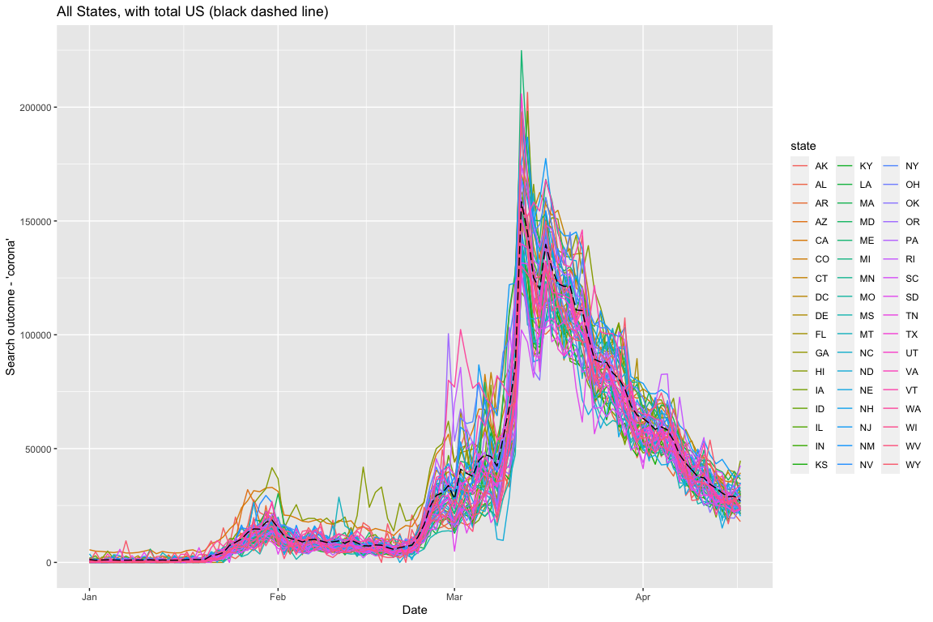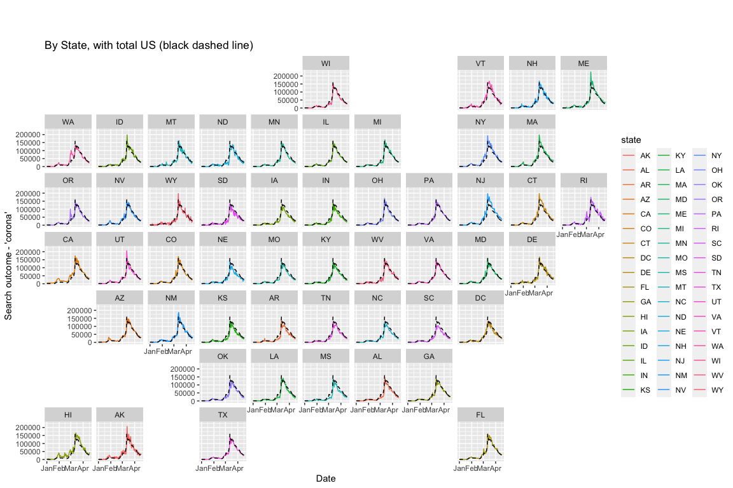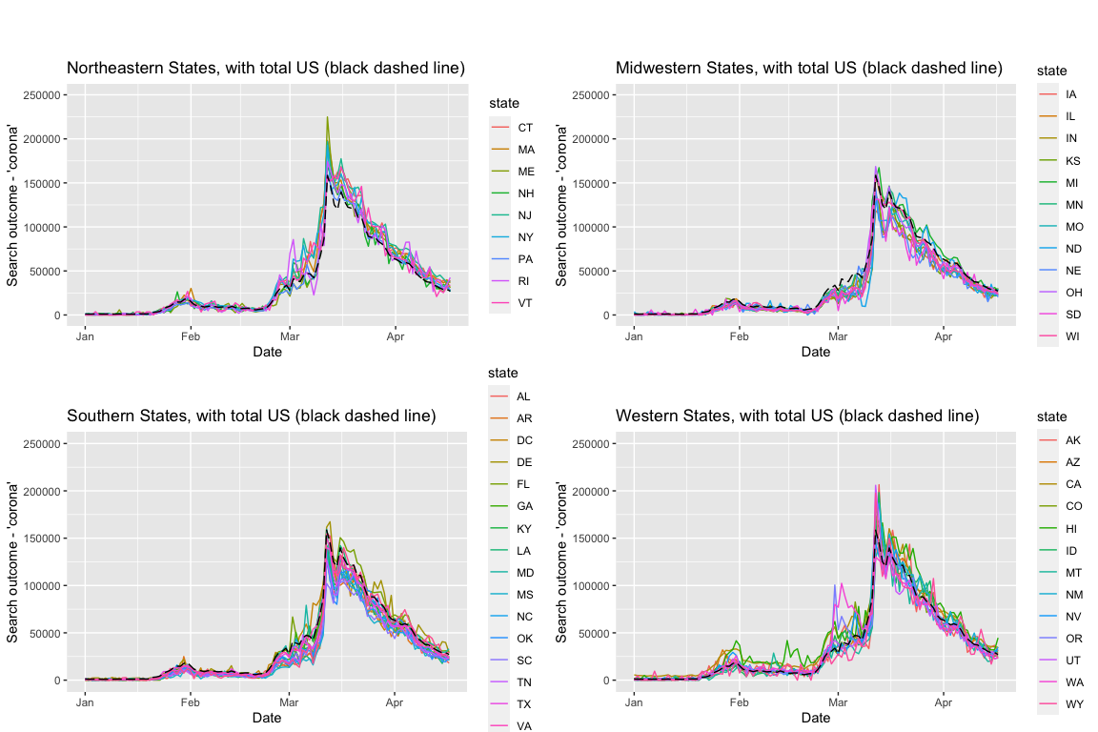

What next test should we run? What questions do we have for the group or Krista?

Questions:

KF: I’m probably not understanding what “value” is actually being captured by Google Health Trends, but I’m confused about why the trend for Total US isn’t higher than for individual states.