HW4

2024-02-09

Corinne Ward, cw42962, Github link:

# **Problem 1**

Theory A

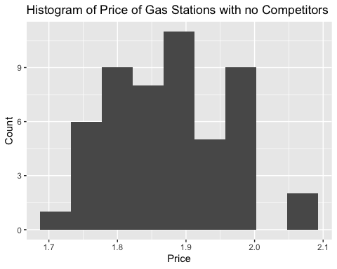 ggplot both include mean for both

means <- c(mean(gas_competitors$Price), mean(gas_no_competitors$Price))  
barplot(means, names.arg = c("Competitors", "No Competitors"), ylim = c(0,2), col = "black", main = "Average Gas Price for Gas Stations With and Without Competitors", ylab = "Price")

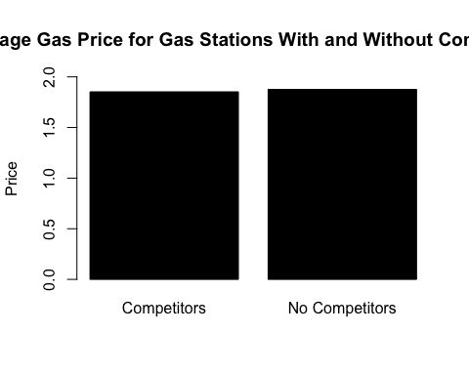

Theory B

Theory C Theory D Theory E

# **Problem 2**

Part A